This is the Title PhL 3.26.05

C.3 The DC inductance of a round wire

We assume here that μi is the permeability of the wire, and μe of the region outside the wire.

(a) Internal DC inductance of a round wire

Inductance is a slightly harder problem. The energy density (joules/m3) stored in an electromagnetic field within a medium of negligible loss is given by uem = (E•D + B•H)/2 [ Jackson p 259 Eq. (6.106) ] . We are interested only in the portion of this energy density stored in the magnetic field, so u = (1/2) B•H. Since μ and ε are assumed to be non-tensor in nature, u = (1/2) μ H2. Denoting by dU the field energy stored in a volume dV, so that u = dU/dV, one finds

dU = (1/2) μH2 dV . (C.3.1)

For any inductor of inductance L carrying current I and having potential difference V, we know that V = L dI/dt and power P = IV = I (L dI/dt) = d/dt [ (1/2)L I2 ]. The total energy U stored in the full field of the inductor must then be U = (1/2)L I2 in order to obtain P = dU/dt.
If we consider a piece of uniform round wire of length dz, we can compute the total energy U stored in the field portion that lies inside the wire, and this piece of wire then has "internal inductance" Lidz where then Li is the internal inductance of the wire per unit length. So,

Ui = (1/2) (Li dz) I2 . (C.3.2)

Looking at (C.3.1), we see that Ui = ∫inside (1/2) μH2dV, so our next task is to determine H inside the wire. Due to the symmetry of the round wire, we know that H = H(r) . We may use the static Maxwell H curl equation (1.1.1) and the static integral form (1.1.37),

curl H = J ⇔ H • ds = ∫S [J] • dA "Ampere's Law" . (1.1.23)

Consider a transverse circular loop of radius r centered on the wire's center line. The enclosed current is ∫J•dA = J$^{\int_{0}^{r}{}}$2πrdr = (I/πa2) (πr2) = I (r/a)2 while H•ds = 2πrH(r). Thus one finds that I (r/a)2 = 2πr H(r) so

H(r) = (I/2πa2) r r ≤ a . (C.3.3)

From (C.3.1) the energy stored in a ring of volume dV =2πrdrdz is

dU(r) = (1/2) μiH2 dV = (1/2) μi (Ir/2πa2)22πrdrdz = μi (I2r2/4π2a4) πrdrdz = μi (I2r3/4πa4) drdz

= (μidzI2/4πa4) r-3dr .

Integrate this from r=0 to r=a to get the total magnetic energy stored inside the wire,

Ui = (μidz I2/16π) = (1/2) [μi/8π] dz I2 . (C.3.4)

Set this equal to (1/2)Lidz I2 in (C.3.2) to find that

Li = μi/8π . (C.3.5)

If this medium is non-magnetic, then μi = μ0. Since μ0 = 4π x 10-7 henry/m we find that (μ0/8π) = (1/2)x10-7 = 50 x 10-9 so the internal inductance per unit length of a round wire is given by

Li = (μi/μ0) * 50 nH/m // nH = nanohenries (C.3.5a)

which agrees with Matick p 97 (4-6) .
Interestingly, this result is independent of the wire radius a. For a given current I, the total field energy stored in the wire is independent of a. For small a, the field is stronger but in a smaller volume.

(b) External DC inductance of a round wire

What about the external inductance of a round wire? We can compute it by the same method. If we use a Stokesian loop of radius r ≥ a, the enclosed current is I. We set this enclosed current equal to 2πrH(r) to get the magnetic field at r,

H(r) = (I/2π) r-1 . (C.3.6)

From (C.3.1) the energy stored in a ring of volume dV = 2πrdrdz is

dU(r) = (1/2) μeH2dV = (1/2)μe(I/2πr)2[2πrdrdz] = μe(I2/4π2r2)πrdrdz = μe(I2/4πr)drdz

= (μedzI2/4π) r-1 dr .

Integrate this from r=a to some large radius r=R to get

Ue = (μedz I2/4π) ln(R/a) = (1/2) [ $\frac{μe}{2π}$ ln$\frac{R}{a}$ ] dz I2 . (C.3.7)

Set this equal to (1/2)Ledz I2 in (C.3.2) to find that,

Le = $\frac{μe}{2π}$ ln$\frac{R}{a}$ . (C.3.8)

If we set R = ∞ to get the total external inductance per unit length of a round wire, the result is logarithmically divergent. The total magnetic energy stored per unit length of an infinitely long round wire in isolation is infinite. It takes an infinite amount of work to build up such a field even in 1 cm worth of the wire.

A "practical wire" is more like a loop of wire than an infinitely long wire. It is difficult to conjure up an experiment to test (C.3.8) even for a very long straight piece of wire without having some return path for the current to return to the driving "battery". For wire and dielectric both having μ0, Jackson shows (p 216-218) that the inductance per unit length of a loop of projected area A of radius-a wire is given by
Le+ Li = (μ0/4π) [ ln(ξA/a2) + 1/2], where ξ is a near-unity factor which accounts for messy details of the calculation. The 1/2 term accounts for the internal inductance Li = μ0/8π as in (C.3.5).

For a circular loop of radius R, one has A = πR2 and, if R >> a, ξ = 64/(πe4) ≈ .373. So,

ln(ξA/a2) = ln(64 πR2/πe4a2) = 2 ln(8R/ae2) = 2 ln(8R/a) + 2 ln(e-2) = 2 ln(8R/a) - 4

and then the total inductance per unit length is

Le + Li = (μ0/4π) [2 ln(8R/a) - 4 + 1/2] = (μ0/2π) [ ln(8R/a) - 2 + 1/4] = (μ0/2π) [ ln(8R/a) -7/4] .

The total inductance of such a loop is then

L = 2πR(μ0/2π) [ ln(8R/a) -7/4] = μ0R [ ln(8R/a) -7/4]

in agreement with Jackson Problem 5.32 p 234. If one omits the internal inductance, the last factor is -2 instead of -7/4, and this result is seen in some sources. The point is that this is a finite result, even though the (dipole) magnetic field of such a loop does extend to infinity. A loop of N turns gets an extra factor N2 because in effect current I → NI in (C.3.4) and (C.3.7), so the total field energy increases by factor N2.

Suppose there were two parallel wires with currents flowing in opposite directions. In this case, we could compute the magnetic field H at any point in space as the vector sum of the fields of the two wires, then we could integrate H2 over all space to get the total energy U and from that the external inductance Le. In this case, the ln(R) divergence does not appear. In effect, the divergence cancels between the two wires, similar to the way opposite short segements of the circular wire cancel to give the finite result quoted above. Since we will be doing this computation by another means in the main text, we do not bother with the parallel wire calculation here.

We really only care about the internal inductance Li of a wire in our transmission line analysis because the external inductance Le is already accounted for by the techniques of Chapter 4. That is, Le is computed by considering the magnetic potential Az ( or W ) between the wires.

C.4 The DC inductance of a wire of arbitrary cross section

The general method described above was this:

Ui = (1/2) (Li dz) I2 = ∫inside (1/2) μiH2dV
Ue = (1/2) (Li dz) I2 = ∫inside (1/2) μeH2dV

so that

Li = μi ∫inside H2 dS

The main purposes of this section are to show how divergences can be handled, and to remind ourselves that we really have to attack differential equations directly to get real solutions, except in the simplest cases.

(a) Statement of a Plan of Attack

1. Compute H everywhere using (B.2.6),

H(x,y) = - $\frac{1}{4π}$∫d2x' ln(R2) curl' J(x') R = |x-x'| (B.2.6)

This integral determines the H field both inside and outside the wire. Section B.5 evaluates (B.2.6) for the round wire as an example.

We make use of "the Jm theorem" described in Appendix B.6 (b) where it is shown that the correct total solution for A(x) can be obtained by adding an artifical surface current source Jm to the true conduction current source Jc.

1. Compute the surface current component of Jm as described

Here is a possible program for computing the DC inductance of a wire of arbitrary cross section. It is very similar to the above except for the first step. The wire is assumed aligned with the z axis.

1. Compute A(x,y) for an arbitrary wire at DC using formula (1.5.9) with β(ω=0) = 0 :

A(x) = $\frac{1}{4π}$ ∫ dV' [μ2Jc(x') + μ0 Jm (x'] $\frac{1}{R}$ R = |x - x'| ω = 0 (1.5.9)

where A(x) means A(x,ω=0) and the same for the J's. Here μ2 is magnetic permeability of the wire, while μ1 is for the dielectric outside the wire. Jm represents the surface magnetization current (expressed as a volume density) that appears on the conductor surface in the case μ1 ≠ μ2. We presume that there is some reasonable prescribed conduction current density Jc inside the wire, and from this one can (with some effort) compute Jm and then one can compute A(x,ω) according to (1.5.9). Since (at DC) Jc is longitudinal along the wire (z direction), Jm is also longitudinal and A = Az . Thus, all equations below should really be written in terms of the z component only, but we continue to use the simpler vector notation.

2. Compute B = curl A.

3. The magnetic energy density is then dU/dV = (1/2)B2/ μ. Integrate this over the interior or exterior of a slice of the wire to get Ui or Ue. For Ue we know we have to use a cutoff because the result is going to be log divergent as was the case for the round wire.

4. Set U = (1/2) L I2 to extract the appropriate inductance. We shall be mainly interested in the internal inductance.

(b) The divergence problem and its resolution

Let us look more closely at the integral for A(x,ω) stated above. At DC, both Jc and Jm will be constant in z, so we may write

A(x) = $\frac{1}{4π}$ ∫dx'dy' [ μ1Jm (x',y') + μ2Jc(x',y')] $^{\int_{-∞}^{∞}{}}$dz' $\sqrt{s2 + z'2}$ (C.4.1)
where
s = $\sqrt{(x-x')2 + (y-y')2}$ and R = $\sqrt{s2 + z'2}$

At DC Jc will be uniform across the wire so we can write Jc(x',y') = Jc.

An attempt to do the dz' integration reveals the first sign of trouble because this integral diverges. This is a reflection of the same problem noted earlier, that there is something unphysical about an infinite wire. So we install a very large cutoff ± Λ/2 on the z integration, as if the wire were of length Λ instead of ∞. Then,

$^{\int_{-∞}^{∞}{}}$ $\sqrt{s2 + z'2}$ → $^{\int_{-Λ/2}^{Λ/2}{}}$$\sqrt{s2 + z'2}$ = 2 $^{\int_{0}^{Λ/2}{}}$$\sqrt{s2 + z'2}$ = 2 ln[ z' + $\sqrt{z'2 + s2}$] | Λ/20

= 2ln[Λ/2 + $\sqrt{(Λ/2)2 + s2} ] - 2 ln s$

≈ 2ln(Λ) - 2lns = -2ln(s/Λ) ,

where in the last step we assume that the transverse dimensions of the wire are much smaller than the cutoff Λ so that s << Λ for all s in the transverse integration. We are then left with

A(x) = $\frac{1}{4π}$ ∫dx'dy' [ μ1Jm (x',y') + μ2Jc] { 2ln(Λ) - 2lns }

= - $\frac{1}{2π}$ ∫dx'dy' [ μ1Jm (x',y') + μ2Jc] { lns - lnΛ} (C.4.2)

= - $\frac{1}{2π}$ ∫dx'dy' [ μ1Jm (x',y') + μ2Jc] ln[ $\sqrt{(x-x')2 + (y-y')2}$] + a constant

where the constant is proportional to ln(Λ). When we compute B = curl A , this constant has no effect on B so we just ignore the constant, setting it to 0 for the purpose of computing B. However, in order to keep track of dimensions, we shall keep the constant Λ around, perhaps later setting it to 1 since its value does not matter. So:

A(x) = $\frac{1}{2π}$ ∫dx'dy' [ μ1Jm (x',y') + μ2Jc] ln(Λ/s) (C.4.3)

where the transverse integral is over the shape of the wire. Whatever shape wire we choose, we can in principle do the above integration and carry out the program. At worst, we have to resort to numerical techniques.

Comment: We could have arrived at (C.4.3) by starting with (1.5.4) treated as a 2D problem since none of the fields depends on z (recall β2 = 0 since we are doing DC treatment ),

- (∇22D )A = [ μ1Jm(i) + μ2J2] . (1.5.4)

The solution to this equation is (C.4.3) "by inspection" since the 2D free-space propagator is $\frac{1}{2π}$ln (1/R) where R = s = $\sqrt{(x-x')2 + (y-y')2}$ . This concept is discussed in Appendix I. See in particular (I.1.8).

In the case that μ1 = μ2 where Jm = 0, the equation (C.4.3) simplifies to

A(x) = - $\frac{1}{2π}$ ∫dx'dy' [μ2Jc] ln(s/Λ) = - $\frac{1}{2π}$μ1 Jc∫dx'dy' ln(s/Λ) // μ1= μ2

which involves a purely geometric transverse integral over the wire cross section.

For a round wire still with μ1 = μ2 the above integration becomes

Az(r) = - $\frac{μ1Jz}{2π}$ $^{\int_{0}^{a}{}}$r' dr'$^{\int_{0}^{2π}{}}$dθ' ln ($\sqrt{r'2+r2- 2rr' cosθ'}$/Λ ) // μ1= μ2 (C.4.4)

Although it looks like a mess, these are standard integrals, and the H field results (C.3.3) and (C.3.6) of the previous section are easily duplicated using H = (1/μ1)B = (1/μ1) curl A. The following exercise shows how this works. Need reference to somewhere else on this!!

Reader Exercise: In the expression (C.4.4) the -ln(Λ) term creates a constant in Az(r) which we ignore as noted above since we only care about B = curl A, so set Λ = 1. Then use GR7 4.224.9 to show that

$^{\int_{0}^{2π}{}}$dθ' ln ($\sqrt{r'2+r2- 2rr' cosθ'}$ ) = π ln [ $\frac{(r'2+r2) + | r'2- r2|}{2}$ ] .

The denominator 2 can be ignored since it too just creates a constant. Then show that for r > a,

Az(r) = - $\frac{μ1Jz}{2π}$$^{\int_{0}^{a}{}}$r' dr' π ln [ $\frac{(r'2+r2) + | r'2- r2|}{2}$ ] = - (μJz/2) a2 ln(r) .

Then compute B using the curl in cylindrical coordinates to get

B = - ∂rAz(r) = (μJza2/2)r-1 = B(r) where B(r) = (μJza2/2)r-1 .

Finally, since I = Jz(πa2), show that one obtains the known result for field outside a round wire,

H(r) = (I/2π) r-1 . (C.3.6)

For r < a, break up the integral into two parts to obtain the internal results

Az(r) = - (μJz/4) r2 => H(r) = (I/2πa2) r r ≤ a (C.3.3)

The reader may notice a similarity between (C.4.3) and results of Chapter 4 such as 4.4 (3) which contain factors ln(s1/s2). This is no coincidence of course since we took the small β limit in Chapter 4, and here we are dealing with the β = 0 limit (DC). // Remove this paragraph because reader probably has not read Chapter 4 when looking at this appendix.

(c) Avoiding the divergence problem

A way to avoid this divergence business is to apply transverse derivatives to both sides of (C.4.1) right at the start, before doing any integrations. It is really these derivatives of A that we need in order to compute B in Step (b) of the program outlined above. For example, in Cartesian coordinates,

∂x R-1 = -R-2∂xR = -R-2∂x = -R-2(1/2)R-1 2(x-x') = - (x-x') R-3

so the x derivative of (C.4.1) becomes

∂x Az(x) = - $\frac{1}{4π}$ ∫∫dx'dy'[ μ1Jmz (x',y') + μ2Jcz] (x-x') $^{\int_{-∞}^{∞}{}}$dz' $\frac{1}{R3}$ . (C.4.5)

The z' integration is now a convergent integral equal to [ GR7 3.252.7 ],

$^{\int_{-∞}^{∞}{}}$dz' $\frac{1}{[z'2+s2]3/2}$ = 2/s2 s = $\sqrt{(x-x')2 + (y-y')2}$ . (C.4.6)

so that

-By = ∂x Az(x) = - $\frac{1}{2π}$ ∫∫dx'dy'[ μ1Jmz (x',y') + μ2Jcz] $\frac{(x-x')}{(x-x')2 + (y-y')2}$
Bx = ∂y Az(x) = - $\frac{1}{2π}$ ∫∫dx'dy'[ μ1Jmz (x',y') + μ2Jcz] $\frac{(y-y')}{(x-x')2 + (y-y')2}$ (C.4.7)

Now the need for a cutoff Λ is completely avoided.
In the special case μ1 = μ2 so Jmz = 0 we have

-By = ∂x Az(x) = - $\frac{μ1Jcz}{2π}$ ∫∫dx'dy' $\frac{(x-x')}{(x-x')2 + (y-y')2}$
Bx = ∂y Az(x) = - $\frac{μ1Jcz}{2π}$ ∫∫dx'dy' $\frac{(y-y')}{(x-x')2 + (y-y')2}$ // μ1 = μ2 (C.4.8)

and the fields are then determined by these purely geometric integrals (see example below)

In any event, we have outlined a method by which both the internal and external DC inductance of any wire can be calculated. For a round wire we know from (C.3.5) above that Li = μ /8π . For a rectangular conductor of dimensions a and b, the result can be obtained using (C.4.7). The result must have the form Li = (μ/8π) f(a/b) where f(x) is the function one obtains by doing the computation. A square wire would then have f(1). As a square wire is gradually deformed into a round wire, f(1) gradually deforms into 1.

Example: Magnetic Field of a Rectangular Wire

As one might expect, the B field for a rectangular conductor is not particularly simple. Here is a Maple calculation of the double integral appearing in the ∂xAz expression of (C.4.7) where we have made a clumsy attempt to minimize the number of terms. We assume μ1

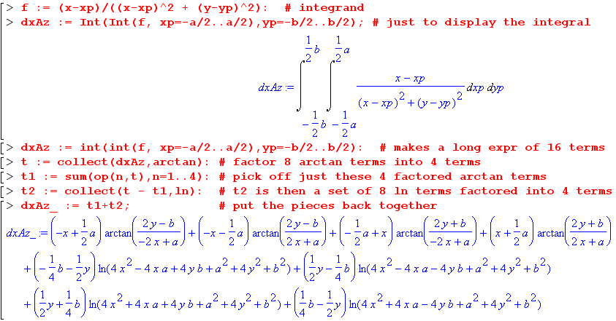

At least the result is expressible in closed form. Using By = -∂xAz as above and Bx = ∂yAz similarly, we can plot the magnetic field lines for a = 1, b = 4 both inside and outside the conductor shown in red:

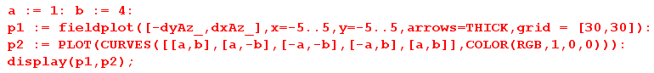

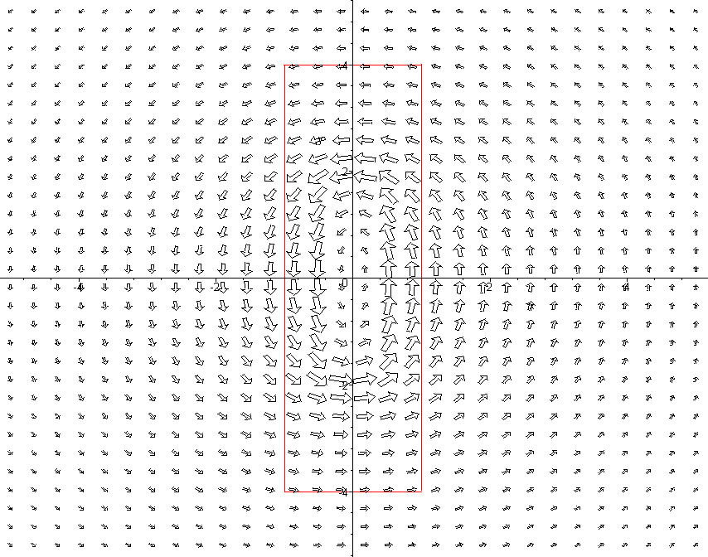

Fig C.1: The DC magnetic field of a rectangular conductor

Far away, the field is the same as that of a round wire carrying the same total current. It would take some work to integrate the energy in this field to obtain Li and Le for such a conductor, but it could be done.

The method presented in this section is not very useful for an AC calculation, because then we can no longer assume that the current density is uniform across the wire. This will become clear later when we compute the exact current density for a round wire at arbitrary frequency. Again, this is similar to Chapter 4 results such as (4.4.3). We need some other method to compute the distribution of charge and current on a conductor.

