New Appendix D PhL 12.1.13

This was installed into lines doc on 12.15.13 after I did a full review of Chapter 2.

Appendix D : The General E and B Fields Inside a Straight Round Wire 1
D.1 Partial Wave Expansion 2
(a) The General Method 2
(b) Partial Wave Expansions 3
(c) The Vector Laplacian in Cylindrical Coordinates 5
(d) The three Helmholtz equations and div E = 0 (in partial waves) 6
D.2 Solutions for E_{z,}E_{r} and E_{φ} 9
(a) The E_{z} Solution 9
(b) The E_{r} Solution 10
(c) The E_{φ} Solution 12
(d) The Charge Pumping Boundary Condition 15
(e) Application of the Boundary Conditions 16
D.3 What about the E_{φ} Helmholtz Equation ? 21
D.4 Computation of the B fields in the round wire 23
D.5 Verification that the E and B fields satisfy the Maxwell equations 27
D.6 The exact E and B fields for the m=0 partial wave 29
D.7 What about the E fields outside the round wire? 30
D.8 About the boundary condition E_{φ}(r=a,m) = 0 32

Appendix D : The General E and B Fields Inside an Infinite Straight Round Wire

This Appendix presents a rather lengthy calculation of the fields and currents inside a round wire without the Chapter 2 assumption that such fields are symmetrical about the axis. This wire may be regarded as one conductor of a transmission line down which a wave is propagating.

Since this Appendix is quite long, a brief summary is in order (see also Table of Contents) :

Section D.1
(a) A longitudinal traveling wave form E(r,φ,z,t) = ej(ωt-β$_{d}$z) E(r,φ) is assumed inside the round wire and E(r,φ,z,t) is then shown to satisfy a certain vector Helmholtz equation.
(b) The field E(r,φ) and the surface charge n(φ) are both expanded onto "azimuthal partial waves" ejmφ with coefficients E(r,m) and Nm.
(c) The Helmholtz equation's vector Laplacian ≡ ∇2 is stated in cylindrical coordinates.
(d) The three Helmholtz component equations and div E = 0 are written out in these coordinates.

Section D.2
(a),(b),(c): The z and r Helmholtz equations and the div E = 0 equation are solved for Ez then Er and then Eφ. These solutions are expressed in terms of Bessel J functions of a complex argument and two unknown constants am and Km for each partial wave.
(d) a boundary condition relating Er to surface charge density n(φ) is derived
(e) this and another boundary condition Eφ(a,m) = 0 (see D.8 below) are used to evaluate am and Km and then the solution E field components are stated in box (D.2.33).

Section D.3
It is noted that the boxed E field solutions also satisfy the ignored third φ Helmholtz equation.

Section D.4
The B fields are computed from the E fields using Maxwell -jωB = curl E, and then box (D.4.9) summarizes both the E and B partial wave fields inside a round wire.

Section D.5 These E and B fields are shown to exactly solve the other three Maxwell equations.

Section D.6 The m = 0 partial wave results are stated and compared to the results of Chapter 2.

Section D.7 The problem of finding an exterior field solution for the round wire is discussed.

Section D.8 Arguments supporting the second boundary condition Eφ(a,m) = 0 are presented.

D.1 Partial Wave Expansion

Warning: In this appendix, we use the same function name E to represent three different functions,

E(r,φ,z,t) E(r,φ) E(r,m)

The functions are distinguished by the arguments shown, and if they are not shown, the general context of the discussion will indicate which function is implied. The symbol E is thus "overloaded".

(a) The General Method

The starting point for the calculation is the damped wave equation (1.3.36, region 2) for the E field inside the wire. Un-subscripted parameters refer to properties of the wire.

(∇2 - με ∂t2 - μσ∂t)E(r,φ,z,t) = 0 . (1.3.36)

Cylindrical coordinates (r,φ,z) are used, as appropriate for an infinite straight round wire. Recall that the damping term arises when the driving current J on the right of (1.2.1) is replaced by Ohm's Law J = σE.
We now make the ansatz that a solution to the above wave equation may be expressed in the following form where the t and z dependence is exposed and where E(r,φ) is a complex function to be determined:

E(r,φ,z,t) = ej(ωt-β$_{d}$z) E(r,φ) . (D.1.1)

This E(r,φ) is also a function of ω and βd but we don't display these arguments. The symbol βd stands for the value that parameter β = ω $\sqrt{μx}$ of (1.5.1) takes in the dielectric outside the round wire. The form shown in (D.1.1) describes a simple "traveling wave" moving down a transmission line in the +z direction. We assume that one of the conductors of this transmission line is our round wire, while the other conductor is (other conductors are) unspecified, but have uniform cross section.
When (D.1.1) is put into the wave equation, time derivatives can be replaced ∂t→ jω with the result

(∇2 + β2) E(r,φ,z,t) = 0 (D.1.2)
where

β2 = μεω2 - jωμσ = ω2μ (ε - jσ/ω) = ω2μ ξ ξ ≡ ε - jσ/ω . (1.5.1)

We could have defined the Fourier Transform of E(r,φ,z,t),

E^(r,φ,z,ω') ≡ FT{ E(r,φ,z,t), ω'} = e-jβ$_{d}$z E(r,φ) 2πδ(ω-ω') = e-jωt E(r,φ,z,t) 2πδ(ω-ω')

as in (1.6.11) and then (D.1.2) would be valid as well for E^(r,φ,z,ω) which would be a more conventional Helmholtz equation, but since E(r,φ,z,t) is monochromatic, we leave (D.1.2) as is.
One can regard (D.1.1) as an assumed variable-separated form for a solution, an "ansatz". If a consistent solution to the Maxwell equations can be found with this assumption, it is justified de facto.

Sign Convention Comment: Section 1.6 discusses the Fourier Transform (1.6.8) where e+jωt appears in the expansion formula. For E^(x,ω) = 2πδ(ω-ω1) one gets E(x,t) = e+jω$_{1}$t and then the form of a wave solution is e+j(ωt-kz) with the + sign associated with ωt. In general, EE people like to assume time dependence of the form e+jωt (and they like j in place of i for $\sqrt{-1}$). The Fourier Transform is of course valid with the other sign choice for the two exponentials, and for that other sign choice one would have E^(x,ω) = 2πδ(ω-ω1) => E(x,t) = e-jω$_{1}$t and one would think of a wave as e-j(ωt-kz) = e+j(kz-ωt). This sign convention is common in many physics texts [e.g. Jackson (7.8)], but in this document we use the e+j(ωt-kz) convention usually used in EE texts [e.g. Haus-Melcher 13.1 (7)]. Jackson suggests a physics/EE conversion algorithm of i ↔ -j. It is all just a convention choice and, as in (1.6.6), only the sign of the imaginary physical field under consideration is affected. If one thinks of the physical field under consideration as Re{ E(x,t)}, the sign convention choice makes no difference at all.

(b) Partial Wave Expansions

The next step is to do a "partial wave expansion" (that is, a complex Fourier series expansion) of E(r,φ) in terms of "azimuthal harmonics" eimφ, so that the variable φ is replaced with the partial wave index m:
E(r,φ) =$\sum_{m = -∞}^{∞}{}$ E(r,m) ejmφ (D.1.3a)
E(r,m) = (1/2π) $^{\int_{-π}^{π}{}}$dφ E(r,φ) e-jmφ . (D.1.3b)

In analogy with (D.1.1) we define a surface charge density n(φ,z,t) which has the following ansatz variable-separated form,

n(φ,z,t) = ej(ωt-β$_{d}$z) n(φ) . (D.1.4)

We then expand n(φ) as in (D.1.3),
n(φ) = $\sum_{m = -∞}^{∞}{}$ Nm ejmφ (D.1.5a)
Nm = (1/2π) $^{\int_{-π}^{π}{}}$dφ n(φ) e-jmφ (D.1.5b)

Nm is the "moment" of the surface charge distribution in the mth partial wave. As with E(r,φ), the function n(φ) is also a function of implicit arguments ω and βd.
We can now make a stricter ansatz than that stated in (D.1.4) by adding to our ansatz the assumption that the function n(φ) is real and so the physical surface charge is then given by the real part of (D.1.4),

nphysical(φ) = cos(ωt-β$_{d}$z) n(φ) // n(φ) is real .

For real n(φ) equation in (D.1.5b) tells us that N-m = Nm* and then

n(φ) = $\sum_{m = -∞}^{∞}{}$ Nm ejmφ = N0 + $\sum_{m = 1}^{∞}{}$[ Nm ejmφ + Nm* e-jmφ ] = N0 + 2 $\sum_{m = 1}^{∞}{}$Re{ Nm ejmφ}
= N0 + 2 $\sum_{m = 1}^{∞}{}${ Re(Nm) cos(mφ) - Im(Nm) sin(mφ) } . (D.1.6)

If furthermore n(φ) is an even function of φ, as symmetry implies for our particular figure below, (D.1.5b) says the Nm are real and then we have

n(φ) = N0 + 2$\sum_{m = 1}^{∞}{}$Nm cos(mφ) // n(φ) even in φ (D.1.7)

For a moderately closely spaced twin lead transmission line (we allow for different radii), one might expect the m=0 and m=1 partial waves to be dominant :

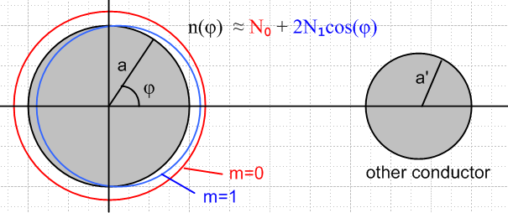 Fig D.1

(c) The Vector Laplacian in Cylindrical Coordinates

Given the following cylindrical-coordinates field components,

E(r,φ,z,t) = Er(r,φ,z,t) + Eφ(r,φ,z,t) + Ez(r,φ,z,t) (D.1.8)

we may write out our ansatz wave form (D.1.1) and the Helmholtz equation (D.1.2) in more detail,

Er(r,φ,z,t) = ej(ωt-β$_{d}$z) Er(r,φ) . [∇2E(r,φ,z,t)]r + β2 Er(r,φ,z,t) = 0
Eφ(r,φ,z,t) = ej(ωt-β$_{d}$z) Eφ(r,φ) . [∇2E(r,φ,z,t)]φ + β2 Eφ(r,φ,z,t) = 0
Ez(r,φ,z,t) = ej(ωt-β$_{d}$z) Ez(r,φ) . [∇2E(r,φ,z,t)]z + β2 Ez(r,φ,z,t) = 0 . (D.1.9)

In Cartesian coordinates, it happens that [∇2E]i = ∇2(Ei), but this is not generally true for curvilinear coordinates. In cylindrical coordinates, it is true for the z coordinate only. The operator ∇2 when applied to a vector field is called "the vector Laplacian" and it is very different from the scalar Laplacian, so much so that some authors replace [∇2E] by [E] which is defined in this manner

[E] ≡ [∇2E] ≡ grad(div E) – curl (curl E) (D.1.10)

whereas

∇2φ ≡ div(grad φ) = ∇•(∇φ) . (D.1.11)

It is the vector Laplacian that appears in our Helmholtz equation (D.1.2). For cylindrical coordinates it turns out that,

(∇2E)r = ∇2Er - (2/r2) ∂φEφ - (1/r2) Er
(∇2E)φ = ∇2Eφ + (2/r2) ∂φEr - (1/r2) Eφ
(∇2E)z = ∇2Ez (D.1.12)

where ∇2 is the scalar Laplacian, given in cylindrical coordinates by

∇2 = (1/r)∂r(r∂r) + (1/r2)∂φ2 + ∂z2 = ∂r2 + (1/r)∂r + (1/r2)∂φ2 + ∂z2 . (D.1.13)

See for example Morse and Feshbach Vol I p 116, Moon and Spencer p 139, or do a web search on "vector Laplacian"; the author's Tensor Analysis document, Sections 13, 14 and 15, derives these results for arbitrary coordinate systems. Here is a summary of vector differential operators in cylindrical coordinates taken from Morse and Feshbach, where the last line corresponds to the above discussion:

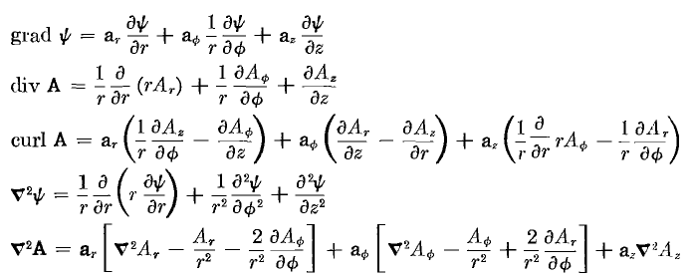 (D.1.14)

Using the ansatz form (D.1.1) and partial wave expansions of the form (D.1.3) or (D.1.5), it is a simple matter to convert an equation involving components like Ei(r,φ,z,t) or n(r,φ,z,t) to a simpler equation involving components like Ei(r,m) and n(r,m).

(d) The three Helmholtz equations and div E = 0 (in partial waves)

1. The z equation: The Ez Helmholtz Equation from (D.1.9) is [∇2E]z + β2 Ez = 0.

Using (D.1.12) and (D.1.13), this may be written,

[∂r2 + (1/r) ∂r + (1/r2) ∂φ2 + ∂z2 + β2 ] ej(ωt-β$_{d}$z)Ez(r,φ) = 0 . (1)

Inserting the expansion (D.1.3) for Ez(r,φ) and moving the m sum to the left gives

$\sum_{m = -∞}^{∞}{}$ [∂r2 + (1/r) ∂r + (1/r2) ∂φ2 + ∂z2 + β2 ] ej(ωt-β$_{d}$z)Ez(r,m) ejmφ = 0 . (2)

We can then make the obvious replacements ∂z = -jβd and ∂φ = +jm to get,

$\sum_{m = -∞}^{∞}{}$ { [∂r2 + (1/r) ∂r -m2 (1/r2) – βd2 + β2 ] ej(ωt-β$_{d}$z)Ez(r,m) } ejmφ = 0 . (3)

Due to the completeness of functions ejmφ on the interval (-π.π), we conclude that { } = 0, or

[∂r2 + (1/r) ∂r -m2 (1/r2) – βd2 + β2 ] ej(ωt-β$_{d}$z)Ez(r,m) = 0 . (4)

Alternatively one can apply $^{\int_{-π}^{π}{}}$dφ e-jm'φ to both sides of (3), use the orthogonality property

$^{\int_{-π}^{π}{}}$dφ ej(m-m')φ = 2π δm,m' , (5)

and then change m' to m to get (4).

Next, multiply both sides of (4) by r2 e-j(ωt-β$_{d}$z) to get,

[r2∂r2 + r ∂r - m2 +r2( β2- βd2)] Ez(r,m) = 0 . (D.1.15)

We may then write these rules for converting equation (1) to equation (D.1.15)

Conversion Rules: ∂z → -jβd (D.1.16)
∂φ → +jm
∂t→ +jω
f(r,φ,z,t ) → f(r,m)

We can now practice with these rules to convert various other equations of interest. A field with unstated arguments has the full arguments (r,φ,z,t).

2. The r equation: The Er Helmholtz Equation from (D.1.9) is [∇2E]r + β2 Er = 0 .

Using (D.1.12) we find,

∇2(Er) - (2/r2) ∂φEφ - (1/r2) Er + β2Er = 0

[∂r2 + (1/r)∂r + (1/r2)∂φ2 + ∂z2] Er - (2/r2) ∂φEφ - (1/r2) Er + β2Er = 0

[∂r2 + (1/r)∂r + (1/r2)∂φ2 + ∂z2 - (1/r2) + β2] Er - (2/r2) ∂φEφ = 0

Now apply the conversion rules to get

[∂r2 + (1/r)∂r + (1/r2) (-m2) - βd2 - (1/r2) + β2] Er(r,m) - (2/r2) jm Eφ(r,m) = 0

Group like terms and multiply by r2 to get

[r2∂r2 + r∂r - (m2+1) + r2(β2-βd2)] Er(r,m) - 2jm Eφ(r,m) = 0 . (D.1.17)

3. The φ equation: The Eφ Helmholtz Equation from (D.1.9) is [∇2E]φ + β2 Eφ = 0 .

Using (D.1.12) we find,

∇2(Eφ) + (2/r2) ∂φEr - (1/r2) Eφ + β2Eφ = 0

[∂r2 + (1/r)∂r + (1/r2)∂φ2 + ∂z2] Eφ + (2/r2) ∂φEr - (1/r2) Eφ + β2Eφ = 0

[∂r2 + (1/r)∂r + (1/r2)∂φ2 + ∂z2 - (1/r2) + β2] Eφ + (2/r2) ∂φEr = 0 .

Now apply the conversion rules to get

[∂r2 + (1/r)∂r + (1/r2)(-m2) + (-βd2) - (1/r2) + β2] Eφ(r,m) + (2/r2) jm Er(r,m) = 0 .

Group like terms and multiply by r2 to get

[r2∂r2 + r∂r - (m2+1) + r2(β2-βd2)] Eφ(r,m) + 2jmEr(r,m) = 0 . (D.1.18)

4. The divE = 0 equation: Using (D.1.14) for div E ( times r) we write div E = 0 as

∂r (r Er) + ∂φEφ + r ∂zEz = 0 .

Applying the conversion rules gives

∂r [r Er(r,m)] + jmEφ(r,m) + r (-jβd)Ez(r,m) = 0

[1 + r∂r ] Er(r,m) + jmEφ(r,m) + r (-jβd)Ez(r,m) = 0 . (D.1.19)

Here then is a summary of the above four results:

The Three Helmholtz Equations and the div E = 0 equation (in partial waves) (D.1.20)

[∇2E]z + β2 Ez = 0 :
[r2∂r2 + r ∂r - m2 + r2 ( β2- βd2)] Ez(r,m) = 0 (D.1.15)

[∇2E]r + β2 Er = 0 :
[r2∂r2 + r∂r - (m2+1) + r2(β2-βd2)] Er(r,m) - 2jm Eφ(r,m) = 0 (D.1.17)

[∇2E]φ + β2 Eφ = 0 :
[r2∂r2 + r∂r - (m2+1) + r2(β2-βd2)] Eφ(r,m) + 2jmEr(r,m) = 0 (D.1.18)

div E = 0 :
∂r [r Er(r,m)] + jmEφ(r,m) -jβd r Ez(r,m) = 0 (D.1.19)

Helmholtz Comments: The scalar Helmholtz equation (∇2+β2)u(r,φ,z) = 0 is fully separable in cylindrical coordinates and the "harmonics" (we call them atomic forms) are as follows

[ Jm(β'r), Ym(β'r)] * [ejmφ, e-jmφ] * [e jβ$_{d}$z , e- jβ$_{d}$z] (D.1.21)

where βd is a free real parameter and where β'2 = β2 - βd2. Here we use parameter names relevant for our particular problem where u = Ez. These atomic forms appear for example in Moon and Spencer p15 with β = κ, m = p, β' = iq, α2 = m2, and -α3 = β'2. Whether a parameter like m or β' is real, imaginary or complex depends on the nature of the problem, and the above is a standard atoms choice for problems of our type. The φ "quantum number" m is quantized to be an integer by the fact that our problem region is the entire range (-π,π) for φ and the solution must be single valued in φ. Our βd is a fixed parameter determined by βd = ω$\sqrt{μdεd}$ and is thus correlated with the selected frequency ω, whereas our parameter β is always complex as in (1.5.1). In general, in any list of atomic forms like that shown above, two of the three atoms will be oscillatory and the third will be exponential, and in our case Jm(β'r) is the exponential one, hence the skin effect with its exponential damping as shown in (2.3.7). Away from a singular point, any solution to (∇2 + β2)u(r,φ,z) = 0 must be writable as a linear combination of the atoms, so

u = ∫dβd Σm [Aβ$_{d}$,m Jm(β'r) + Bβ$_{d}$,m Ym(β'r) [Cβ$_{d}$,m ejmφ + Dβ$_{d}$,m e-jmφ ] [Eβ$_{d}$,m e jβ$_{d}$z + Fβ$_{d}$,m e- jβ$_{d}$z ].

A general solution method is to find a subset of the above most-general form that is appropriate in each "region" of the problem, and then to match boundary conditions between regions. If the problem is well-posed, this will determine all the constants A,B,C,D,E,F. We refer to this solution method as "the method of Smythian forms" (Smythe used this method a lot). Often many of these constants are 0.
In contrast, the vector Helmholtz equation is NOT separable in cylindrical coordinates (see Moon and Spencer p 139), it is not even "R-separable", so there are no associated "harmonics" as there are with the scalar Helmholtz equation.. Nevertheless, the functions ejmφ form a complete set for φ in (-π,π) and our expansion of each Ei onto these ejmφ is certainly allowed, even though these ejmφ are not part of any associated harmonics for the vector Helmholtz equation.
However, in Cartesian coordinates each Helmholtz component equation is a scalar Helmholtz equation. In cylindrical coordinates z is a Cartesian coordinate, so we should not be surprised when we find below that Ez ~ Jm(β'r) eimφ e- jβ$_{d}$z and this fits into the general form noted above. Neither Er nor Eφ will have such a form.

D.2 Solutions for Ez,Er and Eφ

(a) The Ez Solution

As shown in (D.1.15), the Helmholtz equation for Ez(r,m) is

[r2∂r2 + r ∂r + (r2 β'2 - m2)] Ez(r,m) = 0 (D.2.1)

where

β'2 = β2 - βd2 . (D.2.2)

In a conductor like copper, |β| is very large compared to the dielectric βd, so we could ignore the distinction between β and β', but we won't in order to keep our results exact. Recall from (1.5.1) and (2.2.3) that

βd2 = ω2μdξd β2 ≈ - jωμσ => | $\frac{β2}{βd2}$| ≈ $\frac{μ}{μd}$ $\frac{σ}{ωεd}$.

In scale, μ and μd are about the same, so the condition for | $\frac{β2}{βd2}$| >> 1 is that ω << σ/εd. This is the same condition considered with respect to (2.2.3) where for copper and εd ≈ ε0 we found the condition to be met for f << 1018Hz. For example if f = ω/2π = 100 GHz we have $\frac{σ}{ωεd}$≈ 107 so | β/βd|2 ≈ 107 and then we end up with |β/βd| ≈ 3200. Nevertheless, we maintain the distinction between β and β' .

Setting x = β'r one finds ∂r = β'∂x and then r∂r = x∂x and so on so that (D.2.1) reads

[x2∂x2 + x ∂x + (x2- m2)] Ez(x/β',m) = 0 . x = β'r (D.2.3)
This is Bessel's equation [ Spiegel 24.1] and the solution subject to the condition that Ez be finite at r = 0 is Ez(x/β',m) = Czm Jm(x) or

Ez(r,m) = Czm Jm(β'r) (D.2.4)

where Czm is an arbitrary constant for each partial wave m.
For m = 0, equation (D.2.4) is consistent with (2.2.22) found by other means. In Section 2.1 we dealt only with the m=0 partial wave, which embodies the symmetrical part of the problem.

(b) The Er Solution

As shown in (D.1.17), the Helmholtz equation for Er(r,m) is, using (D.2.2),

[r2∂r2 + r∂r - (m2+1) + r2β'2] Er(r,m) - 2jm Eφ(r,m) = 0 (D.2.5)

while the div E = 0 condition was stated in (D.1.19) as

[1 + r∂r ] Er(r,m) + jmEφ(r,m) + r (-jβd)Ez(r,m) = 0
or
-jmEφ(r,m) = [1 + r∂r ] Er(r,m) - r (jβd)Ez(r,m) . (D.2.6)

Inserting this into (D.2.5) gives

[r2∂r2 + r∂r - (m2+1) + r2 β'2] Er(r,m) + [2 + 2r∂r ] Er(r,m) - 2r (jβd)Ez(r,m) = 0
or
[r2∂r2 + 3r∂r + (1-m2) + r2 β'2] Er(r,m) = 2r (jβd)Ez(r,m) . (D.2.7)

Inserting solution (D.2.4) for Ez(r,m) this becomes

[r2∂r2 + 3r∂r + (1-m2) + r2 β'2] Er(r,m) = 2r (jβd) Czm Jm(β'r)
or
[r2∂r2 + 3r∂r + (1-m2) + r2 β'2] Er(r,m) = 2j (βd/β') Czm β' r Jm(β'r)
or
[r2∂r2 + 3r∂r + (1-m2) + r2 β'2] Er(r,m) = Km β'r Jm(β'r) (D.2.8)

where

Km ≡ 2j (βd/β') Czm . (D.2.9)

In order to get the left side of (D.2.8) into something recognizable, we define

Er(r,m) = x-1 fm(x) (D.2.10)

where x is a dimensionless radial variable which will play a major role in the following,

x ≡ β'r and xa ≡ β' a . (D.2.11)

Then (D.2.8) becomes

[x2∂x2 + 3x∂x + (1-m2) + x2] { x-1 fm(x)} = 2j (βd/β') Czm x Jm(x)
or
x [x2∂x2 + 3x∂x + (1-m2) + x2] { x-1 fm(x)} = Km x2 Jm(x) . (D.2.12)

Ever eager, Maple expands the left side of (D.2.12),

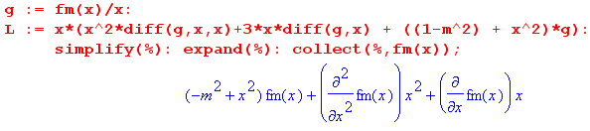
so that (D.2.12) becomes

[ x2 ∂x2 + x ∂x + (x2-m2)] fm(x) = Km x2 Jm(x) . (D.2.13)

The left side of (D.2.13) is the normal Bessel operator [ Spiegel 24.1] , but the equation is also driven by a power times a Bessel function. The solution to the equation is the homogeneous solution of the Bessel equation plus the particular solution which is the response to the driving function on the right hand side.

The homogeneous solution is the usual linear combination of Jm(x) and Ym(x), but we must reject Ym(x) since it blows up at x=0 and thereby causes the field Er to be singular, which it cannot be, smack in the middle of a wire.

The particular solution is not very obvious and required some hunting to find. It is this

fm(x)particular = (1/2) Km [ x Jm+1(x) ] . (D.2.14)

as Maple confirms, continuing the above code,

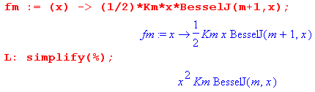

Therefore, we now have this full solution for fm(x)

fm(x) = fm(x)particular + fm(x)homogeneous = (1/2) Km [ x Jm+1(x) ] + am Jm(x)

and then from (D.2.10) the full solution for Er ,

Er(r,m) = am x-1 Jm(x) + $\frac{Km}{2}$ Jm+1(x) . (D.2.15)

For each value of m, there are two as-yet undetermined constants, am and (Km/2). However, looking at (D.2.15), we see that, since J0(x) ≈ 1 for small x, we must have

a0 = 0 (D.2.16)

to keep Er finite at r = 0. Later we shall obtain expressions for am and (Km/2).

(c) The Eφ Solution

Recall (D.2.6) ,

jmEφ(r,m) = -∂r[rEr(r,m)] + r (jβd)Ez(r,m) . (D.2.2)

We can then insert our known Ez and Er to get Eφ :

Ez(r,m) = Czm Jm(x) (D.1.27)
Er(r,m) = am x-1 Jm(x) + $\frac{Km}{2}$ Jm+1(x) . (D.2.11)

so (D.2.6) becomes the following
jmEφ(r,m) = -∂r[r{ am x-1 Jm(x) + $\frac{Km}{2}$ Jm+1(x)}] + r (jβd) Czm Jm(x)
jmEφ(r,m) = -∂x[x{ am x-1 Jm(x) + $\frac{Km}{2}$ Jm+1(x)}] + $\frac{Km}{2}$ x Jm(x) // Km ≡ 2j (βd/β') Czm
jmEφ(r,m) = -∂x[am Jm(x) + $\frac{Km}{2}$ x Jm+1(x)] + $\frac{Km}{2}$ x Jm(x)
jmEφ(r,m) = -am Jm'(x) - $\frac{Km}{2}$ Jm+1(x) -$\frac{Km}{2}$ x Jm+1'(x) + $\frac{Km}{2}$ x Jm(x)
jmEφ(r,m) = - am Jm'(x) + $\frac{Km}{2}$ [ - Jm+1(x) - x Jm+1'(x) + x Jm(x) ] . (D.2.17)

At this point we invoke the recurrence relations [ NIST 10.6.2 ]

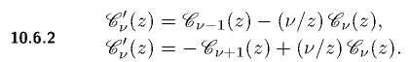
to write

Jm+1' = Jm - (m+1)x-1Jm+1 first relation with ν = m+1
Jm' = -Jm+1 + (m/x)Jm second relation with ν = m (D.2.18)

Insert these into (D.2.17) to get

jmEφ(r,m) = - am Jm' + $\frac{Km}{2}$ [ - x Jm+1' - Jm+1 + xJm]
= - am {-Jm+1 + (m/x)Jm } + $\frac{Km}{2}$ [ - x { Jm - (m+1)x-1Jm+1} - Jm+1 + xJm]
= am Jm+1 - am (m/x)Jm + $\frac{Km}{2}$ [ - x Jm + (m+1) Jm+1 - Jm+1 + xJm]
= am Jm+1 - am (m/x)Jm + $\frac{Km}{2}$ [ m Jm+1]
= - am (m/x)Jm + ( $\frac{Km}{2}$ m + am ) Jm+1

Dividing by m then gives the final solution,

jEφ(r,m) = - am x-1 Jm(x) + ( $\frac{Km}{2}$+ $\frac{am}{m}$ ) Jm+1(x) x = β'r . (D.2.19)

We now gather up the solutions developed above, but first, recall that

Km ≡ 2j (βd/β') Czm (D.2.5)

which we can solve to get

Czm = (1/2j)(β'/βd) Km . (D.2.20)

Installing this into (D.2.4), our three E field components are then

First summary of the E field solutions (D.2.21)

Ez(r,m) = - j (β'/βd) $\frac{Km}{2}$ Jm(x) x = β'r (D.1.27)

Er(r,m) = am x-1 Jm(x) + $\frac{Km}{2}$ Jm+1(x) β'2 = β2 - βd2 (D.2.11)

jEφ(r,m) = - am x-1 Jm(x) + ( $\frac{Km}{2}$+ $\frac{am}{m}$ ) Jm+1(x) (D.2.15)

These solutions were obtained from the z and r Helmholtz equations and from the div E = 0 equation. It is an easy matter to have Maple verify that this solution set solves the div E equation and all three of the Helmholtz equations z, r and φ :

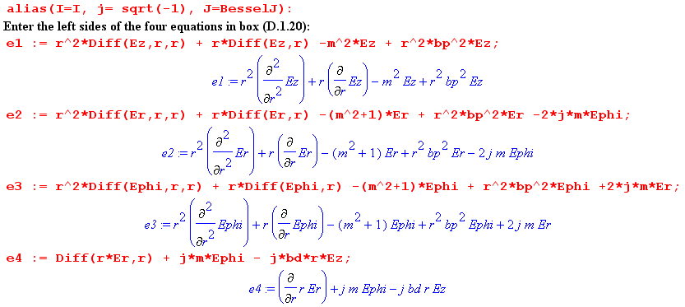

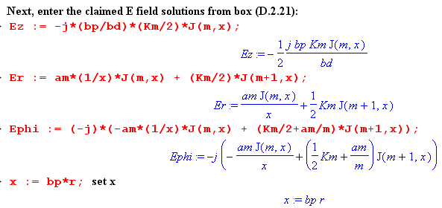

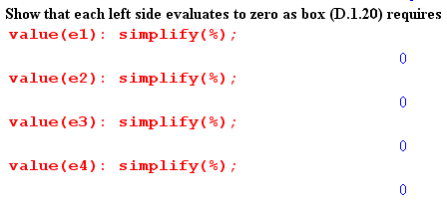
In Maple one must be careful with this kind of verification to make sure Maple has not misunderstood something. For example, perhaps it thinks ∂rEz = 0 because it thinks Ez is a constant. This is the purpose of using the "inert" Diff operators (versus diff) and then forcing them to evaluate later with the value() operator. One should always view expressions before simplification to make sure things are kosher. For example, changing the colon to semicolon after value(e1) to force display,

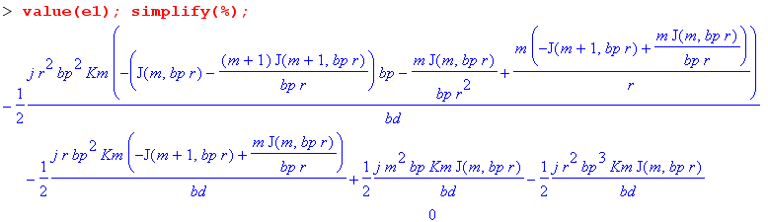
Here Maples has duly computed the Bessel function derivatives in expression e1 but does not yet realize that the expression is 0. This is brought out by the simplify(%) command (simplify that last computed expression) and the output of the simplify command is the 0 on the last line.

(d) The Charge Pumping Boundary Condition

The reason we are interested in the surface charge n(φ) of (D.1.5) is that it acts as a driving source of the radial electric field in the wire. Recall the equation of continuity (1.1.35) converted to the ω domain

div J = - jωρ ⇔ -jω[∫V ρ dV] = ∫S J • dS . (D.2.22)

This is meant to be (1.1.25) where J is conduction current and ρ is free charge. When applied to a thin box of radial area dS straddling the wire surface,

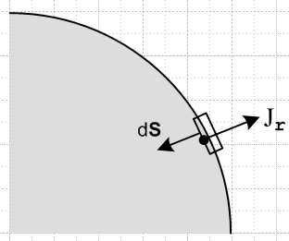 Fig D.2

one finds that ∫S J • dS = -Jr(r=a-ε,φ)dS and ∫V ρ dV = n(φ) dS so that (ε implies just below surface)

Jr(r=a-ε,φ) = jω n(φ) . (D.2.23)

We assume that there is no free current outside the wire to get this result (non-conducting dielectric). Since J = σE, this is really a boundary condition on the radial electric field just below the surface,

Er(r=a-ε,φ) = (jω/σ) n(φ) . (D.2.24)

We convert this to m-space using the conversion rules (D.1.16) to obtain (dropping the ε)

Er(r=a,m) = (jω/σ) Nm . (D.2.25)

Thus, the interior radial electric field must have a certain value at the r=a boundary in each partial wave, and this value is determined by the moment of the surface charge distribution.

By way of interpretation, the surface charge of a transmission line is "pumped" by the radial current in the wire. This radial current is accompanied by the usual longitudinal current one expects to find inside the conductors of a transmission line.

(e) Application of the Boundary Conditions

Our task here is to derive expressions for the constants am and Km appearing in the above E field component equations.

We have two boundary conditions to impose:

Er(r=a,m) = (jω/σ) Nm (D.2.26)

Eφ(r=a,m) = 0 (D.2.27)

The first is the radial charge pumping condition shown in (D.2.25) above. The second boundary condition is an assumption that requires its own discussion in Section D.8 below. It implies that the cross sectional wire surface is an equipotential surface and that therefore Eφ(r=a,φ) = 0. This in turn requires that in each partial wave Eφ(r,m) = 0 since

Eφ(r,m) = (1/2π) $^{\int_{-π}^{π}{}}$dφ Eφ(r,φ) e-jmφ (D.1.3b)
Eφ(a,m) = (1/2π) $^{\int_{-π}^{π}{}}$dφ Eφ(a,φ) e-jmφ = (1/2π) $^{\int_{-π}^{π}{}}$dφ 0 e-jmφ = 0 .

These two boundary conditions serve to determine the two constants am and Km, though a bit of algebra is required. The first step is to use the Er and Eφ expressions shown in summary box (D.2.21) to write out the two boundary conditions as

am xa-1 Jm(xa) + $\frac{Km}{2}$ Jm+1(xa) = (jω/σ) Nm (1)
- am xa-1 Jm(xa) + ( $\frac{Km}{2}$+ $\frac{am}{m}$ ) Jm+1(xa) = 0 . (2)

Addition and subtraction of these equations gives two new equations,

$\frac{Km}{2}$ Jm+1(xa) + ( $\frac{Km}{2}$+ $\frac{am}{m}$ ) Jm+1(xa) = (jω/σ) Nm (3)
2 am xa-1 Jm(xa) - $\frac{am}{m}$ Jm+1(xa) = (jω/σ) Nm (4)

Using the recursion relation 2m x-1 Jm = [Jm+1 + Jm-1] , the second may be immediately solved for am,

$\frac{am}{m}$ = (jω/2σ) 2 Nm $\frac{1}{Jm-1(xa)}$ . (5)

Using this same recursion relation and (5) for am , equation (2) may be solved to get

( $\frac{Km}{2}$+ $\frac{am}{m}$ ) = (jω/2σ) Nm [$\frac{1}{Jm+1(xa)}$ + $\frac{1}{Jm-1(xa)}$ ] (6)

Finally, subtracting (5) from (6) we find

$\frac{Km}{2}$ = (jω/2σ) Nm [$\frac{1}{Jm+1(xa)}$ – $\frac{1}{Jm-1(xa)}$ ] (7)

We summarize the coefficients as follows:

am = (jω/2σ) 2m Nm $\frac{1}{Jm-1(xa)}$ . => a0 = 0 (D.2.28)

$\frac{Km}{2}$ = (jω/2σ) Nm [$\frac{1}{Jm+1(xa)}$ – $\frac{1}{Jm-1(xa)}$ ] => $\frac{K0}{2}$= (jω/σ) N0 $\frac{1}{J1(xa)}$ // J-1(z) = - J1(z)

($\frac{Km}{2}$+ $\frac{am}{m}$ ) = (jω/2σ) Nm [$\frac{1}{Jm+1(xa)}$ + $\frac{1}{Jm-1(xa)}$ ]

The third equation is obvious from adding the first two, and Maple verifies that the first two satisfy (1) and (2). At this point it is convenient to introduce the DC resistance per unit length of the wire

Rdc = $\frac{1}{σπa2}$ (D.2.29)

along with a new symbol to indicate the relative surface charge moment,

ηm ≡ $\frac{Nm}{N0}$ . (D.2.30)

The DC moment N0 can be related to the total current I in the wire as follows:
I = $^{\int_{0}^{2π}{}}$dφ $^{\int_{0}^{a}{}}$r dr Jz(r,φ) = $^{\int_{0}^{2π}{}}$dφ $^{\int_{0}^{a}{}}$r dr { σ $\sum_{m = -∞}^{∞}{}$ Ez(r,m) ejmφ } // (D.1.3a)
= σ $\sum_{m = -∞}^{∞}{}$ $^{\int_{0}^{a}{}}$r dr Ez(r,m) $^{\int_{0}^{2π}{}}$dφ ejmφ = 2π σ$^{\int_{0}^{a}{}}$r dr Ez(r,0)
= 2π σ$^{\int_{0}^{a}{}}$r dr {-j(β'/βd) $\frac{K0}{2}$J0(x) } // (D.2.21) for Ez(r,0)
= -j(β'/βd) 2π σ $\frac{K0}{2}$$^{\int_{0}^{a}{}}$r dr J0(x) // x = β'r so xdx = β'2 rdr
= -j(β'βd)-1 2πσ $\frac{K0}{2}$ [$^{\int_{0}^{xa}{}}$dx x J0(x)] = -j(β'βd)-1 2πσ $\frac{K0}{2}$ [ xa J1(xa) ]
= -j(β'βd)-1 2πσ {(jω/σ) N0 / J1(xa)} [ xa J1(xa) ] // (D.2.28) for $\frac{K0}{2}$

= (β'βd)-1 2πω N0 xa = (β'βd)-1 2πω N0 β'a

= 2πω (a/βd) N0
so that

N0 = (βd/2πωa) I . (D.2.31)

It follows from (D.2.31) that the normalization factor appearing in (D.2.28) may be written as

(jω/2σ) Nm = (jω/2σ) $\frac{Nm}{N0}$N0 = (jω/2σ) ηm [(βd/2πωa) I ] = (j/4) ηm (aβd/σπa2) I

= (j/4) (aβd) ηm I Rdc . (D.2.32)

We may now construct the final form for our E field solutions in (D.2.21) using the coefficients in (D.2.28) and the replacement (D.2.32) :

Ez(r,m) = -j(β'/βd) $\frac{Km}{2}$ Jm(x) = -j(β'/βd) (jω/2σ) Nm [$\frac{1}{Jm+1(xa)}$ – $\frac{1}{Jm-1(xa)}$ ] Jm(x)

= -j(β'/βd) [(j/4) (aβd) ηm I Rdc] [$\frac{1}{Jm+1(xa)}$ – $\frac{1}{Jm-1(xa)}$ ] Jm(x)

= (1/4) ηm I Rdc (aβ') [$\frac{Jm(x)}{Jm+1(xa)}$ - $\frac{Jm(x)}{Jm-1(xa)}$ ]

Er(r,m) = am x-1 Jm(x) + $\frac{Km}{2}$ Jm+1(x)

= [(jω/2σ) Nm] { 2m $\frac{1}{Jm-1(xa)}$ x-1 Jm(x) + [$\frac{1}{Jm+1(xa)}$ – $\frac{1}{Jm-1(xa)}$ ] Jm+1(x) }

= (j/4) (aβd) ηm I Rdc { $\frac{2mx-1Jm(x)}{Jm-1(xa)}$+ $\frac{Jm+1(x)}{Jm+1(xa)}$- $\frac{Jm+1(x)}{Jm-1(xa)}$ }

jEφ(r,m) = - am x-1 Jm(x) + ($\frac{Km}{2}$+ $\frac{am}{m}$) Jm+1(x)

= [(jω/2σ) Nm] { - 2m x-1 $\frac{1}{Jm-1(xa)}$ + [ $\frac{1}{Jm+1(xa)}$+ $\frac{1}{Jm-1(xa)}$] Jm+1(x)

= (j/4) (aβd) ηm I Rdc { - $\frac{2mx-1Jm(x)}{Jm-1(xa)}$ + [ $\frac{Jm+1(x)}{Jm+1(xa)}$+ $\frac{Jm+1(x)}{Jm-1(xa)}$] }

Gathering up one more time:

Second summary of the E field solutions : Rdc = $\frac{1}{σπa2}$ β'2 = β2 - βd2 (D.2.33)
Ez(r,m) = (1/4) ηm I Rdc (aβ') [$\frac{Jm(x)}{Jm+1(xa)}$ - $\frac{Jm(x)}{Jm-1(xa)}$ ] a = radius ηm ≡ $\frac{Nm}{N0}$
Er(r,m) = (j/4) ηm I Rdc (aβd) [ $\frac{2mx-1Jm(x)}{Jm-1(xa)}$+ $\frac{Jm+1(x)}{Jm+1(xa)}$ - $\frac{Jm+1(x)}{Jm-1(xa)}$ ] x = β'r
Eφ(r,m) = (1/4) ηm I Rdc (aβd) [ - $\frac{2mx-1Jm(x)}{Jm-1(xa)}$+ $\frac{Jm+1(x)}{Jm+1(xa)}$ + $\frac{Jm+1(x)}{Jm-1(xa)}$ ] xa = β'a

Maple verification of these solutions is shown below.

Observations about the solution:

(1) We looked for a wave solution inside a round wire in which phase fronts propagate down the wire (z direction) with angular frequency ω and wavelength λd = 2π/βd. We found the solution shown in the above box. This solution satisfies all three components of the vector Helmholtz equation (D.1.2) as well as the div E = 0 equation.

(2) For a good conductor and a good dielectric, one has ξ ≈ σ/(jω) and ξd ≈ εd. These are the complex dielectric "constants". The corresponding wavenumbers are then

β' ≈ β = ω $\sqrt{μx}$ ≈ ω $\sqrt{μ σ/(jω)}$ = ej3π/4 $\sqrt{ωμσ}$ = ej3π/4 ($\sqrt{2}$/δ) (2.2.18) , (2.2.21)

βd = ω $\sqrt{μdxd}$ ≈ ω $\sqrt{μdεd}$ = ω / vd vd = speed of light in the dielectric (D.2.34)

Thus, in our wave solution (D.1.1), the phase fronts propagate down the inside of the wire at vd, the speed of light in the dielectric outside the wire. Although we have been silent about the fields outside the wire, it seems reasonable to presume there is a wave outside also moving down the wire at vd . See Section D.8.

(3) For r near a, where most of the action occurs due do the skin effect, the Bessel function ratios appearing in (D.2.33) are on the general order of unity so we expect the three brackets [...] to be of the same general size. It then follows that the Er and Eφ fields are smaller than Ez by the ratio |βd/β'| which we have shown in the discussion below (D.2.2) is very small at frequencies below 100 GHz. Since Ez is an electric field inside copper, it is already itself quite small, so the Er and Eφ fields are extremely small. This then justifies their omission from the development of Chapter 2.

(4) If there exist moments Nm of the surface charge distribution on the wire with m > 1, then the corresponding ηm ≠ 0 and it is clear that Ez(r,φ) and hence Jz(r,φ) are non-uniform inside the wire. That is, these fields vary with φ as cos(mφ) as well as with r. The non-uniformity is not "small" but has the full strength of ηm. Of course we only expect to get significant moments of charge density n(φ) when conductors are "fat and close". It seems likely in this case that a large contribution will come from m=1.

(5) The surface impedance from (C.2.1) is just Zs(φ) = Ez(r=a,φ)/I. Thus, from (D.1.3a),

Zs(φ) = (1/I) $\sum_{m = -∞}^{∞}{}$ Ez(a,m) ejmφ // (D.1.3a)
= (1/4) Rdc $\sum_{m = -∞}^{∞}{}$ ηm [$\frac{xaJm(xa)}{Jm+1(xa)}$ - $\frac{xaJm(xa)}{Jm-1(xa)}$ ] ejmφ // (D.2.33)
where, (D.2.35)
ηm = Nm/N0 = $\frac{ωa}{βdI}$ $^{\int_{-π}^{π}{}}$dφ n(φ) e-jmφ // (D.1.5b) and (D.2.31)

Thus we see the expected non-uniformity of Zz(φ) around the perimeter of the wire cross section for the m ≠ 0 components.

Maple verification of box (D.2.33)

We use the same method illustrated below box (D.2.21). The same expressions e1,e2,e3,e4 are entered as the left sides of the four equations whose right sides we expect to be 0. Then:

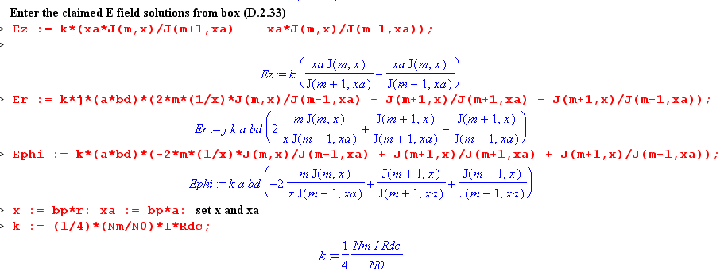
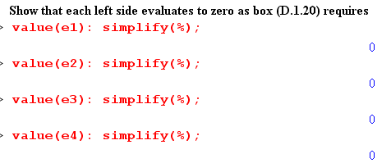
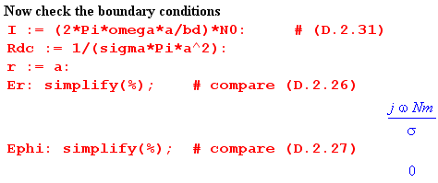

D.3 What about the Eφ Helmholtz Equation ?

A review of the above derivation of the three fields Ez, Er and Eφ shows that the Eφ Helmholtz equation has been completely ignored. The Eφ expression was obtained from the div E = 0 equation after the Ez and Eφ fields were computed.

It is reasonable to wonder whether the solution fields we have found above in fact solve this φ Helmholtz equation which mixes the Er and Eφ fields together in a manner similar to the r Helmholtz equation.

A related question is whether the three Helmholtz equations and div E = 0 are four independent equations, or is one of the three Helmholtz equations dependent? In Cartesian coordinates suppose we know that (implied sums on repeated indices)

(∂j∂j + β2) E1 = 0
(∂j∂j + β2) E2 = 0
∂iEi = 0 . (D.3.1)

Can we show that (∂j∂j + β2) E3 = 0 so this third Helmholtz equation is dependent? If we apply the operator (∂j∂j + β2) to the last equation above we get

(∂j∂j + β2) ∂iEi = 0
or
∂i (∂j∂j + β2) Ei = 0
or
∂1 (∂j∂j + β2) E1 + ∂2 (∂j∂j + β2) E2 + ∂3 (∂j∂j + β2) E3 = 0
or
∂3 [(∂j∂j + β2) E3] = 0 (D.3.2)

This does not prove that (∂j∂j + β2) E3 = 0 since (∂j∂j + β2)E3 = f(x1,x2) ≠ 0 also satisfies (D.3.2).

Rather than pursue this question further, we simply note that the Maple code below box (D.2.21) verifies that the E field solutions given in that box do indeed satisfy the φ Helmholtz equation (as well as the other two Helmholtz equations and the div E = 0 equation).

Reader Exercise: Come up with some reason this had to be the case.

D.4 Computation of the B fields in the round wire

The B field components may be computed from the Maxwell curl E equation (1.1.2)

- ∂tB = curl E . Maxwell curl E equation (1.1.2) (D.4.1)

In cylindrical coordinates one has from (D.1.14),

curl E = [ r-1∂φEz - ∂zEφ] + [∂zEr - ∂rEz] + [ r-1∂r(rEφ) - r-1∂φEr ] (D.4.2)

where the fields are of the form shown in (D.1.1) which we assume also for the B field. Thus, combining (D.1.1) with (D.1.3a), one has
E(r,φ,z,t) = ej(ωt-β$_{d}$z) E(r,φ) = ej(ωt-β$_{d}$z) $\sum_{m = -∞}^{∞}{}$ E(r,m) ejmφ (D.4.3)
B(r,φ,z,t) = ej(ωt-β$_{d}$z) B(r,φ) = ej(ωt-β$_{d}$z) $\sum_{m = -∞}^{∞}{}$ B(r,m) ejmφ . (D.4.4)

Inserting the three cylindrical components of the E expansion (D.4.3) into (D.4.2), one finds that these replacements may be made,

∂t → +jω ∂z → -jβd ∂φ → +jm . (D.4.5)

Similarly, inserting the B expansion (D.4.4) into -∂tB one may replace ∂t→ +jω. After doing this, both sides of (D.4.1) are expansions of the general form of (D.4.3) and one may then equate terms in the m sum [completeness of the ejmφ on (-π.π)] to find that

-jωB(r,m) = [ r-1jmEz +jβdEφ] + [-jβdEr - ∂rEz] + [ r-1∂r(rEφ) - r-1jmEr ] (D.4.6)

and this then gives the three components of the B field

Br(r,m) = (j/ω) [curl E]r = (j/ω) [r-1jmEz +jβdEφ]
Bφ(r,m) = (j/ω) [curl E]φ = (j/ω)[-jβdEr - ∂rEz]

Bz(r,m) = (j/ω) [curl E]= (j/ω) [r-1∂r(rEφ) - r-1jmEr] . (D.4.7)

It is now a mechanical task to insert our E field components, and such tasks are good exercise for Maple. We use the E component forms summary box (D.2.21) which have the am and Km constants not yet specified.

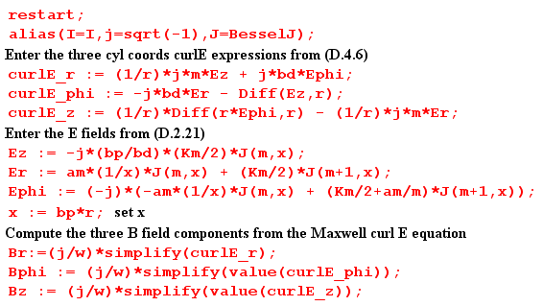

The alias line "unaliases" I, sets j = $\sqrt{-1}$in place of the default I, and allows simple reference to the Bessel functions of interest. Diff(Ez,r) represents ∂rEz, but in an "inert" form which is not executed until later after Ez has been specified. The resulting B field expressions are somewhat ugly but can be cleaned up using a few more Maple manipulations. Having seen the results, we extract certain factors as shown in the following commands,

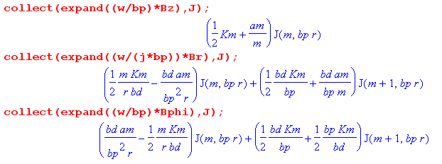
which we then translate back into our normal notation,

(ω/β')Bz(r,m) = ($\frac{Km}{2}$ + $\frac{am}{m}$ )Jm(x)
(ω/jβ')Br(r,m) = + ( m$\frac{Km}{2}$ $\frac{1}{rβd}$ - $\frac{βd}{rβ'2}$ am) Jm(x) + $\frac{βd}{β'}$ ($\frac{Km}{2}$ + $\frac{am}{m}$ ) Jm+1(x)
(ω/β')Bφ(r,m) = - ( m$\frac{Km}{2}$ $\frac{1}{rβd}$ - $\frac{βd}{rβ'2}$ am) Jm(x) + $\frac{Km}{2}$ ($\frac{βd}{β'}$ + $\frac{β'}{βd}$ ) Jm+1(x) . (D.4.8)

The last two equations contain the same term which can be written as (recall x = rβ')

( m$\frac{Km}{2}$ $\frac{1}{rβd}$ - $\frac{βd}{rβ'2}$ am) = ( m$\frac{Km}{2}$ $\frac{β'}{rβ'βd}$ - $\frac{βd}{rβ'2}$ am) = ( m$\frac{Km}{2}$ $\frac{β'}{βd}$ - $\frac{βd}{β'}$ am)(1/x)

The three equations for the exact B field components in the round wire are then shown in the summary box below which includes the earlier E field results as well:

Summary of E and B fields inside a round wire (D.4.9)

Ez(r,m) = - j (β'/βd) $\frac{Km}{2}$ Jm(x) x = β'r β'2 = β2 - βd2
Er(r,m) = am x-1 Jm(x) + $\frac{Km}{2}$ Jm+1(x) .
jEφ(r,m) = - am x-1 Jm(x) + ( $\frac{Km}{2}$+ $\frac{am}{m}$ ) Jm+1(x) (D.2.21)

Bz(r,m) = (β'/ω) ($\frac{Km}{2}$ + $\frac{am}{m}$ )Jm(x)
Br(r,m) = j(β'/ω){ + ( m$\frac{Km}{2}$ $\frac{β'}{βd}$ - $\frac{βd}{β'}$ am) x-1Jm(x) + $\frac{βd}{β'}$ ($\frac{Km}{2}$ + $\frac{am}{m}$ ) Jm+1(x) }
Bφ(r,m) = (β'/ω){ - ( m$\frac{Km}{2}$ $\frac{β'}{βd}$ - $\frac{βd}{β'}$ am) x-1Jm(x) + $\frac{Km}{2}$ ( $\frac{βd}{β'}$ + $\frac{β'}{βd}$ ) Jm+1(x) } , (D.4.8)

where the constants are given in (D.2.28), which we rewrite using (D.2.32),

am = (j/4) (aβd) ηm I Rdc * 2m $\frac{1}{Jm-1(xa)}$
$\frac{Km}{2}$ = (j/4) (aβd) ηm I Rdc * [$\frac{1}{Jm+1(xa)}$ – $\frac{1}{Jm-1(xa)}$ ]
($\frac{Km}{2}$+ $\frac{am}{m}$ ) = (j/4) (aβd) ηm I Rdc * [$\frac{1}{Jm+1(xa)}$ + $\frac{1}{Jm-1(xa)}$ ] .

The three constant quantities at the end of the above summary box are roughly the same size in terms of scale. Using this fact, and the fact that |β'| >> βd (so β = $\sqrt{β'2+βd2}$≈ β') we can simplify (D.4.9) to read,

Bz(r,m) = (β/ω) ($\frac{Km}{2}$ + $\frac{am}{m}$ )Jm(x) β' ≈ β, x = βr
Br(r,m) = j(β/ω){ + ( m$\frac{Km}{2}$ $\frac{β}{βd}$) x-1Jm(x) } // m ≠ 0
Bφ(r,m) = (β/ω){ - ( m$\frac{Km}{2}$ $\frac{β}{βd}$ ) x-1Jm(x) + $\frac{Km}{2}$ ($\frac{β}{βd}$ ) Jm+1(x) } . (D.4.10)

The last line of (D.4.10) can be further simplified,

Bφ(r,m) = (β/ω){ - ( m$\frac{Km}{2}$ $\frac{β}{βd}$) x-1Jm(x) + $\frac{Km}{2}$ ($\frac{β}{βd}$ ) Jm+1(x) }
= (β/ω) $\frac{Km}{2}$ $\frac{β}{βd}$ $\frac{1}{2}$ { - 2mx-1Jm(x) + 2Jm+1(x) }
= (β/ω) $\frac{Km}{2}$ $\frac{β}{βd}$ $\frac{1}{2}$ { - Jm+1(x) - Jm-1(x) + 2Jm+1(x) } // Spiegel 24.17 identity
= (β/ω) $\frac{Km}{2}$ $\frac{β}{βd}$ $\frac{1}{2}$ { Jm+1(x) - Jm-1(x) } . (D.4.11)

Therefore, in the limit |β'| >> βd equations (D.4.10) become

Bz(r,m) = (β/ω) ($\frac{Km}{2}$ + $\frac{am}{m}$ )Jm(x) β' ≈ β
Br(r,m) = j(β/ω) $\frac{β}{βd}${ m$\frac{Km}{2}$ x-1Jm(x) } // m ≠ 0
Bφ(r,m) = (β/ω) $\frac{β}{βd}$ $\frac{Km}{2}$ $\frac{1}{2}$ [ Jm+1(x) - Jm-1(x)] . (D.4.12)

For m>0, |βr| and |βφ| are larger than |Bz| by the large factor| β/βd|. For m = 0, βr ≈ 0 so |βφ| >> |Bz|. It is this large Bφ field which appears in Chapter 2.

D.5 Verification that the E and B fields satisfy the Maxwell equations

The Maple program discussed above goes on to verify that the exact E and B fields obtained above for the round wire in fact satisfy Maxwell's equations. Since the B equations were obtained from the curl E Maxwell equation, this one is not verified. The other three Maxwell equations are projected into their partial wave versions analogous to (D.4.6) above :

div B(r,m) = r-1∂r(rBr) + r-1∂φBφ + ∂zBz
= r-1∂r(rBr) +r-1jmBφ -jβd Bz (D.5.1)

div E(r,m) = r-1∂r(rEr) + r-1∂φEφ + ∂zEz
= r-1∂r(rEr) + r-1jmEφ - jβdEz (D.5.2)

curl B(r,m) = [ r-1∂φBz - ∂zBφ] + [∂zBr - ∂rBz] + [ r-1∂r(rBφ) - r-1∂φBr ]
= [ r-1jmBz + jβdBφ] + [-jβdBr - ∂rBz] + [ r-1∂r(rBφ) - r-1jmBr ] . (D.5.3)

In the round wire we expect to find

div B = 0

div E = 0 // no free charge

curl B = μ J + μ jωεE = μ(σ + jωε) E = μ(jω)( ε - jσ/ω) E = jω μξ E

= j (β2/ω) E // see (1.5.1)

Thus, for the divergence equations we just compute the divergence as shown and see if it comes out zero, while for the curl B equation we verify that

curl B - j(β2/ω) E = 0 (D.5.4)

for each component. The fact (D.2.2) that β'2 = β2 - βd2 is also used.

Here then is the Maple code which does the verification of the three Maxwell equations:

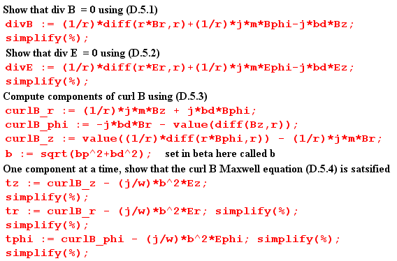

In Maple % refers to the last quantity computed. Prior to each simplify(%) statement we find a huge mess for the expression at hand, but simplify then shows it is really zero. As an example, here is the execution of the verification that [curl B]z - j(β2/ω) Ez = 0 :

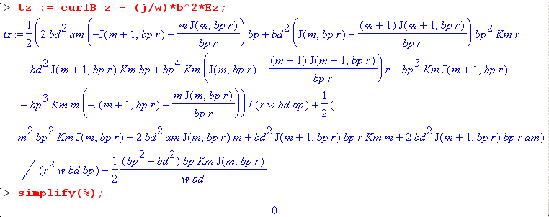

No approximations were made in the E fields, the B fields, or in these Maxwell verifications.

D.6 The exact E and B fields for the m=0 partial wave

The m=0 partial wave is all there is for an axially symmetric problem like that considered in Chapter 2, where the round wire is imagined in isolation, but is operationally the central conductor of a coaxial cable with a very distant return cylinder (outer shield). Here is the reduction of (D.4.9) for m = 0

Summary of E and B fields inside a round wire ( m = 0 only ) (D.6.1)

Ez(r,0) = - j (β'/βd) $\frac{K0}{2}$ J0(x) // large a0 = 0 x = β'r β'2 = β2 - βd2
Er(r,0) = $\frac{K0}{2}$ J1(x) . // small $\frac{K0}{2}$ = (j/2) (aβd) I Rdc $\frac{1}{J1(xa)}$
jEφ(r,0) = $\frac{K0}{2}$ J1(x) // small Rdc = $\frac{1}{σπa2}$

Bz(r,0) = (β'/ω) $\frac{K0}{2}$ J0(x) // small ~ β'
Br(r,0) = j(β'/ω) $\frac{βd}{β'}$ $\frac{K0}{2}$ J1(x) // very small ~ βd
Bφ(r,0) = (β'/ω) ( $\frac{βd}{β'}$ + $\frac{β'}{βd}$ ) $\frac{K0}{2}$J1(x) // large ~ β' (β'/βd)

No approximations have been made in these results, but a very good approximation is that |β| >> βd which means β' ≈ β, as discussed below equation (D.2.2). With this approximation, we have commented in the above box on the size of the various field components. The dominant components are

Ez(r,0) = - j (β/βd) $\frac{K0}{2}$ J0(x) = - j (β/βd) (j/2) (aβd) I Rdc $\frac{J0(x)}{J1(xa)}$
= (1/2) β a I Rdc $\frac{J0(x)}{J1(xa)}$ = (ω/β) (1/2) (aβ2/ω) I Rdc $\frac{J0(x)}{J1(xa)}$

Bφ(r,0) = (β/ω) ($\frac{β}{βd}$ ) (j/2) (aβd) I Rdc $\frac{J1(x)}{J1(xa)}$
= (j/2) (aβ2/ω) I Rdc $\frac{J1(x)}{J1(xa)}$.

As shown in (2.2.3) we can write β2/ω ≈ - jμσ so that

(1/2) (aβ2/ω) I Rdc =(1/2) a (- jμσ) I $\frac{1}{σπa2}$ = - j $\frac{μI}{2πa}$

and then the dominant components become

Ez(r,0) = (ω/β) [ - j $\frac{μI}{2πa}$] $\frac{J0(x)}{J1(xa)}$ = -j (ω/β) $\frac{μI}{2πa}$ $\frac{J0(x)}{J1(xa)}$

Bφ(r,0) = j [- j$\frac{μI}{2πa}$ ] $\frac{J1(x)}{J1(xa)}$ = $\frac{μI}{2πa}$ $\frac{J1(x)}{J1(xa)}$.

These results are in agreement with E(r) and B(r) shown in summary box (2.2.30) from the Chapter 2 calculation where we assumed E = E(r) and B = B(r) (Chapter 2's θ is Appendix D's φ).

D.7 What about the E fields outside the round wire?

The Helmholtz equation (D.1.2) outside the wire contains βd instead of β. The assumed wave solution form is still (D.1.1). In the three component Helmholtz equations this means that

β' = βd2 - βd2 = 0

so that, looking at (D.1.16-19), we get these "exterior" versions: (Note that ∇2 = ∇22D + ∂z2)

[∇2E]z + βd2 Ez = 0 : // [∇22DE]z = 0
[r2∂r2 + r ∂r - m2] Ez(r,m) = 0 (D.1.16)ext

[∇2E]r + βd2 Er = 0 : // [∇22DE]r = 0
[r2∂r2 + r∂r - (m2+1)] Er(r,m) - 2jm Eφ(r,m) = 0 (D.1.17)ext

[∇2E]φ + βd2 Eφ = 0 : // [∇22DE]φ = 0
[r2∂r2 + r∂r - (m2+1)] Eφ(r,m) + 2jmEr(r,m) = 0 (D.1.18)ext

div E = 0 :
∂r [r Er(r,m)] + jmEφ(r,m) -jβd r Ez(r,m) = 0 (D.1.19)ext

The differential operators appearing in the above equations are no longer Bessel-style operators, they are Euler-style operators. Euler ODE's have the general form [ r2∂r2 + a r ∂r + b] f(r) = 0, and the solutions have this form ( from p 45 of Polyanin's excellent ODE compendium, or just use Maple),

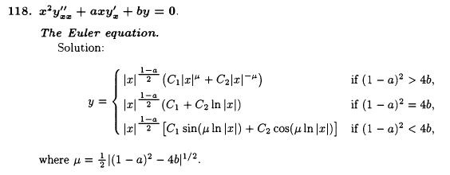

For Ez(r,m) the equation (D.1.16)ext shown just above is in fact an Euler equation which has a = 1 and
b = -m2 so μ = m and the solution forms are these (r ≥a outside the wire),

Ez(r,m) = Amrm + Bmr-m m > 0
Ez(r,0) = Czln(r) + Dz m = 0 . (D.7.1)

Since z is a Cartesian coordinate, [∇22DE]z = 0 is the same as ∇22DEz = 0 which is just the 2D Laplace equation. When this equation is solved in polar coordinates (r,φ), one finds Ez = Ez(r,m) ejmφ and the expressions shown above are the standard atomic forms for the radial function. See for example Stakgold Vol II p 92 (6.7).

We could in theory mimic our interior solution method presented in Section D.2 above, using the div E = 0 equation to eliminate Eφ, and eventually end up with expressions for the three field components outside the wire. For m > 1 the general form for the exterior solution is found to be,

Ez(r,m) = Amrm + Bmr-m
Er(r,m) = -(jβd/2) $\frac{1}{m-1}$ Bm r1-m - 2j βd $\frac{1}{m2-1}$Am r1+m + Cm rm-1 + Dmr-m-1
jEφ(r,m) = (jβd/2) $\frac{1}{m-1}$ Bmr1-m + j βd $\frac{m2+ 2m+3}{m(m2-1)}$Amr1+m - Cm rm-1 + Dm r-m-1 (D.7.2)

where there are now four constants Am, Bm, Cm and Dm to be determined in each partial wave. One could match the three E-field boundary conditions at r = a as per (1.1.50) (subscript d means dielectric)

Ez(a,m) = Ezd(a,m)
ξ Er(a,m) = ξd Erd(a,m)
jEφ(a,m) = jEφd(a,m) (D.7.3)

using the interior solutions shown in (D.2.33) where Eφ(a,m)= 0. This gives 3 conditions on the 4 unknown constants so these boundary conditions can be met.
The problem with this exterior solution method is that more information is needed to solve the problem. The "Smythian Form" solution (D.7.2) is fine, but it only applies inside a (pink) thick cylindrical shell whose inner diameter is r = a and whose outer diameter is r = b, where b causes this shell to touch the nearest other conductor, as illustrated here,

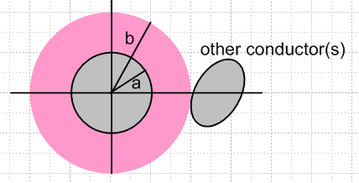 Fig D.3

The reason is that the dielectric E-field wave (Helmholtz) equation is not valid inside the "other conductor", so the form (D.7.2) cannot apply in a region which includes any of this other conductor. Since the pink shell region does not include r = ∞, one cannot rule out coefficients like Am and Cm. One is now stuck with worrying about boundary conditions at r = b and the whole problem becomes intractable. But if one could find the complete exact exterior solution, one would find that inside the pink cylindrical shell the solution's partial wave fields would have the form shown in (D.7.2).

Reader Exercise:

(a) Verify (D.7.2).

(b) In Chapter 6 a transmission line with two round conductors is solved "exactly". Convert the solution to a coordinate system like that shown above, compute the Ei(r,m) using (D.1.3b), and verify that these Ei field components fit into the form shown in (D.7.2).

D.8 About the boundary condition Eφ(r=a,m) = 0

In earlier sections of this Appendix we examined the electric field inside a round wire (radius a) which was regarded as a conductor in a straight transmission line. The electric field was assumed to have the form of a longitudinal wave travelling down the conductor,

E(r,φ,z,t) = ej(ωt-β$_{d}$z) E(r,φ) , (D.1.1)

where βd is the wavenumber parameter of the surrounding dielectric medium. We expanded the function E(r,φ) onto azimuthal partial waves ejmφ and solved the Helmholtz wave equation inside the wire with solutions as shown in box (D.2.21),

Ez(r,m) = - j (β'/βd) $\frac{Km}{2}$ Jm(x) x = β'r (D.1.27)
Er(r,m) = am x-1 Jm(x) + $\frac{Km}{2}$ Jm+1(x) . (D.2.11)
jEφ(r,m) = - am x-1 Jm(x) + ( $\frac{Km}{2}$+ $\frac{am}{m}$ ) Jm+1(x) . (D.2.15)

where β'2 = β2-βd2 with β being the (complex) wavenumber parameter of the conductor, and where am and Km are undetermined constants.
At this point we applied the two boundary conditions,

Er(r=a,m) = (jω/σ) Nm (D.2.26)
Eφ(r=a,m) = 0 . (D.2.27)

where Nm is the mth partial wave moment of the surface charge n(φ) distribution, where

n(φ,z,t) = ej(ωt-β$_{d}$z) n(φ) . (D.1.4)

These conditions determined the constants am and Km giving the resulting E field inside the wire,

Ez(r,m) = (1/4) ηm I Rdc (aβ') [$\frac{Jm(x)}{Jm+1(xa)}$ - $\frac{Jm(x)}{Jm-1(xa)}$ ] a = radius ηm ≡ $\frac{Nm}{N0}$ (D.2.33)
Er(r,m) = (j/4) ηm I Rdc (aβd) [ $\frac{2mx-1Jm(x)}{Jm-1(xa)}$+ $\frac{Jm+1(x)}{Jm+1(xa)}$ - $\frac{Jm+1(x)}{Jm-1(xa)}$ ] x = β'r
Eφ(r,m) = (1/4) ηm I Rdc (aβd) [ - $\frac{2mx-1Jm(x)}{Jm-1(xa)}$+ $\frac{Jm+1(x)}{Jm+1(xa)}$ + $\frac{Jm+1(x)}{Jm-1(xa)}$ ] xa = β'a

where Rdc = 1/(πa2σ) is the DC resistance of the wire per unit length, and I is the amplitude of the current in the wire. Everything is an implicit function of frequency ω. It was noted that, for |βd/β'| << 1, the fields Er and Eφ are much smaller than Ez, and this is the case for f ~ 100 GHz or below.
An implication of the solution is that the E fields inside the wire for each partial wave are described by a single parameter Nm which is the surface charge moment noted above. If the other transmission line conductor(s) were to change their position relative to the round wire and/or to vary their cross sectional shape, the only effect this would have would be to adjust the set of parameters Nm, and the solutions would still be given by (D.2.33) quoted above. Although the set {Nm} is infinite, it seems likely that for reasonable shapes of the other conductor(s), the lowest few Nm partial waves would provide a good approximation to the E fields inside the wire. Since Ohm's Law is assumed to apply inside the wire, one then knows in detail the current densities Jz, Jr and Jz. The magnetic field B inside the wire is then also known and was calculated above. The lowest moment is always N0 = (βd/2πωa) I from (D.2.31).
As a passing example, the following five-conductor transmission line might be expected to have a strong m = 2 quadrupole surface charge moment N2,

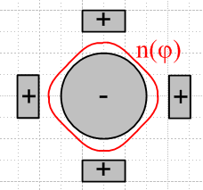 Fig D.4

A critical ingredient of our solution is the assumption that Eφ(r=a,m) = 0 and that is the subject now addressed. We present two somewhat different arguments as to why Eφ(r=a,m) = 0. It should be noted that King in his Transmission-Line Theory book always assumes that any straight transmission line conductor cross section has an equipotential surface (a ring, see for example middle p 14, top 15, 25 bottom).

(a) The Quasi-Static Argument

In electrostatics, we are used to metal surfaces being equipotentials. For example, if we put a point charge q near a metal sphere, it induces a surface charge on that sphere. The electric field lines land on the sphere exactly perpendicular to the surface. One argues that if there were even some tiny E field component tangential to the surface, the surface charges would adjust their position to cancel out that tangential field. Since the situation is static, any adjustment has already been made. Since Etan = 0, the sphere's surface is an equipotential surface.
If we were to then slowly move the charge q around (perhaps it rotates in a circle around the sphere), the surface charge instantly adjusts at each new position of q, and those E field lines remain perpendicular to the surface, and Etan = 0. While the charges are adjusting position, there is admittedly some very tiny surface current driven by some tiny Etan , but if we move the charge slowly, we are "quasi-static" and the approximation Etan ≈ 0 is very good. One might compare the time constant of the moving sphere (T, the period of q's revolution around the sphere) to the time constant of the surface charge adjustment. For copper the time constant is roughly the mean electron collision time which is on the order of 10-14 sec. The upshot here is that for frequencies << 1014 Hz, the quasi-static situation prevails and then Etan ≈ 0 is a very good approximation.
This then is our first argument for why we claim the boundary condition Eφ = 0 on the surface of the round wire in a transmission line operating at a typical frequency.
We note from our solution Eφ(r,m) that if we assume Eφ(a,m) = 0 on the round wire surface, we will still have Eφ(r,m) ≠ 0 inside the wire. This fact is consistent with our argument above since there are no free charges available to adjust themselves inside the wire.

However: if Eφ = 0 by this quasi-static argument, then we should expect that Ez = 0 by the same argument, since Ez is also a tangential field at the round wire surface, and since Ez operates at the same frequency ω as Eφ. But we know that Ez ≠ 0 because Jz ≠ 0 just below the wire surface -- there is current flowing there -- and Ez is continuous through the surface by (1.1.50). So the E field lines are not quite perpendicular to the round wire surface in the z direction. This is not too surprising since we expect everything to vary in the z direction as ej(ωt-β$_{d}$z) so we would expect the surface not to be an equipotential in this direction.
But what happened to that quasi-static argument we applied to Eφ ? What happened is that there is external field activity associated with the wave going down the line which forces Ez ≠ 0. One might say the EM wave travelling down the line induces a Jz in the round wire, with its associated Ez ≠ 0. But then perhaps this same thing could somehow happen with Eφ and then our quasi-static argument that Eφ = 0 collapses. We think this could happen in fact, but only if the transmission line is driven by an apparatus which creates a "torsion wave" in the line. For example, the apparatus could drive counter-rotating azimuthal currents onto the round wire surfaces of a twin-lead transmission line as suggested by this picture (which is not meant to imply that other field components vanish),

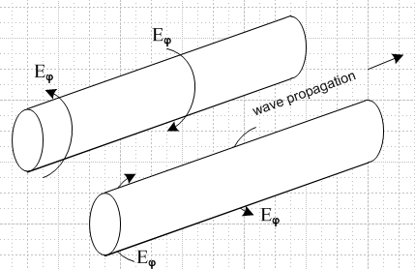 Fig D.5

It seems from our work above that such a wave would satisfy Maxwell's equations and be a viable mode of the transmission line. In this case, Eφ≠ 0 because the EM wave going down the line forces Eφ ≠ 0, just as the normal wave forces Ez ≠ 0.
We have not investigated whether this type of torsion wave is really viable. Whether or not it is, we assume in our transmission line discussion that this mode is not activated and that therefore the quasi-static argument for Eφ = 0 is valid at the round wire surface.

(a) An Ansatz Argument

We make an ansatz that Er,Eφ << Ez in our round wire E field solution, perhaps based on an expectation that most current in the wire will be longitudinal. We assume this is true, and see if this assumption is born out in a final solution of Maxwell's equations. Given that Eφ is then very small, we can make an approximation (another ansatz) that this field Eφ is exactly zero on the surface of the round wire. This may not be exactly true, but again we assume it for our purposes and see where it leads. This is the nature of an "ansatz".
When we make this assumption, the cross section of the transmission line may be regarded as a two dimensional potential theory problem -- basically a capacitor problem where one conductor has potential V and the other -V, say (at some fixed value of z). In such a potential problem, one always assumes that the electrostatic potential Φ is a constant on the surface of each conductor, and that is precisely what our ansatz says: Eφ = -(∇Φ)φ = 0, Φ = constant in the φ direction. Now when we solve the capacitor problem for potential Φ, that gives E = - ∇Φ in the dielectric between the conductors, and from that we may deduce E • at the surface of one of the conductors. For the round wire with a cylindrical coordinate system whose axis is aligned with the wire center, that field is Er. Next, from this surface value of Er (which will be proportional to V) we may compute the surface charge density n(φ) on the round wire using (D.2.24) which says Er(r=a,φ) = (jω/σ) n(φ). For a "fat" twin lead transmission line for example we expect this to have a bulge in n(φ) on the side of the wire facing the other wire (m = 1, dipole), since that is what happens in such a capacitor. In any event, given n(φ) we may compute the moments Nm of the surface charge using (D.1.5b) and this then provides one "boundary condition" on our coefficients am and Km which appear in all the field expressions we found above,

Er(r=a,m) = (jω/σ) Nm . (D.2.26)

But recall that, in order to carry out this entire process just described, we had to start with the assumption that Eφ = 0 on the conductor cross section surface, so that we could have a capacitor problem in the first place. According to (D.1.3b), if Eφ(r=a,φ) = 0, then Eφ(r=a,m) = 0, so that in fact we must have Er(a,m) being zero in all partial waves m. Thus our assumed ansatz condition is

Eφ(r=a,m) = 0 (D.2.27)

which is then a second boundary condition on am and Km. Although (D.2.27) might not be exactly true, we know it is very close to being true. More importantly, we know that the above two conditions on am and Km are consistent with each other, even though both boundary conditions might be slightly wrong. We then expect them to give good values for constants am and Km.
Using these "perhaps slightly wrong" boundary conditions, we obtain the solutions shown in (D.2.33). It has already been noted above that for copper conductors and normal dielectrics, |βd/β'| << 1 up to at least 100 GHz. The condition |βd/β'| << 1 when applied to the (D.2.33) results shows that in fact our ansatz that Er,Eφ << Ez is born out.
There are three footnotes that one might add to the above discussion.
First, we note that the second boundary condition does not force Eφ(r,m) = 0 for r < a inside the wire. In fact, there will be some small azimuthal "swirling" current inside the wire even if Eφ(r=a,m) = 0, and this is just a result of Maxwell's equations and their solutions above.
Second, one might make the argument that the round wire surface is an equipotential since that is the way a line is driven at the source. For example, the center conductor of a coaxial cable plugs into a tiny driving cylinder (jack) in a BNC connector and this drives only the wire surface, and it does so in an azimuthally symmetric way so that one expects to have the wire surface be an equipotential at the driving point; this equipotential surface then moves down the line as the wave progresses.
Third, we have the complication that we don't really have a purely electrostatic situation, and the potential is in fact related to E by equation (1.3.1) which says E = - ∇ Φ - ∂tA . The rescue here comes by claiming that roughly A ≈ A so that the transverse components Ar and Aφ are very small. In this case, we then do get E ≈ -∇Φ so that Eφ = 0 is associated with constant Φ on the wire surface. The argument for A ≈ A is that A is driven by J, and J is mostly in the direction, which in turn is related to our starting ansatz.

Exercise for the Reader

(1) Show that a classical electron inside or on the surface of a conductor of a transmission line traverses a tiny elliptical path of perhaps 1 nm scale and thus never really goes anywhere. That path is traversed once per period T= 2π/ω. Mathematically, show that this amounts to proving that the three equations

x = Acos(ωt-a)
y = Bcos(ωt-b)
z = Ccos(ωt-c) (D.8.1)

are parametric equations for an ellipse with some orientation in 3D space. This goes-nowhere aspect of the electron is similar to what happens with a droplet of water in an ocean wave. (Hint: first show that the first two equations describe an ellipse in the xy plane and that the semi-major axes in general are not A and B .)

(2) When a TEM wave travels down a transmission line with a round conductor, the electric field "raises" a surface charge density on that conductor as it passes by. Exactly where does this surface charge come from? Is the charge density (though not individual charges) just sliding down the line in the z direction at the dielectric light velocity, and that is where it comes from -- the surface charge moves in the z direction, and there is then a z-directed surface current? Or does this charge get pumped off the other side of the conductor through the interior by the radial field Er ? Or does the charge get driven around the cross section surface of the conductor by an Eφ field which we have proposed vanishes?

(3) Use Maple or other software to make a cross-sectional 2D "field plot" of current flow in a round wire for a given partial wave m. A starting point (for z = 0) might be

Etrans (r,φ,t) = cos(-ωt + mφ + arg[Eφ(r)] ) |Eφ| + cos(-ωt + mφ + arg[Er(r)] ) |Er| (D.8.2)

where = -sinφ + cosφ and = cosφ + sinφ . Make a series of plots at sequential t values to obtain a weather pattern for the E field components (and thus the currents), and see if this helps answer question (2) above. Try making a 3D field plot adding in the field component.

