9/20/14

This work has been installed verbatim into lines doc.

D.4 Computation of the B fields in the round wire

The B field components may be computed from the Maxwell curl E equation (1.1.2),

- ∂tB = curl E . Maxwell curl E equation (1.1.2) (D.4.1)

In cylindrical coordinates one has from (D.1.14),

curl E = [ r-1∂θEz - ∂zEθ] + [∂zEr - ∂rEz] + [ r-1∂r(rEθ) - r-1∂θEr ] (D.4.2)

where the fields are of the traveling wave form shown in (D.1.1) which we assume also for the B field. Thus, combining (D.1.1) with (D.1.3a), one has
E(r,θ,z,t) = ej(ωt-kz) E(r,θ) = ej(ωt-kz) $\sum_{m = -∞}^{∞}{}$ E(r,m) ejmθ (D.4.3)
B(r,θ,z,t) = ej(ωt-kz) B(r,θ) = ej(ωt-kz) $\sum_{m = -∞}^{∞}{}$ B(r,m) ejmθ . (D.4.4)

Inserting the three cylindrical components of the E expansion (D.4.3) into (D.4.2), one finds that these replacements may be made,

∂t → +jω ∂z → -jk ∂θ → +jm . (D.4.5)

Similarly, inserting the B expansion (D.4.4) into -∂tB one may replace ∂t→ +jω. After doing this, both sides of (D.4.1) are expansions having the general form of (D.4.3) and one may then equate terms in the m sum [completeness of the ejmθ on (-π.π)] to find that

-jωB(r,m) = [ r-1jmEz +jkEθ] + [-jkEr - ∂rEz] + [ r-1∂r(rEθ) - r-1jmEr ] (D.4.6)

and this then gives the three partial wave components of the B field

Br(r,m) = (j/ω) [curl E]r = (j/ω) [r-1jmEz +jkEθ]
Bθ(r,m) = (j/ω) [curl E]θ = (j/ω)[-jkEr - ∂rEz]

Bz(r,m) = (j/ω) [curl E]z = (j/ω) [r-1∂r(rEθ) - r-1jmEr] . (D.4.7)

It is now a simple task to insert into these Bi expressions the Ei field components from box (D.2.33),

Second summary of the E field solutions : Rdc = $\frac{1}{σπa2}$ β'2 = β2 - k2 (D.2.33)

Ez(r,m) = (1/4) ηm I Rdc (aβ') fm fm = [$\frac{Jm(x)}{Jm+1(xa)}$ - $\frac{Jm(x)}{Jm-1(xa)}$ ] x = β'r
Er(r,m) = (j/4) ηm I Rdc (ak) gm gm = [ $\frac{Jm+1(x)}{Jm+1(xa)}$ + $\frac{Jm-1(x)}{Jm-1(xa)}$ ] xa = β'a
Eθ(r,m) = (1/4) ηm I Rdc (ak) hm hm = [$\frac{Jm+1(x)}{Jm+1(xa)}$ - $\frac{Jm-1(x)}{Jm-1(xa)}$ ]

We have carried out this task manually to obtain the following results (which will be verified below),

Br(r,m) = - (1/4) (a/ω) ηm I Rdc ( r-1m (β') fm + k2 hm )

Bθ(r,m) = (j/4)(a/ω) ηm I Rdc ( k2 gm - β'2fm [ (m/x) - Jm+1(x)/Jm(x)] )

Bz(r,m) = (j/4)(a/ω) ηm I Rdc (k β' em ) . (D.4.8)

Here the fm, gm and hm are the same functions appearing in the box above, and the new function em is

em ≡ [$\frac{Jm(x)}{Jm+1(xa)}$ + $\frac{Jm(x)}{Jm-1(xa)}$ ] . (D.4.9)

Notice that the Ei and Bi fields all have the common factor [(1/4) ηm I Rdc a ]. For purposes of verifying the Bi expressions above, we shall set this factor to 1 everywhere to obtain these scaled fields,

Ez(r,m) = β' fm
Er(r,m) = j k gm
Eθ(r,m) = k hm

Br(r,m) = - (1/ω) ( r-1m (β') fm + k2 hm )
Bθ(r,m) = j (1/ω) ( k2 gm - β'2fm [ (m/x) - Jm+1(x)/Jm(x)] )
Bz(r,m) = j (1/ω) (k β' em ) . (D.4.10)

To verify that -jωB = curl E for the above set of fields, we shall check these three equations

-jωBi = [curl E]i ? i = r,θ.z (D.4.11)

where from above

[curl E]r = [r-1jmEz +jkEθ]
[curl E]θ = [-jkEr - ∂rEz]
[curl E]z = [r-1∂r(rEθ) - r-1jmEr] . (D.4.12)

We start by entering these three curl expressions into Maple,

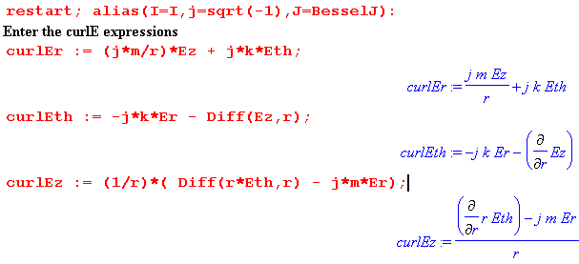
followed by the scaled B and E field expressions from (D.4.10) above,

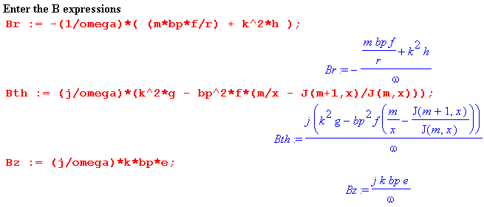
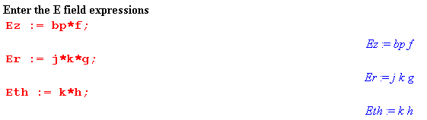

Next come the various supporting functions,

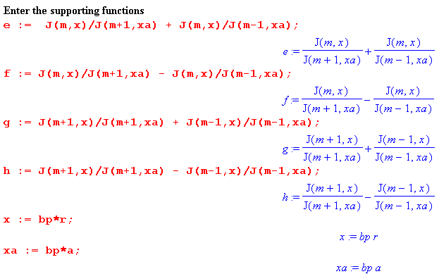

Taking the precautions noted in the "Maple Comment" below (D.2.21), we now verify (D.4.11) that
-jωBi = [curl E]i :

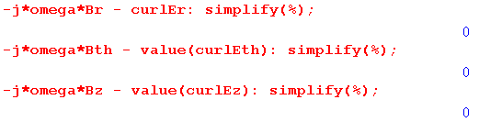
Here then is a summary of all the E and B field results in a single box

Summary of E and B fields inside a round wire (D.4.13)

Ez(r,m) = (1/4) ηm I Rdc (aβ') fm x = β'r xa = β'a β'2 = β2 - k2
Er(r,m) = (j/4) ηm I Rdc (ak) gm
Eθ(r,m) = (1/4) ηm I Rdc (ak) hm

Bz(r,m) = (j/4) (a/ω) ηm I Rdc (k β' em )
Br(r,m) = - (1/4) (a/ω) ηm I Rdc ( r-1m β' fm + k2 hm )
Bθ(r,m) = (j/4) (a/ω) ηm I Rdc ( k2 gm - β'2fm [ (m/x) - Jm+1(x)/Jm(x)] )

em = [$\frac{Jm(x)}{Jm+1(xa)}$ + $\frac{Jm(x)}{Jm-1(xa)}$ ] gm = [ $\frac{Jm+1(x)}{Jm+1(xa)}$ + $\frac{Jm-1(x)}{Jm-1(xa)}$ ] Rdc = $\frac{1}{σπa2}$
fm = [$\frac{Jm(x)}{Jm+1(xa)}$ - $\frac{Jm(x)}{Jm-1(xa)}$ ] hm = [$\frac{Jm+1(x)}{Jm+1(xa)}$ - $\frac{Jm-1(x)}{Jm-1(xa)}$ ]

[ The above box is now

D.5 Verification that the E and B fields satisfy the Maxwell equations

We already know that the Maxwell curl E equation is satisfied, since it was used in the previous section to derive the B fields. As for the other three Maxwell equations, we expect to find that

div B = 0 // since B = (1/jω) curl E so div B = (1/jω) div curl E = 0
div E = 0 // no free charge inside conductor

curl B = μ J + μ jωεE = μ(σ + jωε) E = μ(jω)( ε - jσ/ω) E = jω μξ E (D.5.1)
= j (β2/ω) E . // see (1.5.1c)

In cylindrical coordinates the curl and div operators are, from (D.1.14),

curl B = [ r-1∂θBz - ∂zBθ] + [∂zBr - ∂rBz] + [ r-1∂r(rBθ) - r-1∂θBr ]

div B = r-1∂r(rBr) + r-1∂θBθ + ∂zBz (D.5.2)

Using ∂z → -jk and ∂θ → jm we can write these in m space as

curl B(r,m) = [ r-1jmBz + jkBθ] + [-jkBr - ∂rBz] + [ r-1∂r(rBθ) - r-1jmBr ]

div B(r,m) = r-1∂r(rBr) +r-1jmBθ -jk Bz . (D.5.3)

We continue the Maple code of the previous section to verify that the other three Maxwell equations are satisfied:

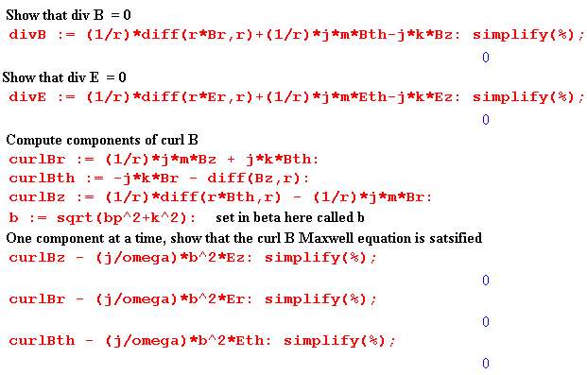
The reader is again referred to the "Maple Comment" below (D.2.21). The expressions on the three last lines prior to simplification are quite complicated, for example

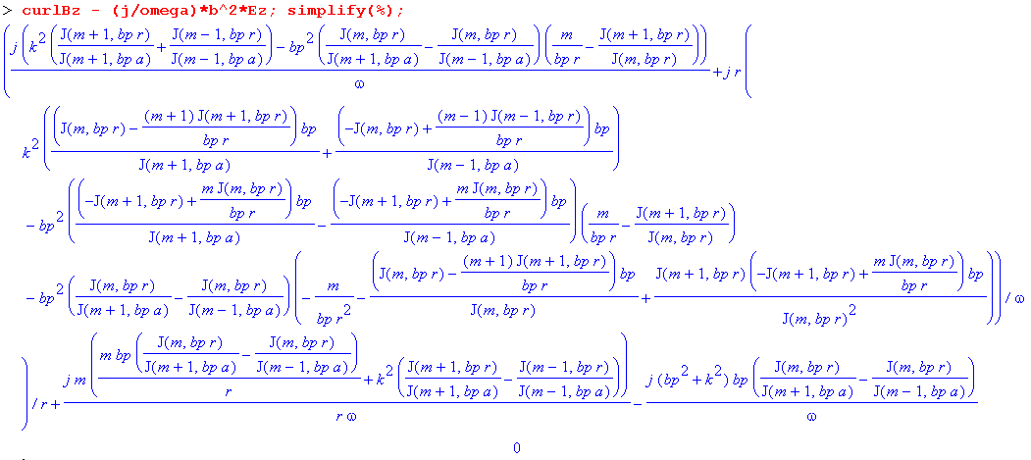
No approximations were made in the E fields, the B fields, or in these Maxwell verifications.

D.6 The exact E and B fields for the m=0 partial wave

The m=0 partial wave is all there is for an axially symmetric problem like that considered in Chapter 2, where the round wire is imagined in isolation, but is operationally the central conductor of a coaxial cable with a very distant return cylinder (outer shield). Here is the reduction of box (D.4.13) for m = 0:

e0 = [$\frac{J0(x)}{J1(xa)}$ + $\frac{J0(x)}{J-1(xa)}$ ] = [$\frac{J0(x)}{J1(xa)}$ - $\frac{J0(x)}{J1(xa)}$ ] = 0
f0 = [$\frac{J0(x)}{J1(xa)}$ - $\frac{J0(x)}{J-1(xa)}$ ] = [$\frac{J0(x)}{J1(xa)}$ + $\frac{J0(x)}{J1(xa)}$ ] = 2 $\frac{J0(x)}{J1(xa)}$
g0 = [ $\frac{J1(x)}{J1(xa)}$ + $\frac{J-1(x)}{J-1(xa)}$ ] = [ $\frac{J1(x)}{J1(xa)}$ + $\frac{J1(x)}{J1(xa)}$ ] = 2 $\frac{J1(x)}{J1(xa)}$
h0 = [ $\frac{J1(x)}{J1(xa)}$ - $\frac{J-1(x)}{J-1(xa)}$ ] = [ $\frac{J1(x)}{J1(xa)}$ - $\frac{J1(x)}{J1(xa)}$ ] = 0 (D.6.1)

Ez(r,0) = (1/4) I Rdc (aβ') f0 = (1/4) I Rdc (aβ') 2$\frac{J0(x)}{J1(xa)}$
Er(r,0) = (j/4) I Rdc (ak) g0 = (j/4) I Rdc (ak) 2$\frac{J1(x)}{J1(xa)}$
Eθ(r,0) = (1/4) I Rdc (ak) h0 = 0

Bz(r,0) = (j/4) (a/ω) I Rdc (k β' e0 ) = 0

Br(r,0) = - (1/4) (a/ω) I Rdc (k2 h0 ) = 0

Bθ(r,0) = (j/4) (a/ω) I Rdc ( k2 g0 + β'2f0 [J1(x)/J0(x)] )
= (j/4) (a/ω) I Rdc ( k2 2 $\frac{J1(x)}{J1(xa)}$ + β'2 2 $\frac{J0(x)}{J1(xa)}$ [J1(x)/J0(x)] )
= (j/4) (a/ω) I Rdc ( k2 2 $\frac{J1(x)}{J1(xa)}$ + β'2 2 $\frac{J1(x)}{J1(xa)}$ )
= (j/4) (a/ω) I Rdc ( k2 + β'2 ) 2 $\frac{J1(x)}{J1(xa)}$
= (j/4) (a/ω) I Rdc β2 2 $\frac{J1(x)}{J1(xa)}$ // β'2 = β2-k2 (D.6.2)

The results then are

Summary of E and B fields inside a round wire ( m = 0 only ) (D.6.3)

Ez(r,0) = (1/2) I Rdc (aβ') $\frac{J0(x)}{J1(xa)}$ Bz(r,0) = 0 x = β'r xa = β'a
Er(r,0) = (j/2) I Rdc (ak) $\frac{J1(x)}{J1(xa)}$ Br(r,0) = 0 Rdc = $\frac{1}{σπa2}$
Eθ(r,0) = 0 Bθ(r,0) = (j/2) (a/ω) I Rdc β2 $\frac{J1(x)}{J1(xa)}$

For a low-loss transmission line k ≈ βd0 = ω/vd. As implied by the comments below (D.2.2), in this situation one has k << |β| and thus also k << |β'| . Ignoring the difference between J0 and J1 in scale, (D.6.3) shows that in this situation | Er / Ez | ~ | k/β'| << 1 so the Er field is very small and Ez is the main electric field. For such a transmission line one has,

Ez(r,0) = (1/2) I Rdc (aβ) $\frac{J0(x)}{J1(xa)}$ = (ω/β) [(1/2) (aβ2/ω) I Rdc] $\frac{J0(x)}{J1(xa)}$
Bθ(r,0) ≈ (j/2) (a/ω) I Rdc β2 $\frac{J1(x)}{J1(xa)}$ = j [(1/2) (aβ2/ω) I Rdc] $\frac{J1(x)}{J1(xa)}$ (D.6.4)

where on the right we have rewritten the expressions in a seemingly obscure manner. As shown in (2.2.3), β2/ω ≈ - jμσ so that

[(1/2) (aβ2/ω) I Rdc] = (1/2) a (- jμσ) I $\frac{1}{σπa2}$ = - j $\frac{μI}{2πa}$. (D.6.5)

Since this is the bracket appearing in both field expressions in (D.6.4), we find that

Ez(r,0) = (ω/β) [- j $\frac{μI}{2πa}$] $\frac{J0(x)}{J1(xa)}$ = -j (ω/β) $\frac{μI}{2πa}$ $\frac{J0(x)}{J1(xa)}$
Bθ(r,0) = j [- j $\frac{μI}{2πa}$] $\frac{J1(x)}{J1(xa)}$ = $\frac{μI}{2πa}$ $\frac{J1(x)}{J1(xa)}$ . (D.6.6)

These results are in agreement with E(r) and B(r) shown in summary box (2.2.30) from the Chapter 2 calculation where we assumed E = E(r) and B = B(r) .

