Appendix K : The Network Model: Comparison of Network and Maxwell Views 1
(a) The Network Model 1
(b) Network Model Characteristic Impedance 2
(c) Network Model Transmission Line Equations 4
(d) Network Model Parameters obtained from Maxwell's Equations 5
(e) Low frequency case (no skin effect) 6
(f) High frequency case for round conductor (strong skin effect) 7

This was installed 6/30/14 at 9 PM.

Appendix K : The Network Model: Comparison of Network and Maxwell Views

(a) The Network Model

The usual network model of a 2-conductor transmission line is an infinite repetition of differentially small R,L,C,G segments as shown here between the vertical red lines,

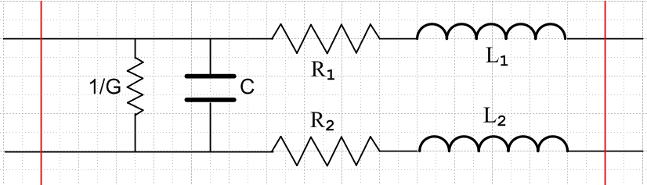 Fig K.1

This is of course electrically identical to the following,

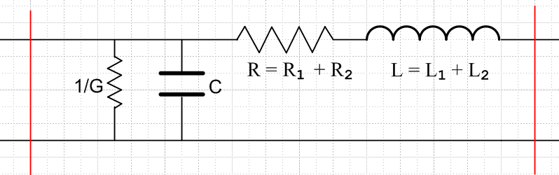 Fig K.2

where R = R1 + R2 and L = L1 + L2. In the circuit diagrams, it is implied that R,L,C,G are all quantities per unit length of the transmission line. Thus, if the distance between the two red lines is δ, the values of the lumped parameters in Fig K.2 are Rδ,Lδ,Cδ,Gδ. For example, if δ doubles, the total conductance of the segment doubles since it is a measure of current flowing between the conductors. The model implied by the picture is then the limit as δ→0.
We wish to compare this "network model" to our Maxwell equation results. To start, we note that the impedance of a capacitor C and inductor L operating at frequency ω is determined by

Q = CV => I = ∂tQ = C ∂tV => I = jωCV => ZC = V/I = 1/(jωC)

V = L ∂tI => V = jωLI => ZL = V/I = jωL . (K.1)

Note that the "admittance" of a capacitor is YC = 1/ZC = jωC. We can then combine the G and C elements together into a single element having y = G+jωC, since parallel admittances are additive. Similarly, we combine the two series elements R and L into impedance z = R+jωL. The network picture is then,

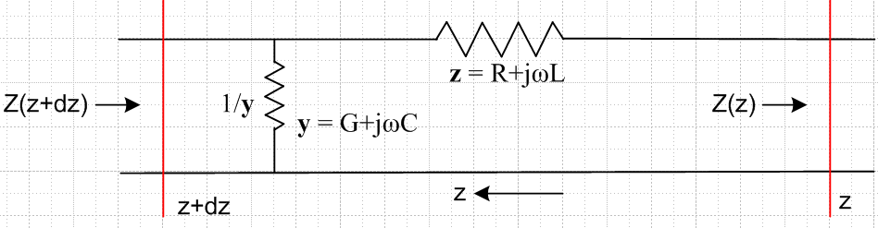 Fig K.3

We use King's bolded symbols y and z and of course z is unrelated to distance z. Here we arbitrarily have the z axis pointing to the left (!), and the vertical red lines area placed at z and z+dz so that δ = dz. The impedance looking into the transmission line from the left is Z(z+dz) at z+dz and is Z(z) at z.

(b) Network Model Characteristic Impedance

Since the impedance 1/y is in parallel with the impedance z + Z(z) we have

Z(z+dz) = (ydz)-1 || (zdz + Z(z)) = product over sum = $\frac{(ydz)-1 (zdz + Z(z))}{(ydz)-1 + (zdz + Z(z))}$

= $\frac{(zdz + Z(z))}{1 + (ydz) (zdz + Z(z))}$ ≈ [Z(z) + zdz] [1 - (ydz)(z dz + Z(z)]

≈ [Z(z) + zdz] [1 - (ydz) Z(z)] // dropping order (dz)2

≈ Z(z) + [z - yZ2(z)] dz . // dropping order (dz)2 again

Therefore Z(z) must solve this non-linear first order differential equation,

$\frac{dZ(z)}{dz}$ = z - yZ2(z) or $\frac{dZ(z)}{dz}$ + y Z2(z) = z . (K.2)

The most general solution to this equation is

Z(z) = $\frac{z}{y}$ th ($\sqrt{zy}$ z + C ) C = constant (K.3)

since

∂zZ = $\frac{z}{y}$* $\sqrt{zy}$ sech2($\frac{z}{y}$ z + C ) = z [ 1 - th2($\frac{z}{y}$ z + C ) ]

= z [ 1 - $\frac{y}{z}$Z2(z)] = z - y Z2(z) .

If the transmission line is of finite length running from z = L (left end ) to z =0 (right end), and if the line is terminated at z = 0 by some impedance Zt, we must have Z(0) = Zt so that

Zt = Z(0) = $\frac{z}{y}$ th ($\sqrt{zy}$0 + C ) = $\frac{z}{y}$ th(C)

=> C = th-1($\frac{y}{z}$Zt)

so then the solution is

Z(z) = $\frac{z}{y}$ th [ $\sqrt{zy}$ z + th-1($\frac{y}{z}$Zt) ]

and at the left end we find

Z(L) = $\frac{z}{y}$ th [ $\sqrt{zy}$ L + th-1($\frac{y}{z}$Zt) ] .

If we take L → ∞ (line becomes infinitely long) , then th [...] → 1 and we find

Z(∞) = $\frac{z}{y}$,

so the impedance looking into the left end of the infinite transmission line is independent of the termination value Zt at z = 0. This infinite line impedance is called the characteristic impedance Z0 and we have shown then that

Z0 = $\frac{z}{y}$ = $\frac{R+jωL}{G+jωC}$. (K.4)

Since this is the same result obtained from Maxwell's equations in (4.11.16), one is motivated to regard the network transmission line model as a correct model, and then the network model parameters R,L,G,C can be identified with the parameters obtained from Maxwell's equations.

Reader Exercise: Consider this purely resistive finite ladder network shorted at the right end,

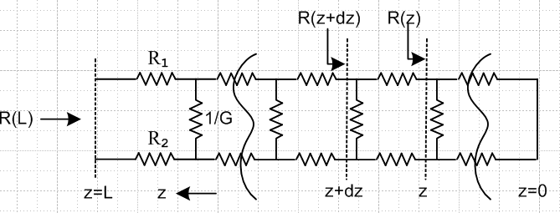

(1) Using the results above, show that

R(L) = $\sqrt{R3/G}$ tanh ($\sqrt{R3G}$ L ) where R3 ≡ R1+ R2 .

(2) Show that

R(L) ≈ $\sqrt{R3/G}$ if L >> 1/$\sqrt{R3G}$ .

Thus, for large L the fact that the line is shorted at the right end makes no difference.

(3) Show that for finite L :

R(L) → R3L as G→ 0 no conductance
R(L) → 0 as R3→ 0 no wire resistance

Both limits should seem obvious.

(c) Network Model Transmission Line Equations

We now switch the z axis back to its usual direction (increasing to the right), and we label currents and voltages on our transmission line section,

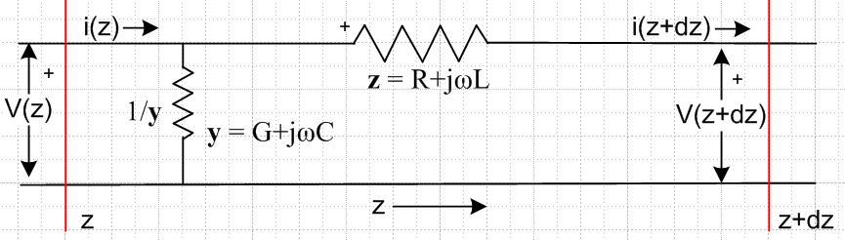 Fig K.4

Staring at the picture, it seems clear that

i(z) - i(z+dz) = current going down through impedance 1/(ydz) = $\frac{V(z)}{1/(ydz)}$ = ydz V(z)

and therefore

- $\frac{di(z)}{dz}$ = y V(z) .

Meanwhile, the voltage across the impedance z is V(z) - V(z+dz) so

V(z) - V(z+dz) = i(z) z

and therefore

- $\frac{dV(z)}{dz}$ = z i(z) .

Thus we have shown that

$\frac{dV(z)}{dz}$= - z i(z) $\frac{di(z)}{dz}$= - y V(z)
with
z = R + jωL y = G +jωC . (K.5)

Differentiating these equations with respect to z, we find that

$\frac{d2V(z)}{dz2}$- zy V(z) = 0 $\frac{d2i(z)}{dz2}$- zy i(z) = 0 (K.6)

But (K.5) and (K.6) are the same transmission line equations obtained from Maxwell's equations as shown in (4.11.14b) and (4.11.15). Thus we are further encouraged in our use of the network model to represent a transmission line. Since the equations found from Maxwell's equations were qualified as being questionable at very low frequencies, the network model is also suspect at very low ω

(d) Network Model Parameters obtained from Maxwell's Equations

The main results of Chapter 4 appear in summary box (4.11.34) from which we quote in part,

$\frac{dV(z)}{dz}$ = - z i(z) ( $\frac{d2}{dz2}$ - zy) V(z) = 0 z = R + jωL transmission line equations
$\frac{di(z)}{dz}$ = - yV(z) ($\frac{d2}{dz2}$ - zy) i(z) = 0 y = G +jωC (4.11.14), (4.11.15)

z = Zs1 + Zs2 + jωLe (4.11.17) XL ≡ ωLe , XC ≡ 1/(ωC)
y = jωC' = jωC + (σd/εd)C (4.11.24) G = (σd/εd)C (4.11.25)

R = Re(Zs1+ Zs2)
L = Le + (1/ω) Im(Zs1+ Zs2)

Le = (μd/4π)K (4.11.29) and (4.11.30)
C = 4πεd/K (4.11.26)
G = 4πσd/K (4.11.26) + (4.11.25) (K.7)

Thus, we make the connection between the network parameters and the Maxwell calculation parameters as follows:

R = Re(Zs1+ Zs2)
L = Le + (1/ω) Im(Zs1+ Zs2)
Le = (μd/4π)K
G = 4πσd/K
C = 4πεd/K (K.8)

where K is the dimensionless real integral in Chapter 4, see (4.4.8). Recall that this integral requires knowledge of both the conductor geometry as well as the normalized transverse surface charge distributions on the conductors. Here ε, μ and σ are for the dielectric between the conductors.

(e) Low frequency case (no skin effect)

At low frequencies, when conductors are not extremely close together, the current densities are close to uniform (see for example Fig 6.16), so that Jz = I/area for each conductor. This uniformity is exact for a conductor which is the central conductor of a coaxial cable, as studied in Chapter 2. There we found at low frequency that

Zs1(ω) = $\frac{1}{σ1πa2}$ + jω $\frac{μ1}{8π}$ // low frequency limit (2.4.12)
=> Re(Zs1) = $\frac{1}{σ1πa2}$ and Im(Zs1) = ω $\frac{μ1}{8π}$ . (K.9)

From (K.8) we then find that for low frequencies and parallel round conductors,

R = $\frac{1}{σ1πa12}$ + $\frac{1}{σ2πa22}$ = Rdc1 + Rdc2 (K.10)
L = Le + ( $\frac{μ1}{8π}$+ $\frac{μ2}{8π}$) = Le + (Li1 + Li2) . (K.11)

In this case parameter R is just the sum of the DC resistances of the conductors (per unit length), and parameter L is the sum of the external inductance Le and the internal inductances of the two wires. Here σi and μi are for the material from which conductor Ci is constructed. The external inductance Le can be interpreted as the inductance of the red wire loop below,

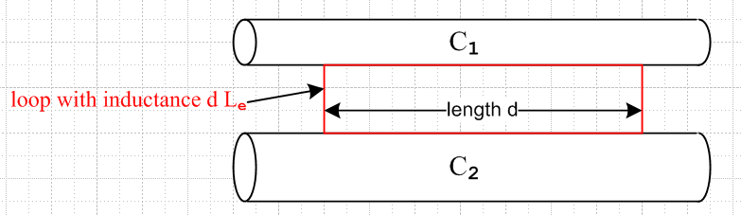 Fig K.3

The sides of the red loop make contact on any line on the conductor surfaces, though here we show it having its minimal size. The red loop may in fact be replaced by any loop, possibly non-planar, which captures all the external magnetic flux passing between the conductors. See Fig 4.11 and discussion there.

Note that Le is not the inductance of a rectangular thin wire loop in isolation occupying the red outline above, but rather Le = (μd/4π)K as in (K.8) above, where K is related to the capacitance between the conductors. If both conductors are round and very thin and separated by distance b, we know from (4.5.7) that K = 4 ln(b/$\sqrt{a1a2}$) and then Le = (μd/π) ln(b/$\sqrt{a1a2}$).

Although we have not formally proven it, it seems clear that for arbitrary conductor cross sections (not too closely spaced) the following equations will apply at low frequency :

R = $\frac{1}{σ1A1}$ + $\frac{1}{σ2A2}$ Ai = cross section area of Ci (K.12)

L = Le + (Li1 + Li2) . (K.13)

Appendix C computes the DC Li for various conductor cross section shapes. One result quoted there from the literature is that for a square conductor,

Li = (μi/8π) [0.96639] . (C.4.12)

Thus the Li for a square cross-section conductor is barely different from that of a round conductor.

(f) High frequency case for round conductor (strong skin effect)

At high frequencies there is a pronounced skin effect. In Chapter 2 for a round conductor C1 at high frequency (and with a symmetric current distribution) we found that

Zs1(ω) ≈ $\frac{1}{σ1(2πa1)δ1}$ (1+j) δ1 << 4a1 (2.4.16)

Re(Zs1) = Im(Zs1 ) = $\frac{1}{σ1(2πa1)δ1}$

where δ1 = $\sqrt{2/(ωμ1σ1)}$ is the skin depth and a1 the wire radius.

From (K.8) we find that for high frequencies and round conductors,

R = $\frac{1}{σ1(2πa1)δ1}$ + $\frac{1}{σ2(2πa2)δ2}$

L = Le + (1/ω) Im(Zs1+ Zs2) = Le + (1/ω) R . (K.14)

In this case, we recognize 2πa1δ1 as the effective current carrying cross-sectional area of round conductor C1 (the area of the current sheath), so the expression for R is quite intuitive. Since,

δ ≡ $\sqrt{2/ωμσ}$ => 1/δ1 = $\sqrt{(ωμ1σ1)/2}$ and 1/ω = μ1σ1δ12/2 (K.15)

we may write
Li(ω) = (1/ω) Im(Zs) = (1/ω) $\frac{1}{σ1(2πa1)δ1}$ = (1/ω) $\frac{1}{σ1(2πa1)}$$\sqrt{(ωμ1σ1)/2}$ = $\frac{1}{2πa1} \sqrt{\frac{μ1}{2σ1ω}}$
(K.16)
so Li(ω) ~ 1/$\sqrt{ω}$. Expressing Li instead in terms of δ1 we find

Li(δ1) = (1/ω) Im(Zs) = (1/ω) $\frac{1}{σ1(2πa1)δ1}$ = μ1σ1(δ12/2) $\frac{1}{σ1(2πa1)δ1}$ = μ1 (1/4π) (δ1/a1)
= $\frac{μi}{8π}$ [ 2 (δ1/a1) ] . (K.17)

The DC internal inductance of a thin shell of radius a and thickness d is shown in Appendix C.6 to be

Li = μi $\frac{1}{6π}$ (d/a) = $\frac{μi}{8π}$ [ (4/3)(d/a) ] thin shell, valid for d << a (C.6.8)

so the high frequency internal inductance of a round wire is the same as the DC internal inductance a shell of thickness d = (3/2)δ which seems fairly reasonable. The above expression (C.6.8) shows that the inductance of a thin cylindrical shell is linear in the shell thickness d, so we expect that the high frequency Li of a round wire should be linear in δ, and thus proportional to 1/$\sqrt{ω}$.
Section 2.5 shows how to handle non-round conductors and non-symmetric current distributions by replacing 2πa by an effective active perimeter D. Chapter 4.11 (b) formalizes this notion, giving the effective perimeter in (4.11.10).

In Section D.10 and D.11 the claims made in the last two sections regarding surface impedance are vindicated when one uses the surface impedance averaged over the round wire surface, see (D.10.17) for large ω and (D.11.10) for low ω.

