old appendix K

Appendix K : The Network Model: Comparison of Network and Maxwell Views

(a) The Network Model

The usual network model of a 2-conductor transmission line is an infinite repetition of differentially small R,L,C,G segments as shown here between the vertical red lines,

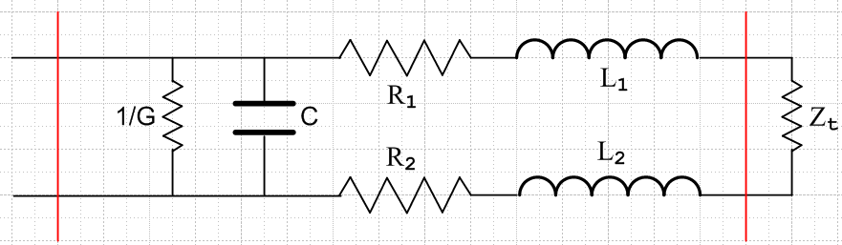 Fig K.1
This is of course electrically identical to the following

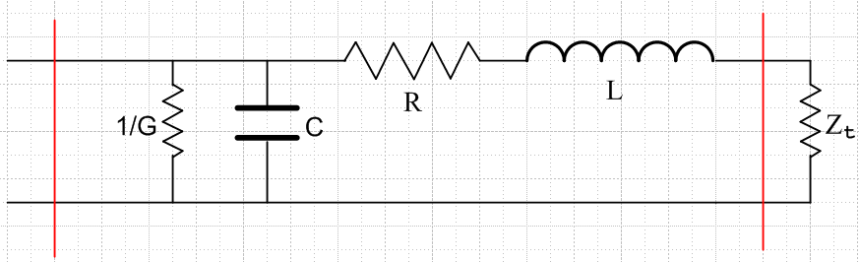 Fig K.2

where R = R1 + R2 and L = L1 + L2. In the circuit diagrams, it is implied that R,L,C,G are all quantities per unit length of the transmission line. Thus, if the distance between the two red lines is δ, the values of the lumped parameters in Fig K.2 are Rδ,Lδ,Cδ,Gδ. For example, if δ doubles, the total conductance of the segment doubles since it is a measure of current flowing between the conductors. The model implied by the picture is then the limit as δ→0.
We wish to compare these parameters R,L,C,G with our parameters calculated from Maxwell's equations.

(b) Characteristic Impedance in the Network Model

The first step to this end is to compute the impedance Zin one would see looking into the left end of the above "two-port network" consisting of a single segment terminated by some impedance Zt. If we set this computed impedance Zin equal to Zt, the resulting Zt must then be the "characteristic impedance" of the infinite transmission line looking in from the left end.
The impedance of a capacitor C and inductor L operating at frequency ω is determined by

Q = CV => I = ∂tQ = C ∂tV => I = jωCV => ZC = V/I = 1/(jωC)

V = L ∂tI => V = jωLI => ZL = V/I = jωL . (K.1)

If we momentarily set δ = 1, then using the usual circuit rules for computing impedance we see that

Zin = (1/G) || ZC || (R + ZL+ Zt) ZC = 1/(jωC) ZL = jωL .

since these three elements are in parallel. For parallel elements, since all have the same voltage Vin, it is easier to add up the inverse impedances ("admittances"), which basically adds up the three currents to get the total current (a fact easily shown) so then

Zin-1 = G + ZC-1 + (R + ZL + Zt)-1
or
Zin-1 = G + jωC + (R + jωL + Zt)-1 . (K.2)

To find the characteristic impedance we set Zin = Zt = Z0 to get

Z0-1 = G + jωC + (R + jωL + Z0)-1 . (K.3)

Now we reinstall our δ factors to get

Z0-1 = (G+jωC)δ + $\frac{1}{(R+jωL)δ + Z0}$ (K.4)
or
[(R+jωL)δ + Z0] Z0-1 = (G+jωC)δ [(R+jωL)δ + Z0]
or
[(R+jωL)δ + Z0] = (G+jωC)δ [(R+jωL)δZ0 + Z02] . (K.5)

We enter into Maple the equation in the form (K.4). The two quadratic solutions go into array elements s[1] and s[2], and s[1] gives the physical solution. This result includes terms of order δ0, δ and δ2 and we then take the limit δ→0 simply by setting δ = 0. The extra Maple commands are just guides to help Maple obtain the result in a simple form.

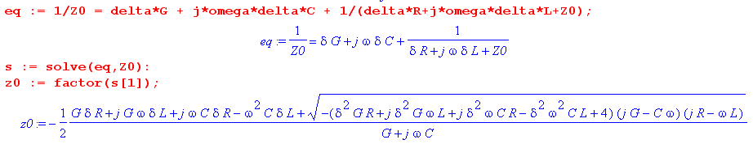

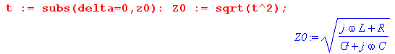

Thus we arrive at the famous result for the characteristic impedance of a transmission line in the network model described above,

Z0 = $\frac{R+jωL}{G+jωC}$ . (K.6)

(c) Characteristic impedance computed from Maxwell's Equations

The main results of Chapter 4 appear in summary box (4.11.34) from which we quote in part,

$\frac{dV(z)}{dz}$ = - z i(z) ( $\frac{d}{dz2}$ - zy) V(z) = 0 z = R + jωL transmission line equations
$\frac{di(z)}{dz}$ = - yV(z) ($\frac{d}{dz2}$ - zy) i(z) = 0 y = G +jωC (4.11.14), (4.11.15)

z = Zs1 + Zs2 + jωLe (4.11.17) XL ≡ ωLe , XC ≡ 1/(ωC)
y = jωC' = jωC + (σ/ε)C (4.11.24) G = (σ/ε)C (4.11.25)

R = Re(Zs1+ Zs2)
L = Le + (1/ω) Im(Zs1+ Zs2)

Le = (μ/4π)K (4.11.29) and (4.11.30)
C = 4πε/K (4.11.26)
G = 4πσ/K (4.11.26) + (4.11.25) (K.7)

Assuming the transmission line carries a wave of the usual (D.1.1) form ej(ωt-kz), we know that

V(z) = V(0)e-jkz => ∂zV(z) = - j kV(z)
i(z) = i(0)e-jkz => ∂zi(z) = - j k i(z) . (K.8)

Thus the transmission line equations above may be written

jkV = z i
jk i = yV . (K.9)

Multiply the first by i and the second by V and subtract the resulting equations to get

0 = z i2 - yV2 => z i2 = yV2 => (V/i)2 = z/y . (K.10)

Therefore we find that, in agreement with (4.11.16), the characteristic impedance of the infinite transmission line is

Z0 = V/i = $\sqrt{z/y}$ = $\frac{R+jωL}{G+jωC}$ (K.11)
where R,L,G,C are the parameters computed from Maxwell's equations. Since this result agrees exactly with our network computation (K.6), we conclude that these R,L,G,C parameters are the same in both the Maxwell and network models. Thus, we make the connection between the network parameters and the Maxwell calculation parameters as follows:

R = Re(Zs1+ Zs2)
L = Le + (1/ω) Im(Zs1+ Zs2)
Le = (μ/4π)K
G = 4πσ/K
C = 4πε/K (K.12)

where K is the dimensionless real integral in Chapter 4, see (4.4.8). Recall that this integral requires knowledge of both the conductor geometry as well as the normalized Jz current distributions inside the conductors. Here ε, μ and σ are for the dielectric between the conductors.

(d) Low frequency case (no skin effect)

At low frequencies, when conductors are not extremely close together, the current densities are close to uniform (see for example Fig 6.16), so that Jz = I/area for each conductor. This uniformity is exact for a conductor which is the central conductor of a coaxial cable, as studied in Chapter 2. There we found at low frequency that

Zs(ω) = $\frac{1}{σ1πa2}$ + jω $\frac{μ1}{8π}$ // low frequency limit (2.4.12)
=> Re(Zs) = $\frac{1}{σ1πa2}$ and Im(Zs) = ω $\frac{μ1}{8π}$ . (K.13)

From (K.12) we then find that for low frequencies and parallel round conductors,

R = $\frac{1}{σ1πa12}$ + $\frac{1}{σ2πa22}$ = Rdc1 + Rdc2 (K.14)
L = Le + ( $\frac{μ1}{8π}$+ $\frac{μ2}{8π}$) = Le + (Li1 + Li2) . (K.15)

In this case parameter R is just the sum of the DC resistances of the conductors (per unit length), and parameter L is the sum of the external inductance Le and the internal inductances of the two wires. Here σi and μi are for the material from which conductor Ci is constructed. The external inductance Le can be interpreted as the inductance of the red wire loop below,

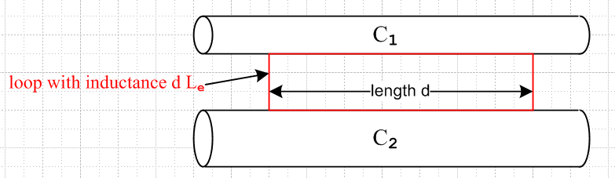 Fig K.3

The sides of the red loop make contact on any line on the conductor surfaces, though here we show it having its minimal size. The red loop may in fact be replaced by any loop, possibly non-planar, which captures all the external magnetic flux passing between the conductors. See Fig 4.11 and discussion there.

Note that Le is not the inductance of a rectangular thin wire loop in isolation occupying the red outline above, but rather Le = (μ/4π)K as in (K.12) above, where K is related to the capacitance between the conductors. If both conductors are round and very thin and separated by distance b, we know from (4.5.7) that K = 4 ln(b/$\sqrt{a1a2}$) and then Le = (μ/π) ln(b/$\sqrt{a1a2}$).

Although we have not formally proven it, it seems clear that for arbitrary conductor cross sections (not too closely spaced) the following equations will apply at low frequency :

R = $\frac{1}{σ1A1}$ + $\frac{1}{σ2πA2}$ Ai = cross section area of Ci (K.16)

L = Le + (Li1 + Li2) . (K.17)

Appendix C computes the DC Li for various conductor cross section shapes. One result quoted there from the literature is that for a square conductor,

Li = (μi/8π) [0.96639] . (C.4.12)

Thus the Li for a square cross-section conductor is barely different from that of a round conductor.

(e) High frequency case for round conductor (strong skin effect)

At high frequencies there is a pronounced skin effect. In Chapter 2 for a round conductor C1 at high frequency (and with a symmetric current distribution) we found that

Zs(ω) ≈ $\frac{1}{σ1(2πa1)δ1}$ (1+j) δ1 << 4a1 (2.4.16)

Re(Zs) = Im(Zs ) = $\frac{1}{σ1(2πa1)δ1}$

where δ1 = $\sqrt{2/(ωμ1σ1)}$ is the skin depth and a1 the wire radius.

From (K.12) we find that for high frequencies and round conductors,

R = $\frac{1}{σ1(2πa1)δ1}$ + $\frac{1}{σ2(2πa2)δ2}$

L = Le + (1/ω) Im(Zs1+ Zs2) = Le + (1/ω) R . (K.18)

In this case, we recognize 2πa1δ1 as the effective current carrying cross-sectional area of round conductor C1 (the area of the current sheath), so the expression for R is quite intuitive. Since,

δ ≡ $\sqrt{2/ωμσ}$ => 1/δ1 = $\sqrt{(ωμ1σ1)/2}$ and 1/ω = μ1σ1δ12/2 (K.19)

we may write
Li(ω) = (1/ω) Im(Zs) = (1/ω) $\frac{1}{σ1(2πa1)δ1}$ = (1/ω) $\frac{1}{σ1(2πa1)}$$\sqrt{(ωμ1σ1)/2}$ = $\frac{1}{2πa1} \sqrt{\frac{μ1}{2σ1ω}}$
(K.20)
so Li(ω) ~ 1/$\sqrt{ω}$. Expressing Li instead in terms of δ1 we find

Li(δ1) = (1/ω) Im(Zs) = (1/ω) $\frac{1}{σ1(2πa1)δ1}$ = μ1σ1(δ12/2) $\frac{1}{σ1(2πa1)δ1}$ = μ1 (1/4π) (δ1/a1)
= $\frac{μi}{8π}$ [ 2 (δ1/a1) ] . (K.21)

The DC internal inductance of a thin shell of radius a and thickness d is shown in Appendix C.6 to be

Li = μi $\frac{1}{6π}$ (d/a) = $\frac{μi}{8π}$ [ (4/3)(d/a) ] thin shell, valid for d << a (C.6.8)

so the high frequency internal inductance of a round wire is the same as the DC internal inductance a shell of thickness d = (3/2)δ which seems fairly reasonable. The above expression (C.6.8) shows that the inductance of a thin cylindrical shell is linear in the shell thickness d, so we expect that the high frequency Li of a round wire should be linear in δ, and thus proportional to 1/$\sqrt{ω}$.
Section 2.5 shows how to handle non-round conductors and non-symmetric current distributions by replacing 2πa by an effective active perimeter D. For the special case of Chapter 6, everything can be computed exactly.

(f) A finite shorted DC transmission line

Consider a DC transmission line network model which is shorted at the right end, has length L, and z increases to the left as shown:

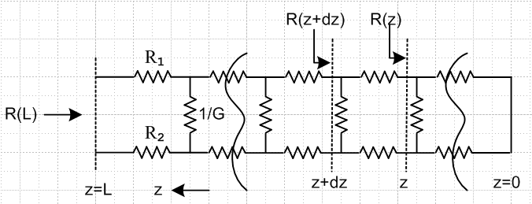 Fig K.4

Since this is for ω = 0, the inductors and capacitors shown in Fig K.1 have been removed. Each section has length dz, the horizontal resistors have resistance Ridz, and the vertical ones have conductance Gdz. The resistance looking in from the left at location z is R(z).

Reader Exercise: Compute R(L).

(a) Show that

R(z+dz) = $\frac{1}{Gdz}$ || ( R(z) + R3dz ) = $\frac{[R(z) + R3dz]}{[R(z) + R3dz]Gdz + 1}$ where R3 ≡ R1+ R2

Note that dim(Ri) = ohms/m, dim(G) = mhos/m, and dim[R(z)] = ohms.

(b) for very small dz show that

R(z+dz) ≈ R(z) + ( R3 - G [R(z)]2 )dz

and therefore R(z) solves the following non-linear differential equation:

$\frac{dR(z)}{dz}$ + G[R(z)]2 = R3 . (K.22)

(c) Show that the general solution to this equation is

R(z) = $\sqrt{R3/G}$ tanh ($\sqrt{R3G}$ z + C ) C = constant

and, since R(z) = 0, the solution is

R(z) = $\sqrt{R3/G}$ tanh ( $\sqrt{R3G}$ z ) (K.23)
so
R(L) = $\sqrt{R3/G}$ tanh ($\sqrt{R3G}$ L ) . (K.24)

(d) Show that

R(L) ≈ $\sqrt{R3/G}$ if L >> 1/$\sqrt{R3G}$

and that this agrees with (K.6) for an infinite line with ω= 0. Thus, for large L the fact that the line is shorted at the right end makes no difference. Interpret the distance 1/$\sqrt{R3G}$ .

(e) Show that

R(L) → R3L as G→ 0 (K.25)

which is the obviously correct limit for the figure shown above when G = 0.

Here is some Maple code related to item (c):

