Reactance PhL 10.18.13

Comments 12/5/13. This is useful stuff. I got things cleared up, and then I treated the transmission line using this model (see below) and got some useful results. That might go into an appendix some time. King does this approach first in his book. This is really Chapter 4 related stuff and I have not gotten to Chapter 4 really even at this late date!

I am messing this up, so let's clear it up. We have to have a circuit in mind!

1. Series RLC circuit:

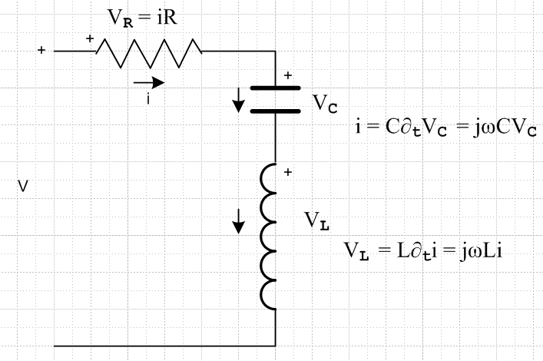

Kirchhoff says

V = VR + VC + VL = iR + i/[jωC] + [jωL] i = i [ R + 1/[jωC] +jωL ]

= iZ => Z = R + 1/[jωC] +jωL = R - j/[ωC] +jωL

If you write this as

Z = R +jX R = resistance X = reactance

then

X = ωL - 1/(ωC) // as on p 121 of Ref Dat EE book

// XC = 1/ωC appears p 47 of my APL book
// XL = ωL appears page 23 of same

So making these two definitions, we get

X = XL - XC = ωL - 1/(ωC) Z = R + jXL - jXC

This agrees with current wiki on reactance

Resonance occurs when X = 0 and your circuit then has Z = C.

XL = XC => ωL = 1/ωC => ω2 = 1/(LC)

You could define Y = Z-1 for this circuit, but it won't be purdy:

Y = Z-1 = $\frac{1}{R+jX}$ = $\frac{1}{R+jX}$$\frac{R-jX}{R-jX}$ = $\frac{R-jX}{R2+X2}$ = $\frac{R}{R2+X2}$ - j $\frac{X}{R2+X2}$ = G + jB

G = conductance = $\frac{R}{R2+X2}$ B = susceptance = - $\frac{X}{R2+X2}$

which agrees with wiki on admittance
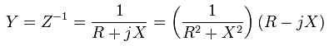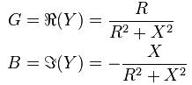

Notice that G ≠ 1/R for example.

Rule:

V = i [ R + 1/[jωC] +jωL ] = i [ZR + ZC + ZL]
R -j XC + jXL

So you can just look at the circuit and write down the impedance by inspectino

Z = ZR + ZC + ZL = R - jXC + jXL

2. Parallel RLC circuit:

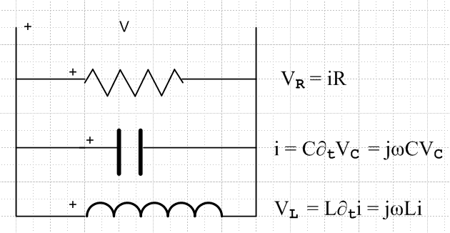

Now i = iR + iC + iL = VR/R + jωCVC + VL/[jωL] = V/R + jωCV + V/[jωL]

= V [ 1/R + jωC + 1/[jωL] ]

Then

Y ≡ i/V = 1/R + j/XC - j/XL = 1/R + j (1/XC - 1/XL) = G + j B

B = (1/XC - 1/XL) = - 1/XP // This is my Ref Data book p 120 definition of XP

XP ≡ -XCXL/(XL- XC) = -(1/ωC)(ωL) / (- 1/ωC + ωL )

= ωL / (1 - ω2LC) // as on page 120 Ref Data

So the result here is fairly ugly

Y = G + jB = 1/R + j XCXL/(XL- XC) = 1/R – j ωL / (1 - ω2LC)

Then

Z = Y-1 = $\frac{1}{G+jB}$ = $\frac{1}{G+jB}$$\frac{G-jB}{G-jB}$ = $\frac{G-jB}{G2+B2}$ = $\frac{G}{G2+B2}$ - j $\frac{B}{G2+B2}$ = R + jX

Rule:

Y = 1/R + jωC + 1/[jωL] = YR + YC + YL

= 1/R + j/XC -j/XL

3. Transmission Line Circuit

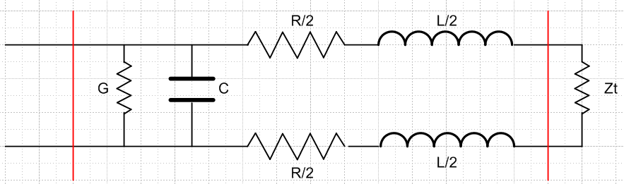

We show a section of length dz between the red lines. Rt is some termination impedance. As you look in from the left, you want to see Rt. This picture is like that of King page 5. We can simplify to get

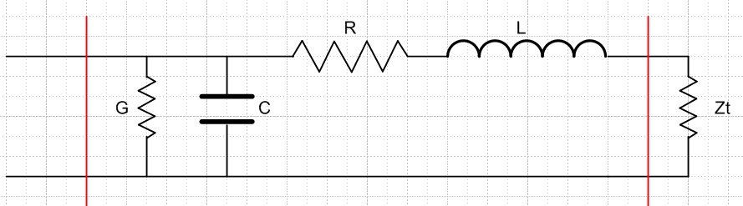

On the right we have a series RL circuit where we can neglect R compared to Zt. Keeping R, we would say those three elements have

Z1 = R + Zt + jXL

Now this is in parallel with G and C so overall looking in the left we have

Y = YG + YC + Y1 = 1/Rd + j/XC + [(R + Zt) + jXL]-1

(a) Ignore Rd term and the R term

Now suppose we ignore1/Rd and ignore R so we have

Y ≈ j/XC + [Zt + jXL]-1

We want then to have

Zleft = Y-1 = Zt

So then we have to solve

j/XC + [Zt + jXL]-1 = 1/Zt
or
(j/XC)[Zt + jXL] + 1 = (1/Zt) [Zt + jXL]
or
(j/XC)[Zt + jXL] + 1 = 1 + (1/Zt) [ jXL]
or
(j/XC)[Zt + jXL] = (1/Zt) [ jXL]
or
(1/XC)[Zt + jXL] = (1/Zt) [ XL]

We can then solve this for Zt, but it is a quadratic in Zt

(1/XC)[Zt2 + jXLZt] = [ XL]
or
Zt2 + jXLZt = [ XCXL]
or
Zt2 + (jXL)Zt + (-XCXL) = 0

So then

Zt = [ -jXL ± $\sqrt{-XL2 +4XCXL}$] /2

Now throw in the values to get

Zt = [ -jωL ± $\sqrt{ω2L2 +4ωL/ωC}$] /2
or
Zt = [ -jωL ± $\sqrt{ω2L2+4L/C}$] /2

Now the trick is to realize that L and C are each tiny since only for dz. In the limit

Zt = ± $\sqrt{4L/C}$/2 = + $\sqrt{L/C}$

This is the traditional result, as on Matick page 8.

(b) Keep Rd term and the R term

Now let's try again, not dropping anything. We have

Y = YG + YC + Y1 = 1/Rd + j/XC + [(R + Zt) + jXL]-1

I suppose right off the bat you can replace the bracket with just Zt since R and L are small. Then

Y = YG + YC + Y1 = 1/Rd + j/XC + 1/Zt

Now for a dz section we can ignore Rd I suppose, and XC as well, and then

Y = 1/Zt.

But now we don't get any expression for Zt, just an identity. You cannot throw things out too early.
So OK, here we go

1/Zt = 1/Rd + j/XC + [(R + Zt) + jXL]-1
or
(1/Zt) [(R + Zt) + jXL] = (1/Rd + j/XC) [(R + Zt) + jXL] + 1
or
1 + (1/Zt) [(R + jXL] = (1/Rd + j/XC) [(R + Zt) + jXL] + 1
or
(1/Zt) [(R + jXL] = (1/Rd + j/XC) [(R + Zt) + jXL]
or
(1/Zt) [(R + jXL] = (1/Rd + j/XC) [R + jXL + Zt]
or
[R + jXL] = (1/Rd + j/XC) [(R + jXL)Zt + Zt2]
or
[R + jXL]/ (1/Rd + j/XC) = [(R + jXL)Zt + Zt2]
or
Zt2 + b Zt + c = 0

c = - [R + jXL]/ (1/Rd + j/XC) b = (R + jXL)
or
c = - [R + jωL]/ (G + jωC) b = (R + jωL)

Then

b2 - 4ac = (R + jωL)2 +4(R + jωL)/ (G + jωC)

In the last term, everything is ∝ dz, so the last term is order unity. The first term is ∝ dz2 so we drop it

b2 - 4ac = 4(R + jωL)/ (G + jωC)

Then

2Zt = - (R + jXL) + $\sqrt{4(R + jωL)/ (G + jωC)}$

Again we drop the first terms since ∝ dz and then we get this famous result

Zt = $\frac{R + jωL}{G + jωC}$

and this appears in my Radio Eng handbook on page 552. And of course it reduces to our previous result when R = G = 0.

