This is the Title PhL 3.26.05

Here I write the last two sections of Appendix L as analogs of the first two sections. All installed.

L.3 The potential of a line charge inside a thick dielectric cylindrical shell

In this section, we repeat everything done in Section L.1 in the 2D world instead of the 3D world. The 3D Poisson propagator (1/4πε0)(1/r) becomes (1/2πε0)ln (1/r) as discussed in Appendix K. We reuse the same drawings, the first of which is

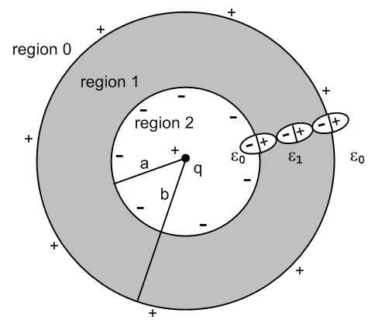 Fig L.1'

This is now a cross section of an infinite uniform cylindrical geometry. Quantity q is now a linear charge density with dimensions Coulombs/m. Rather that copy, paste and edit Section L.1, here we just show the altered equations and skip most of the words. The equation numbers are those of Section L.1 with a prime added. One difference encountered is that we must take b→R (a large value) rather than b→∞. As noted in Appendix K, a constant in a potential can be ignored even if it is infinite, and such constants do not appear in the field E = -∇φ.

Ansatz potential forms: (to-be-determined constants are α, C, D)

φ0(r) = (1/2πε0) q ln(1/r) Er0(r) = (1/2πε0) q/r region 0
φ1(r) = (1/2πα ) q ln(1/r) + C Er1(r) = (1/2πα ) q/r region 1
φ2(r) = (1/2πε0) q ln(1/r) + D Er2(r) = (1/2πε0) q/r region 2 (L.1.1)'

Continuity of φ at r=a and b:

(1/2πε0) q ln(1/b) = (1/2πα ) q ln(1/b) + C region 0/1 boundary, r = b
(1/2πε0) q ln(1/a) + D = (1/2πα ) q ln(1/a) + C region 2/1 boundary, r = a (L.1.3)'

Rule for E field normal components at a boundary:

ε0Er0(b) = ε1Er1(b) region 0/1 boundary, r = b
ε0Er2(a) = ε1Er1(a) region 2/1 boundary, r = a
or
ε0 q/ [2πε0b] = ε1 (1/2πα ) q/b => 1 = ε1/α
ε0 q/ [2πε0a] = ε1 (1/2πα ) q/a => 1 = ε1/α . (L.1.4)'

Restated continuity of φ with α = ε1:

(1/2πε0) q ln(1/b) = (1/2πε1 ) q ln(1/b) + C region 0/1 boundary, r = b
(1/2πε0) q ln(1/a) + D = (1/2πε1 ) q ln(1/a) + C region 2/1 boundary, r = a (L.1.5)'

Second equation minus first above:

D + (1/2πε0) q(ln(1/a)- ln(1/b)) = (1/2πε1)q (ln(1/a)- ln(1/b))
=> D + (1/2πε0) q ln(b/a) = (1/2πε1) q ln(b/a)

Solution for the three constants:

α = ε
C = q ln(1/b)(1/2π) (1/ε0-1/ε1)
D = q ln(a/b)(1/2π) (1/ε0-1/ε1) (L.1.6)'

The potentials in the three regions are then

φ0(r) = (1/2πε0) q ln(1/r)
φ1(r) = (1/2πε1) q ln(1/r) + (q/2π) ln(1/b) (1/ε0-1/ε1)
φ2(r) = (1/2πε0) q ln(1/r) + (q/2π) ln(a/b) (1/ε0-1/ε1) (L.1.7)'

while the fields are

Er0 = (1/2πε0) q/r
Er1 = (1/2πε1) q/r
Er2 = (1/2πε0) q/r . (L.1.8)'

The following Maple plots show the continuity of φ and the jumps in Er at the boundaries

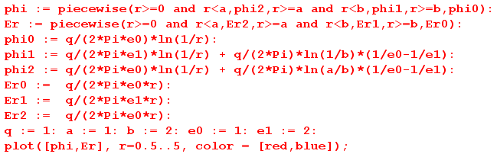

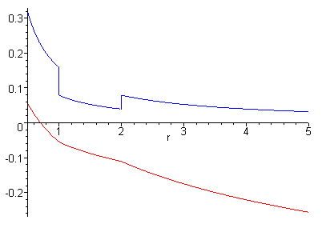 Fig L.2'

What about the (now linear) bound charge densities at r = a and r = b?

P = (ε-ε0)Er

Pr1(r) = (ε1-ε0)Er1(r) θ(r>a)θ(r<b) // points radially outward since ε1 > ε0 (L.1.9)'

From (1.1.11) the polarization charge density is then

ρpol = - div P (1.1.11)

so in cylindrical coordinates,

ρpol(r) = - [r-1∂r(rPr) + r-1∂θPθ + ∂zPz]

= - r-1∂r(rPr)

= - r-1∂r(r[(ε1-ε0)Er1(r) θ(r>a)θ(r<b)])

= - r-1∂r(r[(ε1-ε0) (1/2πε1) q/r θ(r>a)θ(r<b)])

= - q(ε1-ε0) (1/2πε1)r-1∂r[θ(r-a)θ(b-r)]

= - q(ε1-ε0) (1/2πε1)r-1 [ δ(r-a) θ(b-r) - θ(r-a)δ(r-b) ]

= - q(ε1-ε0) (1/2πε1) [ δ(r-a)/a - δ(r-b)/b ] . (L.1.10)'

We may then read off the bound linear charge densities at r = a and b

σinner = - (ε1-ε0) (1/2πε1)(q/a) // Coulombs/m
σouter = (ε1-ε0) (1/2πε1)(q/b) (L.1.11)'

Qinner = ds σinner = - (ε1-ε0) (1/2πε1)(q/a) * 2πa = - (1-ε0/ε1) q
Qouter = ds σouter = (ε1-ε0) (1/2πε1)(q/bb) * 2πb = (1-ε0/ε1) q (L.1.12)'

Q = (1-ε0/ε1) q // exactly the same equation as in the 3D case (L.1.13)'

Here Q is the total charge/m on the outer surface of the cylindrical shell at r = b, and -Q is the same thing at r = a. Recall that q is the charge/m of the central linear line charge.

L.4 Limits of the Previous Problem

(a) Line charge in an infinite cylindrical hole in a dielectric

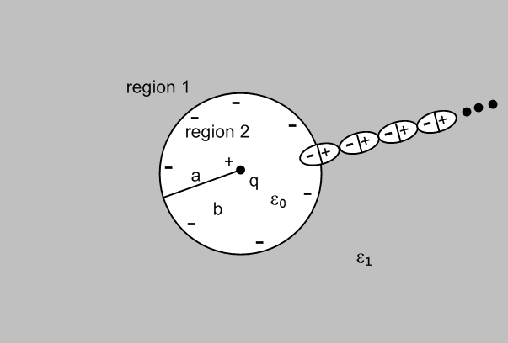 Fig L.3'

The potentials and fields shown in (L.1.7)' and (L.1.8)' are then, taking b→R (some large value)

φ1(r) = (1/2πε1) q ln(1/r) + (q/2π) ln(1/R) (1/ε0-1/ε1)
φ2(r) = (1/4πε0) q/r - (q/4πa)(1/ε0-1/ε1) (L.2.1)'

while the fields are

Er1 = (1/2πε1) q/r
Er2 = (1/2πε0) q/r . (L.2.2)'

The induced bound charge density σ at r = a is still given by

σ = - (ε1-ε0) (1/2πε1)(q/a)
-Q = (1-ε0/ε1) q (L.2.3)'

where -Q is the total bound charge on the r=a surface.

(b) Line charge embedded in an infinite dielectric cylinder

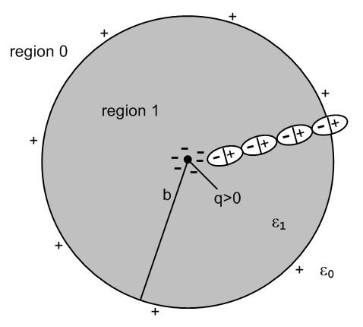 Fig L.5'

The potentials and fields shown in (L.1.7)' and (L.1.8)' are then, taking a→0

φ0(r) = (1/2πε0) q ln(1/r)
φ1(r) = (1/2πε1) q ln(1/r) + (q/2π) ln(1/b) (1/ε0-1/ε1) (L.2.4)'

while the fields are

Er0 = (1/2πε0) q/r
Er1 = (1/2πε1) q/r = (1/2πε0) [q(ε0/ε1)] / r (L.2.5)'

where the last expression shows the "shielded charge interpretation".

(c) Line charge embedded in an infinite dielectric

We now take b→R (a large value) in the previous limit to get:

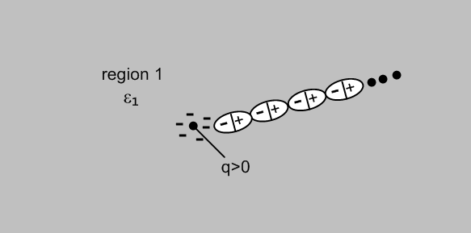 Fig L.6'

There is only one region left and from (L.2.4)' and (L.2.5') we get

φ1(r) = (1/2πε1) q ln(1/r) + (q/2π) ln(1/R) (1/ε0-1/ε1) (L.2.6)'

while the field is

Er1 = (1/2πε1) q/r = (1/2πε0) [q(ε0/ε1)] / r (L.2.7)'

where the last expression shows the "shielded charge interpretation".

