This is the Title PhL 3.26.05

This has all four sections, and it is all installed.

Appendix L: Some simple point charge electrostatic problems 1
L.1 The potential of a point charge inside a thick dielectric spherical shell. 1
L.2 Limits of the Previous Problem 6
(a) Point charge in a cavity in a dielectric 6
(b) Point charge embedded in a dielectric sphere 7
(c) Point charge embedded in an infinite dielectric 8
L.3 The potential of a line charge inside a thick dielectric cylindrical shell 9
L.4 Limits of the Previous Problem 13
(a) Line charge in an infinite cylindrical hole in a dielectric 13
(b) Line charge embedded in an infinite dielectric cylinder 14
(c) Line charge embedded in an infinite dielectric 14

Appendix L: Some simple point charge electrostatic problems

In Chapter 1 we stated in (1.1.19) through (1.1.24) various equations concerning the magnetization of a magnetic medium, then in Appendix B these equations were "exercised" in a discussion concerning how the transmission line theory is altered when the dielectric and conductors have different μ values.

Also in Chapter 1 we stated in (1.1.9) through (1.1.15) various equations concerning the polarization of a dielectric medium. Although the transmission line theory assumes a dielectric between the conductors, and in fact allows for a complex dielectric constant ξ, there has been no "exercise" of the polarization equations, so in this Appendix we provide a simple example.

The example presented here is rarely presented in E&M texts perhaps because it is too simple. The problem appears in the 2nd edition of Corson and Lorrain (p 111-113) but the it got replaced by a short comment in the 3rd edition (Corson and two Lorrains) p 186.

The example is useful to the author in that it provides a physical picture of how the potential and field of a point or line charge are affected by the presence of a dielectric medium. In Sections L.1 and L.2 the problem is solved and limits are taken of the solution. Two of these limits involve a full embedding of the charge in the dielectric. Sections L.3 and L.4 briefly repeat the solution in two dimensions, so the results then apply to an extruded cross section.

L.1 The potential of a point charge inside a thick dielectric spherical shell.

A positive point charge q lies at the center of a spherical shell of radii b>a as follows,

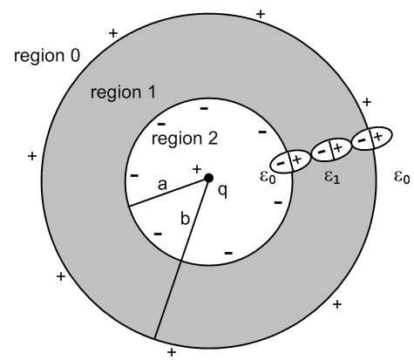 Fig L.1

Inside and outside the shell of dielectric constant ε1 is empty space with ε0.
Whatever the potential φ is for the above picture, it is obviously symmetric and is then φ(r). This in turn means that the E field is just E = Er where Er = -∂rφ (in each region), so the E field is radial. This radial E field polarizes the dielectric in the shell as suggested by the three symbolic polarized molecules shown in the figure. If the total bound charge on the r = a surface is -Q, then the total charge on the r = b surface must be +Q, as one would conclude imagining the entire dielectric having the form of the three molecules shown.
One implication of this fact is that for a sphere of r > b, the total charge enclosed is just q. Applying Gauss's law to a spherical Gaussian box of radius r > b

∫V ρ dV = ∫S ε E • dS = ε0[∫dΩ] r2 E • dr = ε04π r2Er (1.1.33)
or
q = ε0[∫dΩ] r2 E • dr = ε04π r2Er => Er0 =( 1/4πε0) q/r2

The corresponding potential is

φ0(r) = (1/4πε0) q/r r > b region 0

since then Er0 = -∂rφ0(r) = (1/4πε0)q/r2. This is a special case of the fact that any spherical distribution of charge appears outside that distribution as a point charge at the center, so φ0(r) is just the potential of a point charge q at the origin. We then at least know φ in one of the three regions.
In regions 1 and 2 as an ansatz we assume these forms with constants α,C and D to be determined,

φ1(r) = (1/4πα ) q/r + C
φ2(r) = (1/4πε0) q/r + D .

In a spherically symmetric geometry the Laplace equation only allows harmonics that are powers rn and each term above is one such power times a constant. A motivation for the φ2 form is that for r very close to r = 0, the potential must be that of the point charge since everything else is then very far away.

We now determine constants B,C and D from boundary conditions. The three potentials and fields are

φ0(r) = (1/4πε0) q/r Er0(r) = (1/4πε0) q/r2 region 0
φ1(r) = (1/4πα ) q/r + C Er1(r) = (1/4πα ) q/r2 region 1
φ2(r) = (1/4πε0) q/r + D Er2(r) = (1/4πε0) q/r2 region 2 (L.1.1)

The electrostatic potential must be continuous at all values of r. Why? Consider:

Er = -∂rφ $^{\int_{a}^{b}{}}$Erdr = - $^{\int_{a}^{b}{}}$∂rφ dr = - [ φ(b) - φ(a) ] .

The physical electric field at any point must have a well-defined finite single value. Then for small ε

$^{\int_{a}^{a+ε}{}}$Erdr = Er(a) ε = - [ φ(a+ε) - φ(a) ] => φ continuous at a (L.1.2)
As ε → 0, we must have φ(a+ε) → φ(a) so φ(r) must be continuous at r = a.
Apply this rule at our two boundaries to find that,

(1/4πε0) q/b = (1/4πα ) q/b + C region 0/1 boundary, r = b
(1/4πε0) q/a + D = (1/4πα ) q/a + C region 2/1 boundary, r = a (L.1.3)
which is two conditions on the unknown constants α,C,D.
Meanwhile, the normal electric field boundary condition from Chapter 1 is

[ε1En1 - ε2En2] = nfree . (1.1.47)

Although there exists bound charge at each of our two boundaries, there is no free charge, so

ε0Er0(b) = ε1Er1(b) region 0/1 boundary, r = b
ε0Er2(a) = ε1Er1(a) region 2/1 boundary, r = a
or
ε0 q/ [4πε0b2] = ε1 (1/4πα ) q/b2 => 1 = ε1/α
ε0 q/ [4πε0a2] = ε1 (1/4πα ) q/a2 => 1 = ε1/α . (L.1.4)

These equations are the same and tell us that α = ε0. The continuity boundary conditions then say,

(1/4πε0) q/b = (1/4πε1) q/b + C region 0/1 boundary, r = b
(1/4πε0) q/a + D = (1/4πε1) q/a + C region 2/1 boundary, r = a (L.1.5)

Subtract the first from the second to cancel the C,

D + (1/4πε0) q(1/a-1/b) = (1/4πε1)q (1/a-1/b)
so
D = (1/a-1/b)(q/4π)(1/ε1-1/ε0) = - (b/a-1)(q/4πb)(1/ε0-1/ε1)

From the first of ** we find

C = (q/4πb) (1/ε0-1/ε1) .

Thus the boundary conditions have determined our three constants

α = ε0
C = (q/4πb) (1/ε0-1/ε1)
D = (q/4πb)(1/ε0-1/ε1) (1-b/a) . (L.1.6)

The potentials in the three regions are then

φ0(r) = (1/4πε0) q/r
φ1(r) = (1/4πε1) q/r + (q/4πb)(1/ε0-1/ε1)
φ2(r) = (1/4πε0) q/r + (q/4πb)(1/ε0-1/ε1) (1-b/a) (L.1.7)

while the fields are

Er0 = (1/4πε0) q/r2
Er1 = (1/4πε1) q/r2
Er2 = (1/4πε0) q/r2 (L.1.8)

The following Maple plots show the continuity of φ and the jumps in Er at the boundaries

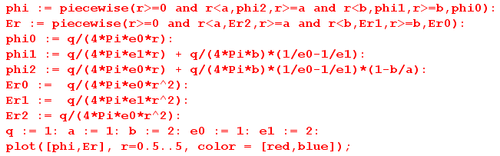

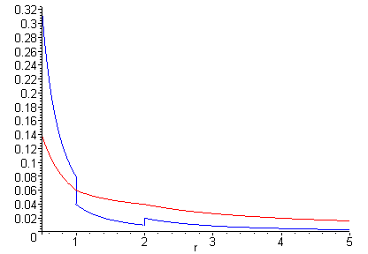 Fig L.2
φ(r) [red] and Er(r) [blue] for r in (0.5, 5)

What about the bound charge densities at r = a and r = b?

One must first compute polarization P, and for a region with ε P is given by

P = ε0χeE // polarization assumed proportional to the polarizing E field (1.1.12)

so
P = ε0χeEr χe = (ε/ε0- 1) => P = ε0(ε/ε0- 1)Er = (ε-ε0)Er

Obviously P = 0 in regions 0 and 2, while in region 1 we have

Pr1(r) = (ε1-ε0)Er1(r) θ(r>a)θ(r<b) // points radially outward since ε1 > ε0 (L.1.9)

From (1.1.11) the polarization charge density is then

ρpol = - div P (1.1.11)

so in spherical coordinates,

ρpol(r) = - [r-2∂r(r2Pr) + [rsinθ]-1∂θ[sinθPθ] + [rsinθ]-1∂φPφ]

= - r-2∂r(r2Pr1)

= - r-2∂r(r2[(ε1-ε0)Er1(r) θ(r>a)θ(r<b)])

= - r-2∂r(r2[(ε1-ε0) (1/4πε1) q/r2 θ(r>a)θ(r<b)])

= - q(ε1-ε0) (1/4πε1) r-2∂r[ θ(r-a)θ(b-r)]

= - q(ε1-ε0) (1/4πε1) r-2 [ δ(r-a) θ(b-r) - θ(r-a)δ(r-b) ]

= - q(ε1-ε0) (1/4πε1) { δ(r-a)/a2 - δ(r-b)/b2} . (L.1.10)

We may then read off the bound surface charge densities at r = a and b

σinner = - (ε1-ε0) (1/4πε1)(q/a2)
σouter = (ε1-ε0) (1/4πε1)(q/b2) (L.1.11)

Qinner = ∫dS σinner = - (ε1-ε0) (1/4πε1)(q/a2) * 4πa2 = - (1-ε0/ε1) q
Qouter = ∫dS σouter = (ε1-ε0) (1/4πε1)(q/b2) * 4πb2 = (1-ε0/ε1) q (L.1.12)

Thus the outer boundary has total charge

Q = (1-ε0/ε1) q (L.1.13)

and the inner boundary has -Q. If the dielectric were a conductor, we would replace ε1 = ξ1 as in (1.5.1) and then a perfect conductor has ξ1 = ∞ and so Q = q, as one would expect looking at Fig **.

L.2 Limits of the Previous Problem

(a) Point charge in a cavity in a dielectric

Taking b→∞ in the previous problem removes region 0 and leaves us with this picture of a point charge at the center of a spherical hole in an infinite medium of ε1

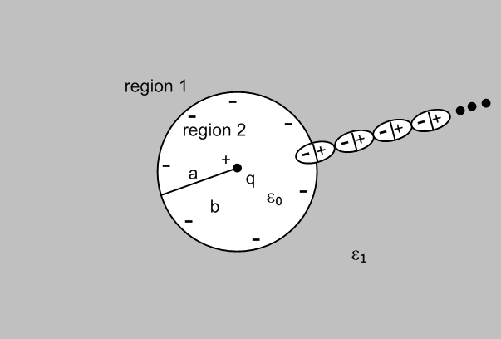 Fig L.3

The potentials and fields shown in (L.1.7) and (L.1.8) are then, taking b→∞,

φ1(r) = (1/4πε1) q/r
φ2(r) = (1/4πε0) q/r - (q/4πa)(1/ε0-1/ε1) (L.2.1)

while the fields are

Er1 = (1/4πε1) q/r2
Er2 = (1/4πε0) q/r2 (L.2.2)

The induced bound charge density σ at r = a is still given by

σ = - (ε1-ε0) (1/4πε1)(q/a2)
-Q = (1-ε0/ε1) q (L.2.3)

where -Q is the total bound charge on the r=a surface.

(b) Point charge embedded in a dielectric sphere

Here we take the limit a→0 so that region 2 goes away. Looking at (L.1.12), the total inner surface bound charge continues to be - (1-ε0/ε1) q = -Q in this limit. It just crowds around the point charge and of course the surface density σinner → ∞. Here is a suggestive drawing of a piece of region 1 in this limit:

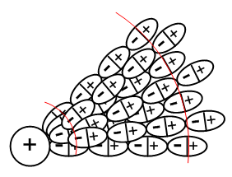 Fig L.4

The limiting picture of Fig L.1 is then the following,

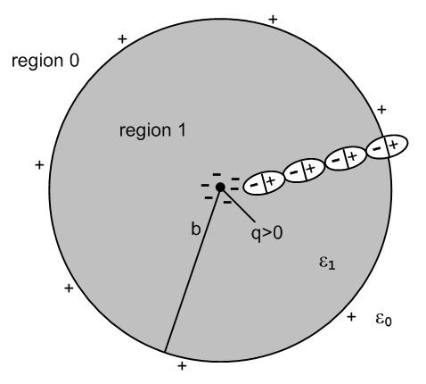 Fig L.5

The potentials and fields shown in (L.1.7) and (L.1.8) are then, taking a→0,

φ0(r) = (1/4πε0) q/r
φ1(r) = (1/4πε1) q/r + (q/4πb)(1/ε0-1/ε1) (L.2.4)

while the fields are

Er0 = (1/4πε0) q/r2
Er1 = (1/4πε1) q/r2 (L.2.5)

Inside the dielectric the E field is Er1 = (1/4πε1) q/r2 where ε1 takes into account both the point charge q and the bound charge crowding around it which is - (1-ε0/ε1) q. One could interpret this as saying that the total charge at the origin is q - (1-ε0/ε1) q = q(ε0/ε1) and then E = (1/4πε0) [q(ε0/ε1)]/r2. Remember from (1.1.5) that E sees both free and bound charge. In this last interpretation, the dielectric is shielding the point charge, reducing it from q to q(ε0/ε1).

Outside the sphere, the E field is Er1 = (1/4πε0) q/r2, just as if the sphere were not there at all. The reason of course is that the surface charge at r = b still cancels the crowded surface charge at r =0, so outside one sees in effect just the point charge q.

(c) Point charge embedded in an infinite dielectric

We now take b→∞ in the previous limit to get:

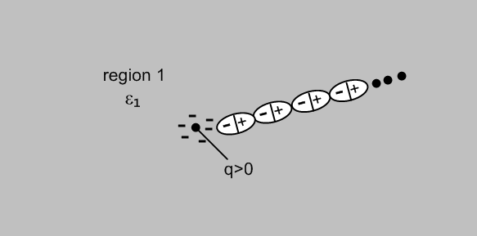 Fig L.6

There is only one region left and from (L.2.4) and (L.2.5) we get

φ1(r) = (1/4πε1) q/r (L.2.6)

while the field is

Er1 = (1/4πε1) q/r2 (L.2.7)

The presence of the dielectric ε1 is then completely accounted for by the (1/4πε1) factor. As before, one could interpret this as a shielded charge [q(ε0/ε1)] and E = (1/4πε0) [q(ε0/ε1)]/r2. The crowded-around polarization charge is still -Q = - (1-ε0/ε1) q, and the positive Q that was on the r = b surface is still there, but at r = ∞.

L.3 The potential of a line charge inside a thick dielectric cylindrical shell

In this section, we repeat everything done in Section L.1 in the 2D world instead of the 3D world. The 3D Poisson propagator (1/4πε0)(1/r) becomes (1/2πε0)ln (1/r) as discussed in Appendix K. We reuse the same drawings, the first of which is

Fig L.1'

This is now a cross section of an infinite uniform cylindrical geometry. Quantity q is now a linear charge density with dimensions Coulombs/m. Rather that copy, paste and edit Section L.1, here we just show the altered equations and skip most of the words. The equation numbers are those of Section L.1 with a prime added. One difference encountered is that we must take b→R (a large value) rather than b→∞. As noted in Appendix K, a constant in a potential can be ignored even if it is infinite, and such constants do not appear in the field E = -∇φ.

Ansatz potential forms: (to-be-determined constants are α, C, D)

φ0(r) = (1/2πε0) q ln(1/r) Er0(r) = (1/2πε0) q/r region 0
φ1(r) = (1/2πα ) q ln(1/r) + C Er1(r) = (1/2πα ) q/r region 1
φ2(r) = (1/2πε0) q ln(1/r) + D Er2(r) = (1/2πε0) q/r region 2 (L.1.1)'

Continuity of φ at r=a and b:

(1/2πε0) q ln(1/b) = (1/2πα ) q ln(1/b) + C region 0/1 boundary, r = b
(1/2πε0) q ln(1/a) + D = (1/2πα ) q ln(1/a) + C region 2/1 boundary, r = a (L.1.3)'

Rule for E field normal components at a boundary:

ε0Er0(b) = ε1Er1(b) region 0/1 boundary, r = b
ε0Er2(a) = ε1Er1(a) region 2/1 boundary, r = a
or
ε0 q/ [2πε0b] = ε1 (1/2πα ) q/b => 1 = ε1/α
ε0 q/ [2πε0a] = ε1 (1/2πα ) q/a => 1 = ε1/α . (L.1.4)'

Restated continuity of φ with α = ε1:

(1/2πε0) q ln(1/b) = (1/2πε1 ) q ln(1/b) + C region 0/1 boundary, r = b
(1/2πε0) q ln(1/a) + D = (1/2πε1 ) q ln(1/a) + C region 2/1 boundary, r = a (L.1.5)'

Second equation minus first above:

D + (1/2πε0) q(ln(1/a)- ln(1/b)) = (1/2πε1)q (ln(1/a)- ln(1/b))
=> D + (1/2πε0) q ln(b/a) = (1/2πε1) q ln(b/a)

Solution for the three constants:

α = ε
C = q ln(1/b)(1/2π) (1/ε0-1/ε1)
D = q ln(a/b)(1/2π) (1/ε0-1/ε1) (L.1.6)'

The potentials in the three regions are then

φ0(r) = (1/2πε0) q ln(1/r)
φ1(r) = (1/2πε1) q ln(1/r) + (q/2π) ln(1/b) (1/ε0-1/ε1)
φ2(r) = (1/2πε0) q ln(1/r) + (q/2π) ln(a/b) (1/ε0-1/ε1) (L.1.7)'

while the fields are

Er0 = (1/2πε0) q/r
Er1 = (1/2πε1) q/r
Er2 = (1/2πε0) q/r . (L.1.8)'

The following Maple plots show the continuity of φ and the jumps in Er at the boundaries

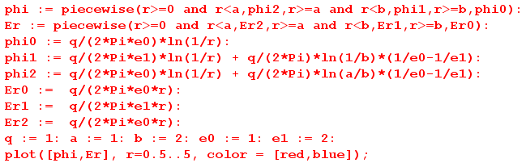

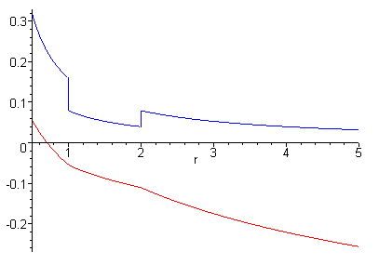 Fig L.2'
φ(r) [red] and Er(r) [blue] for r in (0.5, 5)

What about the (now linear) bound charge densities at r = a and r = b?

P = (ε-ε0)Er

Pr1(r) = (ε1-ε0)Er1(r) θ(r>a)θ(r<b) // points radially outward since ε1 > ε0 (L.1.9)'

From (1.1.11) the polarization charge density is then

ρpol = - div P (1.1.11)

so in cylindrical coordinates,

ρpol(r) = - [r-1∂r(rPr) + r-1∂θPθ + ∂zPz]

= - r-1∂r(rPr)

= - r-1∂r(r[(ε1-ε0)Er1(r) θ(r>a)θ(r<b)])

= - r-1∂r(r[(ε1-ε0) (1/2πε1) q/r θ(r>a)θ(r<b)])

= - q(ε1-ε0) (1/2πε1)r-1∂r[θ(r-a)θ(b-r)]

= - q(ε1-ε0) (1/2πε1)r-1 [ δ(r-a) θ(b-r) - θ(r-a)δ(r-b) ]

= - q(ε1-ε0) (1/2πε1) [ δ(r-a)/a - δ(r-b)/b ] . (L.1.10)'

We may then read off the bound linear charge densities at r = a and b

σinner = - (ε1-ε0) (1/2πε1)(q/a) // Coulombs/m
σouter = (ε1-ε0) (1/2πε1)(q/b) (L.1.11)'

Qinner = ds σinner = - (ε1-ε0) (1/2πε1)(q/a) * 2πa = - (1-ε0/ε1) q
Qouter = ds σouter = (ε1-ε0) (1/2πε1)(q/bb) * 2πb = (1-ε0/ε1) q (L.1.12)'

Q = (1-ε0/ε1) q // exactly the same equation as in the 3D case (L.1.13)'

Here Q is the total charge/m on the outer surface of the cylindrical shell at r = b, and -Q is the same thing at r = a. Recall that q is the charge/m of the central linear line charge.

L.4 Limits of the Previous Problem

(a) Line charge in an infinite cylindrical hole in a dielectric

Fig L.3'

The potentials and fields shown in (L.1.7)' and (L.1.8)' are then, taking b→R (some large value)

φ1(r) = (1/2πε1) q ln(1/r) + (q/2π) ln(1/R) (1/ε0-1/ε1)
φ2(r) = (1/4πε0) q/r - (q/4πa)(1/ε0-1/ε1) (L.2.1)'

while the fields are

Er1 = (1/2πε1) q/r
Er2 = (1/2πε0) q/r . (L.2.2)'

The induced bound charge density σ at r = a is still given by

σ = - (ε1-ε0) (1/2πε1)(q/a)
-Q = (1-ε0/ε1) q (L.2.3)'

where -Q is the total bound charge on the r=a surface.

(b) Line charge embedded in an infinite dielectric cylinder

Fig L.5'

The potentials and fields shown in (L.1.7)' and (L.1.8)' are then, taking a→0

φ0(r) = (1/2πε0) q ln(1/r)
φ1(r) = (1/2πε1) q ln(1/r) + (q/2π) ln(1/b) (1/ε0-1/ε1) (L.2.4)'

while the fields are

Er0 = (1/2πε0) q/r
Er1 = (1/2πε1) q/r = (1/2πε0) [q(ε0/ε1)] / r (L.2.5)'

where the last expression shows the "shielded charge interpretation".

(c) Line charge embedded in an infinite dielectric

We now take b→R (a large value) in the previous limit to get:

Fig L.6'

There is only one region left and from (L.2.4)' and (L.2.5') we get

φ1(r) = (1/2πε1) q ln(1/r) + (q/2π) ln(1/R) (1/ε0-1/ε1) (L.2.6)'

while the field is

Er1 = (1/2πε1) q/r = (1/2πε0) [q(ε0/ε1)] / r (L.2.7)'

where the last expression shows the "shielded charge interpretation".

