Point charge in two dielectrics, Part 3 PhL 10.25.13

This is the second version of my doc on this subject, Part 2 is the earlier one. I think this is an interesting and correct solution to the Jackson problem from a Smythian form point of view. But in the end I felt it was not relevant enough to include in lines doc. At an earlier stage when I was befuddled by the King gauge, I was convinced that the Az potential had to somehow propagate from inside a wire conductor to the surface and then do a secondary propagation to a dielectric point of interest. I thought the Az field was then going to "diffract" at the conductor boundary. This Jackson problem seemed then to be an analogous problem of diffraction, so that is why I got interested in it. Luckily I cleared up the King gauge stuff enough so that there is no such extra diffraction required on the part of Az. The fix was to use the region 1 King gauge in all regions, an approach different from that I first took.

1. Doing the problem again 1
2. Interpreting the solution: the surface polarization charge 6
3. Computing the surface charge integral 9
4. How are things different if region 2 has conductivity σ ? 11

1. Doing the problem again

The purpose here is to put the boundary at z = 0 and therefore make the effect of the polarization charge symmetric in z. Here is the picture of interest. A unit point charge q=1 lies in region 1 and is to be viewed from observation points in region 1 and region 2. Labeling is the same as Jackson.

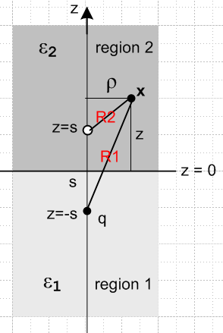

The following facts are going to utilized:

(a) Atoms. The atoms ("harmonics") of the Laplace equation in cylindrical coordinates are these

e±kz e±imφ [ Jm(kρ), Nm(kρ) ] m = integer k in (0,φ)

where we have selected a form in which the atoms are oscillatory in φ and ρ and are exponential in z. This choice is appropriate for our current problem since we expect exponential decay in z. The Nm(kρ) blow up at ρ = 0 so can be eliminated. Since our problem has azimuthal symmetry, only m = 0 contributes, so we end up with this simplified set of atoms

e±kz J0(kρ) 0 ≤ k ≤ ∞

The "quantum number" k is continuous since the interval of variable ρ is infinite, being (0,∞).

(b) Atomic representation of 1/R. The following is 1/R for an origin located at the position z = b and ρ = 0

1/R|z=b = $^{\int_{0}^{∞}{}}$dk e-k|z-b|J0(kρ) = 1/$\sqrt{ρ2+(z-b)2}$

This follows from the fact that a Laplace equation Green's function can always be expanded as a sum over the Laplace operator eigenfunctions in the sense g(x|x') = Σ φi(x)φi(x') which for cylindrical coordinates is this statement,

1/R = Σm eimφ e-imφ'$^{\int_{0}^{∞}{}}$dk exp(-k|z-z'|) Jm(kρ) Jm(kρ') R = |x - x'|

When the origin x' is placed at x' = b on the z axis, R = |x - b| = $\sqrt{ρ2+z2}$ . We are free to select φ' = 0, and obviously R then does not depend on φ, so only the m = 0 term in the above sum contributes, which results in the expansion ***.
A more direct verification of ** follows from just doing the integral. We use GR7 ***

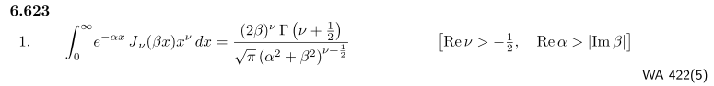
with x = k, α = |z-b|, ν = 0 and β = ρ to get

$^{\int_{0}^{∞}{}}$dk e-k|z-b|J0(kρ) = (2ρ)0Γ(1/2)/ [ $\sqrt{π}$ (|z-b|2 + ρ2)1/2 = 1/$\sqrt{ρ2+(z-b)2}$ = 1/R

Our interest will be then R1 with the origin at z = -s, and then R2 with origin at z = +s

1/R1 = $^{\int_{0}^{∞}{}}$dk e-k|z+s|J0(kρ) R1 = | x + s|

1/R2 = $^{\int_{0}^{∞}{}}$dk e-k|z-s|J0(kρ) R1 = | x - s|

(c) the boundary conditions on the E field at z = 0 are these

ε2 En2 = ε1 En1 n = normal to local boundary plane
Et2 = Et1 t = tangent to local boundary plane

The potential is continuous at the boundary, but this fact duplicates one of the above conditions so is not needed.

The first step is to represent the potential in the two regions as follows,

φ1(ρ,z) = (1/4πε1)(1/R1) +$^{\int_{0}^{∞}{}}$ dk Ak ekz J0(kρ) R1 = $\sqrt{ρ2 +(z+s)2}$ // region 1

φ2(ρ,z) = $^{\int_{0}^{∞}{}}$ dk Bk e-kz J0(kρ) // region 2

In these "Smythian fits" for the two regions, the sign in e±kz is selected to obtain decay e-k|z| as z goes to the great sphere in its region. The Ak and Bk are coefficients to be determined by the boundary conditions. The point charge in region 1 is "broken out separately" so that the difference between φ1 and this point charge's potential is a Laplace solution and can thus be represented by an atomic form. This point charge "propagates" with a factor (1/4πε1) within region 1 which has ε1. A charge in isolation inside a very large sphere of radius R of media ε1 will have its potential propagate with ε1 which automatically includes the (1/4πε0) propagation of the point charge plus the (1/4πε0) propagation of the polarization charge induced on the surface of that sphere. As R→∞, this polarization charge exists on the great sphere at infinity.

We rewrite the potentials using the 1/R1 expansion shown in **

φ1(ρ,z) = (1/4πε1) $^{\int_{0}^{∞}{}}$dk e-k|z+s|J0(kρ) + $^{\int_{0}^{∞}{}}$ dk Ak ekz J0(kρ) // region 1
φ2(ρ,z) = $^{\int_{0}^{∞}{}}$ dk Bk e-kz J0(kρ) // region 2

The next step is to compute the electric field components in the two regions in cylindrical coordinates:

E = -∇φ = ∂ρφ + ∂zφ = Eρ + Ez

so then, at an arbitrary location (ρ,z), the field components are given by

Eρ1 = ∂ρφ1 = (1/4πε1) $^{\int_{0}^{∞}{}}$dk k e-k|z+s|J0'(kρ) + $^{\int_{0}^{∞}{}}$ dk k Ak ekz J0'(kρ)
Eρ2 = ∂ρφ2 = $^{\int_{0}^{∞}{}}$ dk k Bk e-kz J0'(kρ)

Ez1 = ∂zφ1 = (1/4πε1) $^{\int_{0}^{∞}{}}$dk [∂ze-k|z+s|] J0(kρ) + $^{\int_{0}^{∞}{}}$ dk Ak k ekz J0(kρ)
Ez2 = ∂zφ2 = $^{\int_{0}^{∞}{}}$ dk Bk (-k) e-kz J0(kρ)

Now

∂ze-k|z+s| = ∂ze-k(z+s) = -k e-k(z+s) = -ke-k|z+s| // for z+s > 0 or z > -s
∂ze-k|z+s| = ∂ze+k(z+s) = +k e+k(z+s) = +ke-k|z+s| // for z+s < 0 or z < -s

Notice that the first line is appropriate for the plane z = 0 of the boundary. We then rewrite the field components at z = 0 as follows

Eρ1 = ∂ρφ1 = (1/4πε1) $^{\int_{0}^{∞}{}}$dk k e-ksJ0'(kρ) + $^{\int_{0}^{∞}{}}$ dk k Ak J0'(kρ)
Eρ2 = ∂ρφ2 = $^{\int_{0}^{∞}{}}$ dk k Bk J0'(kρ)

Ez1 = ∂zφ1 = (1/4πε1) $^{\int_{0}^{∞}{}}$dk [-k e-ks)] J0(kρ) + $^{\int_{0}^{∞}{}}$ dk Ak k J0(kρ)
Ez2 = ∂zφ2 = $^{\int_{0}^{∞}{}}$ dk Bk (-k) J0(kρ)

At z = 0 Eρ is the tangent field component and Ez is the normal component. The boundary conditions are then

ε2 Ez2 = ε1 Ez1
Eρ2 = Eρ1

which we can write out as

ε2$^{\int_{0}^{∞}{}}$ dk Bk (-k) J0(kρ) = ε1 { (1/4πε1) $^{\int_{0}^{∞}{}}$dk [-k e-ks] J0(kρ) + $^{\int_{0}^{∞}{}}$ dk Ak k J0(kρ) }

$^{\int_{0}^{∞}{}}$ dk k Bk J0'(kρ) = (1/4πε1) $^{\int_{0}^{∞}{}}$dk k e-ksJ0'(kρ) + $^{\int_{0}^{∞}{}}$ dk k Ak J0'(kρ)

In the first equation all terms have J0(kρ) and in the second they all have J0'(kρ) = - J1(kρ). Now the Hankel transform may be summarized in this way for any fixed ν :

f(ρ) = $^{\int_{0}^{∞}{}}$dk k Jν(kρ) Fν(k) // expansion
Fν(k) = $^{\int_{0}^{∞}{}}$dρ ρ Jν(kρ) f(ρ) // projection
$^{\int_{0}^{∞}{}}$dρ ρ Jν(kρ) Jν(k'ρ) = δ(k-k')/k // orthogonality
$^{\int_{0}^{∞}{}}$dk k Jν(kρ) Jν(kρ') = δ(ρ-ρ')/ρ // completeness

which says that the functions Jν(kρ) form a complete set for f(ρ) defined on interval ρ = (0,∞). For this reason, we may identify the coefficients in our two boundary condition equations above to find

ε2 Bk(-1) = ε1 { (1/4πε1)(- e-ks) + Ak }
Bk = (1/4πε1)e-ks + Ak
or
ε2 Bk = (1/4π)e-ks – ε1Ak
ε1Bk = (1/4π)e-ks + ε1Ak

Adding we find that

(ε2+ε1)Bk = (1/2π)e-ks

and then from the second equation

ε1Ak = ε1{ (1/2π)e-ks/ (ε1+ε1) } - (1/4π)e-ks

= (1/4π) e-ks { 2ε1/(ε1+ε2) - 1 } = (1/4π) e-ks (ε1- ε2)/(ε1+ε2)

Thus the coefficients which cause matching of the two boundary conditions are these

Ak = (1/4πε1) e-ks (ε1- ε2)/(ε1+ε2) = α (1/4πε1) e-ks α = (ε1- ε2)/(ε1+ε2)

Bk = (1/4πε1)e-ks 2ε1/(ε1+ε2) = β (1/4πε1) e-ks β = 2ε1/(ε1+ε2)

We can then insert these determined coefficients into the potential to find

φ1(ρ,z) = (1/4πε1) $^{\int_{0}^{∞}{}}$dk e-k|z+s|J0(kρ) + α (1/4πε1) $^{\int_{0}^{∞}{}}$ dk ek(z-s) J0(kρ) // region 1
φ2(ρ,z) = β (1/4πε1)$^{\int_{0}^{∞}{}}$ dk e-k(z+s)J0(kρ) // region 2

In region 1 which has z < 0, we know that z < s so z-s < 0 so (z-s) = - |z-s| .
In region 2 which has z > 0, we know that z > -s so z+s > 0 so (z+s) = + |z+s| .

Thus, we can rewrite the potentials this way:

φ1(ρ,z) = (1/4πε1) $^{\int_{0}^{∞}{}}$dk e-k|z+s|J0(kρ) + α (1/4πε1) $^{\int_{0}^{∞}{}}$ dk e-k|z-s| J0(kρ) // region 1
φ2(ρ,z) = β (1/4πε1)$^{\int_{0}^{∞}{}}$ dk e-k|z+s|J0(kρ) // region 2

But then using *** this becomes

φ1(ρ,z) = (1/4πε1) 1/R1 + α (1/4πε1) 1/R2 // region 1
φ2(ρ,z) = β (1/4πε1)1/R1 // region 2

and we see that 1/R1 is associated with the position of the physical charge q, whereas 1/R2 is associated with the image position mirrored through the boundary. In region 2 we would like to see the potential from a point charge propagating with ε2 instead of ε2 so we set

β (1/4πε1) = κ (1/4πε2) => κ = (ε2/ε1)β = (ε2/ε1) 2ε1/(ε1+ε2) = 2ε2/(ε1+ε2)

and then the solution potential is

φ1(ρ,z) = (1/4πε1) 1/R1 + α (1/4πε1) 1/R2 α = (ε1- ε2)/(ε1+ε2) // region 1
φ2(ρ,z) = κ (1/4πε2)1/R1 κ = 2ε2/(ε1+ε2) // region 2
or
φ2(ρ,z) = κ' (1/4πε1)1/R1 κ' = 2ε1/(ε1+ε2) // region 2

Here then is how things are seen in the respective regions (reinstating q which has been 1)

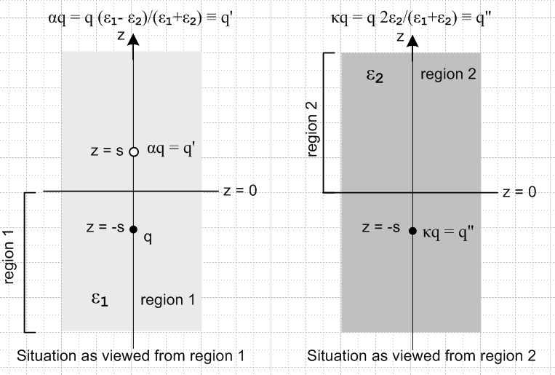

For example, on the left we have the original charge q and an image charge q' = αq both embedded in a medium ε1 so that both charges propagate with factor (1/4πε1). On the right, there is only a single charge at the physical charge location with charge q" = κq and this charge propagates into region 2 with (1/4πε2). This is just an interpretation of the solution potential.
If one knows what the solution to this problem looks like ahead of time, one can position the charges q' and q" as shown and treat these as unknown quantities which are then determined by the boundary conditions. This is the "method of images", see Jackson ***.

2. Interpreting the solution: the surface polarization charge

On the right above, we can think of the single charge at z = -s as the sum of two charges

q" = q + Q = q - q'

as we now verify,

Q = q"-q = q (κ-1) = q [ 2ε2/(ε1+ε2) - 1] = q (ε2-ε1)/(ε1+ε2) = - q'

For each region view, we can write the potential in two ways, For region 2 for example, we can write φ2 as either of the following,

φ2(ρ,z) = (1/4πε2) q"/R1
φ2(ρ,z) = (1/4πε1) q/R1 + ∫dS [(1/4πε0)σpol/R3 ] // region 2

where σpol is the polarization charge induced on the boundary z = 0 by the presence of charge q, and the integral is over the z = 0 plane with R3 being the distance between a patch of charge on this plane and the observation point. In the second line, the first term on the right accounts for both the point charge q and the tiny sphere of polarization charge surrounding it.

The corresponding equations for the region 1 observer are these

φ1(ρ,z) = (1/4πε1) q/R1 + (1/4πε1) q'/R2
φ1(ρ,z) = (1/4πε1) q/R1 + ∫dS [(1/4πε0)σpol/R3 ] // region 1

Since the expressions on the right in the lower equation in each pair are the same, we can write a uniform expression for the potential in either region 1 or region 2

φ(ρ,z) = (1/4πε1) q/R1 + ∫dS [(1/4πε0)σpol/R3 ]

for which we might draw the following picture,

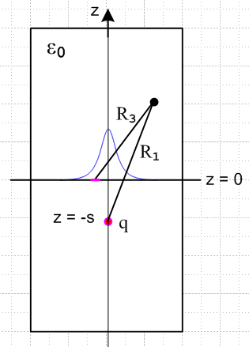

where the blue curve represents the distribution of polarization charge on the z = 0 plane.

From the region 2 equations above we conclude that

∫dS [(1/4πε0)σpol/R3 ] = (1/4πε2) q"/R1 - (1/4πε1) q/R1 z > 0 region 2

= (1/4πε1) q'/R1

where the last step we derive here in a painful sequence of algebraic steps

q"/ε2 - q/ε1 = q'/ε1 ? // next use q" = κq and q' = αq
κ/ε2 - 1/ε1 = α/ε1 ? // next multiply by ε1(ε1+ε2)
κ(ε1+ε2) ε1/ε2 -(ε1+ε2) = α (ε1+ε2) ? // install κ = 2ε2/(ε1+ε2) and α =(ε1- ε2)/(ε1+ε2)
[2ε2/(ε1+ε2)](ε1+ε2) ε1/ε2 -(ε1+ε2) = [(ε1- ε2)/(ε1+ε2)] (ε1+ε2) ?
[2ε2] ε1/ε2 -(ε1+ε2) = (ε1- ε2) ? // cancel factors
2ε1 -(ε1+ε2) = (ε1- ε2) ? // cancel factors
ε1-ε2 = (ε1- ε2) ? yes!

Meanwhile, from the region 1 equations *** we instead get the first line below, while the second line repeats ***,

∫dS [(1/4πε0)σpol/R3 ] = (1/4πε1) q'/R2 z < 0 region 1
∫dS [(1/4πε0)σpol/R3 ] = (1/4πε1) q'/R1 z > 0 region 2

This says that, when viewed from region 1, the potential arising from the boundary polarization charge is equivalent to that arising from a point charge q' embedded in an ε1 medium at the mirror point in region 2, as shown in the left part of Fig ***. The same can be said regarding the polarization charge as viewed from region 2,as we have stated in ***, though that is not the interpretation presented in the right side of Fig ***.
One might wonder how the integral shown above can "give two different results", one involving R1 and the other involving R2 which are of course different functions of z. What one is really wondering is how an integral F(z) can give different results for different signs of z, when we know f(z) = f(-z). We shall see exactly how this happens when we evaluate the integral, but for the moment, we can make some general comments on this issue. Defining functions f, h and g in an obvious manner for some fixed value of ρ, the above say

f(z) = h(z) for z < 0 only h(z) = (1/4πε1) q'/R2
f(z) = g(z) for z > 0 only g(z) = (1/4πε1) q'/R1

where f(z) is the surface integral shown. If we take the second line above and negate z we get

f(-z) = g(-z) for z < 0 only

But taking z ↔ -z takes R1↔R2 and thus g(-z) = h(z) for any z. On the other hand, since f(z,ρ) is the potential of the surface charge on the z = 0 plane, it must be even in z. Thus, the above line says

f(z) = h(z)

which then duplicates ***. We are just checking that things make sense here.

3. Computing the surface charge integral

We expect, therefore, that the integral for z > 0 should give

f(z,ρ) = ∫dS [(1/4πε0)σpol/R3 ] = (1/4πε1) q'/R1 = (1/4πε1)αq/$\sqrt{ρ2+ (z+s)2}$

We know that

σpol = - (qε0/2πε1) (ε2-ε1)/(ε2+ε1) s/ (s2+ρ2)3/2 = + (qε0/2πε1)α s/ (s2+ρ2)3/2

so the claim is that

f(z,ρ) = ∫dS (1/R3) [(1/4πε0) (qε0/2πε1)α s/ (s2+ρ2)3/2 ] = (1/4πε1)αq/R1

Canceling ε0 and α the claim is that, since dS = dρ' ρ'dφ',

(1/2π)s ∫dS (1/R3) [1 / (s2+ρ2)3/2 ] = 1/R1
or
(1/2π) s$^{\int_{0}^{∞}{}}$ρ'dρ' $^{\int_{-π}^{π}{}}$ dφ' (1/R3) [1 / (s2+ρ'2)3/2 ] = 1/R1

The distance R3 between two points in cylindrical coordinates is given by

D2 = ρ2 + ρ'2 + (z-z')2 - 2ρρ'cos(φ-φ')

In our application where x' lies on the z = 0 plane, we have z' = 0 so

R32 = ρ2 + ρ'2 + z2 - 2ρρ'cos(φ-φ')

and then our claimed integral must evaluate in this manner

I ≡ (1/2π) s$^{\int_{0}^{∞}{}}$ρ'dρ' $^{\int_{-π}^{π}{}}$ dφ' $\sqrt{ρ2 + ρ'2 + z2 - 2ρρ'cos(φ-φ')}$ $\frac{1}{(s2+ρ'2)3/2}$ = 1/R1 z>0

This is a formidable-looking double integral. One can do the dφ' integral to get an unpleasant function of ρ' which involves the complete elliptic K function (error in GR7) of a complicated argument and other factors, and one is then backed into an intractable corner. A more profitable approach is to expand 1/R3 in terms of the cylindrical harmonics as discussed above, and we then have

1/R3 = Σm eimφ e-imφ'$^{\int_{0}^{∞}{}}$dk e-k|z| Jm(kρ) Jm(kρ')

so that

I = (s/2π) Σm eimφ $^{\int_{0}^{∞}{}}$dk e-k|z| Jm(kρ) $^{\int_{0}^{∞}{}}$ρ'dρ' Jm(kρ') $\frac{1}{(s2+ρ'2)3/2}$$^{\int_{-π}^{π}{}}$ dφ' e-imφ'

But $^{\int_{-π}^{π}{}}$ dφ' e-imφ' = 2πδm,0 so only the m = 0 term survives in this integral and

I = s $^{\int_{0}^{∞}{}}$dk e-k|z| J0(kρ) $^{\int_{0}^{∞}{}}$ρ'dρ' J0(kρ') $\frac{1}{(s2+ρ'2)3/2}$

The ρ' integral is the Hankel transform of 1/ (s2+ρ2)3/2 which can be looked up in a table such as ET II page 7 (7). That integral is quoted in GR7 in the following more useful form,

so we conclude that, since k>0 and s>0,

$^{\int_{0}^{∞}{}}$ρ'dρ' J0(kρ') $\frac{1}{(s2+ρ'2)3/2}$ = (1/s) e-ks

and therefore our integral becomes

I = $^{\int_{0}^{∞}{}}$dk e-k(|z|+s) J0(kρ)

If z > 0, the exponential factor is e-k|z+s| and we then recognize the integral from ** as

I = 1/$\sqrt{ρ2+(z+s)2}$ = 1/R1

which is precisely our desired result.

If z < 0, the exponential factor is e-k|z-s| and we then recognize the integral from ** as

I = 1/$\sqrt{ρ2+(z-s)2}$ = 1/R2

which is our desired result for z < 0. So that is how an integral I(z) can give a different function for different signs of z.

4. How are things different if region 2 has conductivity σ ?

We trace through the steps in Section 1. Item (c) concerns the boundary conditions on the E field. As shown in ***, if the dielectric media in regions 1 and 2 have some conductivity σ1 and σ2, then the E field boundary conditions are these
ξ2 En2 = ξ1 En1 ξ1 = ε1 - σ1/jω ξ2 = ε2 - σ2/jω
E||,2 = E||,1

In the analysis of section 1, we assume a certain Smythian form for the potential , compute the E fields, and then apply the E field boundary conditions. That is how ε1 and ε2 "got into" the solution of the problem. The solution coefficients now become

Ak = (1/4πξ1) e-ks (ξ1- ξ2)/(ξ1+ξ2) = α (1/4πξ1) e-ks α = (ξ1- ξ2)/(ξ1+ξ2)

Bk = (1/4πξ1)e-ks 2ξ1/(ξ1+ξ2) = β (1/4πξ1) e-ks β = 2ξ1/(ξ1+ξ2)

BUT, our electrostatics problem was a DC problem, and now we have some ω in our ξ formula! Write

ξ2 En2 = ξ1 En1 ⇔ (ε2 - σ2/jω) En2 = (ε1 - σ1/jω) En1

⇔ (jω ε2 - σ2) En2 = (jωε1 - σ1) En1

Not very useful. In the DC problem when say only region 2 has conductivity, there should be some simple solution reflecting this fact. Does the current deplete the point charge? Well, to make the picture work, you have to have the point charge q constantly replenishing itself.

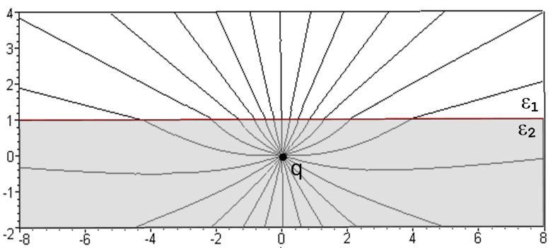

In region 1 on the top, we have current J = σE flowing along the field lines. Where does that current come from if region 2 is not a conductor? Polarization charge does not flow. I think in this case, you would get a free charge distribution σ building up on the boundary (in addition to σpol). If q is positive, then those E field lines push plusons away, so that would leave a negative charge σ on the boundary that grows with time. I think that charge would be equivalent to a negative image charge at the position of q. Eventually this image charge grows to be -q, and then things stop. We have the real q there, we have a surface charge that sits there and counters that thing. and in region 1 the field goes to 0 and the current stops!! In region 2, that surface charge creates an image charge -q in ε1, and we get then the usual dipole field. This is the standard problem then of a point charge and a conductor. Very good.
What happens in a transmission line? In that case, region 2 is also a conductor and a very good one in general, and this forces q to the surface. Then the conductor replenishes the charge q over time, and we are then able to maintain our picture.
But now think about Az and Jz. In the transmission line case, we have Jz inside the conductor like the q shown above. We can think then of Az having the same shape as the potential φ in our q problem. The difference at this point is that we don't then say E = -∇Az to get an electric field. Instead, we say that B = curl A to get a magnetic field. How do these differ:

E = -∇φ => Ez = -∂zφ
Eρ = -∂ρφ

B = curl A => Bz = 0
Bρ = (1/ρ)∂φAz // like E
Bφ = ∂ρAz // like Eρ but opposite sign

We get this from

curl A = [ (1/ρ)∂φAz - ∂zAφ] + [ ∂zAρ - ∂ρAz] + [ (1/ρ)∂ρ[rAφ] - (1/ρ)∂φAρ ]

≈ [ (1/ρ)∂φAz] + [ ∂ρAz]

But I don't really care right now about the B field, it doesn't push charge around like E does. I think the main idea is the analogy between φ and Az and forget B. And if μ1 = μ2, I think Az has a very simple radial pattern and we are done with it. I will return to this in a moment.
Now back to charge q. So let region 1 be a conductor, and put q on the boundary, fine. Then we don't have any of this refraction business at the boundary, just radial E line emission with no diminishing of the charge q. Now if region 1 conducts, we have to replenish q, and that brings in a time element. If we don't, q just drains away and we are then done. So there is some I = dq/dt which replenishes q.
But if we are doing q = q0cos(ωt), then q changes polarity and the region 1 J current runs back and forth, and maybe q does not get depleted. So what is the time constant for q depletion? We have to integrate J over all those radial rays. We know in this case that E is just that of the point charge q, and we then integrate over half a sphere. I just did this problem on scratch and found that

-∂tq = (σ2/2ε2)q = q/τ => q = q0e-t/τ

If σ = 10-10 say, then τ ~ 10-10/ 10-11 ≈ 10 seconds. So as long as your AC is a lot faster than this, you won't deplete your q ?? But what then feeds the power loss?

Question: it seems if you go to AC sine and ignore displacement current the above equation is

-jωq = (σ2/2ε2)q

What is this equation saying? It is saying q = 0. You cannot have a steady state sine solution. Take a resistor and put q at one end and -q at the other end. The current flows, both q's go away in a transient solution, game over. You have to have an external battery replenish q, even in the AC case! In our transmission line case, this is some longitudinal voltage drop in the conductor which does this replenishing. So then the above equation is really

∂tq = - (σ2/2ε2)q + iext

and there is our replenishing term. Then we have

jωq = - (σ2/2ε2)q + iext

q[jω + (σ2/2ε2)] = iext

q = iext / [jω + (σ2/2ε2)] = iext / [jω + 1/τ] = τ iext/ [jωτ + 1]

and then q is phase shifted from iext by some amount. At DC, you just get q = τ iext and your q is in phase with iext. At higher ω, there is a phase shift.
In the AC case we really have to feed both conduction current and displacement current in region 2. The displacement current is Jd = jωε2E to which we add Jc = σE and we get Jt = [σ2+jωε2] E . Only the σ phase component creates a power loss. Then our corrected equation above becomes

jωq = -([σ2+jωε2]/2ε2)q + iext = - (σ2/2ε2)q - (jω/2)q + iext

[jω + (σ2/2ε2) - (jω/2) ] q = iext

[jω/2 + (σ2/2ε2) ] q = iext

q = τ iext/ [jωτ/2+ 1]

and result is slightly different due to factor 2. We really have

Jt = [σ2+jωε2] E = [σ2+jωε2] (1/4πε2)(1/r2) q

Jt = [σ2+jωε2] (1/4πε2)(1/r2) q

so the point is that Jt follows q, has same phase as q. Energy is burned up in region 2, and that energy is supplied by iext in the region 1 wire.

