An electrostatics problem PhL 10.25.13

This stuff all ended up in Appendix L!

1. Attempts at the point charge at center of dielectric sphere problem 1
Attempt 1: 1
Attempt 2: sphere radius is a 4
2. Point charge at the center of a thick spherical dielectric shell 5
3. Point charge at the center of a thick spherical dielectric shell wedge 10

Overview:

Section 1 considers a point charge at the center of a dielectric ball of radius a sitting in free space. This is like the right picture below, but radius a instead of b.
Attempt 1 was the first time I can remember I have ever done this trivial problem, but it did not seem trivial when I started. The method is simple: continuity of φ, jump in normal E, everything is simple and radial. I was looking for verification in Purcell and other places and got it. An old version of Corson and Lorraine had the problem written up! I then drew my excellent picture showing how a point charge has a local shield of pol charge around it. Yes, there is pol charge on the outer surface of such a sphere. I have a temporary little paradox which is resolved by the fact that there is local pol charge right at the point charge. I had been omitting this local pol charge.
In Attempt 2 I repeat the same problem solution. I write down φ and Er inside and outside. I let -Q be the unknown local pol charge near q and deduce that Q = q(1-ε0/ε1) so -Q acts as a partial shield. Then there must be Q > 0 on the outer surface. I then realize that I could start with a vacuum cavity inside the sphere and then let it gradually go away as a cleaner way to understand the problem and that comes next.

Section 2 then treats a thick spherical shell of ε1 with b > a that is sitting in vacuum as shown on the LEFT below (ignore right for the moment)
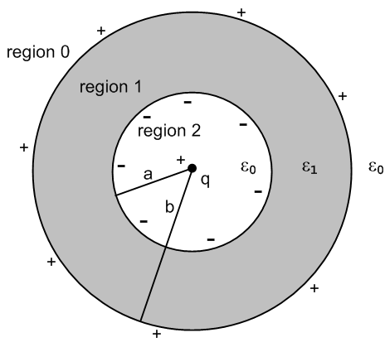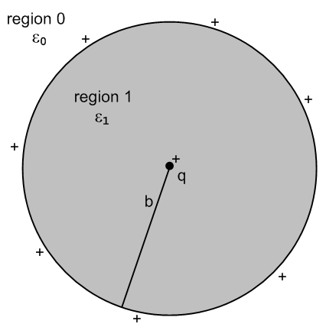
Again I solve for φ and E everywhere. It is harder now because there are now two finite boundaries to worry about. The field solution is this:

E0r = (1/4πε0) q/r2
E1r = (1/4πε1) q/r2
E2r = (1/4πε0) q/r2

Outside in region 0, the two shells of equal and opposite pol charge Q and -Q cancel, and the resulting field is as if there were no shell present at all! But inside the shell, you see ε1 sitting there.
I plot φ and Er and see that φ has kinks while Er has jumps, all as expected.
I then let a→0 to get a gradual approach to the first problem. This makes region 2 go away and we just have these results

E0r = (1/4πε0) q/r2
E1r = (1/4πε1) q/r2

Finally you could make b → ∞ to get q embedded in ε1 everywhere, and then region 0 is gone, and you get the final result E1r = (1/4πε1) q/r2. This is the "trivial result" I always assumed was true, but now I have a careful derivation of the fact! I might put this into an Appendix somewhere.
Finally, Section 3 takes a very quick look at just a wedge of a sphere and concludes that this is a much harder problem which will only have a Stakgold like infinite series solution of atom, and I then ignore this problem, though it would make a good "exercise" but not for today.

1. Attempts at the point charge at center of dielectric sphere problem

Attempt 1: Consider a sphere of ε1 and radius a which contains a point charge q at its center which we take to be our coordinate system origin,

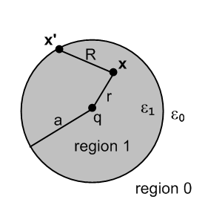

Outside the sphere is infinite free space with ε0. Compute the potential φ everywhere. Then take the limit of that potential as a→ ∞. +

Comments: we expect the solution to be spherically symmetric so φ = φ(r). The Laplace equation spherical atoms for this kind of symmetry are just these:

[rn, r-n-1] n = 0,1,2...

We model the potential in Smythian tradition this way, taking a guess concerning B by itself

φ1(r) = A q/r + B // inside
φ0(r) = C q/r // outside

We next compute the field components using

E = Er + Eθ + Eφ

Er = ∂rφ Eθ = (1/r)∂θφ Eφ = (1/rsinθ)∂φφ

But since φ = φ(r), we have only Er non-vanishing. Thus we have

Er1 = -Aq/r2 // inside
Er0 = -Cq/r2 // outside

This is a normal field, and the BC is this

ε1 Er1 = ε0 Er0

Therefore

ε1(-Aq/a2) = ε0(-Cq/a2) => ε1A = ε0C

Meanwhile, the potential must be continuous at r = a so we find

Aq/a + B = C q/a

So we then have two equations to determine three coefficients A,B,C.

We need another boundary condition! As an ansatz, I will assume that the solution for an infinite sphere is (1/4πε1) q/r, and later check consistency. Then as we go to very small r, it is as if that situation were prevailing, and we would then claim that A = (1/4πε1).

Assuming then that A = (1/4πε1), we must have

C = (ε1/ε0)A = (ε1/ε0) (1/4πε1) = (1/4πε0)

But this then says that far away on the outside, we have φ0(r) = (1/4πε0) q/r so the sphere of dielectric surrounding the charge has no effect at all when viewed from outside that sphere. So this would have been an alternate ansatz to assume.

B = Aq/a - C q/a = (q/a)(A-C) = (q/a)[ (1/4πε1- (1/4πε0)]

= (q/a)(1/4π) ( 1/ε1-1/ε0) = (q/a)(1/4π)(ε0-ε1)/ε0ε1

Then our solution is this

φ1(r) = A q/r + B // inside
φ0(r) = C q/r // outside
or
φ1(r) = (1/4πε1) q/r + (q/a)(1/4π)(ε0-ε1)/ε0ε1 // inside
φ0(r) = (1/4πε0) q/r // outside

This seems to be the problem solution. We can then take the limit as a→∞ to get

φ1(r) = (1/4πε1) q/r // inside

and of course there only exists an inside now, and we get the expected result! And this is consistent with our first ansatz above.

Question and Paradox: Is there a polarization charge density associated with Problem #1 ?

If there were a σpol on the sphere surface, it would certainly be uniform and thus a constant. Then the total polarization charge would be Qpol = 4πa2 σpol . One would think that such a shell of charge would act as a point charge of size Qpol at the center. If that were so, then we must have Qpol = 0 because the distant field we claim on the outside is (1/4πε0) q/r . It is getting no shielding at all from the polarization charge. I don't think this is right, and it is now time to "look up" a solution to this problem.

Purcell talks about it on page 332. He says that if you draw any sphere around a positive point charge in infinite ε1 medium, that sphere will contain more negative bound charge than positive, and that is where the shielding is coming from causing (1/4πε1) which is smaller than(1/4πε0). But he only talks about an infinite ε1 medium, not my specific problem.

Corson and Lorrain some earlier edition has my exact problem! In the later edition which has two Lorrain's as authors (a Jim book), this problem has been replaced by a comment on p 186.

The fact I have overlooked is that there is polarization charge immediately surrounding a point charge.
You regard this as a surface polarization layer on the surface of the dielectric which partially cancels the point charge itself. That is why in the infinite dielectric, you are reduced to 1/ε instead of 1/ε0.

But now I am confused even by the layout of primitive dipoles as in Purcell p 332 figure. If I draw a sphere excluding the outer layer of molecules, that sphere contains a total of 0 bound charge, which conflicts with Purcell's statement that it should be net negative. But this is just a lucky sphere!

Consider first this electret picture

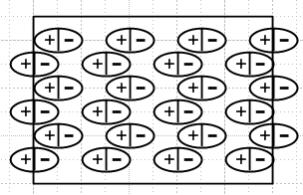

It is true that some rows contribute nothing to the surface charge, but "on the average" there is a net surface charge. Here is a piece of the Purcell sphere with the same idea

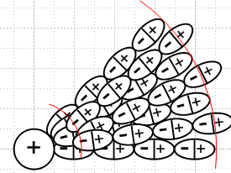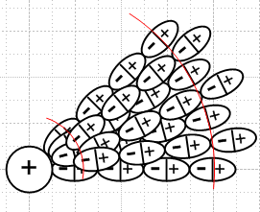

For my particular choice of the outside sphere boundary on the left, some + charge has been excluded, so the sphere must contain an overall negative amount of bound charge. Some of the rays of molecules don't contribute to this effect, but on the average you see the effect is there. And you see the negative charge layer around the central point charge represented as a sphere. If we move the outer boundary in a little bit, the fact that positive charge is excluded does not change, as shown on the right above. So Purcell is right.

Attempt 2: sphere radius is a

Problem 1, Version 2

Start as before with

φ1(r) = A q/r + B // inside
φ0(r) = C q/r // outside

Match potential at boundary to get

Aq/a + B = C q/a

Fields are

Er1 = Aq/r2 // inside
Er0 = Cq/r2 // outside

ε1 Er1 = ε0 Er0
=> ε1A = ε0C

Now we are aware of two shells of polarization charge. The outer has some total value Q, the inner has the same value by negative -Q. On the outside of the sphere, these two effective point charges cancel and the potential is just (1/4πε0) q/R, which tells us that C = (1/4πε0). Inside the sphere, however, we have (1/4πε1) q/R + B which tells us that A = (1/4πε1). Therefore from the φ match at the boundary.

B = Aq/a - C q/a = (q/a)(A-C) = (q/a)[ 1/4πε1- 1/4πε0]

= (q/a)(1/4π) ( 1/ε1-1/ε0) = (q/a)(1/4π)(ε0-ε1)/ε0ε1

My conclusion then is this:

φ1(r) = (1/4πε1)q/r + (q/a)(1/4π) ( 1/ε1-1/ε0) // inside
φ0(r) = (1/4πε0) q/r // outside

This is the same solution I found earlier. The constant is needed to match at r = a. Rewrite:

4πφ1(r) = (1/ε1)q/r + ( 1/ε1-1/ε0)q/a // inside
4πφ0(r) = (1/ε0) q/r // outside

Er1 = (1/4πε1)q/r2 // inside
Er0 = (1/4πε0)q/r2 // outside

Now about those polarization charges. Assume the inside layer has total charge -Q. Then we can write

Er1 = (1/4πε0)q/r2 + (1/4πε0)(-Q)/r2 = (1/4πε0)(q-Q)/r2 // inside

= (1/4πε1)q/r2

Therefore we conclude that

(1/4πε0)(q-Q) = (1/4πε1)q

ε1(q-Q) = ε0q

(ε1- ε0)q = ε1Q => Q = q (ε1-ε0)/ε1 = q(1-ε0/ε1) 0 < Q < q

So there is a positive surface charge layer on the outside of the sphere of total amount Q and it is spread uniformly on the sphere so that

σpol_outer = q(1-ε0/ε1)/ (4πa2)

If the inner point charge had radius b, then

σpol_inner = q(1-ε0/ε1)/ (4πb2)

So the polarization charge only has an effect in the region between the inner and outer spheres. Perhaps this would have been a better problem:

2. Point charge at the center of a thick spherical dielectric shell

A positive point charge q is placed at the center of a thick spherical shell of radii b > a which has dielectric constant ε1. Compute the potential and fields in all three regions and plot.

Solution: We know that φ = φ(r) and E = Er in all three regions. We know there are two uniform surfaces of polarization charge such that the total integrated charge is Q on the outer surface and -Q on the inner surface; Q is to be determined. Without the need to know Q, we know that

φ2 = (1/4πε0) q/r + D region 2, shell surface charges cancel, allow const D
φ0 = (1/4πε0) q/r region 0 since far away see just q

In region 1 we write, using known spherical atoms just as a trial ansatz

φ1 = Ar + B/r + C

Now we write the fields in the three regions

E2r = (1/4πε0) q/r2
E0r = (1/4πε0) q/r2
E1r = - A + B/r2

Our two boundary conditions on the radial E field are these. First the outer boundary

ε0 E0r = ε1 E1r => ε0 (1/4πε0) q/b2 = ε1 (- A + B/b2)

- A + B/b2 = (ε0/ε1) (1/4πε0) q/b2

Next the inner boundary

ε0 E2r = ε1 E1r => ε0 (1/4πε0) q/a2 = ε1 E1r(- A + B/a2)

- A + B/a2 = (ε0/ε1) (1/4πε0) q/a2

Since we have two equations in two unknowns, A and B are determined. But we have two more conditions which are continuity of φ at the two boundaries, so first the outer boundary

φ0 = φ1 => (1/4πε0) q/b = Ab + B/b + C

and then the inner boundary

φ2 = φ1 => (1/4πε0) q/a + D = Aa + B/a + C

So now we have 4 equations in 4 unknowns A,B,C,D so the problem has a solution and it satisfies Laplace and all boundary conditions so it is a viable solution. Here are the four equations:

- A + B/b2 = (ε0/ε1) (1/4πε0) q/b2 = (1/4πε1) q/b2
- A + B/a2 = (ε0/ε1) (1/4πε0) q/a2 = (1/4πε1) q/a2

(1/4πε0) q/b = Ab + B/b + C
(1/4πε0) q/a + D = Aa + B/a + C

We can solve the first pair of equations for A and B as follows.

B/b2 - B/a2 = (1/4πε1)[ q/b2 - q/a2]

B(1/b2- 1/a2) = q (1/4πε1) (1/b2- 1/a2)

B = q (1/4πε1)

Then

A = B/b2- (1/4πε1) q/b2 = (1/4πε1)q/b2 - (1/4πε1) q/b2 = 0

Thus my linear term was not necessary. The next two pairs of equations then read

(1/4πε0) q/b = B/b + C
(1/4πε0) q/a + D = B/a + C

From the first we find that

C = (1/4πε0) q/b- B/b = 1/(4πε0) q/b- q (1/4πε1)/b

= (1/4π)(q/b) ( 1/ε0-1/ε1)

Then finally we can get D:

D = B/a + C - (1/4πε0) q/a

= q (1/4πε1)/a + (1/4π)(q/b) ( 1/ε0-1/ε1) - (1/4πε0) q/a

= (1/4π)(q/a) [ 1/ε1-1/ε0] + (1/4π)(q/b) ( 1/ε0-1/ε1)

= - (1/4π)(q/a) [ 1/ε0-1/ε1] { 1 - (a/b) }

To summarize

A = 0
B = q (1/4πε1)
C = (1/4π)(q/b) ( 1/ε0-1/ε1)
D = - (1/4π)(q/a) ( 1/ε0-1/ε1) (1 - a/b)

The potentials in the three regions are then

φ0 = (1/4πε0) q/r
φ1 = (1/4πε1) q/r + (1/4π)(q/b) ( 1/ε0-1/ε1)
φ2 = (1/4πε0) q/r - (1/4π)(q/a) ( 1/ε0-1/ε1) (1 - a/b)

The fields in the three regions are

E0r = (1/4πε0) q/r2
E1r = (1/4πε1) q/r2
E2r = (1/4πε0) q/r2

Plotting values are: q := 1;a := 1; b := 2; e0 := 1; e1 := 2;

Here is a plot of the potential and field from r = 1/2 out to r = 5

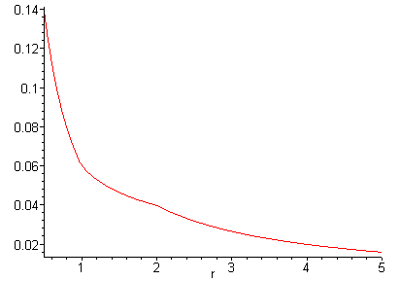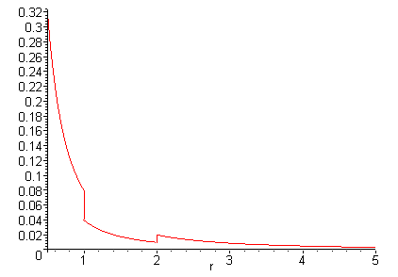

φ is seen to be continuous at a = 1 and b = 2, but does have slope discontinuities at those points.
The field is this over the same range of r. Inside the medium, the field is suppressed, then bounces back outside.

Limit as inner radius goes to zero. This then should duplicate our previous simpler problem.

Here were our solutions from above

φ0 = (1/4πε0) q/r
φ1 = (1/4πε1) q/r + (1/4π)(q/b) ( 1/ε0-1/ε1)
φ2 = (1/4πε0) q/r - (1/4π)(q/a) ( 1/ε0-1/ε1) (1 - a/b) r < a

E0r = (1/4πε0) q/r2
E1r = (1/4πε1) q/r2
E2r = (1/4πε0) q/r2 r < a

As a → 0 only φ2 is affected, but this region goes away and that is the only place a appears. So for a point charge in a sphere of ε1 and radius b we get

φ0 = (1/4πε0) q/r
φ1 = (1/4πε1) q/r + (1/4π)(q/b) ( 1/ε0-1/ε1) r < b

E0r = (1/4πε0) q/r2
E1r = (1/4πε1) q/r2 r < b

The plots are now (same range of r)

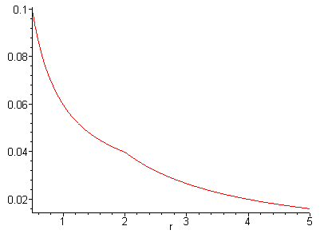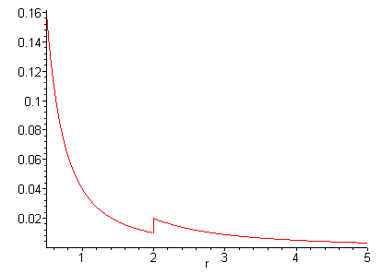
Yes, this does duplicate the previous solution, but radius is now b.

Question: We know there is a polarization charge on the outer shell sphere surface. Does this affect anything inside this surface?

Answer: I don't think so. You could add some glued free charge to cancel it, and we know that has no affect on fields inside. It would affect the field outside. In particular, if we take b→∞, this outer polarization still exists, its integral amount stays the same, but it moves off to the Great Circle and the field is just region 2 and region 1 as described above.

3. Point charge at the center of a thick spherical dielectric shell wedge

What happens in this situation:

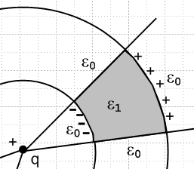

The previous solution does not work because the potential won't be continuous at the new boundaries. The polarization charges won't be uniform, there will probably be non-radial fields, it sounds messy. This result is going to be some infinite sum thing like the Stak potential theory wedge problems.

Question: If we take the outer wedge radius to infinity, can we ignore the polarization charge density on the infinitely far away part of the outer wedge surface?

Answer: I think the answer is yes, but now I make a different argument why. The total surface charge on the outer face is sort of constant, in the electret sense. If we double the outer radius b, this charge does not change in magnitude, but it moves twice as far away and has 1/4 as much effect as before on activities near the inner boundary. In some sense E = Q/r2 and as r increases, Q does not increase so this effect just goes completely away in the limit. But the charge is there, and it does add up to Q, because it is the other end of a very long electret.

Question: In my Jackson problem, can we ignore polarization charge on infinitely distance surfaces?

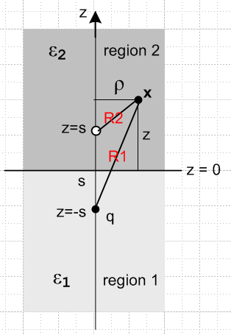

Answer: I think the answer is yes, based on the answer to the previous question. But you cannot ignore the polarization charge around the point charge q! If you try to solve the problem in terms of both free and bound charges, you have to compute this charge and include it in your analysis.
How would you compute this polarization charge? Since the problem has been solved, we know the exact fields everywhere. Since P = ε0 χeE [ Jackson 4.36] and since , if we know E then we also know P, and from that we compute the pol charge using div P = -ρbound.
But near the point charge in medium ε1 the E and P fields are basically radial and don't see the rest of the problem, and this just says that you incorporate this pol charge if you use (1/4πε1)q/r as the total effect of that point charge!

