The King Boundary Conditions PhL 10.20.13

1. Introduction 1
2. Review of Jackson Sections which Seem Relevant 2
3. Panofsky and Phillips 8

1. Introduction

King shows these boundary conditions,

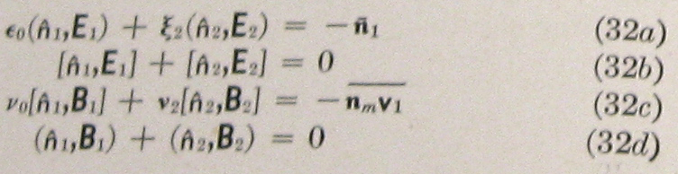

My job is to figure out how he obtains these results. In lines after (1.1.12) I have a derivation of my version of the first (32a) above, and it contains no ξ. Here is my derivation:

Wee put a tiny "Gaussian box" straddling the two media. Area A and height 2s are both very small so the fields are the same at all points in the box.

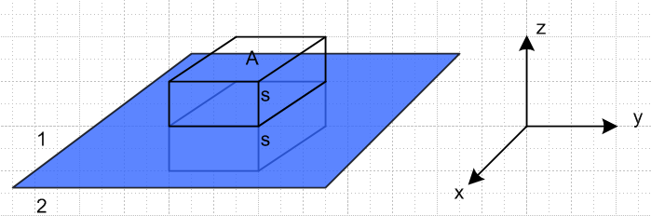

For the electric displacement D we consider

div D = ρ ⇔ ∫V ρ dV = ∫S D • dA (1.1.13)

where volume V is the box shown. The surface integral is

∫S D • dA = Dz(1)A - Dz(2)A + contributions from the sides of the box

The contributions from the pairs of box sides cancel since the fields are assumed constant over the box on either side of the boundary. Assuming the only charge density is a surface charge density n on the boundary between the two media, the volume integral is nA and then the conclusion, generalized to the perpendicular field component, is

[D⊥(1) - D⊥(2)] = n or [ε1E⊥(1) - ε2E⊥(2)] = n (1.1.22)

The only way I can get his result is if I use D = ξ E. This would be a major change in thinking and requires going back to relearn the notion of D. There is just no other way! [ Wrong! See King meets Stak. Yes the result (1.1.22) is correct as stated. But it is also true that ξ1 E⊥(1) = ξ2 E⊥(2), and THIS is the equation you see in King above as (32a). ]

2. Review of Jackson Sections which Seem Relevant

Due diligence!

Jackson 1Ed pp 103-108 talks about averaging fields in the dielectric world. His page 107 drawing shows the origin of the extra "ρ" which appears in (4.34) when you take div of the averaged field. So he ends up with this fact that div E = 4πρ - 4π div P which we can write as div (E + 4πP) = 4πρ [ cgs units all] and then you have div D = 4πρ. He does not talk about conductivity of the dielectric in this discussion, it might change the way things work. He only brings in σ on page 222 in his plane wave discussion.

Comment: Since div D = 4πρ, we conclude that D is "driven by" only free charge. In contrast, since we also have div E = 4πρ - 4π div P, we see that E is "driven by" both free charge AND polarization charge!

Jackson 3Ed on this same subject starts on p 151 where he uses the word "ponderable" without any comment. Ordering is changed in this edition, so lets read this section right now.

Chapter 4. He says the fancy averaging will be done later in Chapter 6 and here in Chapter 4 he is just going to give a summary. Fine. He has the same little picture with the same unclear comment about it. If we apply the divergence theorem to div P we get

div P = ρ ⇔ ∫V ρ dV = ∫S P • dA

This says that the total charge in a volume equals the surface integral of P, nothing flows here. So if P is non-uniform, you might get a non-zero left side, and that is what his picture is showing, where the circle is the volume V,

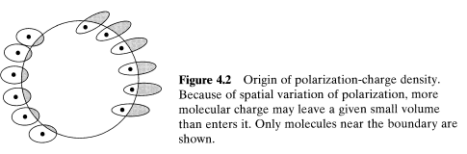

The word "enters" seems wrong to me. It just seems to be the total charge that lies inside the volume at some instant in time. Nothing is entering or leaving, we are at an instant in time. So OK. He then goes on to obtain

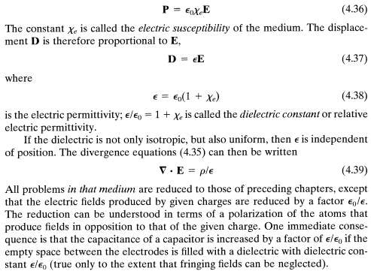

OK, this is the standard stuff. Note that a conductive medium has no free charge, but is perhaps different from his discussion above.

Chapter 6. Let's now look at the macroscopic discussion of Chapter 6. He starts off with the four Maxwell's with D and H appearing, just as I have them in lines. Then come A and φ. And then the wave equations,
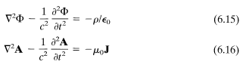

Jackson has a footnote now on Lorenz right in his book, good. Not much mea culpa. Meanwhile, the above equations must be in free space. Notice that a discussion of E,B and A,φ says nothing about "media" and D and H.
He then starts into gauge transformations. The Lorenz condition is (6.14). On page 241 he refers to my Λ transformation as a "restricted" gauge transformation because I guess (6.14) is preserved. So within the Lorenz condition world, there is a whole class of potential pairs (A,φ). [ *********]
Jackson works for a while in the Coulomb gauge div A = 0 and in that gauge he shows that

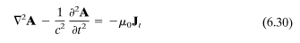

where A is driven only by "transverse" current defined in a certain manner. I skip this since I am not going to be working in this gauge, but it is a good fact to know.
Now we come to Section 6.4 where he does the wave equation Green's function stuff. On page 245 he shows the usual particular solution. He comments on adding a homo solution. Then he is off on the incident wave at t = -∞ and all that scattering stuff. His green's gives the retarded potential stuff.
Next is Section 6.5. Here he deals with wave equations for E and B and gives their retarded integral solutions. This stuff is developed and Jefimenco is given a shout-out. He then ends up comparing a Feynman and a Heaviside form for the solution in this retarded world, and claims they are the same.
Next is Section 6.6 on the macroscopic business. Jackson gives here a much more elaborate development of the averaging process which I have not read, but we end up below (6.92) where he starts to talk about current density J! I am all ears. Earlier he did averaging for ρ, here he only outlines the averaging process for J which he says is much messier. At one point he writes

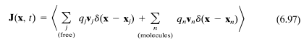

so he allows for current within a molecule. Sadly, there is still no discussion of conductivity of the medium, even in this messy section which involves magnetization. The free current sum shown above could be the sum of plus and minus ions so that the total charge is 0 but the current is not.
Section 6.7 is then off on Poynting and energy and all that stuff.
Section 6.8 does talk about "dispersive media", maybe the first time in the book. But dispersive here must means that ε = ε(ω).
Section 6.9 he claims is based on a book by Fano, Chu and Adler, and it is the ejωt stuff, but Jackson uses e-iωt as time dependence. Called a harmonic field. Here is a good comment

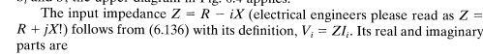

He draws some very general EE situation where there is a medium of σ with boundary S which may go out to infinity and thereby involve radiation. The medium has conductivity σ. But nothing useful for me here I think.
Section 6.10 is off on symmetries.
Section 6.11 on magnetic monopoles. Fancy section worth reading some day.
Section 6.12 continues the above, Dirac quantization of charge idea. Did not read.
Section 6.13 is on Hertz vectors, I never heard of such things.

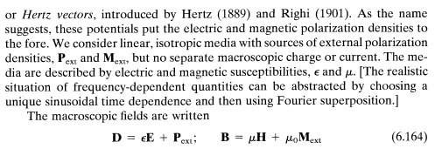

What is he saying here??? What does "external" mean? This section does not seem to have a bearing on me, but he says Born and Wolf use it.
So that is the end of Chapter 6, and nothing really on a conducting medium. But let's look at Chapter 7 where I think conductivity will appear.

Chapter 7. In Section 7.1 medium is non-conducting. We writes Maxwell's for now sources but with D and H, so it is not vacuum, it is a dielectric that does not conduct. Here is how he deals with the harmonic issue:

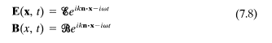

and so we have fancy fonts entering the scene! He then writes down a whole page of properties of the scripted fields.
Section 7.2 does polarization and Stokes parameters (did not appear in 1Ed)
Section 7.3 is on reflection etc at a dielectric boundary. We are in a wave context here and the whole chapter 7 in fact is on Waves.
Section 7.4 on total internal reflection and some new name I don't know.
Section 7.5. For the first time, we are going to thing of ε as being complex! The energy loss here is damping in molecules, it is not due to general conductivity. But then he looks at the DC world which I think involves free current. On page 312 we see Ohm's Law for the first time, J = σE. Then here we go: but first I will back up and quote a few earlier results.

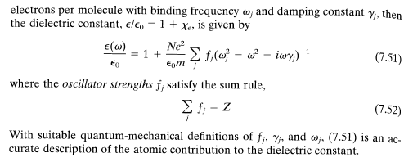

This is his "simple model" for ε(ω). Then he has

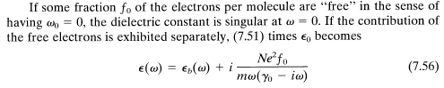
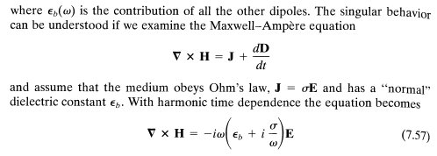

Nothing has happened except J = σE. Here is maybe a critical statement

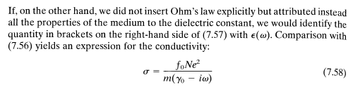

So here he is talking about replacing ε with ξ and his simple ε(ω) model in fact makes a prediction for σ and in fact σ is complex! Ouch, but that is what the simple model says. Fine. He claims this is the Drude model of 1900. He goes on

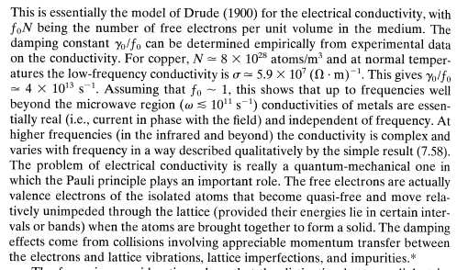

So he is saying that for reasonable frequencies ω, γ0 is huge (up to ω = 1011 = 100 GHz which is "well beyond the microwave region), so σ shown above is then real.

Pause: Jackson has thus stated the notion of thinking of ε → ξ as a way of incorporating conductivity into your model. I am very glad to see Jackson broach this notion. It is what King says as well,

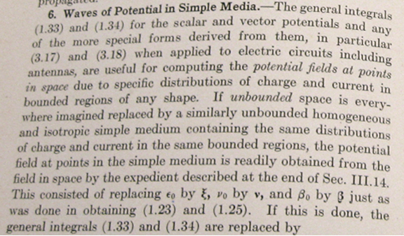

However, Jackson is only saying ε→ξ in the context of the curl H equation, and this is really nothing new to me. We are just combining the conduction and displacement current. No one is saying D = ξ E .

I think I am finally onto something here.
Jackson goes on to talk about the plasma high frequency limit.
He then does a detailed study of ε(ω) for water!
Section 7.6 is on ionosphere propagation and "whistlers". No mention of faster than c.
Section 7.7 is magnetohydrodynamics. He allows here how you can have current with no ρ in a conducting medium with Ohm's law. A new feature here is this: [ ****** v x B in lines!!! ]

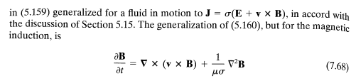

Here the idea is that you don't have a simple Ohm's law because charges curve due to B fields. Why were we allowed to ignore this in our transmission line discussion? Probably the second term is small, but where does someone argue that? I could compute it. Here we are talking about a fluid and v is the fluid velocity of the charged particles. Alfvén waves appear.
So somewhere I have to comment on why the v x B term for charges in my dielectric don't matter. They would be electrons. Probably v is small due to collisions. [ v and B are parallel? ]
Section 7.8 is group velocity.
Section 7.9 is a spreading pulse.
Section 7.10 is Kramers-Kronig
Section 7.11 is about the arrival of a signal. The Somerfeld Precursor is mentioned. The Brillouin Precursor (second) is also mentioned. Again no mention of faster than c as in our class.
And so ends Chapter 7!

Chapter 8. On waveguides.
Section 8.1. Boundary conditions at a conductor surface.

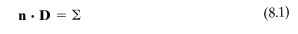

Here Σ is surface charge and this is just the Gauss box idea so that Dn = Σ in our SI units. Then

He is not allowing the dielectric to have a conductivity.
I have perused the rest of Chapter 8, nothing there for my current problem.

3. Panofsky and Phillips

I just happened to see this while reviewing Jim's books. It is on line at scribd but not for free.
Tried http://www.mediafire.com/download/5nkxpmjdwpd/panofsky.rar but these rar never pan out. But this time it worked, rar handled by filzip, and I have it! I have the 1955 original edition hard cover, but the download is the 1962 second edition. I will now work with the newer edition.

It is page 240 (210 of the 1955) and they are writing wave equations for the potentials. They quote the Lorentz condition in (14-2) as being the King gauge condition which includes conductivity! They come up with this pair of wave equations for the potentials

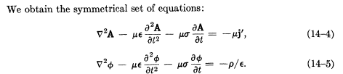

This deals with one of my issues. I never could get a current on the right of the first equation, but they have somehow done it. I can now backtrack to see how they did it. This is the first time ever I have seen the above wave equation for A with j on the right. Even King never stated it.

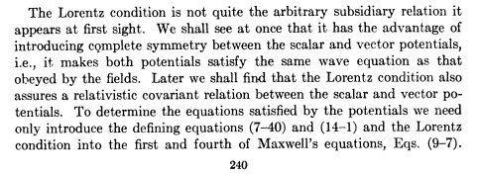
[ but I thought adding σ broke the relativity thing? ********]

I will now look up the supporting equations

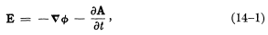

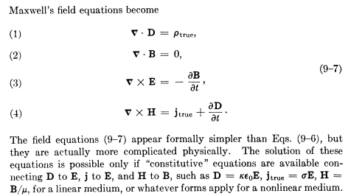

But none of these equations helps I don't think. What do they mean by j' with the prime? Here is their answer:

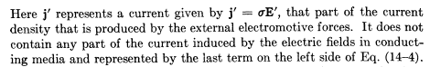

This is the "applied" business again! Ouch! At least I now have someone talking about this concept. It was imbued in my original lines doc, but I never had a reference for it. Maybe I will go look at my lines old notes again right now.

