A problem in electrostatics PhL 10.22.13

See red comment in later versions.

1. Preliminaries 1
2. Try the Smythian method in spherical coordinates: Attempt #1 2
3. Try the Smythian method in spherical coordinates: Attempt #2 5
4. Jackson's Solution 7
5. What did I do wrong in Attempt #1 and #2 9
6. Attempt #1 in cylindrical coordinates 10
7. Attempt #2 in cylindrical coordinates 14
8. Maple plots of the field lines 20
9. The polarization charge density on the boundary, a Question, and a painful integral 21
10. A propagator interpretation of the above results 25
11. Conjecture 26

1. Preliminaries

Here is the picture, and I admit that I don't even know what to expect here; I draw two tentative electric field lines. I put the test point charge in region 2.

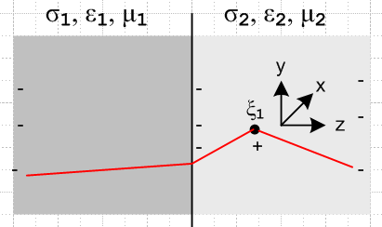

I think each region has its own Poisson equation

∇2φ1 = -δ(x-ξ1) φ1(-∞) = 0
∇2φ2 = 0 φ2(+∞) = 0
φ1(z=0) = φ2(z=0)

So I want the potential to be continuous at the boundary ( I think). I also know at the boundary that

ε2 En2 = ε1 En1
E||,2 = E||,1

Recalling that

n = ε2Ez2 - ε1Ez1

we conclude that there is no surface charge n at the boundary in this problem!
I think from distant memory that the solution of this problem is the in region 1 the potential is just that of ξ1 while in region 2 it is that of the point charge moved to some image position as my lines suggest. BUT, Bleaney page 21 has a picture which claims the E lines are curved in region 1 and come in normal to the boundary. So I guess I need to try to solve this problem exactly and see what goes on.
Notice that in region 1 we don't really have a Green's function problem because we don't a priori know that φ = 0 on the boundary, and probably φ ≠ 0 there.

2. Try the Smythian method in spherical coordinates: Attempt #1

I might try the Smythian method here. The 3D harmonics or atoms are these,

[Arn + Br-n-1] Ynm(θ,φ)

Let's put the coordinate system origin on the boundary at the level of ξ1. In fact, let's just restate the problem from scratch like so:

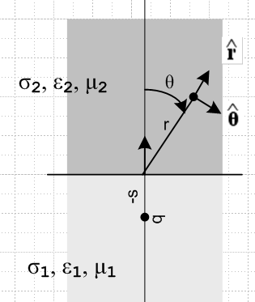

Since the solution will have azimuthal symmetry, our atoms simplify to

φ1(r,θ) = Σn=0∞[Anrn + Bnr-n-1] Pn(cosθ)
φ2(r,θ) = Σn=0∞[Cnrn + Dnr-n-1] Pn(cosθ)

At a point on the boundary we have θ = π/2 so

φ1(r,π/2) = Σn=0∞[Anrn + Bnr-n-1] Pn(0)
φ2(r,π/2) = Σn=0∞[Cnrn + Dnr-n-1] Pn(0)

which we let rest for a moment. Now

E1(r,θ) = -∇φ1 = ∂rφ1(r,θ) + (1/r)∂θφ1(r,θ) = Er1(r,θ) + Eθ1(r,θ)
E2(r,θ) = -∇φ2 = ∂rφ2(r,θ) + (1/r)∂θφ2(r,θ) = Er2(r,θ) + Eθ2(r,θ)

We can calculate

∂θPn(cosθ) = d/dθ Pn(cosθ) = dz/dθ * d/dz Pn(z) = -sinθ Pn'(z)

and then

∂rφ1(r,θ) = Σn=0∞[nAnrn-1 - (n+1) Bnr-n-2] Pn(z) = Er1(r,θ)
∂θφ1(r,θ) = - sinθ Σn=0∞[Anrn + Bnr-n-1] Pn'(z) = r Eθ1(r,θ)

∂rφ2(r,θ) = Σn=0∞[nCnrn-1 - (n+1) Dnr-n-2] Pn(z) = Er2(r,θ)
∂θφ2(r,θ) = - sinθ Σn=0∞[Cnrn + Dnr-n-1] Pn'(z) = r Eθ2(r,θ)

If we now go to the boundary which is θ = π/2 we find that is a parallel unit vector and is normal, and recall

ε2 En2 = ε1 En1
E||,2 = E||,1

which says

ε2 Eθ2(r,π/2) = ε1Eθ1(r, π/2)
Er2(r,π/2) = Er1(r,π/2)

and with the expansions we then have

ε2 { - 1 Σn=0∞[Cnrn + Dnr-n-1] Pn'(π/2) } = ε1 { - 1 Σn=0∞[Anrn + Bnr-n-1] Pn'(0) }

Σn=0∞[nCnrn-1 - (n+1) Dnr-n-2] Pn(π/2) = Σn=0∞[nAnrn-1 - (n+1) Bnr-n-2] Pn(0)

But we now go look up to find that

Pnm(x=0) = (-1)(n+m)/2 (n+m-1)!!/ (n-m)!! // n+m = even
Pnm(x=0) = 0 // n+m = odd

so then

Pn(x=0) = (-1)(n)/2 (n-1)!!/ (n)!! // n = even
Pn(x=0) = 0 // n = odd

Thus our expansions are really this

ε2 { - 1 Σn,even[Cnrn + Dnr-n-1] Pn'(π/2) } = ε1 { - 1 Σn,even [Anrn + Bnr-n-1] Pn'(0) }

Σn,even [nCnrn-1 - (n+1) Dnr-n-2] Pn(π/2) = Σn,even [nAnrn-1 - (n+1) Bnr-n-2] Pn(0)

We learn nothing at all here about the possible odd n coefficients.

In each line, I think we have to balance the powers of r to get an equality, so then

ε2Cn = ε1An 1
ε2Dn = ε1Bn 2

nCn = nAn 3
Dn = Bn 4 n = even

Assuming ε1 ≠ ε2, from 2 and 4 we find that we must have Dn = 0 and Bn = 0 for n = even, which is a great simplification. We really knew that from the start since we could not have blow up at the origin, but here we got the result a different way. Then we are left with these two BC's

ε2Cn = ε1An 1
nCn = nAn 3 n = even

If n ≠ 0, this says An = 0 and Cn = 0, but for n = 0 we are OK.
So here is what we have found out:

For n = even > 0: Dn = 0 and Bn = 0
An = 0 and Cn = 0

For n = 0: Dn = 0 and Bn = 0

Thus we can write our Smythian expansions in this manner

φ1(r,θ) = A0 + Σn=odd Anrn Pn(cosθ)

φ2(r,θ) = C0 + Σn=odd Cnrn Pn(cosθ)

We have fully incorporated the electric field BC's at the boundary.

Now what about the continuity of φ at the boundary?

φ1(r,π/2) = A0 + Σn=odd Anrn Pn(0)

φ2(r,π/2) = C0 + Σn=odd Cnrn Pn(0)

But Pn(0) = 0 for n odd, so we really have

φ1(r,π/2) = A0

φ2(r,π/2) = C0

which tells us that

A0 = C0

and then our potentials must have these Smythian forms

φ1(r,θ) = A0 + Σn=odd Anrn Pn(cosθ)

φ2(r,θ) = A0 + Σn=odd Cnrn Pn(cosθ)

The corresponding fields are

Er1(r,θ) = ∂rφ1(r,θ) = Σn=odd nAnrn-1 Pn(cosθ)

Eθ1(r,θ) = 1/r * ∂θφ1(r,θ) = -sinθ (1/r) Σn=odd Anrn Pn(z) = -sinθ Σn=odd Anrn-1 Pn(z)

and similarly in region 2. It seems unreasonable to have n > 1 because if so, the fields blow up at infinity! So I think we are now limited to n = 1 as the only term and we have

φ1(r,θ) = A0 + A1r cosθ
φ2(r,θ) = A0 + C1r cosθ

Er1(r,θ) = A1cosθ Eθ1(r,θ) = -sinθA1cosθ
Er2(r,θ) = C1cosθ Eθ1(r,θ) = -sinθC1cosθ

Why am I allowing the potential to blow up?

Put a Halt on this attempt and start over.

3. Try the Smythian method in spherical coordinates: Attempt #2

STOP! I made a bad choice of coordinate system? The potential should blow up at the point charge, but my solution does not show that boundary condition. Try this coordinate system:

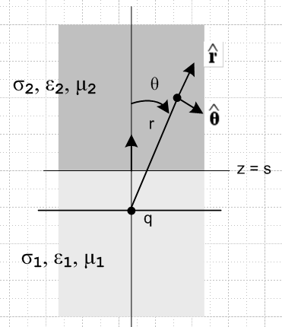

Then start all over with the general atomic forms

φ1(r,θ) = Σn=0∞[Anrn + Bnr-n-1] Pn(cosθ)
φ2(r,θ) = Σn=0∞[Cnrn + Dnr-n-1] Pn(cosθ)

Now right off the bat, if we go far away we expect potential to look somehow like 1/r so that means we have to have An = Cn = 0 for ALL n. But there could be powers like 1/r2 somehow created by the boundary, so don't throw them out. It just seems you cannot have higher powers like r0 or r1 and so on. So write

φ1(r,θ) = Σn=0∞ Bnr-n-1Pn(cosθ)
φ2(r,θ) = Σn=0∞ Dnr-n-1Pn(cosθ)

Now try to match these on the boundary where rcosθ = s. Not so easy to do this.

φ1(s/cosθ,θ) = Σn=0∞ Bn(s/cosθ)-n-1Pn(cosθ)
φ2(s/cosθ,θ) = Σn=0∞ Dn(s/cosθ)-n-1Pn(cosθ)

This seems to force Bn = Dn and then we have the same potential everywhere, which is no good.

And it suggests (at least) that maybe the only surviving coefficients are in fact B0 and D0 in order to get 1/r . Then we just have

φ1(r,θ) = B0r-1
φ2(r,θ) = D0r-1

which is pretty simple. In our new coordinate system the boundary is located at z = s which is rcosθ = s. So maybe write this as r = s/cosθ. Then we have, on the boundary,

s φ1(s/cosθ,θ) = B0cosθ/s
φ2(s/cosθ,θ) = D0cosθ/s

That seems to suggest that B0 = D0 and we now have this universal potential

φ1(r,θ) = B0r-1
φ2(r,θ) = B0r-1

But this implies that the boundary has no affect whatsoever, and that cannot possibly be right and certainly does not agree with the Bleaney picture.

Put a Halt on this attempt and start over.

4. Jackson's Solution

STOP. I have flailed enough this morning. It is time to go look up how this elementary problem is done, I have a mental block against it, I have some bad assumption. Maybe φ is not continuous? So who is going to give me the solution? I just have to start perusing books or the web.

Jacksons? This is too simple a problem for Jackson. But blue Jackson draws the Bleaney picture! Jackson's entire Section 4.4 is a treatment of this problem! He has the charge at z = +d. He puts the boundary at z = 0 as in my original picture. He is going to use the "method of images". Here are his pictures:

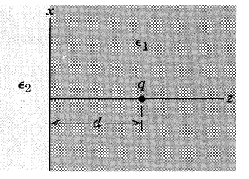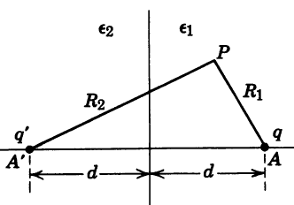

He puts an image charge q' at z = -d, just an ansatz. Here is the potential in region 1 in SI units,

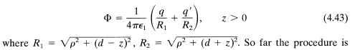 region 1

He uses cylindrical coordinates, I was using sphericals.
Now for region 2 he tries this ansatz,

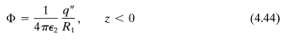
where some image is put at exactly z = d again! We now have q' and q" both unknown.
He then computes the fields in regions 1 and 2 from the assumed potential forms, and then he applies the E field boundary conditions (not a φ one!) and he concludes that the problem is solved if you choose

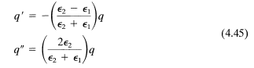

This gives a solution because it satisfies all the BC's at the boundary, and it also has 1/r at large r. So here is his solution

φ = (1/4πε1) ( q/R1 + q'/R2) z > 0

φ = (1/4πε2) ( q"/R1 ) z < 0

Jackson then calculates the polarization charge density on the boundary.

On the boundary z = 0 we have R1 = R2 ≡ R so we have

φ1 = (1/4πε1) ( q + q') /R

φ2 = (1/4πε2) ( q" /R )

Maple shows that these do in fact match at the boundary,

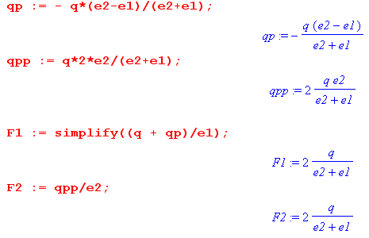

5. What did I do wrong in Attempt #1 and #2

In Attempt #1 I had this picture and I wrote

φ1(r,θ) = Σn=0∞[Anrn + Bnr-n-1] Pn(cosθ)
φ2(r,θ) = Σn=0∞[Cnrn + Dnr-n-1] Pn(cosθ)

Then since nothing blows up at r = 0 in this picture, you get

φ1(r,θ) = Σn=0∞[Anrn] Pn(cosθ)
φ2(r,θ) = Σn=0∞[Cnrn] Pn(cosθ)

But at infinity expect both φ = 0 and so you end up with

φ1(r,θ) = 0
φ2(r,θ) = 0

Here is what I did wrong, and I have made this error before in my recent electrostatics binge. You cannot represent the potential in region 1 in terms of the atoms shown because such atoms are for a region in which the Laplace equation is valid, and region 1 is not such a region since q is sitting there! But even ignoring that, you can see that nothing in the φ1 expansion is going to give a blowup at the point charge

φ1(s,π) = Σn=0∞[Ansn + Bns-n-1] Pn(-1) Pn(-1) = (-1)n

Your only hope would be that this series diverges magically just at the point charge but not near it. But let's not waste more time on that.
What you COULD do and I may try below is write φ1 = q/R + ψ1 and then ψ1 could have an atomic expansion. Then φ1 can blow up as R→ 0.

In Attempt #2 I just shifted the origin to get this picture,

but my error of using the atoms for region 2 is still present, so it is the same error really.

6. Attempt #1 in cylindrical coordinates

Sphericals are very clumsy for this problem because: if you put the point charge at the origin so it will have the simple q/r form, then the boundary surface does not have a constant coordinate. If you put the boundary at z = 0, then you need q/R where R = r - s which is messy. I have no idea why I used sphericals. The problem has azisym to cylindricals are the right coordinates to use. Then

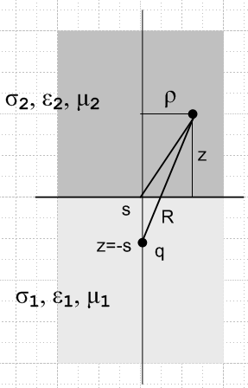 R2 = ρ2 + (z+s)2

Now you want to use cylindrical atoms and a point charge. Those atoms are:

e±kz [ Jm(kρ), Nm(kρ)] e±imφ

where in our case we must have m = 0 and I guess k just floats as a real number for now

e±kz [ J0(kρ), N0(kρ)]

But the N0 probably blows up at ρ = 0 which is along our innocent axis above, so we must have just

φ1(ρ,z) = (1/4πε1)R-1 + $^{\int_{0}^{∞}{}}$ dk Ak ekz J0(kρ) // always need z decay

φ2(ρ,z) = $^{\int_{0}^{∞}{}}$ dk Bk e-kz J0(kρ) R = $\sqrt{ρ2 + (z+s)2}$

This might be a bit clumsy due to the integrals, but I have done these things before.

Continuity of φ at the boundary gives

q/$\sqrt{ρ2 + s2}$ + $^{\int_{0}^{∞}{}}$ dk Ak J0(kρ) = $^{\int_{0}^{∞}{}}$ dk Bk J0(kρ)

which is an integral condition on Ak and Bk.

Next, we need to compute the two field conditions at the boundary

E = -∇φ = ∂ρφ + ∂zφ = Eρ + Ez

And then

Eρ1 = ∂ρφ1 = (1/4πε1) [ -R-2 ∂ρR ] + $^{\int_{0}^{∞}{}}$ dk Ak ekz ∂ρ J0(kρ)

But ∂ρR = ρ/R and ∂ρ J0(kρ) = k J0'(kρ) so we have then

Eρ1 = - (1/4πε1) ρ/R3 + $^{\int_{0}^{∞}{}}$ dk k Ak ekz J0'(kρ)

Next,

Ez1 = ∂zφ1 = (1/4πε1) [ -R-2 ∂zR ] + $^{\int_{0}^{∞}{}}$ dk Ak ∂zekz J0(kρ)

But ∂zR = 1/R * (z+s) so we get

Ez1 = - (1/4πε1)(z+s)/R3 + $^{\int_{0}^{∞}{}}$ dk k Ak ekz J0(kρ)

For region 2, we change A to B and omit the point charge, so here is our summary:

Eρ1 = - (1/4πε1) ρ/R3 + $^{\int_{0}^{∞}{}}$ dk k Ak ekz J0'(kρ)
Ez1 = - (1/4πε1)(z+s)/R3 + $^{\int_{0}^{∞}{}}$ dk k Ak ekz J0(kρ)

Eρ2(ρ,z) = $^{\int_{0}^{∞}{}}$ dk k Bk ekz J0'(kρ)
Ez2(ρ,z) = $^{\int_{0}^{∞}{}}$ dk k Bk ekz J0(kρ)

Now at z = 0 we have our boundary conditions. Eρ are the tangential or parallels, Ez is the normal or perp. The rules are

ε2 En2 = ε1 En1 n = normal to surface
Et2 = Et2 t = tangential to surface

So therefore

ε2 Ez2(ρ,0) = ε1 Ez1(ρ,0)
Eρ2(ρ,0) = Eρ1(ρ,0)

which says

ε2 $^{\int_{0}^{∞}{}}$ dk k Bk J0'(kρ) = ε1 { - (1/4πε1)(s)/R3 + $^{\int_{0}^{∞}{}}$ dk k Ak J0(kρ) }

$^{\int_{0}^{∞}{}}$ dk k Bk J0(kρ) = - (1/4πε1) ρ/R3 + $^{\int_{0}^{∞}{}}$ dk k Ak J0'(kρ)

q/$\sqrt{ρ2 + s2}$ + $^{\int_{0}^{∞}{}}$ dk Ak J0(kρ) = $^{\int_{0}^{∞}{}}$ dk Bk J0(kρ) R = $\sqrt{ρ2 + s2}$

On the last line we show the continuity condition.
Now pause to note that I could have used an expansion of the point charge of this form,

1/R = Σm eimφ e-imφ'$^{\int_{0}^{∞}{}}$dk exp(-k|z-z'|) Jm(kρ) Jm(kρ')

If we put the point charge at z' = -s and ρ' = 0 and say φ' = 0 this says

1/R = Σm eimφ $^{\int_{0}^{∞}{}}$dk exp(-k|z+s|) Jm(kρ) Jm(0)
or

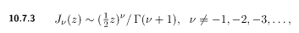

This last says that at z = 0, Jm(z) = 0 for m > 0, and you have then only J0(0) = 1, so

1/R = Σm eimφ $^{\int_{0}^{∞}{}}$dk exp(-k|z+s|) Jm(kρ) δm,0 1
or
1/R = $^{\int_{0}^{∞}{}}$dk exp(-k|z+s|) J0(kρ)

I am not sure this would be very helpful due to the k+z combination.

So what do I do next? Maybe my choice of the Jm(kρ) was bad because this has to decay at large ρ.

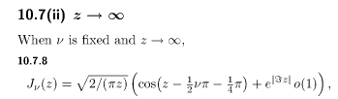

at least it decays somewhat.
I think you have to apply $^{\int_{0}^{∞}{}}$ dρ ρ J0(k'ρ) to the conditions above in order to expose the coefficients, a sort of Hankel projection. For example,

$^{\int_{0}^{∞}{}}$ dk k Bk J0(kρ) = - (1/4πε1) ρ/R3 + $^{\int_{0}^{∞}{}}$ dk k Ak J0'(kρ)
so
$^{\int_{0}^{∞}{}}$ dρ ρJ0(k'ρ) $^{\int_{0}^{∞}{}}$ dk k Bk J0(kρ)

= - (1/4πε1) $^{\int_{0}^{∞}{}}$ dρ ρJ0(k'ρ) ρ/R3 + $^{\int_{0}^{∞}{}}$ dρ ρJ0(k'ρ) $^{\int_{0}^{∞}{}}$ dk k Ak J0'(kρ)

Then you know that (transforms.doc)

$^{\int_{0}^{∞}{}}$dρ ρ Jν(kρ) Jν(k'ρ) = δ(k-k')/k // orthogonality

and we use this with ν = 0 to get

$^{\int_{0}^{∞}{}}$dρ ρ J0(kρ) J0(k'ρ) = δ(k-k')/k

Our condition above is then

$^{\int_{0}^{∞}{}}$ dk k Bk [$^{\int_{0}^{∞}{}}$ dρ ρJ0(k'ρ) J0(kρ)]

= - (1/4πε1) $^{\int_{0}^{∞}{}}$ dρ ρJ0(k'ρ) ρ/R3 + $^{\int_{0}^{∞}{}}$ dk k Ak $^{\int_{0}^{∞}{}}$ dρ ρJ0(k'ρ) J0'(kρ)

The LHS is then

$^{\int_{0}^{∞}{}}$ dk k Bk [δ(k-k')/k ] = Bk'

and then we have

Bk' = - (1/4πε1) $^{\int_{0}^{∞}{}}$ dρ ρJ0(k'ρ) ρ/R3 + $^{\int_{0}^{∞}{}}$ dk k Ak $^{\int_{0}^{∞}{}}$ dρ ρJ0(k'ρ) J0'(kρ)

OK, enough on this huge distraction. It just goes to show how powerful the method of images really is, compared to this brute force approach. If you look at the expansions of the known solutions, you will find something like this

φ2 = (1/4πε1) ( q/R1 + q'/R2) z > 0

φ1 = (1/4πε2) ( q"/R1 ) z < 0

where you would expand the 1/R objects as something like

1/R1 = $^{\int_{0}^{∞}{}}$dk exp(-k|z+s|) J0(kρ)

1/R2 = $^{\int_{0}^{∞}{}}$dk exp(-k|z-s|) J0(kρ)

Let's go back to those original atoms,

e±kz [ J0(kρ), N0(kρ)]

Maybe I needed to divide space up into more strips, such as

7. Attempt #2 in cylindrical coordinates

Let's put the cylindrical origin at the point charge. Then

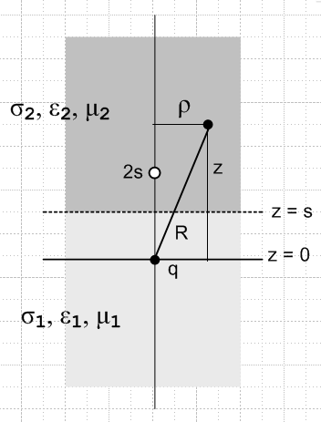

Atoms are again

e±kz [ J0(kρ), N0(kρ)]

Do our same expansions wrt this new origin,

φ1(ρ,z) = (1/4πε1)R-1 + $^{\int_{0}^{∞}{}}$ dk Ak ekz J0(kρ) // always need z decay

φ2(ρ,z) = $^{\int_{0}^{∞}{}}$ dk Bk e-kz J0(kρ) R = $\sqrt{ρ2 +s2}$

The expected solutions are

φ1 = (1/4πε1) ( q/R1 + q'/R2) z > s

φ2 = (1/4πε2) ( q"/R1 ) z < s

and we know we can do this

1/R = $^{\int_{0}^{∞}{}}$dk e-k|z|J0(kρ)

Using this, our expansions are

φ1(ρ,z) = (1/4πε1) $^{\int_{0}^{∞}{}}$dk e-k|z|J0(kρ) + $^{\int_{0}^{∞}{}}$ dk Ak ekz J0(kρ)

φ2(ρ,z) = $^{\int_{0}^{∞}{}}$ dk Bk e-kz J0(kρ) R = $\sqrt{ρ2 +s2}$

and now things are all on the same footing! The potential match then says (set z = s > 0)

(1/4πε1) $^{\int_{0}^{∞}{}}$dk e-ks J0(kρ) + $^{\int_{0}^{∞}{}}$ dk Ak eks J0(kρ) = $^{\int_{0}^{∞}{}}$ dk Bk e-ks J0(kρ)

and maybe you can then argue that

(1/4πε1) e-ks + Ak eks = Bk e-ks

and there you have a nice clean relationship. I think this path will pan out. You have to do the field match conditions of course. Have I done this problem somewhere? Maybe, but let's finish it here.

Next, we need to compute the two field conditions at the boundary

E = -∇φ = ∂ρφ + ∂zφ = Eρ + Ez

And we compute:

Eρ1 = ∂ρφ1 = (1/4πε1) $^{\int_{0}^{∞}{}}$dk k e-k|z|J0'(kρ) + $^{\int_{0}^{∞}{}}$ dk kAk ekz J0'(kρ)
Eρ2 = ∂ρφ2 = $^{\int_{0}^{∞}{}}$ dk kBk e-kz J0'(kρ)

This is a tangential field as the picture shows, and our BC for it is that at z = s they are equal

(1/4πε1) $^{\int_{0}^{∞}{}}$dk k e-ksJ0'(kρ) + $^{\int_{0}^{∞}{}}$ dk kAk eks J0'(kρ) = $^{\int_{0}^{∞}{}}$ dk kBk e-ks J0'(kρ)

and maybe we can conclude here that

(1/4πε1)k e-ks + kAk eks = kBk e-ks
or
(1/4πε1)e-ks + Ak eks = Bk e-ks // same as matching potentials
or
(1/4πε1)e-ks = Bk e-ks - Ak eks

which we see is the same as what we learned from equating the potentials. Hmmm... Next,

Ez1 = ∂zφ1 = (1/4πε1) $^{\int_{0}^{∞}{}}$dk (∂ze-k|z|)z=sJ0(kρ) + $^{\int_{0}^{∞}{}}$ dk Ak k eks J0(kρ)
Ez2 = ∂zφ2 = $^{\int_{0}^{∞}{}}$ dk Bk (-k) e-ks J0(kρ)

This is a normal field, and our BC for it at z = s says

ε1 { (1/4πε1) $^{\int_{0}^{∞}{}}$dk (∂ze-k|z|)z=s J0(kρ) + $^{\int_{0}^{∞}{}}$ dk Ak k eks J0(kρ)}
= ε2 $^{\int_{0}^{∞}{}}$ dk Bk (-k) e-ks J0(kρ)

and maybe we can conclude here that

ε1 { (1/4πε1) (∂ze-k|z|)z=s + Ak k eks } = ε2 Bk (-k) e-ks

Now in the region of z = s, we have z > 0, so

(∂ze-k|z|)z=s = (∂ze-kz)z=s = -ke-ks

so our last condition is then

ε1 { (1/4πε1) (-ke-ks) + Ak k eks } = ε2 Bk (-k) e-ks
or
ε1 { (1/4πε1) (ke-ks) – Ak k eks } = ε2 Bk k e-ks
or
ε1 (1/4πε1) ke-ks = ε2 Bk k e-ks + ε1Ak k eks
or
ε1 (1/4πε1) e-ks = ε2 Bk e-ks + ε1Ak eks

Thus, from our three boundary conditions, we end up with these two equations only:

(1/4πε1)e-ks = Bk e-ks - Ak eks (*)

ε1 (1/4πε1) e-ks = ε2 Bk e-ks + ε1Ak eks

This is 2 in 2, so we should have a nice solution coming in a moment. multiply top by ε1

ε1 (1/4πε1)e-ks = ε1Bk e-ks - ε1Ak eks

ε1 (1/4πε1) e-ks = ε2 Bk e-ks + ε1Ak eks

Add so the Ak terms cancel and we get

2 ε1 (1/4πε1)e-ks = (ε1+ε2)Bk e-ks

Bk = (1/2π) / (ε1+ε2)

Then solve first equation (*) for Ak:

Ak eks = Bk e-ks - (1/4πε1)e-ks

Ak eks = (1/2π) / (ε1+ε2)e-ks - (1/4πε1)e-ks

4πε1Ak eks = 2ε1 / (ε1+ε2)e-ks - e-ks

(ε1+ε2)4πε1Ak eks = 2ε1e-ks - (ε1+ε2)e-ks

(ε1+ε2)4πε1Ak eks = (ε1-ε2)e-ks

Ak = (1/4πε1)e-2ks (ε1-ε2)/ (ε1+ε2)

Thus we think we have found our two unknown Smythian coefficients,

Ak = (1/4πε1)e-2ks [(ε1-ε2)/ (ε1+ε2)] // I got this right the first time.
Bk = (1/4πε1) [ 2ε1 / (ε1+ε2)] // first time had e-2ks wrongly here

So let's install these into the potentials and see what we have:

φ1(ρ,z) = (1/4πε1)R-1 + $^{\int_{0}^{∞}{}}$ dk {(1/4πε1)e-2ks [(ε1-ε2)/ (ε1+ε2)]} ekz J0(kρ)

= (1/4πε1)R-1 + (1/4πε1) [(ε1-ε2)/ (ε1+ε2)] $^{\int_{0}^{∞}{}}$ dk e-2ks+kz J0(kρ)

The second term must be the image charge sitting in Region 2! Recall that

1/R|charge_at_a = $^{\int_{0}^{∞}{}}$dk e-k|z-a|J0(kρ)

Suppose this charge is at location z = 2s, just as a guess, then we have

1/R|charge_at_2s = $^{\int_{0}^{∞}{}}$dk e-k|z-2s|J0(kρ)

Observed from region 1, wherein z < s, we have

z-2s < s-2s = -s => z-2s < 0 => |z-2s| = -(z-2s)

Thus, viewed from Region 1 we have

1/R|charge_at_2s = $^{\int_{0}^{∞}{}}$dk e+k(z-2s)J0(kρ)

Thus we can write

φ1(ρ,z) = (1/4πε1)R-1 + (1/4πε1) [(ε1-ε2)/ (ε1+ε2)] 1/R|charge_at_2s

and if we install charge q instead of q = 1 this says

φ1(ρ,z) = (q/4πε1)R-1 + (q'/4πε1) 1/R|charge_at_2s

q' = [(ε1-ε2)/ (ε1+ε2)]q

and this agrees with Jackson's solution which I quote again

Comment: The solution for φ1 has ε1 in both leading factors. This means all of space is filled with ε1 and we have our image charge at z = 2s and the ε2 space does not exist as far as the region 1 observer is concerned.

Now let's make sure we have the region 2 result correct as well.

Ak = (1/4πε1)e-2ks [(ε1-ε2)/ (ε1+ε2)]
Bk = (1/4πε1) [ 2ε1 / (ε1+ε2)]

φ2(ρ,z) = $^{\int_{0}^{∞}{}}$ dk Bk e-kz J0(kρ)

= (1/4πε1) [ 2ε1 / (ε1+ε2)] $^{\int_{0}^{∞}{}}$ dk -kz J0(kρ)

Now suppose we put a charge Q" at point z = 0 and view it from Region 2 where z > s. then

1/R|charge_at_a = $^{\int_{0}^{∞}{}}$dk e-k|z-a|J0(kρ)

1/R|charge_at_(0) = $^{\int_{0}^{∞}{}}$dk e-k|z|J0(kρ) = $^{\int_{0}^{∞}{}}$dk e-kzJ0(kρ)

Then we have shown that

φ2(ρ,z) = (1/4πε1) [ 2ε1 / (ε1+ε2)] 1/R|charge_at_(0)

If we call this charge Q" then we have

φ2(ρ,z) = Q" (1/4πε1) 1/R|charge_at_(0)

Again, the region 2 observer sees all space filled with ε1 and sees this image at z = 0. The image is at the same position as the physical charge, but is Q" instead of q. All of our equations have 1/4πε1 because that is how the original point charge entered the problem.

BUT, we can rewrite the above as follows:

φ2(ρ,z) = Q" (1/4πε1) 1/R1 = [ 2ε1 / (ε1+ε2)] (1/4πε1) 1/R1

= [ 2ε2 / (ε1+ε2)] (1/4πε2) 1/R1

= q" (1/4πε2) 1/R1

and this is the way Jackson presents it. The benefit of this approach is that we now have ε2 matching the general ε in region 2. This seems much more reasonable.

Thus I have 100% confirmed Jackson's solution using cylindrical atoms in two regions with unknown Smythian coefficients. Here is what the solution looks like

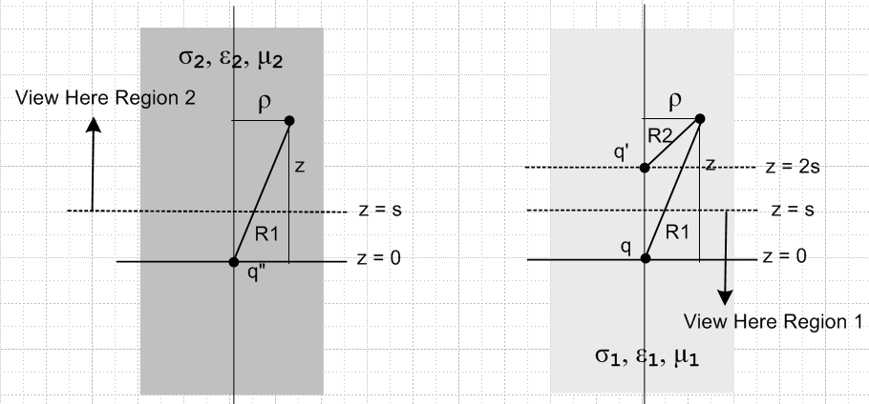

In Region 2 you just see a point charge, so E lines will be straight lines emanating from the origin,

In Region 1 you get that same field plus the distorting dipole effect of a second charge and that makes the lines be curved in region 2.

8. Maple plots of the field lines

Here are plots I just made in Maple stealing my toroid code, for ε1= 1 and ε2 = 2:

File is charge in "2 diel.mws" and "2 diel v1.mws". In the first I start at z = 3 and work toward the point charge. In the second I start at points around a circle around the point charge and work out.

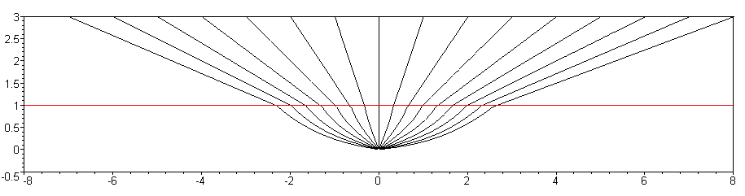

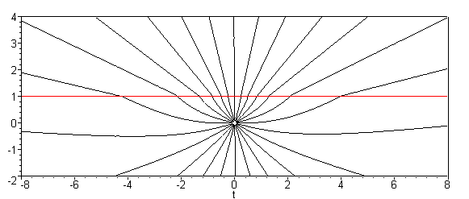

As the Bleaneys point out, the field lines are "refracted" at the boundary between the dielectrics.

9. The polarization charge density on the boundary, a Question, and a painful integral

Jackson computes this as

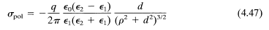 // units are OK

where his d is my s. I think if we include this σpol(ξ) as a real charge, we could say that

φ1(r) = E1(0|r) + ∫dSξ σpol(ξ) E1(ξ|r) // in region 1

φ2(r) = ∫dSξ σpol(ξ) E2(ξ|r)

Question: In the region 1 solution picture, if we are in region 1, can we simply replace the image charge q' with a surface charge density σpol and everything stays the same in region 1 ? In other words, does the E field created by the polarization charge equal that created by the image charge q' as seen in region 1?

Answer: I think the answer is yes, but let's just calculate it.

σpol(ρ) = ε0(1/2πε1) q' s/ (ρ2+s2)3/2 // units OK

φpol(x) = ∫ dSξ E(x|ξ) σpol(ξ) dSξ = ρdρdφ

E(x|ξ) = (1/4πε1)/|ξ-x|

Now this distance comes from this picture

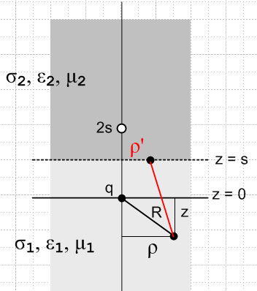

Now in general the distance between two points in cylindrical coordinates is given by
[ see study of 1/R for cylindricals]

D2 = ρ2 + ρ'2 + (z-z')2 - 2ρρ'cos(φ-φ')

In our picture above we take the upper red line endpoint as the primed location, so

D2 = ρ2 + ρ'2 + (z-s)2 - 2ρρ'cos(φ-φ')

D = |ξ-x| = $\sqrt{ρ2 + ρ'2 + (z-s)2 - 2ρρ'cos(φ-φ')}$

Then we have this result [ I later learned that σpol propagates with 1/4πε0R ! ]

φpol(x) = ∫ dSξ E(x|ξ) σpol(ξ)

= ∫ ρdρ∫dφ [(1/4πε0) 1/D ] σpol(ρ)

= ∫ ρ'dρ'∫dφ [(1/4πε0) 1/D ] ε0(1/2πε1) q' s/ (ρ'2+s2)3/2

= (1/2πε1) (1/4π) q' s ∫ ρ'dρ'∫dφ [1/$\sqrt{ρ2 + ρ'2 + (z-s)2 - 2ρρ'cos(φ-φ')}$ ] / (ρ'2+s2)3/2

Now this potential is symmetric in both directions, ± z, in its contribution to φ, because as just noted, the propagator either way is (1/4πε0).

Now this is how things must work out. If we are in region 1, the potential φpol must be the same as that of an image charge q' at z = 2s immersed in an all ε1 world, and we would get

φpol(x) = q' (1/4πε1) 1/R|z=2s = q' (1/4πε1)1/$\sqrt{(2s-z)2 + ρ2}$ Region 1

On the other hand, if we are in region 2, the potential φpol must be the same as that of an image charge
q-q" at the origin immersed in an all ε2 world, and we would get

φpol(x) = (q-q") (1/4πε2) 1/R|z=0 =(q-q") (1/4πε2) 1/$\sqrt{z2 + ρ2}$ Region 2

Somehow the above integral produces both these results, where the difference is in sign(z-s). I have seen how this fancy stuff arises before.

To make this fly for Region 1, the following would have to be true

q' (1/4πε1)1/$\sqrt{(2s-z)2 + ρ2}$

= (1/4πε1) (1/2π) q' s ∫ ρ'dρ'∫dφ [1/$\sqrt{ρ2 + ρ'2 + (z-s)2 - 2ρρ'cos(φ-φ')}$ ] / (ρ'2+s2)3/2
or

1/$\sqrt{(2s-z)2 + ρ2}$

= (1/2π) s ∫ ρ'dρ'∫dφ [1/$\sqrt{ρ2 + ρ'2 + (z-s)2 - 2ρρ'cos(φ-φ')}$ ] / (ρ'2+s2)3/2

= (s/2π) ∫ ρ'dρ' [1/(ρ'2+s2)3/2] ∫dφ [1/$\sqrt{ρ2 + ρ'2 + (z-s)2 - 2ρρ'cos(φ-φ')}$ ]

These are famous integrals I have messed with many times.

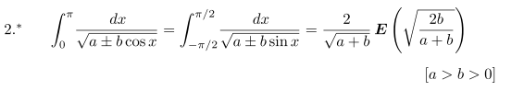
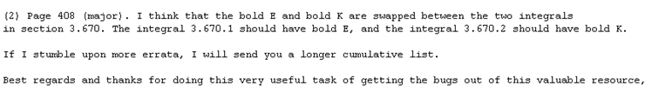

and this is right where I found the bug in GR7 (never got a response). So assume it is a K. Then

a = ρ2+ρ'2+(z-s)2 b = 2ρρ' > 0 assume - sign in quote above

a + b = (ρ+ρ')2 + (z-s)2

Then I claim

∫dφ'[1/$\sqrt{ρ2 + ρ'2 + (z-s)2 - 2ρρ'cos(φ-φ')}$ ]

= 2*2 1/$\sqrt{(ρ+ρ')2 + (z-s)2}$K($\frac{4ρρ'}{(ρ+ρ')2 + (z-s)2}$)

The ρ' integral is then very painful, but I know I have done all this before. We have to show that

2π/$\sqrt{(2s-z)2 + ρ2}$ = s ∫ ρ'dρ' [ 1/ (ρ2+s2)3/2] 4 [1/$\sqrt{(ρ+ρ')2 + (z-s)2}$] K($\frac{4ρρ'}{(ρ+ρ')2 + (z-s)2}$)

Are the dimensions right? LHS = 1/L RHS = L L2 1/L3 1/L = 1/L so yes. Maybe replace y = z-s

2π/$\sqrt{(y-s)2 + ρ2}$ = 4s ∫ ρ'dρ' [ 1/ (ρ'2+s2)3/2] [1/$\sqrt{(ρ+ρ')2 + y2}$] K($\frac{4ρρ'}{(ρ+ρ')2 + y2}$)
when y = z-s < 0 , and the left side is different when y > 0.

It will turn out that both sides are functions of a complex variable y which has cuts, etc.

This would take me a very long time to get figured out, so let's stop. I think the claim is correct that the polarization charge does create a field which looks like the point charge q' field.

10. A propagator interpretation of the above results

Each region has its own Poisson equation

∇2u = ρ/ε1 region 1 z < s
∇2u = 0 region 2 z > s

Reg 1 bottom

Consider the following canonical equation form

u1(x) = ∫R dξ g1(x|ξ) q(ξ) – ∫σ dSξ f(ξ) ∂ξng1(x|ξ) .

If we regard the z = 0 plane as a boundary, then g1(x|ξ) would have to vanish on that boundary and I know how to do that by putting an exact opposite mirror charge at z = 2s. That is to say

g1(x|ξ) = (1/4πε1) 1/R|z=0 – (1/4πε1) 1/R|z=2s

This of course also vanishes on the lower great half sphere. And ∇2g1(x|ξ) = -δ(x-0)/ε1 because the second term has no hit in region 1. Then ∂ξng1(x|ξ) is the normal E field at z = s which would be twice the normal component of just the lower point charge on that plane.
In region 2 there exists no charge ρ, so we get just

u2(x) = – ∫σ dSξ f(ξ) ∂ξng2(x|ξ) .

I think the correct g2 for this case would be

g2(x|ξ) = (1/4πε2) 1/R|z=2s – (1/4πε2) 1/R|z=0

which is the solution IF we put a unit charge at z = 2s in region 2.
But I don't know the value of f(ξ) on the boundary. It is not a metallic boundary.
Well of course I really do know φ on the boundary because I know the solution of the problem. For example, in region 2 I know that

φ2(ρ,z) = q" (1/4πε2) 1/R|charge_at_(0) = q" (1/4πε2) 1/R1 R1 = $\sqrt{ρ2+z2}$

Then

φ2(ρ,s) = q" (1/4πε2) 1/$\sqrt{ρ2+s2}$ = f(ξ)

which varies with ρ and is thus not a constant.

In this last discussion, the "propagator" g1 or g2 is a boundary-specific propagator, not the free-ε propagator.

11. Conjecture

I think in each region the potential is created entirely by the physical point charge and the physical polarization charge on the surface, and in that context you can ignore everything else and use the Coulomb law integral with the appropriate ε for the region. Of course that integral may be a complete nightmare to compute.

