Electrostatics: Potential inside a ring of charge PhL 11.12.13

I think my treatments below are viable. It is not clear to me now 2/9/14 why I was interested in this problem at the time. I guess if you think of the mag surface current Kz on a piece of round conductor, it is a like a ring of charge??? I have totally lost the connection and the edit log for this date is also confusing. But I think the work here regarding this Jackson problem is probably all OK. I might file a copy of this in electrostatics somewhere.

My interest in this problem arose recently when doing the transmission line Chapter 4 work where I mistakenly used the 3D propagator instead of the 2D one. I was reminded of my GR7 errata with the two integrals, and it all has a bearing on this simple problem.

We want to look at this 3D problem solved a two different ways. Using spherical atoms, Jackson blue provides a solution at the top of page 104. I see he has dropped equation numbers on equations that perhaps are just applications. I will quote this result in a while. [ This is also in green in cgs.]

In Part 1 I do it my way and get a K function
In Part 2 I do it Jackson's way and get a spherical coordinate solution.
// I never show that the two solutions in general are equivalent.
// But I do show that they agree at the center of the ring
In Part 3 I plot my solution, it is a very simple plot in the plane only, log diverge at the ring
In Part 4 I provide "atomic support" for the Jackson method
In Part 5 I do the 2D ring charge problem which is a completely different animal.

1. The Poisson Integral Solution to the 3D ring charge problem. 1
2. The Jackson Solution to the 3D ring charge problem 3
3. More on My Solution to the 3D ring charge problem 7
4. Jackson's method written out 9
5. The 2D ring charge problem 9

1. The Poisson Integral Solution to the 3D ring charge problem.

My interest however is the Poisson Integral solution. Start with

∇2φ = -ρ/ε0 ρ = ρ0δ(r-a)δ(z) = ring of charge

Then I expect to have, using cylindrical coordinates,

φ(x) = (1/4π) (1/ε0) ∫dV' ρ(x')/R = (1/4π) (ρ0/ε0) $^{\int_{0}^{∞}{}}$r'dr'∫dθ'$^{\int_{0}^{∞}{}}$dz' δ(r'-a)δ(z')/R

= (a/4π) (ρ0/ε0) ∫dθ' /R

where

R2 = [r2 + a2 + z2] - 2arcos(θ-θ') = A2 - 2arcos(x)

Our result is then

φ(x) = (a/4π) (ρ0/ε0) $^{\int_{-π}^{π}{}}$dx 1/$\sqrt{A2 - 2arcosx}$ = 2 (a/4π) (ρ0/ε0) $^{\int_{0}^{π}{}}$dx 1/$\sqrt{A2 - 2arcosx}$

This integral appears wrong TWICE in GR7, I did not notice that until today. Here are the correct integrals from my note:

$^{\int_{0}^{π}{}}$dx(1 /$\sqrt{a ± bcosx}$) = (2 /$\sqrt{a+b}$) K($\sqrt{2b/(a+b)}$) a > b > 0

$^{\int_{0}^{π}{}}$dx $\sqrt{a ± bcosx}$ = (2 $\sqrt{a+b}$) E($\sqrt{2b/(a+b)}$) a > b > 0

Now in my application of this second integral, I have a = A2 = r2 + a2 + z2 and b = 2ar. This means

a+b = r2 + a2 + z2+ 2ar = (r+a)2 + z2
The solution is then $\sqrt{(r+a)2 + z2}$

φ(x = r,θ,z) = 2 (a/4π) (ρ0/ε0) $\sqrt{(r+a)2 + z2}$K($\frac{4ar}{(r+a)2 + z2}$)
or
φ(x = r,θ,z) = (a/π) (ρ0/ε0) $\sqrt{(r+a)2 + z2}$K($\frac{4ar}{(r+a)2 + z2}$)

Dimensions of ρ0 are C/m (linear charge density) while ε0 = farad/m so

dim(φ) = m * C/m * m/farad * m-1 = C/F = volt

I am now going to change the symbols in my cylindrical coordinates solution to be

φ(x = ρ,φ,z) = (a/π) (ρ0/ε0) $\sqrt{(ρ+a)2 + z2}$ K($\frac{4aρ}{(ρ+a)2 + z2}$)

Now I have 2πaρ0 = q, the total charge of my ring, so

(a/π) (ρ0/ε0) = (a/π) (q/2πaε0) = q/(2π2ε0)

and then my solution is

φ(x = ρ,φ,z) = q/(2π2ε0) $\sqrt{(ρ+a)2 + z2}$ K($\frac{4aρ}{(ρ+a)2 + z2}$) // ring at z = 0

As expected, things are independent of φ. Now I want to make one more change: I will put my ring of charge at z = b to match Jackson below. Then

φ(x = ρ,φ,z) = q/(2π2ε0) $\sqrt{(ρ+a)2 + (z-b)2}$ K($\frac{4aρ}{(ρ+a)2 + (z-b)2}$)

2. The Jackson Solution to the 3D ring charge problem

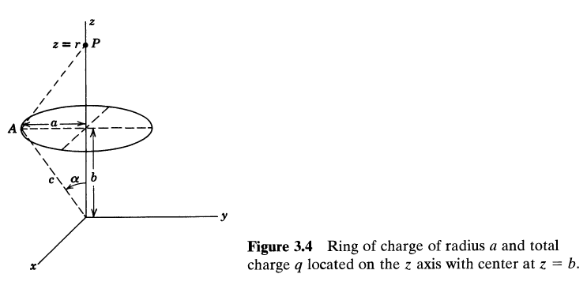
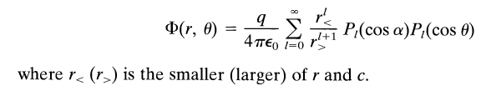

For some reason Jackson writes his z value as r. His solution is actually quite unclear because he doesn't really say what "r" is for his general solution I quoted above. I presume it is the distance of the observation point from his picture's origin. I am guessing that r,θ are two spherical coordinates since I see spherical atoms in his formula, and then there is no φ dependence. My solution is more geared to cylindrical coordinates.
Now do we relate Jackson's r and θ to my ρ and z ?

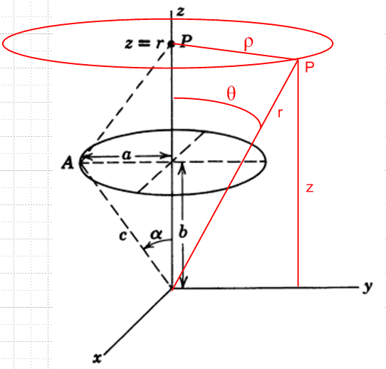

r2 = ρ2 + z2

z = rcosθ = $\sqrt{ρ2+z2}$cosθ => cosθ = z/$\sqrt{ρ2+z2}$

Then Jackson also has cosα = b/c = b/$\sqrt{a2+b2}$ which is just a constant. Then

r< = min(r, $\sqrt{a2+b2}$) = min($\sqrt{ρ2+z2}$, $\sqrt{a2+b2}$)
r> = max(r, $\sqrt{a2+b2}$) = max($\sqrt{ρ2+z2}$, $\sqrt{a2+b2}$)

Then I can write his solution as

φJ = [q/4πε0] Σn=0∞ [min($\sqrt{ρ2+z2}$, $\sqrt{a2+b2}$)]n [max($\sqrt{ρ2+z2}$, $\sqrt{a2+b2}$)]-n-1

Pn(b/$\sqrt{a2+b2}$) Pn(z/$\sqrt{ρ2+z2}$)

which I can compare to my solution

φL(x = ρ,φ,z) = q/(2π2ε0) $\sqrt{(ρ+a)2 + (z-b)2}$ K($\frac{4aρ}{(ρ+a)2 + (z-b)2}$)

Let's examine both solutions in the plane of the ring. For me, z = b. For him, we still have to do the min max depending no whether we are inside or outside the ring. So

φJ = [q/4πε0] Σn=0∞ [min($\sqrt{ρ2+b2}$, $\sqrt{a2+b2}$)]n [max($\sqrt{ρ2+b2}$, $\sqrt{a2+b2}$)]-n-1

Pn(b/$\sqrt{a2+b2}$) Pn(b/$\sqrt{ρ2+b2}$)

φL = q/(2π2ε0) $\frac{1}{ρ+a}$ K($\sqrt{4aρ}$)

Now at ρ = a, I have K(2a/2a) = K(1) which is no doubt a singular point for K. Now let's restrict interest to "inside the ring". Then$\sqrt{ρ2+b2}$ < $\sqrt{a2+b2}$ and we get

φJ = [q/4πε0] Σn=0∞ ($\sqrt{ρ2+b2}$)n ($\sqrt{a2+b2}$)-n-1 Pn(b/$\sqrt{a2+b2}$) Pn(b/$\sqrt{ρ2+b2}$)

φL = q/(2π2ε0) $\frac{1}{ρ+a}$ K($\sqrt{4aρ}$)

Now how about right at the center of the ring:

φJ = [q/4πε0] Σn=0∞ bn ($\sqrt{a2+b2}$)-n-1 Pn(b/$\sqrt{a2+b2}$) Pn(1)

φL = q/(2π2ε0) $\frac{1}{a}$ K(0)

Now look up K(0) in AS special values (I hope)

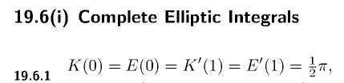

So then my solution becomes

φL = q/(2π2ε0) $\frac{1}{a}$ (π/2) = [ 1/4πε0 ] q/a

which is of course the correct result since all parts of the ring are distance a away.

Jackson meanwhile gets

φJ = [q/4πε0] Σn=0∞ bn ($\sqrt{a2+b2}$)-n-1 Pn(b/$\sqrt{a2+b2}$)

which seems to depend on b, but as I will show below, it does not in fact depend on b. First, for b = 0 it gives the right answer since then only the n=0 term survives and

φJ = [q/4πε0] 1/a P0(0) = [q/4πε0] 1/a

In order for this result to be correct for any b, one would have to show that

Σn=0∞ bn ($\sqrt{a2+b2}$)-n-1 Pn(b/$\sqrt{a2+b2}$) = 1/a for any b !! (*)

Maple seems to indicate that this is true! Rewrite differently,

x ≡ b/$\sqrt{a2+b2}$< 1 => $\sqrt{a2+b2}$ = b/x a2 + b2 = b2/x2

=> a2 = b2(1/x2-1) = b2(1-x2)/x2

=> b2 = a2x2/(1-x2)

=> (b/a)2 = x2/(1-x2)

=> (b/a) = x/$\sqrt{1-x2}$

Σn=0∞ bn (b/x)-n-1 Pn(x) = 1/a ?

Σn=0∞ bn b-n-1xn+1 Pn(x) = 1/a ?

Σn=0∞ b-1xn+1 Pn(x) = 1/a ?

b-1Σn=0∞ xn+1 Pn(x) = 1/a ?

Σn=0∞ xn+1 Pn(x) = b/a = x/$\sqrt{1-x2}$ ?

Σn=0∞ xn Pn(x) = 1/$\sqrt{1-x2}$ ?

Now there is the following generating function sum rule:

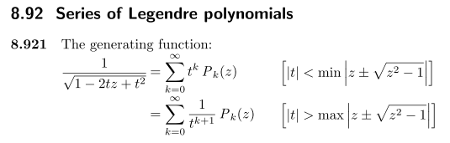

If I set t = z = x this says

1/$\sqrt{1-x2}$ = Σn=0∞ xnPn(x) |x| < min | x ± $\sqrt{x2-1}$| = min | x ± i $\sqrt{1-x2}$| (**)

But
| x ± i $\sqrt{1-x2}$|2 = (x ± i $\sqrt{1-x2}$) (x ∓ i $\sqrt{1-x2}$) = x2 - i2(1-x2) = x2+(1-x2) = 1

Thus I have shown that

| x ± i $\sqrt{1-x2}$| = 1 => min | x ± i $\sqrt{1-x2}$| = 1 => |x| < 1

and therefore the sum (**) is valid in my application. Therefore the last ? line above is true, and therefore (*) is true in fact for any real b.

3. More on My Solution to the 3D ring charge problem

If the ring is at z = 0, my solution is this:

φ(x = ρ,φ,z) = q/(2π2ε0) $\sqrt{(ρ+a)2 + z2}$ K($\frac{4aρ}{(ρ+a)2 + z2}$) // ring lies at z = 0

If we are interested in φ inside the ring itself, we set z = 0 to get

φ = q/(2π2ε0) $\frac{1}{ρ+a}$ K($\sqrt{4aρ}$) 0 < ρ < a

where the argument of K runs 0 to 1. Rewrite this as

φ = q/(4πε0) [ (2/π) $\frac{1}{ρ+a}$ K($\sqrt{4aρ}$) ]

If we plot the argument of K versus ρ we find

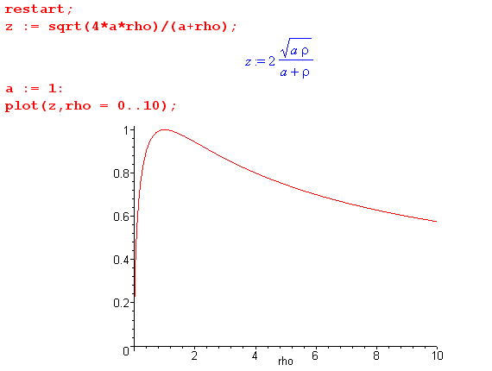

which tells us that as ρ ranges from ρ= 0 to ρ = ∞, the K argument is always ≤ 1. It is only = 1 at the point where ρ = a. So we don't need any fancy K transformation formulas.

For small ρ we have already shown that [...] → 1/a as expected.

For large ρ we have

K($\sqrt{4aρ}$) ≈ K($\sqrt{4aρ}$) = K($\sqrt{4a/ρ}$) ≈ K(0) = π/2

and then

[ (2/π) $\frac{1}{ρ+a}$K($\sqrt{4aρ}$) ] ≈ (2/π) (1/ρ) (π/2) = 1/ρ

and then

φ = q/(4πε0) (1/ρ) // as expected.

Here is a Maple plot for ρ in (0,a):

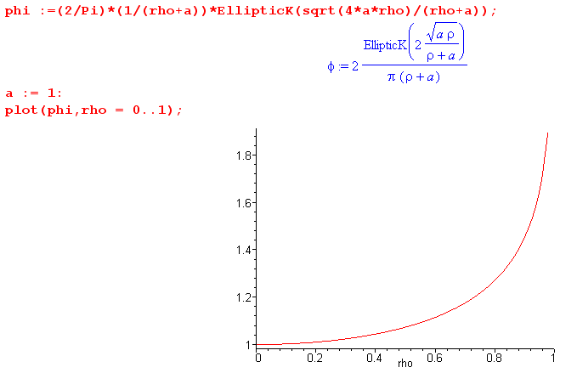

At ρ = 0 we know the result is [... ] = 1/a which in our plot is just 1.
At ρ→a we expect logarithmic divergence since it is like a point next to an infinite line charge which has the general behavior (1/2π) ln(1/(a-ρ)) where a-ρ = r, and the 2D propagator in Stak is (1/2π)ln(1/r). I can in fact plot right through the singular point like so
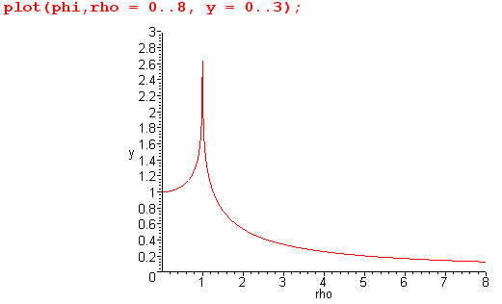

and then you see the usual 1/r drop off.

Conclusion: I think my expression for φ of the ring change in terms of the K function is correct.

4. Jackson's method written out

For this azisym problem, we know what the atoms are, so

φ(r,θ) = Σn=0∞ An r-n-1 Pn(cosθ) large r

He computes things for θ = 0 and finds there that

φ(r,θ=0) = Σn=0∞ [ (q/4πε0)cn Pn(cosα)] r-n-1 Pn(1) large r

where Pn(1) = 1. This then determines that

An = (q/4πε0)cn Pn(cosα)

and then the full result must be

φ(r,θ) = Σn=0∞ (q/4πε0)cn Pn(cosα) r-n-1 Pn(cosθ) large r

He does a similar thing for small r and there you have it. I think his presentation is a little strange.

5. The 2D ring charge problem

I don't recall ever doing this problem before. I scanned Stak Chapter 6 and did not notice it. The result I get here seems reasonable in various ways. So here is the derivation:

Consider the general 2D situation

∇22D φ = -ρ/ε0

The potential of a unit positive point charge is φ = (1/4πε0)(1/R) in 3D. For Stak, the ε0 is just missing in the bottom, as on his page 50 (5.103). So I would say that in 2D the potential of a unit point charge at the origin is given by

φ = (1/2πε0)ln(1/r). (*)

This diverges logarithmically at both r = 0 and r = ∞. I think Stak gets this by assuming the divergence theorem div E = -ρ/ε0 in two dimensions and maintaining E = -∇φ.

This is also the Green's Function, so our solution is then

φ(x) = (1/2πε0)∫dA' ρ(x') ln(1/R) R = |x - x'| R2 = (x-x')2 + (y-y')2

Writing this in polar coordinates

φ(x) = (1/2πε0)∫r'dr' ∫dθ' ρ(r',θ') ln(1/R) R2 = r2+r'2 - 2rr'cos(θ-θ')

Now install our ring charge

ρ(r',θ') = ρ0δ(r'-a)

to get

φ(x) = ρ0(a/2πε0) ∫dθ' (1/2)ln(1/R2) R2 = r2+a2 - 2racos(θ-θ')

= - ρ0(a/4πε0) $^{\int_{-π}^{π}{}}$dx ln[r2+a2 - 2racosx ]

= - ρ0(a/2πε0) $^{\int_{0}^{π}{}}$dx ln[r2+a2 - 2racosx ]

= - ρ0(a/2πε0) $^{\int_{0}^{π}{}}$dx ln[(a2)(1 + (r/a)2 - 2(r/a) cosx )]

= - ρ0(a/2πε0) $^{\int_{0}^{π}{}}$dx { ln(a2) + ln(1 + (r/a)2 - 2(r/a) cosx ) }

= - ρ0(a/2πε0)[ ln(a2)π + $^{\int_{0}^{π}{}}$dx ln(1 + (r/a)2 - 2(r/a) cosx ) ]

I cannot find this second integral in GR7 where it ought to be. So I am now looking for

I ≡ $^{\int_{0}^{π}{}}$dx ln(1 + A2 - 2A cosx ) ]

Can Maple do this? It gives a big mess including lots of dilogs. But I remember this in Stak and (6.22) claims that

ln(1 + A2 - 2A cosx ) = -2 Σn=1∞ (An/n)cos(nx) // where |A| < 1

Then my integral becomes

I ≡ $^{\int_{0}^{π}{}}$dx {-2 Σn=1∞ (An/n)cos(nx)}

= -2 Σn=1∞ (An/n) $^{\int_{0}^{π}{}}$dx cos(nx)

= -2 Σn=1∞ (An/n) [sin(nπ)/n] // Maple

But sin(nπ) = 0 for n = 1,2,3... and so this integral is I = 0. My answer is then

φ(x) = - ρ0(a/2πε0)[ ln(a2)π ] // inside

which, if correct, says φ = a constant. This says that φ = this constant everywhere inside the ring of charge in 2D! I guess that is possible. Then for the outside region I will swap a and r and get

φ(x) = - ρ0(a/2πε0)[ ln(r2)π ] // outside

Meanwhile, write ρ02πa = q for the total ring. Then

ρ0(a/2πε0) = (q/2πa) (a/2πε0) = (q/4π2ε0)

and then our result is

φ(x) = - (q/4π2ε0) [ ln(a2)π ] // inside
φ(x) = - (q/4π2ε0) [ ln(r2)π ] // outside

or

φ(x) = - (q/2πε0) ln(a) // inside (***)
φ(x) = - (q/2πε0) ln(r) // outside

At least things match at the boundary.
If I take a→0 so the ring becomes a point charge, the result is

φ(x) = - (q/2πε0) ln(r)

and this agrees with my starting form (*) for such a point charge, so that is encouraging.
Here is a Maple plot with a = 2 and I omit the leading factor but keep the minus sign:

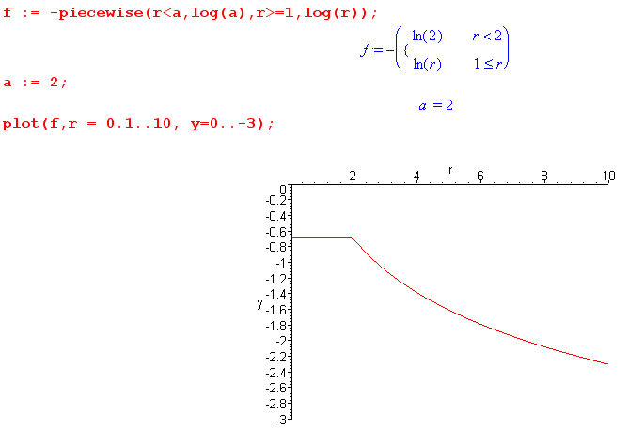

Recall that in 3D, inside a sphere of uniform charge you get φ = constant, and outside the sphere the charge appears as if it were q at the sphere center.
Here, in 2D we find that inside a circle of uniform charge we also get φ = constant. Outside the ring, the ring behaves as a point charge at the center of charge q. So very similar result.

Let's now go back and look at the integral again. I will do the integral and then we don't need that Stak 6.22 expansion.

I ≡ $^{\int_{0}^{π}{}}$dx ln(1 + α2 - 2α cosx )

Then

∂αI = $^{\int_{0}^{π}{}}$dx $\frac{1}{1 + α2 - 2α cosx}$ (2α - 2cosx) = 2 $^{\int_{0}^{π}{}}$dx $\frac{α - cosx}{1 + α2 - 2α cosx}$

= 2α $^{\int_{0}^{π}{}}$dx $\frac{1}{1 + α2 - 2α cosx}$ - 2 $^{\int_{0}^{π}{}}$dx $\frac{cosx}{1 + α2 - 2α cosx}$

I would probably make this a contour integral, but let's try to look it up in GR7. The second integral seems to be this

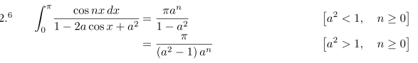

so with n = 1 and a = α we get

$^{\int_{0}^{π}{}}$dx $\frac{cosx}{1 + α2 - 2α cosx}$ = πα/(1-α2) α < 1
= -(π/α)/(1-α2) α > 1

$^{\int_{0}^{π}{}}$dx $\frac{1}{1 + α2 - 2α cosx}$ = π/(1-α2) α < 1
= -(π)/ (1-α2) α > 1

So we then find

∂αI = 1/(1-α2) { 2α π - 2 πα } = 0 α < 1

∂αI = -1/(1-α2) { 2α π - 2 π/α} α > 1

This second is

∂αI = -2π/(1-α2) { α - 1/α} = -2π/(1-α2)* (α2- 1)/α = 2π/α

So we summarize

∂αI = 0 α < 1
∂αI = 2π/α α > 1

Now integrate to get

I = C1 α < 1
I = 2π lnα + C2 α > 1

Now match at α = 1 to get

C1 = 2πln1 + C2 = C2

so we then have

I = C1 α < 1
I = 2π lnα + C1 α > 1

where recall

I ≡ $^{\int_{0}^{π}{}}$dx ln(1 + α2 - 2α cosx )

How do we get the constant C1? If α is very large we get

I = $^{\int_{0}^{π}{}}$dx ln(α2) = π lnα2 = 2πlnα large α

Equate this to

I = 2π lnα + C1

to find that C1 = 0. Thus

I = 0 α < 1
I = 2π lnα α > 1

or

I = 2πlnα θ(α>1) // here is the integral all done!

Now go back to

φ(x) = - ρ0(a/2πε0)[ ln(a2)π + $^{\int_{0}^{π}{}}$dx ln(1 + (r/a)2 - 2(r/a) cosx ) ]

= - ρ0(a/2πε0)[ ln(a2)π + I(α = r/a)]

= - ρ0(a/2πε0)[ ln(a2)π +2πln(r/a) θ((r/a)>1)]

= - ρ0(a/2πε0)[ 2 π ln(a) +2πln(r/a) θ(r>a)]

If r < a, the result is just

φ(x) = - ρ0(a/2πε0)[ 2 π ln(a) r < a

If r > a then

φ(x) = - ρ0(a/2πε0) [ 2 π ln(a) +2πln(r/a) ] = - ρ0(a/2πε0) 2πln(r)

so then solution is then

φ(x) = - ρ0(a/2πε0) 2π { either ln(a) or ln(r) }

Then recall

ρ0(a/2πε0) = (q/2πa) (a/2πε0) = (q/4π2ε0)

so get

φ(x) = - (q/4π2ε0) 2π { either ln(a) or ln(r) }

= - (q/2πε0) { either ln(a) or ln(r) }

which then replicates our solution (***) above.

This solution also applies to an infinite cylinder with a uniform surface charge! I think I am going to make use of this fact when I look at the curl J around a cylinder in which J = constant!

