Appendix M rewrite done Aug 19, 2014.

This version has a major error: you cannot assume that the Bessel function groups have "the same scale" when you go to low ω. As shown in version 2, at low ω it is the factor |k/a-1| that you want to show is small, not the factor |k/β'|.

Notes on Appendix M (appendix rewrite follows) 1
Appendix M: Why the transverse vector potential A_{t} is small for a transmission line 9

Notes on Appendix M (appendix rewrite follows)

I realized today that this Appendix refers to my now-defunct loss model and its low frequency cutoff concept. I now do things with k(ω) and I know that,

Fact 3: In the low frequency limit with G > 0 : (Q.3)

Re(k) ≈ (ω/2) $\sqrt{RG}$
Im(k) ≈ - $\sqrt{RG}$- (ω2/8) $\frac{(RC-LG)2}{(RC)3/2}$ ω << R/L and ω << G/C

Fact 4: In the low frequency limit with G = 0 , (Q.4)

Re(k) ≈ $\sqrt{RC/2}$ ω1/2 + $\sqrt{C/8R}$ ω3/2
Im(k) ≈ - $\sqrt{RC/2}$ ω1/2 + $\sqrt{C/8R}$ ω3/2 ω << R/L

For G > 0, there is a lower finite limit for Im(k), but there is none for G = 0.
In both cases, Re(k) → 0.

So I will try to edit right in place here [ below in this doc] . Red text is stuff that needs work! I will comment in this section with the edited result below.

The equation (1.5.9) really does have βd sitting in it because this comes from the Helm equation in the dielectric. No matter what value k(ω) has at some ω, we still have βd sitting in (1.5.9) as quoted below.

"Ouch, I claim that Jt,i(x,y,z) = e-jβ$_{d}$z Jt,i(x,y) with βd there instead of k. Did I do that back in Chapter 4? I am now looking thru Ch 4. The e-jβ$_{d}$z gets into the discussion thru (1.5.9), yes. I then do the TL limit idea to get (4.3.7). But then bang, I say q(z) = q(0) e-jβ$_{d}$z so everything is suddenly limited to the lossless theory! I am claiming that βd is very small as a general rule, based on long λ idea. "

OK, I have now repaired this problem with Chapter 4, see notes in the normal edit log. [ ok ] I am back to Appendix M again below! // I have worked my way down to (M.6), but at that point big changes are going to be needed since I have k in place of βd . I am trying to carry out Appendix M for the lossy case, not just for the lossless case where k = βd. I need some general statement about the ratio

ratio = $\frac{|k|}{|β'|}$

I have now done lots of gyrations and I end up with

| $\frac{k}{β}$| < 10-8 for all ω < 1018

which is much different from my former claim of 10-3. Do I believe this result? Let's check it at the extremes:

High ω: k = ω$\sqrt{LC}$ - $\sqrt{LC}$ says (Q.2)
= ω/vd - (RC+GL) (vd/2)

In my Belden example R(ω) = 4.8 x 10-5 $\sqrt{ω}$ and G = G = tanLωC so this becomes

k = ω/vd - (4.8 x 10-5 $\sqrt{ω}$C+ tanLωC L) (vd/2)

= ω/vd - (4.8 x 10-5 $\sqrt{ω}$+ tanLω L) (Cvd/2)

= ω/vd - (4.8 x 10-5 $\sqrt{ω}$(Cvd/2) + tanLω L (Cvd/2)

= ω/vd - (4.8 x 10-5 $\sqrt{ω}$(Cvd/2) + tanLω (vd/2) LC

= ω/vd - (4.8 x 10-5 $\sqrt{ω}$(Cvd/2) + tanLω (1/2vd)

= (ω/vd)( 1 + tanL/2) - (4.8 x 10-5 $\sqrt{ω}$(Cvd/2)

≈ (ω/vd) - (4.8 x 10-5 $\sqrt{ω}$(Cvd/2)

≈ (ω/vd)

Ouch! I just realized that Appendix Q assumes R,L,G,C are all constants independent of ω! That means that in practice, Appendix Q is useless! I have to go now and deal with that, since it might have many implications!

9/3/14. Several weeks has now past, EV came and went, Appendix Q has been fully rewritten but not yet installed. I want now to continue these notes using the new App Q results! I am looking for the set of ω such that |k| << |β|, since this is the defining condition for ignoring transverse action as noted below. So I want then to use my new "model" for |k|.

At high ω the new App Q (Q.3.5) shows that

Re(k) ≈ (ω/vd) + (vdκC/2) $\sqrt{ω}$ + (1/4vd)(ωd +vd4C2κ2/2) tanL + O(1/$\sqrt{ω}$)
Im(k) ≈ - (ω/vd) tanL/2 - (vdκC/2) $\sqrt{ω}$ - (1/2vd)(ωd - vd4C2κ2/2) + O(1/$\sqrt{ω}$)

where κ ≡ ( $\frac{1}{p1}$ + $\frac{1}{p2}$)$\frac{μ}{2σ}$ and ωd ≡ (σd/εd)

You can see that | k| ≈ |Re(k)| ≈ (ω/vd) at high ω. This in this regime our inequality in question is this:

|k2| << |β|2 ?

(ω/vd)2 << μσω ?

ω << μσ vd2 ? dim(RHS) = hen/m * mho/m * m2/sec2 = 1/sec OK

RHS = 4π x 10-7 * 5.81 x 107 * 9 x 1016 = 4π * 5.81 * 9 * 1016 = 113 x 1016 ~ 1018

This is just my "usual calculation" and we then have |k| << |β| for all ω in the feasible high ω regime.

What about in the very low ω regime? There I show in new App Q that for ωd = 0,

Fact 4: The small ω limit for k(ω), assuming ωd = 0, is given by (Q.4.9)

Re(k) ≈ + $\sqrt{RdcC/2}$ $\sqrt{ω}$( 1 - tanL/2) + O(ω3/2)
Im(k) ≈ - $\sqrt{RdcC/2}$ $\sqrt{ω}$( 1 + tanL/2) + O(ω3/2)

So here we have roughly |k|2 = [$\sqrt{RdcC/2}$ $\sqrt{ω}$]2 + same = 2 RdcC/2 ω = RdcC ω, so then the question becomes this:

|k2| << |β|2 ?

RdcC ω << μσω ?

RdcC << μσ ?

RdcC << 73 sec/m2 ?

This is a bit new I think. For the Belden cable we had in App R,

Rdc = .036 ohm/m C = 69 x 10-12 far/m

RdcC ~ 2.5 x 10-12 which is <<<<< 73 !

Now look at the other case

Fact 3: The small ω limit for k(ω), assuming ωd > 0, is given by (Q.4.6)

Re(k) ≈ (ω/2) (Rdc + ωdLdc) $\sqrt{C/(ωdRdc)}$ + O(ω2) ω < ωd = (σd/εd)
Im(k) ≈ - $\sqrt{RdcCωd}$ [ 1 + (tanL/2) (ω/ωd)] + O(ω2)

In this case, things are more complicated. We have

|k|2 = [(ω/2) (Rdc + ωdLdc) $\sqrt{C/(ωdRdc)}$]2 + [- $\sqrt{RdcCωd}$ [ 1 + (tanL/2) (ω/ωd)]]2

= (ω/2)2(Rdc + ωdLdc)2 C/(ωdRdc) + (RdcCωd)

≈ (RdcCωd) at very low ω

Then the question becomes:

|k2| << |β|2 ?

(RdcCωd) << μσω ?

At ω= 0 this is of course not true since RHS = 0. Write as

RdcC << μσ (ω/ωd) ?

2.5 x 10-14 << (ω/ωd) ?

But with ωd = 113 for Belden, this says we just need ω >> 10-12Hz which seems not much of a problem. So in any practical very low ω range we also have |k2| << |β|2 !

I suspect that |k| << |β| for all ω, but don't have a proof. In "Q2 hi omega k version 3.mws" I arrive at this point,

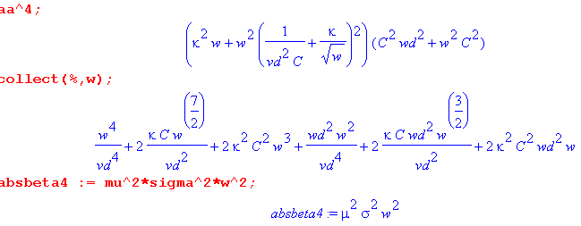

The question is this: is aa4 always << (μσω)2 for all ω? I have just shown it is true for large ω. That means I have shown that

ω4/vd4 << (μσω)2 for all practical ω up to very high. perhaps 1 MHz to 109 GHz

For lower ω, you would have to show that the other terms in the "polynomial" above don't invalidate this inequality. I could plot both sides using the Belden 8281 specific parameters and find out. I guess that will be tomorrows task.

OK, I duly did the plot for Belden and it really does show that |k| << |β| for all ω, from 0 Hz up to about 1016Hz. So this is good news really, I never knew it before. The question now is: how would you show this is true analytically? I think you have to take the High and Low models separately and study each one:

High ω Model

G(ω) = C (ωd + tanL ω ) ωd ≡ (σd/εd)

R(ω) = κ $\sqrt{ω}$
L(ω) = 1/(Cvd2) + (κ/$\sqrt{ω}$) . κ ≡ ( $\frac{1}{p1}$ + $\frac{1}{p2}$)$\frac{μ}{2σ}$ (Q.3.1)

k2 = - (R+jωL)(G+jωC) = - (κ $\sqrt{ω}$+jω[1/(Cvd2) + (κ/$\sqrt{ω}$)])( ωd + tanLω +jω) C

≈ - (κ $\sqrt{ω}$+jω[1/(Cvd2) + (κ/$\sqrt{ω}$)])( ωd + jω) C

≈ - (κ $\sqrt{ω}$+ jω /(Cvd2) + j κ$\sqrt{ω}$) jω C

≈ - [(1+j) κ $\sqrt{ω}$+ jω /(Cvd2)] jω C

|k|2 = ωC | (1+j) κ $\sqrt{ω}$+ jω /(Cvd2) |

We want to compare this to

|β|2 = μσω

The comparison is then this:

|k|2 << |β|2 ??

ωC | (1+j) κ $\sqrt{ω}$+ jω /(Cvd2) | << μσω ?

C | (1+j) κ $\sqrt{ω}$+ jω /(Cvd2) | << μσ = 73 ?

1/vd2 = εdμd so write this as

C | (1+j) κ $\sqrt{ω}$+ jω εdμd /C | << μσ = 73 ?

| (1+j) κ C $\sqrt{ω}$+ jω εdμd | << μσ = 73 ?

Well. really need to get the re and im parts, so write as

| κ C $\sqrt{ω}$+ j (ω εdμd + κ C $\sqrt{ω}$) | << μσ = 73 ?

| κ C $\sqrt{ω}$+ j (ω εdμd + κ C $\sqrt{ω}$) |2 << 732 ?

κ2C2ω +(ω εdμd + κ C $\sqrt{ω}$) 2 << 732

2κ2C2ω + (εdμd)2ω2 + 2εdμd κ C ω3/2 << 732

(εdμd)2ω2 + 2εdμd κ C ω3/2 + 2κ2C2ω << 732

NOW we can look at the coefficients for the Belden 8281 case:

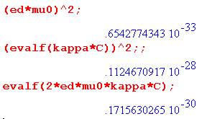

Then we ask

.65 x 10-33 ω2 + .17 x 10-30 ω3/2 +.22 x 10-28 ω << 732 ?

10-28( .65 x 10-5 ω2 + .17 x 10-2 ω3/2 +.22ω) << 732 ?

Now the quantity in (...) is monotonic increasing. If we set ω = 1012 we get

10-28( .65 x 10-5 1024 + .17 x 10-2 1018 +.22 1012) << 732 ?

10-28( .65 x 1019 + .17 x 1016 +.22 x 1012) << 732 ?

10-28 1012( .65 x 107 + .17 x 104 +.22) << 732 ?

10-16 ( .65 x 107 + .17 x 104 +.22) << 732 ?

.65 x 10-9 << 732 ?

6.5 x 10-10 << 732 ?

2.5 x 10-5 << 73 ? // this is |k|2 << |β|2 ?

25 x 10-6 << 73 ?

5 x 10-3 << 8.5 ? // this is |k| << |β| ?

.001 << 1.7 ?

So this is in fact true for the Belden model at high ω.

Low ω Model

G(ω) = C (ωd + tanL ω ) ωd ≡ (σd/εd)
R(ω) = Rdc
L(ω) = Le + Lidc ≡ Ldc . (Q.4.1)

k2 = - (R+jωL)(G+jωC) = -(Rdc + jω Ldc)( ωd + tanLω +jω) C

≈ -(Rdc + jω Ldc)( ωd + jω) C

-k2 = C (Rdc + jω Ldc)( ωd + jω) = C [(Rdc ωd - ω2 Ldc) + j ω (Ldcωd + Rdc) ]

|k|4 = C2 [(Rdc ωd - ω2 Ldc)2 +ω2 (Ldcωd + Rdc)2 ]

|k|4 = C2 [(Rdc ωd - ω2 Ldc)2 +ω2 (Ldcωd + Rdc)2 ]

Then our question is

|k|4 << |β|4 ?

C2 [(Rdc ωd - ω2 Ldc)2 +ω2 (Ldcωd + Rdc)2 ] << (μσω)2

C2 [(Rdc ωd - ω2 Ldc)2 +ω2 (Ldcωd + Rdc)2 ] << (μσω)2

It is true that at ω = 0 this inequality is not valid, but that is only below ω = 10-18 Hz !! Studying the above is not a trivial problem. LHS = Aω4 + B ω2 + C.

I think it is better just to do my plot rather than all the above analysis!

blue means "needs editing"

Appendix M: Why the transverse vector potential At is small for a transmission line

Claim: In the King gauge, the transverse vector potential At may be neglected for frequencies in the range 0 to 500 GHz. (M.1)
Overview: The vector potential is written below as At = ∫conductors dxdy Jt(x,y) * (stuff).
We shall make the following three claims:

(1) | Jt | < 10-3 |Jz| for f = 0 to 500 GHz (which is to say: "transverse currents are small inside the conductors") (M.12)
(2) in the At integral there is a cancellation effect not present in the Az integral
which in effect reduces At by a factor of 10 (ballpark) relative to Az . (M.14)
(3) the net ballpark result is that |At| < 10-4 |Az| for f = 0 to 500 GHz which is essentially the opening claim (M.1) above. (M.22)

As shown in the Anomaly section below, there is an exception to the Claim (M.1)

According to (1.5.9) one can express the King gauge vector potential at all points in space in terms of the currents in the transmission line conductors in this manner,

A(x,ω) = $\frac{1}{4π}$ Σi∫μi Ji(x',ω) $_{d}$dV' R = | x - x' | (1.5.9)

where Σi is a sum over all the conductors, and βd is the wavenumber in the dielectric. Therefore, the transverse part At may be written as an integral of the transverse conductor currents Jt,i :

At(x) = $\frac{1}{4π}$ Σi μi∫Jt,i(x',y',z') $_{d}$dx' dy' dz' . (M.2)

Transverse refers to the x and y directions, where the infinite conductors are aligned in the z direction. The main current in a transmission line conductor is the longitudinal one Jz . When the above equation is processed in the manner of Chapter 4, and one assumes the transmission line limit, the result is

At(x) = - $\frac{1}{4π}$ Σi μi∫Jt,i(x',y') ln(s2) dx' dy' . s2 = (x-x')2 + (y-y'2) (M.3)

As discussed in Section 4.3, in the transmission line limit both βd and k are small (long wavelength), so
e-jβ$_{d}$R ≈ 1 and e-jkR ≈ 1. We assume the standard wave functional form such that Jt,i(x,y,z) = e-jkz Jt,i(x,y) and then set e-jkz ≈ 1 for the contributing portion of the dz' integration and that integration produces -ln(s2) as in Ch 4 or (J.10).

Meanwhile, Appendix D computes the E fields inside a round conductor for each partial wave m, and here we multiply them each by σ to get the current density components,

Current Densities in a Round Wire: Rdc = $\frac{1}{σπa2}$ β'2 = β2 - k2 (D.2.33)

Jz(r,m) = σ(1/4) ηm I Rdc (aβ') fm fm = [$\frac{Jm(x)}{Jm+1(xa)}$ - $\frac{Jm(x)}{Jm-1(xa)}$ ] x = β'r
Jr(r,m) = σ(j/4) ηm I Rdc (ak) gm gm = [ $\frac{Jm+1(x)}{Jm+1(xa)}$ + $\frac{Jm-1(x)}{Jm-1(xa)}$ ] xa = β'a
Jθ(r,m) = σ(1/4) ηm I Rdc (ak) hm hm = [$\frac{Jm+1(x)}{Jm+1(xa)}$ - $\frac{Jm-1(x)}{Jm-1(xa)}$ ]

The currents are expressed in terms of a cylindrical coordinate system whose z axis runs down the center of the round conductor. Coefficient ηm is the "surface charge moment" of the mth partial wave, and the θ-space currents are given by (D.1.3a),

J(r,θ) =$\sum_{m = -∞}^{∞}{}$ J(r,m) ejmθ . // partial wave expansion (M.4)

The moments ηm may be obtained by solving the transmission line "capacitor problem" as outlined in Section 6.5 (a). One finds potential φ, then E, then surface charge n(θ), and finally ηm.

The current components are,

J = Jz + Jr + Jθ = Jz + Jt Jt = Jr + Jθ . (M.5)

Rather than study these round wire internal solutions in detail, we make two observations:

Observation (1): The transverse currents Jr and Jθ are very small compared to Jz. (M.6)

Looking at (D.2.33) above one sees that the transverse currents Jr and Jθ are in general smaller than the longitudinal current Jz by factor |k/β'|. In making this claim we regard the combinations of Bessel functions shown in (D.2.33) as being of the same general scale, which can be confirmed by doing plots of the various complex function magnitudes (for large ω).

So how small is |k/β'| ? Since β'2 = β2 - k2 we may write

|k/β'|2 = $\frac{|k/β|2}{1 - |k/β|2}$ . (M.7)

If we can show that |k/β| = α << 1, then we know that |k/β'| ≈ |k/β| = α << 1. So we then ask: how small is |k/β| ? Recall that

β2 = - jωμσ (1.5.1d) (M.8)

k = - j $\sqrt{(R+jωL)(G+jωC)}$ (5.3.5) (M.9)

so therefore

|k/β| = $\frac{| (R+jωL)(G+jωC)|}{ωμσ}$ . (M.10)

For "large" ω we find that [ see (4.11.34) and following comments ]

|k/β| = $\frac{| (jωL)(jωC)|}{ωμσ}$ = $\frac{ω2LC}{ωμσ}$ ≈ $\frac{ω2LeC}{ωμσ}$ = $\frac{ω2μdεd}{ωμσ}$ = $\frac{ωμdεd}{μσ}$

≈ $\frac{εdω}{σ}$ ≈ $\frac{2.3ε0ω}{σ}$ . (M.11)

We have assumed that L = Le, μd = μ = μ0 and εd/ε0 = 2.3. Here then is a plot of |k/β| for f = ω/2π in the range 1 MHz to 500 GHz.

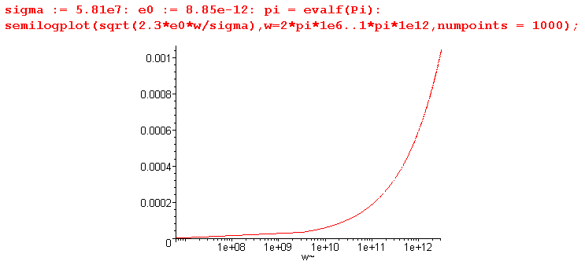

This shows that in fact |k/β| is small, being < .001. But what about "low" frequencies? To get a more complete view we may use the crude transmission line parameter model of Appendix Q,

Simple Transmission Line Parameter Model (Q.1.9)
C(ω) = C = independent of ω κ ≡ ( $\frac{1}{p1}$ + $\frac{1}{p2}$)$\frac{μ}{2σ}$

G(ω) = C (ωd + tanL ω ) ωd ≡ (σd/εd) Gdc ≡ ωd C

R(ω) = Rdc θ(ω<ωR) + (κ $\sqrt{ω}$) θ(ω≥ωR) ωR ≡ (Rdc/κ)2

L(ω) = Le + Lidc θ(ω<ωL) + (κ/$\sqrt{ω}$) θ(ω≥ωL) ωL ≡ (κ/ Lidc)2

LeC = μdεd = 1/vd2 (4.11.34)

Using this model, we may again compute the ratio |k/β| for all ω,

|k/β| = $\frac{| (R+jωL)(G+jωC)|}{ωμσ}$ . (M.9)

In passing, we note that the relation k = - j $\sqrt{(R+jωL)(G+jωC)}$ is accurate for the network model of a transmission line (Appendix K), but is questionable at low ω for the true physics model of a transmission line as presented in Chapters 4 and 5. We use the k expression nevertheless, with the presumption that it is roughly correct at low ω.

The |k/β| ratio involves the transmission line parameters like Rdc, C, Le, Lidc and σd in a complicated way. For parameters appropriate to the Belden 8281 coaxial cable of Appendix R, we can have Maple compute and then plot the ratio. Omitting the Maple details, we first show the resulting plot of |k/β| for frequency in the range 1 MHz to 500 GHz :

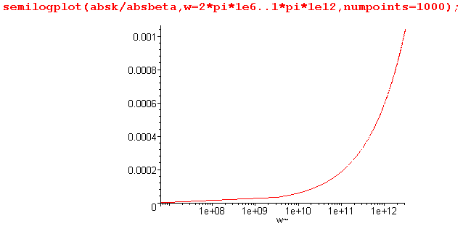

The plot is basically the same as the previous plot using the large ω limit of the ratio. For the range
10-4 Hz to 1 MHz we get instead

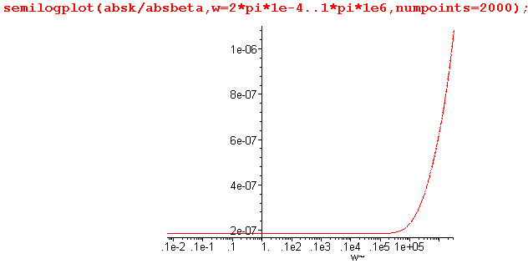

which says |k/β| < 10-6 which is much smaller than the ratio at the higher end of the range. Although our model is inaccurate in the mid ω range, it seems reasonable to nevertheless arrive at this :

Conclusion: For frequencies from 0 to 500 GHz, |k/β| < .001 and therefore |k/β'| < .001 and therefore the ratio of transverse to longitudinal current densities is < .001 = 10-3. That is to say

| Jr | < 10-3 | Jz |
| Jθ | < 10-3 | Jz | f = 0 to 500 GHz (M.12)

The conclusion then is that the transverse currents are less than 1/1000th of the size of the longitudinal currents for the round copper conductor at all frequencies of interest below 500 GHz, and we can reasonably assume that a similar conclusion applies to a conductor of any cross sectional shape (while maintaining the transmission line limit). This then concludes our "proof" of the claim that "transverse currents are very small" inside the conductors of a transmission line.

Anomaly: For a conducting dielectric (σd> 0 => ωd> 0) the ratio |k/β| for small ω has the form

|k/β| = $\frac{| (R+jωL)(G+jωC) |}{ωμσ}$ → $\frac{| Rdc(Cωd+jωC) |}{ωμσ}$ = $\frac{RdcCωd}{ωμσ}$ = $\frac{RdcGdc}{ωμσ}$ (M.13)

which becomes infinite at ω = 0. The issue here is that as ω→0 we have β→0 but k→ -j $\sqrt{RdcGdc}$ ≠ 0. Since the dielectric conducts current, there must be a DC loss going down the transmission line in z and this is associated with Im(k) = - $\sqrt{RdcG}$, so it is expected that k 0. We then expect our 10-3 inequality rule of (M.12) to be violated when

10-6 < RdcGdc/ (ωμσ)
or
ω < 106 RdcGdc/ (μσ) ≈ 106 RdcGdc/73 . // copper conductors

For the Belden 8281 cable of Appendix R, we find that Rdc ≈ .036, Gdc = ωdC ≈ 0.8 x 10-14 so our condition for violation becomes

ω < 106 (.036)( 0.8 x 10-14/73 ) = 3.9 x 10-12 sec-1

It is not unreasonable that at such ultra-low frequencies near DC the transverse current Jr can be large relative to Jz. The network model is then that of Fig K.4. One could solve the DC magnetostatics problem for an infinite transmission line with round conductors to determine Jr and Jz and compare their magnitudes. Since a practical transmission line is not operated at such ultra low frequencies, we ignore the anomaly and state the claim (M.1) as if it were valid all the way down to ω = 0.

NOTE in red: In (D.11.14) I claim to know Jz and Jr as ω→0 for each partial wave. The ratio seems to be this

Jr/Jz ≈ aG / $\sqrt{G/R}$ = a $\sqrt{GR}$

For Belden 8281 center wire this is

Jr/Jz = a1 $\sqrt{GR}$ = .00039 * $\sqrt{(.036)(0.8 x 10-14/73)}$ = .7 x 10-11

which disagrees with the above discussion!! I do state there that k ≈ -j $\sqrt{RG}$ which agrees with above. In box (D.11.7) the ratio Er/Ez is clearly just (ak). What happened to (k/β) ? Aha! It is those Bessel functions that I ignored above !!!!

Observation (2): In the Helmholtz integration (M.3) there is a large amount of cancellation. (M.14)

Let us consider the nature of this integration in the illustrative case of a two round conductors,

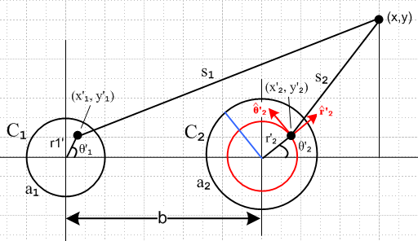 Fig M.1

Consider the contribution to the transverse vector potential component Ax from the right conductor C2,

Ax(x) = - $\frac{μd}{4π}$∫Jx(x'2,y'2) ln(s22) dx'2 dy'2 s22 = (x-x'2)2 + (y-y'22) (M.15)
or
Ax(x) = - $\frac{μd}{4π}$∫ [Jr(r'2,θ'2) '2 • + Jθ(r'2,θ'2) '2 • ] ln(s22) [a2dθ'2] dr'2 (M.16)
or
Ax(x) = - $\frac{μd}{4π}$∫ [Jr(r'2,θ'2) cosθ'2 - Jθ(r'2,θ'2) sinθ'2] ln(s22) [a2dθ'2] dr'2 . (M.17)

The transverse currents in conductor C2 have this partial wave expansion from (M.4),
Jr(r'2,θ'2) =$\sum_{m = -∞}^{∞}{}$ Jr(r'2,m) ejmθ'$_{2}$ (M.18)

and similarly for Jθ . Thus we get

Ax(x,y) = - $\frac{μd}{4π}$a2 Σm $^{\int_{0}^{a2}{}}$dr'2 Jr(r'2,m) $^{\int_{0}^{2π}{}}$dθ '2 ejmθ'$_{2}$ cosθ'2 ln(s22)
+ $\frac{μd}{4π}$a2 Σm $^{\int_{0}^{a2}{}}$dr'2 Jθ(r'2,m) $^{\int_{0}^{2π}{}}$dθ '2 ejmθ'$_{2}$ sinθ'2 ln(s22) (M.19)

where, from (D.2.33) quoted above,

Jr(r,m) = σ(j/4) ηm I Rdc (aβd) [$\frac{Jm+1(x)}{Jm+1(xa)}$ + $\frac{Jm-1(x)}{Jm-1(xa)}$ ] x = β'r
Jθ(r,m) = σ(1/4) ηm I Rdc (aβd) [$\frac{Jm+1(x)}{Jm+1(xa)}$ - $\frac{Jm-1(x)}{Jm-1(xa)}$ ] xa = β'a .

It is in theory possible to first do the dθ'2 integration in (M.19) and then do the dr'2 integration and get an analytic result for Ax(x,y). We have dealt with similar angle integrations elsewhere in this document. Rather then attempt this task, we instead consider the portion of the 2D integration represented by the red ring in Fig M.1. On this ring, r'2 is constant, and our interest is the θ'2 integration. For any value of m (except for ±1) the trigonometric functions like ejmθ'$_{2}$ cosθ'2 integrate to 0, for example,

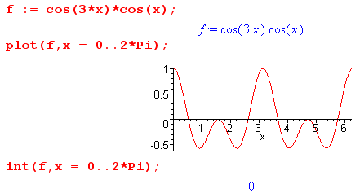 Fig M.2

For these values of m, were it not for the fact that s22 varies around the red circle, Ax(x,y) would be identically 0. Although s22 does vary on the red circle, ln(s2) varies very little, and we expect to still have this strong cancellation in the θ'2 integral so Ax(x,y) is then small. It is true that if x and x'2 were to approach the conductor boundary from opposite sides, then ln(s2) would vary a lot more and the cancellation would be less, but we ignore this detail in our qualitative argument.
For m = ± 1 this smallness argument fails since for example cos2(θ'2) does not average to 0 around the red ring. Ignoring the θ'2 variation in s22 we get in this case (setting e±jθ'$_{2}$ ~ cosθ'2)

Ax(x,y) ≈ - $\frac{μd}{4π}$a2 Σm $^{\int_{0}^{a2}{}}$dr'2 Jr(r'2,m) ln(s22) $^{\int_{0}^{2π}{}}$dθ '2 cos2θ'2
≈ - $\frac{μd}{4π}$a2 Σm $^{\int_{0}^{a2}{}}$dr'2 Jr(r'2,±1) ln(s22) π (M.20)

Now we make a different argument which concerns the behavior of the complex Bessel functions as a function of r'2. As studied in Chapter 2, these functions have a dramatically oscillating phase even in the soft skin depth limit, and we expect then to get cancellation due to this phase as we integrate on the radial segment shown blue in Fig M.1, and again ln(s22) varies slowly on this ray due to the nature of ln.
The arguments made above for Ax(x,y) also apply to Ay(x,y), and it seems reasonable to assume that the arguments are generally valid for an arbitrary conductor cross section.
Admittedly our analysis here is imprecise and qualitative, but we think it is convincing that there is in fact much cancellation when the transverse currents are integrated over the conductors.

This stands in stark contrast to the longitudinal situation where Az, being the Helmholtz integral of Jz, involves a generally non-cancelling integration (per conductor) over a generally large current component.

We now wish to compare the following two integrals, where we pick component Ar to represent a transverse component of At,

Ar(x) = - $\frac{1}{4π}$ Σi μi∫Jr,i(x',y') ln(s2) dx' dy' . s2 = (x-x')2 + (y-y'2) (M.3)
Az(x) = - $\frac{1}{4π}$ Σi μi∫Jz,i(x',y') ln(s2) dx' dy' . s2 = (x-x')2 + (y-y'2) (M.21)

We have shown in (M.13) that | Jr | < 10-3 | Jz |. Without any mathematical rigor, and allowing a factor of 10 "gain" from the cancellation effect of Observation (2), we make the following ballpark estimate,

|At| < 10-4 |Az| f = 0 to 500 GHz. (M.22)

It is assumed that as ω increases, the transmission line geometry is appropriately shrunk so the transmission line limit remains operative.

