PhL 3.28.14

Appendix N: Drude, Magnetic Ohm's Law, Regular Hall Effect, Radial Hall Effect 1
N.1 The Drude Model of Conduction 1
N.2 A Theory of the Hall Effect 3
N.3 The Cyclotron Frequency 7
N.4 Steady-state Electron Motion with E and B fields: Magnetic Ohm's Law 8
N.5 Theory of the Hall Effect Revisited 10
N.6 Theory of the Hall Effect with Multiple Carrier Types 12
N.7 The Radial Hall Effect in a Round Wire 15

Appendix N: Drude, Magnetic Ohm's Law, Regular Hall Effect, Radial Hall Effect

The first sections of this Appendix follow the general outline of notes prepared by Pengra et. al. for a Laboratory Class at the University of Washington.

N.1 The Drude Model of Conduction

The current due to carriers of charge q and density n with drift velocity v is easily shown to be

J = nqv . dim RHS = m-3 * Coul * m/sec = amp/m2 (N.1.1)

In the classical Drude (and Lorentz) model (1900), which of course predates quantum mechanics, the charges are assumed to be electrons with charge q = - |e| and mass m = me. At this time there was no band-gap theory, no holes, no effective mass, none of that good stuff. The density n is one electron per atom for a metal like copper. Here are some basic numbers :

n = 8.5 x 1028 electrons/m3 // for copper

|e| = 1.6 x 10-19 Coul . (N.1.2)

If a relatively large current of 1000 Amps flows through a wire of 1 cm2 cross sectional area, one has

J = 1000 amps/ 10-4m2 = 107 amp/m2 .

The drift velocity is then

v = J/(nq) = $\frac{100}{1.6*8.5}$ x 105+19-28 = 7.4 x 10-4 m/sec = 0.74 mm/sec ≈ 1 mm/sec

In this same classical vein, if the electron has thermal energy (1/2) mvth2 = (3/2) kT, one can solve for the thermal electron velocity at room temperature,

vth ~ 100,000 m/sec .

Although this number is wrong from a quantum view, the fact that it is very much larger than the drift velocity is correct. In the Drude theory, these fast-moving electrons are colliding with copper ions at a high rate, and every collision results in a complete redirection of the electron. In copper the effective mean collision time is on the order of τ = 10-14 sec. It is only between these closely spaced collisions that the electrons have time to drift a little bit in the presence of an electric field. Since F = qE = dp/dt, one concludes that Δp = qEΔt or just p = qEτ where p is the amount of drift momentum an electron picks up between collisions. Since on average an electron on each collision dumps this momentum into the lattice, the lattice can be regarded as a frictional or drag force acting against the electron's flow, and that force is - Δp/Δt = - p/τ . So,

Ff = - p/τ = - (m/τ) v . (N.1.3)

This frictional force is proportional to velocity, as is typical for low-velocity fluid drag, and is of course in a direction opposite the velocity. When combined with the Lorentz force,

F = qE + qvxB (N.1.4)

and F = ma, one obtains a fairly reasonable equation describing the motion of a conduction electron,

m$\frac{dv}{dt}$ = qE + qvxB - (m/τ) v . (N.1.5)

If B = 0 and the conduction is in steady-state, this says

0 = qE- (m/τ) v
or
v = (qτ/m)E . (N.1.6)

The constant appearing here is called the carrier mobility μ, so then

v = μE μ = (qτ/m) . // units of μ are tesla-1 (N.1.7)

Officially mobility is (|q|τ/m) > 0, but we shall use the signed mobility shown above.

Warning: μ is the same symbol used for magnetic permeability.

If one now installs the drift velocity (N.1.6) into (N.1), one gets

J = nqv = (nq2τ/m)E = σE . σ = conductivity (N.1.8)

The coefficient appearing in (N.1.8) is known as the conductivity of the medium, as we well know by now, so the classical Drude theory is predicting that

σ = (nq2τ/m) . // σ = n q μ (N.1.9)

If one measures σ for copper, one can deduce the value of τ for the Drude model of conduction:

τ = mσ/(nq2) (N.1.10)

But

m = 9.109 x 10-31 kg // electron mass
σ = 5.81 x 107 mho/m // conductivity of copper (N.1.11)

so that, along with the numbers stated earlier in (N.1.2),

τ = mσ/(nq2) = 2.43 x 10-14 ~ 10-14 (N.1.12)

as claimed earlier.
If the electrons are moving with time dependence ejωt, the left side of the equation of motion (N.1.5) becomes jωm v. We then get

jωm v = qE- (m/τ) v

(m/τ)(1+jωτ) v = qE

v = $\frac{1}{1+jωτ}$(qτ/m)E μac = $\frac{1}{1+jωτ}$μ (N.1.13)

J = nqv = $\frac{1}{1+jωτ}$(nq2τ/m)E = σacE σac = $\frac{1}{1+jωτ}$ σ (N.1.14)

In our analysis of transmission lines, ωτ << 1, so we may neglect this AC adjustment of the mobility and conductivity. Roughly ωτ ≈ 1 when

ω = 2πf = 1/τ = 1014 => f ≈ 16,000 GHz (N.1.15)

so for f < 160 GHz there will be < 1% change in μ or σ in the Drude Model.

N.2 A Theory of the Hall Effect

All theories and models are deficient in some way but might still deliver a reasonable result. The Drude model above is generally "reasonable" in this regard, though it fails to match reality in various ways. Here we present an instant theory of the Hall Effect which correctly predicts the main result to within about 30%, but has an annoying theoretical defect noted at the end of the section.
Using the traditional directions x, y, and z, here is the classical Hall Effect picture, where we put the origin at the center of the sample,

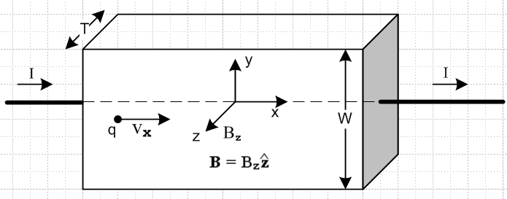 Fig N.1

The idea is that current flows through a sample in the presence of a uniform transverse magnetic field which in this case is B = Bz . Semiconductors have much lower carrier densities than copper, and one can imagine for a semiconductor sample that the block above is placed between two highly conductive gold plates (gray on right) to cause the applied current to be spread out evenly in the sample. This is one of several technical details we shall ignore, and we just assume the current is spread out evenly. Typically the thickness T is made very small because this boosts the Hall voltage as we shall see below.
For the sake of our discussion, we assume we are in an anti-matter universe where the carriers are positive electrons (positrons) and the lattice consists of negative ions. We just want to deal first with positively charged carriers since then vx and Jx and I are all positive. So assume q > 0. The Lorentz force acting on a carrier of charge q, along with the friction term, was shown in (N.1.5),

F = q E +q vxB - (m/τ) v . (N.1.5)

One's right hand indicates that vxB is downward in the -y direction, so there is a force deflecting the positive carriers downward, and so for a while there is some downward vy drift. This naturally piles up a positive surface charge on the lower face of the sample. Since the density of positrons and anti-copper ions must be the same to maintain neutrality in the copper sample, these positrons in effect come from the upper face which then has a negative surface charge. Thus we have in effect a parallel plate capacitor, positive on the bottom, with spacing W, and a transverse field Ey > 0 appears due to these surface charges. This Ey field then stops further downward deflections, and the positrons then have only v = v . The steady-state solution value of Ey is determined by

Fy = qEy + q (vxB)y - (m/τ) vy = 0

But vy = 0 so this says

Ey = - (vxB)y = - (vxB)• = - { [vx] x [Bz ]} • = vxBz • = vxBz
or
Ey = vxBz . // the Hall field (N.2.1)

From (N.1.1) we have Jx = nqvx and also Jx = I/(WT) so

vx = $\frac{I}{nqWT}$ and then Ey = $\frac{IBz}{nqWT}$ . (N.2.2)

One usually then defines

RH ≡ $\frac{1}{nq}$ // the Hall coefficient (N.2.3)

so (N.2.2) becomes

vx = RH $\frac{I}{WT}$ and Ey = RH $\frac{IBz}{WT}$ // the Hall field (N.2.4)

This Ey field produces a potential (a voltage) between the top and bottom faces, and since E = - ∇V,

VH = Vtop - Vbot = V(W) -V(0) = $^{\int_{0}^{W}{}}$$\frac{dV}{dy}$ dy = – $^{\int_{0}^{W}{}}$Ey dy = - Ey W = - RH $\frac{IBz}{WT}$ * W
so
VH = – RH * $\frac{IBz}{T}$ // the Hall voltage (N.2.5)

We now return the reader to the regular universe. How is the above discussion altered? Since the carriers are now electrons with q = -|e| < 0, the vx arrow in Fig N.1 points to the left and we have vx < 0. From (N.2.2) the Hall field Ey changes sign, becoming negative (though it is still Ey = vxBz ), and the Hall voltage changes polarity and is now positive ( the Hall coefficient is negative). To summarize:

RH = $\frac{1}{nq}$ = - $\frac{1}{n|e|}$ < 0
Ey = RH $\frac{IBz}{WT}$ = – $\frac{1}{n|e|}$ $\frac{IBz}{WT}$ < 0
VH = – RH $\frac{IBz}{T}$ = + $\frac{1}{n|e|}$$\frac{IBz}{T}$ > 0 (N.2.6)

Notice that the electrons are still deflected down (as were the positrons) because both q and v x B change sign in the Lorentz force. This now creates negative charge on the bottom face and positive on the top and so now Ey < 0, consistent with Ey = vxBz with vx < 0.

Fact: The sign of the Hall voltage VH indicates the sign of RH and thus the sign of the charge carriers! If for some metal the carriers are holes ( in the quantum theory of metals), RH will be positive. Pre-quantum researchers were indeed surprised when they found different signs of RH for different metals.

Using the numbers in (N.1.2), the Drude theory for copper predicts that

RH ≈ -.73 x 10-3 // Drude theory (N.2.7)

Here is the simple Maple calculation using numbers from (N.1.2) above,

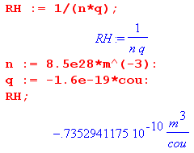
This is not too far from the measured and quantum-correct value of -0.55 x 10-10 (though the literature seems a bit unsure of this number). This is an impressive success of the classical Drude theory.

As claimed earlier, and as seen in (N.2.5), making thickness T very small makes VH larger so it can be measured with a voltmeter one can afford to place in a student lab. Typical numbers for a student lab experiment might be

T = 18 microns = 18 x 10-6 m // a thin film of copper
W = 1 cm = 1 x10-2m
Bz = 5000 gauss = 0.5 T
I = 10 amps (N.2.8)

so that, according to the Drude theory,

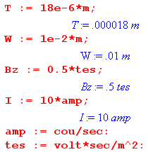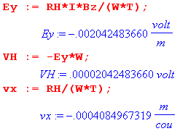

so we end up for this experiment with

Ey = - 2 mV/m Hall field
VH = 20 μV Hall voltage
vx = - 0.4 mm/sec drift velocity (N.2.9)

Notice that RH = - $\frac{1}{n|e|}$. Since the carrier densities in a semiconductor are much smaller than in a metal, n is smaller and RH is much larger, and practical Hall devices are more feasible. But our theory has to first be generalized to two types of carriers (electrons and holes), and this is done in Section N.6 below.
A Hall effect sensor exists in almost every fan in every personal computer in the world. Since the fan has some rotating permanent magnets, the Hall sensor can detect the rotational position and speed of the blades and most importantly detects when the fan has stopped rotating altogether (pulses stop). In general, Hall sensors are used to measure magnetic fields, and can be used as simple magnetic switches.
If we assume that Ohm's Law J = σ E is operative in our Hall sample, we run into a small deficiency in the theory. Since there is an internal field Ey in the sample, there should be a corresponding and uniform current density Jy = σ Ey in the sample. Unfortunately, at the top face (for example) this current has no place to go, so something is wrong. This problem will be dealt with in Section N.5 below.

N.3 The Cyclotron Frequency

When a charged particle travels through a region of space having a uniform B field and no E field, the equation of motion (N.1.5) becomes (dot means time derivative),

m = q vxB . (N.1.5)

Assume that B = B so then

q vxB = [vx + vy + vz] x [qB] = - vxqB + vyqB

so
mx = vyqB => x = ωcvy => x = -ωc2vx
my = -vxqB y = - ωcvx y = -ωc2vy
mz = 0 z = 0 where ωc ≡ (qB/m) . (N.3.1)

Looking at the 2nd order ODE for vx we may write the general solution for vx in terms of two constants R and φ in this way

vx = -Rωcsin(ωct + φ) => vy = (1/ωc) x = - Rωccos(ωct + φ)

so that

v = $\sqrt{vx2+vy2}$ = Rωc = (RqB/m) (N.3.2)

vx = - Rωcsin(ωct + φ) => x = R cos(ωct + φ) + x1
vy = - Rωccos(ωct + φ) => y = -R sin(ωct + φ) + y1
vz = vz => z = vzt + z0 (N.3.3)
so
(x-x1) = R cos(ωct + φ)
(y-y1) = - R sin(ωct + φ) => (x-x1)2 + (y-y1)2 = R2
(z-z0) = vzt . (N.3.4)

In the x,y dimension the particle goes around in a circle of radius R at rate ωc (clockwise if ωc > 0), while in the z direction of B it moves at some constant velocity, resulting in a circular or slinky spiral trajectory.
The angular frequency ωc is known as the cyclotron frequency, named after a charged-particle accelerator invented in 1932 by Lawrence known as a cyclotron, see wiki and left drawing below. In this machine particles traverse an outward going spiral (different from the one just mentioned) because they are accelerated by an AC electric field driving two hollow D-shaped conductors of a capacitor enclosing the particle beam. As v increases, R must increase as shown above in (N.3.2). The capacitor is driven at the cyclotron frequency ωc so the accelerating E field is in sync with the circular particle motion. Since ωc ≡ (qB/m), this frequency has to be reduced if the charged particle bunch being accelerated reaches relativistic speeds and m increases.
The circular motion of charged particles in a uniform B field is also used to identify particles produced in high energy collisions inside particle accelerator detectors. Since v = RqB/m, if the particle m and q is known, the speed v and hence energy can be determined from R, and the sign of q can be found from the CW or CCW nature of the particle path. Alternatively, if the energy and speed are known from "calorimetry" and a charge q is assumed, the mass m of the particle can be found from R.

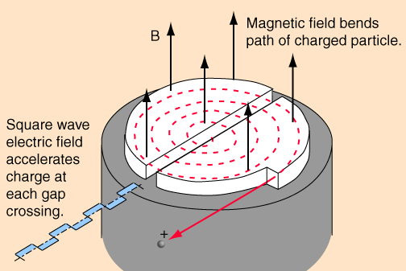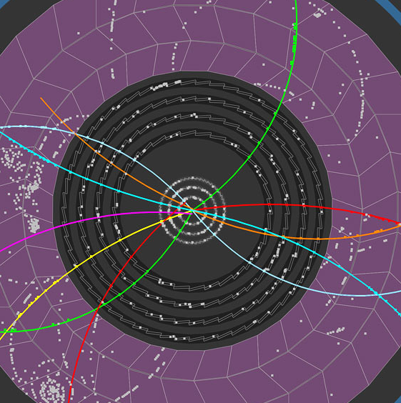
http://hyperphysics.phy-astr.gsu.edu/hbase/magnetic/cyclot.html CERN
The Cyclotron Particle Tracks (B field out of paper) Fig N.2

N.4 Steady-state Electron Motion with E and B fields: Magnetic Ohm's Law

We start again with the motion equation for an electron in copper,

m$\frac{dv}{dt}$ = qE + qvxB - (m/τ) v . (N.1.5)

We now seek a steady-state solution, so the equation becomes

(m/τ) v = qE + qvxB . (N.4.1)

Making use of the signed mobility μ = qτ/m shown in (N.1.7), we can write (N.4.1) as

v = μE + μvxB
or
v - μvxB = μE . (N.4.2)

The plan is to solve this equation for v and then to obtain the current density using J = nqv from (N.1.1). Recall that Ohm's Law says J = σ E, but with B present, Ohm's Law will be different. For simplicity, we again assume B = B . Then

μ vxB = [vx + vy + vz] x [μ B ] = - vxμB + vyμB

so that (N.4.2) becomes

[vx + vy + vz] - [- vxμB + vyμB ] = [μEx + μEy + μEz ]

which may be decomposed into the following three equations,

vx - μBvy = μEx
vy + μBvx = μEy
vz = μEz . (N.4.3)

The first two equations may be expressed in matrix form

$\left(\begin{matrix}1 & -μB \\ μB & 1\end{matrix}\right)$$\left(\begin{matrix}vx \\ vy\end{matrix}\right)$ = μ $\left(\begin{matrix}Ex \\ Ey\end{matrix}\right)$ (N.4.4)

and then

$\left(\begin{matrix}vx \\ vy\end{matrix}\right)$ = μ $\left(\begin{matrix}1 & -μB \\ μB & 1\end{matrix}\right)$ $\left(\begin{matrix}Ex \\ Ey\end{matrix}\right)$ . (N.4.5)
Maple tells us

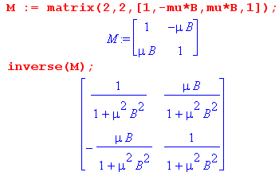
so then

$\left(\begin{matrix}vx \\ vy\end{matrix}\right)$ = $\frac{μ}{1+(μB)2}$ $\left(\begin{matrix}1 & μB \\ -μB & 1\end{matrix}\right)$ $\left(\begin{matrix}Ex \\ Ey\end{matrix}\right)$ = $\frac{μ}{1+(μB)2}$$\left(\begin{matrix}Ex + μBEy \\ Ey - μBEx\end{matrix}\right)$ . (N.4.6)

But using (N.3.1) that ωc ≡ (qB/m) one finds that

μB = (qτ/m)B = (qB/m)τ = ωcτ (N.4.7)

so the solutions above, combined with the known third solution vz = μEz, become

vx = μ( Ex + ωcτ Ey) $\frac{1}{1+(ωcτ)2}$
vy = μ (Ey - ωcτ Ex) $\frac{1}{1+(ωcτ)2}$

vz = μEz . (N.4.8)

We have found our solution for v ! To find J use (N.1.1) that J = nqv and the fact that

nqμ = nq(qτ/m) = (nq2τ/m) = σ // from (N.1.7) and (N.1.9) (N.4.9)

to find that (in agreement with (10) of Pengra),

Jx = σ (Ex + ωcτ Ey) $\frac{1}{1+(ωcτ)2}$ ωc ≡ (qB/m)
Jy = σ (Ey - ωcτ Ex) $\frac{1}{1+(ωcτ)2}$ B = B

Jz = σEz . σ = (nq2τ/m) (N.4.10)

The is the "Magnetic Ohm's Law" which, in the presence of B = B , replaces the usual Ohm's Law,

Jx = σEx
Jy = σEy
Jz = σEz (1.1.7)

Fortunately, as will be shown below, the magnetic field strength in a transmission line is small enough so that ωcτ << 1, which means that the normal Ohm's Law is justified despite the presence of B fields.

N.5 Theory of the Hall Effect Revisited

We replicate the Hall geometry from above, where recall that B = Bz :

Fig N.1

Looking at the drawing, and recalling the small "defect" in the theory of Section N.3, and staring at the Magnetic Ohm's Law (N.4.10), we insist that Jy = 0 at least at the top and bottom faces, since as noted earlier, this current "has nowhere to go" in the steady state. Since things are generally uniform in this slab of material, we make the ansatz that Jy ≡ 0 everywhere in the sample. The second equation of (N.4.10) then says

Ey - ωcτ Ex = 0 (N.5.1)

and when this is inserted into the first equation we find, along with the other two equations of (N.4.10),

Jx = σ (Ex + ωcτ [ωcτ Ex]) $\frac{1}{1+(ωcτ)2}$ = σ Ex
Jy = 0

Jz = σEz . (N.5.2)

There is no reason to have Ez ≠ 0 since the electrons are only deflected up and down. Moreover, we would like to have Jz = 0 on the front and back face, so Ez ≡ 0 is the obvious choice.

Then from (N.5.1) we must have

Ey = ωcτ Ex = ωcτ [Jx/σ] = $\frac{ωcτ Jx}{σ}$ * $\frac{I}{JxTW}$ * $\frac{qBz/m}{ωc}$ * $\frac{σ}{nq2τ/m}$
= $\frac{τ}{1}$ * $\frac{I}{TW}$ * $\frac{qBz/m}{1}$ * $\frac{1}{nq2τ/m}$
= $\frac{1}{nq}$ * $\frac{I Bz}{TW}$ . (N.5.3)

This is the Hall field ! The Hall voltage is then

VH = – EyW = $\frac{1}{nq}$ * $\frac{I Bz}{T}$ = – RH $\frac{I Bz}{T}$ RH = $\frac{1}{nq}$ . (N.5.4)

This is the same as the Hall voltage obtained in our previous derivation, as shown in (N.2.4) and (N.2.5). But now we end up with Jy = 0 so there is no vertical current having nowhere to go, nor is there front-back current, and we also have Jx doing the regular Ohm's Law as shown in (N.5.2)

Jx = σEx
Jy = 0
Jz = 0 . (N.5.5)

This seems a more complete solution to the Hall problem than that of Section N.2.

N.6 Theory of the Hall Effect with Multiple Carrier Types

Let index i label the types of carriers. The developments of Sections N.1 through Section N.4 carry through as is, but everything now has an i index. For example, we now have

J = Σiniqivi (N.1.1) (N.6.1)

vi = (qiτi/mi)E = μi E μi = (qiτi/mi) = signed mobility (N.1.7) (N.6.2)
σi = niqi μi = niq (qiτi/mi) = (niqi2τi/mi) (N.1.9) (N.6.3)

vi - μivixB = μiE . (N.4.2) (N.6.4)

This leads to solutions for velocities vi ,

vxi = μi( Ex + ωciτi Ey) $\frac{1}{1+(ωciτi)2}$ ωci ≡ (qiB/mi)
vyi = μi (Ey - ωciτi Ex) $\frac{1}{1+(ωciτi)2}$ μi = (qiτi/mi)

vzi = μi Ez (N.4.8) (N.6.5)

and we can define the total conductivity as

σ ≡ Σi σi . (N.6.6)

The current densities from (N.6.1) and (N.6.5) are then, using also (N.6.3) that σi = niqi μi ,

Jx = Σi σi { ( Ex + ωciτi Ey) $\frac{1}{1+(ωciτi)2}$} ωci ≡ (qiB/mi)
Jy = Σi σi { (Ey - ωciτi Ex) $\frac{1}{1+(ωciτi)2}$} ωciτi = (qiτiB/mi) = Bμi

Jz = Σi σi Ez = Ez Σi σi = Ez σ . (N.6.7)

At this point it is useful to define objects α and β having the dimensions of conductivity, and a third object which is γ = β/B :

α ≡ Σi σi $\frac{1}{1+(ωciτi)2}$
β ≡ Σi σi $\frac{ωciτi}{1+(ωciτi)2}$ = B Σi σi $\frac{μi}{1+(ωciτi)2}$
= B γ γ ≡ Σi σi $\frac{μi}{1+(ωciτi)2}$ . (N.6.8)

In terms of α and β we rewrite (N.6.7) as

Jx = α Ex + βEy
Jy = α Ey - βEx
Jz = Ez (Σi σi) = Ez σ . (N.6.9)

Our Hall effect geometry again requires that Jy = 0 and that Jz = 0 ("nowhere to go") ,
Fig N.1

so the second equation of (N.6.9) says

α Ey = βEx
or
Ey = (β/α) Ex // = the Hall field (N.6.10)

and this is the Hall-effect electric field in the case of multiple carrier types. Inserting this into the first equation of (N.6.9) gives

Jx = α Ex + βEy = α Ex + β (β/α) Ex = [ α + β2/α ] Ex ≡ σmr Ex (N.6.11)

so our triplet of current densities is now

Jx = [α + β2/α] Ex
Jy = 0
Jz = 0 . (N.6.12)

The conductivity appearing in the Jx equation we might define as σmr so that

Jx = σmr Ex σmr = α + β2/α = α(B) + B2 γ(B)2/α(B) (N.6.13)

where we must remember that α, β and γ all depend on B through each ωciτi = Bμi. In general, we have σmr ≠ σ, so the Hall sample has a conductivity in the main current direction x which depends in a complicated manner on field B. This effect is called magnetoresistance. However, if there is only one carrier type, one finds that σmr = σ (see below) and there is then no magnetoresistance effect, as we already saw in the first equation of (N.5.2).

The Hall field can be written

Ey = (β/α) Ex = (β/α) [ α + β2/α ]-1 Jx = (β/α) [ α + β2/α ]-1 I / (WT)

= $\frac{β}{α2+β2}$ I / (WT) = $\frac{Bγ}{α2+Bγ2}$ I / (WT) = $\frac{γ}{α2+Bγ2}$ B I / (WT) (N.6.14)

and then the Hall voltage is

VH = - EyW = - $\frac{γ}{α2+B2γ2}$ B I / T (N.6.15)

and the Hall coefficient is

RH = $\frac{γ}{α2+β2}$ = $\frac{γ(B)}{[α(B)]2+[β(B)]2}$ . (N.6.16)

Unlike the single-carrier case, RH now depends on B in a complicated manner. Just to verify the single carrier case we evaluate:

α = σ $\frac{1}{1+(ωcτ)2}$ β = σ $\frac{ωcτ}{1+(ωcτ)2}$ γ = σ μ $\frac{1}{1+(ωcτ)2}$

α2 + β2 = σ2 $\frac{1}{1+(ωcτ)2}$ RH = $\frac{γ}{α2+β2}$ = $\frac{σμ}{σ2}$ = μ/σ = (qτ/m) / (nq2τ/m) = 1/(nq)

σmr = α + β2/α = (1/α)( α2 + β2) = σ2/σ = σ . // no magnetoresistance (N.6.17)

If we take the magnetic field B small enough so that ωciτi << 1 for all carrier types, where recall that ωci ≡ (qiB/mi), there is considerable simplification. We find that

α ≡ Σi σi $\frac{1}{1+(ωciτi)2}$ ≈ Σi σi = σ
β = Σi σi $\frac{ωciτi}{1+(ωciτi)2}$ ≈ Σi σi $\frac{ωciτi}{1}$ << Σi σi 1 << σ

α2 + β2 ≈ α2 ≈ σ2
γ = Σi σi $\frac{μi}{1+(ωciτi)2}$ ≈ Σi σiμi . // signed mobilities (N.6.18)

Then we find that

RH ≈ $\frac{Σi σiμi}{σ2}$ = $\frac{Σi σiμi}{(Σi σi)2}$ . (N.6.19)

For two charge carrier types this gives

RH = $\frac{σ1μ1 + σ2μ2}{(σ1+σ2)2}$ = $\frac{n1q1 μ1 μ1 + n2q2 μ2 μ2}{(n1q1 μ1 + n2q2 μ2)2}$ . (N.6.20)

Now suppose 1 = hole and 2 = electron so then q2 = -q1. Then we get, where q1 = |e|,

RH = $\frac{1}{|e|}$$\frac{n1μ12 - n2μ22}{(n1μ1 - n2μ2)2}$ → $\frac{1}{|e|}$$\frac{n1μ12 - n2μ22}{(n1μ1 + n2μ2)2}$ // weak B field (N.6.21)

where in the last form we revert to the official all-positive mobilities. This result is in agreement with Eq. (13) of our Pengra et. al. reference. The Hall coefficient could have either sign!

N.7 The Radial Hall Effect in a Round Wire

The author has had difficulty finding a treatment of this subject, but it must exist somewhere.

Consider an "isolated" infinitely long round wire of radius a carrying static current I. We use cylindrical coordinates r,θ,z with the symmetry axis along the wire center line. It is often casually claimed that the current density Jz in such a wire is uniform throughout the cross section and that there is no charge density on the surface. Here we wish to explore these claims.
In cross section, the situation is as follows:

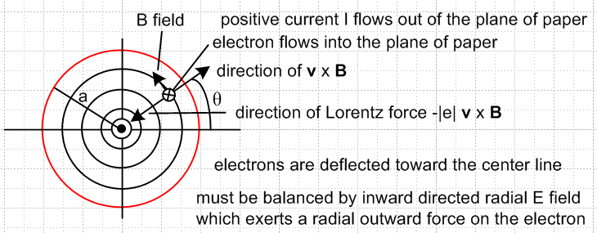

Each electron sees the magnetic field B created by all the other flowing electrons. At any azimuthal location θ, the electrons are deflected toward the center line by this B field, causing a free charge distribution inside the wire which results in a radial field component Er. This radial Hall field then offsets the deflection resulting in all electrons flowing exactly in the z direction.
This problem differs from the regular Hall effect problem studied in Sections N.2 and N.5 in two major ways: (1) The magnetic field is generated by the flowing current under study, it is not externally applied; (2) the magnetic field is non-uniform and in fact is a function of r.
We shall use the method of Section N.5 to determine the Er field and the associated charge distribution. The three unit vectors , , of that section can be replaced by the cylindrical unit vectors , , where the usual cyclic sense of unit vector cross products is then maintained. In a cross section of the round wire, r and θ are then "the usual" polar coordinates, while the z axis comes out of the plane of paper.
Since the situation is static, one must have curl E = 0 . But in cylindrical coordinates,

curl E = [ r-1∂θEz - ∂zEθ] + [∂zEr - ∂rEz] + [ r-1∂r(rEθ) - r-1∂θEr ] .
1 2 3 4 5 6

We certainly expect to have Eθ = 0 at r = a since the round wire surface should be an electrostatic equipotential, and it seems reasonable to have Eθ = 0 everywhere inside the wire, so we set Eθ= 0 as an ansatz in a search for a Maxwell-Equations solution, and this knocks out terms 2 and 5 Any term with ∂z must also vanish since the wire is static and infinite in length, killing off terms 2 and 3. Since the wire is in isolation, the field pattern must be azimuthally symmetric, so ∂θ terms vanish, killing off 1and 6. Having thus removed terms 1,2,3,5,6, we are left only with term 4 so

curl E = [- ∂rEz] . (N.7.1)

Since the static situation requires curl E = 0, we end up with

∂rEz(r,θ,z) = ∂rEz(r) = 0 => Ez(r) = constant . (N.7.2)
Recalling from Section N.4 that Ohm's Law can be affected by magnetic fields, we now make a second ansatz which is that the regular Ohm's Law applies in the z direction. We then obtain

Jz(r) = σ Ez(r) = constant Jz = uniform (N.7.3)

and in this way we arrive at a uniform Jz in the wire, but we need to verify that our assumptions made so far are consistent with other requirements. Given then that Jz is constant in r and θ, we can compute the magnetic field inside the wire from Ampere's Law in the usual fashion,

2πr H(r) = $\frac{πr2}{πa2}$ I => H(r) = $\frac{I}{2πa}$ (r/a) => B(r) = $\frac{μ0I}{2πa}$ (r/a) = B(r) (N.7.4)

Here we make a third ansatz that the other two B field components are 0. Note that μ0 is magnetic permeability, while μ to appear below is the (signed) electron mobility.

At this point, we recall the static equation (N.4.2) arising from the Lorentz force and collision friction,

v - μvxB = μE (N.4.2) (N.7.5)

and we solve for v using the method of Section N.4. First,

μ vxB = [vr + vθ + vz ] x [μ B ] = vr μ B - vz μ B

v = vr + vθ + vz

Then (N.7.5) becomes

[vr + vθ + vz ] - [vr μ B - vz μ B ] = μEr + μEθ + μEz

which may be decomposed into the following three equations ( here in z,r,θ order),

vz - μ B vr = μEz
vr + μ B vz = μEr
vθ = μEθ . (N.7.6)

We note that the first two equations of (N.7.6) have the same form as the first two equations in (N.4.3) which were

vx - μBvy = μEx
vy + μBvx = μEy (N.4.3)

Taking then the previous solution with (x,y) → (z,r) we find from (N.4.8) that

vz = μ( Ez + ωcτ Er) $\frac{1}{1+(ωcτ)2}$
vr = μ (Er - ωcτ Ez) $\frac{1}{1+(ωcτ)2}$

vθ = μEθ . (N.7.7)

where we have carried down the third equation from above. Recall that the cyclotron frequency ωc enters the picture since μB = ωcτ as shown in (N.4.7). However, now since B = B(r), we have ωc = ωc(r) = qB(r)/m. Nothing in the development of Section N.4 precluded the B field from having spatial dependence because no spatial derivatives (like curl or div) were involved.
The next step is to use (N.1.1) that J = nqv and the fact (N.4.9) that nqμ = σ to obtain,

Jz = σ ( Ez + ωcτ Er) $\frac{1}{1+(ωcτ)2}$ ωc ≡ (qB/m)
Jr = σ (Er - ωcτ Ez) $\frac{1}{1+(ωcτ)2}$ B = B

Jθ = σEθ . σ = (nq2τ/m) (N.7.8)

Since the radial current at the surface "has nowhere to go" we set Jr = 0 just as we set Jy = 0 in the Hall effect analysis of Section N.5. One then finds

Er = ωcτ Ez (N.7.9)

where Er is a radial Hall field. Insertion of (N.7.9) into the first line of (N.7.8) gives

Jz = σ ( Ez + ωcτ [ωcτ Ez]) $\frac{1}{1+(ωcτ)2}$ = σEz (N.7.10)

and then our current components are

Jz = σEz
Jr = 0
Jθ = 0 (N.7.11)

where in the last line we have applied our ansatz that Eθ = 0. Our earlier assumption that the regular Ohm's Law applies in the z direction is now self-consistently born out.
The radial Hall field from (N.7.9) is

Er(r) = ωc(r)τ Ez = (qB(r)/m) τ Ez = (qτ/m) B(r) Ez = μ B(r) Ez // (N.1.7) for μ

= μ * $\frac{μ0I}{2πa}$ (r/a) * $\frac{Jz}{σ}$ // (N.7.4) for B(r) and (N.7.11) for Ez

= $\frac{μ}{σ}$ * $\frac{μ0I}{2πa}$ (r/a) * $\frac{I}{πa2}$ = $\frac{1}{nq}$ * $\frac{μ0I2}{2π2a3}$ (r/a) // (N.1.9) for μ/σ

= $\frac{μ0I2}{2π2a3nq}$(r/a) ≡ Es (r/a) (N.7.12)
where
Es ≡ Er(a) = $\frac{μ0I2}{2π2a3nq}$ volts/m . // Es < 0 since q = -|e| (N.7.13)

The three electric field components are then

Ez = I / (πa2)
Er = Es (r/a)
Eθ = 0 . (N.7.14)

We may then compute div E,

div E = r-1∂r(rEr) + r-1∂θEθ + ∂zEz = r-1∂r(rEr)

= r-1∂r(r[Es(r/a)]) = (Es/a) r-1∂r(r2) = (Es/a) r-12r = (2Es/a) (N.7.15)

Since div E = ρ/ε0 , we conclude that there must be a constant free charge density inside the wire,

ρ = ε0(2Es/a) . (N.7.16)

In a slice of the round wire of length dz, the total internal charge is

Q = ρ * (area) * dz = ρ πa2 dz = ε0(2Es/a) πa2 dz = ε0(2πaEs)dz . (N.7.17)

Since this charge had to come from somewhere, we conclude that the outer surface of the wire slice has charge - Q and surface charge density ns

ns = -Q/(2πadz) = - ε0(2πaEs)dz / (2πadz) = -ε0Es , (N.7.18)

a result one could also obtain from a gaussian box at the surface. Outside the wire, each charge density acts as a line charge at the wire center and they cancel out, so there is no external Hall field.
There exists a Hall voltage between the wire surface and the wire's center line,

VH = V(a) - V(0) = $^{\int_{0}^{a}{}}$$\frac{dV}{dr}$ dr = – $^{\int_{0}^{a}{}}$ Er(r) dr = – (Es/a) $^{\int_{0}^{a}{}}$ r dr
= -(a/2)Es = -(a/2) $\frac{μ0I2}{2π2a3nq}$ = - $\frac{1}{nq}$ * $\frac{μ0I}{2πa}$ * $\frac{I}{2πa}$ = – $\frac{1}{nq}$ * Bθ(a) * $\frac{I}{2πa}$ (N.7.19)
so
VH = – RH [Bθ(a)/2π] I/ a RH = $\frac{1}{nq}$ (N.7.20)

which we compare to the normal Hall effect result (N.2.5)

VH = – RH Bz I / T . // the Hall voltage (N.2.5)

The RH is the same in both geometries, but the thickness T is replaced by radius a, and the uniform Hall B field is replaced by Bθ(a)/2π . We make this arbitrary partitioning of the factors since radius a seems the distance that most corresponds to thickness T of the normal Hall effect.
It is certainly unclear how one would measure this radial Hall voltage, since it is rather difficult to place one of the voltmeter probes on the center line of a round copper wire, but doubtless this could be managed in some manner.

Radial Hall Effect Hypothetical Experiment

We have shown in (N.7.19) that

VH = -(a/2)Es = -(a/2) $\frac{μ0I2}{2π2a3nq}$ = - $\frac{μ0I2}{4π2a2nq}$ = - $\frac{μ0}{4π2nq}$ (I/a)2 . (N.7.21)

We would like to maximize I/a in order to maximize VH, but we don't want our wire to melt. According to http://www.powerstream.com/wire-fusing-currents.htm, a fairly large I/a ratio of 45 (SI) is provided by an AWG #16 copper wire having a diameter d = 1.29 mm and a fusing current of 117 amps, so we shall run this lab experiment optimistically with I = 100 amps. What voltage VH might one observe? We have Maple evaluate these quantities:

Es = $\frac{μ0I2}{2π2a3nq}$ volts/m
VH = -(a/2)Es volts
vz = Jz/nq = (I /πa2) (1/nq) = I/(πa2nq) m/sec

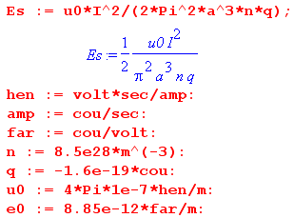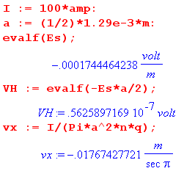

The results are then

Er(a-ε) = Es = - 0.17 mV/m
VH = 56 nV
vx = -18 mm/sec (N.7.22)

which can be compared with the results of our "regular" Hall effect experiment shown in (N.2.9). The Hall field is about 10x smaller, the Hall voltage about 350x smaller, and the drift velocity 45x larger.
The Hall field just below the surface is Er(a) = Es = - 174 μV/m and decreases linearly to 0 at the wire center. Just outside the surface the field is zero since it is cancelled by the surface charge.
The internal charge density ρ and the surface charge density n are then,

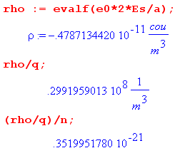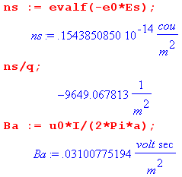

The internal constant negative charge density ρ is very small and represents an excess of about 1 electron for every 1021 conduction electrons. The positive surface charge ns is also tiny, being a deficiency of only 10,000 electrons per square meter.
One reason the radial Hall effect is small is that the self-created B field is relatively small. On the right above Maple shows our lab example field is Bθ(a) = .03T = 300 gauss, whereas in the Section N.2 the external B field was assumed to be 0.5 T = 5000 gauss.
So why were we allowed to ignore the self-generated B field in the regular Hall effect of Fig N.1? Presumably the "radial" Hall effect due to the (not shown) self-generated B field will create an internal and surface charge distribution pattern (and an internal Hall field) in Fig N.1 that is mirror-symmetric in the y = 0 plane. Thus, the regular Hall field Ey gets equal and opposite radial Hall effect contributions above and below this plane and is therefore not affected by superposing the two problems.

Reader Exercise: Calculate the "radial Hall effect" for a rectangular wire like that in Fig N.1

Conclusions

In the above analysis, we made certain assumptions (Eθ = 0, Jz = σEz, and B = B ) in seeking a solution for the E and B fields of an isolated, axially symmetric infinite round wire carrying static current I. We found a solution which satisfies all four Maxwell equations, and since solutions are unique, that is the solution to the problem. The characteristics of this solution are:

1. There exists no radial or azimuthal current densities inside the wire, Jr = Jθ = 0. The only current density is Jz .

2. This current density Jz is uniform over the wire cross section, so Jz = I/(πa2).

3. The regular Ohm's Law applies to Jz, so that Jz = σ Ez.

4. The magnetic field inside the wire is given by B(r) = $\frac{μ0I}{2πa}$ (r/a) .

5. In order to balance internal radial Lorentz deflections of the current-carrying electrons, a very small internal radial Er Hall field exists inside the wire which is directed toward the center line and has the form
Er(r) = Es (r/a) where Es = - $\frac{μ0I2}{2π2a3n|e|}$ . (N.7.12)

6. Associated with this radial Hall field is a very small, negative, constant free charge distribution inside the wire which is given by

ρ = ε0(2Es/a) Q = ρ πa2 dz = ε0(2πaEs)dz

7. This fact contradicts (but in a very small way) the claim of Section 3.1 that there can be no free charge inside a conductor. That section did not include the possible effect of magnetic fields.

8. This negative charge is extracted from the wire surface which then has a positive surface charge which is equal and opposite to Q shown above. Observed from outside the wire, the electric fields of these two charge distributions exactly cancel, resulting in no external radial E field.

9. We refer to the last items 5,6,7,8 above as "the radial Hall effect", for want of a better term.

10. It is hard to imagine how would might measure this effect.

*******************

D.B. Pengra, J. Stoltenberg, R. Van Dyck, O. Vilches, "The Hall Effect" (University of Washington, Dept of Physics, 2007). http://courses.washington.edu/phys431/hall_effect/hall_effect.pdf

