Hall Effect Readings PhL 3.22.14

[ Reviewed 5/6/14]. I am here looking for papers on Hall effect with a B field which varies over the sample. I did in fact find a good one I call FFA.

Motivation: I imagine a rectangular conductor on the left, and a round one on the right. The round one on the right (just a wire, say) creates a magnetic field within the rectangular conductor which is non-uniform going left to right. This means that the vxB Lorentz force has a different B going left to right, and that means that the required Hall E field to balance this vxB field will have to vary, provided v is the same going left to right. I want to know the solution to this kind of problem. Do you end up with v varying going left to right? Do you end up with a polarization charge distribution inside the conductor which allows v = constant and then the Hall E can vary going left to right? Somewhere, someone must have pondered this basic problem.

As noted in a related doc, I do now think there will be a ρ ≠ 0 inside the sample (as there is in the radial Hall effect) and this causes the tiny Hall Ex field to vary just right with x so as to balance the varying Lorentz force. I was having trouble imagining how this Ex field could vary if it was only caused by surface charges on the faces of the sample! None of the papers below mentions this ρ detail.

Web searching does not show up any obvious sources. Here is one source that caught my attention: (1955 AEC Ames)

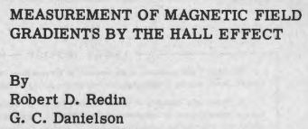

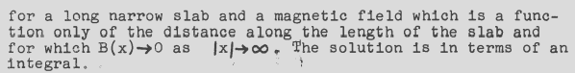
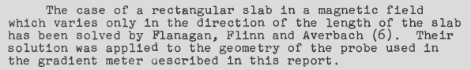
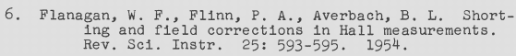

This last reference is FFA.

In their Hall geometry, B is in z, current is in x, and hall voltage is in y. These are traditional I think.

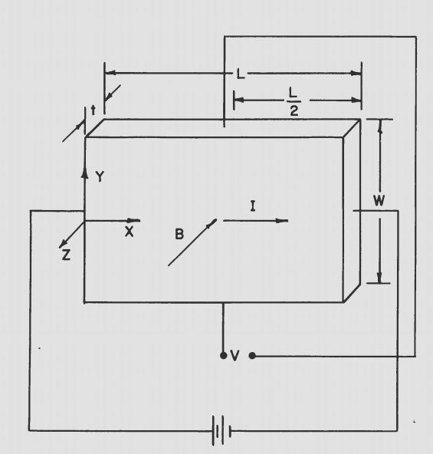

These authors are going to measure the Hall voltage as a function of x (left to right) which is the direction in which they assume Bz(x) is varying. So they are on my wavelength at least! Vm(x) is their measured voltage and VH is a certain constant with voltage dimensions. They assume the gradient is linear and so B has the form B(x) = BL/2 φ(x) with φ(x) = 1 + a(x-L/2), so a is the gradient strength. Their conclusion is this:

Vm(x)/VH = (8/π2) (L/H) [ Σn=odd fn(x) - (aL/2) Σn=even fn(x)

where fn(x) = (1/n2) tanh(nπW/2L) sin(nπx/L)

They get this result from the reference FFA noted above. But then having done this fancy theory, they show that the obvious simple model of just doing the classic Hall thing at each x gives the same result within about 1% accuracy! This is an experimental paper, not a theory one, and they are just using the theory from this FFA source.

So the upshot is that there is some Hall Ey(x) that just follows the field strength Bz(x) of their "simple model". I am looking for someone to tell me the charge density associated with this Ey(x) field, but these authors are not interested in that theoretical question. [ Magnetoresistance may be something to look into]

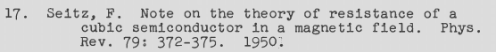
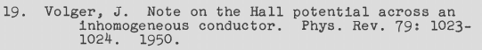

I guess the idea is that in the simple model approach, they are assuming a uniform Jx and maybe this is slightly modified in the fancy theory? Can I find any of these references?

Koppe Bryan: It does show in the Canadian phys journal, but of course I am blocked.

Koppe Bryan "on the theory of the Hall effect". I go to Marriott, Jim gets me in, but they only have since 2001.

I then try the FFA reference while logged on, and I have it! Also I got the Seitz reference. I log off by closing all the windows.

I have FFA as Hall,pdf, it is about the "shorting effect" of the end caps.

FFA: right off the bat, they just assume Jx = J = constant, all done. Then the Hall voltage does vary with x,

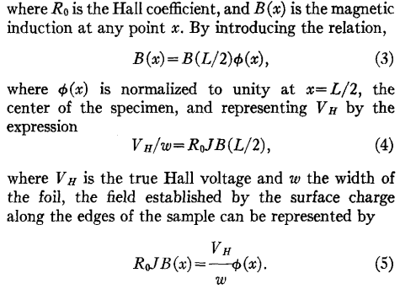

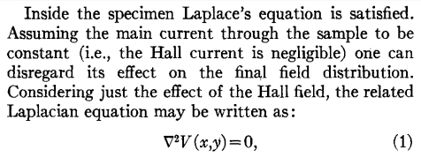

So OK, V(x,y) is the electrostatic potential inside the specimen, fine. Remember the current is Jx and the Hall direction is y, so this is just Laplace and so they are assuming therefore no free or polarization charge density inside the metal! I am sort of claiming this is wrong, but let's keep going, maybe not.

What are the boundary conditions on V? They claim one is this

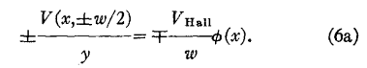

This makes no sense to me at all. Why would you divide the potential at (x,y) = (x,w/2) by y ?

OK, these guys are assuming that V = 0 all along the two ends of the sample where the current is applied, as if those contacts did not have their own Hall effect? "heavy contacts". That then sets V = 0 on the two ends and then you have a Laplace Dirichlet problem which yields their fancy integral. The claim is that these end contacts short out the Hall voltage. The title of the paper is "shorting correction".

So this paper basically leaves my question totally unanswered! Too bad, nice try. It does at least claim without proof that J is a constant even though B(x) varies. The shorting situation is irrelevant for me.

I think I will just have to roll my own solution to this problem.

Again, the conclusion is that at DC, Jz really is perfectly uniform.

This FFA paper did two things for me:

(1) it claimed that Jz is uniform even if B has a gradient (pushing me in that direction)
(2) it shows the Hall voltage EH(x) just tracking B(x), as one would guess is the solution

