Ohms Law and Magnetic Fields PhL 3.26.14

The first 8 sections of this doc are now written up in Appendix N. But then the remaining sections get review comments below. These are inserted at the start of each section below. This doc overall is a very meaty document where I did lots of development and was led to the radial Hall effect and later to my eddy current analysis work. I keep it for the record! [ Reviewed second time 5/6/14 ]

Motivation: I always intended to analyze the effect of v x B on lines doc, but I somehow never got to it. I knew that the drift velocity v/c was quite small, so I just assumed this Lorentz force could be ignored. Now, however, after pondering the "radial Hall effect" in a round wire, I see that (if I did it right which is always in doubt) you end up with a radial Er field, but no radial Jr current, so Jr = σ Er cannot be true in that situation. But I have assumed this is always true everywhere, and this certainly has implications in may locations in lines doc. Luckily, I ran across a nice PDF which does a good and simple treatment of the general situation and I will try to state that "in my own words" here to see where it leads. This PDF is Pengra et al a "tex" document from U of Washington Physics 431 hall_effect_10-07.tex. Their last update is clearly Oct 2007, so this is a modern day treatment. Section 1.2 is where I start.

The F = ma equation for a free charge 1 is this

m∂tv = q(E + vxB) - (m/τ)v

where the last term is a frictional force that is proportional to velocity, which is a normal thing one encounters in physics, for example in car motion. My first task here I guess is to understand the coefficient of this frictional term. I have found a good "handle" for this topic:

0. The Drude Model of Conduction in Metals (1900) 1
1. The average electron momentum 3
2. The current density J and the conductivity σ 5
3. The frictional drag force and equation of motion. 6
4. Solution for E field only and e^{jωt} time dependence: AC conductivity 6
5. Steady-state electron motion with E and B fields present. 7
6. The Simple Theory Hall Effect 10
7. The Fancy Theory Hall Effect 13
8. Apply the Fancy Hall Theory to a Round Wire : the Radial Hall Effect 15
9. How does this new Ohm's Law for Magnetics affect Appendix D? 17
10. What is ω_{c} in for a typical round wire situation; rescue of Lines doc? 20
Appendix A: A potential source of confusion and how it is resolved. 22
Appendix B. The Notion of Adding Momentum Trajectories 25
Appendix C. Extensive and intensive physical properties 25

0. The Drude Model of Conduction in Metals (1900)

1. B&B on page 85 review the "classical Drude theory of 1900" (of conduction in metal) which is exactly the theory I am right now interested in, no quantum stuff. But even in this simple theory, things are not totally clear.

Imagine an electron at rest which is accelerated by force F = -|e|E for a time τ. Since F = dp/dt, this electron would have momentum p = F τ = -|e| τ E after time τ which is B&B (4.2). But this is not the average momentum that electron has during time τ. In fact, since p is linear in time τ, you would think that the average was <p> = p/2. B&B never mention this. Now we have a collision, and what exactly happens in that collision? Is it elastic or not? If elastic, then electron has this same p but in some other random direction. So sadly, I must claim that the B&B discussion drops the ball here and I now have to look somewhere else. But if we are willing to ignore this factor of 1/2, we can continue with the B&B presentation.
They show in a clear manner that, if each collision puts an electron in a random direction, these collisions destroy momentum (friction) and this must be balanced against the momentum created by an E field, and you end up with

p = -|e| τ E

being the momentum (just before collision) that an electron has during current flow. Dimensions are fine, and I just updated lines doc to get kg m/sec2 into my little list of dimensions. Current is then

J = - n |e| v = - n |e| p/m = (n |e|2τ/m) E = σ E

[ Here is where I would expect to be using <p> = p/2 in the J expression.]

So the first nice piece of information is a prediction for σ

σ = (ne2τ/m)

B&B put in numbers for copper and they claim you get τ ≈ 2 x 10-14sec. They make no further comments on that. Next the define mobility as the ratio

μ ≡ |v/E| = |p/E|/m = |e|τ/m dim = m2 sec-1 volt-1 "mobility"

and we then have a second payoff from B&B. Can then compute this for copper. They don't address that frictional term in this book section.

2. Wiki has a page on this subject, http://en.wikipedia.org/wiki/Drude_model . They get right to this issue of <p>. Here is their discussion:

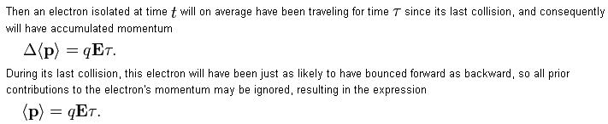

OK, in my normal picture the electron is going in the field direction and bounces "backwards. If this is all that happened, I think you have a factor of 1/2 for mean p. But what happens to this backwards-bounced electron? It is decelerated by the E field and just reaches p = 0 when the next collision occurs. I think it would also have <p> = p/2. If I average these two cases, I still have factor 1/2. So wiki has dropped the ball as well, and I need another source.

Extra fact: in fact, electrons are going very fast at their thermal velocity, so this amount of momentum pickup is a tiny faction of their actual momentum. But I don't see this explaining the factor 1/2.

3. Source: Lecture 1 Drude Model . (e > 0) Their opening claim is this

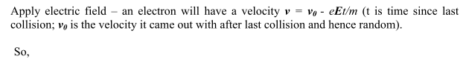
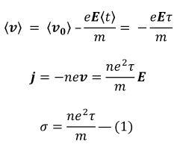
I am going now to do my own derivation, where I maintain the notation e > 0.

1. The average electron momentum

This subject is more subtle that most sources make it appear, so extra time taken below. I would probably write this up better.

Consider a single electron i that starts free flight at time t = 0 and ends it at t = τ, Then during its first flight, we know that

p(1)(t) = p(1)(0) - (eE)t => p(1)(τ) = p(1)(0) - (eE)τ 0 < t < τ

The superscript label indicates this is the first flight of this electron. What happens next to this particular electron? It experiences a "collision" and on average, it ends up going in some new random direction. We express this by a rotation R(α(1)) where α(1) is some Euler angles. Probably this rotation is not isotropic because we don't expect a Coulomb collision to be isotropic. In other words, all rebound directions are not equally likely for this particular particle of interest. Fine. So we then have at t = τ+ε

p(2)(τ+) = R(α(1)) p(1)(τ) = R(α(1)) [p(1)(0) - (eE)τ ]

We then go into flight #2:

p(2)(t) = p(2)(τ+) - (eE)(t-τ) = R(α(1)) [p(1)(0) - (eE)τ ] - (eE)(t-τ) τ < t < 2τ

We then have a second random direction collision after which we have

p(3)(2τ+) = R(α(2)) { R(α(1)) [p(1)(0) - (eE)τ ] - (eE)τ }

and then after this collision we get a third free flight,

p(3)(t) = p(3)(2τ+) - (eE)(t-2τ)

= R(α(2)){ R(α(1)) [p(1)(0) - (eE)τ ] - (eE)τ } - (eE)(t-2τ) 2τ < t < 3τ

and this goes on and on in this fashion. Now suppose we have an ensemble of such electrons, and just suppose, to make things simple, they all have their collisions at exactly the same times. Then this last line for electron i could be written

pi(3)(t) = R(αi(2)) { R(αi(1)) [pi(1)(0) - (eE)τ ] - (eE)τ } - (eE)(t-2τ)

= R(αi(2)) R(αi(1)) pi(1)(0) - R(αi(2)) (eE)τ - (eE)τ 2τ < t < 3τ
term 3 term 2 term 1

Now suppose we add up all the electron momenta in this time interval to get the total momentum P(t),

P(3)(t) = Σi=1N { R(αi(2)) R(αi(1))pi(1)(0) - R(αi(2)) (eE)τ } - Σi=1N (eE)τ

= Σi=1N { R(αi(2)) R(αi(1)) pi(1)(0) - R(αi(2)) (eE)τ } - N(eE)τ 2τ < t < 3τ

We now divide by N to get the ensemble average momentum carried by an electron

<P(3)(t)>e = (1/N) Σi=1N { R(αi(2)) R(αi(1)) pi(1)(0) - R(αi(2)) (eE)τ } - (eE)τ

If we have N > 106, and if the rotations are random, the first terms are going to average to 0. We would claim all these averages are 0:

< pi(1)(0) >e = 0 // this does not appear above

< R(αi(1))pi(1)(0) >e = 0 // nor does this

< R(αi(1))E >e = 0 // this does appear above in term 2

< R(αi(2)) R(αi(1))pi(1)(0) >e = 0 // this does appear above in term 3

One point to note is this: even though R(αi(1)) might not be "isotropic", the ensemble average over all particles < R(αi(1))E >e for a static vector E will still be 0. For example, suppose any specific rotation were strongly peaked in the forward direction. That is fine, but that "forward direction" is different in a random way for all the particles in the ensemble. In a 2D analogy, suppose you have some function f(θ) around a circle which has some shape and is not isotropic but averages to 0. Then (1/N)Σi=1N f(θ + θr,i) = 0 where θr,i is some random angle.

Thus we are going to find that

<P(3)(t)>e = - (eE)τ 2τ < t < 3τ

But if we consider any other time interval (any later flight), clearly we get the same result. Thus, we can delete the flight number index and just say

<P(t)>e = - (eE)τ 0 < t < ∞

Now the collisions don't really occur at the same time, but we could partition the N particles into bins each of which does have this property pretty closely. Then the above conclusion applies to each bin separately, and then it must be true when averaged over all the bins.

Conclusion: In the classical Drude model for the electron cloud in an external E field, the average momentum of an electron is given by

p = - (eE)τ e > 0

2. The current density J and the conductivity σ

The current density is given by

J = -nev

where e > 0. The positive current J flows in a direction opposite v since v is electron average drift velocity. Then we can write

J = -ne(p/m) = -(ne/m) p = -(ne/m)(-eτ)E = (e2nτ/m) E = σ0 E // 0 = DC

Current J flows in the direction of E regardless of the sign of the carriers. So the Drude theory makes this prediction for the conductivity of a metal (m is mass of electron)

σ0 = (e2nτ/m) = n(e2/m)τ = conductivity // as shown in B&B (4.3) p 85

Since we also have from a few lines above that

v = (-eτ/m)E

then

μ ≡ | v / E | = |e|τ/m = (|e|/m) τ = mobility

So far then we have several nice Drude theory predictions.

3. The frictional drag force and equation of motion.

Every τ, the average electron dumps momentum p into the ion lattice. This is because the average electron has momentum p, and on average it loses this in every collision, since the rebound can be in any direction. Thus the force on the lattice is F = Δp/Δt = p/τ due to this average electron. The lattice then supplies a force F = - p/τ = - (m/τ) v on our "average electron". We interpret this as a frictional force acting on the electron in a direction opposite to its motion. As with many such frictional forces, it is linear in velocity. The undecorated letters always refer to the averages as discussed earlier. We then have for our electron in an electric field

m (dv/dt) = -|e| E - (m/τ) v

This frictional force depends only on v, it knows nothing about E and B fields. If there is a B field present we get

m (dv/dt) = -|e| [ E + v x B ] - (m/τ) v

and now v appears in this ODE in three places!
Just to confirm, from our Hall Effect PDF we have for a generic charge q,

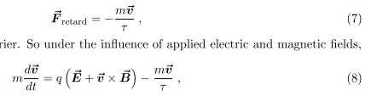

4. Solution for E field only and ejωt time dependence: AC conductivity

mjω v = -|e| E - (m/τ) v

v ( jωm+m/τ) = -|e| E

v m( jω+1/τ) = -|e| E

v = $\frac{-|e|}{m(jω+1/τ)}$ E

J = -n|e| v = $\frac{n|e|2}{m(jω+1/τ)}$ v = $\frac{n|e|2τ}{m(jωτ+1)}$ v = σ0 $\frac{1}{jωτ + 1}$ v = σ v

So the next Drude prediction is an AC conductivity

σ = σ0 $\frac{1}{jωτ + 1}$

Perhaps we can say that σ = σ0 up to the region of ω = 1014 if τ = 10-14 so f = ω/2π ~ 1013 which is about 10,000 GHz, so something that gets in there at the high end of frequencies. In my lines doc, I have assumed σ = constant at all frequencies of interest. Maybe add a lines doc comment on this. ******
This agrees with my Drude PDF which uses e-iωt:

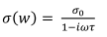

5. Steady-state electron motion with E and B fields present.

Assume a steady current flow so that J = -n|e| v has not time dependence, n is constant in time, and so then is v. Then

m (dv/dt) = -|e| [ E + v x B ] - (m/τ) v

-|e| [ E + v x B ] - (m/τ) v = 0

If there is no B field, then we just get

-|e| E - (m/τ) v = 0 p = -|e| Eτ

which we already know.

Comment: In a completely different problem, if we have an electron in free space where there is a B field, there is no lattice ion drag and the equation is just ma = q vxB which implies circular motion of the electron (to which you could add a drift in the B field direction, so spiral motion). Then ma = qvB or mω2r = q ωr B or mω = q B or ω = qB/m ≡ ωc known as the cyclotron frequency which will appear below. The idea here is that if a charge gets some "transverse velocity", it is going to going to do transverse circular motion if there is space to do it. Particle detectors! Cyclotrons!

Put a constant B field in the z direction and work Cartesian, so

-|e| [ E + v x (B ) ] - (m/τ) v = 0
or
|e| [ E + B v x ] + (m/τ) v = 0
or
E + B v x + (m/τ|e|) v = 0
or
E + B v x + (m/τ|e|) v = 0

We now want to solve this equation for v, velocity of the electron, and hence J = -nev : (e>0)

Recall from above that

μ ≡ (|e|/m) τ = $\frac{|e|τ}{m}$ = mobility => $\frac{m}{|e|τ}$ = 1/μ

so we can write

E + B v x + (1/μ) v = 0
or
μE + μB v x + v = 0

Check dimensions:

μ = v/E in dimensions, so first term is v, second term is v/E* B * v = v2 B/E

= v2 amp-henry/m2 / volts/m = v2 volt-sec m-1 /volt = v2 sec m-1 = v2/v = v OK

Now

[v x ]i = εijkvjδk3 = εij3vj = δi,1ε123v2 + δi,2 ε213 v1 = δi,1v2 - δi,2v1

Then

[v x ]1 = v2
[v x ]2 = -v1
[v x ]3 = 0

We then have these three equations

μE1 + μBv2 + v1 = 0
μE2 – μBv1 + v2 = 0
μE3 + v3 = 0 => v3 = -μ E3 along the field

We get a Cramer's Rule with the first two equations

v1 + μBv2 = -μE1
- μBv1 + v2 = -μE2

so we have

$\left(\begin{matrix}1 & μB \\ -μB & 1\end{matrix}\right)$$\left(\begin{matrix}v1 \\ v2\end{matrix}\right)$ = -μ $\left(\begin{matrix}E1 \\ E2\end{matrix}\right)$ and v3 = -μ E3

Now the inverse of this matrix

M = $\left(\begin{matrix}1 & μB \\ -μB & 1\end{matrix}\right)$
is
M-1 = $\left(\begin{matrix}1 & -μB \\ μB & 1\end{matrix}\right)$/ (1+μ2B2) (m/τ|e|) = 1/μ μ = (|e|/m) τ

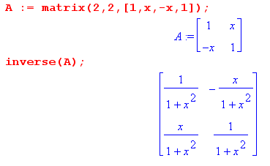
Therefore

$\left(\begin{matrix}v1 \\ v2\end{matrix}\right)$ = $\frac{-μ}{1+μ2B2}$$\left(\begin{matrix}1 & -μB \\ μB & 1\end{matrix}\right)$$\left(\begin{matrix}E1 \\ E2\end{matrix}\right)$

= $\frac{-μ}{1+μ2B2}$$\left(\begin{matrix}E1-μBE2 \\ μBE1 + E2\end{matrix}\right)$

Now make this definition:

ωc ≡ - |e| B/m => μB = τ |e|B / m = - τ ωc ωc < 0 for electron

We can then write

$\left(\begin{matrix}v1 \\ v2\end{matrix}\right)$ = $\frac{-μ}{1+(τωc)2}$ $\left(\begin{matrix}E1+τωcE2 \\ -τωcE1 + E2\end{matrix}\right)$

so then we finally get our solution for v where B field is hidden in ωc :

v1 = -μ ( E1 + τωcE2) $\frac{1}{1+(τωc)2}$
v2 = -μ ( E2 - τωcE1) $\frac{1}{1+(τωc)2}$
v3 = -μ E3

Now we have J = -n|e|v and we have

(-n|e|)*(-μ) = μn|e| = (|e|/m) τ n|e| = (|e|2nτ/m)

Then we find that (remember that this is a steady-state solution only! )

J1 = σ0( E1 + τωcE2) $\frac{1}{1+(τωc)2}$ σ0 = (n|e|2τ/m)
J2 = σ0( E2 - τωcE1) $\frac{1}{1+(τωc)2}$ ωc = - |e| B/m

J3 = σ0 E3

This all agrees with my Hall PDF, where he uses q = -|e|

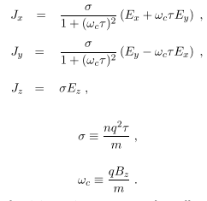

Notice how "different" from the normal Ohm's Law we are for the first two components!!

If τωc << 1, which is the "weak field" situation, then you have normal Ohm's Law in all components!

Fact: If E = 0, having B alone does not result in a steady-state current of any kind.

Questions: What is the situation in a round wire or a transmission line?? How do you express this all in cylindricals?

6. The Simple Theory Hall Effect

Here I think is the standardized picture for selection of x,y,z:

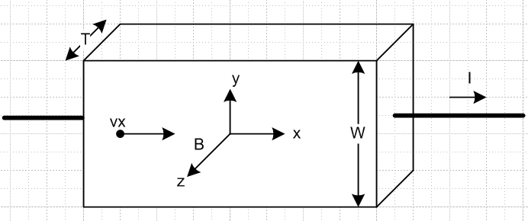

Equation of motion for black dot charge q is

m (dv/dt) = q [ E + v x B ] - (m/τ) v

If we assume steady state and we assume v = vx, then v x B = vx x B = - vxB so then

0 = q [ E - vxB ] - (m/τ) vx

The solution to this equation is

Ey = vxB and qEx = (m/τ) vx or px = q τ Ex

The second equation is simply the conclusion of our Section 1 above. The first equation says there must be a transverse field which is the Hall field. For positive charge carriers, vx > 0 and the Hall field then points up. For negative carriers like electrons, vx < 0 and the Hall field points down. The Hall voltage is

Fact: The Hall field tells you the sign of the majority of carriers.

Fact: The Hall field in this idealized example is a constant inside the block.

We know that Jx = nqvx and that I = Jx WT so then

vx = Jx/(nq) = I/(nqWT)

Then the Hall field is

Ey = vxB = I/(nqWT) * B (**)

The Hall voltage is just Ey W so

VH = Ey W = I/(nqT) * B = [1/nq] I B / T

This is independent of the height W and depends on I, B and T in linear fashion as shown. The ratio shown has a name

[1/nq] = RH = "the Hall coefficient".

We can compute this for copper as follows

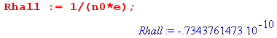

Typical Hall voltage: Suppose I = 100 mA, B = 5x10-3T (fridge magnet 50 gauss), T = 10-3 m

VH = [1/nq] I B / T = 36.5 picovolts

as shown here:

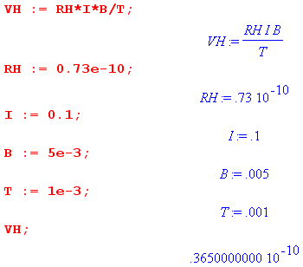

and in this example we are just getting VH = 1/2 RH. How do you measure picovolts?

I found an experiment here http://www.phy.davidson.edu/ModernPhysicsLabs/halleffect.htm and their first trick is to make T be very small. Instead of 1 mm as I used above, they make it 18μ

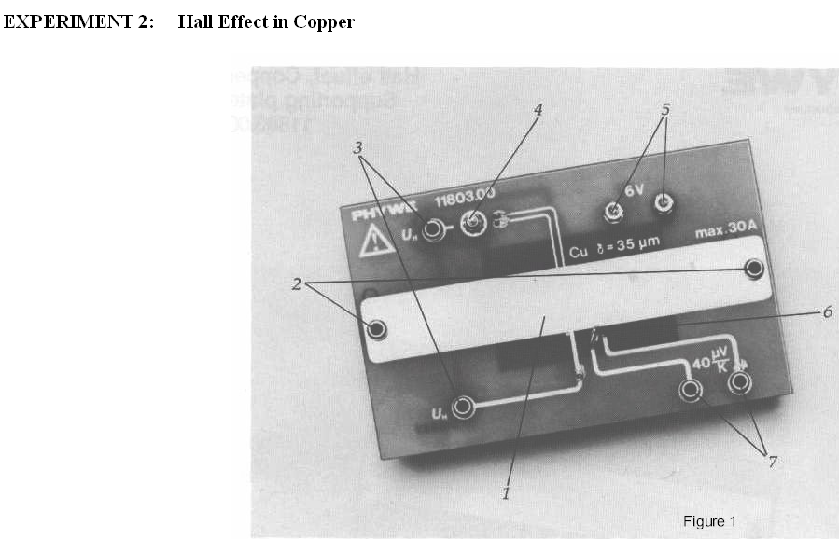

Next, they use a "large cenco electromagnet coil" which can great 10,000 gauss in its "gap" which can be about 10 cm diameter disk and 2 cm gap! . So with these numbers and raising I to 10 amp we get

VH = (0.4x10-10) 10 1 / [ 18 x 10-6] = (0.4/18) x 10-4 ≈ 40 μV

A second lab description uses this same thickness copper and says VH ~ μV so I guess I am OK with my numbers. They have to use a "measuring amplifier". Keithley makes a Nanovoltmeter I notice.

Paradox: Just below the top surface, there is some finite Ey field. This seems wrong because the block ends there and if Jy = σEy at least for low B, this implies a current leaving the block, which I assume is in a vacuum. So I have a little problem here just with the "regular Hall effect" which I think just propagates into my "radial Hall effect" problem. Best to solve it here first! I don't recall this issue being raised by any Hall effect writers, but I will look harder now.

Related Question: Consider a steady-state parallel-plate conducting capacitor. There is a constant E field inside. But in this case, it drives a current between the plates, so there is no paradox at the boundaries, since current is coming through each boundary, being fed by the external wire.

7. The Fancy Theory Hall Effect

Start here with our equations found in Section 5 [ recall that B was in the z direction there, just as in our current Hall block geometry.]

Jx = σ0( Ex + τωcEy) $\frac{1}{1+(τωc)2}$ σ0 = (nq2τ/m)
Jy = σ0( Ey - τωcEx) $\frac{1}{1+(τωc)2}$ ωc = qB/m

Jz = σ0 Ez // Magnetic version of Ohm's Law

Now make the ansatz that Jy = 0 and Jz = 0 everywhere. This is pretty strong ansatz but we try it. Then

Jx = σ0( Ex + τωcEy) $\frac{1}{1+(τωc)2}$ σ0 = (nq2τ/m)
0 = σ0( Ey - τωcEx) $\frac{1}{1+(τωc)2}$ ωc = qB/m

0 = σ0 Ez => Ez = 0 // that part was pretty simple

The second line requires that

Ey = τωcEx

Then the first line says

Jx = σ0( Ex + τωc[τωcEx]) $\frac{1}{1+(τωc)2}$ = σ0( 1 + [τωc]2)Ex $\frac{1}{1+(τωc)2}$ = σ0Ex

Here then is our full "fancy Hall effect" solution:

Jx = σ0Ex // just as it would be with no B field!
Jy = 0
Jz= 0

Ex = Ex
Ey = τωcEx
Ez = 0

Now as in the simple case we have Jx = nqvx and that I = Jx WT so then

Jx = σ0Ex => (I/WT) = σ0Ex => Ex = (I/σ0WT) = $\frac{I}{σ0WT}$

Then the solution is

Jx = $\frac{I}{WT}$
Jy = 0
Jz = 0

Ex = $\frac{I}{σ0WT}$
Ey = τωc $\frac{I}{σ0WT}$
Ez = 0

Now our "paradox" is resolved. Yes we have a constant Ey everywhere inside the block, but we do not have Jy = σ0Ey so this does not give the paradox. So it is crucial to use the "magnetic" version of Ohm's Law.

Key point: One is tempted to say that for small B field, the regular Ohm's Law applies, and that would imply that Jy = σ0Ey and one would say that we then get the paradox for small B fields. But consider

Jy = σ0( Ey - τωcEx) $\frac{1}{1+(τωc)2}$ ωc = qB/m

The quantity Ex is fixed by the current so Ex = $\frac{I}{σ0WT}$ as shown above. Now if B is a weak field, yes, maybe we have τωc << 1. But all that means is that Ey is then "very small" and Jy = 0 is fine.

What about the Hall field and voltage in this "fancy" model of things? We find here that

Ey = τωc $\frac{I}{σ0WT}$

But we have

τωc/σ0 = τqB/m / (nq2τ/m) = B/(nq) = B RH
so
Ey = RH B/ (WT)
VH = RH B/ (T)

and these are the exact same results as from the "simple theory" Hall effect analysis.

8. Apply the Fancy Hall Theory to a Round Wire : the Radial Hall Effect

Start at the beginning with

m (dv/dt) = q[ E + v x B ] - (m/τ) v

We now seek a steady state solution for which B = B . Then

(m/τ) v = q[ E + v x (B) ]

Then write

v = vr + vθ + vz

so that

v x (B) = B [vr + vθ + vz ] x = B[ vr - vz ]

Then we have these three equations

(m/τ) vr = q[ Er -Bvz ]
(m/τ) vθ = q[ Eθ ]
(m/τ) vz = q[ Ez + Bvr ]

vr = (qτ/m)[ Er -Bvz ]
vθ = (qτ/m) [ Eθ ]
vz = (qτ/m) [ Ez + Bvr ]

Then since Ji = nqvi we get

Jr = (nq2τ/m)[ Er -Bvz ]
Jθ = (nq2τ/m) [ Eθ ]
Jz = (nq2τ/m) [ Ez + Bvr ]
or
Jr = σ0[ Er - Bvz ]
Jθ = σ0 [ Eθ ]
Jz = σ0 [ Ez + Bvr ]

Now we can maybe mimic the fancy Hall effect next step. Make the ansatz that Jr = 0 and Jθ = 0. This latter just says Eθ = 0 and the first says vr = 0. The first line then says

Er = Bvz

Here is what we end up from our "Ohms's Law with B field equations" :

Jr = 0 Er = Bvz
Jθ = 0 Eθ = 0
Jz = σ0 Ez Ez = what it is to get Jz = I / (πa2)

Now I know that

B(r) = B(a) (r/a) since it is just linear inside the wire

vz = Jz / (qn)

Er(r) = Bvz = B(a) (r/a) Jz / (qn) = B(a) (r/a) * 1 / (qn) * I / (πa2)

= B(a) RH * I/(πa2) * (r/a) = Er(a) (r/a).

So here is our radial Er field and we can have it ≠0 but Jr = 0 at the same time due to our fancier Ohm's Law. So this resolves a "paradox" I had somewhere.

Now, what is the implication of such an internal Er field? I think my previous solution is all Ok as summarized, and it says that Er(r) = K(r/a) so K = Er(a). I found there that

K = $\frac{μ0I2}{2π2a3e n0}$

Once you know that Er(r) = K(r/a) you can do div E = ρ/ε0

r-1∂r(rEr(r)) = ρ(r)/ε0

which at once tells you that ρ/ε0 = 2K/a and then]

ρ = 2Kε0/a = $\frac{ε0μ0I2}{π2a4e n0}$ = $\frac{I2}{c2π2a4e n0}$

But I later claim that

ρ = e n0 2/β where 1/β = $\frac{I2}{c22π2a4e2 n02}$

so then

ρ = $\frac{I2}{c2π2a4e n0}$

which is the same result. But why am I able to avoid the fancy ODE for η ?

Conclusion: I think I am "good" with the radial Hall effect and might "write it up" for site, since I could find on-one describing it.

9. How does this new Ohm's Law for Magnetics affect Appendix D?

Here I realize that this Ohm's Law issue could totally screw up Appendix D and in fact Chapter 1.5 because I assumed that J = σE inside the dielectric and conductors, etc etc. I was panicked, and things were not resolved in this section, but I did start a General-Direction Magnetic Ohm's Law idea, and this is now at the end of Appendix N in lines doc.

Well, I think everything above (D.2.22) is OK because in all those pages I never mention currents of any kind, only electric field components. I solve the Helm and div E = 0 equations. But starting in Section D.2 (d), I start talking about "currents" and so I have to be more careful. Perhaps the "charge pump boundary condition" as stated here is OK

Jr(r=a-ε,θ) = jω n(θ) . (D.2.23)

But then I make the big error of saying "since J = σE", and then I guess this is wrong

Er(r=a-ε,θ) = (jω/σ) n(θ) . WRONG (D.2.24)

In this transmission line situation, there is some unknown B field which has both and components inside the round wire which is one of the two conductors. True, in the skin limit it is only in the direction, but at low ω both components will be active (see DC plot for two round wires! )
So let's try to write a generalized Ohm's law inside our round wire in partial waves. Go back to

m (dv/dt) = q[ E + v x B ] - (m/τ) v

Since we are no longer static, this becomes

m jω v = q[ E + v x B ] - (m/τ) v // assuming ejωt time dep
or
(jω + 1/τ) mv = q[ E + v x B ]
or
(1 + jωτ) (m/τ) v = q[ E + v x B ] [ ok ]

From my single wire experience, I think we can set n ≈ n0 with little error, so that J = n0 q v. Also, maybe we are good saying ωτ << 1 up to ω = 1014 Hz, [ ok ] so let's go ahead and throw that in to get

(m/τ) v = q[ E + v x B ]

v = (qτ/m)[ E + v x B ]

v = μ[ E + v x B ] μ = qτ/m = mobility

where basically we have said it is a static problem and we have thrown out m (dv/dt). So we are back to our old static problem, but now things are functions at least of r,θ and B has at least two components. Maybe assume that as a further simplification. We then have [ here r,θ are usual coords for round wire which is being affected by some external total field unspecified but is some B(r,θ) ]

(m/τ) v(r,θ) = q[ E(r,θ) + v(r,θ) x B(r,θ)]

(m/n0qτ) J(r,θ) = q[ E(r,θ) + (1/n0q) J(r,θ) x B(r,θ)]

Problem: What now happens to the partial wave expansion??? We have a product of two functions of θ, and that never occurred before in Appendix D!!

I now have this rather messy equation involving all three objects J, E and B fields, In partial waves, I at least know something about the E field, but the B field depends on that other unknown conductor!

But OK, let's blindly forge ahead. Let's define

κ = 1/μ = inverse mobility = (m/qτ)

Then we start with

κ v = E + v x B

Then using 1,2,3 as r,θ,z we can say

κvi = Ei + εijkvjBk
so
κv1 = E1 + v2B3-v3B2
κv2 = E2 + v3B1-v1B3
κv3 = E3 + v1B2-v2B1

Then we have these three Cramer type equations:

κv1 - B3 v2 + B2 v3 = E1
κv2 - B1 v3 + B3 v1 = E2
κv3 - B2 v1 + B1 v2 = E3

Here is the Maple solution:

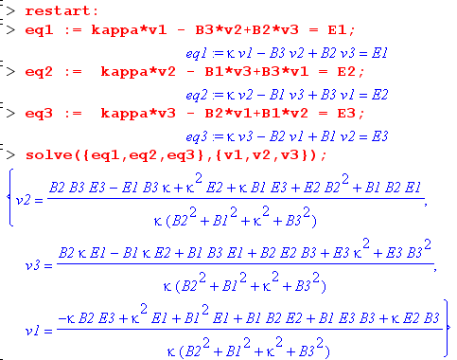

Well, at least this is something. But again, these are not partial wave fields, they are full fields!

Continue in Appendix D for a moment. I cannot apply the boundary conditions, but I think the fields as stated in (D.2.21) are correct, where the am and Km are as yet unknown. Later I go on to compute the B fields using Maxwell's equation -jωB = curl E . These are first stated in (D.4.7) and I would in theory stick those into the above solution! That would give me a solution for v entirely in terms of E. But again, everything here is full fields, not partial wave fields.

Let's try a simplification: Just assume that B3 = Bz = 0. Then the above becomes

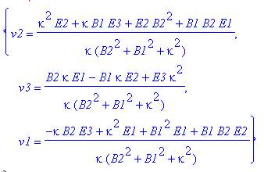

But this still has both double and triple products which defy partial wave analysis!

What happens if I now just try Eθ = 0 everywhere. That would be E2 = 0. Result is then

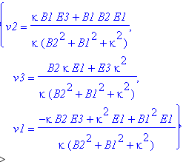

A completely different plan. Suppose I compute the Ei as I now do in Appendix D, then I get the B fields from that, and then I use curl H = ∂tD + J to compute J directly from the B and E fields. Then I don't have to worry about the above ugly matrix equation system. And I can stay in partial waves! But the curl operator might make things even messier than the above stuff.

OK, this is a large enough subject that I will start it up in some other doc. [ Well. this led me to do all the Hall effect docs. ]

Note added 3/31/14. Let's write out the three equations above before I set E2= 0

v1 = $\frac{1}{κ}$ $\frac{(-κB2E3+κ2E1+ B12E1+ B1B2E2)}{(B22+B12+κ2)}$

v2 = $\frac{1}{κ}$ $\frac{(κB1E3+κ2E2+B22E2+ B1B2E1)}{(B22+B12+κ2)}$

v3 = $\frac{1}{κ}$ $\frac{(κB2E1+κ2E3 - κB1E2)}{(B22+B12+κ2)}$

I could then use Ji = nqvi and the fact that J

nq/κ = nqμ = nq[qτ/m] = nq2τ/m = σ

and then we have our Ohm's Law replacement:

J1 = σ $\frac{(-κB2E3+κ2E1+ B12E1+ B1B2E2)}{(B22+B12+κ2)}$ κ = 1/μ = (m/qτ) = tesla units, same as B.

J2 = σ $\frac{(κB1E3+κ2E2+B22E2+ B1B2E1)}{(B22+B12+κ2)}$

J3 = σ $\frac{(κB2E1+κ2E3 - κB1E2)}{(B22+B12+κ2)}$

I just added to App N that μ = tesla-1 so κ = tesla. Then all three equations look good on dimensions. You would use these three equations to study a rectangular Hall effect situation. But I am interested right now in 1,2,3 = r,θ,z

1 = r
2 = θ
3 = z

but I will keep using 1,2,3 in this implied sense

Your next step would be to require that Jr = J1= 0 AND Jθ = J2 = 0 (see reason in Section 11 below).
Then we get [ it is Jθ that would generate Ohmic loss, not Eθ etc. ]

-κB2E3+κ2E1+ B12E1+ B1B2E2 = 0
κB1E3+κ2E2+ B22E2+ B1B2E1 = 0
or
-κB2E3 + (κ2+B12) E1 + B1B2E2 = 0 1
κB1E3 + (κ2+B22) E2 + B1B2E1 = 0 2

This is two equations in my three unknowns Ei so not enough to solve.

OK, fine. Let's take our two equations

-κB2E3 + (κ2+B12) E1 + B1B2E2 = 0 1
κB1E3 + (κ2+B22) E2 + B1B2E1 = 0 2

I could solve these for E1 and E2 in terms of E3. But that turns out to be quite simple!

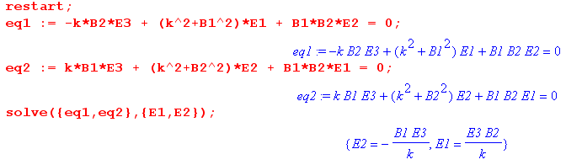
The solutions are thus

E1 = B2E3/k
E2 = -B1E3/k

and these must make J1 = J2 = 0. What then do we get for J3???

J3 = σ $\frac{(κB2E1+κ2E3 - κB1E2)}{(B22+B12+κ2)}$

Do it by hand

numJ3 = κB2E1+κ2E3 - κB1E2

= κB2(B2E3/k)+κ2E3 - κB1(-B1E3/k)

= B2(B2E3)+κ2E3 - B1(-B1E3)

= [ B2(B2)+κ2E3 - B1(-B1)]E3

= [B22+B12+κ2] E3

and then indeed we get

J3 = σE3

Wow! I have just shown for an arbitrary direction B field in the 1,2 plane that I can impose the conditions J1 ≡ 0 and J2≡ 0 and I end up with these currents:

J1 = 0
J2 = 0
J3 = σE3

If I cycle the coordinates forward 1 place I get

J2 = 0
J3 = 0
J1 = σE1 for B in the 2-3 plane

I think I could just superpose two regular Hall effect problems and get this result! One has B in the z direction, and the other has B in the y direction, and you then get your two Hall voltages. They could then tell you the direction of the B field in that 2-3 plane!

Then I think if you add a longitudinal B component, it probably does nothing since v x B = 0 for that component. So my result is now much more general that it was earlier today!

I think I can justify this all another way: superposition. TBC.

10. What is ωc in for a typical round wire situation; rescue of Lines doc?

Here I conclude that ωcτ << 1 for my situations of interest, so probably that means the regular Ohm's law is just fine, but I need to keep going on this idea. This would then "rescue" lines doc, very important!

First, we know that the magnetic field is maximal at r = a and there we have

2πaHθ = I Bθ = μ0 I/(2πa)

So for my 8281 cable a = 394 μ ≈ 400 x 10-6 = 4 x 10-4 m. If we run I = 1 amp through this wire, which would certainly be reasonable if not quite large for doing a signal thing, then

Bθ = μ0 I / 2πa

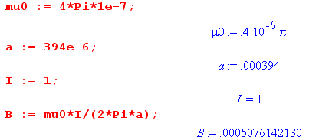

and the result is a B field of 5/10,000 T = 5 gauss, pretty small. Good. Meanwhile,

ωc = qB/m.

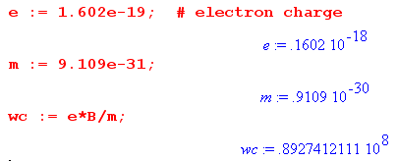

If we assume that τ = 10-14 we then get

ωτ ≈ 108 * 10-14 = 10-6 << 1

so that is at least hopeful! How about a power line situation? Try I = 1500 amps and r = 1/2" ≈ 1 cm.
In this case we get B = .03 T at the wire surface. Then (I found 10-14 for aluminum somewhere)

ωc ≈ (1/2)x 1010 ωcτ ≈ (1/2)x 1010 x 10-14 ≈ (1/2) x 10-4 still << 1

So maybe I can argue that in the transmission line realm, ωcτ << 1 and then Ohm's Law is approximately true in all directions regardless of the B field, and then I can rescue Lines doc. [ correct! ]

Interpretation of ωcτ << 1. This really says τ << Tc , the cyclotron circle rotation period. In this limit, the electron only gets to start a tiny fraction of its arc when it has another collision and starts completely over again, so basically there is no cyclotron rotation at all and thanks to collisions, we can just forget about this cyclotron stuff and its effect on Ohm's law, except for the detail brought out in the Hall effect examples above.

11. Question: What can be said about Jr and Jθ at the surface of a round wire?

Here I argue that if regular Ohm's law were known to apply, then Jz = uniform even in some generic non-uniform, non-self-generated B field. Approximate Ohm's would imply Jz = approx uniform.

I am thinking here only of a magnetostatic situation, not a transmission line. Left conductor is round, right wire is unknown, stable currents flow in the both wires, nothing changes in time.

[ This is a precursor to my eddy current research!! ]

I am inclined to say that Jr(r=a,θ) = 0 because "this current component has nowhere to go". [ correct] If it were not zero, it would be piling up charge on the surface and things would not be static. But a counter argument might be that such piled up charge could be carried away by some Jθ(r=a,θ) which also exists at the surface. A gaussian box shows that really you need a surface current Kθ to make this work, a bulk current that is finite won't do it. That would just give a smooth convection pattern with Jr= 0 (but maybe Jθ not 0). So you would need a current convection flow something like this (left side)

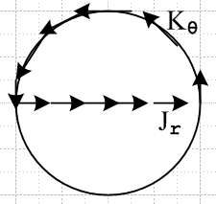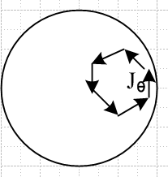

A counter-counter argument is that if such a convection current flow existed, it would quickly damp out to nothing due to ohmic energy loss. There is no mechanism to sustain this current as there might be in a time dependent scenario where there might be an induced EMF around such a loop. The only energy source is in the longitudinal direction. You might expect the above situation in a waveguide mode. So with this counter-counter argument, I think I am happy to claim that Jr(r=a,θ) = 0 and Kθ(θ) = 0 for a magnetostatic situation.

What can be said about Jθ(r=a,θ) ? I think if you have Jθ , current has to again "go somewhere" and it has to go in a loop like that shown on the right. But again, ohmic losses would cause such a loop to quickly decay away. It could maybe exist in a time-dependent situation as an eddy current!

I think these arguments also imply that Jr(r,θ) = 0 and Jθ(r,θ) = 0 for any radius r inside the wire. You just pull the above loops inside and make the same argument.

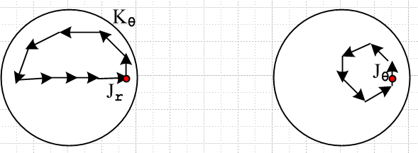

A possible way out would be some kind of "coupling" between these transverse currents and the longitudinal current, something like this (now a side view) [ probably this would be turbulent flow ]

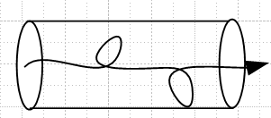

If this could somehow happen, you could have Jr(r,θ) ≠ 0 but still have Jr(a,θ) = 0 . But such a picture seems to violate z-axis invariance of a steady-state solution inside a wire so I rule it out.

My conclusion here is that inside a wire with some arbitrary but static imposed external B field, the current component Jz(r,θ) is the only component that can exist. If we knew that Ohm's Law was valid in all directions so Ji = σ Ei, then only Ez exists and then curl E = 0 has this implication:

curl E = [ r-1∂θEz - ∂zEθ] + [∂zEr - ∂rEz] + [ r-1∂r(rEθ) - r-1∂θEr ]

= [ r-1∂θEz] + [- ∂rEz] + [ 0 ] = 0

and this then says

∂θEz = 0 and ∂rEz = 0

and this tells us that Jz(r,θ) = Jz = uniform!!! A slight violation of Ohm's law would perhaps cause a slight violation of this claim. So essentially Jz = uniform in a static situation, and this is true no matter what kind of complicated B field (with gradient etc) is hanging around, all static. This seems to imply that no matter how close you space two round wires each carrying ±I, the flow in each wire is uniform, and there exists no magnetostatic "proximity effect". This is something I have been wondering about. Their will exist small transverse Hall E fields in the conductors which with Lorentz's force law result in electrons drifting only in the z direction and these do represent a violation of Ohm's Law in the small sense noted above.

Appendix A: A potential source of confusion and how it is resolved.

This concerns the naive 1/2 factor you might get with accelerating electrons.

The argument presented above in summary is this: Consider first one electron,

p(t) = p(0) - (eE)t

which shows a linear momentum increase. If it started at p(0) = 0 and final is p(τ) = - (eE)τ, then you obtain a factor of 1/2 where <p(t)>t = (1/2) [ - (eE)τ ] . But if you average over all collisions, the claim is that

< p(0) >e = 0

and then

<p(τ) >e = - (eE)τ

and how there is no factor of (1/2). This is the average momentum had by an electron at the end of its little free-flight time. Above I have shown that, in fact, this is the average p of an electron in the metal without restriction to where we are in the flight time, and that is why I had to have all that extra stuff above to show this fact.

But now let's go back to an individual flight in a 1D toy scenario. The goal here is to understand why a factor of 1/2 appears when a single flight occurs, but does not appear when things are averaged.

Consider first a situation where electron starts off at p = 0, and p(t) = p(0) + αt :

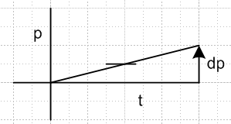

Here we have one (momentum) trajectory which is p(t) = p(0) + α t = 0 + α t. The average value of p for this single trajectory is

<p(t)>t = (1/2) [p(t) - p(0)] = (1/2) [p(t) - 0] = (1/2) p(t) = (1/2) α t = 1 box

<p(t)>t = (1/τ) $^{\int_{0}^{τ}{}}$dt' p(t')

But now add the offset thermal velocity, so that these two trajectories are equally likely:

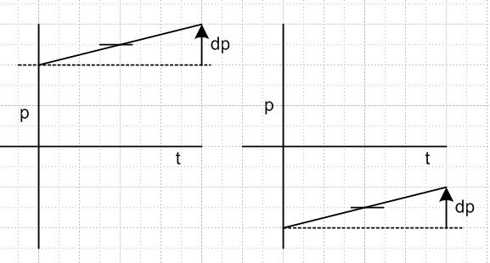

We now consider a system composed of just these two particles. Since momentum is extensive (see Appendix A and B below), we can talk about the total momentum P of the system.

p1(t) = p(0) + α t
p2(t) = - p(0) + α t

P(t) = p1(t) + p2(t) = 2α t = total momentum of system

<P(t)>e = α t = average momentum of particle in the system = P(t) / 2

There is no factor 1/2 in this last equation. Notice that we first added the momentum trajectories, and then we did an ensemble average.
We can also talk about

<p1(t)>t = (1/τ) $^{\int_{0}^{τ}{}}$dt' p1(t') = (1/2) [ (p(0))+( p(0) + α τ) ] = p(0) + ατ/2
<p2(t)>t = - p(0) + ατ/2

We could then talk about " the average of the time averages of the particle momenta"

< < pi(t) >t>e = (1/2) [<p1(t)>t + <p2(t)>t] = α τ / 2

and there is the factor of (1/2) again. In general this "average of momentum time averages" would be

[< < pi(t) >t>e] (τ) = (1/N) Σi=1N < pi(t) >t = (1/N) Σi=1N (1/τ) $^{\int_{0}^{τ}{}}$dt' pi(t')

whereas the "average momentum" is

<P(τ)>e = (1/N) Σi=1N pi(τ)

These are simply two different quantities. What we really care about is the average momentum of an electron in a conductor which is this second quantity. The previous "average of averages" might be interesting and valid, but it has no bearing on the problem at hand. We have in general

[< < pi(t) >t>e] (τ) ≠ <P(τ)>e

which is to say

Σi=1N (1/τ) $^{\int_{0}^{τ}{}}$dt' pi(t') ≠ Σi=1N pi(τ)

Appendix B. The Notion of Adding Momentum Trajectories

Momentum is an "extensive property" so addition makes sense.

Here is a thought experiment. Imagine at t = 0 that 60 particles at the origin start 60 different radial trajectories each at different vi(t). They all have the same mass. You have then 60 "trajectories" which would be the corresponding ri(t).

1. You could compute the average of these trajectories if you wanted.

<r(t)> = (1/60) Σ ri(t)

At any time t, this would tell you the average position of the 6 particles. That seems just fine.

2. You could compute the average velocity:

<v(t)> = (1/60) Σ vi(t)

and then at any time t, this would tell you the average vector velocity of this ensemble of particles.

3. You could compute the average momentum:

<p(t)> = (1/60) Σ pi(t)

and then at any time t, this would tell you the average vector momentum of this ensemble of particles.

In all three examples, we "add functions of t". We can think of these as being "trajectories" just in this sense of being a function of t, but of course only r(t) is an official "trajectory". But we might talk anyway about a velocity trajectory or a momentum trajectory.

Note that in these three examples, only momentum is an extensive property (see Appendix B). Thus it makes sense to talk about the total momentum of the system

P(t) = 60 <p(t)> = Σ pi(t) = sum of the "momentum trajectories"

You would never talk about R(t) or V(t) as the total position or total velocity of the system.

Appendix C. Extensive and intensive physical properties

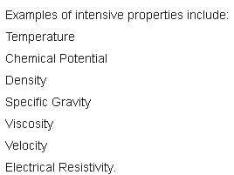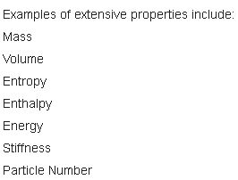
position momentum
color
acceleration

An intensive property is one that is independent of "how much of something you have". More specifically, if you have "one of something", then if you take two such things and create a new thing from it, an intensive property does not change.

If a 1-particle has color red, then a 2-particle has color red as well, intensive.

Here the mass and color are regarded as independent. You would not say that adding mass changed the color, unless you had some external rule which said that mass and color are related in some manner. Such a rule might say color = c(m). We rule out any "external rules" when talking about intensive versus extensive quantities. Now consider:

If a particle has temperature 50C, then a 2-particle has temperature 50C, intensive.

If you imposed an external rule which said the total particle has to maintain a constant thermal energy E = 3/2 mkT, then you would have temperature = T(m) = E/[(3/2)km] and then temperature would drop when you double the mass. But such external rules are not allowed.

If a particle has acceleration a, then a particle twice as large has acceleration a, intensive.

If there are no external rules, the particle twice as large continues to have acceleration a, so acceleration is like color. You could certainly imagine an external rule which says that there is a constant force acting on the particle. Then since F = ma, you have a = a(m) = F/m and then doubling the mass halves the acceleration. But we are supposed to ignore any possible "external rules" in the classification. Similarly

If a particle has velocity v, then a particle twice as large has velocity v, intensive.

If a particle has position r, then a particle twice as large has position r, intensive.

Finally, consider

If a particle has charge q, then a 2-particle has charge 2q 50C, extensive.

Here we don't say we have a particle (m,q) and we just double the mass. We double the number of particles to get (2m,2q) and both m and q are extensive.

Theorem 1: If xi are all intensive, then f(xi) is intensive as long as f includes no extensive properties.

Example: Since v is intensive, so is (1/2)v2.

Theorem 2: If you multiply an intensive quantity by an extensive one, the result is extensive.

Example: m = extensive v = intensive p = mv = extensive

Example: m = extensive, (1/2)v2= intensive E = (1/2)mv2 = extensive

