Notes for hall effect-1 PDF PhL 3.28.14

University of Washington, public, in Seattle, big med school, three campuses, main in Seattle, others in Tacoma and Bothell, 30,000 undergrads and 12,000 grad students! Huskies. Pengra is in the Physics Dept, no picture, no home page for guy. Authors of my blurb were

Last one is emeritus, second last physics prof, Stot is some medical guy, Penra phys lecturer.

Here is a photo of the equipment they describe!

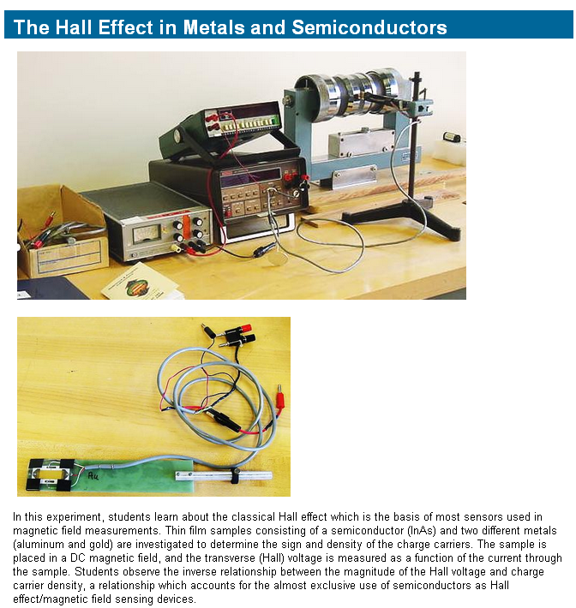

The course is this



