Superpositions Practice PhL 4.1.14

[Reviewed 5/7/14] After reviewing the famous electrostatic superposition cases which involve having constant potentials on surfaces (in one case superposition fails!) , I switch to some magnetic superposition cases. In these cases the potential Az is not mentioned and is certainly not constant on the conductor boundaries. I look at three different superposition problems and I show (I think) that they are all valid superpositions, where valid means that if Problems 1 and 2 satisfy all Maxwell equations, then so does Problem 3 = 1+2. BC's don't get much mention, and I conclude that all three cases are valid superpositions. The superposition cases are these:

(a) DC wire with current + external DC B field =
DC current with wire in external DC B field

The conclusion here is the there is no DC proximity effect and the wire current is unaffected.

(b) DC wire with current + external AC B field =
DC current with wire in external AC B field

The wire current IS affected here, so we have an AC proximity effect.

(c) AC wire with current + external AC B field =
AC current with wire in external AC B field

Again the wire current IS affected here, so we have an AC proximity effect.

I think I assume the latter two superpositions are in fact used in my Appendix P on eddy currents! At the time of writing, I was still wondering if there might be a DC proximity effect, and here was another argument that there is no such thing.

1. The canonical electrostatics superposition scenario. 1
2. Magnetic superposition examples 2
(a) Suppose everything is DC. 3
(b) Suppose Problem 1 stays DC but Problem 2 becomes AC 4
(c) Suppose both Problem 1 and Problem 2 are running at ω so both AC 5

1. The canonical electrostatics superposition scenario.

In the famous electrostatic superposition of two metal spheres scenario, we have this:

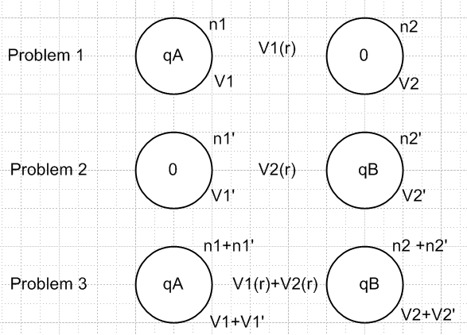

In Problem 1, the right sphere is at least present, causing its surface to be an equipotential. A charge density will be induced on this sphere. Same idea for Problem 2. So is Problem 3 really a superposition here? In each problem we have the Laplace equation ∇2V = 0 with BC's, and both the equation and the boundary conditions superpose correctly, so yes, it really does work. We could ground the sphere with 0 charge in problems 1 and 2 and it would still work, but we would have V2= 0 and V1' = 0.

Here is what does not work:

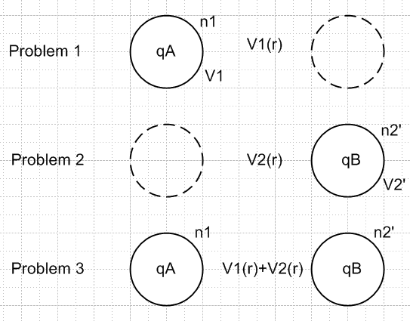

Here Problem 1 does not have V1(r) = constant on the right sphere whereas Problem 2 does, so when you add the two problems, Problem 3 does not have an equipotential surface for the right sphere so the superposition "fails on boundary conditions". Problem 1 has no BC associated with the dotted math sphere on the right.
I recall working on this kind of question several years ago. The moral is that in each sub-problem you have to have all the pieces of metal hanging around that you will have in the sum problem.

2. Magnetic superposition examples

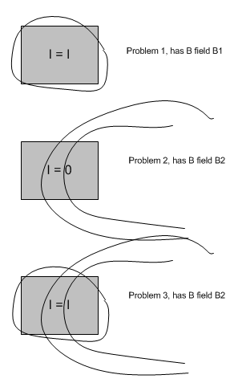

I assume that the square wire has μ = μ0 and the vacuum is outside the wire. We shall study this situation in the following:

(a) Suppose everything is DC.

Problem 1: The conductor is in isolation and surrounded by vacuum with some J3 = σE3 flowing. We assume we have examined this problem elsewhere. For this problem, presume that we have shown that v3 and J3 and E3 are all constant and that there are no transverse currents and there are small transverse Hall fields and there is some tiny internal negative charge density ρ and a positive one on the surface. Current is I = J3 x area. The current generates its own B field B1. This problem must satisfy:

curl B1 = μ0J
curl E = 0
div E = 0 where we ignore the tiny internal negative charge density ρ auto-Hall effect.

Problem 2: The externally applied B2 field all by itself with the conductor just quietly sitting there. The B2 field is generated by some external mechanism, and again it is in vacuum. This external B field is static and generates no E fields or currents in the wire and the field lines just go right through the wire. Since there is no current inside the conductor (or anywhere else) , we know that curl B2 = 0. There is no E field so the other Maxwell equations are of no concern for Problem 2. Of course we must have div B2 = 0 as well.

Each of these two problems satisfies Maxwell's equations and the Lorentz force equation.

Problem 3: We superpose the above two problems. In problem 3 we have a wire with current I, and we have a total magnetic field B1 + B2 . The Ei and Ji are exactly as in Problem 1. We then have

curl B = curl B1 + curl B2 = μ0J + 0

div B = div B1 + div B2 = 0 + 0 = 0

Thus, superposition is really a viable thing to do here.

Conclusion: The addition of the external magnetic field to a scenario of a current flowing in a wire does not alter the Ei fields in that wire and does not alter the currents Ji . If the vz was constant without the external B2 field, it is still constant and in fact unchanged.

Corollary: There is no DC "proximity effect".

Now how are things different if we are doing AC? There are several possible scenarios, I will do them one at a time.

(b) Suppose Problem 1 stays DC but Problem 2 becomes AC

Problem 1 is as above, so again

curl B1 = μ0J1
curl E1 = 0
div E1 = 0
div B1 = 0
J1 = σE1 = constant

Problem 2 has an AC B field going at ω and the wire is present. We know that any loop inside the conductor which captures B flux will have an EMF around it, and so there is going to be some kind of current action inside the conductor and that is J2. These are the famous eddy currents. For a given B2 field I could compute everything about these eddy currents J2, but I have never attempted that problem! We then have these equations:

curl B2 = μ0J2 + jωμ0ε0E2
curl E2 = -jωB2
div E2 = 0 // no charge density in this problem
div B2 = 0

I think the B2 field lines just pass through the conductor unaltered except perhaps by some B field generated by this induced eddy currents which are probably small. Probably the E fields are continuous through the boundary and probably there is no surface charge, but I could easily be wrong about that. If there is surface charge, then there is some div E2.

Problem 3 is the superposition of the above two problems, and we look inside the conductor and we expect to have these four Maxwell equations all happy.

μ0J3 = curl B3 - ∂tμ0ε0E3 1
curl E3 = -∂tB3 2
div E3 = 0 3
div B3 = 0 4

So what do they each say? The last two will be OK obviously, but the other two I should look at:

μ0J3 = curl B3 - ∂tμ0ε0E3 1

μ0J3 = curl (B1+ B2) - ∂tμ0ε0(E1+ E2)

= μ0J1 + μ0J2 + jωμ0ε0E2 - jω μ0ε0E2 // since E1 is a constant

Therefore we find that

J3 = J1 + J2 1

and so we just add the eddy currents to the Problem 1 current. Next,

curl E3 = -∂tB3

curl (E1+ E2) = -∂t(B1+ B2)

0 -jωB2 = -jω B2 // since B1 is a constant

and this then is just an identity.

So I think we have here a successful superposition where eddy currents make there way into a DC carrying wire. This is of course how signals get into power lines and such things. So if you have just Problem 1 and you then "bring in" the external field B2, you alter the current in the wire, and thus we for sure have some kind of proximity effect.

(c) Suppose both Problem 1 and Problem 2 are running at ω so both AC

Problem 1: I guess we imagine the wire as the center conductor of a coax line as in lines doc. There will be skin effect and there will be surface charge. There will be Maxwell equations:

curl B1 = μ0J1 + jωμ0ε0E1
curl E1 = -jωB1
div E1 = 0 // except at surface since now there is surface charge
div B1 = 0

Problem 2: Exactly same as in previous case.

curl B2 = μ0J2 + jωμ0ε0E2
curl E2 = -jωB2
div E2 = 0 // no charge density in this problem
div B2 = 0

Problem 3:

μ0J3 = curl B3 - ∂tμ0ε0E3 1
curl E3 = -∂tB3 2
div E3 = 0 3
div B3 = 0 4

So equation 1 says

μ0J3 = curl (B1+ B2) - jωμ0ε0(E1+ E2) 1

= curl B1 + curl B2 - jωμ0ε0E1- jωμ0ε0E2

= μ0J1 + jωμ0ε0E1 + μ0J2 + jωμ0ε0E2 - jωμ0ε0E1- jωμ0ε0E2

= μ0J1 + μ0J2

which again says

J3 = J1 + J2

Next we have

curl E3 = -∂tB3 2

curl (E1+ E2)= -jω (B1+ B2)

But this again is just an identity, which is a good thing. Finally

div E3 = div E1 = the surface charge stuff

div B3= 0

So here we have the transmission line "proximity effect". The B field from "the other conductor" is changing at ω, and it does something to the current in our wire. I think this should agree with my partial wave expansion conclusion where we get asymmetric Jz.

