Connection between Eddy Currents and Transmission Lines PhL 4.7.14

[ Reviewed on May 5, 2014, see red comments below, App P (v3) survived this review. ]

Eddy Current Analysis

Recall the two Maxwell curl equations, where the first is written for constant μ and ε,

curl B = jωμεE + μJ Maxwell curl H equation (J = Jc) (1.1.1)
curl E = - jωB . Maxwell curl E equation (1.1.2)

Inside a good conductor one normally ignores the displacement current in the first equation, as discussed in ***. Using Ohm's Law J = σE in the second equation then produces this pair of equations,

curl B = μJ Ampere
curl J = - jωσB . Faraday

We now imagine a scenario where some "external" B field Bext is created by some external current source Jext. A system of interest (call it DUT for Device Under Test), is immersed in this external field Bext and this time-changing field "induces" currents Jeddy in the DUT. With this partitioning, we write the above as

curl (Bext + Beddy) = μ(Jext + Jeddy) (1)
curl (Jext + Jeddy) = - jωσ(Bext + Beddy) . (2)

We then make the ansatz that

Beddy << Bext (3)
Jeddy << Jext . (4)

Then (1) becomes

curl (Bext) ≈ μ(Jext) (5)

Subtracting (5) from (1) gives,

curl (Beddy) ≈ μ(Jeddy) . (6)

[ This last was the step I didn't like. I subtract "an approximation to (1)" from (1), I just don't think this makes any sense. Consider

A + a = B + b suppose a and b are both small (1)
A ≈ B approximation of the above equation (5)
a ≈ b subtracting the equations (6)

But just because a and b are both small, we cannot conclude that a and b are the same size! One could be 1000 larger than the other. My later perturbation approach I think is better. ]

We assume next that Jeddy in the DUT exists in a region of space which is disjoint from the region where Jext flows in the generating apparatus. In the DUT region, Jext = 0, and in the generating region we have Jeddy = 0, following from our definitions of Jext and Jeddy. Any eddy currents which the generating system induces into itself we assume are included in Jext. Then we can write (2) as

curl (Jeddy) ≈ - jωσ(Bext) // within the DUT (7)

[ this is of course the correct desired equation ]

Within the context of our assumptions, this last equation is the basis of "eddy current analysis". The time-changing external B field generates eddy currents in the DUT according to (7). These eddy currents create their own magnetic field Beddy according to (6) which we have assumed is small and can be ignored compared to Bext. We do know from Lenz's Law that Beddy will create a magnetic flux through any loop which will reduce the flux in that loop caused by Bext.
So when might the ansatz conditions of (3) and (4) be justified? Looking at (7), for a fixed size of Bext , it is clear that Jeddy must get smaller as ω gets smaller, which in turn through (6) means that Beddy also gets smaller. So at sufficiently low frequency ω, we expect our "eddy current analysis" to be viable.

[ but eddy current analysis should be possible for large ω as well ]

When conditions (3) and (4) are not justified, the problem cannot be partitioned as we have done it above. In this case, we have a single monolithic problem that must be solved all at once by some method other than eddy current analysis. What happens at higher frequencies is this: the external field Bext still creates eddy currents in the DUT, but these currents in turn generate Beddy fields which are large enough so that they significantly alter Bext within the DUT and one must then deal with B ≡ Bext + Beddy as the true field which is causing those eddy currents. Since Beddy and Bext have different phases (according to (6) and (7) ) , one ends up with a very complicated feedback-like situation. In this case, one must combine the two curl equations into a Helmholtz equation as we have done in Section ***, and then one must solve that Helmholtz equation subject to appropriate boundary conditions. In effect we did this for an isolated round wire in Chapter 2 and the solution there involved extremely complicated E and B fields (recall the Kelvin functions) exhibiting skin effect and a rapidly winding phase as shown in Figures ** and **.

Although we have no proof, it seems likely that an eddy current analysis can only be viable at a frequency low enough that the skin depth δ is large compared to the dimensions of the DUT.

In typical Eddy Current Testing (ECT) systems, the frequency used might range from 10Hz to 1500 Hz. The idea of an ECT system is to try to detect Beddy using a sensitive Hall Effect or SQUID device, and take note of the field pattern produced by a DUT which is "known good" (has no internal cracks in the metal). An internal crack in a bad DUT will alter Jeddy in some way, which in turn causes an alteration in Beddy which can hopefully be detected. Due to the skin depth penetration issue, the useful depth of such non-destructive testing systems might be up to 15 mm (ballpark). Higher ω generates a larger signal, gives more accuracy on the defect size and location, but penetration depth is less, so there is always a compromise. Often scans at different ω values are optimal for different depths of the defect. ECT is a subject of much current interest and many papers have been and are being written.

Solution of a Simple Problem using Eddy Current Analysis

Do the thin round plate with uniform B field here

Solution of a Slightly Harder Problem using Eddy Current Analysis

Do the gradient round plate problem here

I have concluded my small voyage into the land of eddy current analysis. When it comes time to relate this to transmission lines, I can only claim the following qualitative picture:

curl E = - ∂tB ⇔ C E • ds = - [∫S • dS] . (1.1.36)
curl E = - jωB ⇔ C E • ds = - jω [∫S B • dS] . (1.1.36)

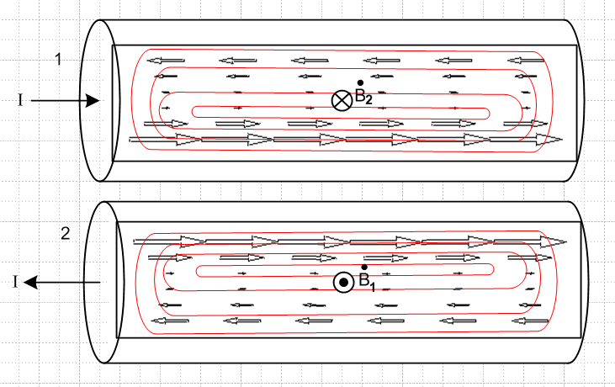

[ This picture was so painful to create that I just included it toward the end of Appendix P ]

If we assume that I is increasing, then the magnetic field B2 inside conductor 1 due to conductor 2 is increasing into the plane of paper, as indicated by the arrow tail. Faraday's Law as shown in (1.1.36) then creates E field lines which circulate in the sense shown inside conductor 1 (note minus sign in Faraday's Law). The field B2 is stronger on the side of conductor 1 which is closest to conductor 2 (the near side), and this causes the induced E field vectors to be larger in this region than on the far side. We saw this effect in our eddy current analysis of the thin round plate in the presence of an external B field having a gradient. In the picture above, we draw only a qualitative induced E field in each conductor on a certain plane which slices through both conductors. If one were to do a complete analytical or numerical analysis, one would find that the current density Jz in each conductor is asymmetrical and is larger in each wire on the side of that wire closest to the other wire. Obviously this effect can only occur if the current I is changing in time. This effect is known as the proximity effect.
One can regard the arrows in the above figure as mapping out the eddy current flow, since Jz = σ Ez. The arrows show only the eddy currents induced by the B field of the other conductor. To get a set of arrows to represent the total current , one would have to add a set of arrows like that shown in Figure ** below.
As we saw with the round plate, the proximity effect is proportional to the gradient of the B field, and this becomes larger as the wires come closer together. If the two wires are widely spaced, then B2 in wire 1 is nearly uniform across wire 1, the gradient is tiny, the current asymmetry is very small.
[ but it turns out that the main proximity effect is NOT due to that gradient, but instead due to cancellation and reinforcement of the self-induced eddy current with the other-wire-induced eddy current even ignoring its gradient. It is still true that the proximity effect is small for wide spacing simply because the field of the distant "other wire" when added and subtracted has less effect. ]
In order to have a proximity effect, there must be a time-changing B field [ true ]and that B field must have a gradient [not true ! see Appendix P fig P.11 ]. If there is no gradient, one still has eddy currents which result in Ohmic loss, but there is no proximity effect (at least we know this is true in the thin round plate case).
Based on (1.1.36) above, one would expect all eddy currents to be proportional to ω, but the amount of Jz asymmetry might then be independent of ω.
In the following plot, the red curve shows the vertical component By of the magnetic field produced only by the left wire in the y=0 plane ( I flowing out of paper), while the blue curve is the corresponding gradient ∂xBy. The red By field has a larger magnitude on the left side of the right conductor than it has on the right side, and that is why the eddy current arrows are larger are the left side.

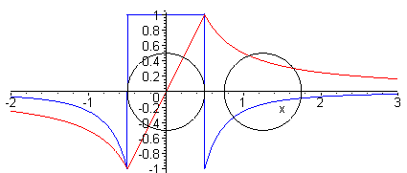

The above plot is done for ω = 0 (DC) where the conductors have uniform current distributions, but one may assume the general nature of the plot is similar for small ω > 0.

In Fig ** we show the main current I going the opposite direction in the two wires, as would be the case in an audio cable feeding loudspeakers.. If the currents go the same direction, as would be the case in a power transmission line two closely spaced conductors going each direction, the eddy currents are larger on the conductor portions farthest from the other conductor. [ but how does that work with the above picture!!!!??? ]

[ The above picture is incomplete! It shows the Bext from left wire which acts on right wire, but it does not show the effect on right-wire Bext due to the current in the right wire. You really have to include eddy currents induced from the other wire AND those that are self induced. I think I have this right in Fig P.15 of Appendix P. ]

Proximity Effect and Wire Resistance [ used verbatim in App P ]

Consider a small differential volume rdθdrdz in one of the conductors (relative to a cylindrical coordinate system for that wire). Its cross sectional area is dA = rdθdr . This volume has resistance

dR = "ρL/A" = ρ dz / dA

and the current through this little resistor will be

dI = Jz(r,θ) dA .

The Ohmic power generated in this tiny resistor is, from P = I2R,

dP = (dI)2(dR) = [Jz(r,θ)dA]2 ρ dz / dA = ρ Jz(r,θ)2 dA dz .

For the larger resistor consisting of length dz of the entire cross section we find then that

P = ∫dP = dz ∫dA ρ Jz(r,θ)2 .

The total current in the wire is

I = ∫dA Jz(r,θ)

and then from P = I2R the effective wire resistance of a cross sectional slice of wire of length dz is,

R = $\frac{P}{I2}$ = ρdz $\frac{∫dA [Jz(r,θ)]2}{[ ∫dA Jz(r,θ) ]2}$ ∫dA [...] = $^{\int_{0}^{a}{}}$dr r $^{\int_{-π}^{π}{}}$dθ [...]

We now redefine R to mean resistance per unit length, so we then have

R = [ ρ/A ] $\frac{∫dA [Jz(r,θ)]2/A}{[ ∫dA Jz(r,θ)/A ]2}$ = Rdc $\frac{<Jz2>}{<Jz>2}$ = Rdc $\frac{E(Jz2)}{[E(Jz)]2}$

where Rdc is the DC resistance per unit length of the wire. Our notations <> and E() mean "expected value". In elementary probability theory one writes

μx = E(X) // mean

σx2 ≡ varx = E(X2) - E(X)2 = E(X2) - μx2 // variance; σx = standard deviation

so that

$\frac{E(X2)}{[E(X)]2}$ = $\frac{σx2+ μx2}{μx2}$ = 1 + $\frac{σx2}{μx2}$

Thus, taking X = Jz we find this result for AC resistance per unit length,

R = Rdc (1 + $\frac{σJz2}{μJz2}$ ) $\frac{R}{Rdc}$ = 1 + $\frac{σJz2}{μJz2}$ $\frac{P}{Pdc}$ = [1 + $\frac{σJz2}{μJz2}$] // loss

At DC, Jz is constant across the cross section so its variance is 0 and the above says R = Rdc. For any other function Jz(r,θ) ≠ constant, one will have some variance σJz2 > 0 and then R > Rdc.
Thus, the proximity effect increases the effective resistance of the wires in Fig XX, causing an increase in the Ohmic loss.
Notice that the percentage proximity loss is independent of the current I.

Skin Effect as a Proximity Effect

For a single round wire in isolation, we know from Ampere's Law that inside the wire, B(r) = Kr , and obviously this B field has a gradient, so we might expect to have some sort of self-proximity effect in such an isolated wire:

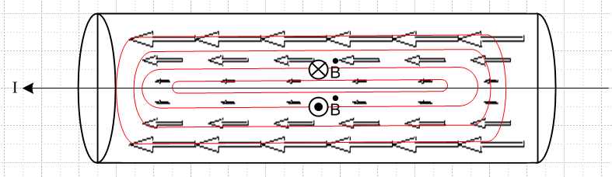

As current I increases, increases in the directions shown. Since the directions of increase are different above and below the center line, we end up with all the eddy current arrows pointing in the same direction, which differs from the previous figure. Small eddy loops farther from the center line have larger induced EMF from Ampere's Law than loops close to the axis, resulting in an E and J field pattern like that shown in the picture. This is of course just the "skin effect" discussed in Chapter 2, but interpreted in terms of a self-proximity effect. Usually one uses the phrase "proximity effect" to refer to the effect of an external B field, and "skin effect" to refer to this self-proximity effect situation.
Companies with names like "Monster Cables" advocate using their low-ohm expensive cables for driving audio speakers in order to offset the resistance increases due to the proximity and skin effects.

