Appendix P version 2 PhL 4.30.14

Appendix P: Eddy Currents and the Proximity Effect 1
P.1 Eddy Current Analysis 1
P.2. Eddy currents in a thin round plate in a uniform B field 3
P.3. Eddy currents in a thin round plate in a non-uniform B field 6
(a) The stream function method in Cartesian Coordinates 8
(b) The stream function method in Cylindrical Coordinates 9
(c) Using the stream function method to solve the plate problem 10

Appendix P: Eddy Currents and the Proximity Effect

The Maxwell curl E equation (1.1.2) and its integral form are,

curl E = - ∂tB ⇔ C E • ds = -∂t[∫S B • dS] . (1.1.36)

The integral form is often written as Eemf = -∂t[magnetic flux] and one says that a changing magnetic flux through a loop induces a voltage Eemf (an "electro motive force") in that loop which then drives a current around the loop if the loop lies in a conducting medium. This is Faraday's Law of Induction and the loop of interest is usually a thin wire or coil of such wires inside, say, an electric generator. The wire or coil of wires is attached to some Rload and some current I flows through the loop and load. There is Ohmic loss I2Rloop in the generating loop(s), but if Rload >> Rloop this loss is minimal in the context of the generator.
When the loop lies inside an open conducting medium, things become more complicated and the currents which are then driven around mathematical loops in that medium are called eddy currents. The word eddy suggests the way water swirls around in a constrained environment when driven by wind or water currents (see Fig P.2 below). Just as the water flow velocity can have no normal component at a boundary (a steep river bank for example), an electrical eddy current generally has no normal component at a boundary of the conductor. An exception to this rule occurs if the eddy current is feeding a charge density on the outer surface of that boundary, and this exception would apply to water flow as well if a bank were shallow and can act as a temporary reservoir of water. The analogy is not exact, but the word eddy is apt.
In practical terms, eddy currents are normally seen as undesirable, as in a transformer core, since they represent Ohmic loss which results in power waste and heating of the core (Rload = 0). Sometimes, however, eddy currents are useful, such as in non-destructive testing for internal cracks in metal parts, as noted below. Other eddy current applications include crucible induction heating, object movement and levitation, and braking.
In this Appendix, we explore the nature of eddy currents and compute these currents for some simple situations. We then show how one can interpret both the skin effect and the proximity effect (non-uniform current densities in nearby conductors) in terms of eddy currents.

P.1 Eddy Current Analysis

There are whole books on the subject of eddy currents, and the web reveals a proliferation of papers and theses on eddy current applications. However, simple analytic examples of eddy current problems are hard to find. The general theory is quite complicated, and we present here a simplified approach which suits are limited purposes, then we work through two specific sample problems.

Recall the two Maxwell curl equations, where the first is written for constant μ and ε,

curl B = jωμεE + μJ Maxwell curl H equation (J = Jc) (1.1.1)
curl E = - jωB . Maxwell curl E equation (1.1.2)

Inside a good conductor one normally ignores the displacement current in the first equation, as discussed below (2.2.2). Using Ohm's Law J = σE in the second equation then produces this pair of equations,

curl B = μJ Ampere (P.1.1)
curl J = - jωσB . Faraday (P.1.2)

We now imagine a scenario where some "external" B field Bext is created by some external current source Jext. A system of interest (call it DUT for Device Under Test), is immersed in this external field Bext and this time-changing field "induces" currents Jeddy in the DUT. With this partitioning, we write the previous two equations as

curl (Bext + Beddy) = μ(Jext + Jeddy) (P.1.3)
curl (Jext + Jeddy) = - jωσ(Bext + Beddy) . (P.1.4)

We then make the ansatz that

Beddy << Bext (P.1.5)
Jeddy << Jext . (P.1.6)

Then (P.1.3) becomes

curl Bext ≈ μJext . (P.1.7)

Subtracting approximate (P.1.7) from exact (P.1.3) gives the following approximate equation,

curl Beddy ≈ μJeddy . (P.1.8)

We assume next that Jeddy in the DUT exists in a region of space which is disjoint from the region where Jext flows in the external generating apparatus. In the DUT region, Jext = 0, and in the generating region we have Jeddy = 0, following our definitions of Jext and Jeddy. Any eddy currents which the generating system induces into itself we assume are included in Jext. Then we can write (P.1.4) as

curl Jeddy ≈ - jωσ Bext // within the DUT (P.1.9a)
or
curl Eeddy ≈ - jω Bext . // since Jeddy = σEeddy (P.1.9b)

Within the context of our assumptions, (P.1.9) is the basis of "eddy current analysis". The time-changing external B field generates eddy currents in the DUT according to (P.1.9a). These eddy currents create their own magnetic field Beddy according to (P.1.8) which we have assumed is small and can be ignored compared to Bext. We know from Lenz's Law that Beddy will create a magnetic flux through any loop which will reduce the flux in that loop caused by Bext.
So when might the ansatz conditions of (P.1.5) and (P.1.6) be justified? Looking at (P.1.9a), for a fixed size of Bext, it is clear that Jeddy must get smaller as ω gets smaller, which in turn through (P.1.8) means that Beddy also gets smaller. So at sufficiently low frequency ω, we expect our "eddy current analysis" to be viable.

When conditions (P.1.5) and (P.1.6) are not justified, the problem cannot be partitioned as we have done above. In this case, we have a single monolithic problem that must be solved all at once by some method other than our simple eddy current analysis. What happens at higher frequencies is this: the external field Bext still creates eddy currents in the DUT, but these currents in turn generate Beddy fields which are large enough so that they significantly alter Bext within the DUT and one must then deal with B ≡ Bext + Beddy as the true field which is causing those eddy currents. Since Beddy and Bext have different phases (according to (P.1.8) and (P.1.9) ), one ends up with a very complicated feedback-like situation. In this case, one must combine the two Maxwell curl equations into a wave / Helmholtz equation as we have done in (1.2.2) and later in (1.5.27) and (1.5.32), and then one must solve that Helmholtz equation subject to appropriate boundary conditions, both inside and outside the DUT. In effect we did this for an isolated round wire in Chapter 2 and the solution there involved extremely complicated E and B fields (recall the Kelvin functions) exhibiting skin effect and a rapidly winding phase as shown in Figure 2.9.

Although we present no formal proof, it seems likely that our simple eddy current analysis can only be viable at a frequency low enough that the skin depth δ is large compared to the dimensions of the DUT.

In typical Eddy Current Testing (ECT) systems, the frequency used might range from 10Hz to 1500 Hz. The idea of an ECT system is to try to detect Beddy using a sensitive Hall Effect or SQUID device, and take note of the field pattern produced by a DUT which is "known good" (has no internal cracks in the metal). An internal crack in a bad DUT will alter Jeddy in some way, which in turn causes an alteration in Beddy which can hopefully be detected. Due to the skin depth penetration issue, the useful depth of such non-destructive testing systems might be up to 15 mm (ballpark). Higher ω generates a larger signal, gives more accuracy on the defect size and location, but penetration depth is less, so there is always a compromise. Often scans at different ω values are optimal for different depths of the defect. ECT is a subject of much current interest and many papers have been and are being written.

P.2. Eddy currents in a thin round plate in a uniform B field

To reduce excess symbols, in this section we use the following notation in relation to Section P.1 :

B ≡ Bext
E ≡ Eeddy
J ≡ Jeddy J = σE (P.2.1)

A thin round plate of radius a and thickness h lies centered in the z = 0 plane of a cylindrical coordinate system. This plate is the Device Under Test (DUT) for this problem. An unseen external apparatus creates a time-varying and spatially uniform magnetic field B = B perpendicular to the plate. The problem is to compute the electric field E in the plate, and the corresponding eddy currents J = σE. The region surrounding the plate is assumed non-conducting, perhaps it is air.

Faraday's Law and symmetry imply circular closed electric field lines in the plate. We assume sufficiently low ω so skin depth δ >> h, so the E field lines are uniform in the z direction of the plate thickness. We are perhaps more used to magnetic field lines being closed since div B = 0, but here we have closed electric field lines since div E = 0 inside the plate (since there is no free charge inside the plate, see Section 3.1). The plate is gray, and some of the circular closed E field lines are shown in red,

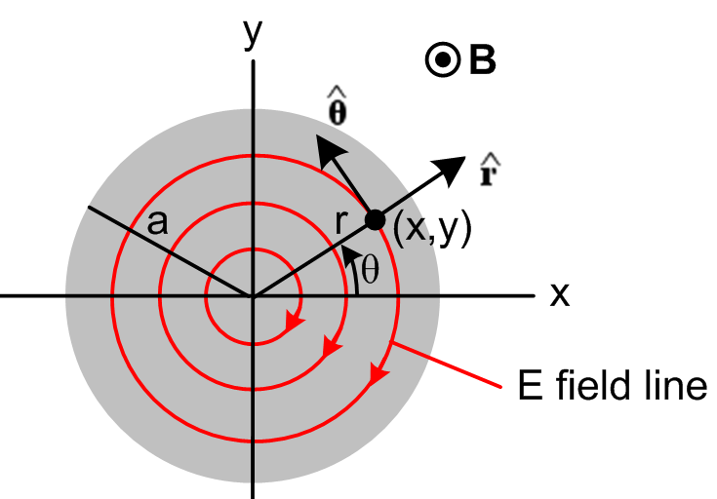 Fig P.1

The magnitude of the E field is constant on each circle due to symmetry.
Working in the time domain instead of the frequency domain, our "eddy current analysis" equation (P.1.9b) with symbols (P.2.1) is this:

curl E = - ∂tB ⇔ C E • ds = -∂t[∫S B • dS] . (P.2.2)

Consider a circle at radius r. We then have from the right equation of (P.2.2),

Eθ * 2πr = - πr2 => Eθ(r) = - πr2/2πr = (- /2) r . (P.2.3)

The field is linear in r, and is reminiscent of the result for the H field inside a round wire which carries a DC current I,

H * 2πr = I πr2/πa2 =< H(r) = I r2/a2 / 2πr = (I/2πa2)r (C.3.9)

Notice that the E field line circles continue outside the plate and under and over it, but there will only be current in the plate. Here then is our result for E and J inside the plate:

E(r) = Eθ(r) Eθ(r) = (- /2) r Jθ(r) = σ (- /2) r (P.2.4)

We digress momentarily to study the heat loss generated in the plate. Consider a thin cylindrical shell of height dz and radius r and thickness dr. Think of this as a circular wire of rectangular cross section dA = dzdr. The current in this wire is given by,

dI = Jθ dA = Jθ dzdr . (P.2.5)

The resistance of the wire is dR = ρ L/dA = ρ 2πr/(dzdr). The power burned from P = I2R is

dP = (dI)2dR = [Jθ dzdr]2 * ρ 2πr/(dzdr) = Jθ2 [dzdr] * ρ 2πr

= Jθ2 2πrρ dr dz = [σ (-z /2) r]2 2πrρ dr dz = (π/2)σ z2 r3 drdz . (P.2.6)

Now integrate over the plate thickness h to replace dz by h. Then integrate r from 0 to a to get

P = (π/2)σ z2 h(a4/4) = (π/8)σ z2a4h . (P.2.7)

Dimensions:
RHS = ohm-1m-1 sec-2 [volt-sec/m2]2 m5 = ohm-1 sec-2 [volt-sec]2 = volt2/ohm = watts

The total current going around the plate as observed through any azimuthal slice θ = θ1 is,

I = h$^{\int_{0}^{a}{}}$dr Jθ(r) = h σ (-z /2)$^{\int_{0}^{a}{}}$rdr = h σ (-z /4)a2 = - (1/4) hσa2z . (P.2.8)

To summarize our conclusions for eddy currents in the thin round plate of radius a, thickness h and conductivity σ ,

Jθ(r) = - (1/2)σ r (P.2.4)
I = - (1/4) σha2 (P.2.8)
P = (π/8) σha4 2 (P.2.7) (P.2.9)

These results are in agreement with equations (36), (37) and (38) of Siakavellas. Since → jωB, the power loss is proportional to the square of the frequency of the external B field, and it is proportional to the conductivity of the plate and its thickness. [Siakavellas also treats thin plates with polygonal boundaries.]

It is a simple matter now to plot the eddy current vector inside the plate:

Jx = Jθ • = -Jθ sinθ = -Jθ (y/r) = + (1/2) σ y ≡ ky θ(r<a) k = (1/2) σ
Jy = Jθ • = Jθ cosθ = Jθ (x/r) = -(1/2) σ x ≡ -kx θ(r<a)

With k = 1 and a = 1 Maple produces the following plot of the eddy currents inside the plate:

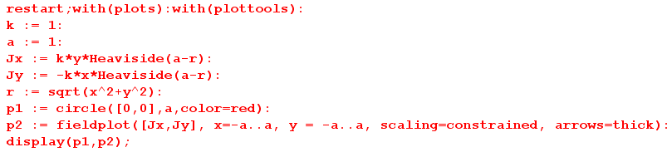

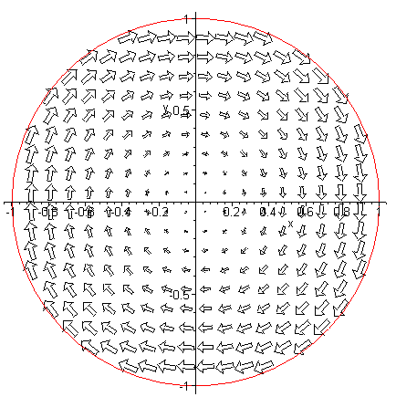Fig P.2

With k = 1 we have assumed that > 0 (out of plane of paper), and according to Lenz's Law, the eddy current creates a B field whose flux cancels some of the applied B flux, hence the clockwise direction.

Reader Exercise. Notice that the Eeddy current arrows are largest near the edge of the plate according to (P.2.4) which says Eθ(r) = constant * r. Is it correct to interpret this as a 2D skin effect of the type encountered in Chapter 2? What is Eθ(r) for r > a assuming Bext has an infinite x,y extent? In terms of the external B field penetrating the disk, since the disk is thin we have assumed no skin effect in the z dimension and that B field penetrates fully and δ >> h.

Reader Exercise. The EMF due to Faraday induction drives Jeddy in a tangential direction as Fig P.2 shows. Each electron appears to maintain its radius from the disk center. Interpret this behavior in terms of the Lorentz force acting on the electron. Is there a "radial Hall effect" present in this problem? [ see Appendix *** ]

N.J. Siakavellas, "Two Simple Models for Analytical Calculation of Eddy Currents in Thin Conducting Plates", IEEE Trans. on Magnetics, Vol 33, No. 3, May 1997, pp 2245-2257.

P.3. Eddy currents in a thin round plate in a non-uniform B field

This example is the same as that of the previous section, except the B field is no longer spatially uniform and for simplicity we assume it has the following simple linear form,

B(x) = B0 - α x α > 0 // B(x) larger for x < 0 (on the left) (P.3.1)
This is then a simple case where Bext(r) = B(r) has a gradient over the plate.
Even with this simple form, the problem is considerably more complicated that the previous problem since we can no longer make use of azimuthal symmetry. First consider (P.2.2) now in the frequency domain, where as before E ≡ Eeddy and B ≡ Bext. (This equation is really (P.1.9b) of Section P.1. )

curl E = - jωB . (P.2.2) (P.3.2)

In cylindrical coordinates this says

[ r-1∂θEz - ∂zEθ] + [∂zEr - ∂rEz] + [ r-1∂r(rEθ) - r-1∂θEr ] = - jω B . (P.3.3)

As in the previous example, we assume the plate is very thin and ω is very small so δ >> h, so fields are constant in the z direction allowing us to replace ∂z → 0. At the same time, we assume Ez = 0 since Ez has no apparent source. Then the above vector curl equation boils down to this scalar equation for the z component,

r-1∂r(rEθ) - r-1∂θEr = - jω[B0 - α x]
or
∂r(rEθ) - ∂θEr = - jω[B0 - α rcosθ]r (P.3.4)

since x = rcosθ. Since there is no charge inside the plate (as before), we know div E = 0, or

div E = r-1∂r(rEr) + r-1∂θEθ + ∂zEz = 0 . (P.3.5)

Again we set Ez= 0 which kills off the last term. Then (P.3.3) and (P.3.4) may be written

∂r(rEθ) - ∂θEr = - jω[B0 - α rcosθ]r

∂r(rEr) + ∂θEθ = 0 . (P.3.6)

These equations form a system of coupled first-order linear PDE's in variables r and θ for functions Er(r,θ) and Eθ(r,θ). There is no z argument since we assumed ∂z → 0 above, so basically we have a 2D problem in polar coordinates. The first equation is inhomogeneous (has a driving term) while the second is homogeneous.
We wish to emphasize how the addition of a simple linear external B field variation has converted the trivial problem of Section P.2 to a non-trivial problem involving coupled partial differential equations. There are of course associated boundary conditions, such as Er(a,θ) = 0 since Jr can have no normal component at the rim of the plate. This complexity is typical of "eddy current problems". Below we shall solve this problem using a potential method, and one can then show that the solutions so obtained do in fact satisfy (P.3.6).

(a) The stream function method in Cartesian Coordinates

In our treatment of transmission lines in Chapter 4, we used the fact that div B = 0 to describe the magnetic field in terms of a magnetic vector potential A, where B = curl A (since div curl A = 0 for any A). Under suitable conditions, it was then possible to ignore the "transverse" components of A and deal only with the z component Az. This then replaced the complexity of three fields Bi with one field Az.
In our current context of dealing with electric fields inside a conductor (where ρ = 0) we have div E = 0 and therefore div J = 0 since J = σE. We can then describe the current J in terms of a current vector potential T, where J = curl T (since div curl T = 0 for any T). For a thin plate at low frequency ω, we will argue that the transverse components of T may be neglected, and then the complexity of three fields Ji is replaced by one field Tz, which is known in this context as a stream function.

Here then is the stream function method presented in Cartesian coordinates. First,

J = curl T = (∂yTz - ∂zTy) + (∂zTx - ∂xTz) + (∂xTy - ∂yTx)

Jx = ∂yTz - ∂zTy
Jy = ∂zTx - ∂xTz
Jz = ∂xTy - ∂yTx . // components of the above (P.3.7)

The J we have in mind is Jeddy appearing in (P.1.9a). Using the symbols of (P.2.1), we have

curl J = - jωσ B (P.1.9a) (P.3.8)

where B = Bz [ = Beddy] . Using a standard vector identity we find then that

curl J = curl curl T = grad(div T) - ∇2T . (P.3.9)

Just as we are allowed to work in the "Coulomb gauge" div A = 0 with the magnetic vector potential (see Appendix A), here we can work in the div T = 0 gauge for the current vector potential. In this gauge, we combine (P.3.8) and (P.3.9) to get

∇2T = jωσB (P.3.10)

where ∇2 is the vector Laplacian operator. This equation can be compared with ∇2A = - μJ which is (1.3.5) for a magnetostatic situation where A has no time dependence. As shown in (H.1.9), equation (P.3.10) has the solution

T(x) = -∫d3x' [1/4πR][jωσB] + possible homogeneous solutions R = |x-x'| (P.3.11)

where the integral is the "particular solution" of (P.3.10). We now sidestep a detailed analysis and make the ansatz first of all that no homogeneous solutions are required in order to meet boundary conditions on T. Recalling that B is really Beddy in the above equation, and anticipating that the current J = Jeddy has no z component inside our thin plate at low ω, the field Beddy inside the plate will be mostly in the z direction. Therefore T(x) in (P.3.11) will also be mostly in the z direction. With this slightly wobbly justification, as well as the justification that we shall be led to a reasonable solution, we now make the ansatz that

Tx, Ty << Tz . (P.3.12)

Basically, we shall assume that Tx = Ty = 0 and only Tz is significant. Then (P.3.7) becomes

Jx = ∂yTz
Jy = - ∂xTz
Jz = 0 . (P.3.13)

Furthermore, we assume that Tz = Tz(x,y) with no z dependence, since then (P.3.13) will lead to currents Jx and Jy which have no z dependence. With all these assumptions, (P.3.10) becomes a scalar equation

∇2D2Tz(x,y) = jωσBz(x,y) (P.3.14)

where ∇2D2 ≡ ∇2 - ∂z2 is the transverse component of the 3D scalar Laplacian.

Equation (P.3.14) is just the 2D Poisson equation of 2D potential theory [see (A.0.1) for the normal Poisson equation in 3D ]. Many tools are available for solving this equation, and we shall use some of these tools below in our solution of the thin plate problem.

(b) The stream function method in Cylindrical Coordinates

In cylindrical coordinates (really polar coordinates) one writes

∇2D2 Tz = r-1∂r(r∂rTz) + r-2∂θ2Tz

so (P.3.14) becomes

r-1∂r[r∂rTz(r,θ)] + r-2∂θ2Tz(r,θ) = jωσ B(r,θ) . (P.3.15)

The ansatz (P.3.12) becomes

Tr, Tθ << Tz . (P.3.16)

The cylindrical replacement for (P.3.7) is

J = curl T = [ r-1∂θTz - ∂zTθ] + [∂zTr - ∂rTz] + [ r-1∂r(rTθ) - r-1∂θTr ]

Jr = r-1∂θTz - ∂zTθ
Jθ = ∂zTr - ∂rTz
Jz = r-1∂r(rTθ) - r-1∂θTr // components of the above (P.3.17)

which, using (P.3.16), we approximate as

Jr = r-1∂θTz
Jθ = - ∂rTz
Jz = 0 (P.3.18)

(c) Using the stream function method to solve the plate problem

From (P.3.1) we have B(x) = B0 - α x = B0 - α rcosθ, so (P.3.15) states that

∂r[r∂rTz(r,θ)] + r-1∂θ2Tz(r,θ) = jωσ [B0 - α rcosθ] r . (P.3.19)

Here we have a single PDE in r,θ for a single function Tz(r,θ) [ the stream function]. One can compare this with the pair of coupled PDE's found earlier in (P.3.6).
Since the angle θ has the full range (0,2π) we can expand the various functions into "partial waves" as shown in (D.1.5) for a scalar function, so

Tz(r,θ) = $\sum_{m = -∞}^{∞}{}$ Tz(r,m) ejmθ (D.1.5a)
Tz(r,m) = (1/2π) $^{\int_{-π}^{π}{}}$dθ Tz(r,θ) e-jmθ (D.1.5b) (P.3.20)

where we use our usual overloaded notation for Tz. Then (P.3.15) becomes, using ∂θ→ +jm,

∂r(r∂rTz(r,m)) - r-1m2Tz(r,m) = jωσ B(r,m) r (P.3.21)

where

Bz(r,m) = (1/2π) $^{\int_{-π}^{π}{}}$dθ Bz(r,θ) e-jmθ = (1/2π) $^{\int_{-π}^{π}{}}$dθ [B0 - α rcosθ] e-jmθ

= B0 (1/2π) $^{\int_{-π}^{π}{}}$dθ e-jmθ - α r (1/2π) $^{\int_{-π}^{π}{}}$dθ cosθ e-jmθ

= B0 (1/2π) $^{\int_{-π}^{π}{}}$dθ cos(mθ) - α r (1/2π) $^{\int_{-π}^{π}{}}$dθ cosθ cos(mθ)

= B0 (1/π) $^{\int_{0}^{π}{}}$dθ cos(mθ) - α r (1/π) $^{\int_{0}^{π}{}}$dθ cosθ cos(mθ)

= δm,0B0 (1/π) π - α r (1/π)δm,±1 π/2

= δm,0B0 - α r (1/2)δm,±1 (P.3.22)

where we use the following integral for integers m and n,

$^{\int_{0}^{π}{}}$dθ cos(mθ)cos(nθ) = . // Spiegel p 96 15.27

Equations (P.3.21) become

∂r(r∂rTz(r,0)) = jωσ B0 r m = 0 (P.3.23)

∂r(r∂rTz(r,±1)) - r-1Tz(r,±1) = - (1/2)jωσ r2 m = ±1 (P.3.24)

∂r(r∂rTz(r,m)) - r-1m2Tz(r,m) = 0 m = other integers (P.3.25)

We assume the solution to (P.3.25) is Tz(r,m) = 0. Maple tells us the general solutions to the other equations:

Tz(r,0) = jω σ B0 (1/4)r2 + C1 ln(r) + C2

Tz(r,±1) = - (1/8) jωσ (α/2) r3 + D1(r-1/r) + D2(r+1/r) . (P.3.26)

To have Tz(r,0) finite at r = 0 we must have C1 = 0.
To have Tz(r,±1) finite at r = 0 we must have D1 = D2. The solution forms are then

Tz(r,0) = jωσ B0 (1/4)r2 + C2
Tz(r,±1) = - (1/8) jωσ (α/2) r3 + 2D1 r . (P.3.27)

Inserting these partial wave amplitudes into (P.3.20) gives

Tz(r,θ) = Tz(r,0) + T(r,+1)ejθ + T(r,-1)e-jθ = Tz(r,0) + T(r,+1) 2 cosθ

= [jω σ B0 (1/4)r2 + C2] + 2 cosθ [- (1/8) jωσ (α/2) r3 + 2D1 r]

= [jω σ B0 (1/4)r2 + C2] - 2 cosθ r [ (1/8) jωσ (α/2) r2 - 2D1] . (P.3.28)

At the origin point r = 0 we arbitrarily set the potential Tz(0,θ) = 0 so C2 = 0. One always has this freedom with a potential: since J = curl T, constants in T don't affect J. We then compute Jr as shown in (P.3.18) to obtain

Jr(r,θ) = r-1∂θTz = 2 sinθ [(1/8) jωσ (α/2) r2 - 2D1 ] . (P.3.29)

But at r = a, we must have Jr(a,θ) = 0 since there can be only tangential currents at the rim of our circular plate, and this determines D1 giving this final result for the stream function Tz ,

Tz(r,θ) = jωσ B0 (1/4) r2 - (1/4) cosθ r jωσ (α/2) (r2-a2)

= jωσ [ (1/4)B0 r2 - (α/8) cosθ (r3-a2r) ] . (P.3.30)

The eddy current components are then, again from (P.3.18),

Jr(r,θ) = r-1∂θTz = r-1 jωσ (α/8) sinθ (r3-a2r) = jωσ [(α/8) sinθ (r2-a2)]

Jθ(r,θ) = - ∂rTz = jωσ [ - (1/2)B0 r + (α/8) cosθ (3r2-a2) ] . (P.3.31)

Here then is a summary of the solution for a circular plate of radius r and conductivity σ in the presence of an external magnetic field B(x) = B0 - α x :

Tz(r,θ) = jωσ [ (1/4)B0 r2 - (α/8) cosθ r (r2-a2) ]

Jr(r,θ) = jωσ [(α/8) sinθ (r2-a2)] // the eddy currents
Jθ(r,θ) = jωσ [ - (1/2)B0 r + (α/8) cosθ (3r2-a2) ]

Er(r,θ) = jω [(α/8) sinθ (r2-a2)]
Eθ(r,θ) = jω [ - (1/2)B0 r + (α/8) cosθ (3r2-a2) ] . (P.3.32)

The eddy currents Jr and Jθ are proportional to ω as expected from (P.1.9a). Current Jr vanishes at the edge of the plate. When α = 0, we find Jr(r,θ) = 0 and Jθ(r,θ) = jωσ [ - (1/2)B0 r ] which replicates our uniform-B solution (P.2.4) which was Jθ(r) = σ (- /2) r .
We have verified using Maple that the stream function Tz(r,θ) shown in (P.3.32) satisfies (P.3.19) and that the electric fields Er(r,θ) and Eθ(r,θ) satisfy (P.3.6).
Finally, we have Maple plot the resulting eddy currents. We first write

Jx = Jr • + Jθ • = Jr cosθ – Jθ sinθ
Jy = Jr • + Jθ • = Jr sinθ + Jθ cosθ . (P.3.33)

For plotting we set jωσ = 1, a = 1, B0 = 1, and α = 1. Here is the plotting code,

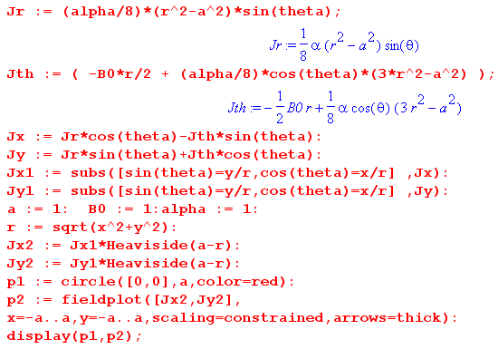

and here is the resulting plot,

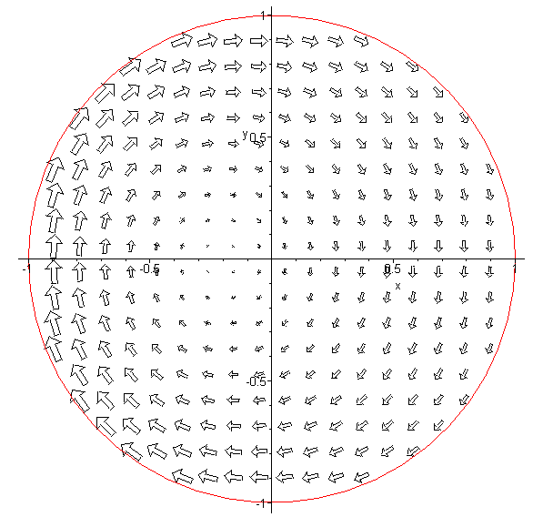 Fig P.3

which one can compare with our no-gradient plot of Fig P.2. As expected, the eddy currents are larger on the left side because the external B field is larger there. One can imagine the E field lines being a set of distorted circles which shrink down about a point to the left of the origin.
The main point of this example is to demonstrate the fact that a gradient in the external B field results in an asymmetry in the eddy current distribution such that the larger eddy current vectors are in the region in which the external B field is largest. We shall see below in a different geometry how this fact accounts for the so-called proximity effect in a transmission line.

P.4 Self-Induced Eddy Currents in a Round Wire

As a prototype example, we consider our well-studied axially symmetric radius-a round wire of Chapter 2. We wish to examine this wire at low frequency in terms of the eddy current analysis of Section P.1. Now the "external apparatus" and the "device under test" are one in the same! At ω = 0, the current in the wire is uniform over the cross section and creates a certain magnetic field which we will take to be Bext which we know is in the direction. From Ampere's Law we find

2πr Bext(r) = $\frac{πr2}{πa2}$μ Ienc = $\frac{πr2}{πa2}$ μ Jext πa2 = πr2μJext

=> Bext(r) = (1/2) μ r Jext .

In this problem the "external" current density Jext is generated by the wire itself, as if it were somehow its own "external apparatus". A better notation would be Jdc since this is the ω = 0 current distribution, but we continue to use Jext to maintain contact with the Section P.1. Similarly, Bext = Bdc .

(a) Eddy Current Analysis applied to the round wire at low ω

If the skin depth δ is large compared to the wire radius a, we expect the eddy current analysis of the previous section to be viable, and we find that

curl Jeddy ≈ - jωσBext where Bext = (1/2) μ r Jext = Bext(r) . (*)

In cylindrical coordinates one writes for an arbitrary vector field F,

curl F = [ r-1∂θFz - ∂zFθ] + [∂zFr - ∂rFz] + [ r-1∂r(rFθ) - r-1∂θFr ]

For a vector field F which is a function only of r one finds

curl F = [- ∂rFz] + [ r-1∂r(rFθ) ] .

Thus (*) becomes these two equations,

r-1∂r[r(Jeddy)θ] = 0 // z component

- ∂r(Jeddy)z = -jωσ Bext(r) = -jωσ (1/2) μ r Jext // θ component

The first equation may be written as

∂r[r(Jeddy)θ] = 0
or
[r(Jeddy)θ] = C1
or
(Jeddy)θ(r) = C1/r

from which we must conclude that C1 = 0 and then (Jeddy)θ(r) = 0, so there is no azimuthal eddy current in the wire.

The second equation may be integrated from r=0 to r=r to obtain

(Jeddy)z(r) - (Jeddy)z(0) = jωσ (1/2) μ Jext $^{\int_{}^{r}{}}$dr' r' = jωσ (1/4) μ Jext r2 .

Consider now a tiny circular math loop centered on the round wire axis. Since Bext → 0 as r→ 0, this loop has no flux, so the induced eddy current around this loop → 0. Thus (Jeddy)z(0) = 0 and we have

(Jeddy)z(r) = jωσμ (1/4) μ Jext r2 = - (β2/4) Jext r2

where we use the complex wavenumber symbol β2 = - jωμσ from (2.2.4).
Thus, the total current density in the wire obtained from eddy current analysis is in the z direction and is given by

Jz = Jext + (Jeddy)z = Jext [ 1 - (β2/4)r2] = Jext [ 1 + j ωσμ (1/4)r2 ] .

Notice that the eddy current contribution is π/2 out of phase with Jext. Since we have assumed δ >> a, it follows that |βa| << 1 ( since β2 = -2j/δ2 ) and thus (|β|2/4)r2 << 1 so the eddy current contribution is very small, which matches the ansatz (P.1.6) . Defining dimensionless quantity κ as

κ ≡ ωσμ (1/4)r2 = |β|2 (1/4) r2 << 1

we have

|Jz| = | Jext | $\sqrt{(1+jκ)(1-jκ)}$ ≈ | Jext | $\sqrt{(1 + κ2)}$ ≈ | Jext | [ 1 + (1/2)κ2]

so that

$\frac{|Jz|}{| Jext |}$ = 1 + $\frac{1}{2}${|β|2(1/4)r2}2 = 1 + $\frac{1}{2}${(2/δ2) (1/4)r2}2 = 1 + $\frac{1}{2}${(1/δ2) (1/2)r2}2

= 1 + $\frac{1}{8}$(r/δ)4

which then exhibits a very slight skin effect and has the same r dependence as (2.3.10), see also Fig 2.7.

In Chapter 2 we found in (2.2.30) the following exact result for Jz in a round wire operating at ω,

Jz(r) = $\frac{I}{2πa}$ $\frac{J0(βr)}{J1(βa)}$ β . (2.2.30)

For small ω (small β) one has for small arguments [ Spiegel 24.5 and 24.6 ]

J0(x) ≈ 1 - x2/4

J1(x) ≈ (x/2)(1 - x2/8) ⇒ 1/J1(x) ≈ (2/x) (1 + x2/8) ≈ (2/x)
so
$\frac{J0(βr)}{J1(βa)}$ ≈ (2/βa) (1-β2r2/4)

and then

Jz(r) = $\frac{I}{2πa}$ [(2/βa) (1-β2r2/4)] β = $\frac{I}{2πa}$ [(2/a) (1-β2r2/4)] = $\frac{I}{πa2}$ [ (1-β2r2/4)]

= Jext (1-β2r2/4)

in agreement with our eddy current analysis result ***.

(b) Qualitative Eddy Current Analysis applied to the round wire at larger ω

At higher frequencies where we no longer have δ >> a one must instead a Helmholtz equation to solve the problem, as discussed toward the end of Section P.1 above. In Chapter 2 this task was in essence carried out and the skin effect was observed. One can then interpret the skin effect by saying that the eddy currents cancel the DC current density in the interior of the round wire, allowing a net current to exist only at the periphery. In other words, the skin effect is caused by eddy currents. But this is just a manner of speaking, and is like saying that the skin effect is "caused by Maxwell's Equations", which it is.
For a moderate skin effect, we can illustrate the eddy currents by crudely plotting them just in the gray plane of the following drawing :

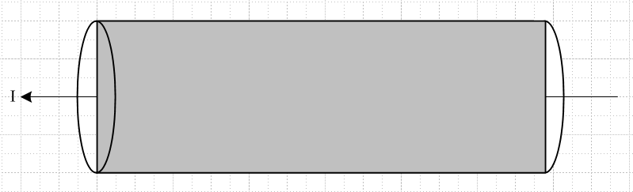

Theses qualitative-only plots are for some particular instant in time. We know that the phase of J varies as shown in Fig 2.8, so we attempt to illustrate only the real parts the currents:

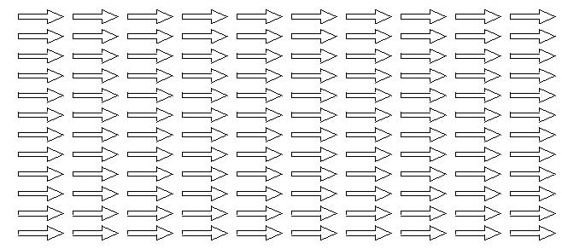 Re {Jext} (a)

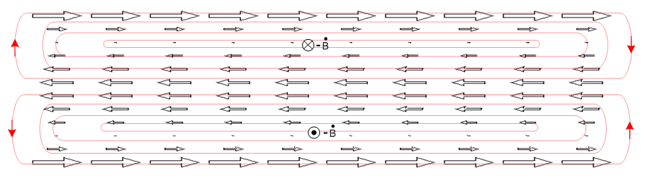 Re{Jeddy} (b)

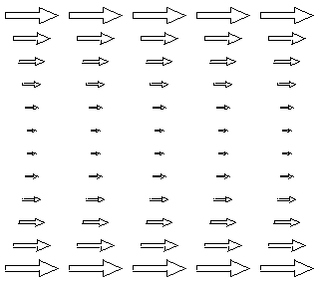 Re{Jext+Jeddy} (c)

The closed red curves in the middle drawing represent the Jeddy field lines, and these then represent the actual induced "eddies" of current. One could write Jeddy = σ Eeddy and then they are electric field lines. The lines close on themselves because they have no sources: inside the wire ρ = 0 so div Jeddy = 0 and div Eeddy = 0. Recall that a field in general does not have a constant magnitude along a field line. In the geometry of a round wire, the field lines in fact loop around at the ends of the wire.

