Eddy Current Problem: Attempt #1 PhL 4.2.14

After fumbling around here, I am ready to find someone on the web who tries to solve a problem like this one. It does seem that there will be induced currents, but I cannot really find what they look like. I gave it pretty much a 6 hour shot, and I could not solve the problem. Perhaps I am (as usual) overlooking some important facts about the situation.

You can see that I don't have any kind of "framework" here, as I now have in Appendix P. I am just flailing around here, jumping from one idea to another. I never found a solution to this problem on the web. I think I was lucky to find the thin round plate symmetric solution! I now think this kind of problem is extremely difficult, as suggested by the formal sources talking about combined interior/exterior problems. I did a lot of web scanning, see different doc.

I don't think there is anything useful below in this doc! Last reviewed may 5, 2014.

Plan A. This is a screw-up, but keep it for the record and move to Plan B below. 2
Plan B. All I do here is end up with a Helmholtz equation as in Appendix D 3
Plan C. Try it with loops. 5

Motivation: This is my first attempt at doing such a problem. The web is filled with references to eddy current effects which alter the current distribution in a wire causing it to be stronger in the part closest to "the other wire". This type of distribution is a natural result of my two-cylinder exact solution. I want to know whether the eddy current "method" will give the exact same result. I have this little feeling that the two methods will not agree, call it a "concern". This is the kind of thing that always happens to me.

[ But I was never able to solve this problem by the "eddy current method" so I won't get any disagreement. But I do have some graphs from an eddy paper that I think are measurements. ]

Scenario. Two widely spaced conductors. This allows me to approximate both conductors as having a uniform Jz , and then I will see what effect the time-changing magnetic field of the left conductor has on the Jz of the right conductor. The uniform Jz approx on the left conductor allows me to know its magnetic field, and then that will be an "externally applied field" for the right conductor.

Solution: My first step always is to "draw a picture (the picture starts simple then accumulates features as they are required)

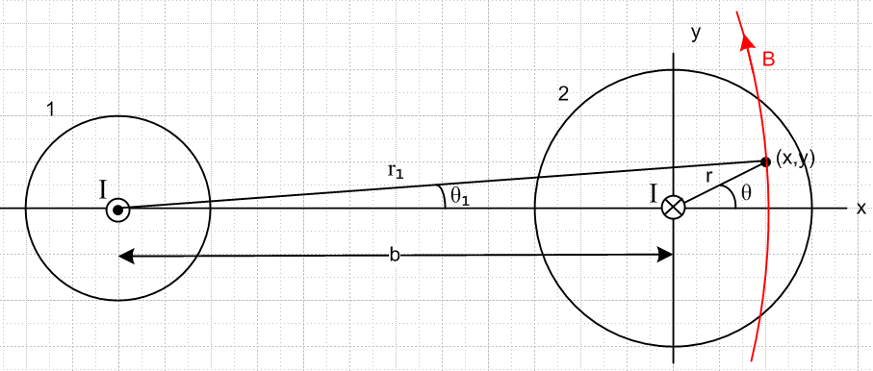

Plan A. This is a screw-up, but keep it for the record and move to Plan B below.

The current "induced" inside the right conductor will be this:

J2 = curl H1

By the usual method, we compute H1 due to conductor 1

2πr1H1 = I H1 = I/(2πr1)

What is the direction of H1 at the point shown on the right? It is mostly "up" with a small component to the "left".

H1y = H1cosθ1
H1x = -H1sinθ1

I don't yet know now precise this has to be. In order to take the curl, we need H1 in our cylindrical coordinates on the right. How about this

sinθ1 = y/r1 = rsinθ/r1
cosθ1 = (x+b)/r1 = (rcosθ-b)/r1
r12 = y2 + (x+b)2 = (rsinθ)2 + (b + rcosθ)2 = r2 + b2 + 2rbcosθ // agrees w LOC

Should we compute curl in Cartesians or cylindricals? Write them both out

H1y = I/(2πr1) * (x+b)/r1 = (I/2π) (x+b)/r12 (**)
H1x = - I/(2πr1) * y/r1 = - (I/2π) y/r12 r12 = y2 + (x+b)2

Cartesians seems simple enough. I will let Maple do the work. I have failed to put "curl" into Maple doc, so I will fix that as part of this little effort. DONE. So here we go:

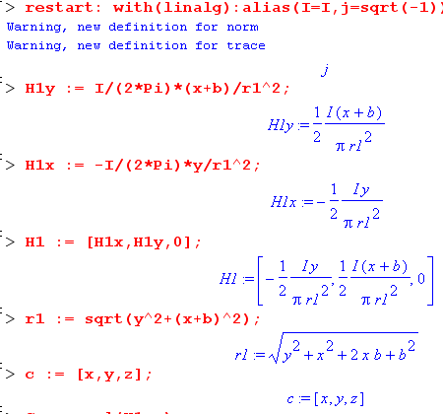

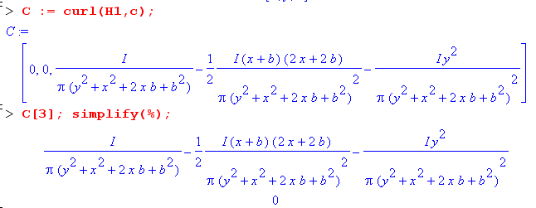

Oops! We get curl H1 = 0. But that is just what one should expect if the wire on the right is missing, because in that case, there certainly is no current there. Adding the wire does not change curl H1

[ Had this come out curl H ≠0 , I would have demonstrated a DC eddy current effect, but we know there is no such thing. ]

Plan B. All I do here is end up with a Helmholtz equation as in Appendix D

Let's try a superposition concept. New picture where right has I = 0 and just sits there. So this is what I called Problem 2 in another doc:

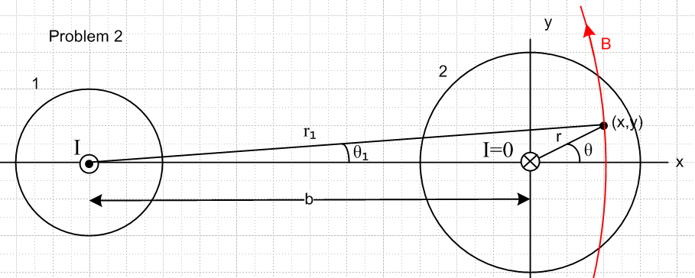

I think the time-changing B field from the left conductor creates an E field on the right. We know that

curl H1 = ∂tD2 + J 2 = jωε0E2 + J2

Here E2 and J2 are inside the conductor on the right, created by the time changing H1 field on the left. We have two unknowns, but let's use regular Ohm's Law to get

curl H1 = ∂tD2 + J 2 = jωε0E2 + σE2 = (jωε0+σ)E2

But I know from Plan A that curl H1 = 0, so we end up with E2 = 0 and then J2 = 0 and then there is nothing happening on the right. This is not what I expect. I expect "eddy currents" on the right. Where did they go?

OK, here is where Eddy Currents are supposed to come from: Put a horizontal rectangular math loop in the right conductor in the x = 0 plane. This loop sees a changing flux, so we get

curl E = - ∂tB ⇔ C E • ds = -∂t[∫S B • dS] . (1.1.36)

and then

Eemf = C E • ds = -jω ∫S B • dS ≠ 0

Doesn't this imply there exists some E ≠ 0 in the conductor??? Perhaps it is the Lenz Law fact that this current creates its on H field H2 which I am ignoring? Then we would have

curl (H1 + H2) = curl H2 = (jωε0+σ)E2 [ compare to P.1.9 second line ]

Well then I am stuck with this equation with two unknowns,

curl H2 = (jωε0+σ)E2

We need more equations! Such as

curl E2 = -jωB = -jω(B1 + B2) = -(jωμ0) (H1 + H2) [ compare to P.1.9 first line ]

where H1 is from the left conductor, and H2 is that due to the induced current in the right conductor.

Take the curl of this to get

curl curl E2 = -(jωμ0) curl H2 // since curl H1 = 0

= -(jωμ0) (jωε0+σ)E2

But this is just taking us to the Helm equation for E2 . But let's do it

∇ x (∇ x E2) = ∇(∇• E2) - ∇2 E2 = - ∇2 E2 since div E2 = 0 we presume inside conductor

Then we have

- ∇2 E2 = -(jωμ0) (jωε0+σ)E2 ≈ -(jωσμ0) E2

[∇2 - (jωσμ0)] E2 = 0

According to my lines (1.5.27) I should have

(∇2+β22)E = 0 (∇2+β22)B = 0 // region 2

β22 = ω2μ0ξ2 = ω2μ0 [ε0 - jσ/ω] ≈ ω2μ0[- jσ/ω] = -jμ0σω

which agrees with what I just got. So now I am stuck with a vector Helmholtz equation to solve for E2 in the right wire. There must be some simple approximate way to solve this problem. Otherwise I have to use all of Appendix D to write down the solution of this Helm equation.

Plan C. Try it with loops.

[ I think this calculation is similar to Section P.5 Non-uniform Bext , but instead of using a linear gradient as in Section P.5, I am using the actual gradient of the other wire. The problem is that the proximity effect and skin effect must include the self-induced eddy current in the right wire which here I ignore. So the log function I get here is then probably analogous to the Ax + Bx2 result of (P.5.6) ]

Consider only a horizontal loop inside the right side wire. Here is a top view of that loop:
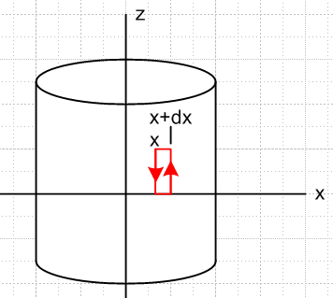

If the induced E2 is independent of z, then the top and bottom segments should cancel and then

Eemf = C E • ds = -jω ∫S B • dS from curl E = -jωB

Eemf = C E • ds = Ez(x+dx) h - Ez(x)h

The flux through the loop is [ I am assuming the left wire makes H1y which makes eddies in the right wire #2 where I have drawn my loop. ]

∫S B • dS = H1y(x,y)h dx // I ignore induced B2 which maybe is small

so then

Ez(x+dx) h - Ez(x)h = -jω H1y(x,y)h dx

∂xEz(x,y) = -jω H1y(x) = -jω (I/2π) (x+b)/r12 [ from (**) above ]

Let's integrate this from x1 to x2 so that

Ez(x2,y) - Ez(x1,y) = $^{\int_{x1}^{x2}{}}$ dx [-jω (I/2π) (x+b)/r12]

= -jω (I/2π) $^{\int_{x1}^{x2}{}}$ dx (x+b)/r12 r12 = y2 + (x+b)2

= -jω (I/2π) (1/2) ln [ $\frac{y2+ (x2+b)2}{y2+ (x1+b)2}$ ]

where we use:

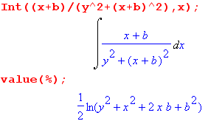

Our math loop could be inside or outside the wire, the result is the same, but a current will only flow one would think if the loop were inside the wire.

Is there some way to extract Ez(x,y) inside the wire from this result?? Here is what I know

Ez(x,y) = Ez(x1,y) -jω (I/2π) (1/2) ln [ $\frac{y2+ (x+b)2}{y2+ (x1+b)2}$ ]

This also says

Jz(x,y) = Jz(x1,y) - jω (I/2π) (1/2) ln [ $\frac{y2+ (x+b)2}{y2+ (x1+b)2}$ ]

Idea: Maybe I can require this to be true

$^{\int_{0}^{a}{}}$r dr $^{\int_{-π}^{π}{}}$dθ Jz(x,y) = 0

No go! There is no reason why the induced I would be 0, and probably it is not 0 !

It is 4.2.14 at 1:45PM and I am stumped, see no way forward.

Idea: Suppose ω is very low. Then maybe argue that Ez = 0 on the left and right edges of the right conductor. Let's just try x1 = 0 and then have

Ez(x,y) = Ez(0,y) -jω (I/2π) (1/2) ln [ $\frac{y2+ (x+b)2}{y2+ b2}$ ]

What does this function actually look like? Let's try if for y = 0 first:

Ez(x,0) = Ez(0,0) -jω (I/2π) (1/2) ln [ $\frac{(x+b)2}{b2}$ ] where -a < x < a for conductor

But this is a monotonic function so you could not make it be 0 on both edges of the right conductor:

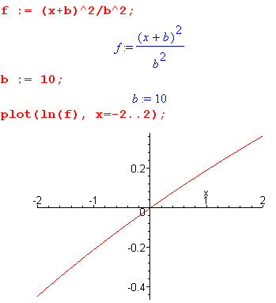

So that plan won't work.

What about div E = 0 inside the conductor? I already have ∂zEz = 0 and no other components, so this seems to add nothing.

What happens if you put the little loop like this:

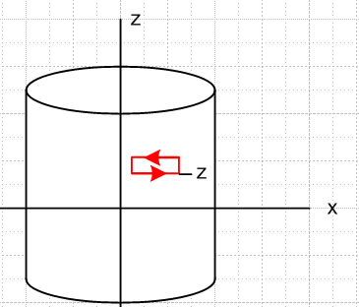

Then

Eemf = C E • ds = -jω ∫S B • dS from curl E = -jωB

Eemf = C E • ds = Ex(z) w - Ex(z+dz) w

The flux through the loop is

∫S B • dS = H1y(x,y)w dz // I ignore induced B2 which maybe is small

so then

Ex(z) w - Ex(z+dz) w = -jω H1y(x,y)w dz
∂zEx(x,y) = +jω H1y(x) = + jω (I/2π) (x+b)/r12

This says Ex exists, and also that it depends on z, and in fact

Ex(x,y,z) = [jω (I/2π) (x+b)/r12] z

which certainly seems strange. Maybe the problem is that I know there is a wave going down this transmission line even though the current is imbalanced, but I am here ignoring this wave

Suppose instead of our fat cylinder we had an actual wire that was the red math loop. We would then know EMF around the loop. But if it is real wire, then I is the same everywhere in the wire, and therefore J is the same, and therefore E is the same, and you could conclude that |E| = constant everywhere in the math loop. Is it possible to "model" the solid cylinder as a sum of math loops? I don't think so. Current would not "stay in its loop", etc. You are then again looking at Mr. Helmholtz.

******************************************************************

Basically any kind of EMF-based analysis is not capable of setting a DC level anywhere for the E field. Suppose for the moment that I arbitrarily set Ez = 0 in the plane (x,y) = (0,0). So I set x1 = 0 to get

Ez(x,y) = -jω (I/4π) ln [ $\frac{y2+ (x+b)2}{y2+ b2}$ ]

But this will never tell me the true current in the wire. I need something else.

But I do have something else, namely,

curl H2 = (jωε0+σ)E1

But

curl H = (∂yHz - ∂zHy) + (∂zHx - ∂xHz) + (∂xHy - ∂yHx)

But nothing varies in z, so we simplify

curl H = (∂yHz) + (- ∂xHz) + (∂xHy - ∂yHx)

But I think H2z = 0 almost exactly so then

curl H = (∂xHy - ∂yHx)

and then

(jωε0+σ)E1z(x,y) = ∂xH2y(x,y) - ∂yH2x(x,y)

But I know nothing about H2 so what good does this do me?

*************************************************************

BUG: If y = 0, this seems to say Ez(x2,y) - Ez(x1,y) = 0 which seems wrong. Let's back up and start off with y = 0 and see what happens:

Ez(x2,0) - Ez(x1,0) = $^{\int_{x1}^{x2}{}}$ dx [-jω (I/2π) (x+b)/(x+b2] = -jω (I/2π) $^{\int_{x1}^{x2}{}}$ dx 1/(x+b)

= -jω (I/2π) [ ln(x2+b) - ln(x1+b)] = -jω (I/2π) ln ($\frac{x2+b}{x1+b}$) ≠ 0 !

where we used

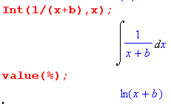

*******************************************************************

= -jω (I/2π) [ θ2 - θ1]

I show on scratch that

tan(θ2-θ1) = y $\frac{x1-x2}{(x1+b)(x2+b)+y2}$

θ2-θ1 = tan-1[y $\frac{x1-x2}{(x1+b)(x2+b)+y2}$]

and then

Ez(x2,y) - Ez(x1,y) = -jω (I/2π) tan-1[y $\frac{x1-x2}{(x1+b)(x2+b)+y2}$]

So at least this is something. But if y = 0, why does it give 0 ?

where we use

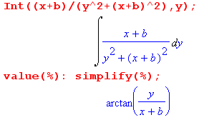

From Appendix A below we integrate to get

Ez(x,y) = jωk tan-1[y/(x+b)] + C2(y)

************************Appendix A*******************

curl E = - jωB

How do you solve this for the E field? We know B from above,

B1y = (μ0I/2π) (x+b)/r12
B1x = - (μ0I/2π) y/r12 r12 = y2 + (x+b)2
B1z = = 0

curl E = (∂yEz - ∂zEy) + (∂zEx - ∂xEz) + (∂xEy - ∂yEx)

But nothing varies in z, so we simplify

curl E = (∂yEz) + (- ∂xEz) + (∂xEy - ∂yEx)

We then have to solve these three equations:

∂yEz = jωky/r12 x k ≡ (μ0I/2π)

∂xEz = jωk (x+b)/r12 y

∂xEy - ∂yEx = 0 z

Let's just see if Maple can hit a homer on this problem. But no, this is a PDE and I don't want Maple to try that. I will do it first myself. Integrate the first equation

Ez(x,y) = jωk ∫dy y / (y2 + (x+b)2) + C1(x) = (jωk/2) ln( y2 + (x+b)2) + C1(x)

Now integrate the second,

Ez(x,y) = jωk ∫dx (x+b) / (y2 + (x+b)2) + C2(y) = jωk tan-1(y/(x+b)) + C2(y)

Here are these two integrals from Maple:

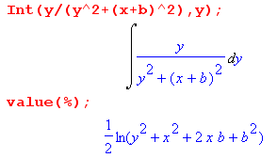

So far then we know that

(jωk/2) ln( y2 + (x+b)2) + C1(x) = jωk tan-1(y/(x+b)) + C2(y)

or let Di = jωkCi so then we know [ this certainly looks fishy! ]

(1/2) ln( y2 + (x+b)2) + D1(x) = tan-1(y/(x+b)) + D2(y)

Now what does our third equation say?

∂xEy - ∂yEx = 0

