Simple eddy current problems PhL 4.3.14

This is the basis for the examples of Sections P.2 and P.3 of Appendix P. These were the first eddy current problems I ever did (and probably they will be the last). There is more detail here than in Appendix P, and I explore extra subjects here like magnetic Ohm's and electric version of Biot Savart. For the harder problem I obtained here the coupled PDE's but I never got a good solution to them directly. I eventually got a solution using the stream function method in item 3 below. I think that everything useful in this doc is not included in Appendix P. [ May 5, 2014 ]

1. Eddy Problem 1. Circular Plate with Uniform B field 1
2. Eddy Problem 2: B field with linear gradient, still circular plate 11
(a) Obtain PDE#1 two different ways and write down PDE #2 as well 12
(b) What does Magnetic Ohm's Law say? 14
(c) Try making the same assumption made in Problem 1, that J_{r} ≡ 0 everywhere in cylinder 14
(d) Process the two PDE's to obtain a single ODE for E_{r} with J_{r}≡ 0 15
(e) Try to solve the single ODE for E_{θ} : still using J_{r}≡ 0 ansatz 17
(f) Conclusion: the assumption that J_{r} ≡ 0 made in part (c) is invalid 19
(g) Try partial waves on general PDF (*) 19
(h) Direct Helmholtz equation approach using App D results 25
Magnetic Ohm's Law 26
Boundary Condition 27
Boundary Condition Cannot be Met in the K_{m}= 0 scenario 27
Try stupid L_{m} idea, goes nowhere 28
Smythian Forms Comment 29
Back to K_{m}= 0 but allow rim surface charge similar to App D 29
Warning: 30
Try sin(β_{d}z) in the z direction 33
3. What about that stream function gizmo? 33
Inverse curl operator idea 35
General Remarks about What We Know 35
Why people use potentials 36
Theory of the Stream Function T_{z} 36
Application of stream method to the uniform B field circular plate 38
Try Eddy Problem 2 with this stream method! 39
Magnetic Ohm's Law and the Stream Problem 2 Solution 46
Stream Method for E ? 47
Why can the transverse T components be neglected? 48
Eddy Current Testing 50
Skin Effect and Problem 2 50
What about the Lenz's Law B field? 50

1. Eddy Problem 1. Circular Plate with Uniform B field

A thin round plate lies in a uniform ω external B field. Find the induced E field in the plate.

Faraday and symmetry tells us that we get circular closed electric field lines in the plate! Assume low ω so δ >> plate thickness. Then those E lines are uniform in the plate thickness.
I am not used to closed E field lines! I am used to them starting and ending on charges, but if there is no ρ inside the plate, then div E = 0 and that means the E lines are closed. We know they are there because that is what curl E = -jωB tells.
The useful new thing I learn from pondering this problem is that you have these closed lines. Remember that a field line is a direction thing, and field strength can vary along a line.
But in this simple problem, we know that field strength will be constant on each circle.

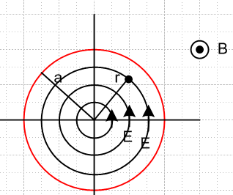

In my infinite cylinder problem, I think things were complicated by the infinite aspect since the lines have to stretch way down the line and somehow eventually close back. Here with a finite plate, we don't have such a problem.
So OK, here is Faraday:

curl E = - ∂tB ⇔ C E • ds = -∂t[∫S B • dS] . (1.1.36)

So consider a circle at radius r. We then have

Eθ * 2πr = - z πr2 => Eθ(r) = - z πr2/2πr = (-z /2) r

This has a lot of similarity to our famous magnetic problem

H * 2πr = I πr2/πa2 =< H(r) = I r2/a2 / 2πr = (I/2πa2)r

The big similarity is a linear field growing from the center.
Notice that these E circles continue outside the plate and under and over it! It's just that there will only be current in the plate. So here are our findings:

E(r) = Eθ(r) Eθ(r) = (-z /2) r Jθ(r) = σ (-z /2) r OK ωτ << 1

So OK, how much heat is generated in this plate? Think of a thin cylinder shell of height dz and radius r and thickness dr. Think of this as a wire of rectangular cross section dA = dzdr. The current in this wire is given by,

dI = Jθ dA = Jθ dzdr

Just for fun, the total current going around the circle as observed through any azimuthal slice:

I = h ∫Jθ dr = h σ (-z /2) ∫ rdr = h σ (-z /4)a2 = - (1/4) h σa2z

The resistance of the wire is dR = ρ L/dA = ρ 2πr/(dzdr). The power burned from P = I2R is

dP = (dI)2dR = [Jθ dzdr]2 * ρ 2πr/(dzdr) = Jθ2 [dzdr] * ρ 2πr

= Jθ2 2πrρ dr dz

= [σ (-z /2) r]2 2πrρ dr dz = (π/2)σ z2 r3 drdz

Now integrate over the plate thickness h to replace dz by h. Then integrate r from 0 to a to get

P = (π/2)σ z2 h(a4/4) = (π/8)σ z2a4h

Dimensions:
RHS = ohm-1m-1 sec-2 [volt-sec/m2]2 m5 = ohm-1 sec-2 [volt-sec]2 = volt2/ohm = watts

So THIS is the kind of "simple eddy problem" I have been looking for that no one bellies up with on the web. Notice the ω2 factor here, as well as B2. Metal with higher σ (more conductive) has higher power loss.

Verification from the two methods paper !! I had

Jθ(r) = σ (-z /2) r
I = - (1/4) h σa2z
P = (π/8)σ z2a4h

while he has (S = area = πa2) . All three of my results agree with his circle results!

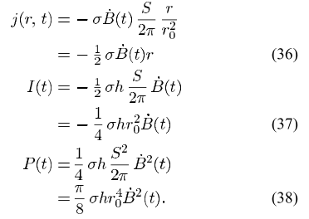

More on Power in the ω-domain (but I changed the above to the time domain!) . You have to be careful with a power calculation since non-linear, just dim memories that should get cleared up right here. In the world of phasor time dependence, how does this all work? For example one might have

I = I0ejωtejα V = V0ejωtejβ Iphys = I0cos(ωt+α) Vphys = V0cos(ωt+β)

Then

Pphys = Iphys Vphys = I0 V0 cos(ωt+α) cos(ωt+β)

= I0 V0 1/2 { cos(α-β) + cos(2ωt) }

<Pphys> = (1/2) I0 V0 cos(α-β)

So there is an overall (1/2) and there is a phase factor as well.
But in my case I have P = I2R and so we are talking I*I and so α = β and there is no extra phase factor. So I think we just add the 1/2 to get P = (1/2) I02 R where I0 is magnitude. Then

<P> = (π/4)σω2B2a4h

But my two theories PDF guy has a (π/8), so why is that?

Resume:

Interpretation? Think of the conduction electrons trying to do their circular motion using the Lorentz Force equation from the Hall effect.

mjωv = q(E + vxB) - (m/τ)v

Write this as

κ v = E + v x B κ = (1+jωτ) (1/μ)

and then

κv1 = E1 + v2B3-v3B2
κv2 = E2 + v3B1-v1B3
κv3 = E3 + v1B2-v2B1

In our little problem here we have B3 only

κv1 = E1 + v2B3
κv2 = E2 -v1B3
κv3 = E3

and we assume v3 = E3 = 0 so these are the only equations

κv1 = E1 + v2B3
κv2 = E2 - v1B3

which in cylindricals I write as

κvr = Er + vθB3 1
κvθ = Eθ - vrB3 2
or
κnqvr = nqEr + nqvθB3
κnqvθ = nqEθ - nqvrB3
or
κJr = nqEr +JθB3
κJθ = nqEθ -JrB3

But we certainly need Jr = 0 at r = a, (also vr= 0) and seems true everywhere if we get circular lines, so then our two equations become

0 = nqEr +JθB3 1 Jθ = nqvθ Jr = nqvr = 0
κJθ = nqEθ 2

The first equation tells us that

Er = - vθB3

Digression. This is forcing the current to travel in a circle I think. The Lorentz v x B is radial in direction and it is neutralized by this Hall-like field, so vr then does not change, the particle has r = 0. But that seems wrong for circular motion? Let's check on this:

v = vr + vθ = d/dt = d/dθ dθ/dt = Ω Ω ≡ dθ/dt
= d/dt = d/dθ dθ/dt = - Ω

= a = r + vr Ω + θ - vθ Ω

= (r - Ω vθ) + (θ + Ω vr)

What is Ω for our problem? If everything is doing ejωt including angle θ, then I guess

Ω = dθ/dt = jωθ

So then we have

= a = (r - jωθ vθ) + (θ +jωθ vr)

For circular motion, we have only vθ = constant and vr = 0 so this says

= a = (- jωθ vθ) + (θ) = - jωθ vθ

and there is your expected acceleration toward the center! End of digression.

The second equation tells us that

κJθ = nqEθ
or
Jθ = nqμ Eθ / (1+jωτ) = σ Eθ/(1+jωτ) ≈ σ Eθ

So this tells us that we have the regular Hall effect in the θ direction if ωτ << 1. Aside:

vθ = Jθ/nq = μ Eθ / (1+jωτ) =

The current is therefore

Jθ(r) = σ Eθ/(1+jωτ) = σ (1/2) (-jωB) r /(1+jωτ)

So here is my complete solution to this problem:

vr = 0
vθ = μ Eθ / (1+jωτ) = - (1/2) jωB μ r / (1+jωτ) linear in r
vz = 0

Er = - vθB = (1/2) jωB2 μ r / (1+jωτ) linear in r
Eθ = (1/2) (-jωB) r
Ez = 0

Jr = 0
Jθ = σ Eθ/(1+jωτ) = -(1/2) jωBσ r/(1+jωτ) linear in r
Jz = 0

You could calculate the total current going around the plate by integrating Jθ but I don't think that really means anything.

Is there a charge density inside as in my radial Hall effect?

ρ/ε0 = div E = r-1∂r(rEr) + r-1∂θEθ + ∂zEz

= r-1∂r(rEr) + r-1∂θEθ

= r-1∂r(r[ (1/2)jωB2 μ r / (1+jωτ)]) + r-1(1/2)∂θ[(-jωB) r]

= (1/2)jωB2 μ/ (1+jωτ) * r-1∂r(r2 ) - (1/2)jωB r-1∂θ(r)

= (1/2) jωB2 μ/ (1+jωτ) r-1 2r - 0

= jωB2 μ/ (1+jωτ)

So yes, there is a uniform inside charge density

ρ = ε0 jωB2 μ/ (1+jωτ) ≈ ε0 μ jωB2

and then there will be a corresponding surface charge on the surface of the plate rim.

Now let's plot the current vector. We can say

Jx = Jθ• = -Jθsinθ = -Jθ (y/r) = + (1/2)jωBσ y/(1+jωτ) = ky θ(r<a)
Jy = Jθ• = Jθcosθ = Jθ (x/r) = -(1/2)jωBσ x/(1+jωτ) = -kx θ(r<a)

Then here is Maple:

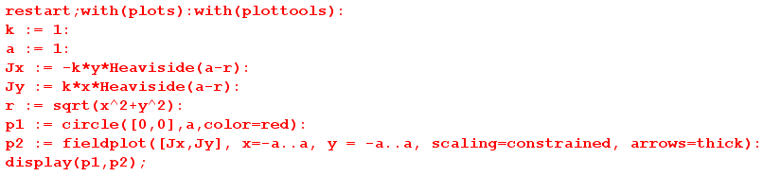

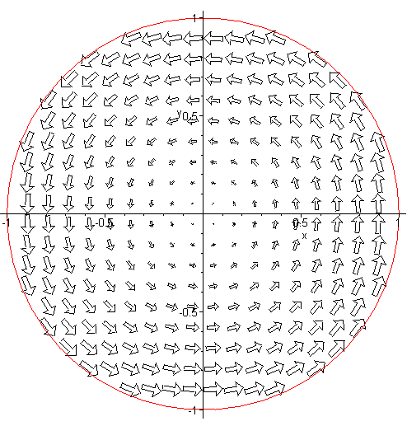

So there are your eddy currents in the plate! The do of course produce a Lenz's Law B field that is opposite the applied and, and we do neglect this correction to B.

2. Electric Biot-Savart ? Maybe ∇2E = 0 ?

Suppose B is non uniform in Problem 1. We now lose our symmetry benefit, but I have a dim idea. Look at lines below (B.2.12) where I derive the Biot Savart Law. I compute H in terms of J. Could there be some analogous development starting with a Helm equation for E? Start back at B.2.1 and copy paste and edit:

Start with Maxwell's equation (1.1.1), and we are now working inside a conductor so E = 0 and then

curl E = -jωB (B.2.1)

where B is the magnetic field. Apply curl to both sides and use curl curl = grad div -∇2 to get

grad div E - ∇2E = -jω curl B . (B.2.2)

But in a medium with no charge density we have div E = 0 so we get

∇2E = jω curl B (B.2.3)

Now jump down below B.2.12 and continue this process. We basically makes these replacements:

H → E and -curl J → + jω curl B

The very first step is then

E(x) = jω ∫d3x' [ $\frac{1}{4πR}$] curl' B(x') R ≡ |x-x'| (B.2.13)

But

curl B = (∂yBz - ∂zBy) + (∂zBx - ∂xBz) + (∂xBy - ∂yBx)

= 0 because the B field is uniform.

Thus right here you get E(x) = 0 so you really have

We then sort of have

∇2E = 0 (B.2.3)

as your equation of interest. For our circular plate in Cartesian this seems to say

∇2Ex = 0
∇2Ey = 0

In cylindricals this vector Helm becomes (as in Appendix D.1.12)

(∇2E)r = ∇2Er - (2/r2) ∂θEθ - (1/r2) Er
(∇2E)θ = ∇2Eθ + (2/r2) ∂θEr - (1/r2) Eθ

For our Problem 1 case we have

Er(r) = (1/2)jωB2 μ r / (1+jωτ)
Eθ(r) = (1/2) (-jωB) r

so then the vector Helm is

(∇2E)r = ∇2Er - (1/r2) Er = r-1∂r(r∂r Er) - (1/r2) Er
(∇2E)θ = r-1∂r(r∂r Eθ) - (1/r2) Eθ

Well, either equation has the form E = k r so we get

(∇2E)r = r-1∂r(r∂r Er) - (1/r2) Er = k r-1∂r(r∂r r) - k (1/r2) r

= k r-1∂r(r) - k /r = k r-1 - k /r = 0

so YES, my circular plate solution does explicitly satisfy ∇2E = 0. I just derived this equation above with the uniform B field only which made curl B = 0, so this was a special case. So how does this gibe with

(∇2+β12)E = (1/ε1) Σi=2N+1grad ρi (∇2+β12)B = 0 // region 1
(∇2+β22)E = 0 (∇2+β22)B = 0 // region 2
(∇2+β32)E = 0 (∇2+β32)B = 0 // region 3 (1.5.27)

where in a conductor region 2 it seems you really should have

(∇2+β22)E = 0 β22 = ω2μ2ξ2 ≈ - jωμσ

I guess since I ignored the Lenz induced B field, that is the same as thinking "low ω" and then β2 = 0.

But let's continue anyway from (B.2.13) above. We then just go through all the same steps to end up with

E(x) = -jω ∫d3x' $\frac{1}{4πR3}$ B(x') x R . R ≡ x - x' (B.2.18)

and this is the 3D Biot-Savart Analog. If E does not depend on z (only on x,y) I think you can also write down the 2D Biot-Savart Analog,

E(x,y) = -jω ∫d2x' $\frac{1}{2πR2}$ B(x') x R R ≡ x - x' (B.2.24)

Wow, I wonder if I can do the circular plate with one of these guys? There is one painful problem, however. In regular Biot-Savart, J(x') is usually a well-defined limited "source" such as a wire or maybe a cylinder. Here we have to integrate over all space where B(x') exists and that sounds like trouble.
For example, suppose

B(x') = B . We then get

E(x,y) = -jωB x { ∫d2x' $\frac{1}{2πR2}$ R } R ≡ x - x' (B.2.24)

and this looks log divergent. Well, write it out

R2 = (x-x')2 + (y-y')2 R = (x-x') + (y-y')

x R = x [(x-x') + (y-y')] = (x-x') - (y-y')

E(x,y) = -jωB $\frac{1}{2π}$ ∫d2x' $\frac{1}{(x-x')2 + (y-y')2}$ [ (x-x') - (y-y') ]

= -jωB $\frac{1}{2π}$ { [∫dx'dy' $\frac{(x-x')}{(x-x')2 + (y-y')2}$ - ∫dx'dy' $\frac{(y-y')}{(x-x')2 + (y-y')2}$ }

Look at the first integration: (±∞ say)

∫ dy' $\frac{(x-x')}{(x-x')2 + (y-y')2}$ = signum(x-xp) π

Then we are left with

∫dx' signum(x-xp) π = π ∫ds signum(s) = 0 since signum(s) is odd.

So we get E = 0. This assumed that our uniform B field was everywhere! At least it agrees with the initial result noted earlier!

2. Eddy Problem 2: B field with linear gradient, still circular plate

Continue with the circular plate and assume that B is stronger to the left of the plate. If you drew little loops in various places, you would find generally that EMF's were greater to the left, so I might expect a picture to look something like this: [ created with k := 1 - (1/4)*(x/r) added as a factor ] [ but this picture is wrong because the correct lines don't have the origin as their center ]

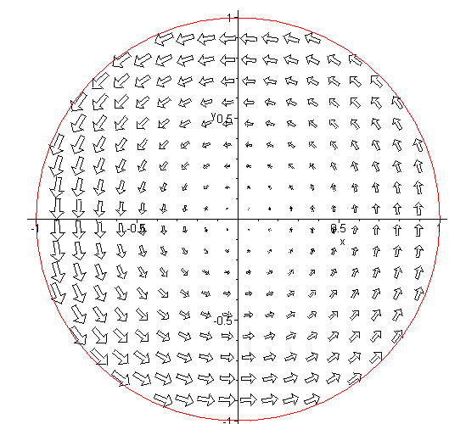

Maybe the E circles are the same, but the field mag is just larger on the left side? [ wrong ]
Suppose we assume this for the moment. Then looking back at the derivation for Problem 1 :

C E • ds = C Eθ(r,θ) rdθ = - z πr2
or
r C Eθ(r,θ) dθ = - z πr2
or
$^{\int_{-π}^{π}{}}$Eθ(r,θ) dθ = - z(x) πr

But now with no symmetry, I am stuck. But this is just a result applied to a single selected loop, and I can maybe learn more (extract more) by taking some smaller math loops as I did in my previous doc.

(a) Obtain PDE#1 two different ways and write down PDE #2 as well

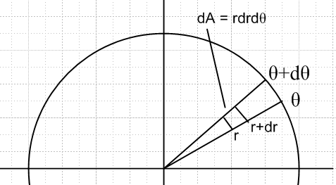

Assume that B is only in the z direction and that it varies linearly in the x direction

B(x) = B0 - α x α > 0 B(x) bigger for x < 0 (on left)

Then apply Faraday,

Eemf = C E • ds = -jω ∫S B • dS from curl E = -jωB

C E • ds

= Er(r + dr/2, θ)dr + Eθ(r+dr, θ + dθ/2)([r+dr]dθ) - Er(r+dr/2,θ+dθ)dr - Eθ(r, θ + dθ/2)(rdθ)

= [Er(r + dr/2, θ) - Er(r+dr/2,θ+dθ)] dr + [(r+dr)Eθ(r+dr, θ + dθ/2) - rEθ(r, θ + dθ/2)] (dθ)

The right side is

∫S B • dS = [ B0 - α x ] dr rdθ = [ B0 - α rcosθ ] dr rdθ

So then

[Er(r + dr/2, θ) - Er(r+dr/2,θ+dθ)] dr + [(r+dr)Eθ(r+dr, θ + dθ/2) - rEθ(r, θ + dθ/2)] dθ

= -jω [ B0 - α rcosθ ] dr rdθ

Divide through by drdθ to get

[Er(r + dr/2, θ) - Er(r+dr/2,θ+dθ)]/dθ + [(r+dr)Eθ(r+dr, θ + dθ/2) - rEθ(r, θ + dθ/2)] /dr

= -jω [ B0 - α rcosθ ] r
or
∂θ Er(r + dr/2, θ) + ∂r(r Eθ(r, θ + dθ/2)) = -jω [ B0 - α rcosθ ] r

which is at least something. Perhaps at this point we can simplify it to say

∂θ Er(r, θ) + ∂r(r Eθ(r, θ)) = -jω [ B0 - α rcosθ ] r (*)

So what exactly IS this equation? Probably just curl E = -jωB in the z component.

curl E = [ r-1∂θEz - ∂zEθ] + [∂zEr - ∂rEz] + [ r-1∂r(rEθ) - r-1∂θEr ]

= [ r-1∂r(rEθ) - r-1∂θEr ]

so then we get from curl E = -jωB the result that,

r-1∂r(rEθ) - r-1∂θEr = -jω [B0 - α rcosθ]
or
∂r(rEθ) - ∂θEr = -jω [B0 - α rcosθ] r (**) = same!

Just checking. So the main point is that we have this PDE to somehow solve

∂r(rEθ) - ∂θEr = -jω [B0 - α rcosθ] r PDE#1

We also know that div E = 0 inside the circular plate, and that says

div E = r-1∂r(rEr) + r-1∂θEθ + ∂zEz ≈ 0

I am expecting some small radial Hall ρ but I will neglect it. Then we get

∂r(rEr) + ∂θEθ = 0 PDE#2

I think the above two PDE's involve no extra assumptions like Jr = 0. They are just two Maxwell equations! [ the above two PDE's are correct ]

(b) What does Magnetic Ohm's Law say?

What do I know from the Magnetic Ohm's Law type stuff? I just look back over the Problem 1 work and think I can steal some things:

κvr = Er + vθB3(x) 1
κvθ = Eθ - vrB3(x) 2
or
κnqvr = nqEr + nqvθB3(x)
κnqvθ = nqEθ - nqvrB3(x)
or
κJr = nqEr +JθB3(x)
κJθ = nqEθ -JrB3(x)

There is more to steal, but the above is enough for the next section.

(c) Try making the same assumption made in Problem 1, that Jr ≡ 0 everywhere in cylinder

[ this ansatz turns out to be no good, but I don't find that out until section (f) below, so reader may skip to that point. ]

I can TRY the idea that Jr = 0 (also vr= 0) and see what happens:

0 = nqEr +JθB3(x) 1 Jθ = nqvθ Jr = nqvr = 0
κJθ = nqEθ 2

The first says

Er = - vθB3(x)

The second equation tells us that

κJθ = nqEθ
or
Jθ = nqμ Eθ / (1+jωτ) = σ Eθ/(1+jωτ) ≈ σ Eθ

vθ = Jθ/(Nq) = μ Eθ / (1+jωτ) ≈ μ Eθ

So here is what I know from just doing this stuff

vr = 0
vθ = μ Eθ / (1+jωτ) ≈ μ Eθ
vz = 0

Er = - vθ B3(x) = - μ Eθ / (1+jωτ) * B3(x) (*)
Eθ = unknown!
Ez = 0

Jr = 0
Jθ = σ Eθ/(1+jωτ)
Jz = 0

Everything is in terms of Eθ. But equation is very helpful because it says

Er = [ -μB3(x)/(1+jωτ)] Eθ ≡ β(x) Eθ β = no dimensions β' = m-1

and then instead of having two PDE's with two unknown functions, we have only 1 fctn! In other words, we get this very simple relationship between the two field components with our Assumption above.

(d) Process the two PDE's to obtain a single ODE for Er with Jr≡ 0

In this section, I continue with the Jr≡0 ansatz to see if we end up in contradiction.

So here then are those two PDE's again:

∂r(rEθ) - ∂θEr = -jω [B0 - α rcosθ] r PDE#1
or
∂r(rEθ) - ∂θ[β(x) Eθ] = -jω [B0 - α rcosθ] r // Jr≡0 used here

∂r(rEr) + ∂θEθ = 0 PDE#2
or
∂r(r[β(x) Eθ]) + ∂θEθ = 0 // Jr≡0 used here

so here are the two PDE's now:

∂r(rEθ) - ∂θ[β(rcosθ) Eθ] = -jω [B0 - α rcosθ] r
∂r( [β(rcosθ) rEθ]) + ∂θEθ = 0

Now consider

∂θ β(rcosθ) = β'(rcosθ) * (-rsinθ)

∂r β(rcosθ) = β'(rcosθ)*cosθ

Then our equations become

∂r(rEθ) - β(rcosθ) ∂θEθ + β'(rcosθ) (rsinθ) Eθ = -jω [B0 - α rcosθ] r PDE#1

β(rcosθ) ∂r(rEθ) + β'(rcosθ)*cosθ (rEθ) + ∂θEθ ≈ 0 PDE#2

or more compactly

∂r(rEθ) - β ∂θEθ + β' (rsinθ) Eθ = -jω [B0 - α rcosθ] r PDE#1

β ∂r(rEθ) + β' cosθ (rEθ) + ∂θEθ ≈ 0 PDE#2

and this seems a lot to know about our one function Eθ . Suppose I use #2 to eliminate ∂θEθ

- ∂θEθ = β ∂r(rEθ) + β'cosθ (rEθ)

so # 1 becomes

∂r(rEθ) + β [β ∂r(rEθ) + β'cosθ (rEθ)] + β' (rsinθ) Eθ = -jω [B0 - α rcosθ] r
or
[ 1+β2 ] ∂r(rEθ) + [ββ' r cosθ + β' r sinθ] Eθ = -jω [B0 - α rcosθ] r
or
[ 1+β2 ] ∂r(rEθ) + β'r [β cosθ + sinθ] Eθ = -jω [B0 - α rcosθ] r

and this is then an ODE!
So how big is β ?

β = [ -μB3(x)/(1+jωτ)] ~ μB = small if B is << 569 tesla,

I remember this from "Hall Effect for General B". We can then simplify to get

∂r(rEθ) + β'r (sinθ) Eθ = -jω [B0 - α rcosθ] r

Now

β(x) = [ -μB3(x)/(1+jωτ)] ≈ -μB3(x) = -μ [B0 - α rcosθ] = -μ[B0 - αx]

∂xβ(x) = -μ∂xB3(x) = -μ∂x[B0 - αx] = μα = β'

So again

∂r(rEθ) + μα r sinθ Eθ = -jω [B0 - α rcosθ] r Here is the ODE based on Jr≡ 0

First, as a test, suppose I set α = 0. This should give the uniform B result:

∂r(rEθ) = -jω [B0] r

Integrate both sides to get

rEθ(r) - 0Eθ(0) = -jωB0 [ (r2/2) - 0]
or
rEθ(r) = -jωB0 [ (r2/2)

Eθ(r) = -jωB0 [ (r/2) ] // agrees with my Problem 1 solution !!

So that is very encouraging. Now let's give Maple a shot at the ODE. But once gain we have

∂r(rEθ) + μα r sinθ Eθ = -jω [B0 - α rcosθ] r

r∂rEθ + Eθ + μα r sinθ Eθ = -jω [B0 - α rcosθ] r

r∂rEθ + (1+ μα r sinθ) Eθ = -jω [B0 - α rcosθ] r

∂rEθ + (1/r+ μα sinθ) Eθ = -jω [B0 - α rcosθ] dim(α) = B/m dim(μ) = 1/B

(e) Try to solve the single ODE for Eθ : still using Jr≡ 0 ansatz

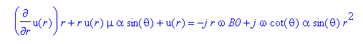

- ∂θEθ = β ∂r(rEθ) + β'cosθ (rEθ)

Maple DOES get a solution for the first equation, but it is a big mess and does not seem to have a limit as α→ 0 as it should. I think Maple has a problem.

OK, let's simplify the first ODE a bit. I have it down to

∂ru + (s+1/r)u = c+bsr

where

b = jωcotθ/μ dim(b) = B/sec
c = -jωB0 dim(c) = B/sec
s = μαsinθ bs = jωcotθ/μ * μαsinθ = jωαcosθ dim(s) = 1/m
dim(sr) = 1
Dimension check of the ODE.

Note added. For very small r, the above ODE is roughly

∂ru + (1/r)u = c

and Maple says the solution to this is [ it is the homo solution that blows up ]

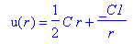

So I can set C1 = 0 to get a non-divergent u = (C/2)r. Fine.

I enter this and Maple now finds a relatively simple solution:

∂ru + (s+1/r)u = c+bsr

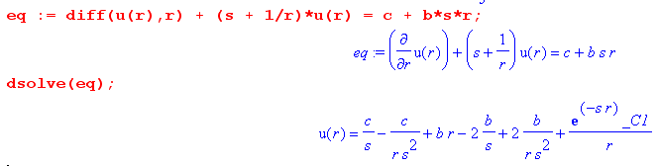
which I now write out as

u(r) = br - $\frac{2b-c}{s}$ + $\frac{2b-c}{s2r}$ + C1 e-sr/r

Note added. I have verified that this really does solve the ODE. But for very small r, this diverges, which seems to contradict what happened above where I first considered small r, then solves. But if I just look at the ODE by hand and try to make the solution be u = Ar, because parameter s appears on both sides of the equation, I find that I need A = c/2 and A = b at the same time, which does not fly. To wit:

∂ru + (s+1/r)u = c+bsr Try u = Ar

A + (s+1/r)Ar = c + bsr

A + Asr + A = c + bsr => 2A = c and A = b

This then is why the 1/r divergent term goes away if 2b = c!

I then seek the α = 0 solution this way

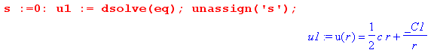

which is correct. Then I enter the constants

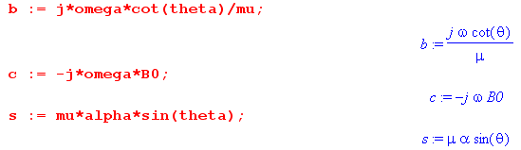

I verify that the ODE is correct

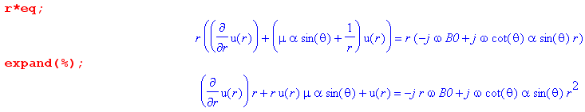

And then I verify that the simple solution is correct

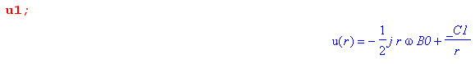

So good, at least we have some kind of solution. Let's now examine it!

April 4, 2014. Well the solution was this

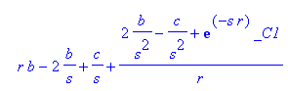

But it has a piece I cannot remove which blows up at r = 0 unless 2b = c

b = jωcotθ/μ
c = -jωB0

which is not realized. So how can we have Eθ(r) blow up at r = 0 ???

(f) Conclusion: the assumption that Jr ≡ 0 made in part (c) is invalid

I first went through all the math above (single full pass) looking for math errors and I found none, so things are restored to black.

I often say that an ansatz will prove itself either right (self consistent solution) or wrong (contradiction). So here the ansatz leads to a divergent Eθ field at r = 0. So ansatz is no good.
In retrospect, you can see that the ansatz was OK for the symmetric uniform B field case, because the E field contours are exactly circles. In this problem they are NOT going to be circles. But perhaps more to the point, the current flow will not be in perfect circles, so we won't have vr ≡ 0 which goes with Jr≡ 0. My quick picture above is a little misleading in this respect. It seems totally reasonable NOW that the solution cannot really have Jr ≡ 0. We will still have Jr(a) = 0, however.

(g) Try partial waves on general PDF (*)

We still have our two PDF equations which just follow from curl E = -jωB and div E = 0:

∂r(rEθ) - ∂θEr = -jω [B0 - α rcosθ] r PDE#1

∂r(rEr) + ∂θEθ = 0 PDE#2

We are ignoring the induced B field here. So I will probably be taking a little boat trip headed toward Helmholtz Island, but just do it anyway. First, mult #1 by r

r∂r(rEθ) - ∂θ(rEr) = -jω [B0 - α rcosθ] r2

Then apply ∂r to this thing:

∂r[r∂r(rEθ)] - ∂θ ∂r(rEr) = -jω ∂r { [B0 - α rcosθ] r2}

Now use #2 to replace the second term here

∂r[r∂r(rEθ)] - ∂θ [-∂θEθ] = -jω ∂r { [B0 - α rcosθ] r2}
or
∂r[r∂r(rEθ)] + ∂θ2Eθ = -jω ∂r { [B0 - α rcosθ] r2} (*)

So now at least we have only one unknown function. This is a PDE: function is Eθ and variables are r,θ. This does not quite seem to be Helmholtz, but has similarities. It follows from the two Maxwell's and no other assumptions.

Boundary Condition

Meanwhile, magnetic Ohm's still has this stuff

κvr = Er + vθB3(x) 1
κvθ = Eθ - vrB3(x) 2
or
κnqvr = nqEr + nqvθB3(x)
κnqvθ = nqEθ - nqvrB3(x)
or
κJr = nqEr +JθB3(x)
κJθ = nqEθ -JrB3(x)

So this does not generate any obvious BC on the function Eθ . The BC for Jr is certainly more obvious, and we have

κJr(a,θ) = nqEr(a,θ) +Jθ(a,θ) B3(x=acosθ) = 0
κJθ(a,θ) = nqEθ(a,θ) - Jr(a,θ)B3(x = acosθ) = nqEθ(a,θ)

So these equations tell us that

nqEr(a,θ) +Jθ(a,θ) B3(x=acosθ) = 0 // Jr(a,θ) = 0 BC
Jθ(a,θ) = σ Eθ(a,θ) // regular Ohm's in θ

Insert the second into the first to get

nqEr(a,θ) + σ Eθ(a,θ)B3(x=acosθ) = 0 μ = (qτ/m) σ = (nq2τ/m) = nqμ
or
Er(a,θ) + μ Eθ(a,θ)B3(x=acosθ) = 0
or
Er(a,θ) = - μ Eθ(a,θ)B3(x=acosθ) // Jr(a,θ) = 0 BC in terms of fields

So we end up with a boundary condition at r = a that involves both Er and Eθ fields which certainly is not very pleasant.

The F Idea.

One idea would be to define a new field:

F(r,θ) ≡ Er(r,θ) + μ Eθ(r,θ)B(x=rcosθ) = Er(r,θ) + μ Eθ(r,θ)B(x)

Then maybe I can come up with an ODE for F, and it then has a clean BC. Let's try this. Start again with

∂r(rEθ) - ∂θEr = -jω B(x) r PDE#1

∂r(rEr) + ∂θEθ = 0 PDE#2

Now replace Er(r,θ) = F(r,θ) - μ Eθ(r,θ)B(x) :

∂r(rEθ) - ∂θ[F(r,θ) - μ Eθ(r,θ)B(x)] = -jω B(x) r PDE#1

∂r(r[F(r,θ) - μ Eθ(r,θ)B(x)]) + ∂θEθ(r,θ) = 0 PDE#2

Write them out

∂r(rEθ) - ∂θF + μ∂θ[EθB(x)] = -jω B(x) r

∂r(rF) - μ ∂r [EθB(x)] + ∂θEθ = 0

But now I don't see how to "separate" these to obtain an ODE for F. So give up on the F idea.

Resume trying to solve: go to partial waves

Here I try partial waves on the PDE (*) above (has no assumptions), and I get a half-baked solution pathway. Things don't really work right in the details, but at least it is something possibly viable.

So OK, let's forget the BC for the moment and go back to our PDE (*) from above

∂r[r∂r(rEθ)] + ∂θ2Eθ = -jω ∂r { [B0 - α rcosθ] r2} (*)

I am then forced to go into partial waves as in Appendix D, where ∂θ = jm. Then

∂r[r∂r(rEθ)] - m2 Eθ = -jω ∂r { [B0 - α rcosθ] r2} (*)

where now Er means Er(r,m). What does Maple have to say about this ODE? Write

-jω B0 = c as above

jωαcosθ = d = a new symbol. Then we have

∂r[r∂r(rEθ)] - m2 Eθ = ∂r { [c - dr] r2} = 2rc-3dr2
or
∂r[r∂r(rEθ)] - m2 Eθ = 2rc-3dr2

∂r[r∂r(ru)] - m2 u = 2rc-3dr2

Amazingly, Maple has a solution for this equation that is not too bad:

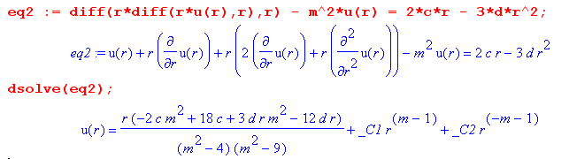

Unfortunately this solution is singular when m = ±2 or ± 3 so that seems to ruin things. But Maple has solutions in these cases as well:

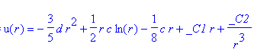 m = ±2

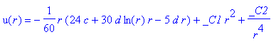 m = ± 3

So in principle we have a partial wave series solution with lots of unknown constants. The boundary condition for Er(r,m) has products of functions of θ

Er(a,θ) = - μ Eθ(a,θ)B3(x=acosθ)

and that does not work well in the partial waves. [ but see later ]
I could have set B0 = 0 to have a simpler problem, which causes c = 0 in the above. The results are then a lot simpler. For general m we get

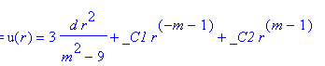

and for m = ±3 we get

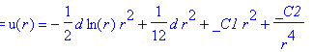

For m = 0 get

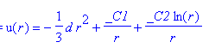

For m = ±1 get

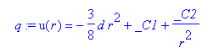
Here then is my summary

m = 0: u0(r) = -(1/3)dr2 um = Eθ(r,m)

m = ±1: u±1(r) = -(3/8)dr2 + A±1

m = ±3: u±3(r) = A±3 r2

other m u±m(r) = 3d/(m2-9)* r2 + A±m r|m|-1

d = jωαcosθ

It is interesting that there is a m=0 contribution in this case of having just a field gradient where the average field B0 on the circular plate is zero.

I would perhaps take for the solution just the m = 0 and 1 terms to get some idea of things. But I don't see why the series should be fast converging. That would all still be a lot of work to do. I think the result would be

Eθ(r,θ) = Ar2 + [B + Cr2]cosθ A = -(1/3)d C = -(3/8)d

∂θEθ = - [B + Cr2]sinθ d = jωαcosθ

The two PDE's are now

∂r(rEθ) - ∂θEr = -jω B(x) r PDE#1
∂r(rEr) + ∂θEθ = 0 PDE#2

Then from the second we get

∂r(rEr) = [B + Cr2]sinθ

and Maple says the solution of this is
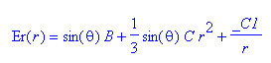
which says

Er(r,θ) = B sinθ + (1/3)Csinθ r2

So given B0 = 0 and a pure gradient field described by α, if we keep only the m = 0 and m = ±1 terms we get

Eθ(r,θ) = Ar2 + [B + Cr2]cosθ A = -(1/3)d C = -(3/8)d

Er(r,θ) = B sinθ + (1/3)Csinθ r2 d = jωαcosθ

The boundary condition is then

Er(a,θ) + μ Eθ(a,θ)B3(x=acosθ) = 0 B3(x=acosθ) = [B0 - α rcosθ] = -α r cosθ
or
Er(a,θ) - μα cosθ Eθ(a,θ) = 0
or

Aa2 + [B + Ca2]cosθ - μα cosθ [B sinθ + (1/3)Csinθ a2] = 0

Now insert the known values

-(1/3)d a2 + [B -(3/8)d a2]cosθ - μα cosθ [B sinθ - (1/3) (3/8)d sinθ a2] = 0

-(1/3) jωαcosθ a2 + [B -(3/8) jωαcosθ a2]cosθ - μα cosθ [B sinθ - (1/3) (3/8) jωαcosθ sinθ a2] = 0

Write as

cosθ [-(1/3) jωα a2 + B]

+ cos2θ [-(3/8) jωα a2 ]

+ cosθsinθ [- μα B ]

+ cos2θ sinθ [ +(1/8) μα jωαa2 ]

Things obviously don't work very wall. One item is

B = -(1/3) jωα a2

and then I have to argue the other terms away based on "small α". So here we are:

Eθ(r,θ) = Ar2 + [B + Cr2]cosθ A = -(1/3)d C = -(3/8)d

Er(r,θ) = B sinθ + (1/3)Csinθ r2 d = jωαcosθ
or

Eθ(r,θ) = -(1/3) jωαcosθ r2 + [-(1/3) jωα a2 -(3/8) jωαcosθr2]cosθ

Er(r,θ) =-(1/3) jωα a2sinθ + (1/3)[ -(3/8) jωαcosθ]sinθ r2
or

Eθ(r,θ) = -(1/3) jωαcosθ r2 -(1/3) jωα a2cosθ - (3/8) jωαr2cos2θ

Er(r,θ) = -(1/3) jωα a2sinθ - (1/8) jωα cosθsinθ r2

or
Eθ(r,θ) = jωα { -(1/3) cosθ r2 -(1/3) a2cosθ - (3/8) r2cos2θ }

Er(r,θ) = jωα {-(1/3) a2sinθ - (1/8) cosθsinθ r2}

Obviously this is a wrong result because I had to fudge a lot of things, but it does suggest a few things:

• the fields go to 0 if α = 0, as expected

• fields are proportional to ω, as I would expect

• fields have power r2 here and there and reasonably simple angular dependence.

Conclusion: This sort of confirms my guess after reading some literature that eddy current problems are quite difficult to solve, even in the simplest of situations beyond the uniform B case. That two methods paper did not venture beyond a uniform B field.

(h) Direct Helmholtz equation approach using App D results

I think you could approach this circular disk eddy current problem along the lines of Appendix D, where the z direction is more or less ignored. I think this means setting βd = 0, meaning infinitely long wavelength. You do the partial waves and you get down to the box (D.1.20) with the three Helm and the one divergence equation. You then solve these equations and you arrive at (D.2.21) in the circular thin plate, where as usual we have Km and am undetermined in each partial wave. So far there is no connection to any magnetic fields, such as the one that is causing our "action" in the plate.
At this point I might say the following: for this thin plate, Jz= 0 because it has nowhere to go and because that just seems reasonable for a "thin" plate where we don't really activate any currents in that direction. I think it also reasonable to say the Jz = σEz so that Ez= 0 as well. Then especially noting the appearance of 1/βd in the Ez equation, it just seems that you need to set Km = 0, something new to me. There is just no way around this, at least for the Jz part. Certainly we can TRY it!

First summary of the E field solutions (D.2.21)

Ez(r,m) = - j (β'/βd) $\frac{Km}{2}$ Jm(x) x = β'r (D.1.27)

Er(r,m) = am x-1 Jm(x) + $\frac{Km}{2}$ Jm+1(x) β'2 = β2 - βd2 (D.2.11)

jEθ(r,m) = - am x-1 Jm(x) + ( $\frac{Km}{2}$+ $\frac{am}{m}$ ) Jm+1(x) (D.2.15)

Then we get

Er(r,m) = am x-1 Jm(x) x = βr β'2 = β2 (D.2.11) (D.2.21)
jEθ(r,m) = - am x-1 Jm(x) + $\frac{am}{m}$ Jm+1(x) (D.2.15)

Remember that this includes div E = 0 and all the Helmholtz stuff.

Magnetic Ohm's Law

Now maybe look again at Magnetic Ohm's law in the x,y plane of this thin circular plate. I go back to Appendix N.4 where also we had B in the z direction (not necessarily uniform. I write the motional Lorentz and solve to get

Jx = σ (Ex + ωcτ Ey) $\frac{1}{1+(ωcτ)2}$ ωc ≡ (qB/m)
Jy = σ (Ey - ωcτ Ex) $\frac{1}{1+(ωcτ)2}$ B = B σ = (nq2τ/m)

Jz = σEz . σ = (nq2τ/m) (N.4.10)

Now let's throw out the tiny correction ratio, and install arguments:

Jx = σ (Ex + ωcτ Ey)

Jy = σ (Ey - ωcτ Ex)

I don't think I ever wrote this down above for Problem 1 maybe because it was not needed. Now since no cross products etc, I can translate this so the x,y = 1,2 = r,θ to get

Jr = σ (Er + ωcτ Eθ)

Jθ = σ (Eθ - ωcτ Er)

and this is our magnetic Ohm's Law in the plane of our disk. But now there are no θ function products, so we can take this right to m-space to get

Jr(r,m) = σ (Er(r,m) + ωcτ Eθ(r,m))

Jθ(r,m) = σ (Eθ(r,m) - ωcτ Er(r,m))

Boundary Condition

Then we have this clean boundary condition

Jr(a,m) = 0
or
Er(a,m) + ωcτ Eθ(a,m) = 0

Boundary Condition Cannot be Met in the Km= 0 scenario

What happens now if I use this with the expressions above:

Er(r,m) = am x-1 Jm(x) x = βr β'2 = β2 (D.2.11) (D.2.21)
jEθ(r,m) = - am x-1 Jm(x) + $\frac{am}{m}$ Jm+1(x) (D.2.15)

Here we go:

Er(a,m) + ωcτ Eθ(a,m) = 0
am xa-1 Jm(xa) + ωcτ j [am xa-1 Jm(xa) - $\frac{am}{m}$ Jm+1(xa) ] = 0

Unfortunately (and but of course), am cancels out and we get

xa-1 Jm(xa) + ωcτ j [xa-1 Jm(xa) - (1/m) Jm+1(xa) ] = 0

xa-1 Jm(xa) [ 1 + jωcτ] = (1/m) Jm+1(xa)

So our solution has failed! I think this probably means that the Ez= 0 assumption is no good. Maybe there is some Ez and some Jz and it is pumping charge onto the top and bottom surfaces of the plate! That give the problem a little bit of an escape hatch. I guess another option is surface charge on the rim of the disk. This then links us to the "external problem".

Try stupid Lm idea, goes nowhere

So go back to this point:

First summary of the E field solutions (D.2.21)

Ez(r,m) = - j (β'/βd) $\frac{Km}{2}$ Jm(x) x = β'r (D.1.27)

Er(r,m) = am x-1 Jm(x) + $\frac{Km}{2}$ Jm+1(x) β'2 = β2 - βd2 (D.2.11)

jEθ(r,m) = - am x-1 Jm(x) + ( $\frac{Km}{2}$+ $\frac{am}{m}$ ) Jm+1(x) (D.2.15)

It is certainly off-putting to see that βd sitting there. We might replace

$\frac{Km}{2}$(1/βd) = $\frac{Lm}{2}$

Then we have

Ez(r,m) = - j β' $\frac{Lm}{2}$ Jm(x) x = β'r (D.1.27)

Er(r,m) = am x-1 Jm(x) + βd $\frac{Lm}{2}$ Jm+1(x) β'2 = β2 - βd2 (D.2.11)

jEθ(r,m) = - am x-1 Jm(x) +( βd$\frac{Lm}{2}$+ $\frac{am}{m}$ ) Jm+1(x) (D.2.15)

But then in our limit that βd → 0 we get

Ez(r,m) = - j β' $\frac{Lm}{2}$ Jm(x) x = β'r (D.1.27)

Er(r,m) = am x-1 Jm(x) β'2 = β2 - βd2 (D.2.11)

jEθ(r,m) = - am x-1 Jm(x) +( $\frac{am}{m}$ ) Jm+1(x) (D.2.15)

and we are back to our no good boundary condition problem. So this Lm idea accomplished nothing.

Smythian Forms Comment

If I think in terms of Smythian Forms and this Helm equation, I have already incorporated the θ and r forms, but my z direction is weak.

e±kz [ Jm(kr), Nm(kr)] e±imθ

To what equation do these atoms apply? They are for Laplace, M&S page 14 second grouping. The solutions for scalar Helm start bottom of page 15 and see first grouping on page 16 with q = β' and then this is what App D is all about. Their χ is then β and then χ2-q2 = βd2 so then χ2 = β'2 + βd2 = β2 and everyone is happy.

Back to Km= 0 but allow rim surface charge similar to App D

Let's go back to Km = 0 where we then had

Er(r,m) = am x-1 Jm(x) x = βr β'2 = β2 (D.2.11) (D.2.21)
jEθ(r,m) = - am x-1 Jm(x) + $\frac{am}{m}$ Jm+1(x) (D.2.15)

Then suppose we try a charge pumping condition on the disk perimeter surface. Something like in lines doc.

Er(r=a,m) = (jω/σ) Nm

Then we get

am xa-1 Jm(xa) = (jω/σ) Nm

and this then relates am to Nm. OK, let that lie for a moment and lets then look at the corresponding B fields,

Bz(r,m) = (β'/ω) ($\frac{Km}{2}$ + $\frac{am}{m}$ )Jm(x)
Br(r,m) = j(β'/ω){ + ( m$\frac{Km}{2}$ $\frac{β'}{βd}$ - $\frac{βd}{β'}$ am) x-1Jm(x) + $\frac{βd}{β'}$ ($\frac{Km}{2}$ + $\frac{am}{m}$ ) Jm+1(x) }
Bθ(r,m) = (β'/ω){ - ( m$\frac{Km}{2}$ $\frac{β'}{βd}$ - $\frac{βd}{β'}$ am) x-1Jm(x) + $\frac{Km}{2}$ ( $\frac{βd}{β'}$ + $\frac{β'}{βd}$ ) Jm+1(x) } , (D.4.8)

I set Km = 0 here right off the bat to get

Bz(r,m) = (β'/ω) ( $\frac{am}{m}$ )Jm(x)
Br(r,m) = j(β'/ω){ + (- $\frac{βd}{β'}$ am) x-1Jm(x) + $\frac{βd}{β'}$ ( $\frac{am}{m}$ ) Jm+1(x) }
Bθ(r,m) = (β'/ω){ - (- $\frac{βd}{β'}$ am) x-1Jm(x) } , (D.4.8)

Then I also let βd = 0 and we then have

Bz(r,m) = (β'/ω) ( $\frac{am}{m}$ )Jm(x)
Br(r,m) = 0
Bθ(r,m) = 0 (D.4.8)

Warning:

I think the Bz field here is the Lenz'z Law Bz field associated with the E fields earlier, and is not the applied Bz external field, so forcing it to be that external field might cause trouble.

OK, maybe this determines the am from the applied B field, and then we have everything. We then have

Bz(r,m) = (1/2π) $^{\int_{-π}^{π}{}}$dθ Bz(r,θ) e-jmθ

OK, let's try our particular B field of interest [ see warning above! ]

Bz(r,θ) = α rcosθ = αx

which is a linear in x field which is zero at x = 0 = center of disk. Then

Bz(r,m) = (1/2π)αr $^{\int_{-π}^{π}{}}$dθ cosθ e-jmθ = (1/2π)αr$^{\int_{-π}^{π}{}}$dθ cosθ cos(mθ) = (1/2π)αr π δm,1

= (1/2)α r δm,±1

That was easy. I just showed that the transform of cos(mθ) is this

(1/2π) $^{\int_{-π}^{π}{}}$dθ cosθ e-jmθ = (1/2π) π δm,±1

So set the above deal equal to

Bz(r,m) = (β'/ω) ( $\frac{am}{m}$ )Jm(x) = (1/2)α r δm,±1

Then

$\frac{am}{m}$ = (1/2)α r (ω/β)/Jm(x) δm,±1

But this is of course junk since there is no constant am that works. The problem here is that I am here dealing with the B field corresponding to the currents, not the "applied" B field.

curl E = -jωB

r-1∂r(rEθ) - r-1∂θEr = -jω [B0 - α rcosθ]
or
∂r(rEθ) - ∂θEr = -jω [B0 - α rcosθ] r

Transforming this equation says

∂r(rEθ) - jmEr = -jω [B0 - α r (1/2π) π δm,±1] r

Let's simplify with B0 = 0 and restate

∂r(rEθ) - jmEr = jωα r (1/2) δm,±1] r

At least this is something vaguely new. It says

∂r(rEθ(r,m)) - jEr(r,m) = jωα r (1/2) δm,±1] r PDE#1

∂r(rEr) + jmEθ = 0 PDE#2 just recalling

which then says

∂r(rEθ(r,m)) = jEr(r,m) m ≠ ±1

∂r(rEθ(r,1)) - jEr(r,1) = jωα (1/2) r2

How about using this as a condition on our fields:

Er(r,m) = am x-1 Jm(x) x = βr β'2 = β2 (D.2.11) (D.2.21)
jEθ(r,m) = - am x-1 Jm(x) + $\frac{am}{m}$ Jm+1(x) (D.2.15)

Then :
∂r(r[am x-1 Jm(x)]) - jm(-j)[- am x-1 Jm(x) + $\frac{am}{m}$ Jm+1(x)] = jωα r (1/2) δm,±1] r

For m = 0 everything is 0 which is fine.

What about m = 2:

∂r(r[am x-1 Jm(x)]) - m[- am x-1 Jm(x) + $\frac{am}{m}$ Jm+1(x)] = 0

Solution is a2 = 0, which is just fine.

Now try m = +1

∂r(r[a1 x-1 J1(x)]) - [- a1 x-1 J1(x) + $\frac{a1}{1}$ J2(x)] = jωα r (1/2)] r

But again, you have a fancy function of x on the left, and a simple function of r on the right, how can it work? Again in curl E = -jωB we must have the TOTAL B, and I show only the applied B and we get a contradiction. But be patient just a little more and grind this into the ground.

∂r(r[a1 x-1 J1(x)]) = ∂x(x[a1 x-1 J1(x)]) = ∂x([a1J1(x)]) = a1 J1'(x)

Then the above says

a1 [J1'(x) + x-1 J1(x) - J2(x) ] = jωα r (1/2)] r
or
a1 [xJ1'(x) + J1(x) - xJ2(x) ] = jωα r (1/2)] r x

I can replace

xJ1'(x) = J1(x) - xJ2(x)

so we then have

2a1 [xJ1'(x)] = jωα r (1/2)] r x

2a1 J1'(x) = jωα (1/2)] r2

and again we just have garbage. Something is very wrong with this approach, I guess it is the "warning" given above.

Try sin(βdz) in the z direction

I suppose I could assume something like sin(βdz) instead of e-jβdz . I think this just shows that you are activating a whole spectrum of modes of the thin disk with your external B field. I was hoping to get a mode in which βd = 0

If I were to assume sin(βdz) instead of e-jβdz in Appendix D, I think the rule is this:

wherever βd appears not squared, replace it with βdcot(βdz).

This arises because these linear Bd factors all come from divE = 0. It easy to show the above idea if you just look at the way ∂z appears in the div E = 0 equation in App D.

Then you end up with I guess

First summary of the E field solutions (D.2.21)

Ez(r,m,z) = - j (β'/βd)tan(βdz) $\frac{Km}{2}$ Jm(x) x = β'r (D.1.27)

Er(r,m) = am x-1 Jm(x) + $\frac{Km}{2}$ Jm+1(x) β'2 = β2 - βd2 (D.2.11)

jEθ(r,m) = - am x-1 Jm(x) + ( $\frac{Km}{2}$+ $\frac{am}{m}$ ) Jm+1(x) (D.2.15)

But now βd has nothing to do with waves, something else will determine it. If we want Jz(z=0) = Jz(z=h) = 0 as our nowhere to go conditions, and if Jz = σ Ez , then Jz(z=0)= 0 is already met, and then we have to say that sin(βdh) = 0 where the bottom of the circular disk is at z = 0 and its height is h. This means βdh = Mπ and we then have a new mode number M floating around. For M = 0 there is no solution because we don't get Ez = 0 at z = h since (β'/βd)tan(βdz) = (β'/βd)sin(βdz) = β'z. So βd = M(π/h) and if h is small, then βd is large.

βd = M(π/h) M = 1,2,3...

Now we don't have to say Km = 0! That is the new benefit.

Maybe NOW we can apply the boundary conditions? I think this is not a good path.

3. What about that stream function gizmo?

What about that stream function gizmo mentioned in the numeric section of "two methods" . That is after all how they DID their numeric stuff. Here is that plan:

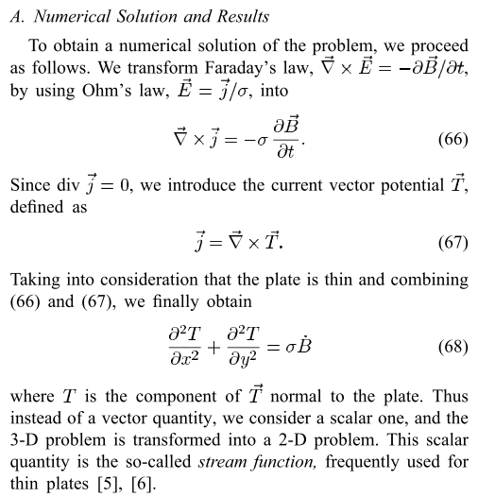
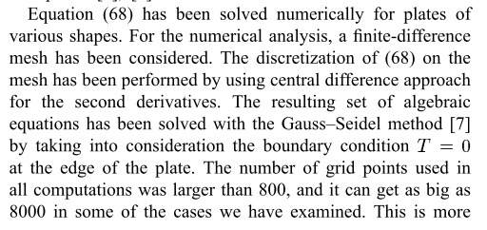

If this is correct, then this whole thing is boiled down to a simple scalar Laplace equation, holy cow, that is sure easier than what I have been doing here. The two refs are these:

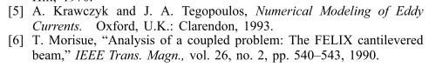
I found another PDF that also uses this T idea. Maybe a little fiddle on this tomorrow.

April 5, 2014 (Sat)

Many things to say concerning all the above work. My main approach was to make use of these two Maxwell equations each of which is a PDE:

curl E = -jω B
div E = 0

My plan was to use for B the driving external field and ignore any Lenz Field. So I was hoping to just solve these equations for E and be done with it! But when you write it all out, it is just not obvious how you invert that curl equation.

Inverse curl operator idea

Belatedly today I recall a PDF I got about the "inverse curl operator". I looked at it just now, and yes, it does seem to give a general formula for the solution and it does so in any curvilinear orthogonal system! Author notes that the inversion is not unique

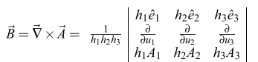
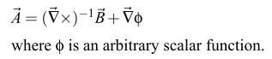

So perhaps I could use his formula to find that

E1 = curl-1 [-jωB]
E = E1 + grad ψ
div E = 0 but div grad = ∇•∇ = ∇2

so you would end up with

div { curl-1 [-jωB] } + ∇2ψ = 0

and you still have to find ψ, so it would be a long road.

General Remarks about What We Know

Let's go back to our starting point

curl E = -jω B
div E = 0

If we can use J = σE, then the second equation implies div J = 0. But I well know that in magnetic circumstances, this is not quite true, such as Hall effect and all that stuff. But I think I regard it as basically true for ω ranges of my interest. But maybe its non-truth in the exact is important in my current problem of interest?
Normally you use the other Maxwell equations to show that div J = 0 :

curl H = ∂tD + J
div D = ρ
D = εE

Then taking div of the first equation and using div curl = 0 you end up with div J = -∂tρ.
So inside our metal we do know that ρ = 0 (for all practical purposes) and so div J = 0. Maybe this is a separate condition that I have not been using, so I have missing information in my solutions.

Why people use potentials

Now, in lines doc and in King, we know that div B = 0 and that allows us to define A such that B = curl A and in the lines doc situation we get to think only about Az so it is easier to work with a scalar function like Az than a vector function like B.
Similarly, since curl E = 0 in electrostatics, we can define E = -grad φ and then div E = ρ/ε0 gives us the Poisson equation for φ, and again, we are dealing with a scalar potential instead of a vector function. Think what a mess "potential theory" would be if you tried to only work with E.

Theory of the Stream Function Tz

OK, so in a similar vein, we have this plan with the stream function Tz. Since inside a metal we know that div J = 0, we can write J = curl T where T is a "vector current potential". In cylindricals for example, we get

J = curl T = [ r-1∂θTz - ∂zTθ] + [∂zTr - ∂rTz] + [ r-1∂r(rTθ) - r-1∂θTr ]

and then we have

Jr = r-1∂θTz - ∂zTθ

Jθ = ∂zTr - ∂rTz

Jz = r-1∂r(rTθ) - r-1∂θTr

Now consider again

curl E = -jω B

and suppose we go ahead and assume J = σE so this says

curl J = (-jωσ) B

Then make use of ∇ x (∇ x A) = ∇(∇•A) - ∇2A to write

curl J = curl curl T = grad(div T) - ∇2T

Then we have this equation

grad(div T) - ∇2T = (-jωσ) B (*)

This does not look all that nice, but let's keep going a bit. We have

div T = r-1∂r(rTr) + r-1∂θTθ + ∂zTz

Now I will shoot from the hip, but will read soon. Perhaps you now argue that Tr and Tθ << Tz so you can ignore the first two "transverse terms", just as I keep doing in the King world. Maybe this is an ansatz. You are then saying that

div T ≈ ∂zTz

Now take the z component of (*) to get

∂z [ 0 + 0 + ∂zTz] - ∇2Tz = (-jωσ) Bz
or
∂z2Tz - (∇2D2Tz + ∂z2Tz = (-jωσ) Bz
or
- ∇2D2Tz = (-jωσ) Bz
or
∇2D2Tz = σ [jω Bz] = σ z

which is a 2D Poisson equation for Tz !
Meanwhile we have

Jr = r-1∂θTz - ∂zTθ ≈ r-1∂θTz

Jθ = ∂zTr - ∂rTz ≈ - ∂rTz

Jz = r-1∂r(rTθ) - r-1∂θTr ≈ 0

Write the first two in more detail

Jr(r,θ) = r-1∂θTz(r,θ)
Jθ(r,θ) = - ∂rTz(r,θ)

Now consider our boundary condition at the disk edge! Jr(r=a,θ) = 0. Suppose we did partial waves here so the first equation says

Jr(r,m) = r-1jm Tz(r,m)

Then at least for m ≠ 0, we find that Jr(a,m) = 0 => Tz(r,m) = 0 !! I think the m=0 component of T is just the constant part, and the constant part of any "potential" can be ignored so we set Tz(r,0) = 0 by fiat, and then we have this very nice fact:

Jr(a,θ) = 0 => Tz(a,θ) = 0

We then have this relatively simple 2D potential theory problem:

∇2D2Tz(r,θ) = σ [jω Bz] = σ z Tz(a,θ) = 0

which is like a 2D Poisson problem where z is like the charge density. If we can solve this problem, then we have a solution for our currents and E fields since J = σE :

Jr = r-1∂θTz
Jθ = - ∂rTz

So the Poisson problem I just derived matches the two methods PDF,

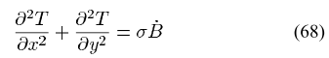

This general stream function method can be applied to any shaped thin plate, not just a circular one.

Comment: The above discussion assumes at the start that J = σE . That is how J entered the discussion since we started with curl E = -jωB.

Application of stream method to the uniform B field circular plate

Since we know we will get a symmetric solution, we can write

∇2D2Tz(r,θ) = r-1∂r(r∂rTz)

Our problem is then

r-1∂r(r∂rTz) = σ z Tz(a,θ) = 0

So integrate to get

∂r(r∂rTz) = r σ z = rσ jωBz => ∂r(r∂rTz) - rσ jωBz = 0

r∂rTz = σ z (1/2)r2 + C1

∂rTz = σ z (1/2)r + C1/r

Tz(r) = σ z (1/4)r2 + C1 ln(r) + C2

Jr = r-1∂θTz = 0
Jθ = - ∂rTz = - (1/2) σ z r - C1/r

Since Jθ = finite at disk center, must have C1 = 0 and our solution is then

Jr = 0
Jθ = - (1/2) σ z r

and this agrees with Jθ(r) = σ (-z /2) r which I found by other means in Problem 1 above! Very excellent! Meanwhile, we can do this:

Tz(r) = σ z (1/4)r2 + C2 = σ z (1/4) (r2-a2) = jωσ Bz (1/4) (r2-a2) (***)

so that Tz(a) = 0.

Try Eddy Problem 2 with this stream method!

Since no longer have symmetry, we have

∇2D2Tz(r,θ) = σ [jω Bz] = σ z Tz(a,θ) = 0

or
r-1∂r(r∂rTz) + r-2∂θ2Tz = σ z(r,θ) = jωσBz = jωσ[B0 - α rcosθ] Tz(a,θ) = 0
or
∂r(r∂rTz) + r-1∂θ2Tz = σ z(r,θ) = jωσBzr = jωσ[B0 - α rcosθ]r Tz(a,θ) = 0

Now take this to partial waves as per App D to get

r-1∂r(r∂rTz(r,m)) - r-2m2Tz(r,m) = σ z(r,m) = jωσ Bz(r,m)

This is a very simple ODE driven by the right side, I like it! Now we have this assumed B field (in ω space)

Bz(r,θ) = B0 - α rcosθ note that dim(α) = B/m

so that

Bz(r,m) = (1/2π) $^{\int_{-π}^{π}{}}$dθ Bz(r,θ) e-jmθ = (1/2π) $^{\int_{-π}^{π}{}}$dθ [B0 - α rcosθ] e-jmθ

= B0 (1/2π) $^{\int_{-π}^{π}{}}$dθ e-jmθ - α r (1/2π) $^{\int_{-π}^{π}{}}$dθ cosθ e-jmθ

= B0 (1/2π) $^{\int_{-π}^{π}{}}$dθ cos(mθ) - α r (1/2π) $^{\int_{-π}^{π}{}}$dθ cosθ cos(mθ)

= B0 (1/π) $^{\int_{0}^{π}{}}$dθ cos(mθ) - α r (1/π) $^{\int_{0}^{π}{}}$dθ cosθ cos(mθ)

But Spiegel page 96 says

$^{\int_{0}^{π}{}}$dθ cos(nθ) cos(mθ) = 0 if m ≠n; = π/2 if m = n ≠ 0; = π if m = n = 0

So I find that

Bz(r,m) = B0 (1/π) $^{\int_{0}^{π}{}}$dθ cos(0θ)cos(mθ) - α r (1/π) $^{\int_{0}^{π}{}}$dθ cos(1θ) cos(mθ)

= δm,0B0 (1/π) π - α r (1/π)δm,±1 π/2

= δm,0 B0 - (α/2) r δm,±1

So we then have

r-1∂r(r∂rTz(r,m)) - r-2m2Tz(r,m) = jωσ[δm,0 B0 - (α/2) r δm,±1] Tz(a,m) = 0

Now for m ≠ 0 and m ≠ ±1, we know that Tz(r,m) = 0 from potential theory of Laplace's equation where the function has no source and vanishes on a closed boundary. Great! So this leaves us with these two equations for non-zero solutions:

r-1∂r(r∂rTz(r,0)) = jωσB0 EQ1

r-1∂r(r∂rTz(r,±1)) - r-2Tz(r,±1) = - jωσ r (α/2) = -A r EQ2

I just solved EQ1 above and found that

Tz(r,0) = jω σ B0 (1/4)r2 + C1 ln(r) + C2

We cannot have ln(r) so C1 = 0 and then

Tz(r,0) = jω σ B0 (1/4)r2 + C2

The boundary condition Tz(a,0) = 0 says

C2 = - jω σ B0 (1/4)a2

and therefore

Tz(r,0) = jω σ B0 (1/4)(r2-a2)

EQ2 looks Besslesque to me. Write as

r-1∂r(r∂rTz(r,±1)) - r-2Tz(r,±1) = -A r

∂r(r∂ru) - (1/r)u = -Ar2 A = jωσ (α/2)

Hand this off to Maple. It is NOT Bessel after all:

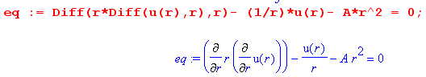

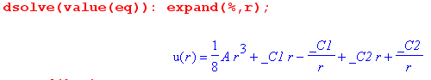

So our solution is then this:

Tz(r,±1) = - (1/8)Ar3 + C1(r-1/r) + C2(r+1/r)

= - (1/8)Ar3 + r (C1+ C2) + (1/r)(-C1+C2)

To be finite at r = 0 we have to pick C1 = C2 and then

Tz(r,±1) = - (1/8)Ar3 + C3 r = jωσ(α/16) r3 + C3r A = jωσ (α/2)

Wow, I like it. The boundary condition is

0 = Tz(a,±1) = -jωσ(α/16) a3 + C3a => C3 = + jωσ(α/16) a2

so then

Tz(r,±1) = - (1/8)Ar3 + C3 r = -jωσ(α/16) r3 + jωσ(α/16) a2 r

= - jωσ(α/16)r(r2-a2) ok pass 3

So here is a summary of our partial wave solutions for the vector current potential component Tz :

Tz(r,0) = jω σ B0 (1/4)(r2-a2)

Tz(r,±1) = - jωσ(α/16)r(r2-a2)

Tz(r,m) = 0 for all other values of m

Very good, now get back to θ space

Tz(r,θ) = Tz(r,m) ejmθ = Tz(r,0) + Tz(r,1) ejθ + Tz(r,-1) e-jθ

= Tz(r,0) + Tz(r,1) 2cosθ

= jω σ B0 (1/4)(r2-a2) - jωσ(α/8)r(r2-a2) cosθ

= jωσ [B0 (1/4)(r2-a2) - (α/8)r(r2-a2)cosθ]

= jωσ [B0 (1/4)(r2-a2) - (α/8)(r3-a2r)cosθ]

Note that for α = 0, this Tz(r,θ) agrees with (***) above found for Problem 1! So the B0 term is certainly correct.

Wow, a genuine answer. Then we get

Jr = r-1∂θTz = - r-1 jωσ(α/8)r(r2-a2) [-sinθ] = + jωσ(α/8) (r2-a2)sinθ

Jθ = - ∂rTz = - ∂r { jωσ [B0 (1/4)(r2-a2) - (α/8)(r3-a2r)cosθ]}

= - jωσ { B0 (1/2) r - (α/8)(3r2-a2)cosθ }

To summarize,

Jr(r,θ) = jωσ [ + (α/8) (r2-a2)sinθ ]

Jθ(r,θ) = jωσ [-(1/2)B0r + (α/8) cosθ [ 3r2 - a2 ]

and

Er(r,θ) = jω [ + (α/8) (r2-a2)sinθ ]

Eθ(r,θ) = jω [-(1/2)B0r + (α/8) cosθ [ 3r2 - a2 ]

Now I want to run a lot of checks, since I will no doubt publish this result.

• both currents proportional to jω as we expect

• Jr(a,θ) = 0

• when α = 0, we duplicate the uniform B result

• Verify that Tz(r,θ) satisfies the stream PDE: First, here is that PDE after I enter it as eq in Maple
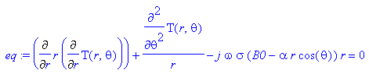

This matches a result above

∂r(r∂rTz) + r-1∂θ2Tz = σ z(r,θ) = jωσBzr = jωσ[B0 - α rcosθ]r Tz(a,θ) = 0

I then enter T from above and see if I get 0=0 for the equation

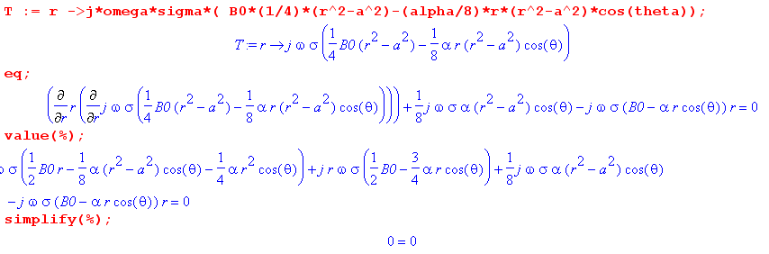
• Now I want to look at my big two PDE's of yesterday which were

∂r(rEθ) - ∂θEr = -jω [B0 - α rcosθ] r PDE#1 curl B = -jωE
∂r(rEr) + ∂θEθ = 0 PDE#2 div E = 0

Here is the code and it works! First here is all the entry

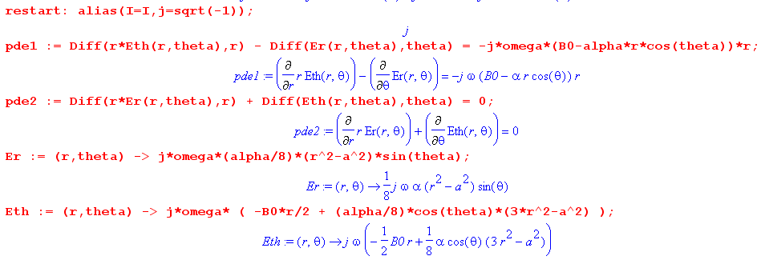

Then here is evaluation of the two PDE's

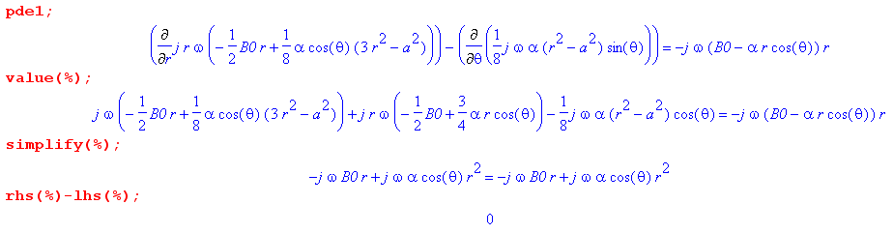
Then
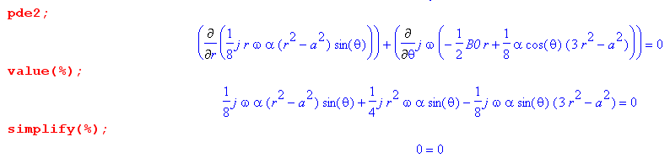
and all seems well. Here is an alternative verification using Maple's fancy diff ops:

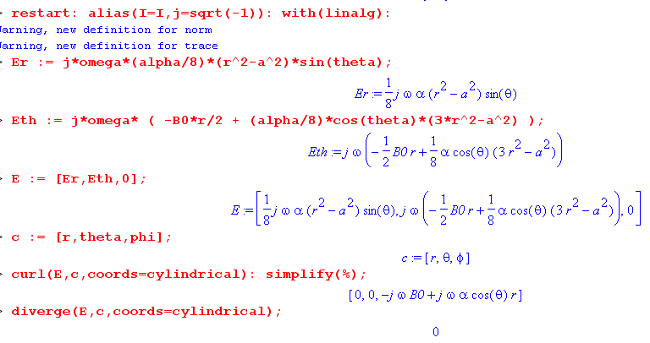
So, here is our Problem 2 solution,

Jr(r,θ) = jωσ [ + (α/8) (r2-a2)sinθ ]
Jθ(r,θ) = jωσ [-(1/2)B0r + (α/8) cosθ [ 3r2 - a2 ]

We can of course write

Jx = Jr • + Jθ• = Jr cosθ - Jθ sinθ
Jy = Jr • + Jθ• = Jrsinθ + Jθcosθ

OK, here is some new plotting code. I replicate the old plot of α = 0, but here is a plot with B0 = 1 and
α = 1 (in file "problem2.mws")

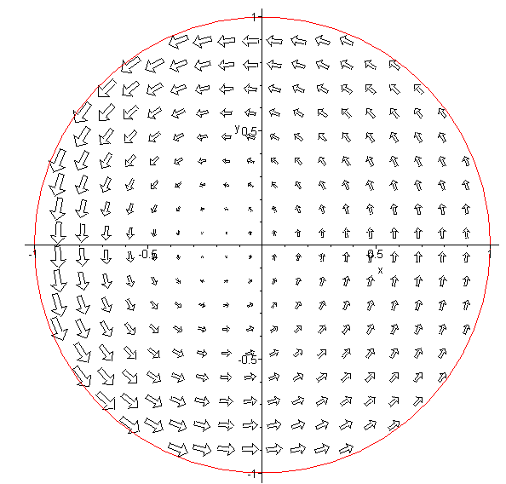

This is what I have long been looking for!!! Several days now. It shows the proximity effect induced by having a perp B field with a gradient! The current is larger where the field is larger! I would like to get some field lines going here!! You can see that the field lines are no longer circles centered at the center. And you can see that current is tangent at the circle edge. Wow, finally!

Each question spawns five new questions:
What about the force on the above plate? skip this item
What about the Lenz B field? DONE BELOW
What about the T components that I neglected? Was that justified? DONE BELOW
Can you make a skin effect comment here? DONE BELOW
Why was I able to ignore Magnetic Ohm's Law in my solution? DONE BELOW

Magnetic Ohm's Law and the Stream Problem 2 Solution

In Cartesians we know from App N that the MOL solution is this

Jx = σ (Ex + ωcτ Ey) $\frac{1}{1+(ωcτ)2}$ ωc ≡ (qB/m)
Jy = σ (Ey - ωcτ Ex) $\frac{1}{1+(ωcτ)2}$ B = B σ = (nq2τ/m)

Jz = σEz . σ = (nq2τ/m) (N.4.10)

which I now convert to cylindricals,

Jr = σ (Er + ωcτ Eθ) $\frac{1}{1+(ωcτ)2}$ ωc ≡ (qB/m)
Jθ = σ (Eθ - ωcτ Er) $\frac{1}{1+(ωcτ)2}$ B = B σ = (nq2τ/m)

Jz = σEz . σ = (nq2τ/m) (N.4.10)

In an analysis in which MOL was respected, you would have the BC that Jr(a,θ) = 0 so that

Er(a,θ) + ωcτ Eθ(a,θ) = 0 precision BC

The MOL shown above of course violates the regular Ohm's law unless ωcτ << 1. Since the stream method assumes regular Ohm's Law, we may conclude that the stream method is only valid when ωcτ << 1 . Recall that our stream solutions above were.

Er(r,θ) = jω [ + (α/8) (r2-a2)sinθ ] Er(a,θ) = 0
Eθ(r,θ) = jω [-(1/2)B0r + (α/8) cosθ [ 3r2 - a2 ] Eθ(a,θ) = jω [-(1/2)B0a + (α/8) cosθ a2 ]

Thus, you cannot expect the "precision BC" above to be respected by these fields since these fields were derived in a way that ignored the MOL. Indeed the precision BC is violated to order ωcτ , no surprise.

Stream Method for E ?

Could we redo the stream method entirely in terms of the E field and not use ROL (regular)? Let's try in with copy paste and edit:

Since div E = 0 inside the plate, we try

E = curl T = [ r-1∂θTz - ∂zTθ] + [∂zTr - ∂rTz] + [ r-1∂r(rTθ) - r-1∂θTr ]

and then we have

Er = r-1∂θTz - ∂zTθ

Eθ = ∂zTr - ∂rTz

Ez = r-1∂r(rTθ) - r-1∂θTr

We again argue that Tr and Tθ << Tz and we end up with

∇2D2Tz = σ [jω Bz] = σ z

But now we cannot use the boundary condition Tz(a,θ) = 0! See derivation above which is then flawed because

Er(a,θ) = 0 => Tz(a,θ) = 0 is useless

It is useless because we only know that Jr = 0 at the edge, not that Er = 0. Recall in the Hall effect that in fact we have Jr = 0 at the edge but Er ≠ 0. So this stream approach does not fly!

The Conclusion is this: The stream method is valid as long as ωcτ << 1

Why can the transverse T components be neglected?

In the stream method we use ROL to start with curl J = (-jωσ) B and J = curl T . We can then write out the Maxwell components to get

Jr = r-1∂θTz - ∂zTθ
Jθ = ∂zTr - ∂rTz
Jz = r-1∂r(rTθ) - r-1∂θTr

If the plate is thin, we argue that everything is constant in the z direction so then Ti = Ti(r,θ) only. Then we can discard ∂z wherever it appears, and we then have

Jr = r-1∂θTz
Jθ = - ∂rTz
Jz = r-1∂r(rTθ) - r-1∂θTr

We then get "everything we want" from the first two equations. In order to "be happy with" the third equation, we then argue that Tr ≈ constant and Tθ ≈ constant/r so that Jz ≈ 0. Alternatively, we could just hope that Tr ≈ 0 and Tθ ≈ 0 so again Jz ≈ 0.
If we maintain these components and look back at our derivation, we have

curl curl T = (-jωσ) B (*)

so we really do have three equations here. If we don't assume smallness on the transverse components, we get three hugely complicated equations involving double derivatives. Just for Maple practice, I will have it show these three equations, see "stream mess.mws"

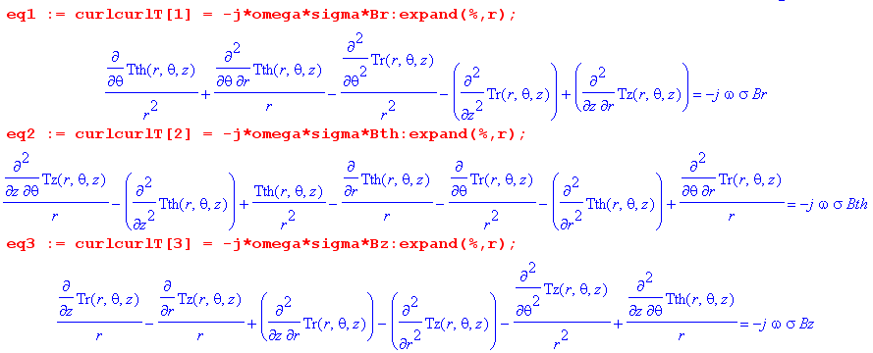

If I assume that the components do not depend on z, the results are at least simpler,

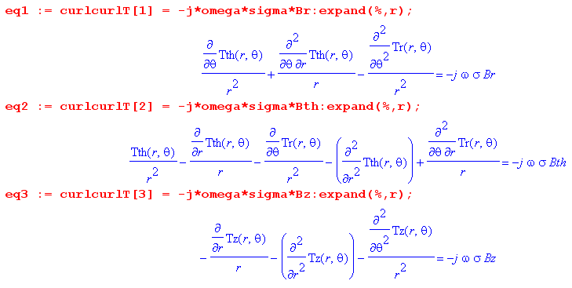

The last equation is basically that of the stream theory which says ∇2D2Tz = σ [jω Bz] . If we have no sources for the first two equations, then reasonable solutions to these equations are Tr = Tθ= 0. Notice that the first two equations do not contain Tz anywhere. But for a thick plate, these Laplace-like equations could have non-zero solutions even if no source on the right. I imagine these somehow as "modes" of the solid resonant cylinder that are excited by the applied B field, and this is not a subject I want to pursue.
Thinking of my sine business earlier and BC's at top and bottom of the plate, perhaps you can use the thin plate theory as long as the plate thickness is much smaller than your ω wavelength! If you cannot fit a half sine wave vertically, you cannot have a mode. Inside a solid copper cylinder we have the Helm equation and it says k = β = 2π/λ where

β = (j - 1) $\sqrt{ωμσ/2}$ real part k = - $\sqrt{ωμσ/2}$ = 2π/λ

λ = 2π/$\sqrt{ωμσ/2}$ = 2π$\sqrt{2/ωμσ}$ = 2π δ

So the wavelength is the skin depth. So I would guess that my result above applies as long as the plate thickness is much smaller that δ. At 100 Hz we have δ = 0.66 cm for copper. If plate is thinner than this, perhaps you cannot get the Jz mode going, ball park.

Eddy Current Testing

I just did some reading on a very popular topic "eddy current testing" or ECT. Lots of papers on this practical non-destructive testing topic! They are typically looking for cracks that are maybe up to 15 mm below the surface, or less. They note that (1) lower ω increases skin depth so get stronger penetrating signal, but (2) lower ω reduces scattering from a defect. (3) lower ω reduces resolution of the scattering data. Therefore, for a given depth there is some optimal ω that maximizes the scattered defect signal. One paper looking for deep defects at 15 mm (1.5 cm) used 16Hz to 64Hz. But another paper looking at smaller depths used 1.5 KHz. Airplane wheel system with SQUID sensitive detectors uses 100-300Hz.

Skin Effect and Problem 2

As noted above, I think you need the plate thickness to be << δ to shut down z direction action. But as for the transverse field and current pattern, it is true that it is smaller at the center, but I think that is just because of Faraday's emf being small on small loops near the center since flux is small etc. Recall

Er(r,θ) = jω [ + (α/8) (r2-a2)sinθ ] Er(a,θ) = 0
Eθ(r,θ) = jω [-(1/2)B0r + (α/8) cosθ [ 3r2 - a2 ] Eθ(a,θ) = jω [-(1/2)B0a + (α/8) cosθ a2 ]

There is no radial damping that is related to ω here! Of course signal increases linearly with ω. So I claim there is no transverse skin effect visible in these solutions. The B field always penetrates in the z direction all the way!

What about the Lenz's Law B field?

Suppose we start with our driving B field having some extent larger than the plate. We induce the eddy currents. The eddy currents then create a dipole-like Lenz B field in response and this field then extends out beyond the external driving field's radius. I guess you could make some kind of simple estimate of the size of this field. Maybe compute the total circulating current I and assume you have a ring of that current which has radius a and then look up the field made by such a ring.

What is the magnetic field on axis of a current ring radius a? See B&B p 150

Bz = (1/2)μ Ia2 / (z2+a2)3/2 on axis distance z from the ring

At the center of the ring we then get

Bz(z=0) = (1/2)μ Ia2/a3 = (1/2) μI/a dim(RHS) = hen/m *amp/m = amp-hen/m2 = OK

Let's go back to the symmetric Problem 1 where

I = - (1/4) h σa2z = - (1/4) h σa2jωBz

Then we get

BzLenz = - (1/4) h σa2jωBO * (1/2) μ a2 / (z2+a2)3/2

= { - jω (1/8) σμha $\frac{a3}{(z2+a2)3/2}$} BO

dim(ωσμha) = sec-1 mho m-1 hen m-1 m2 = sec-1 mho hen = sec-1 sec = 1

So we have a dimensionless fraction sitting there, so I can try some numbers. Maple

ω (1/8) σμha = ?

2*Pi*f*(1/8)*sigma0*mu0*(.01)*(.001):evalf(%);

.0005734240159 f

So if f = 60 Hz, this dimensionless quantity is .0006*60 = .036 = 3.6%
So there is my first-ever estimate of the Lenz field which I am ignoring at 60 Hz. Fine.

Stream theory for rectangular x,y z:

J = curl T = (∂yTz - ∂zTy) + (∂zTx - ∂xTz) + (∂xTy - ∂yTx)

Jx = ∂yTz - ∂zTy
Jy = ∂zTx - ∂xTz
Jz = ∂xTy - ∂yTx

curl J = (-jωσ) B

curl J = curl curl T = grad(div T) - ∇2T

grad(div T) - ∇2T = (-jωσ) B

Tx, Ty << Tz

div T ≈ ∂zTz

∂z [ 0 + 0 + ∂zTz] - ∇2Tz = (-jωσ) Bz

∇2D2Tz = σ [jω Bz] = σ z

OK, same as before.

Let's put the upper and lower edges at y = ±a and call it the center plane of cylinder. Then we have

Tz(x,±a) = 0 since no current there.

So here is our problem:

(∂x2 + ∂y2) Tz(x,y) = jωσ[B0 + αy] Tz(x,±a) = 0 field stronger at the top

Maybe throw in Tz(0,y) =Tz(L,y) at the left and right ends.

The general solution is

φ(x) = ∫R dx' g(x|x') q(x') – ∫σ dSξ f(ξ) ∂ξng(x|ξ) // Stakgold (6.81) . (1.5.11)

But since f(ξ) = 0 on the entire rectangular boundary, we just get

φ(x) = ∫R dx' g(x|x') q(x')

The Green's function will be some mess like this

g(x,y|x',y') = Σm Σn odd cos( nπy/2a) cos( nπy'/2a)sin(mπx/L) sin(mπx'/L)An,m

based on this idea

g(x|ξ) = Σn φλn(x)λn(ξ) / λn

So yes, I could do this problem and keep some finite number of terms and try to make a plot.

It would be nice to have a tool that could just do a numerical solution! Maple can only do this with ODE not PDE. I looked around, $1000 for a package, various people have them. I could write my own. This is not for today!

[ This section Added 4/30/14.] In my App P version 2 writeup I have these two PDE's

∂r(rEθ) - ∂θEr = - jω[B0 - α rcosθ]r ≡ p(r,θ)

∂r(rEr) + ∂θEθ = 0 (P.3.5)

Why can't I do the usual partial wave analysis where ∂θ → jm as in App D and then we have

∂r[rEθ(r,m)] - jmEr(r,m) = p(r,m)

∂r[rEr(r,m)] +jmEθ(r,m) = 0

where p(r,m) has only m = 0 and m = ±1 components. I could then solve the second

Eθ(r,m) = (1/jm) ∂r[rEr(r,m)]

and plug this into the first equation,

(1/jm) ∂r[r ∂r[rEr(r,m)]] - jmEr(r,m) = p(r,m)

But then this is really a Helmholtz equations as per Appendix D. In any event, I already went down this path in section (g) above. No doubt it can be made to work, but the stream function method is very much simpler!

