Web Scan on Eddy Currents PhL 4.2.14

[ Most of the stuff I found here is way too complicated for my limited interest in the subject. I eventually found the nice Siakavellas paper which did the round plate for uniform B. My main complaint was that none of the fancy sources do any examples! I included this round plate and a fancier gradient B example as well (with no external verification) in my Appendix P. ]

1. Full Book on the Subject (Alonso) 1
2. PDF from Stuttgart, Harrach, May 2013. 2
3. Ammari Buffa Nedelec. 3
4. Back to Harrach since I now understand his starting equation 6
5. wiki page http://en.wikipedia.org/wiki/Eddy_current 7

No shortage of hits on the general subject.

1. Full Book on the Subject (Alonso)

Someone has written an entire book on this subject, google books has some views

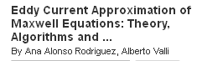

I have a suspicion that Ana Alonso got married after her 1999 paper below.

Also known as Foucault currents, circa ?? Used to melt metals in crucibles. Flaw detection.

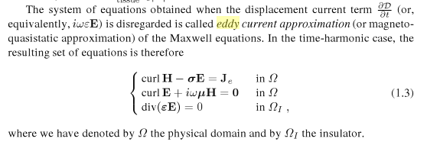

This seems nothing new. They go on:

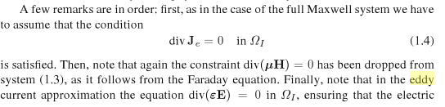
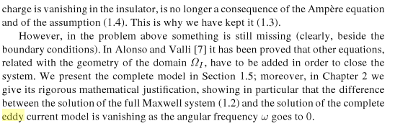

I don't grok the last sentence right now. They seem to pay more attention than I did to the insulating region around the conductor which they call ΩI and which I just ignored. This whole text is in BS notation IMHO, fancy language for a simple situation. I suspect it will not go far with me.

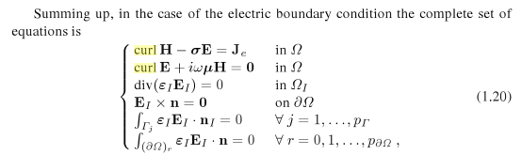

I understand the first four. Fourth says no tangential E fields on a metal surface, hmmmm. I went and tried in my little test case to make Ez = 0 on left and right edge, no can do since monotonic. I doubt the remaining items above are significant for me.
OK enough, this source is too complicated for me. I want the main jewels, not some thesis deal.

2. PDF from Stuttgart, Harrach, May 2013.

He says

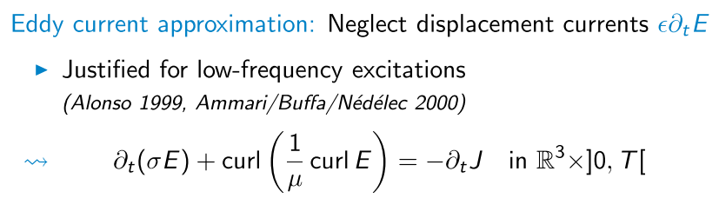

What is this saying? Start with (1.1.1),

curl H = ∂tD + J

Take time derivative of this thing (something I have never done?)

curl ∂tH = ∂t2D + ∂tJ

Use (1.1.2)

curl E = - ∂tB = -μ0∂tH => ∂tH = -(1/μ0) curl E

Insert into the above to get

curl [-(1/μ0) curl E ] = ∂t2D + ∂tJ

Then set J = σ E on the right

curl [-(1/μ0) curl E ] = ∂t2D + ∂t(σE)

So then I get

∂t(σE) + curl [(1/μ0) curl E ] = - ∂t2D

But his equation has a different right hand side! He gives a reference or two though. OK, he bases all the reset of his presentation on the main equation quoted above which I don't agree with. But here are his references:

I have found a PDF by Ammari et al that contains this equation, so let's switch to that. I was lucky to find this PDF online I think.

3. Ammari Buffa Nedelec.

This is in SIAM J Applied Math in 2000, so all this stuff is fairly recent. Maybe eddy currents is a harder problem that I thought it was. It is good to see others struggling with it even with fancy math tools.

They claim they will derive it so let's give it a shot:

ΩC = the conductor
Γ = the conductor boundary
Ωe = the space outside the conductor in which σ = 0
BR = a ball which contains everything of interest, radius R

J is referred to as "the source current" .

We have L2(Ωe) as usual space of functions over the insulator.
On the boundary Γ they define "classical Sobolev spaces of over -1/2", something of course I have never heard of.

Now finally we some equations: The very first one is trouble:

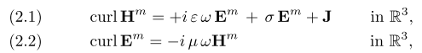

whereas I would say

curl H = iωεE + J

which sounds like my old "applied current" bugaboo. They say "m" means Maxwell, but they do not then clarify what they mean by the symbol J other than calling it "the source current". Should I think of this as the current that is my "distant left wire" which creates the field which makes the eddy current? If so, then the two terms J and εEm are never non-zero in the same place for me. So OK I will do the clarification:

σEm = Jc = the current in the conductor on the right

J = Js = the current in the "source" which is for me a ways off to the left.

In my own effort, I was thinking of a "source field Hs" whereas they want to think of a "source current Js " instead, which is just fine by me. One idea I guess is that somehow the goings on the right are not going to alter the source current Js so it is indeed "applied".
OK, given this partition of the current into two terms, I can start over as in the previous section, so this is my new statement of (1.1.1),

curl H = ∂tD + (σE) + Js

and if you were to ignore the displacement current, you would say

curl H = σE + Js which is their (2.4)

Take time derivative of the previous equation (something I have never done?)

curl ∂tH = ∂t2D + ∂t(σE) + ∂tJs

Use (1.1.2)

curl E = - ∂tB = -μ0∂tH => ∂tH = -(1/μ0) curl E

Insert into the above to get

curl [-(1/μ0) curl E ] = ∂t2D + ∂t(σE) + ∂tJs

So then I get

∂t(σE) + curl [(1/μ0) curl E ] = - ∂t2D - ∂tJs

NOW we ignore the displacement current (low ω) which is here in the - ∂t2D term, getting then

∂t(σE) + curl [(1/μ0) curl E ] ≈ - ∂tJs

and now we are finally on the same page. It looks messy, but maybe given Js you can solve for the desired electric field E. Not sure where they will go with this baby.
I then agree with their assessment of the low ω eddy current problem:

Eddy Current Model

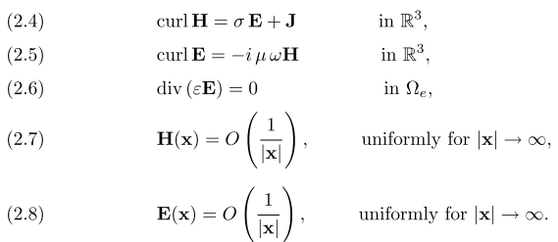

where their J is my Js.

They are then off on existence and well-posed proofs and "Hodge Decompositions" and so on.

Eventually in Section 5 they expand everything in a power series in ω, since they want to do low ω. They are then still talking about "well-posed".

4. Back to Harrach since I now understand his starting equation

I will quote a few lines that seem relevant

Page 7: This is the same equation from above where J is the source current: Note Lenz mention!

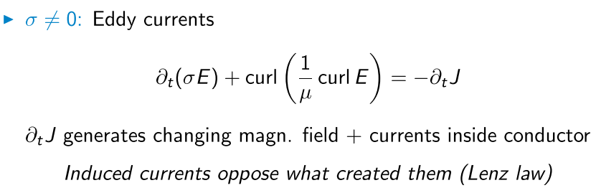

Then we have

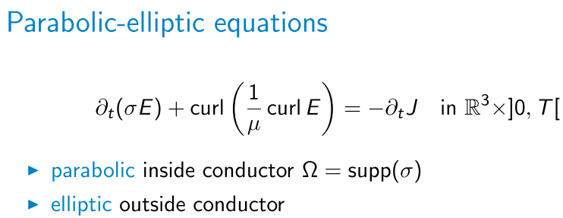

Let me try to explain this claim. We are staring here at a PDE with (x,y,z,t). Outside where σ = 0, you might use ∇ x (∇ x A) = ∇(∇•A) - ∇2A and div E = 0 (no charge) to get

curl curl E = - ∇2E

so then you have

- ∇2E = -∂tJs μ // outside, elliptic operator on left

which, being Laplace on the left, is a Laplace equation (vector) driven by the source shown, and the Laplace equation has all same derivative sign so it is elliptic.

Inside the conductor, I am not sure what is being claimed. Perhaps we can still say div E = 0 inside as I always do, then we have

∂t(σE)μ - ∇2E = -∂tJs μ // inside, parabolic operator on left

and yes, we then have a parabolic PDE operator on the LHS, I agree. He then gives an example which I don't understand, it is not explained, these are really slides of a talk.
He talks about the direct and the inverse problems. But not a single example of course.

My reading: In the conductor, if Js = 0 there which it is for me, I think the above is the good old Helmholtz equation inside the conductor for E . They are somehow linking this to the second problem which is outside the conductor, and of course these solutions have to meet at the boundary. This really is then sort of transmission line problem where I do have inside and outside solutions. Why don't they do some simple example perhaps with a bar of metal ??

5. wiki page http://en.wikipedia.org/wiki/Eddy_current

Might as well give this a gander. Interesting statements.

Eddy currents in conductors of non-zero resistivity generate heat as well as electromagnetic forces. The heat can be used for induction heating. The electromagnetic forces can be used for levitation, creating movement, or to give a strong braking effect. Eddy currents can also have undesirable effects, for instance power loss in transformers. In this application, they are minimized with thin plates, by lamination of conductors or other details of conductor shape.

Self-induced eddy currents are responsible for the skin effect in conductors.[4] The latter can be used for non-destructive testing of materials for geometry features, like micro-cracks.[5] A similar effect is the proximity effect, which is caused by externally induced eddy currents.[6]

Electrons cannot cross the insulating gap between the laminations and so are unable to circulate on wide arcs. Charges gather at the lamination boundaries, in a process analogous to the Hall effect, producing electric fields that oppose any further accumulation of charge and hence suppressing the eddy currents. The shorter the distance between adjacent laminations (i.e., the greater the number of laminations per unit area, perpendicular to the applied field), the greater the suppression of eddy currents.

Here then is their little "model" that might be useful:

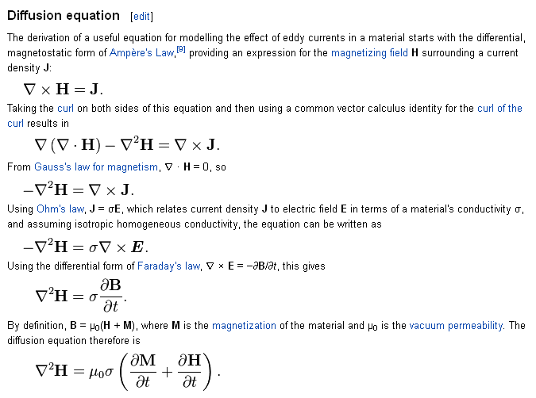

The first is my (1.1.1) ignoring displacement current. Here is how the third relates to me:

The B wave equation uses these steps :

curl H = ∂tD + J // Maxwell (1.1.1)

curl curl H = curl [∂tD] + curl J // curl both sides

grad div H - ∇2H = ε ∂t(curl E) + curl J // vector identity on left and D = εE

(1/μ)grad div B - ∇2H = εμ ∂t(-∂tH) + curl J // Maxwell (1.1.2) and B = μH twice

(∇2 - με ∂t2)H = - curl J // since div B = 0 (1.1.4)

If I were to throw out all the red terms ("ignore displacement current") I get their third equation.
Their 4th equation is fine then. Then I agree with the 5th equation as well , and then finally the last one as well where they bring in M. If M = 0, we get a parabolic equation for H! In these equations I guess that H is the total field (left plus right) and J is the total current, no Js separation. If M = 0 we have

∇2H = μ0σ jωH

and this is then just my usual Helm equation for H. Nothing new under the sun. Still no examples! But there are more referenced. Many interesting comments, like dropping a strong magnet down a copper tube.

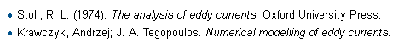

Looks like more books on the subject. I am having a lot of trouble finding anyone presenting any kind of example of a calculation! All just qualitative stuff. Here is someone who does something with "plates"

Siakavellas, N.J. ; Dept. of Mech. Eng., Patras Univ., Greece
"Two simple models for analytical calculation of eddy currents in thin conducting plates"
IEEE Transactions on Magnetics, vol. 33, issue 3, pp. 2245-2257 13 pages 1997

but of course I am blocked since it is IEEE. But Jim saved the day again. These are quite interesting and quite simple too, worth a look.

