Appendix Q Rewrite PhL 8.30.14

1. Notes on a model for R,G,L,C 1
2. Notes on computing large ω limits of things 6
3. Notes on computing low-ω limits of things 12
4. More Notes Made 9.2.14 16

I just realized that I take frequency limits in this appendix taking R,L,G,C all as constants, but that is totally the wrong thing to do in the real world!! So I want to go through App Q and make fixes as needed.

(a) Properties of k(ω)

The opening (Q.1) section is OK because no limits on ω are taken, no assumption is made about whether the four parameters are constants or functions of ω.

Fact (Q.2) is the high ω limit, and this is going to require work.

1. Notes on a model for R,G,L,C

_____________________________________________________________________

In the original appendix, I treat R,G,L,C as constants, independent of ω.

I know from my Belden appendix that this is a very bad assumption at higher frequencies certainly. So I guess my first task is to come up with "models" for the four parameters. I avoided doing this up to now, but I suppose I really should do this right!

Model for C: At all frequencies, I will treat C as a constant. That leaves G,R,L to worry about.

Model for G: The exact model is this: [ ε'd is the real part of εd ]

G = (σeff/εd) C where σeff = ( σd + ωε'd tanL)

Then

G = (1/εd)C [σd + ωε'd tanL] = Gdc + (εd'/εd) tanL C ω Gdc= (σd/εd) C

Should I maintain all this detail? Any good transmission line should have Gdc very small, such as is the case with Belden 8281. G only becomes an issue at higher ω. One thing I CAN do is absorb (εd'/εd) into tanL to have fewer symbols. Then

G = Gdc + (tanLC) ω

So the above line would be a find model for G.

Model for L and R: In App R I deal specifically with the coaxial cable. I first work at DC and there I compute the external inductance Le using the K formula. I don't think Le changes with ω very much, what changes is the distribution of the currents inside the two conductors and probably outside you can regard things as crudely constant. My whole Chap 4 is oriented to high ω anyway, so I think Le = $\frac{μ0}{4π}$ K is a fine model for Le at all ω. Meanwhile, I compute Li for each conductor at DC. But then if you look at Fig R.2, you see that, at all frequencies ω, you really could neglect Li relative to Le as a rough approximation. You could make some kind of combined model if you wanted. My high ω model is this for R and Li

R1 = $\frac{1}{σ(2πa1)δ}$ (2.4.18)
L1i = (1/ω) R1 = $\frac{1}{ωσ(2πa1)δ}$ = $\sqrt{2/ωμ0σ}$ = $\frac{1}{2πa1} \sqrt{\frac{μ0}{2σω}}$ . (2.4.19)

and similar equations for conductor #2. Let's write the above again as

L1i = $\frac{1}{2πa1}$ $\frac{μ0}{2σ}$ω-1/2 decreases with ω

R1 = ω L1i = $\frac{1}{2πa1}$ $\frac{μ0}{2σ}$ω+1/2 increases with ω

I think my generalizations of these equations to an arbitrary conductor #1 would be this

L1i = $\frac{1}{p1}$ $\frac{μ0}{2σ}$ω-1/2 decreases with ω

R1 = ω L1i = $\frac{1}{p1}$$\frac{μ0}{2σ}$ω+1/2 increases with ω

where p1 is the active perimeter of the cross section of conductor C1. Then adding we get

Li = ( $\frac{1}{p1}$ + $\frac{1}{p2}$) $\frac{μ0}{2σ}$ω-1/2 decreases with ω

R = ( $\frac{1}{p1}$ + $\frac{1}{p2}$) $\frac{μ0}{2σ}$ω+1/2 increases with ω κ = ( $\frac{1}{p1}$ + $\frac{1}{p2}$) $\frac{μ0}{2σ}$

dim check: dim(κ) = m-1 * (hen/m * ohm-m)1/2 = m-1 * (ohm-sec* ohm)1/2 = ohm/m * sec1/2 for κ
Then dim(Li) = ohm/m * sec1/2 sec1/2 = ohm-sec/m = henry/m = correct
Then dim(R) = ohm/m * sec1/2 sec-1/2 = ohm/m = correct

So I think this is a good model for Li and R at high ω. How high should ω be for this model to be viable? One approach is to say that δ << a1 and δ << a2 where the ai are the effective radii of the two conductors. That means, using δ ≡ $\sqrt{2/ωμσ}$,

$\sqrt{2/ωμσ}$ << ai

2/ωμ0σ << ai2

2 << (μ0σai2)ω

1 << (μ0σai2/2)ω

1/ω << (μ0σai2/2)

ω >> 2/( μ0σai2) ≡ ωi ok

What is this for the Belden case?

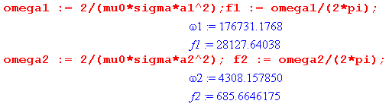

So for Belden we would use our high ω model as long as f >> 28 KHz and f > 685 Hz, where the inner conductor dominates the bound. For a power transmission line we would take the a2 case above but instead of a2 = .0025 m, we would use a2 = 1/2" = 1.27 cm = .0127 m so ωi will be smaller by the following ratio: (.0127/ .0025)2 = 5.082 =26. Then we would have

f2 = 686 Hz / 26 = 26 Hz

so a power line is in fact in the high ω limit more or less.

I would like some simple way to morph from high ω model to the DC model.

How about this very simple approximation:

R(ω) = Rdc + ( $\frac{1}{p1}$ + $\frac{1}{p2}$) $\frac{μ0}{2σ}$ω+1/2 = Rdc + κ ω+1/2 κ = ( $\frac{1}{p1}$ + $\frac{1}{p2}$) $\frac{μ0}{2σ}$

Probably it is inaccurate at low ω, but it is exact near ω = 0 and exact for ω >> ω1,2 and so maybe it is reasonable for all ω.
Here is another approach

R(ω) = Rdc θ(ω<ω1) + κ ω+1/2 θ(ω≥ω1) ω1 = (ω1+ ω2)/2 perhaps

where ω1 makes the two sides of the function match:

Rdc = κ ω1+1/2 => (Rdc/κ)2 = ω1 .

My model for Li(ω) is this

Li(ω) = Li,DC θ(ω < ωa) + κ ω-1/2 θ(ω ≤ ωa) ωa = (κ/ Li,DC)2

where the value ωa causes the two sides of the function to meet at Li,DC.

and then

L(ω) = Le + Li,DC θ(ω < ωa) + κ ω-1/2 θ(ω ≥ ωa)

For large ω, we get L(ω) ≈ Le in this model.

For small ω, we get L(ω) = Le + Li,DC in this model.

We know that

Le = μdK/(4π)

C = 4πεd/K

So we can express things in terms of C as follows:

C = 4πεd/K => K = 4πεd/C ok

Le = (μd/4π) K => Le = (μd/4π) 4πεd/C = (μdεd)/C = 1/(vd2C) ok

Gdc = 4πσd/K = 4πσd C / 4πεd = (σd/εd)C ok

or

Le = 1/(vd2C)

Gdc = (σd/εd)C

dim(1/RHS1) = m2/sec2* far/m = far/sec2 * m = m/hen = correct
dim(RHS2) = mho/m * m/far * far/m = mho/m = correct

Summary of my proposed model:

C(ω) = C

G(ω) = Gdc + (tanLC) ω Gdc = (σd/εd) C

R(ω) = Rdc θ(ω<ω1) + κ ω+1/2 θ(ω≥ω1) κ = ( $\frac{1}{p1}$ + $\frac{1}{p2}$) $\frac{μ0}{2σ}$ ω1 = (Rdc/κ)2

L(ω) = Le + Lidc θ(ω < ω0) + (κ/$\sqrt{ω}$) θ(ω ≥ ω0) ω0 = (κ/ Li,DC)2

Notes:

1. For a good transmission line, one has σd ~ 10-15 so Gdc is very small and can be neglected except very close to ω = 0, more specifically, for ω ≤ σd/(εdtanL).

2. Lidc = μ0/(4π) for both conductors being round wires. For other cross sectional shapes, this expression is approximately valid. See ****.

3. Parameter pi is the length of the active perimeter of conductor i, see ****.

4. μ0 has been assumed inside the conductors.

Now restate using C wherever possible:

C(ω) = C

G(ω) = (σd/εd) C + (tanLC) ω
R(ω) = Rdc θ(ω<ω1) + κ ω+1/2 θ(ω≥ω1) κ = ( $\frac{1}{p1}$ + $\frac{1}{p2}$) $\frac{μ0}{2σ}$ ω1 = (Rdc/κ)2

L(ω) = 1/(vd2C) + Lidc θ(ω < ω0) + (κ/$\sqrt{ω}$) θ(ω ≥ ω0) ω0 = (κ/ Li,DC)2

I want a better symbol for (σd/εd) which has dimensions:

dim(σd/εd) = mho/m // farad/m = mho/m * m/far = mho/far = 1/(far-ohm) = 1/sec

Lets then define

ωd ≡ σd/εd // all DC

Then we have

C(ω) = C

G(ω) = ωd C + (tanLC) ω = C ( ωd + tanL ω )
R(ω) = Rdc θ(ω<ω1) + κ ω+1/2 θ(ω≥ω1) κ = ( $\frac{1}{p1}$ + $\frac{1}{p2}$) $\frac{μ0}{2σ}$ ω1 = (Rdc/κ)2

L(ω) = 1/(vd2C) + Lidc θ(ω < ω0) + (κ/$\sqrt{ω}$) θ(ω ≥ ω0) ω0 = (κ/ Li,DC)2

Right away I want to think about small and high ω limits of these results,

2. Notes on computing large ω limits of things

high ω:

C(ω) = C
G(ω) = C ( ωd + tanL ω )
R(ω) = κ ω+1/2
L(ω) = 1/(vd2C) + κ ω-1/2

(R2+ω2L2) = κ2 ω + ω2 [1/(vd2C) + κ ω-1/2]2

≈ ω2 1/(vd2C)2

(G2+ω2C2) = [(σd/εd) C + (tanLC) ω]2+ω2C2 ≈ ω2C2(1 + tanL2) ≈ ω2C2

We then know that

a2 = |k|2 = [(R2+ω2L2)(G2+ω2C2)]1/2

= ω /(vd2C) * ωC = ω2/vd2
and
a = |k| = ω/vd as expected

Let's now have Maple do the high ω limit of things: I call the maple file q2.mws, and here are my results.

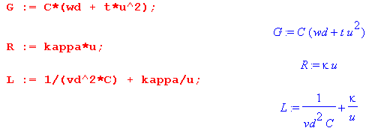
I am using u = $\sqrt{ω}$ . Now I first compute a , I convert it to a series in small u, and then I take that result for small t. Here are some results. First, here is a:

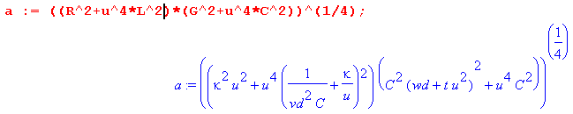

Then here is the series for a, which I call a1:

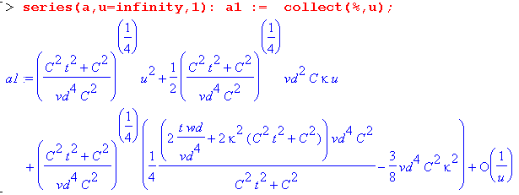

which you see has the form a1 = Au2 + Bu + C + O(1/u). I then take each of the three leading terms, simplify the term, then get a series for small t,

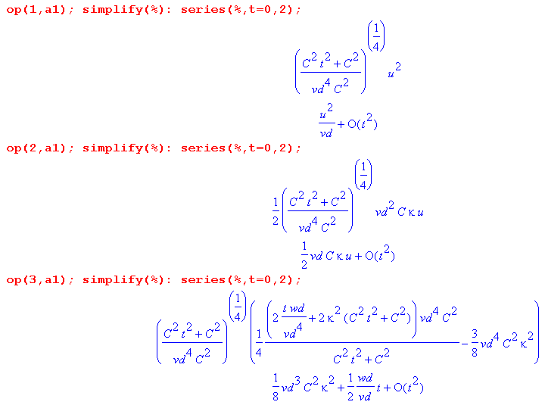
My result for a is then

a = (1/vd)ω + (1/2)vdCκ $\sqrt{ω}$ + [ (1/8) vd3(Cκ)2 + (1/2) (ωd/vd) t]

It seems save to ignore the term here that is constant in ω, so then

|k| = a ≈ (1/vd)ω + (1/2)vdCκ $\sqrt{ω}$

and this then gives some idea as to the correction for the expected leading term ω/vd.

Next, I consider Re(k):

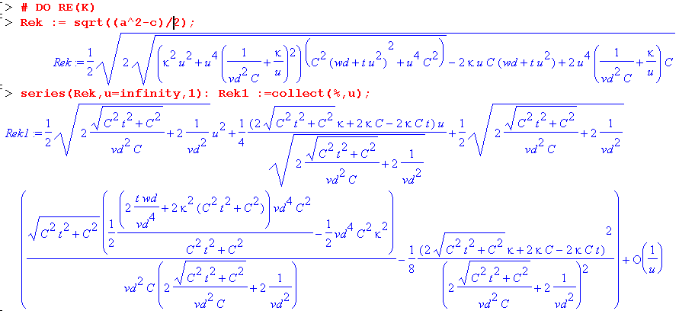

It is a mess, but now again I take each term, simplify it, then take the small t limit. I have to display the ops because sometimes the ops are wrong.

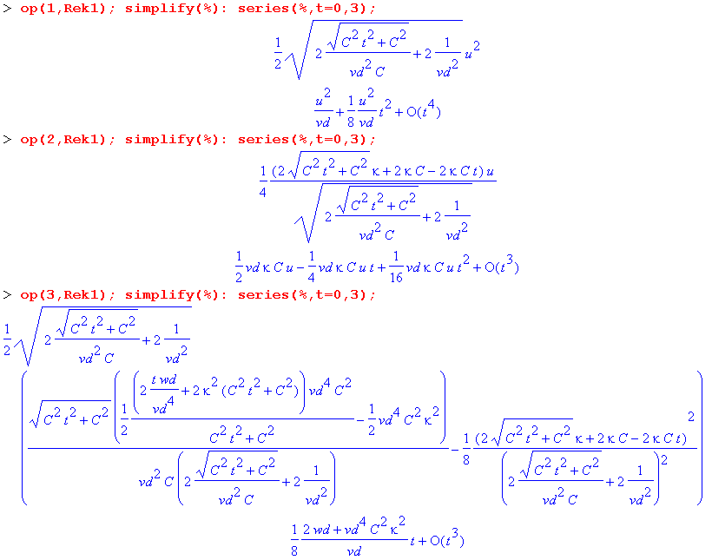
Thus, my result is (since t << 1)

Re(k) ≈ ω/vd + (1/2)vdκC $\sqrt{ω}$ + (1/8vd) (2 ωd + κ2vd4C2) tanL + O(1/$\sqrt{ω}$)

= Aω + B$\sqrt{ω}$ + C + O(1/$\sqrt{ω}$)

The leading term is as expected, but now you see some of the lower terms as well.

I then treat Imk the same way

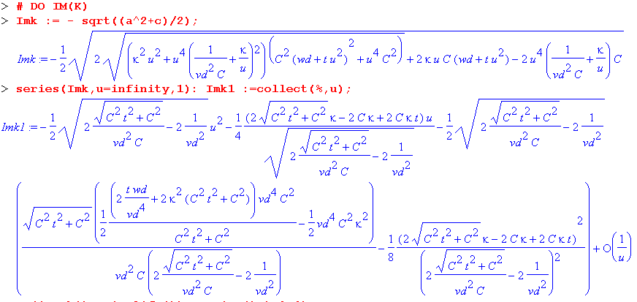

Then here are the series

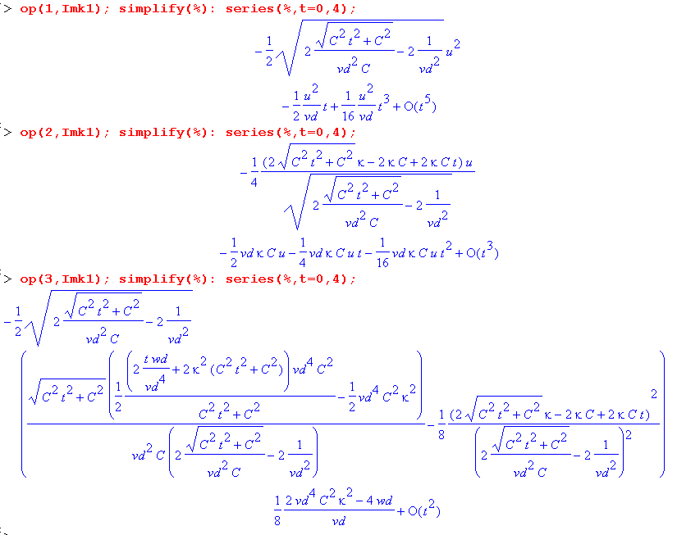
and then I can read off the result

Im(k) = - (1/2vd) ω tanL - (1/2)vdCκ $\sqrt{ω}$ - (1/2vd) (ωd - vd4C2κ2/2)

This result seems wrong since Im(k) should be negative!

Summary of the large ω limit of k(ω): // This is the new (Q.2) I suppose.

Re(k) ≈ ω/vd + (1/2)vdκC $\sqrt{ω}$ + (1/8vd) (2 ωd + κ2vd4C2) tanL + O(1/$\sqrt{ω}$)

Im(k) = - (1/2vd) ω tanL - (1/2)vdCκ $\sqrt{ω}$ - (1/2vd) (ωd - vd4C2κ2/2) + O(1/$\sqrt{ω}$)

These are completely new results for Appendix Q. They are completely different from the results I got in my original Appendix Q !!! If I just keep the leading terms,

Re(k) ≈ (ω/vd) the usual result

Im(k) = - (1/2)(ω/vd) tanL perhaps this is something new.
_______________________________________________________________________

3. Notes on computing low-ω limits of things

low ω:

Start again with

C(ω) = C

G(ω) = ωd C + (tanLC) ω = C ( ωd + tanL ω )
R(ω) = Rdc θ(ω<ω1) + κ ω+1/2 θ(ω≥ω1) κ = ( $\frac{1}{p1}$ + $\frac{1}{p2}$) $\frac{μ0}{2σ}$ ω1 = (Rdc/κ)2

L(ω) = 1/(vd2C) + Lidc θ(ω < ω0) + (κ/$\sqrt{ω}$) θ(ω ≥ ω0) ω0 = (κ/ Li,DC)2

Then for low ω we get

G(ω) = C ( ωd + tanL ω )

R(ω) = Rdc

L(ω) = 1/(vd2C) + Lidc

I made a copy and paste version of the Maple file which is Q2 lo omega k. First, I do a:

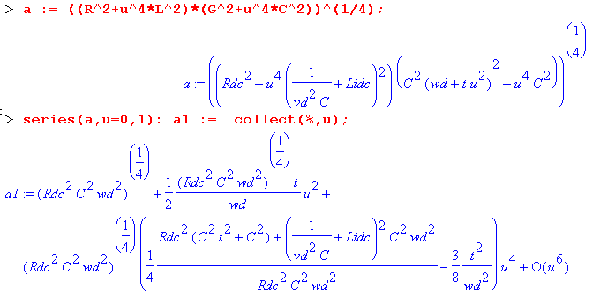
Then the t series,

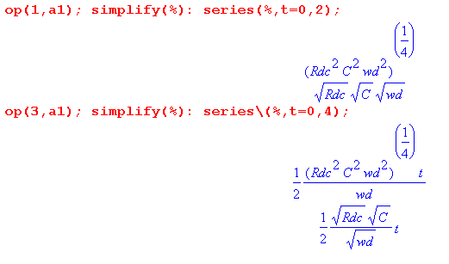

I conclude then that

a = $\sqrt{RdcCωd}$ + (1/2) $\sqrt{RdcC/ωd}$ t ω + O(ω2)

Next comes Re(k):

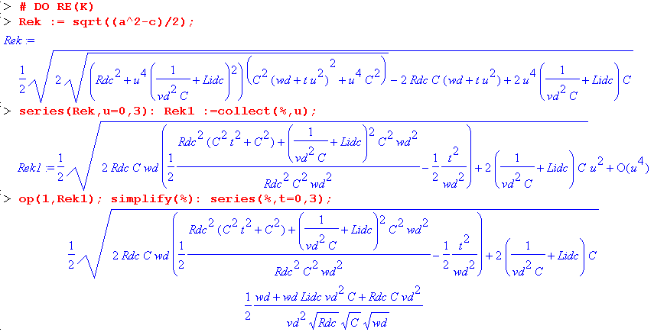

Here you see that Re(k) = A ω + B ω2 so I just keep the leading term to get [ there is no constant term!]

Re(k) = (ω/2) (ωd + ωdLidcvd2C + RdcC vd2) / ( vd2$\sqrt{RdcCωd}$ ) ω

or
Re(k) = (ω/2) (ωd + C vd2[Rdc + ωdLidc] ) / ( vd2$\sqrt{RdcCωd}$ )

This is similar to my G > 0 result (Q.3) but not the same.

Now for the Imaginary part:

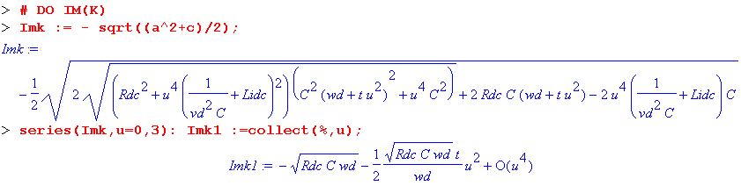

I can then just read off

Im(k) ≈ - $\sqrt{RdcC ωd}$ - (1/2ωd) $\sqrt{RdcC ωd}$ tanL ω + O(ω2)

Summary for low ω:

Re(k) = (ω/2) (ωd + C vd2[Rdc + ωdLidc] ) / ( vd2$\sqrt{RdcCωd}$ ) + O(ω2)

Im(k) ≈ - $\sqrt{RdcC ωd}$ - (1/2ωd) $\sqrt{RdcC ωd}$ tanL ω + O(ω2)

There have the form

Re(k) = Aω + O(ω2)
Im(k) = A + Bω + O(ω2)

Now recall that ωd ≡ σd/εd . For a non-conducting dielectric, we have σd = 0 so ωd = 0 and then my results are singular. I will run them again for this special case. First

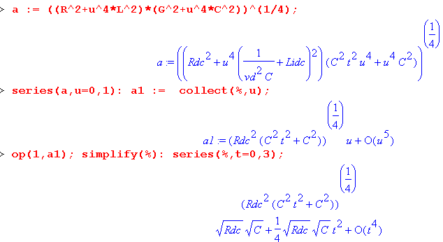

So we end up with

a = $\sqrt{RdcC}$ $\sqrt{ω}$ + O(ω5/2)

Next comes Re(k)

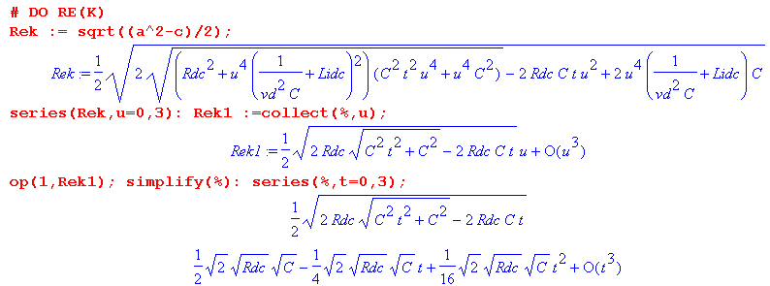

So the result here is

Re(k) = $\sqrt{RdcC/2}$ $\sqrt{ω}$ + O(ω3/2)

Next,

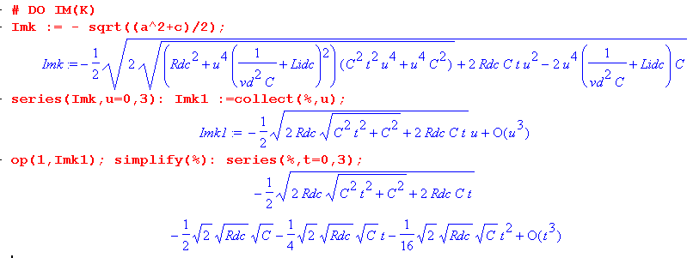

and the result is

Im(k) = - $\sqrt{RdcC/2}$$\sqrt{ω}$ + O(ω3/2)

and then for ωd = 0 we find that

Re(k) = $\sqrt{RdcC/2}$ $\sqrt{ω}$ + O(ω3/2)

Im(k) = - $\sqrt{RdcC/2}$$\sqrt{ω}$ + O(ω3/2)

and this in fact agrees with (Q.4), though I don't have the coefficient here of ω3/2 .

This concludes my efforts to evaluate k(ω) for large ω and then for small ω.

4. More Notes Made 9.2.14

In "math mystery" doc I have pondered the issue of ωd → 0 and Gd → 0 and problems this causes in my analysis. The situations in which this limit might arise would be when the dielectric is a perfect vacuum. In the case of an air dielectric, I now realize that air has some finite conductivity,

http://chemistry.about.com/od/moleculescompounds/a/Table-Of-Electrical-Resistivity-And-Conductivity.htm

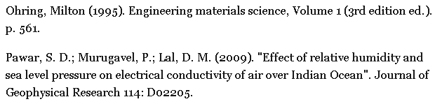

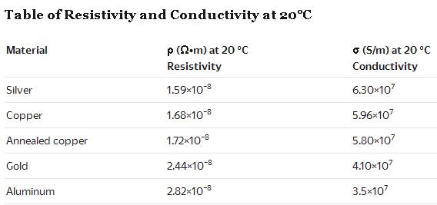
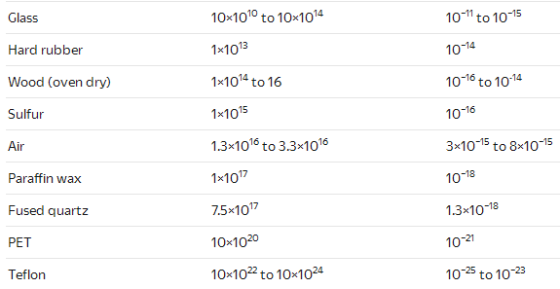

I know that PE is about 10-15 and air is seen to be in that same ballpark. So even an air dielectric conducts at room temperature to this 10-15 extent. You see above that ideal PET and ideal teflon are much better insulators getting to 10-24 or so.

I think therefore that when doing a low ω limit for a practical transmission line, even with PE and Belden we would use the ωd > 0 version of things. In particular for PE or air,

ωd ≡ (σd/εd) = 10-15 / 8.8541877 x 10-12 = 1000/8.85 = 113 for PE dielectric

fd = ω/2π = 18 Hz.

Thus I get ωd = 113 and not some super small number like 10-10 say.

