This was installed into lines doc on 9/9/14, after the previous App Q was archived.

Appendix Q; Properties of the functions k(ω) and Z₀(ω) 2
Q.1 A Simple Model for R, L, G and C 2
Q.2 Real and Imaginary parts of k(ω) 9
Q.3 Large ω limit of k(ω) 11
Q.4 Small ω limit of k(ω) 15
Q.5 The general appearance of Re(k) and Im(k) for Belden 8281 cable 19
Q.6 Real and Imaginary parts of Z₀(ω) 24
Q.7 Large ω limit of Z₀(ω) fix this replacing sign σ by sign S 26
Q.8 Small ω limit of Z₀(ω) 30
Q.9 The general appearance of Re(Z₀) and Im(Z₀) for Belden 8281 cable 35

Appendix Q: Properties of the functions k(ω) and Z0(ω)

The two functions of interest are,

k = -j$\sqrt{zy}$ = -j $\sqrt{(R+jωL)(G+jωC)}$ (5.3.5) (K.7)

Z0 = $\frac{z}{y}$ = $\frac{R + jωL}{G + jωC}$ . (4.11.16) (K.4)

These expressions for k and Z0 were derived from both the "physics model" of Chapters 4 and 5 and the network model of Appendix K, with equations numbers shown above. The expressions are valid for all ω in the network model, but in the physics model they were derived only in the skin effect regime, though we might have some expectation that the expressions are approximately valid for low ω.

The four parameters R,L,G and C are by definition all real numbers. For example, in the physics model R is defined to be the real part of z and ωL the imaginary part. In the k and Z0 sections below, our first task shall be to compute the real and imaginary parts of k and Z0. We shall then be interested in the large ω and small ω limits of these expressions. In order to compute these limits properly, we must remember that the four real parameters R,L,G and C are in general functions of ω and cannot be treated as constants. This requires that we construct some kind of model for these parameters as functions of ω, and that is the task of the following section.

Q.1 A Simple Model for R, L, G and C

The model considered here is just an ad hoc "reasonable" model which is accurate at high and low frequencies and which bridges the gap in a crude manner just so we have something to work with. We shall assume that C and Le are the constants appearing in (4.11.34), namely

C = 4πεd/K capacitance per meter
Le = $\frac{μd}{4π}$ K external inductance per meter
Gdc = 4πσd/K DC conductance per meter

where K is the constant defined also in (4.11.34). The conductance has a dc subscript because σd is the DC conductivity of the transmission line dielectric.

Model for C

We assume C to be the constant value shown above, so

C(ω) = C = 4πεd/K = independent of ω (Q.1.1)

Model for G

Recall first from (3.3.2) and (3.3.4) that

σeff = ( σd + ωε'd tanL) where tanL ≡ (ε"d/ε'd) and εd = ε'd - jε"d .

This σeff is the effective conductivity of a dielectric whose dielectric constant has an imaginary part. The dielectric burns energy just as if the loss were all simple ohmic loss. From (4.11.34) we then have

G = (σeff/εd)C = ( σd + ωε'd tanL)C/εd = (σd/εd)C + (ε'd/εd) tanL ωC

= Gdc + (ε'd/εd) tanL ωC

where recall that tanL is the so-called loss-tangent or dissipation factor of the dielectric. Clearly G has a strong dependence on ω, being a linear function of ω. Normally (ε'd/εd) ≈ 1 since ε"d and tanL are normally very small. Rather than set (ε'd/εd) = 1, we just absorb this factor into the definition of tanL and then write G(ω) in this simpler form,

G(ω) = Gdc + (C tanL) ω where Gdc = (σd/εd)C . (Q.1.2)

Since (σd/εd) has the dimensions sec-1 it is convenient to rewrite the above G(ω) as

G(ω) = C (ωd + tanL ω ) ωd ≡ (σd/εd) (Q.1.3)

This then is our working model for the frequency-dependent real parameter G(ω). The interpretation of ωd is straightforward. If one constructs a parallel plate capacitor with area A, separation s, dielectric constant εd and dielectric conductivity σd, one finds that R = s/(σdA) and C = Aεd/s so that RC = εd/σd which is the discharge time constant τd for such a capacitor. Then ωd = 1/τd.

Examples:

1. A perfect vacuum dielectric has σd = 0 so both ωd = (σd/εd) = 0 and tanL = 0, resulting in G(ω) = 0. This situation with ωd = 0 presents special problems noted below.

2. As excellent low-conductivity dielectrics, both polyethylene and air have σd ~ 10-15 mho/m. For such dielectrics one finds that

ωd = σd/εd ≈ 10-15/ 8.85 x 10-12 = 10-3/8.85 = (10/8.85) x 10-4 = 1.13 x 10-4 sec-1

As will be seen below, our low-ω limits are only valid for ω < ωd and are thus in fact "very low ω" limits. This is fine, since we are interested in what happens as ω→ 0.

3. The loss tangent for the polyethylene used in Belden 8281 coaxial cable has tanL ≈ .0005 and this can be regarded as a typical value for tanL.

Model for L and R

Recall from Chapter 2 these expressions for the high-frequency resistance and internal inductance of a round wire of radius a1 ,

R1 = $\frac{1}{σ(2πa1)δ}$ δ ≡ $\sqrt{2/ωμσ}$ (2.4.18)
L1i = (1/ω) R1 = $\frac{1}{ωσ(2πa1)δ}$ = $\sqrt{2/ωμσ}$ = $\frac{1}{2πa1} \sqrt{\frac{μ}{2σω}}$ . (2.4.19)

These are for conductor C1 and similar expressions apply to conductor C2 for a transmission line of the type considered in Chapter 6. Note that σ and μ are parameters of the conductor, not the dielectric. We can rewrite the above equations in this manner

L1i = $\frac{1}{2πa1}$ $\frac{μ}{2σ}$ω-1/2 decreases with ω
R1 = $\frac{1}{2πa1}$ $\frac{μ}{2σ}$ω+1/2 = ω L1i . increases with ω (Q.1.4)

We now generalize these results for an arbitrary conductor C1 as follows

L1i = $\frac{1}{p1}$ $\frac{μ}{2σ}$ω-1/2 decreases with ω
R1 = ω L1i = $\frac{1}{p1}$$\frac{μ}{2σ}$ω+1/2 increases with ω (Q.1.5)

where p1 is the "active perimeter" distance around the cross section of the conductor, as mentioned in the text near (4.11.10). Recall that surface impedance Zs1(θ) = R1(θ) + ωL1i(θ) but we average these quantities over θ to get the above results, as discussed in Section 4.11 (b). For widely spaced thin wires (or a centered coaxial cable), the active perimeter of a round wire is the full perimeter so p1 = 2πa1, but the active perimeter is much less than the total perimeter for a pair of closely spaced conductors such as shown in Fig 4.12. We regard the generalization (Q.1.5) as being "reasonable" if not precise. Summing over the two conductors of our transmission line, we then find for large ω that

Li = ( $\frac{1}{p1}$ + $\frac{1}{p2}$) $\frac{μ}{2σ}$ω-1/2 ≡ κ ω-1/2 κ ≡ ( $\frac{1}{p1}$ + $\frac{1}{p2}$) $\frac{μ}{2σ}$

R = ( $\frac{1}{p1}$ + $\frac{1}{p2}$) $\frac{μ}{2σ}$ω+1/2 ≡ κ ω+1/2 . dim(κ) = ohm/m * sec1/2 (Q.1.6)

In order to crudely blend these expressions down into the low ω region, we write

R(ω) = Rdc θ(ω<ωR) + (κ $\sqrt{ω}$) θ(ω≥ωR) ωR ≡ (Rdc/κ)2

Li(ω) = Lidc θ(ω<ωL) + (κ/$\sqrt{ω}$) θ(ω≥ωL) ωL ≡ (κ/ Lidc)2 (Q.1.7)

where θ(bool) = 1 if bool = true, else 0. Here Rdc = 1/(σA1) + 1/(σA2) is the total DC resistance of the two conductors of cross sectional area An, while Lidc is the total DC internal inductance. Examples of computing the latter appear in Appendix C. For a round wire, Li = μ/8π, so for a pair of same, Lidc = μ/4π henry/m.

Using parameters shown in Appendix R for Belden 8281 coaxial cable, we may plot R(ω) and Li(ω) for our crude model. First, the two expressions are entered into Maple (using w for ω),

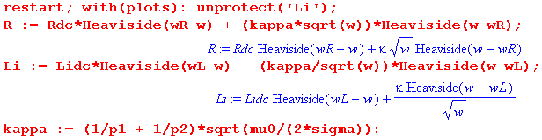

followed by parameters for the Belden cable obtained in Appendix R,

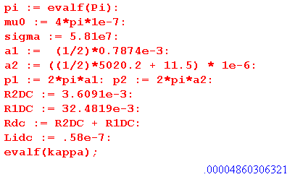

The two blending frequencies are computed,

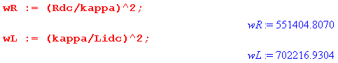
and are seen to be in the 1 MHz range. Finally, here are plots for R and Li versus ω for a very wide range of ω: ω = 1 to ω = 1010 ,

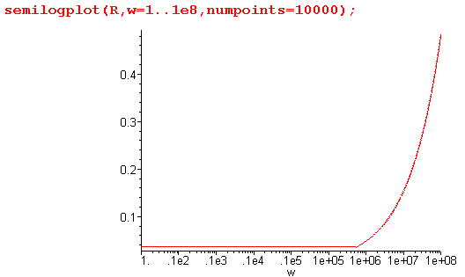 Fig Q.1.1

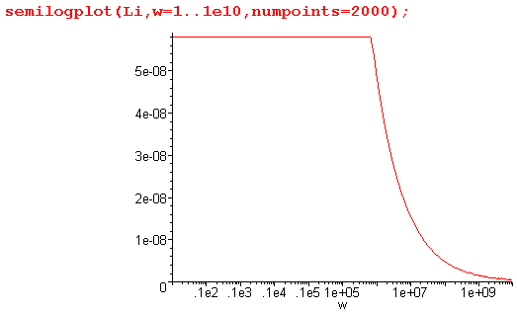 Fig Q.1.2
which duly show the resistance increasing as $\sqrt{ω}$ and internal inductance decreasing as 1/$\sqrt{ω}$ . It would not be difficult to provide a smooth blending function to remove the sharp corners from these plots, but since our main interest is in very large and very small ω, we leave things as is (but see below).

The final step is to add in the external inductance Le so our model for R(ω) and L(ω) is then

R(ω) = Rdc θ(ω<ωR) + (κ $\sqrt{ω}$) θ(ω≥ωR) ωR ≡ (Rdc/κ)2

L(ω) = Le + Lidc θ(ω<ωL) + (κ/$\sqrt{ω}$) θ(ω≥ωL) ωL ≡ (κ/ Li,DC)2 . (Q.1.8)

For the Belden cable example Le = 0.37 μH/m = 3.7 x 10-7 H/m, giving this plot for L(ω) versus ω:

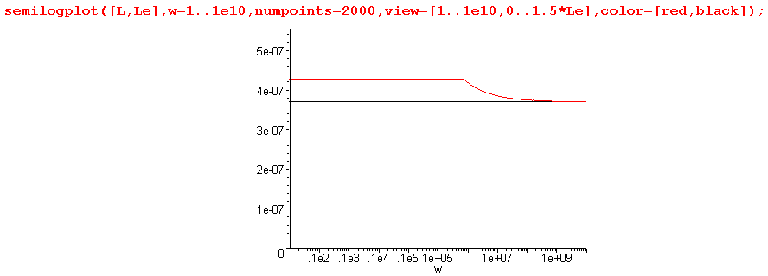
Fig Q.1.3

L(ω) is shown in red, while Le is shown in black. This last plot shows that Le is really the dominant term in L(ω) at all ω. More magnetic energy is stored in the dielectric than inside the conductors. So:

Simple Transmission Line Parameter Model (Q.1.9)
C(ω) = C = independent of ω κ ≡ ( $\frac{1}{p1}$ + $\frac{1}{p2}$)$\frac{μ}{2σ}$

G(ω) = C (ωd + tanL ω ) ωd ≡ (σd/εd) Gdc ≡ ωd C

R(ω) = Rdc θ(ω<ωR) + (κ $\sqrt{ω}$) θ(ω≥ωR) ωR ≡ (Rdc/κ)2

L(ω) = Le + Lidc θ(ω<ωL) + (κ/$\sqrt{ω}$) θ(ω≥ωL) ωL ≡ (κ/ Lidc)2

LeC = μdεd = 1/vd2 (4.11.34)

The last line shows that Le has a simple relation to C in terms of the dielectric speed of light vd. The two pi are the active perimeters of the conductors, μ and σ are for the conductors, and σd, εd and μd are for the dielectric. Rdc and Lidc are the DC resistance and internal inductance total for the two conductors.

How Good is this Crude Model?

Recall that R and ωLi are the real and imaginary parts of the total (mean) surface impedance Zi of the two transmission line conductors. For the Belden coaxial cable example, the central conductor is in a symmetric environment and for that situation we have an exact expression for Zi from (2.4.6),

Zs(ω) = $\frac{-jωμ}{2πaβ}$ $\frac{J0(βa)}{J1(βa)}$ β2 = -jωμσ . (2.4.6)

We do not have an exact expression for the surface impedance of the shield, but based on the high and low ω numbers shown in Appendix R, we can roughly account for the shield by adding 15% to the above central conductor function, resulting in a function for the total Zi(ω) which is a smooth function of ω. We can then plot this function and compare it with our simple Heaviside model presented above, again for the Belden 8281 example. First, here is the "smooth 115% model" followed by the "crude Heaviside model",

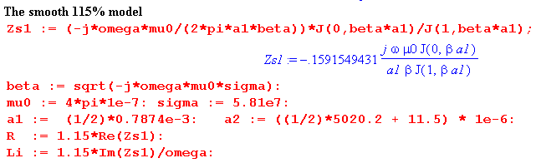

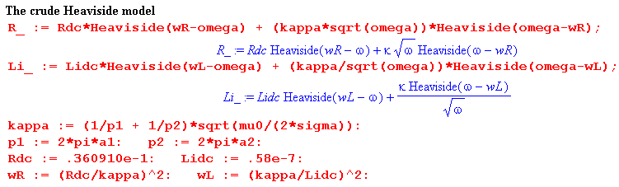

And here are "side by side" plots of R and Li for the two models for ω = 104 to 108 ,

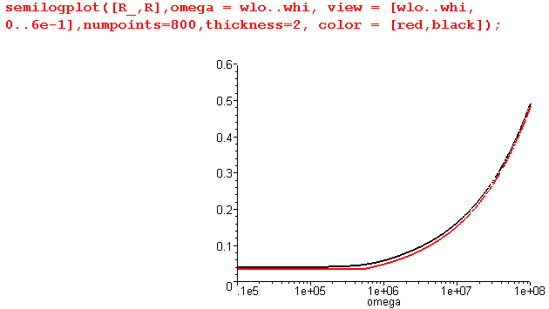 Fig Q.1.4

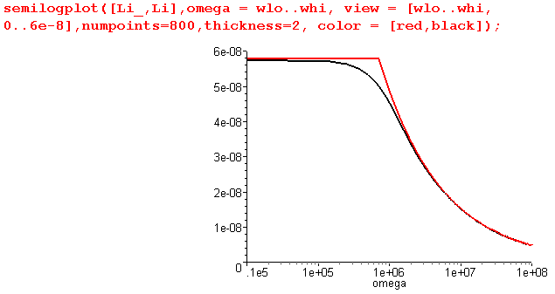 Fig Q.1.5

Below ω = 104 and above ω = 108 the two models are in very close agreement, and the smooth model (black) then shows what the correct interpolation of the crude Heaviside model (red) might look like. The Heaviside model we think gives the essence of the behavior of R and Li versus ω.

Reader Exercise: Using the methods of Chapter 2, develop an expression for Zi (like (2.4.6) quoted just above) which applies to the sheath of a coaxial cable. Verify against data presented in Appendix R. The DC limit should agree with (C.6.6) and the large-ω limit with (Q.1.5). Perhaps assume t << a2.

Q.2 Real and Imaginary parts of k(ω)

Fact 1: The real + imaginary decomposition of k is given by (Q.2.1)
k = $\frac{a2-c}{2}$ - j $\frac{a2+c}{2}$ k ≡ -j $\sqrt{(R+jωL)(G+jωC)}$
jk = $\frac{a2+c}{2}$ + j $\frac{a2-c}{2}$ jk = $\sqrt{zy}$= $\sqrt{(R+jωL)(G+jωC)}$

where
a ≡ [(R2+ω2L2)(G2+ω2C2)]1/4 = |k| dim(a) = 1/m a > 0

c ≡ RG - ω2LC dim(c) = 1/m2 c = real, |c| < a2

Proof of Fact 1: Let

q ≡ zy = (R+jωL)(G+jωC) = (RG-ω2LC) + jω(LG+RC) = c + jω(LG+RC) = |q| ejθ

=> |q|2 = | (R+jωL)(G+jωC) |2 = | (R+jωL)|2|(G+jωC) |2 = (R2+ω2L2) (G2+ω2C2) ≡ a4

|q| = a2

cosθ = Re(q) /|q| = c/a2

Now write

s ≡ $\sqrt{zy}$ = $\sqrt{(R+jωL)(G+jωC)}$ = $\sqrt{q}$ = |s| eiφ |s| = $\sqrt{|q|}$ = a φ = θ/2
Re(s) = |s| cosφ = a cos(θ/2) = a $\sqrt{(1 +cosθ)/2}$ = (a/$\sqrt{2}$)$\sqrt{1+c/a2}$ = $\frac{a2+c}{2}$
Im(s) = |s| sinφ = a sin(θ/2) = a $\sqrt{(1 -cosθ)/2}$ = (a/$\sqrt{2}$)$\sqrt{1-c/a2}$ = $\frac{a2-c}{2}$
s = $\sqrt{zy}$ = $\frac{a2+c}{2}$ + j $\frac{a2-c}{2}$
k = -j$\sqrt{zy}$ = -js = $\frac{a2-c}{2}$ - j $\frac{a2+c}{2}$ QED

Maple verification:

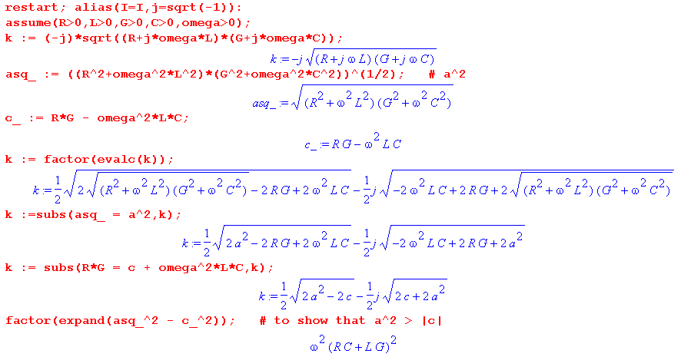

Q.3 Large ω limit of k(ω)

The model of box (Q.1.9) at large ω reads, using Le = 1/(Cvd2),

G(ω) = C (ωd + tanL ω ) ωd ≡ (σd/εd)

R(ω) = κ $\sqrt{ω}$
L(ω) = 1/(Cvd2) + (κ/$\sqrt{ω}$) . κ ≡ ( $\frac{1}{p1}$ + $\frac{1}{p2}$)$\frac{μ}{2σ}$ (Q.3.1)
Defining t ≡ tanL these expressions are,

G = C(ωd + t ω) R = κ$\sqrt{ω}$ L = 1/(Cvd2) + κ/$\sqrt{ω}$ . (Q.3.2)

We duly enter the expressions into Maple (using w for ω)

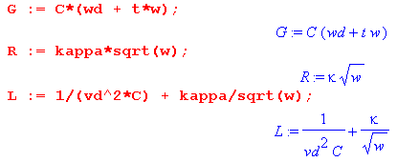

followed by the intermediate variables a and c from box (Q.2.1),

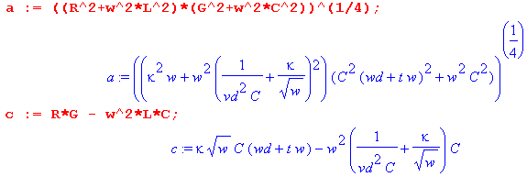

The real part of k(ω) is then given from (Q.2.1) as follows:

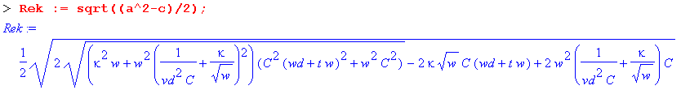

The asymptotic expansion of Re(k) for large ω is then found to be,

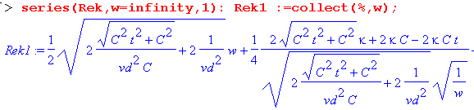

which has the form Aω + B$\sqrt{ω}$+ C + D/$\sqrt{ω}$ + O(1/ω), but we have not displayed the C and D terms since they are quite complicated. Maple next processes the terms by first simplifying them, then expanding them in small parameter t. That is, we now regard t ≡ tanL << 1. The results are :

Maple notes: (1) The nth term in the Rek1 series can be accessed as op(n,Rek1); (2) Maple displays the output of a command terminated by a semicolon, but suppresses the output if terminated by a colon; (3) in the series command, the second argument gives the variable and point of expansion, the third the number of terms; (4) symbol % always refers to the last thing computed.

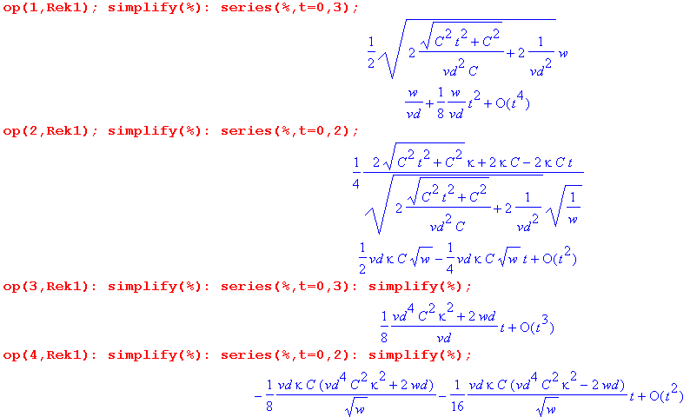
Although we have suppressed the last two "op" expressions, we did verify that they were the correct terms in the series. Maple sometimes orders series in strange ways but here the ordering was as expected.

Collecting the results and keeping only the leading terms in t = tanL, the resulting large ω limit for Re(k) is seen to be,

Re(k) ≈ (ω/vd) + (1/2)vdκC $\sqrt{ω}$ + (1/8vd)( vd4C2κ2 + 2ωd) tanL + O(1/$\sqrt{ω}$) (Q.3.3)

where we have ignored the details of the O(1/$\sqrt{ω}$) term.

Treating Im(k) in the same manner one finds,

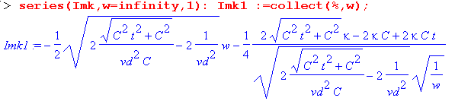

Once again the series has the form Aω + B$\sqrt{ω}$+ C + D/$\sqrt{ω}$ + O(1/ω), but we have not displayed the C and D terms since they are complicated. Expanding each series term for small t gives

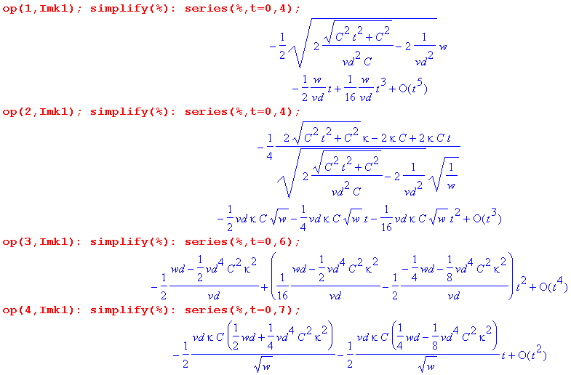
Collecting the results and keeping only the leading terms in t = tanL, the resulting large ω limit for Im(k) is seen to be,

Im(k) ≈ - (ω/vd) tanL/2 - (vdκC/2) $\sqrt{ω}$ - (1/2vd)(ωd - vd4C2κ2/2) + O(1/$\sqrt{ω}$) (Q.3.4)

where we have again ignored the details of the O(1/$\sqrt{ω}$) term. We now summarize these results :

Fact 2: The large ω asymptotic expansion for k(ω), assuming tanL << 1, is given by (Q.3.5)

Re(k) ≈ (ω/vd) + (vdκC/2) $\sqrt{ω}$ + (1/4vd)(ωd +vd4C2κ2/2) tanL + O(1/$\sqrt{ω}$)
Im(k) ≈ - (ω/vd) tanL/2 - (vdκC/2) $\sqrt{ω}$ - (1/2vd)(ωd - vd4C2κ2/2) + O(1/$\sqrt{ω}$)

where κ ≡ ( $\frac{1}{p1}$ + $\frac{1}{p2}$)$\frac{μ}{2σ}$ and ωd ≡ (σd/εd)

Keeping only the leading terms for large ω,

Re(k) ≈ (ω/vd) vd = 1/$\sqrt{LeC}$ ≈ 1/$\sqrt{LC}$
Im(k) ≈ - ω tanL /(2vd)

The leading term Re(k) = ω/vd is the usual result obtained from taking the large ω limit of the expression k = -j$\sqrt{(R+jωL)(G+jωC)}$ when the four parameters are treated as constants in ω,

k = -j$\sqrt{(R+jωL)(G+jωC)}$ ≈ -j $\sqrt{(jωL)(jωC)}$ = (-j)(j)ω$\sqrt{LC}$ = ω$\sqrt{LC}$ ≈ ω$\sqrt{LeC}$ = ω/vd .

This fact is obvious from the large-ω model stated in (Q.3.1) which we repeat here:

G(ω) = C (ωd + tanL ω ) ωd ≡ (σd/εd)

R(ω) = κ $\sqrt{ω}$
L(ω) = 1/(Cvd2) + (κ/$\sqrt{ω}$) . κ ≡ ( $\frac{1}{p1}$ + $\frac{1}{p2}$)$\frac{μ}{2σ}$ (Q.3.1)
Since tanL << 1 one has for large ω,

G + jωC = C (ωd + tanL ω) + jωC = C ωd + ωC( tanL + j) ≈ ωCj = jωC
R + jωL = κ $\sqrt{ω}$ + jω [Le + (κ/$\sqrt{ω}$) ] ≈ jωLe ≈ jωL
so
k = -j$\sqrt{(R+jωL)(G+jωC)}$ = -j $\sqrt{(jωL)(jωC)}$ = ω$\sqrt{LC}$ ≈ ω$\sqrt{LeC}$ = ω/vd

The leading term Im(k) = - ω tanL /(2vd) indicates the presence of loss due to the aptly named loss tangent tanL.

Q.4 Small ω limit of k(ω)

If the DC conductance Gd = ωd C is non-vanishing (because σd > 0) we find one set of results, but if the dielectric is a perfect vacuum with σd = 0, we get a different set of results. The two cases are treated separately below with an explanation.

Small ω limit of k(ω) for ωd > 0

The model of box (Q.1.9) at small ω reads,

G(ω) = C (ωd + tanL ω ) ωd ≡ (σd/εd)
R(ω) = Rdc
L(ω) = Le + Lidc ≡ Ldc . (Q.4.1)

Defining t ≡ tanL these expressions are,

G = C(ωd + t ω) R = Rdc L = Ldc . (Q.4.2)

We duly enter the expressions into Maple (using w for ω)
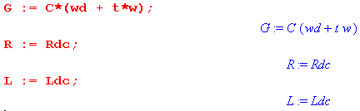
followed by the intermediate variables a and c from box (Q.2.1),

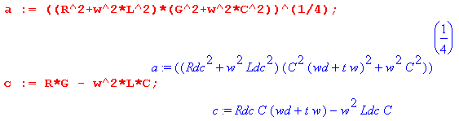

The real part of k(ω) is given from (Q.2.1) as follows:

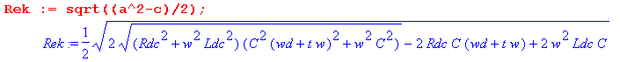

The expansion of Re(k) for small ω is found to be,

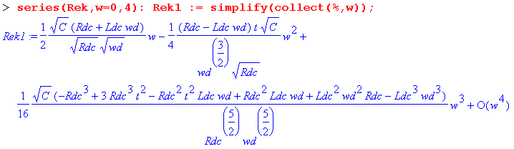

We show several terms to illustrate that the general form of this series is

Re(k) = $\sqrt{ωd}$ Σn=1∞ An(Rdc, Ldc, ωd) (ω/ωd)n . (Q.4.3)

The coefficients An do not vanish as ωd → 0, so we infer that the power series converges only for ω < ωd, which is a very low frequency as noted earlier (ωd = 10-4 for Belden 8281 cable). If one attempts to take the limit ωd → 0 of the above series, the function Re(k) has a branch point in the complex ω plane which impinges on the origin as ωd → 0, causing the series' radius of convergence to shrink down to nothing, and the series then diverges and is meaningless. That is why ωd = 0 is treated separately below.

Keeping only the first term of the expansion above, we find

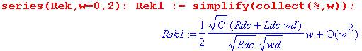
so that

Re(k) ≈ (ω/2) (Rdc + ωdLdc) $\sqrt{C/(ωdRdc)}$ + O(ω2) (Q.4.4)

Treating Im(k) in the same manner one finds,

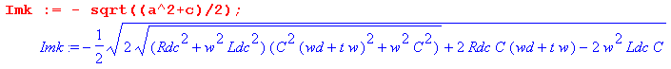

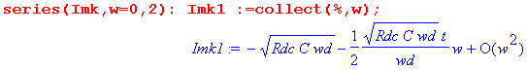
so that

Im(k) ≈ - $\sqrt{RdcCωd}$ [ 1 + (1/2) tanL (ω/ωd) ] + O(ω2) (Q.4.5)

To summarize:

Fact 3: The small ω limit for k(ω), assuming ωd > 0, is given by (Q.4.6)

Re(k) ≈ (ω/2) (Rdc + ωdLdc) $\sqrt{C/(ωdRdc)}$ + O(ω2) ω < ωd = (σd/εd)
Im(k) ≈ - $\sqrt{RdcCωd}$ [ 1 + (tanL/2) (ω/ωd)] + O(ω2)

Notice that Im(k) → - $\sqrt{RdcCωd}$ > 0 as ω→ 0, indicating the presence of loss at DC. This loss is just the ohmic loss in the dielectric due to σd > 0.

Small ω limit of k(ω) for ωd = 0

Here we rerun the Maple code shown above setting ωd = 0 at the start. For Re(k) we find,

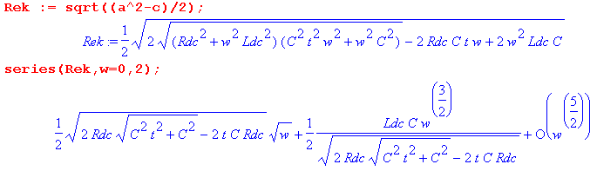
Expanding each coefficient for small t gives

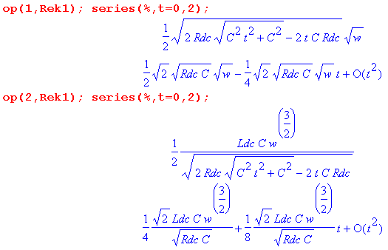

Keeping only the first term in the ω expansion, we have shown that

Re(k) ≈ $\sqrt{RdcC/2}$ $\sqrt{ω}$( 1 - tanL/2) + O(ω3/2) . (Q.4.7)

Treating Im(k) in the same manner one finds:

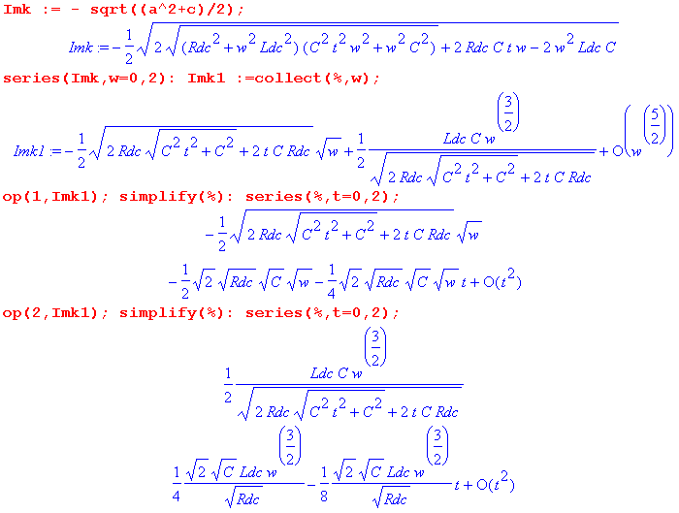

from which we read off the leading term,

Im(k) ≈ - $\sqrt{RdcC/2}$ $\sqrt{ω}$( 1 + tanL/2) + O(ω3/2) . (Q.4.8)

To summarize:

Fact 4: The small ω limit for k(ω), assuming ωd = 0, is given by (Q.4.9)

Re(k) ≈ + $\sqrt{RdcC/2}$ $\sqrt{ω}$( 1 - tanL/2) + O(ω3/2)
Im(k) ≈ - $\sqrt{RdcC/2}$ $\sqrt{ω}$( 1 + tanL/2) + O(ω3/2)

In this case, Im(k) → 0 as ω→0 so there is no DC loss in the dielectric, as one would expect with σd= 0.

Q.5 The general appearance of Re(k) and Im(k) for Belden 8281 cable

Here we are interested in viewing the real and imaginary parts of Re(k) over the full frequency range, not just at the extremes of small ω and large ω. The expressions shown in (Q.2.1) are,

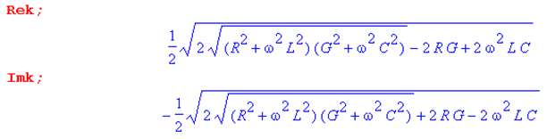 (Q.5.1)

For frequencies below ωL and ωR of our parameter model of Section Q.1, the above expressions become

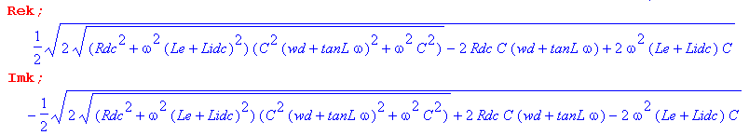
(Q.5.2)
Each expression depends on ω in five places, and is also a function of Rdc, Le, Lidc, C, ωd, and tanL. For this reason, it is difficult to make generalizations about the ω dependence of Re(k) and Im(k) which would apply to all possible transmission lines. We shall consider the Belden 8281 cable of Appendix R to be a "typical" transmission line with regard to the relative sizes of the parameters just listed, and we shall create plots of Rek and Imk for that specific system. For this cable, ωR ≈ 550,000 and ωL ≈ 700,000 so the above expressions for Rek and Imk would apply for ω < 500,000 as used in the plots below.
First of all, recall from (Q.2.1) that

Rek = $\frac{a2-c}{2}$ -Imk = $\frac{a2+c}{2}$. (Q.5.3)

Here is a plot of the ratio c/a2 (using our model and the Belden parameters),

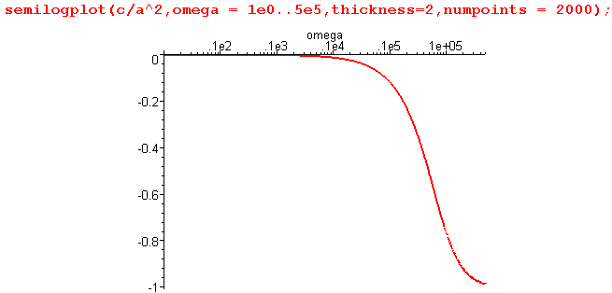 Fig Q.5.1

This shows that c << a2 on the left side of the graph, so for that range we would expect to find that Rek and Imk are about the same. That fact is born out in this plot of Rek and -Imk for ω in (10,500,000):

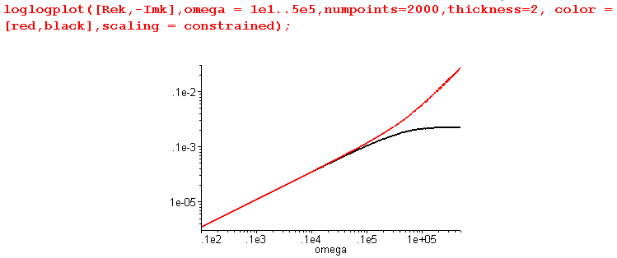 Fig Q.5.2

The red curve is Rek, while the black curve is - Imk. This plot then gives a good view of Rek and Imk for what one would normally call "the low frequency range" of this Belden cable, roughly below 1 MHz. However, this is not the low frequency range for which (Q.4.6) applies. Recall that (Q.4.6) only applies for ω < ωd and ωd = σd/εd ≈ 5 x 10-5 for the Belden 8281 cable, so ω < ωd is what we might call the "ultra low frequency range". We can redo the above plot in the ultra-low range ω = 10-7 to 10-2 sec-1 :

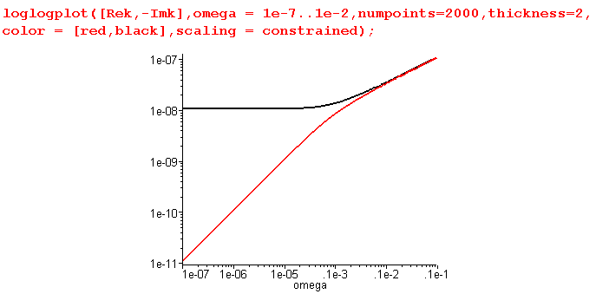 Fig Q.5.3

This shows what happens as we go off the left edge of the previous graph. We find that -Imk goes to a constant, while Rek has slope 1 so is proportional to ω. This is consistent with the low ω limit (Q.4.6),

Re(k) ≈ (ω/2) (Rdc + ωdLdc) $\sqrt{C/(ωdRdc)}$ + O(ω2) ω < ωd = (σd/εd) (Q.4.6)
Im(k) ≈ - $\sqrt{RdcCωd}$ [ 1 + (tanL/2) (ω/ωd)] + O(ω2)

Specifically, $\sqrt{RdcCωd}$ = $\sqrt{RdcGdc}$ = $\sqrt{.036 *.34 x 10-14}$= 1.1 x 10-8 as the plot shows.

Having dealt with low and ultra-low frequencies, we turn now to higher frequencies, and for this purpose we reinstall the full Heaviside model into our Maple code and then continue to make plots. For ω in the range 103 to 107 one finds,

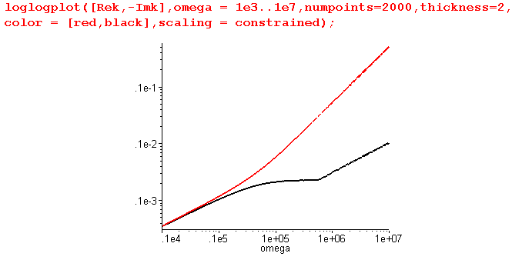 Fig Q.5.4

which shows what happens off the right end of Fig *** . For ω range 103 to 1010 the plot is,

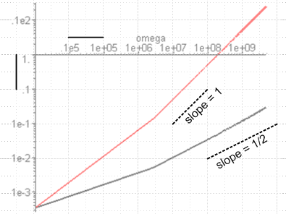 Fig Q.5.5

where we have used a Visio transparent overlay to show the slopes of Rek and Imk. Certainly ω = 1010 corresponding to f = 1.6 GHz is getting near the high end of the usefulness of Belden 8281 cable, but theslope of Imk (on this log log plote) is still 1/2, indicating that Imk ~ $\sqrt{ω}$. Thus we have not yet reached the true high frequency limit for Im(k) which (Q.3.5) says is this,

Re(k) ≈ (ω/vd) + (vdκC/2) $\sqrt{ω}$ + (1/4vd)(ωd +vd4C2κ2/2) tanL + O(1/$\sqrt{ω}$)
Im(k) ≈ - (ω/vd) tanL/2 - (vdκC/2) $\sqrt{ω}$ - (1/2vd)(ωd - vd4C2κ2/2) + O(1/$\sqrt{ω}$) (Q.3.5)

It is the smallness of tanL/(2vd) which causes - (vdκC/2) $\sqrt{ω}$ to still be the leading term. Finally, we take ω even higher to get this final plot for ω in 108 to 1013 ( 1600 GHz )

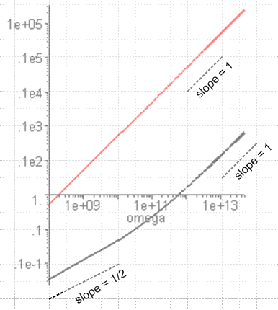 Fig Q.5.6

and finally the slope of Imk is 1 showing that the first term in (Q.3.5) is now dominant. Of course at this value of 1600 GHz (ω=1013) one sees that -Im(k) ≈ .1e3 = 100 which means the cable is good for a length of about 1 cm (ejkz ~ e-Im(k)z ).

Finally, we can combine all the above onto a single graph, where the horizontal axis shows log10(ω) :

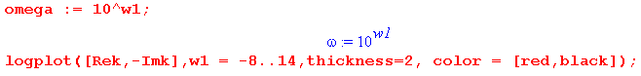

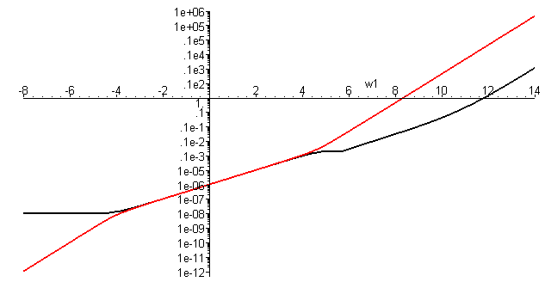
Fig Q.5.7

The origin represents (ω = 100 = 1 sec-1, value = 1 m-1). Note that all plotted values are positive, and that the functions plotted are Re(k) and - Im(k). The plots are for the simple model presented in Section Q.1.
Function Re(k) is the lower function on the left and the upper function on the right.

Note on Log Plots: We are using ancient Maple V which has a bug in its distribution of sample points for the semilogplot and loglogplot functions. For this reason, these plotting calls are inaccurate if the ω domain is more than a few decades wide. This bug has no doubt been fixed in later Maple releases. As a workaround, we use the method shown above to force an equal spacing of points per decade. Just for the record, here is what Maple V does with the above plot even with 10,000 plotting points

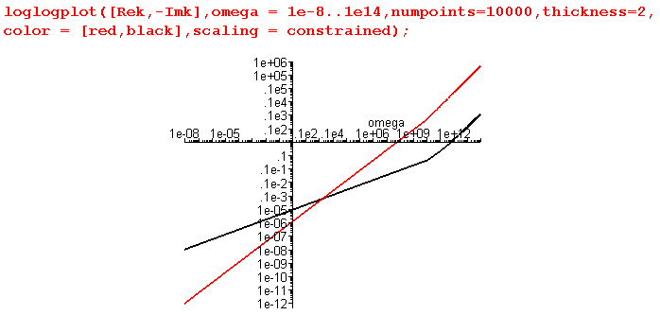// Bad Plot !

Q.6 Real and Imaginary parts of Z0(ω)

Fact 5: The real + imaginary decomposition of Z0 is given by (Q.6.1)

Z0 = $\frac{R + jωL}{G + jωC}$ = $\frac{z}{y}$ = ( b/$\sqrt{2}$) [ $\sqrt{1+(d/a2)}$ - jσ$\sqrt{1-(d/a2)}$ ]

where b = ( $\frac{R2+ω2L2}{G2+ω2C2}$)1/4 = |Z0| a = [(R2+ω2L2)(G2+ω2C2)]1/4 as in (Q.2.1)
σ = sign(RC-LG) d = RG + ω2LC

Proof of Fact 5: The proof is similar to that of Fact 1. Let

q = $\frac{z}{y}$ = $\frac{R+jωL}{G+jωC}$ = |q| ejθ -π < θ < π ( but see few lines below) .

Then
|q|2 = | $\frac{R+jωL}{G+jωC}$| 2 = $\frac{R2+ω2L2}{G2+ω2C2}$ ≡ b4 => |q| = $\frac{R2+ω2L2}{G2+ω2C2}$= b2 .

Next,

q = $\frac{R+jωL}{G+jωC}$ = $\frac{R+jωL}{G+jωC}$ $\frac{G-jωC}{G-jωC}$ = $\frac{(R+jωL)(G-jωC)}{G2+ω2C2}$ = $\frac{RG+jω(LG-RC) + ω2LC}{G2+ω2C2}$
so
Re(q) = $\frac{RG + ω2LC}{G2+ω2C2}$ > 0 => -π/2 < θ < π/2

Im(q) = $\frac{ω(LG-RC)}{G2+ω2C2}$ sign[Im(q)] = sign(LG-RC) = sign(θ) ≡ -S .

Then
cosθ = Re(q)/ |q| = $\frac{(RG + ω2LC)}{G2+ω2C2}$ $\frac{G2+ω2C2}{R2+ω2L2}$ = $\sqrt{(G2+ω2C2)(R2+ω2L2)}$

≡ d/a2 where a = [(R2+ω2L2)(G2+ω2C2)]1/4 and d ≡ RG + ω2LC .
Now write

s ≡ $\frac{z}{y}$ = $\sqrt{q}$ = |s| eiφ |s| = $\sqrt{|q|}$ = b = |Z0| φ = θ/2 -π/4 < φ < π /4

Re(s) = |s| cosφ = b cos(θ/2) = b $\sqrt{(1 +cosθ)/2}$ = (b/$\sqrt{2}$)$\sqrt{1+d/a2}$
Im(s) = |s| sinφ = b sin(θ/2) = -σ b $\sqrt{(1 -cosθ)/2}$ = -σ (b/$\sqrt{2}$)$\sqrt{1-d/a2}$

giving the result

s = (b/$\sqrt{2}$) [$\sqrt{1+d/a2}$ - jS $\sqrt{1-d/a2}$]

where b = ($\frac{R2+ω2L2}{G2+ω2C2}$)1/4 = |Z0| a = [(R2+ω2L2)(G2+ω2C2)]1/4
S = sign(RC-LG) d ≡ RG + ω2LC .

Our Maple verification of this result is a bit ugly so we omit the code.
An alternate geometric derivation giving the same results begins as follows:

Z0 = $\frac{R +zL}{G +zC}$ = $\frac{L}{C}$$\frac{z + (R/L)}{z + (G/C)}$ = $\frac{L}{C}$$\frac{z + r}{z + g}$ where r = (R/L) and g = (G/C) .

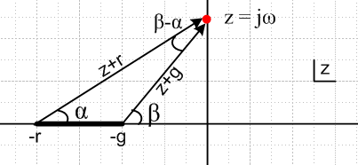 Fig Q.6.1

The drawing shows the complex z plane for the function Z0(z) = $\frac{L}{C}$$\frac{z + r}{z + g}$in the particular case that r > g, where the z-plane has a branch cut from -r to -g. The z values of interest are only those on the positive imaginary axis where z = jω.

Reader Exercise: Finish this derivation and obtain the results shown in (Q.6.1).

Hint: cos(β-α) = (rg+ω2)/(AB) and sin(β-α) = ω(r-g)/(AB) where A = $\sqrt{ω2+r2}$ and B = $\sqrt{ω2+g2}$.

Q.7 Large ω limit of Z0(ω) fix this replacing sign σ by sign S

For large ω, our models for G,R,L were found to be

G = C(ωd + t ω) R = κ$\sqrt{ω}$ L= 1/(Cvd2) + κ/$\sqrt{ω}$ . (Q.3.2)

These expressions are entered into Maple as in Section Q.3 above. Next, we enter the intermediate variables a, b, and d from box (Q.7.1)

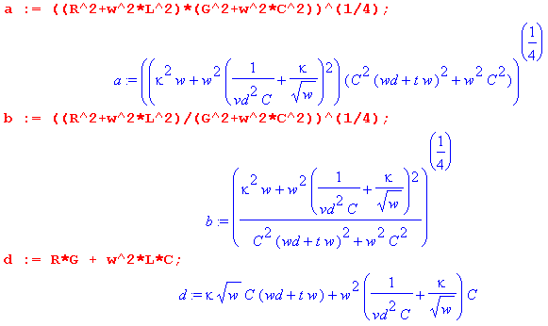
The real part of Z0(ω) is then given from (Q.7.1) as follows:

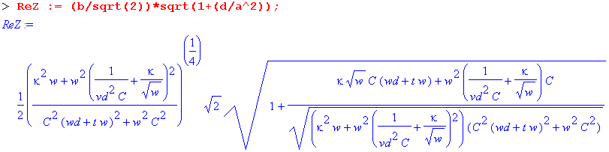
The asymptotic expansion of Re(Z0) for large ω is then found to be,

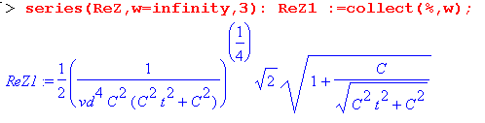

This expansion has the form A + B/$\sqrt{ω}$+ C/ω + O(ω-3/2) but above we only display term A because the other expressions are large and uninspiring. As before, we pick off each term, simplify it, then expand it for small t:

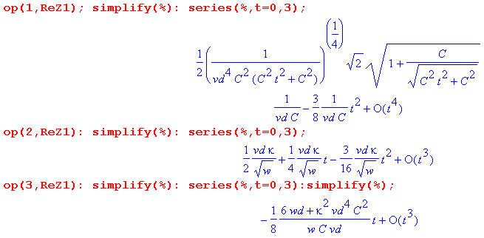

Collecting the results and keeping only the leading terms in t = tanL, the resulting large ω limit for Re(k) is seen to be,

Re(Z0) ≈ 1/(vdC) + (vdκ/2) 1/$\sqrt{ω}$ + O(1/ω) (Q.7.1)

where we have ignored the details of the O(1/ω) term.

Treating Im(Z0) in the same manner one finds,

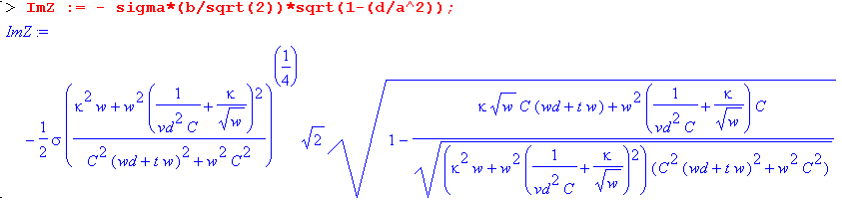
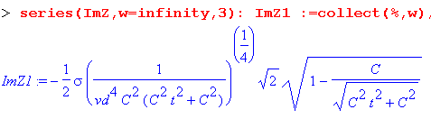
Again this expansion has the form A + B/$\sqrt{ω}$+ C/ω + O(ω-3/2) but we only display term A because expressions are clumsy. As before, we pick off each term, simplify it, then expand it for small t:

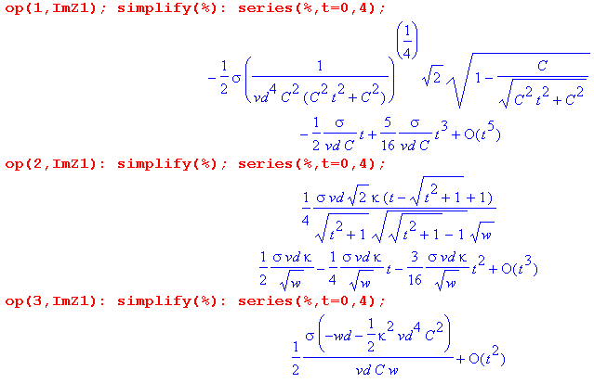
Collecting the results and keeping only the leading terms in t = tanL, the resulting large ω limit for Im(k) is seen to be,

Im(Z0) ≈ -σ tanL /(2vdC) + σ (vdκ/2) 1/$\sqrt{ω}$ + O(1/ω) (Q.7.2)

where we have again ignored the details of the O(1/ω) term.

Finally, σ is the sign of expression RC-LG,

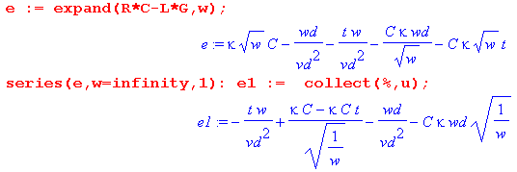
so for large ω and small t = tanL we have

σ = sign [ - (tanL /vd2) ω + κC$\sqrt{ω}$ - ωd/vd2 ] (Q.7.3)

which then gives σ = -1 for very large ω. We now summarize these results :

Fact 6: The large ω asymptotic expansion for Z0(ω), assuming tanL << 1, is given by (Q.7.4)

Re(Z0) ≈ [1/(vdC)] + (vdκ/2) /$\sqrt{ω}$ + O(1/ω)
Im(Z0) ≈ [ 1/(vdC)] tanL/2 - (vdκ/2) /$\sqrt{ω}$ + O(1/ω)
where κ ≡ ( $\frac{1}{p1}$ + $\frac{1}{p2}$)$\frac{μ}{2σ}$

Keeping only the leading terms for large ω,

Re(Z0) ≈ 1/(vdC) = $\sqrt{Le/C}$ ≈ $\sqrt{L/C}$ vd = 1/$\sqrt{LeC}$ ≈ 1/$\sqrt{LC}$
Im(Z0) ≈ + tanL/(2vdC) = (1/2) tanL $\sqrt{Le/C}$ σ = -1

The leading term Re(Z0) ≈ $\sqrt{L/C}$ is the usual result obtained from taking the large ω limit of the expression Z0 = $\frac{R + jωL}{G + jωC}$ when the four parameters are treated as constants in ω. This fact is obvious from the large-ω model stated in (Q.3.1) which we repeat here:

G(ω) = C (ωd + tanL ω ) ωd ≡ (σd/εd)

R(ω) = κ $\sqrt{ω}$
L(ω) = 1/(Cvd2) + (κ/$\sqrt{ω}$) . κ ≡ ( $\frac{1}{p1}$ + $\frac{1}{p2}$)$\frac{μ}{2σ}$ (Q.3.1)

Since tanL << 1 one has

G + jωC = C (ωd + tanL ω ) + jωC = C ωd + ωC( tanL + j) ≈ ωCj = jωC
R + jωL = κ $\sqrt{ω}$ + jω [1/(Cvd2) + (κ/$\sqrt{ω}$) ] ≈ jωLe ≈ jωL
so
Z0 = $\sqrt{jωL/jωC}$ = $\sqrt{L/C}$

Q.8 Small ω limit of Z0(ω)

The same partition into ωd > 0 and ωd = 0 occurs here as in Section Q.4.

Small ω limit of Z0(ω) for ωd > 0

For small ω the parameter model is that stated in (Q.4.2.)

G = C(ωd + t ω) R = Rdc L = Ldc . (Q.4.2)

These expressions are entered into Maple as in Section Q.4 followed by expressions for the intermediate parameters of (Q.8.1)

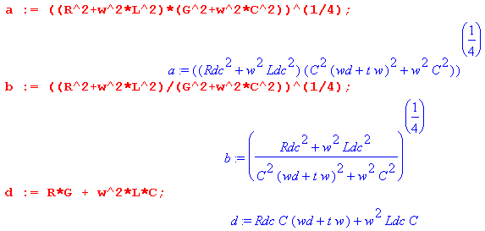

The real part of Z0(ω) is then given from (Q.8.1) as follows:

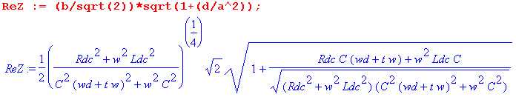

The expansion of Re(Z0) for small ω is found to be,

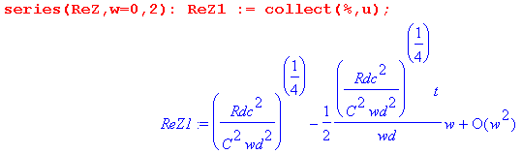

We thus find that, for small ω,

Re(Z0) ≈ $\sqrt{Rdc/(Cωd)}$ - $\sqrt{Rdc/(Cωd)}$ tanL/2 (ω/ωd) + O(ω2) . (Q.8.1)

Treating Im(k) in the same manner one finds,

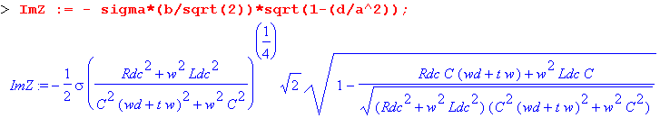

The expansion of Im(Z0) for small ω is then found to be,

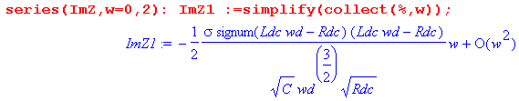
We thus find that, for small ω,

Im(Z0) ≈ - (1/2) σ | Rdc - ωdLdc| (ω/ωd) / $\sqrt{RdcC ωd}$ + O(ω2) (Q.8.2)

Finally, σ is the sign of expression RC-LG,

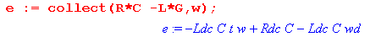

Then for small ω , RC-LG = C(Rdc-ωdLdc), so σ = sign(Rdc-ωdLdc). Thus

Im(Z0) ≈ - (1/2) ( Rdc - ωdLdc ) (ω/ωd) / $\sqrt{RdcC ωd}$ + O(ω2)

To summarize:

Fact 7: The small ω limit for Z0(ω), assuming ωd > 0, is given by (Q.8.3)

Re(Z0) ≈ $\sqrt{Rdc/(Cωd)}$ - $\sqrt{Rdc/(Cωd)}$ tanL/2 (ω/ωd) + O(ω2)
Im(Z0) ≈ - (1/2) ( Rdc - ωdLdc ) (ω/ωd) / $\sqrt{RdcC ωd}$ + O(ω2) ωd ≡ (σd/εd)

As ω→0, we find that Z0 → $\sqrt{Rdc/(Cωd)}$ = $\sqrt{Rdc/Gdc}$, in agreement with result (2) of the Reader Exercise below Fig K.4.

Small ω limit of Z0(ω) for ωd= 0

Here we rerun the Maple code shown above setting ωd = 0 at the start. For Re(Z0) we find,

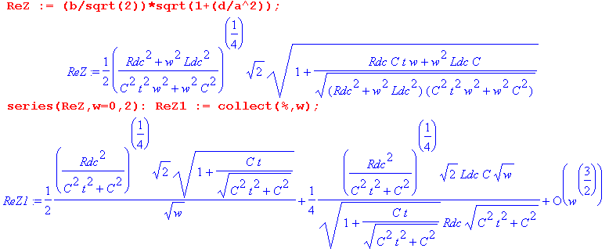
Expanding each coefficient for small t gives,

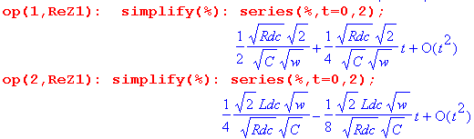

Thus our small ω expansion for Re(Z0) is

Re(Z0) ≈ $\sqrt{Rdc/(2C)}$ 1/$\sqrt{ω}$ + (1/2) [Ldc/$\sqrt{2RdcC}$] $\sqrt{ω}$ + O(ω3/2) (Q.8.4)

Treating Im(Z0) in the same manner one finds,

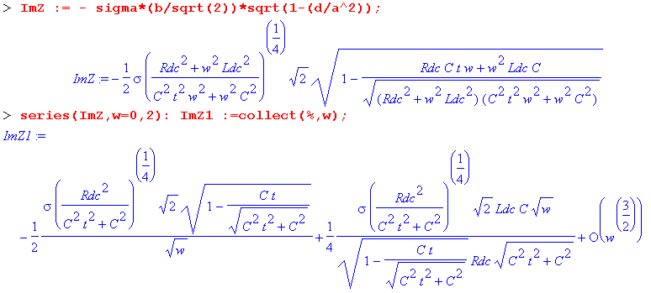
Expanding each coefficient for small t gives,

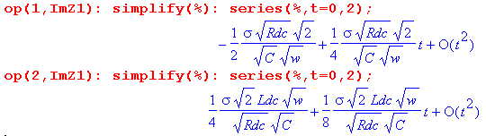

from which we can write the small ω, small t expansion of Im(Z0) ,

Im(Z0) ≈ - σ $\sqrt{Rdc/(2C)}$ 1/$\sqrt{ω}$ + (1/2) σ [Ldc/$\sqrt{2RdcC}$] $\sqrt{ω}$ + O(ω3/2) (Q.8.5)

Since σ is the sign of (RC-LG) and since

we conclude that for small ω, σ = +1. To summarize:

Fact 8: The small ω limit for Z0(ω), assuming ωd = 0, is given by (Q.8.6)

Re(Z0) ≈ $\sqrt{Rdc/(2C)}$ 1/$\sqrt{ω}$ + (1/2) [Ldc/$\sqrt{2RdcC}$] $\sqrt{ω}$ + O(ω3/2)
Im(Z0) ≈ - $\sqrt{Rdc/(2C)}$ 1/$\sqrt{ω}$ + (1/2) [Ldc/$\sqrt{2RdcC}$] $\sqrt{ω}$ + O(ω3/2)

We can quickly verify the leading terms:

Z0 = $\frac{R + jωL}{G + jωC}$ = $\frac{Rdc + jωLdc}{(C tanL) ω + jωC}$ ≈ $\frac{Rdc}{jωC}$ = $\frac{Rdc}{ωC}$ $\sqrt{-j}$ = $\frac{Rdc}{ωC}$(1-j)/$\sqrt{2}$

= $\frac{Rdc}{2C}$ $\sqrt{ω}$ ( 1-j ) .

As suggested by the network model for ωd = 0 and ω = 0,

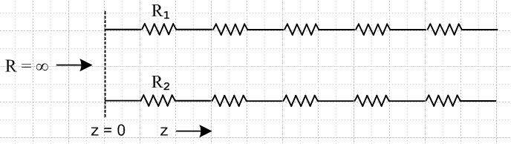 Fig D.8

it is not surprising that Z0 → ∞ as ω→0. The phase is perhaps unexpected.

Q.9 The general appearance of Re(Z0) and Im(Z0) for Belden 8281 cable

This section is very similar to Section Q.5 above concerning the appearance of k(ω). We are interested in viewing the real and imaginary parts of Re(Z0) over the full frequency range, not just at the extremes of small ω and large ω. The expressions shown in (Q.6.1) are,

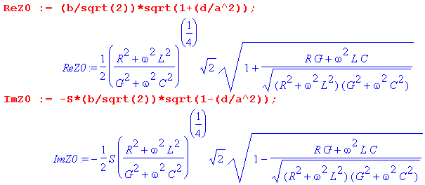 (Q.9.1)

When the full Heaviside model of Section Q.1 is inserted for the parameters R,L and G, one can see that ReZ0 and ImZ0 are complicated functions of ω. Rather than attempt to deal with generic special cases (such as small G), we shall again consider the Belden 8281 cable of Appendix R to be a "typical" transmission line with regard to the relative sizes of the parameters Rdc, Le, Lidc, C, ωd, and tanL. In our model the "low frequency" range will be taken to be ω = 1 to 500,000.
A new feature not present in the k(ω) case is the sign S which from (Q.6.1) is S = sign(RC-LG). Here are plots of RC-LG and S = sign(RC-LG) for the Belden cable, using the same wide-range ω plotting trick mentioned at the end of Section Q.5 ( horizontal axis labeled by log10(ω) ):

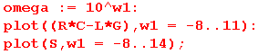

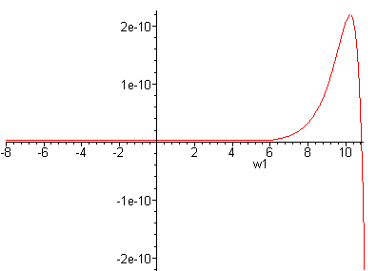 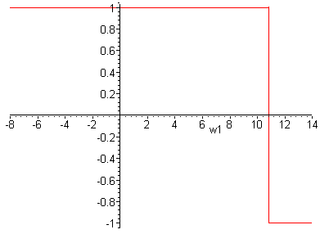 Fig Q.9.1

Basically σ = +1 up to about ω = 1011 then it becomes -1.

Now recall from (Q.6.1) that

Rek = ( b/$\sqrt{2}$) [ $\sqrt{1+(d/a2)}$ ] -Imk = σ ( b/$\sqrt{2}$) [ $\sqrt{1-(d/a2)}$] . (Q.9.2)

Here is a plot of the ratio d/a2 (using our model and the Belden parameters) only up to ω = 500,000 :

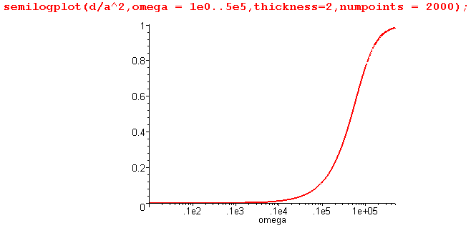 Fig Q.9.2

This shows that d << a2 on the left side of the graph, so for that range we would expect to find that ReZ0 and -ImZ0 are about the same. That fact is born out in this plot of ReZ0 and - ImZ0 for ω in (10,500,000):

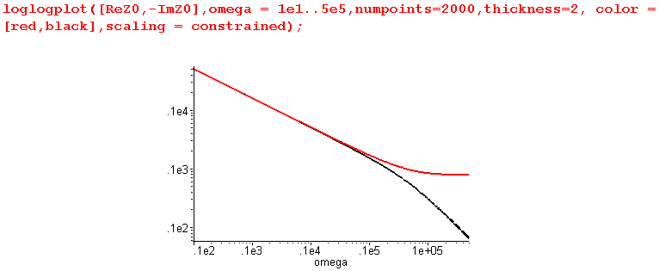 Fig Q.9.3

The red curve is ReZ0, while the black curve is - ImZ0. This plot then gives a good view of ReZ0 and ImZ0 for what one would normally call "the low frequency range" of this Belden cable, roughly below 1 MHz. However, this is not the low frequency range for which (Q.8.3) applies. Recall that (Q.8.3) only applies for ω < ωd (and ωd = σd/εd ≈ 5 x 10-5 for the Belden 8281 cable), which we call "ultra low frequencies". We can redo the above plot in the ultra-low range ω = 10-7 to 10-2 sec-1 :

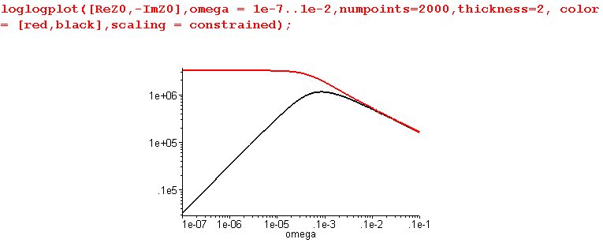 Fig Q.9.4

This shows what happens as we go off the left edge of the previous graph. We find that ReZ0 goes to a constant, while -ImZ0 has slope 1 so is proportional to ω. This is consistent with the low ω limit (Q.8.3),

Re(Z0) ≈ $\sqrt{Rdc/(Cωd)}$ - $\sqrt{Rdc/(Cωd)}$ tanL/2 (ω/ωd) + O(ω2) (Q.8.3)
Im(Z0) ≈ - (1/2) ( Rdc - ωdLdc ) (ω/ωd) / $\sqrt{RdcC ωd}$ + O(ω2) ωd ≡ (σd/εd)

Specifically, $\sqrt{Rdc/(Cωd)}$ = $\sqrt{Rdc/Gdc}$ = $\sqrt{.036 /.34 x 10-14}$= 3.25 x 106 as the plot shows.

Having dealt with low and ultra-low frequencies, we turn now to higher frequencies. For ω in the range 103 to 1010 one finds,

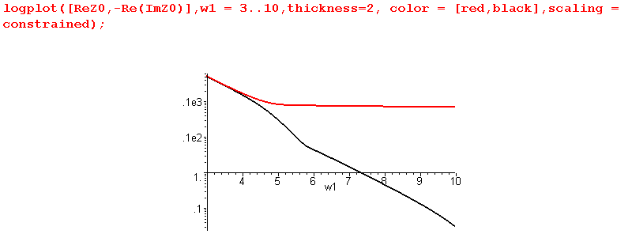Fig Q.9.5

Recall that ImZ0 experiences a sign change in the region of ω = 1011 (sign S goes from +1 to -1) as shown in this non-log plot of just -ImZ0 for ω=109 to 1018:

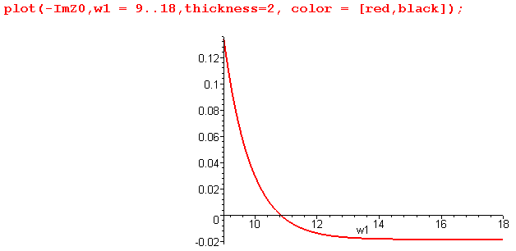 Fig Q.9.6

In fact, -ImZ0 approaches the constant value indicated in our large ω limit given in (Q.7.4),

Re(Z0) ≈ [1/(vdC)] + (vdκ/2) /$\sqrt{ω}$ + O(1/ω)
Im(Z0) ≈ [ 1/(vdC)] tanL/2 - (vdκ/2) /$\sqrt{ω}$ + O(1/ω) (Q.7.4)
where κ ≡ ( $\frac{1}{p1}$ + $\frac{1}{p2}$)$\frac{μ}{2σ}$

that value being about

ImZ0 → [ 1/(vdC)] tanL/2 = [ $\sqrt{εd/ε0}$/(cC)] tanL/2 = [ $\sqrt{2.3}$/(3x108 x 69 x 10-12)] .0005/2

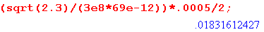

in agreement with the above plot.
Because -ImZ0 goes negative, we cannot do a full log plot of -ImZ0 without adding a small positive offset. This problem did not arise when dealing with k(ω) in Section Q.5 because Imk must always be negative to insure a loss at any ω.
Adding an offset of .02, we then make our plot over a full range of ω:

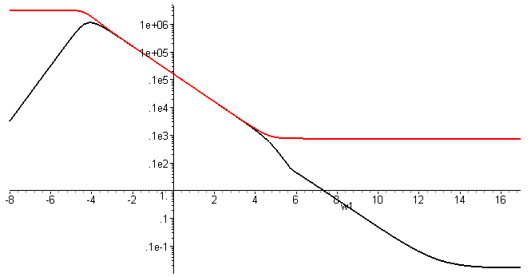
Fig Q.9.7

We have just shown that, for large ω, ImZ0 approaches the constant - .18 Ω shown in (Q.7.4). We now see that ReZ0 also approaches a constant value [1/(vdC)] = [ $\sqrt{εd/ε0}$/(cC)] which is

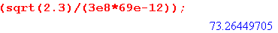

This value of 73.26Ω is slightly less than the nominal cable impedance of 75 Ω. The following plot shows ReZ0 and -ImZ0 for 100 KHz to 1 GHz on the left, and 10 KHz to 100 KHz on the right

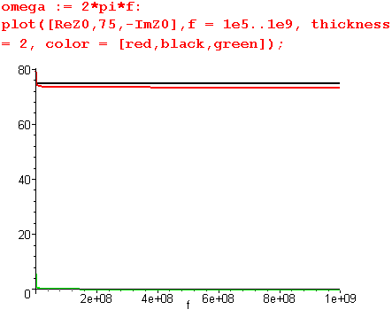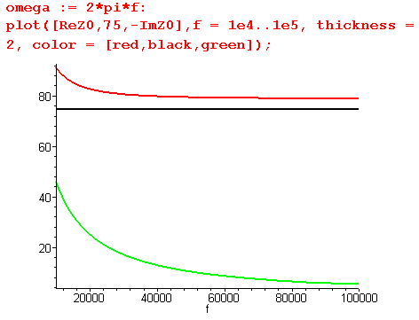
Fig Q.9.8
Above 100 KHz -ImZ0 can be neglected, but at 10KHz it jumps up to 44 Ω.

