Appendix Q: Properties of the functions k(ω) and Z₀(ω) 2
Q.1 A Model for R, L, G and C 2
Q.2 Real and Imaginary part of k(ω) 7
Q.3 Real and Imaginary part of k(ω) for large ω 8
Q.4 Real and Imaginary part of k(ω) for small ω 12
Q.5 Real and Imaginary part of Z₀(ω) 17
Q.6 Real and Imaginary part of Z₀(ω) for large ω 19
Q.7 Real and Imaginary part of Z₀(ω) for small ω 22

Appendix Q: Properties of the functions k(ω) and Z0(ω)

The two functions of interest are,

k = -j$\sqrt{zy}$ = -j $\sqrt{(R+jωL)(G+jωC)}$ (5.3.5) (K.7)

Z0 = $\frac{z}{y}$ = $\frac{R + jωL}{G + jωC}$ . (4.11.16) (K.4)

These expressions for k and Z0 were derived from both the "physics model" of Chapters 4 and 5 and the network model of Appendix K, with equations numbers shown above. The expressions are valid for all ω in the network model, but in the physics model they were derived only in the skin effect regime, though we might have some expectation that the expressions are approximately valid for low ω.

The four parameters R,L,G and C are by definition all real numbers. For example, in the physics model R is defined to be the real part of z and ωL the imaginary part. In the k and Z0 sections below, our first task shall be to compute the real and imaginary parts of k and Z0. We shall then be interested in the high ω and low ω limits of these expressions. In order to compute these limits properly, we must remember that the four real parameters R,L,G and C are in general functions of ω and cannot be treated as constants. This requires that we construct some kind of model for these parameters as functions of ω, and that is the task of the following section.

Q.1 A Model for R, L, G and C

The model considered here is just an ad hoc "reasonable" model which is accurate at high and low frequencies and which bridges the gap in a crude manner just so we have something to work with. We shall assume that C and Le are the constants appearing in (4.11.34), namely

C = 4πεd/K capacitance per meter
Le = $\frac{μd}{4π}$ K external inductance per meter
Gdc = 4πσd/K DC conductance per meter

where K is the constant defined also in (4.11.34). The conductance has a dc subscript because σd is the DC conductivity of the dielectric.

Model for C

We assume C to be the constant value shown above, so

C(ω) = C = 4πεd/K = independent of ω (Q.1.1)

Model for G

Recall first from (3.3.2) and (3.3.4) that

σeff = ( σd + ωε'd tanL) where tanL ≡ (ε"d/ε'd) and εd = ε'd - jε"d .

This σeff is the effective conductivity of a dielectric whose dielectric constant has an imaginary part. The dielectric burns energy just as if the loss were all simple ohmic loss. From (4.11.34) we then have

G = (σeff/εd)C = ( σd + ωε'd tanL)C/εd = (σd/εd)C + (ε'd/εd) tanL ωC

= Gdc + (ε'd/εd) tanL ωC

where recall that tanL is the so-called loss-tangent or dissipation factor of the dielectric. Clearly G has a strong dependence on ω, being a linear function of ω. Normally (ε'd/εd) ≈ 1 since ε"d and tanL are normally very small. Rather than set (ε'd/εd) = 1, we just absorb this factor into the definition of tanL and then write G(ω) in this simpler form,

G(ω) = Gdc + (C tanL) ω where Gdc = (σd/εd)C . (Q.1.2)

Since (σd/εd) has the dimensions sec-1 it is convenient to rewrite the above G(ω) as

G(ω) = C (ωd + tanL ω ) ωd ≡ (σd/εd) (Q.1.3)

This then is our working model for the frequency-dependent real parameter G(ω).

Examples:
A vacuum dielectric has σd = 0 so both ωd = 0 and tanL = 0, resulting in G(ω) = 0.
Air as a dielectric at low temperature presumably has ωd = 0 and tanL << 1.
Polyethylene (App. Q) has σd ~ 10-15 and tanL ≈ .0005.

Model for L and R

Recall from Chapter 2 these expressions for the high-frequency resistance and internal inductance of a round wire of radius a1 ,

R1 = $\frac{1}{σ(2πa1)δ}$ δ ≡ $\sqrt{2/ωμσ}$ (2.4.18)
L1i = (1/ω) R1 = $\frac{1}{ωσ(2πa1)δ}$ = $\sqrt{2/ωμσ}$ = $\frac{1}{2πa1} \sqrt{\frac{μ}{2σω}}$ . (2.4.19)

These are for conductor C1 and similar expressions apply to conductor C2 for a transmission line of the type considered in Chapter 6. Note that σ and μ are parameters of the conductor, not the dielectric. We can rewrite the above equations in this manner

L1i = $\frac{1}{2πa1}$ $\frac{μ}{2σ}$ω-1/2 decreases with ω
R1 = $\frac{1}{2πa1}$ $\frac{μ}{2σ}$ω+1/2 = ω L1i increases with ω (Q.1.4)

We now generalize these results for an arbitrary conductor C1 as follows

L1i = $\frac{1}{p1}$ $\frac{μ}{2σ}$ω-1/2 decreases with ω
R1 = ω L1i = $\frac{1}{p1}$$\frac{μ}{2σ}$ω+1/2 increases with ω (Q.1.5)

where p1 is the "active" perimeter distance around the cross section of the conductor, as discussed in the text near (4.11.10). For widely spaced thin wires (or a centered coaxial cable), the active perimeter of a round wire is the full perimeter so p1 = 2πa1, but the active perimeter is much less than the total perimeter for a pair of closely spaced conductors as shown in Fig 4.12. We regard this generalization as being "reasonable" if not precise. Summing over the two conductors of our transmission line, we then find for high ω that

Li = ( $\frac{1}{p1}$ + $\frac{1}{p2}$) $\frac{μ}{2σ}$ω-1/2 ≡ κ ω-1/2 κ ≡ ( $\frac{1}{p1}$ + $\frac{1}{p2}$) $\frac{μ}{2σ}$

R = ( $\frac{1}{p1}$ + $\frac{1}{p2}$) $\frac{μ}{2σ}$ω+1/2 ≡ κ ω+1/2 dim(κ) = ohm/m * sec1/2. (Q.1.6)

In order to crudely blend these expressions down into the low ω region, we write

R(ω) = Rdc θ(ω<ωR) + (κ $\sqrt{ω}$) θ(ω≥ωR) ωR ≡ (Rdc/κ)2

Li(ω) = Lidc θ(ω<ωL) + (κ/$\sqrt{ω}$) θ(ω≥ωL) ωL ≡ (κ/ Li,DC)2 (Q.1.7)

where θ(bool) = 1 if bool = true, else 0. Here Rdc = 1/(σA1) + 1/(σA2) is the DC resistance of the two conductors, while Lidc is the DC internal inductance. Examples of computing the latter appear in Appendix C. For a round wire, Li = μ/8π, so for a pair of same, Lidc = μ/4π henry/m.

Using parameters shown in Appendix R for Belden 8281 coaxial cable, we may plot R(ω) and Li(ω) for our crude model. First, the two expressions are entered into Maple,

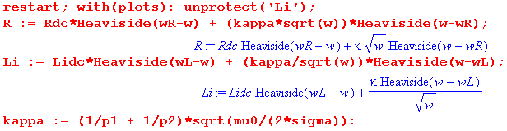

followed by parameters for the Belden cable obtained in Appendix R,

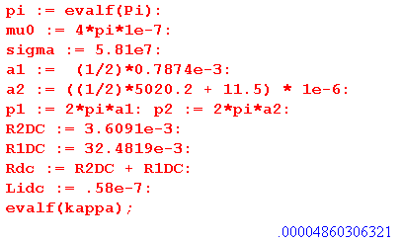

The two blending frequencies are computed,

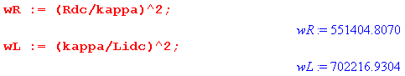
and are seen to be in the 1 MHz range. Finally, here are plots for R and Li versus ω :

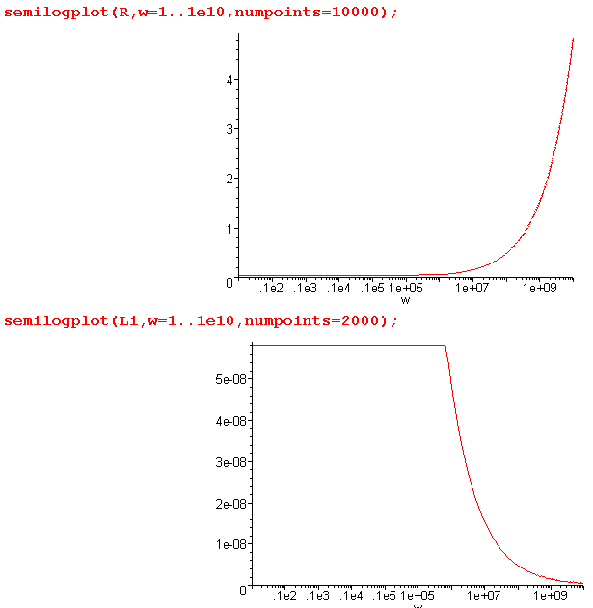
which duly show the resistance increasing as $\sqrt{ω}$ and internal inductance decreasing as 1/$\sqrt{ω}$ . It would not be difficult to provide a smooth blending function to remove the sharp corners from these plots, but since our only real interest is in very large and very small ω, we leave things as is.

The final step is to add in the external inductance Le so our model for R(ω) and L(ω) is then

R(ω) = Rdc θ(ω<ωR) + (κ $\sqrt{ω}$) θ(ω≥ωR) ωR ≡ (Rdc/κ)2

L(ω) = Le + Lidc θ(ω<ωL) + (κ/$\sqrt{ω}$) θ(ω≥ωL) ωL ≡ (κ/ Li,DC)2 . (Q.1.8)

For the Belden cable example Le = 0.37 μH/m = 3.7 x 10-7 H/m, giving this plot for L(ω) versus ω:

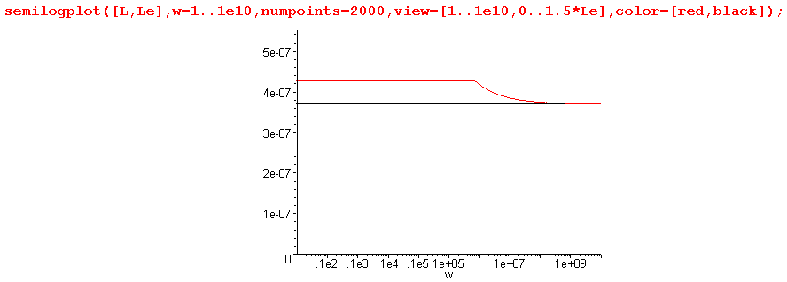

L(ω) is shown in red, while Le is shown in black. This last plot shows that Le is really the dominant term in L(ω) at all ω. More magnetic energy is stored in the dielectric than inside the conductors.

Simple Transmission Line Parameter Model (Q.1.9)

C(ω) = C = independent of ω κ ≡ ( $\frac{1}{p1}$ + $\frac{1}{p2}$)$\frac{μ}{2σ}$

G(ω) = C (ωd + tanL ω ) ωd ≡ (σd/εd) Gdc ≡ ωd C

R(ω) = Rdc θ(ω<ωR) + (κ $\sqrt{ω}$) θ(ω≥ωR) ωR ≡ (Rdc/κ)2

L(ω) = Le + Lidc θ(ω<ωL) + (κ/$\sqrt{ω}$) θ(ω≥ωL) ωL ≡ (κ/ Lidc)2

LeC = μdεd = 1/vd2 (4.11.34)

The last line shows that Le has a simple relation to C in terms of the dielectric speed of light vd. The two pi are the active perimeters of the conductors, μ and σ are for the conductors, and σd, εd and μd are for the dielectric. Rdc and Lidc are the DC resistance and internal inductance total for the two conductors.

Q.2 Real and Imaginary part of k(ω)

Here is the separation of k(ω) into its real and imaginary parts:

Fact 1: The real + imaginary decomposition of k is given by (Q.2.1)
k = $\frac{a2-c}{2}$ - j $\frac{a2+c}{2}$ k ≡ -j $\sqrt{(R+jωL)(G+jωC)}$
jk = $\frac{a2+c}{2}$ + j $\frac{a2-c}{2}$ jk = $\sqrt{zy}$= $\sqrt{(R+jωL)(G+jωC)}$

where
a ≡ [(R2+ω2L2)(G2+ω2C2)]1/4 = |k| dim(a) = 1/m a > 0

c ≡ RG - ω2LC dim(c) = 1/m2 c = real, |c| < a2

Proof of Fact 1: Let

q ≡ zy = (R+jωL)(G+jωC) = (RG-ω2LC) + jω(LG+RC) = c + jω(LG+RC) = |q| ejθ

=> |q|2 = | (R+jωL)(G+jωC) |2 = | (R+jωL)|2|(G+jωC) |2 = (R2+ω2L2) (G2+ω2C2) ≡ a4

|q| = a2

cosθ = Re(q) /|q| = c/a2

Now write

s ≡ $\sqrt{zy}$ = $\sqrt{(R+jωL)(G+jωC)}$ = $\sqrt{q}$ = |s| eiφ |s| = $\sqrt{|q|}$ = a φ = θ/2
Re(s) = |s| cosφ = a cos(θ/2) = a $\sqrt{(1 +cosθ)/2}$ = (a/$\sqrt{2}$)$\sqrt{1+c/a2}$ = $\frac{a2+c}{2}$
Im(s) = |s| sinφ = a sin(θ/2) = a $\sqrt{(1 -cosθ)/2}$ = (a/$\sqrt{2}$)$\sqrt{1-c/a2}$ = $\frac{a2-c}{2}$
s = $\sqrt{zy}$ = $\frac{a2+c}{2}$ + j $\frac{a2-c}{2}$
k = -j$\sqrt{zy}$ = -js = $\frac{a2-c}{2}$ - j $\frac{a2+c}{2}$ QED

Maple verification:

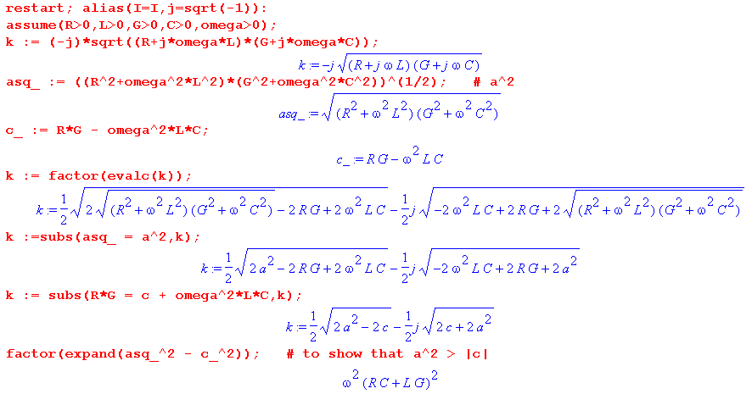

Q.3 Real and Imaginary part of k(ω) for large ω

Large ω limit for k(ω)

The model of box (Q.1.9) at high ω reads, setting Le = 1/(Cvd2),

G(ω) = C (ωd + tanL ω ) ωd ≡ (σd/εd)
R(ω) = κ $\sqrt{ω}$
L(ω) = 1/(Cvd2) + (κ/$\sqrt{ω}$) κ ≡ ( $\frac{1}{p1}$ + $\frac{1}{p2}$)$\frac{μ}{2σ}$ (Q.3.1)
Defining t ≡ tanL and u ≡ $\sqrt{ω}$, wd ≡ ωd, these expressions are

G = C(wd + t u2) R = κu L= 1/(Cvd2) + κ/u (Q.3.2)

We duly enter these expressions into Maple,

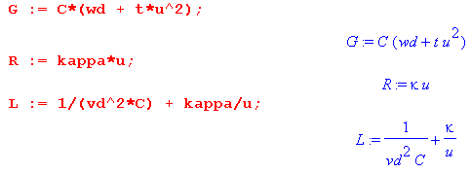

Next, we enter the intermediate variables a and c from box (Q.2.1),

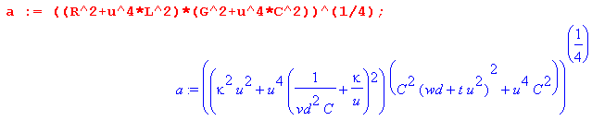

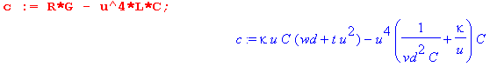
Large ω limit for Re(k)

The real part of k(ω) is then given from (Q.2.1) as follows:

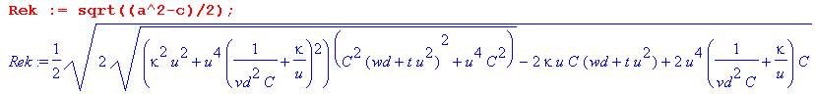

An asymptotic expansion of Re(k) for large ω (large u ≡ $\sqrt{ω}$) is then found to be,

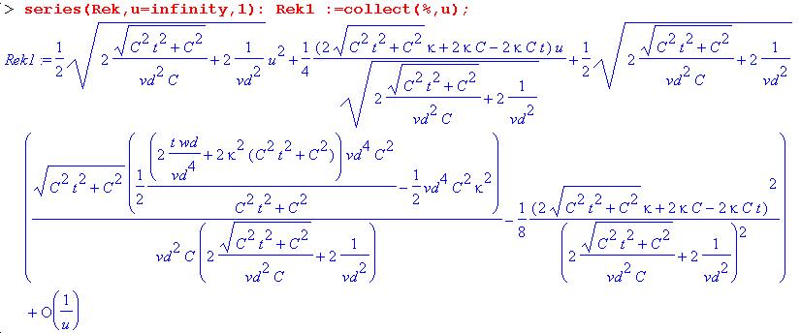

which has the form Au2 + Bu + C +O(1/u). Maple next processes the first three terms by first simplifying them, then expanding them in small parameter t. That is, we now regard t ≡ tanL << 1. The results are

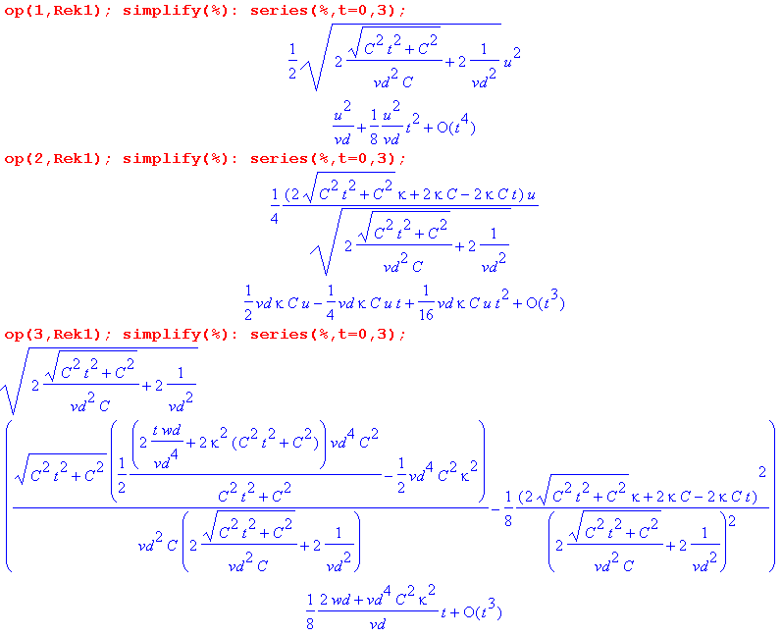
It is important to display the "op" operands to make sure the correct one has been grabbed, since Maple is a little arbitrary in how it orders terms. Collecting the results, replacing u by $\sqrt{ω}$, and keeping only the leading terms in t = tanL, the resulting large ω limit for Re(k) is,

Re(k) ≈ (1/vd)ω + (1/2)vdκC $\sqrt{ω}$ + (1/8vd)( 2ωd + vd4C2κ2) tanL + O(1/$\sqrt{ω}$) (Q.3.3)

Large ω limit for Im(k)

The imaginary part of k(ω) is then given from (Q.2.1) as follows:

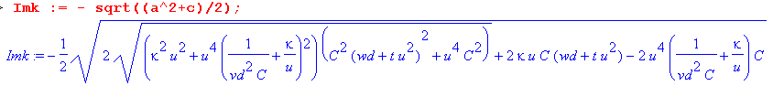
An asymptotic expansion of Im(k) for large ω (large u ≡ $\sqrt{ω}$) is then found to be,

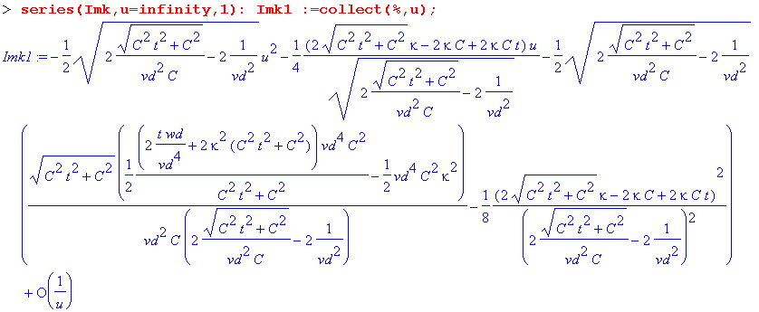

which has the form Au2 + Bu + C +O(1/u). Maple next processes the first three terms by first simplifying them, then expanding them in small parameter t ≡ tanL << 1. The results are

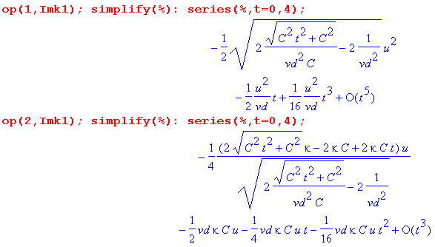
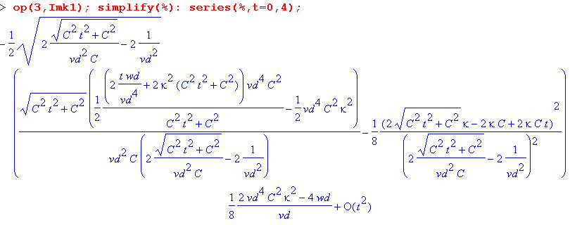

Collecting the results, replacing u by $\sqrt{ω}$, and keeping only the leading terms in t, the resulting large ω limit for Im(k) is,

Im(k) ≈ - ω tanL /(2vd) - (vdκC/2) $\sqrt{ω}$ - (1/4vd)(2ωd - vd4C2κ2) + O(1/$\sqrt{ω}$) (Q.3.4)

We now summarize these results as

Fact 2: The large ω asymptotic expansion for k(ω), assuming tanL << 1, is given by (Q.3.5)

Re(k) ≈ ω/vd + (1/2) vdκC $\sqrt{ω}$ + (1/8vd)( 2ωd + vd4C2κ2) tanL + O(1/$\sqrt{ω}$)
Im(k) ≈ - ω tanL /(2vd) - (vdκC/2) $\sqrt{ω}$ - (1/4vd)(2ωd - vd4C2κ2) + O(1/$\sqrt{ω}$)

where κ ≡ ( $\frac{1}{p1}$ + $\frac{1}{p2}$)$\frac{μ}{2σ}$ and ωd ≡ (σd/εd)

Keeping only the leading terms for large ω,

Re(k) ≈ (ω/vd) vd = 1/$\sqrt{LeC}$ ≈ 1/$\sqrt{LC}$
Im(k) ≈ - ω tanL /(2vd)

Dimension checks!

dim(ω/vd) = sec-1 * sec/m = 1/m = correct

dim(vdκC$\sqrt{ω}$) = m/sec * ohm/m * sec1/2 * far/m * sec-1/2 = 1/sec *ohm-far/m = 1/m OK

dim(ωd/vd) = sec-1 * sec/m = 1/m OK

dim(C2κ2vd3) = ohm2/m2 sec * far2/m2 * m3/sec3 = (ohm-far)2 m-1 sec-2 =sec2 m-1 sec-2 = 1/m

The leading term Re(k) = ω/vd is the traditional result obtained from taking the large ω limit of the expression k = -j$\sqrt{(R+jωL)(G+jωC)}$ when the four parameters are treated as constants in ω,

k = -j$\sqrt{(R+jωL)(G+jωC)}$ ≈ -j $\sqrt{(jωL)(jωC)}$ = (-j)(j)ω$\sqrt{LC}$ = ω$\sqrt{LC}$ ≈ ω$\sqrt{LeC}$ = ω/vd

This fact is obvious from the large-ω model stated in (Q.3.1) which we repeat here:

G(ω) = C (ωd + tanL ω ) ωd ≡ (σd/εd)
R(ω) = κ $\sqrt{ω}$
L(ω) = 1/(Cvd2) + (κ/$\sqrt{ω}$) κ ≡ ( $\frac{1}{p1}$ + $\frac{1}{p2}$)$\frac{μ}{2σ}$ (Q.3.1)

Since tanL << 1 one has

G + jωC = C (ωd + tanL ω ) + jωC = C ωd + ωC( tanL + j) ≈ ωCj = jωC
R + jωL = κ $\sqrt{ω}$ + jω [1/(Cvd2) + (κ/$\sqrt{ω}$) ] ≈ jωLe ≈ jωL

k = -j$\sqrt{(R+jωL)(G+jωC)}$ = -j $\sqrt{(jωL)(jωC)}$ = ω$\sqrt{LC}$ ≈ ω$\sqrt{LeC}$ = ω/vd

Q.4 Real and Imaginary part of k(ω) for small ω

If the DC conductance Gd = ωd C is non-vanishing (because σd > 0) we find one set of results, but if the dielectric is a perfect vacuum (perhaps air) with σd = 0, we get a different set of results. The two cases are treated separately below.

Small ω limit for k(ω) for Gd > 0

The model of box (Q.1.9) at small ω reads,

G(ω) = C (ωd + tanL ω ) ωd ≡ (σd/εd)
R(ω) = Rdc
L(ω) = Le + Lidc (Q.4.1)

Since L(ω) is a constant in the small ω limit of our model, we represent it in the Maple code as the constant symbol Ldc, where Ldc = Le + Lidc .

Defining t ≡ tanL and u ≡ $\sqrt{ω}$, wd ≡ ωd, these expressions are

G = C(wd + t u2) R = Rdc L= Ldc (Q.4.2)

We duly enter these expressions into Maple,
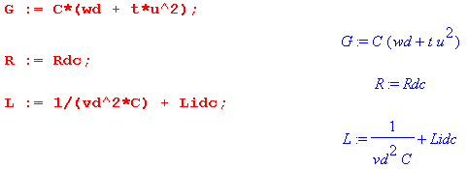
Next, we enter the intermediate variables a and c from box (Q.2.1),

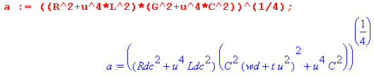

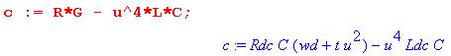

Small ω limit for Re(k) for Gd > 0

The real part of k(ω) is then given from (Q.2.1) as follows:

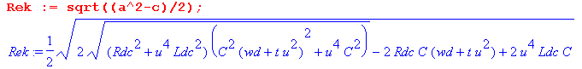

An expansion of Re(k) for small ω (small u ≡ $\sqrt{ω}$) is then found to be,

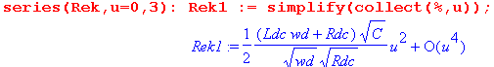

which has the form Au2 + O(u4) and which is independent of t = tanL. We thus find that, for small ω,

Re(k) ≈ (ω/2) (Ldcωd + Rdc) $\sqrt{C/(ωdRdc)}$ + O(ω2) (Q.4.3)

Dimension check:

dim(RHS) = sec-1 * ohms/m * [ far * sec * mho ]1/2 = sec-1 * ohms/m * [sec2 * mho2 ]1/2

= sec-1 * ohms/m * sec * mho = 1/m = correct

Small ω limit for Im(k) for Gd > 0

The imaginary part of k(ω) is given from (Q.2.1) as follows:

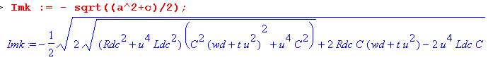

An expansion of Im(k) for small ω (small u ≡ $\sqrt{ω}$) is then found to be,

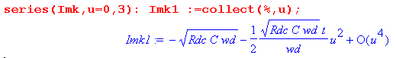
which has the form A + Bu2 + O(u4). We thus find that, for small ω,

Im(k) ≈ - $\sqrt{RdcCωd}$ [ 1 + (1/2) tanL (ω/ωd)] + O(ω2) (Q.4.4)

Fact 3: The small ω limit for k(ω), assuming Gd > 0, is given by (Q.4.5)

Re(k) ≈ (ω/2) (Ldcωd + Rdc) $\sqrt{C/(ωdRdc)}$ + O(ω2)
Im(k) ≈ - $\sqrt{RdcCωd}$ [ 1 + (tanL/2) (ω/ωd)] + O(ω2) ωd ≡ (σd/εd)

Notice that Im(k) → - $\sqrt{RdcCωd}$ > 0 as ω→ 0, indicating the presence of loss at DC. This loss is just the ohmic loss in the dielectric due to σd > 0. One can see that the limit ωd → 0 of the above expressions is ill defined, which is the reason we treat that case separately.

Fact 3 dimension checks:

dim(Cvd2Rdc) = far/m * m2/sec2 * ohms/m = far-ohm/sec2 = sec/sec2 = sec-1 matches ωd

dim (RdcCωd) = ohm/m*far/m*sec-1 = ohm-far sec-1/m2 = 1/m2

dim (vd2$\sqrt{RdcCωd}$) = m2/sec2 * 1/m = m/sec2

dim(ω ωd/ ( vd2$\sqrt{RdcCωd}$ )) = sec-2 * sec2/m = 1/m = correct!

Small ω limit for k(ω) for Gd = 0

Here we rerun the Maple code shown above setting wd = 0 at the start. For Re(k) we find,

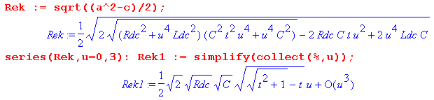
which has the form Au + O(u3). Expanding the coefficient A for small t = tanL then gives

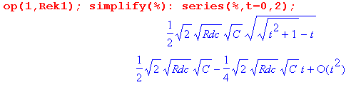

from which we find that with t << 1,

Re(k) ≈ $\sqrt{RdcC/2}$ $\sqrt{ω}$( 1 - tanL/2) + O(ω3/2) (Q.4.6)

For Im(k) the corresponding results are

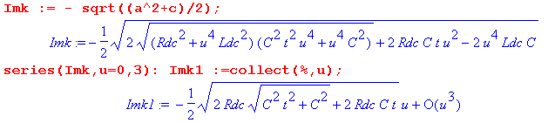
which again has the form Au + O(u3). Expanding the coefficient A for small t = tanL then gives

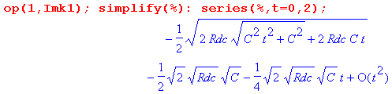
so that

Im(k) ≈ - $\sqrt{RdcC/2}$ $\sqrt{ω}$( 1 + tanL/2) + O(ω3/2)

The results are then.

Fact 4: The small ω limit for k(ω), assuming Gd = 0, is given by (Q.4.7)

Re(k) ≈ + $\sqrt{RdcC/2}$ $\sqrt{ω}$( 1 - tanL/2) + O(ω3/2)
Im(k) ≈ - $\sqrt{RdcC/2}$ $\sqrt{ω}$( 1 + tanL/2) + O(ω3/2)

In this case, Im(k) → 0 as ω→0 so there is no DC loss in the dielectric, as one would expect with σd= 0.

Q.5 Real and Imaginary part of Z0(ω)

Here is the separation of Z0(ω) into its real and imaginary parts:

Fact 5: The real + imaginary decomposition of Z0 is given by (Q.5.1)

Z0 = $\frac{R + jωL}{G + jωC}$ = $\frac{z}{y}$ = (b/$\sqrt{2}$) [ $\sqrt{1+(d/a2)}$ - jσ$\sqrt{1-(d/a2)}$ ]

where b = ( $\frac{R2+ω2L2}{G2+ω2C2}$)1/4 = |Z0| a = [(R2+ω2L2)(G2+ω2C2)]1/4 as in (Q.2.1)
σ = sign(RC-LG) d = RG + ω2LC

Proof of Fact 5: The proof is similar to that of Fact 1. Let

q = $\frac{z}{y}$ = $\frac{R+jωL}{G+jωC}$ = |q| ejθ -π < θ < π ( but see few lines below) .

Then
|q|2 = | $\frac{R+jωL}{G+jωC}$| 2 = $\frac{R2+ω2L2}{G2+ω2C2}$ ≡ b4 => |q| = $\frac{R2+ω2L2}{G2+ω2C2}$= b2 .

Next,

q = $\frac{R+jωL}{G+jωC}$ = $\frac{R+jωL}{G+jωC}$ $\frac{G-jωC}{G-jωC}$ = $\frac{(R+jωL)(G-jωC)}{G2+ω2C2}$ = $\frac{RG+jω(LG-RC) + ω2LC}{G2+ω2C2}$
so
Re(q) = $\frac{RG + ω2LC}{G2+ω2C2}$ > 0 => -π/2 < θ < π/2

Im(q) = $\frac{ω(LG-RC)}{G2+ω2C2}$ sign[Im(q)] = sign(LG-RC) = sign(θ) ≡ Σ .

Then
cosθ = Re(q)/ |q| = $\frac{(RG + ω2LC)}{G2+ω2C2}$ $\frac{G2+ω2C2}{R2+ω2L2}$ = $\sqrt{(G2+ω2C2)(R2+ω2L2)}$

≡ d/a2 where a = [(R2+ω2L2)(G2+ω2C2)]1/4 and d ≡ RG + ω2LC .
Now write

s ≡ $\frac{z}{y}$ = $\sqrt{q}$ = |s| eiφ |s| = $\sqrt{|q|}$ = b = |Z0| φ = θ/2 -π/4 < φ < π /4

Re(s) = |s| cosφ = b cos(θ/2) = b $\sqrt{(1 +cosθ)/2}$ = (b/$\sqrt{2}$)$\sqrt{1+d/a2}$
Im(s) = |s| sinφ = b sin(θ/2) = Σ b $\sqrt{(1 -cosθ)/2}$ = Σ (b/$\sqrt{2}$)$\sqrt{1-d/a2}$

giving the result

s = (b/$\sqrt{2}$) [$\sqrt{1+d/a2}$ + jΣ $\sqrt{1-d/a2}$]

where b = ($\frac{R2+ω2L2}{G2+ω2C2}$)1/4 = |Z0| a = [(R2+ω2L2)(G2+ω2C2)]1/4
Σ = sign(LG-RC) d ≡ RG + ω2LC .

Letting σ = -Σ = sign(RC-LG) one gets the final form,

s = (b/$\sqrt{2}$) [$\sqrt{1+d/a2}$ - jσ $\sqrt{1-d/a2}$]

where b = ($\frac{R2+ω2L2}{G2+ω2C2}$)1/4 = |Z0| a = [(R2+ω2L2)(G2+ω2C2)]1/4
σ = sign(RC-LG) d ≡ RG + ω2LC .

Our Maple verification of this result is a bit ugly so we omit the code.
An alternate geometric derivation giving the same results begins as follows:

Z0 = $\frac{R +zL}{G +zC}$ = $\frac{L}{C}$$\frac{z + (R/L)}{z + (G/C)}$ = $\frac{L}{C}$$\frac{z + r}{z + g}$ where r = (R/L) and g = (G/C) .

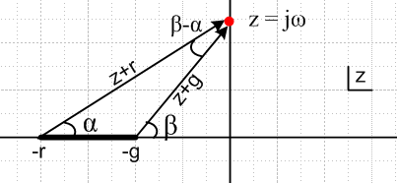 Fig Q.1

The drawing shows the complex z plane for the function Z0(z) = $\frac{L}{C}$$\frac{z + r}{z + g}$in the particular case that r > g, where the z-plane has a branch cut from -r to -g. The z values of interest are only those on the positive imaginary axis where z = jω.

Reader Exercise: Finish this derivation and obtain the results shown in (Q.5).

Hint: cos(β-α) = (rg+ω2)/(AB) and sin(β-α) = ω(r-g)/(AB) where A = $\sqrt{ω2+r2}$ and B = $\sqrt{ω2+g2}$.

Q.6 Real and Imaginary part of Z0(ω) for large ω

For large ω, our models for G,R,L were found to be

G = C(wd + t u2) R = κu L= 1/(Cvd2) + κ/u (Q.3.2)

These expressions are entered into Maple as before. Next, we enter the intermediate variables a, b, and d from box (Q.5.1)

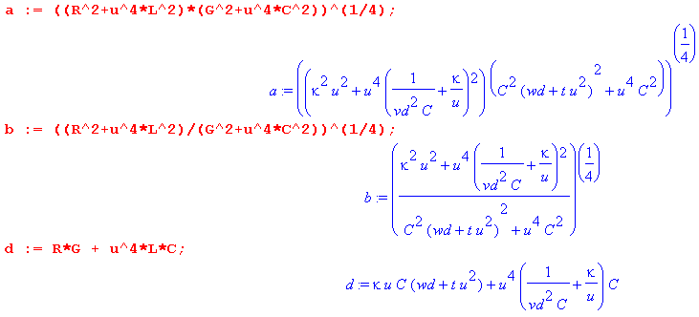
Large ω limit for Re(Z0)

The real part of Z0(ω) is then given from (Q.5.1) as follows:

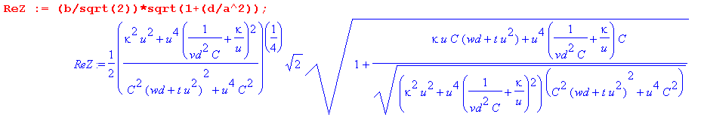
An asymptotic expansion of Re(Z0) for large ω (large u ≡ $\sqrt{ω}$) is then found to be,

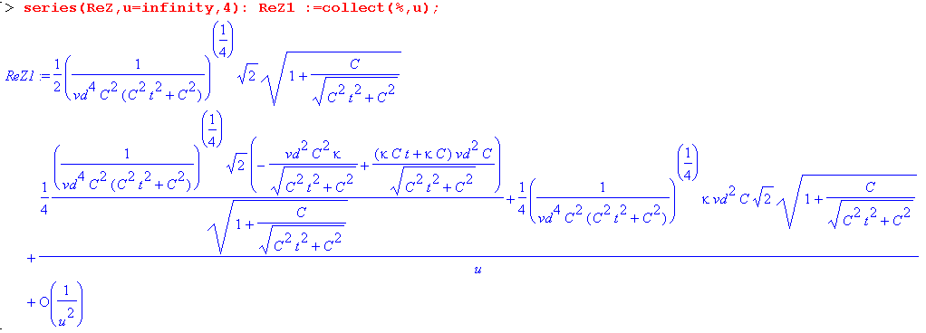

which has the form A + B/u + O(1/u2) . The two leading terms are then expanded for small t to get

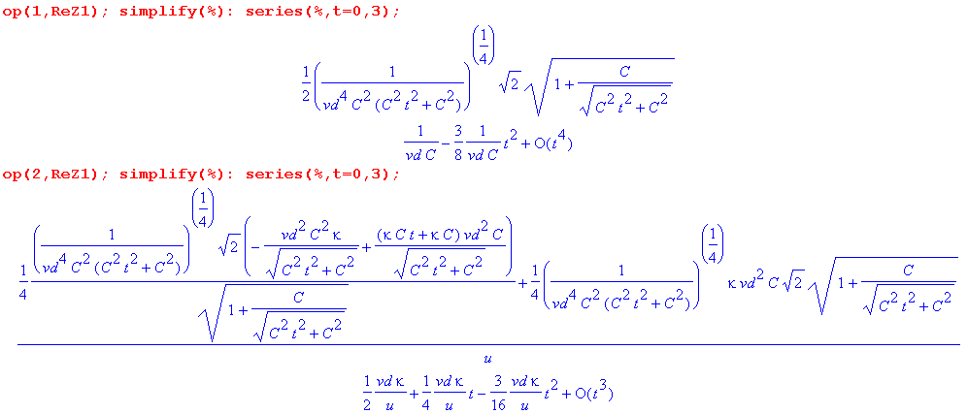

Collecting the results, replacing u by $\sqrt{ω}$, and keeping only the leading terms in t = tanL, the resulting large ω limit for Re(Z0) is,

Re(Z0) ≈ 1/(vdC) + (vdκ/2) 1/$\sqrt{ω}$ + O(1/ω)

Large ω limit for Im(Z0)

The imaginary part of Z0(ω) is given from (Q.5.1) as follows:

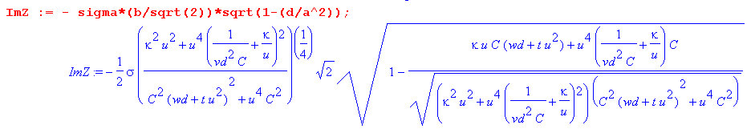
An asymptotic expansion of Im(Z0(ω)) for large ω (large u ≡ $\sqrt{ω}$) is then found to be,

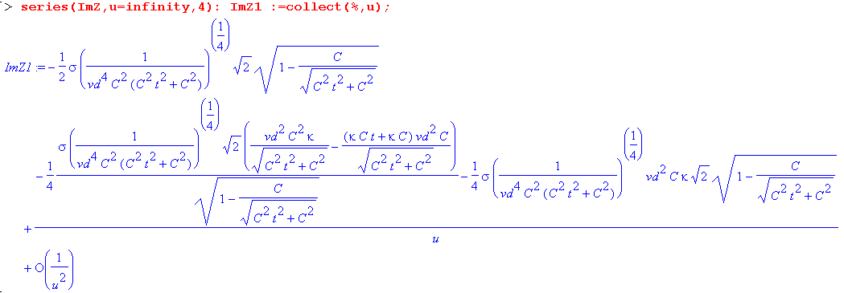

which has the form A + B/u + O(1/u2). Maple next processes the first two terms by first simplifying them, then expanding them in small parameter t ≡ tanL << 1. The results are

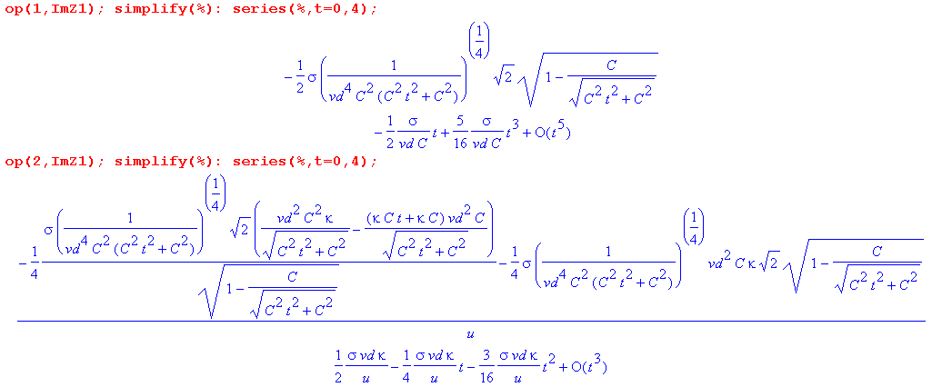

Collecting the results, replacing u by $\sqrt{ω}$, and keeping only the leading terms in t, the resulting large ω limit for Im(Z0) is,

Im(Z0) ≈ - σ tanL/(2vdC) + σ(vdκ/2)/ $\sqrt{ω}$ + O(1/ω)

Finally, the sign σ is the sign of expression RC-LG,

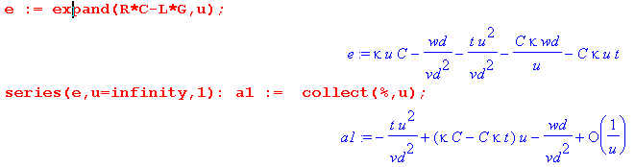
so for large ω and small t = tanL we have

σ = sign [ - (tanL /vd2) ω + κC$\sqrt{ω}$ - ωd/vd2 ]

which is then σ = -1 for very large ω.

Dimension check:

dim(ω/vd2) = sec-1 * sec2/m2 = sec/m2

dim (κC$\sqrt{ω}$) = ohm/m * sec1/2 * far/m * sec-1/2 = far-ohm/m2 = sec/m2

We now summarize these results as

Fact 6: The large ω asymptotic expansion for Z0(ω), assuming tanL << 1, is given by (Q.3.5)

Re(Z0) ≈ 1/(vdC) + (vdκ/2) 1/$\sqrt{ω}$ + O(1/ω)
Im(Z0) ≈ - σ tanL/(2vdC) + σ(vdκ/2)/ $\sqrt{ω}$ + O(1/ω)
where κ ≡ ( $\frac{1}{p1}$ + $\frac{1}{p2}$)$\frac{μ}{2σ}$ σ = sign [ - (tanL /vd2) ω + κC$\sqrt{ω}$ - ωd/vd2 ]

Keeping only the leading terms for large ω,

Re(Z0) ≈ 1/(vdC) = $\sqrt{Le/C}$ ≈ $\sqrt{L/C}$ vd = 1/$\sqrt{LeC}$ ≈ 1/$\sqrt{LC}$
Im(Z0) ≈ + tanL/(2vdC) = (1/2) tanL $\sqrt{Le/C}$ σ = -1

The leading term Re(Z0) ≈ $\sqrt{L/C}$ is the traditional result obtained from taking the large ω limit of the expression Z0 = $\frac{R + jωL}{G + jωC}$ when the four parameters are treated as constants in ω. This fact is obvious from the large-ω model stated in (Q.3.1) which we repeat here:

G(ω) = C (ωd + tanL ω ) ωd ≡ (σd/εd)
R(ω) = κ $\sqrt{ω}$
L(ω) = 1/(Cvd2) + (κ/$\sqrt{ω}$) κ ≡ ( $\frac{1}{p1}$ + $\frac{1}{p2}$)$\frac{μ}{2σ}$ (Q.3.1)
Since tanL << 1 one has

G + jωC = C (ωd + tanL ω ) + jωC = C ωd + ωC( tanL + j) ≈ ωCj = jωC
R + jωL = κ $\sqrt{ω}$ + jω [1/(Cvd2) + (κ/$\sqrt{ω}$) ] ≈ jωLe ≈ jωL

Q.7 Real and Imaginary part of Z0(ω) for small ω

For small ω the parameter model is that stated in (Q.4.2.)

G = C(wd + t u2) R = Rdc L= Le + Lidc (Q.4.2)

These expressions are entered into Maple followed by expressions for the intermediate parameters of (Q.5.1)

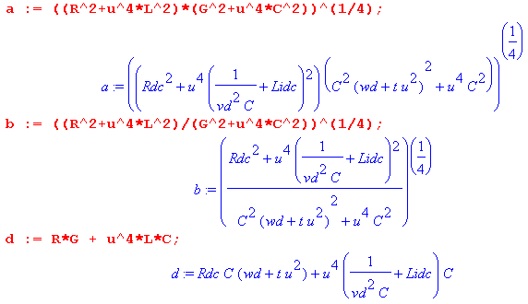

The real part of Z0(ω) is then given from (Q.5.1) as follows:

An expansion of Re(Z0) for small ω (small u ≡ $\sqrt{ω}$) is then found to be,

