Plotting k(ω) PhL 9.8.14

I have done this somewhere before, but I will just start over. The goal here is simple: use the Appendix Q Heaviside model for the R,G,C,L parameters (which model I now think is good), and install these values into the Rek and Imk functions found in Appendix Q. Or, just use the full k(ω) expression and try to get Maple to carry out the plots. I expect lots of trouble in doing this. I will use the Belden parameters in order to get actual plots. The mws file will be called "plotting k.mws.". I will start with "plotting Li and R" mws since this already has the Heaviside model entered with various Belden numbers.

First, here are the Rek and Imk expressions in terms of R,G,C,L:

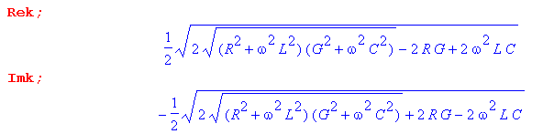

Now first let's install just the low ω part of the Heaviside model (roughly below 1 MHz),

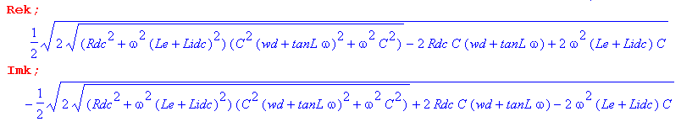

These are rather complicated looking functions in which ω appears in many places. But let's now install our Belden parameters,

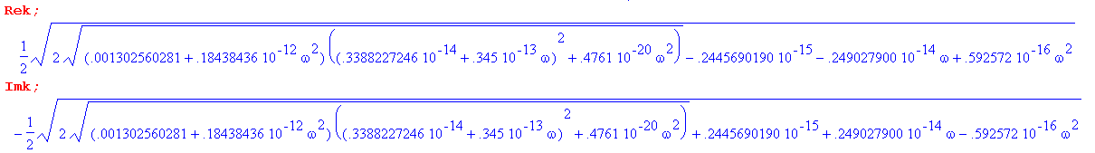

Even now it is hard to state the functional form here for a wide range of ω. I think this is it: for our range of ω you can neglect the term associated with G since has things like 10-26ω2 and smaller. Then the ωC term is left and we have something like this

Rek = [10-10 ω (inside radical) - .6 10-16 ω2 ]1/2 ≈ 10-5 ω1/2 (.001)1/4 ~ 10-5 ω1/2 .17
~ 10-6 ω1/2.

Then logRek = -6 + 1/2 logω. The intercept is 6 units down from vertical marker 1e0 I think, and that agrees with the plot below.

Here is a plot for ω = 100 to ω = 500,000:

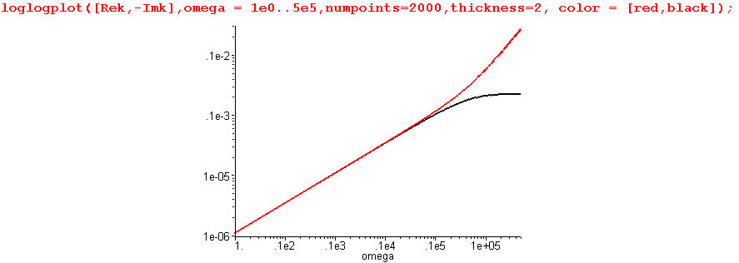

What is this graph telling us? I think things are easier if we start this way instead:

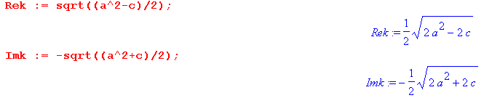

and then we plot the ratio of c to a2

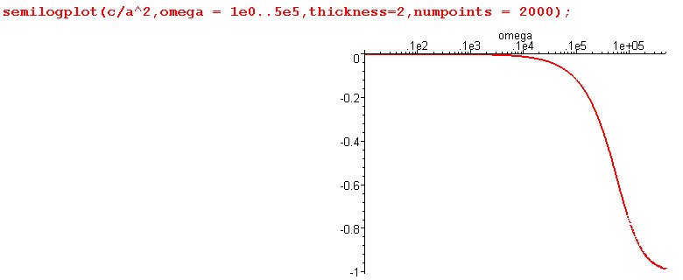

This shows that for ω < 10,000 we can neglect c relative to a2 so in this range we expect to see simply that Rek = -Imk , but then we expect the two curves to pull apart for larger ω, and this is exactly what we see in the plot above.
So go back to the graph above:

I think this gives a very reasonable view of Re(k) and Im(k) for the usual low ω
of ω = 1 to ω = 500,000. Nothing dramatic happens. The slope of the straight part is 1/2 suggesting that the basic form is Rek = ω1/2 in the low range, and I show how this arises above. Notice that we are not looking at any ultra low ω in this plot.
If we extend the above plot to smaller frequencies ω < 1, we find that the red and black curves pull apart,

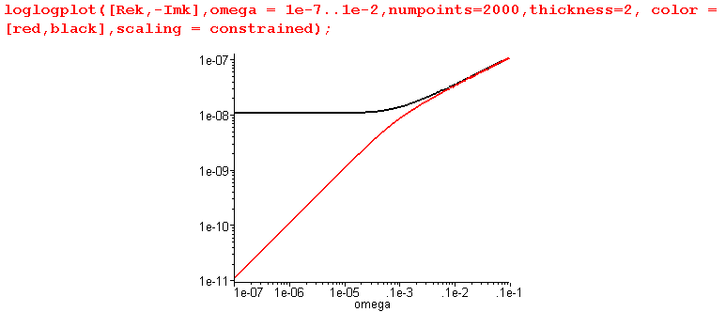

This shows that Im k → constant while Re k ~ ω in this low ω range, in exact agreement with our low ω limit prediction

Fact 3: The small ω limit for k(ω), assuming ωd > 0, is given by (Q.4.6)

Re(k) ≈ (ω/2) (Rdc + ωdLdc) $\sqrt{C/(ωdRdc)}$ + O(ω2) ω < ωd = (σd/εd)
Im(k) ≈ - $\sqrt{RdcCωd}$ [ 1 + (tanL/2) (ω/ωd)] + O(ω2)

Now that we have a handle on the behavior of things below 1 MHz or so, let's install the full Heaviside model and try to extent the frequency range upwards. First, I restore the full R and Li expressions and verify that the above plots don't change! Then I try to extend the first one upwards.

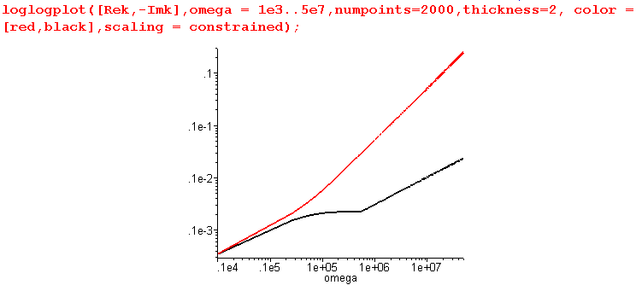

Here you see the Imk curve taking a jag at one of the crossover points.
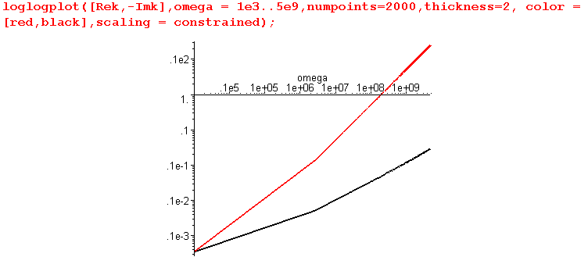

Here is a question: On the right, we should be in the large ω limit of the theory which says this:

Re(k) ≈ (ω/vd) + (vdκC/2) $\sqrt{ω}$ + (1/4vd)(ωd +vd4C2κ2/2) tanL + O(1/$\sqrt{ω}$)
Im(k) ≈ - (ω/vd) tanL/2 - (vdκC/2) $\sqrt{ω}$ - (1/2vd)(ωd - vd4C2κ2/2) + O(1/$\sqrt{ω}$)

On a log log plot, these should both have the same slope, but the plot shows different slopes! This has an interesting answer. Even at ω = 1e9 we have not reached the large ω limit! Due to the small tanL, in this range we really have Rek ≈ (ω/vd) and Imk ≈ - (vdκC/2) $\sqrt{ω}$. Here is a Visio clarification

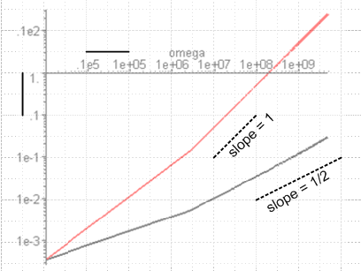

which then verifies the ω and $\sqrt{ω}$behavior or Rek and Imk in the range 1e7 to 1e10. To bring out the parallel slopes, we have to go to much higher ω:

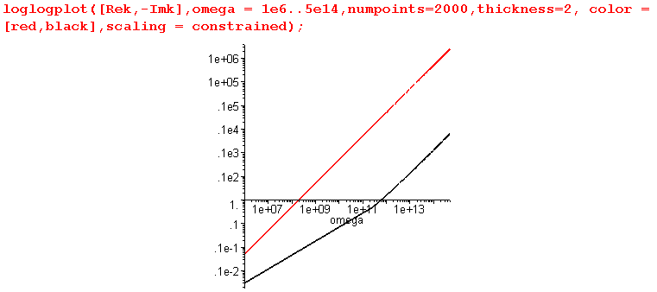
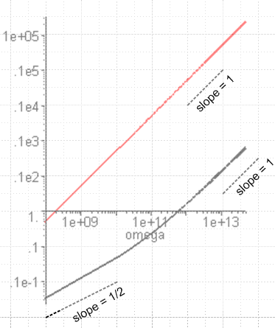

Conclusion: Finally for the Belden cable I have a good view of Rek and Imk over ALL frequencies, and I see how my low ω and high ω limits fit in.

I am reminded right now of a plot I saw in the textbook. It is this:

Pozar, Chapter 14, PDF page 794-5 where we see first this expression of k which is same as mine,

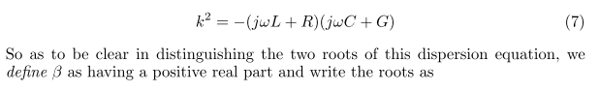

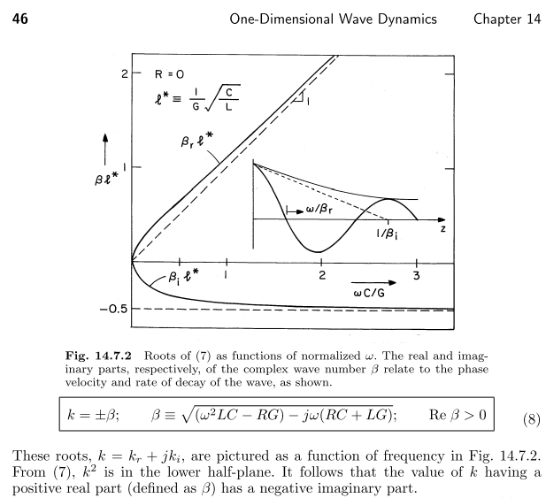

I think he is saying that

Re(k) = kr = βr
Im(k) = ki = βi

where his plot is scaled by factor l* . I presume that the left convergence point should be labeled 0. If we take R,G,L,C to be constants in ω, then

β ≈ j $\sqrt{RG}$ => βr = 0 and βi = $\sqrt{RG}$

but his graph does not show this normally small βi = $\sqrt{RG}$. I think his point is that we have to take the root having the negative imaginary part, just as I always argue.
Again for constant parameters, for large ω I get

and I guess his graph does show this, though he does not comment on it.
Pozar uses the constant-parameters model which I guess I don't really care about.

The other plot I remember is a Z0 one from the Belden paper

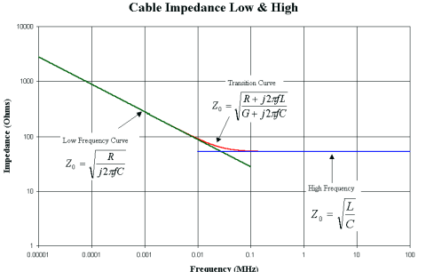

which I will just keep in mind when I get to doing Z0(ω).

