Problem with k(ω) expansion for small ω PhL 9.5.14

The problem: In Appendix Q as it currently stands, I have this expansion of k(ω) for small ω, where I use only my low-ω range model for R,L,G,C : [ this is in "Q2 lo omega k version 3 wd GT 0.mws" ]

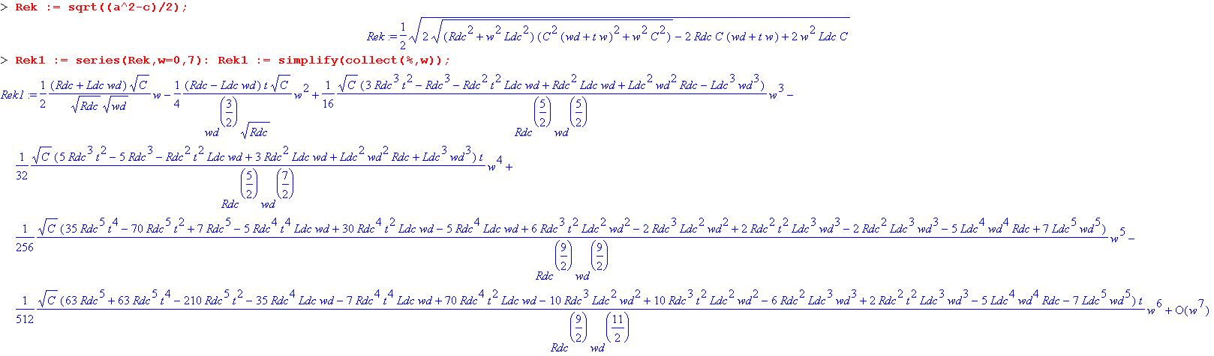

from "Q2 lo omega k version 3 wd GT 0.mws". I know it is illegible, but the problem is this: it seems that this is an expansion in powers of (ω/ωd) where ωd = 10-4. It seems then that the radius of convergence of the expansion is something like 10-4 in ω space, and this makes the series useless (or at least, not too interesting). I want to know something about k(ω) at perhaps ω = 100, 1000 or 10,000, not just ω < 10-4. I can use my "low ω model" up to at least ω = 500,000 so I would like to see a plot of things up to that frequency, but my low-ω expansion cannot do that!
Here is the function I am looking at:

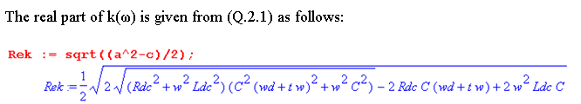
and here are numbers for Belden 8281 cable: [ again, the above uses only the low-ω model ]

Rdc = .036
t = .0005
Ldc = .428 x 10-6
C = 69 x 10-12
wd = .00011

I would certainly like some way to simplify the expression, but everything depends on ω ! I suppose I could just plot the whole thing as is. Just plotting the above functions is a difficult task because I want such a large range of ω. Perhaps it is best to do it in small pieces. For example,

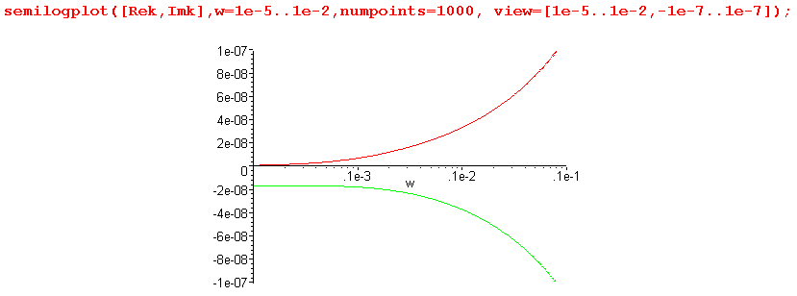

This gives a general idea of what things look like I think from ω = 0 up to ω = 10-2. This does agree with my small ω expansion in that Imk → a negative constant, and Rek→ 0. I can now extend the above picture to the ω = 1 range,

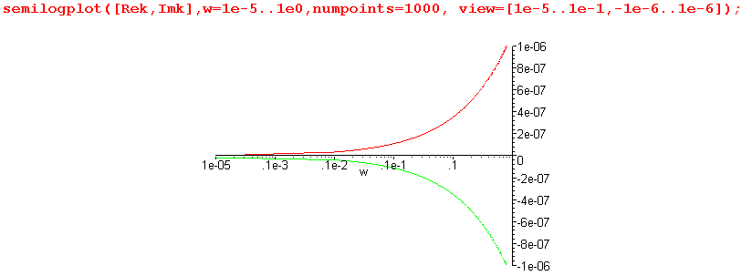

You lose the detail going to ω = 0, but that appears in the previous plot.

Discovery: Once you get above a few Hz, -Imk and Rek are identical! This is an important fact that I have completely missed.

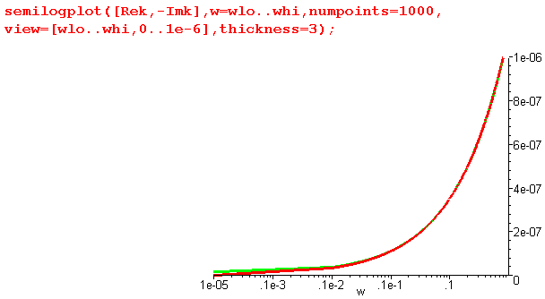

But then they split apart at higher ω

