This was added to the new Appendix Q. Can dump this file soon.

Q.9 The general appearance of Re(Z0) and Im(Z0) for Belden 8281 cable

This section is very similar to Section Q.5 above concerning the appearance of k(ω). We are interested in viewing the real and imaginary parts of Re(Z0) over the full frequency range, not just at the extremes of small ω and large ω. The expressions shown in (Q.6.1) are,

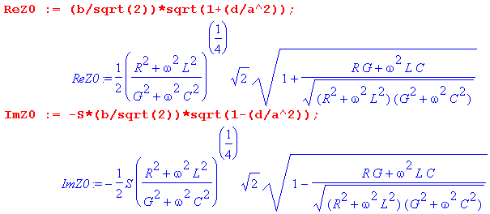 (Q.9.1)

When the full Heaviside model of Section Q.1 is inserted for the parameters R,L and G, one can see that ReZ0 and ImZ0 are complicated functions of ω. Rather than attempt to deal with generic special cases (such as small G), we shall again consider the Belden 8281 cable of Appendix R to be a "typical" transmission line with regard to the relative sizes of the parameters Rdc, Le, Lidc, C, ωd, and tanL. In our model the "low frequency" range will be taken to be ω = 1 to 500,000.
A new feature not present in the k(ω) case is the sign S which from (Q.6.1) is S = sign(RC-LG). Here are plots of RC-LG and S = sign(RC-LG) for the Belden cable, using the same wide-range ω plotting trick mentioned at the end of Section Q.5 ( horizontal axis labeled by log10(ω) ):

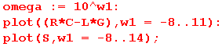

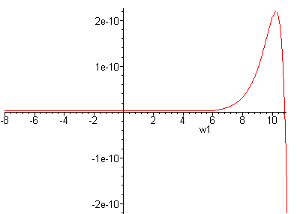 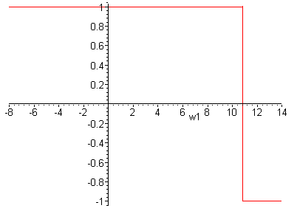 Fig Q.9.1

Basically σ = +1 up to about ω = 1011 then it becomes -1.

Now recall from (Q.6.1) that

Rek = ( b/$\sqrt{2}$) [ $\sqrt{1+(d/a2)}$ ] -Imk = σ ( b/$\sqrt{2}$) [ $\sqrt{1-(d/a2)}$] . (Q.9.2)

Here is a plot of the ratio d/a2 (using our model and the Belden parameters) only up to ω = 500,000 :

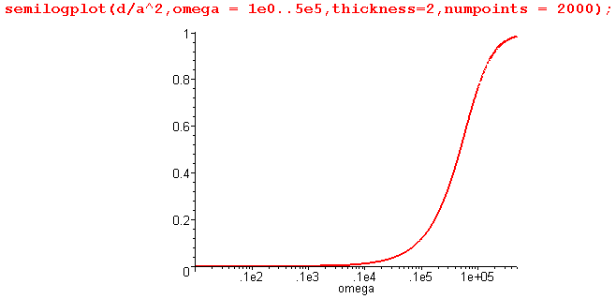 Fig Q.9.2

This shows that d << a2 on the left side of the graph, so for that range we would expect to find that ReZ0 and -ImZ0 are about the same. That fact is born out in this plot of ReZ0 and - ImZ0 for ω in (10,500,000):

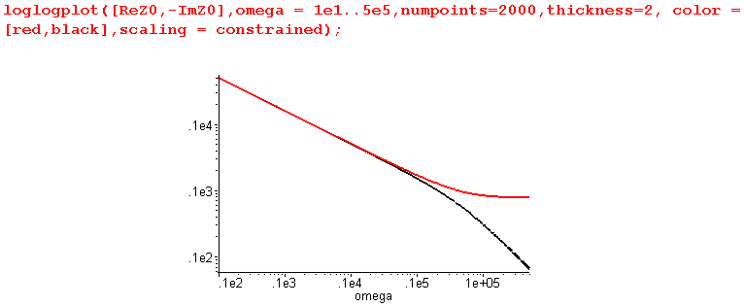 Fig Q.9.3

The red curve is ReZ0, while the black curve is - ImZ0. This plot then gives a good view of ReZ0 and ImZ0 for what one would normally call "the low frequency range" of this Belden cable, roughly below 1 MHz. However, this is not the low frequency range for which (Q.8.3) applies. Recall that (Q.8.3) only applies for ω < ωd (and ωd = σd/εd ≈ 5 x 10-5 for the Belden 8281 cable), which we call "ultra low frequencies". We can redo the above plot in the ultra-low range ω = 10-7 to 10-2 sec-1 :

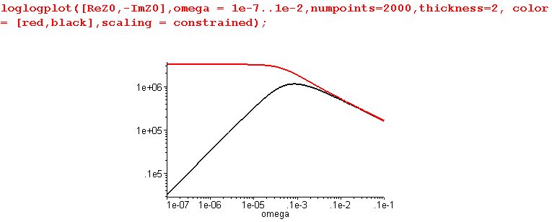 Fig Q.9.4

This shows what happens as we go off the left edge of the previous graph. We find that ReZ0 goes to a constant, while -ImZ0 has slope 1 so is proportional to ω. This is consistent with the low ω limit (Q.8.3),

Re(Z0) ≈ $\sqrt{Rdc/(Cωd)}$ - $\sqrt{Rdc/(Cωd)}$ tanL/2 (ω/ωd) + O(ω2) (Q.8.3)
Im(Z0) ≈ - (1/2) ( Rdc - ωdLdc ) (ω/ωd) / $\sqrt{RdcC ωd}$ + O(ω2) ωd ≡ (σd/εd)

Specifically, $\sqrt{Rdc/(Cωd)}$ = $\sqrt{Rdc/Gdc}$ = $\sqrt{.036 /.34 x 10-14}$= 3.25 x 106 as the plot shows.

Having dealt with low and ultra-low frequencies, we turn now to higher frequencies. For ω in the range 103 to 1010 one finds,

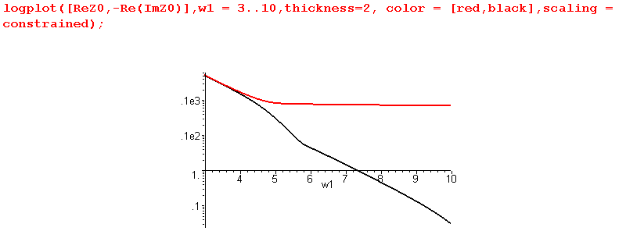Fig Q.9.5

Recall that ImZ0 experiences a sign change in the region of ω = 1011 (sign S goes from +1 to -1) as shown in this non-log plot of just -ImZ0 for ω=109 to 1018:

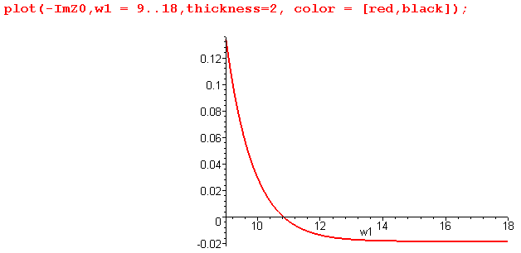 Fig Q.9.6

In fact, -ImZ0 approaches the constant value indicated in our large ω limit given in (Q.7.4),

Re(Z0) ≈ [1/(vdC)] + (vdκ/2) /$\sqrt{ω}$ + O(1/ω)
Im(Z0) ≈ [ 1/(vdC)] tanL/2 - (vdκ/2) /$\sqrt{ω}$ + O(1/ω) (Q.7.4)
where κ ≡ ( $\frac{1}{p1}$ + $\frac{1}{p2}$)$\frac{μ}{2σ}$

that value being about

ImZ0 → [ 1/(vdC)] tanL/2 = [ $\sqrt{εd/ε0}$/(cC)] tanL/2 = [ $\sqrt{2.3}$/(3x108 x 69 x 10-12)] .0005/2

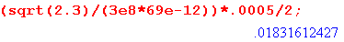

in agreement with the above plot.
Because -ImZ0 goes negative, we cannot do a full log plot of -ImZ0 without adding a small positive offset. This problem did not arise when dealing with k(ω) in Section Q.5 because Imk must always be negative to insure a loss at any ω.
Adding an offset of .02, we then make our plot over a full range of ω:

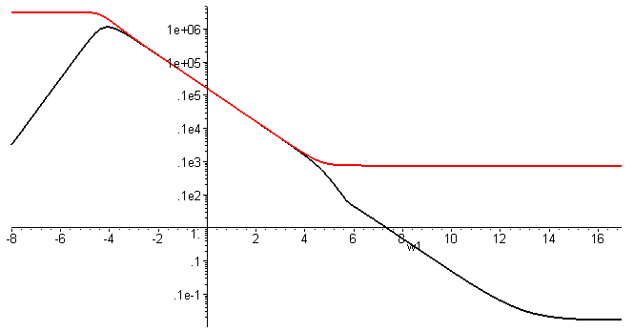
Fig Q.9.7

We have just shown that, for large ω, ImZ0 approaches the constant - .18 Ω shown in (Q.7.4). We now see that ReZ0 also approaches a constant value [1/(vdC)] = [ $\sqrt{εd/ε0}$/(cC)] which is

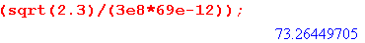

This value of 73.26Ω is slightly less than the nominal cable impedance of 75 Ω. The following plot shows ReZ0 and -ImZ0 for 100 KHz to 1 GHz on the left, and 10 KHz to 100 KHz on the right

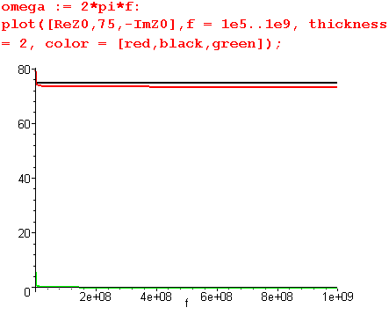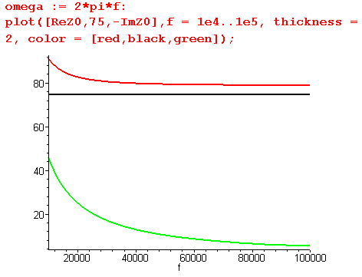
Fig Q.9.8
Above 100 KHz -ImZ0 can be neglected, but at 10KHz it jumps up to 44 Ω.

