Appendix Q: Properties of the function k(ω)

According to Section 5.3 (a), the complex wavenumber k appearing in our standard traveling wave form ej(ωt-kz) is this:

k = k(ω) = -j$\sqrt{zy}$= -j $\sqrt{(R+jωL)(G+jωC)}$ . (Q.1)

Fact 1: The real + imaginary decomposition of k is given by

k = $\frac{a2-c}{2}$ - j $\frac{a2+c}{2}$ k ≡ -j $\sqrt{(R+jωL)(G+jωC)}$ (Q.2)

where
a ≡ (R2+ω2L2)1/4 (G2+ω2C2)1/4 dim(a) = 1/m a > 0 (Q.3)

c ≡ RG - ω2LC dim(c) = 1/m2 c = real, |c| < a2 (Q.4)

Proof of Fact 1: Let

q ≡ zy = (R+jωL)(G+jωC) = (RG-ω2LC) + jω(LG+RC) = c + jω(LG+RC) = |q| ejθ

Then

|q|2 = | (R+jωL)(G+jωC) |2 = | (R+jωL)|2|(G+jωC) |2 = (R2+ω2L2) (G2+ω2C2) = a4

|q| = a2

cosθ = c /|q| = c/a2

Now write

s ≡ $\sqrt{zy}$ = $\sqrt{(R+jωL)(G+jωC)}$ = $\sqrt{q}$ = |s| eiφ |s| = $\sqrt{|q|}$ = a φ = θ/2
Re(s) = |s| cosφ = a cos(θ/2) = a $\sqrt{(1 +cosθ)/2}$ = (a/$\sqrt{2}$)$\sqrt{1+c/a2}$ = $\frac{a2+c}{2}$
Im(s) = |s| sinφ = a sin(θ/2) = a $\sqrt{(1 -cosθ)/2}$ = (a/$\sqrt{2}$)$\sqrt{1-c/a2}$ = $\frac{a2-c}{2}$
s = $\sqrt{zy}$ = $\frac{a2+c}{2}$ + j $\frac{a2-c}{2}$
k = -j$\sqrt{zy}$ = -js = $\frac{a2-c}{2}$ - j $\frac{a2+c}{2}$ QED

Maple verification:

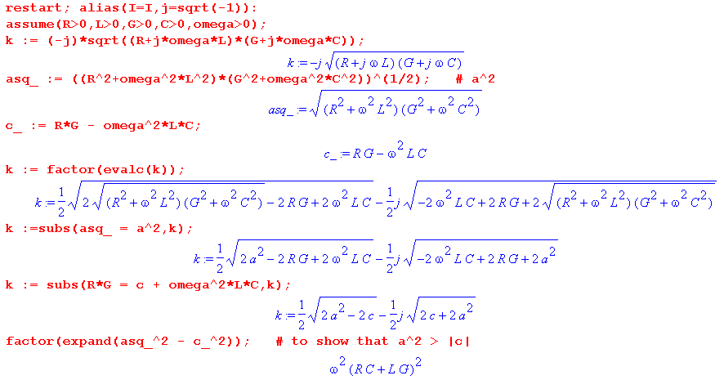

Fact 2: In the high frequency limit,

Re(k) = ω$\sqrt{LC}$ + $\frac{(RC-LG)2}{8ω(LC)3/2}$
Im(k) = - $\sqrt{LC}$ + $\frac{(RC - GL)2 (RC + GL)}{16ω2 (LC)5/2}$ ω >> R/L and ω >> G/C (Q.5)

Proof of Fact 2: All proofs in this appendix were first (laboriously) done by hand, then Maple was used to verify them. For example, the hand derivation of Fact 2 starts out like this:

a2 ≡ (R2+ω2L2)1/2 (G2+ω2C2)1/2 = LC (R2/L2+ω2)1/2(G2/C2+ω2)1/2

= ω2LC ( 1 + R2/(ωL)2)1/2( 1 + G2/(ωC)2)1/2

and then the expansion (1+x)1/2 = 1 + x/2 - x2/8 is used and the derivation continues. For the result to be valid, we must therefore have

R2/(ωL)2 << 1 and G2/(ωC)2 << 1

which says

ω >> R/L and ω >> G/C

Rather than show all the hand-done algebra, we just let Maple do the calculation.

First, for Im(k) all output details are shown:

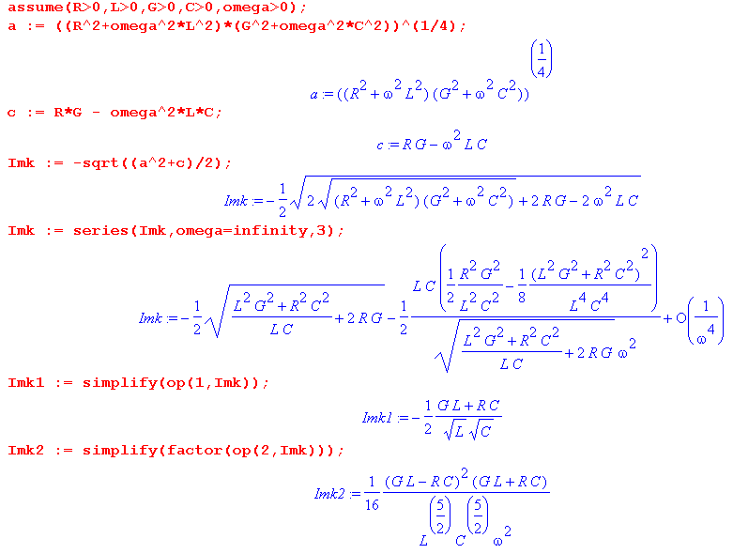

and the reader sees that these first two terms of Im(k) agree with the claim above. Maple has trouble simplifying terms in expressions when they are not isolated, hence the extra code two code lines above.

For Re(k) we suppress the intermediate results to save space (using : instead of ;)

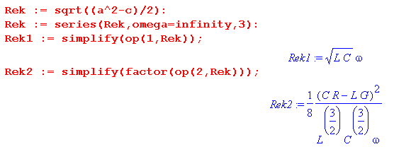
in agreement with the first claim of Fact 2.

Fact 3: In the low frequency limit with G > 0 :

Re(k) = (ω/2)$\sqrt{RG}$
Im(k) = - $\sqrt{RG}$- (ω2/8) $\frac{(RC-LG)2}{(RC)3/2}$ ω << R/L and ω << G/C (Q.6)

Proof of Fact 3:

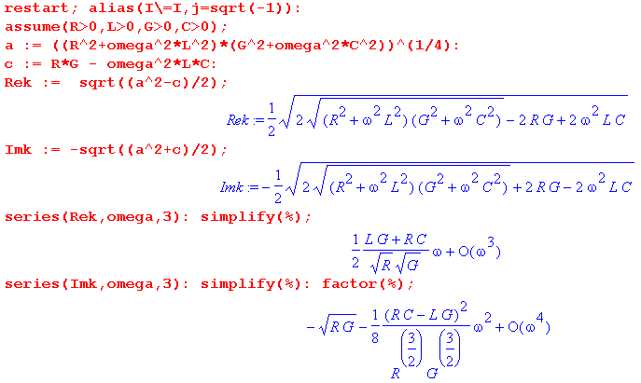

Fact 4: In the low frequency limit with G = 0 ,

Re(k) = $\sqrt{RC/2}$ ω1/2 + $\sqrt{C/8R}$ ω3/2
Im(k) = - $\sqrt{RC/2}$ ω1/2 + $\sqrt{C/8R}$ ω3/2 ω << R/L (Q.7)

Proof of Fact 4:

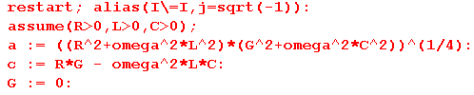
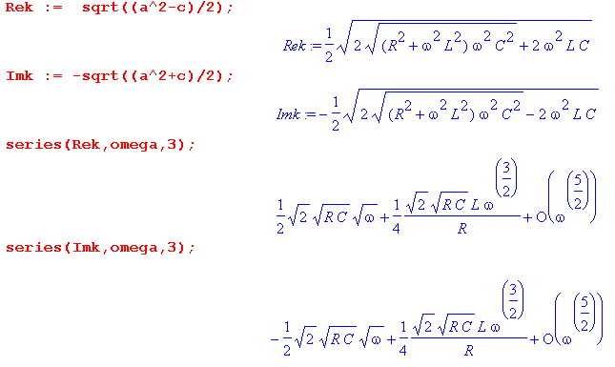

Summary of results:

Summary of k and its limits (Q.8)

k ≡ -j$\sqrt{zy}$= -j $\sqrt{(R+jωL)(G+jωC)}$ // definition of the wavenumber k(ω)

k = $\frac{a2-c}{2}$ - j $\frac{a2+c}{2}$ $\sqrt{zy}$ = $\frac{a2+c}{2}$ + j $\frac{a2-c}{2}$

a ≡ (R2+ω2L2)1/4 (G2+ω2C2)1/4 Re(β'd) = Im($\sqrt{zy}$)
c ≡ RG - ω2LC Im(β'd) = - Re($\sqrt{zy}$)

Large ω: Re(k) = ω$\sqrt{LC}$ + $\frac{(RC-LG)2}{8ω(LC)3/2}$
Im(k) = - $\sqrt{LC}$ + $\frac{(RC - GL)2 (RC + GL)}{16ω2 (LC)5/2}$ ω >> (R/L),(G/C)

Small ω, G>0: Re(k) = (ω/2)$\sqrt{RG}$
Im(k) = - $\sqrt{RG}$- (ω2/8) $\frac{(RC-LG)2}{(RC)3/2}$ ω << (R/L),(G/C)

Small ω, G=0: Re(k) = $\sqrt{RC/2}$ ω1/2 + $\sqrt{C/8R}$ ω3/2
Im(k) = - $\sqrt{RC/2}$ ω1/2 + $\sqrt{C/8R}$ ω3/2 ω << (R/L)

Comment: In principle, all four quantities R,C,L,G can be functions of ω. According to the analysis of Chapter 4 leading to summary box (4.11.34), if we stay away from the low frequency range, only parameter L shows a strong frequency dependence since L = Le + Li(ω). As shown in the comments below (4.11.34), limω→∞ Li(ω) = 0. This is due to the skin effect and result (C.6.8). Thus, we know that limω→∞ L(ω) = Le. But (4.11.34) says LeC = μdεd = 1/vd2 where vd is the speed of light in the dielectric. Therefore, limω→∞ L(ω)C = LeC = 1/vd2 and thus for large ω we get Re(k) = ω $\sqrt{LC}$ = ω/vd and the phase velocity of the wave equals the dielectric speed of light. As ω drops from the high end, the identification of $\sqrt{LC}$ with 1/vd becomes less accurate.

