Fact 5: The real + imaginary decomposition of Z0 is given by

Z0 = $\frac{R + jωL}{G + jωC}$ = $\frac{z}{y}$ = (a/$\sqrt{2}$) [ $\sqrt{1+β/α}$ - jσ$\sqrt{1-β/α}$ ]

where a = ($\frac{R2+ω2L2}{G2+ω2C2}$)1/4 = |Z0| α = $\sqrt{(G2+ω2C2)(R2+ω2L2)}$
σ = sign(RC-LG) β ≡ RG + ω2LC

Proof of Fact 5: The proof is similar to the proof of Fact 1. Let

q = $\frac{z}{y}$ = $\frac{R+jωL}{G+jωC}$ = |q| ejθ -π < θ < π ( but see few lines below)

Then
|q|2 = | $\frac{R+jωL}{G+jωC}$| 2 = $\frac{R2+ω2L2}{G2+ω2C2}$ ≡ a4 => |q| = $\frac{R2+ω2L2}{G2+ω2C2}$= a2

Next,

q = $\frac{R+jωL}{G+jωC}$ = $\frac{R+jωL}{G+jωC}$ $\frac{G-jωC}{G-jωC}$ = $\frac{(R+jωL)(G-jωC)}{G2+ω2C2}$ = $\frac{RG+jω(LG-RC) + ω2LC}{G2+ω2C2}$
so
Re(q) = $\frac{RG + ω2LC}{G2+ω2C2}$ > 0 => -π/2 < θ < π/2

Im(q) = $\frac{ω(LG-RC)}{G2+ω2C2}$ sign[Im(q)] = sign(LG-RC) = sign(θ) ≡ Σ .

Then
cosθ = Re(q)/ |q| = $\frac{(RG + ω2LC)}{G2+ω2C2}$ $\frac{G2+ω2C2}{R2+ω2L2}$ = $\sqrt{(G2+ω2C2)(R2+ω2L2)}$

≡ β/α where α ≡ $\sqrt{(G2+ω2C2)(R2+ω2L2)}$ and β ≡ RG + ω2LC
Now write

s ≡ $\frac{z}{y}$ = $\sqrt{q}$ = |s| eiφ |s| = $\sqrt{|q|}$ = a = |Z0| φ = θ/2 -π/4 < φ < π /4

Re(s) = |s| cosφ = a cos(θ/2) = a $\sqrt{(1 +cosθ)/2}$ = (a/$\sqrt{2}$)$\sqrt{1+β/α}$
Im(s) = |s| sinφ = a sin(θ/2) = Σ a $\sqrt{(1 -cosθ)/2}$ = Σ (a/$\sqrt{2}$)$\sqrt{1-β/α}$

giving the result

s = (a/$\sqrt{2}$) [$\sqrt{1+β/α}$ + jΣ $\sqrt{1-β/α}$]

where a = ($\frac{R2+ω2L2}{G2+ω2C2}$)1/4 = |Z0| α = $\sqrt{(G2+ω2C2)(R2+ω2L2)}$
Σ = sign(LG-RC) β ≡ RG + ω2LC

Letting σ = -Σ = sign(RC-LG) one gets the final form,

s = (a/$\sqrt{2}$) [$\sqrt{1+β/α}$ - jσ $\sqrt{1-β/α}$]

where a = ($\frac{R2+ω2L2}{G2+ω2C2}$)1/4 = |Z0| α = $\sqrt{(G2+ω2C2)(R2+ω2L2)}$
σ = sign(RC-LG) β ≡ RG + ω2LC

Our Maple verification of this result is a bit ugly so we omit the code.
An alternate geometric derivation giving the same results begins as follows:

Z0 = $\frac{R +zL}{G +zC}$ = $\frac{L}{C}$$\frac{z + (R/L)}{z + (G/C)}$ = $\frac{L}{C}$$\frac{z + r}{z + g}$ where r = (R/L) and g = (G/C) .

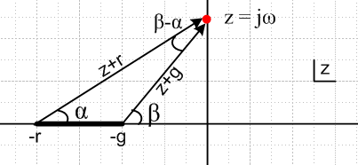

The drawing shows the complex z plane for the function Z0(z) = $\frac{L}{C}$$\frac{z + r}{z + g}$in the particular case that r > g, in which case the z-plane has a branch cut from -r to -g. The z values of interest are only those on the positive imaginary axis where z = jω.

Reader Exercise: Finish this derivation and obtain the same results shown in **

Hint: cos(β-α) = (rg+ω2)/(AB) and sin(β-α) = ω(r-g)/(AB) where A = $\sqrt{ω2+r2}$ and B = $\sqrt{ω2+g2}$.

Fact 6: In the high frequency limit,

Re(Z0) ≈ $\sqrt{L/C}$ + (1/8ω2) (RC+3GL)(RC-GL) / (C5/2L3/2)
Im(Z0) ≈ - (1/2ω)(RC-GL) / (L1/2C3/2) ω >> R/L and ω >> G/C

Proof of Fact 6:

We first enter in Maple the basic parameters, omitting the σ in Im(Z0) just for the moment,

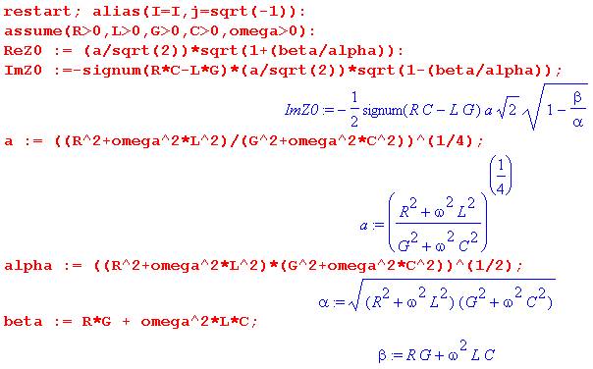
We then request an expansion of Re(Z0) for large ω:

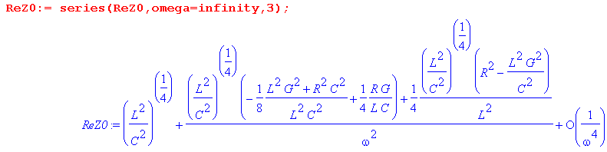
The first term is the expected $\sqrt{L/C}$ . The 1/ω2 term can be simplified as follows:

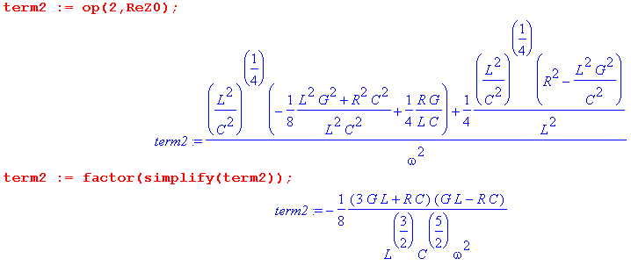
and then the result is

Re(Z0) = $\sqrt{L/C}$ + (1/8ω2) (RC+3GL)(RC-GL) / (C5/2L3/2) + order(1/ω4)

For the imaginary part we do a similar set of steps:

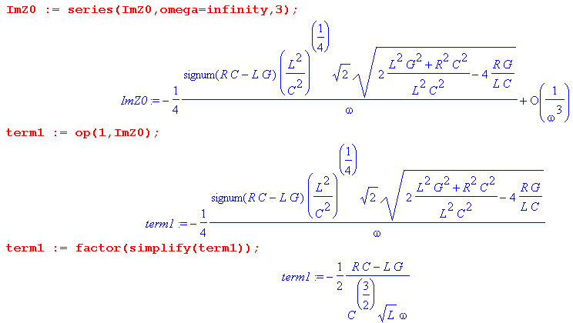
with the result

Im(Z0) = - (1/2ω)(RC-GL) / (L1/2C3/2)

Fact 7: In the low frequency limit with G > 0,

Re(Z0) ≈ $\sqrt{R/G}$ - (ω2/8) (3RC+GL)(RC-GL) / (C5/2L3/2)
Im(Z0) ≈ - (ω/2) (RC-GL) / ( R1/2G3/2) ω << R/L and ω << G/C

Proof of Fact 7:

The Maple expressions are entered as in Fact 6, and then:

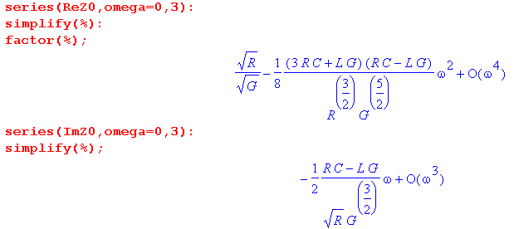
so that

Re(Z0) = $\sqrt{R/G}$ - (ω2/8) (3RC+GL)(RC-GL) / (C5/2L3/2) + order(ω4)

Im(Z0) = - (ω/2) (RC-GL) / ( R1/2G3/2) + order(ω3)

Fact 8: In the low frequency limit with G = 0, both components diverge as:

Re(Z0) ≈ (1/$\sqrt{2}$)$\sqrt{R/C}$ 1/$\sqrt{ω}$

Im(Z0) ≈ - (1/$\sqrt{2}$)$\sqrt{R/C}$ 1/$\sqrt{ω}$

Proof of Fact 8:

We first enter the general forms, setting G = 0,

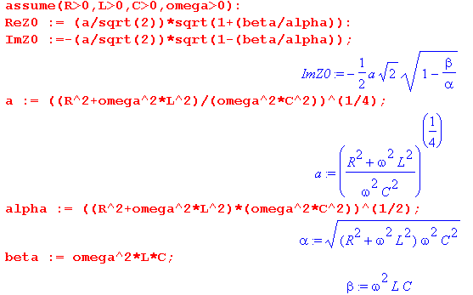
The expansions are then,

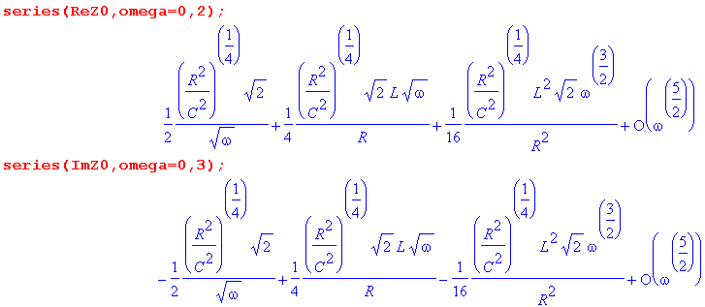
with the final results,

Re(Z0) = (1/$\sqrt{2}$)$\sqrt{R/C}$ $\sqrt{ω}$
Im(Z0) = - (1/$\sqrt{2}$)$\sqrt{R/C}$ $\sqrt{ω}$ .

These results are obvious without using Maple,

Z0 =$\frac{R}{jωC}$ =$\frac{R}{ωC}$ (j)-1/2 = $\frac{R}{ωC}$e-jπ/4 = $\frac{R}{ωC}$ [ 1-j]/$\sqrt{2}$,

but the expansions provide more terms if needed.

