This is the "old" Appendix Q saved from lines doc. This version treats R,G,L,C all as constants, which then gives some wrong limits for large and small ω. The new Appendix Q does it right.

Appendix Q: Properties of the functions k(ω) and Z0(ω)

(a) Properties of k(ω)

According to Section 5.3 (a), the complex wavenumber k appearing in our standard traveling wave form ej(ωt-kz) is this:

k = k(ω) = -j$\sqrt{zy}$= -j $\sqrt{(R+jωL)(G+jωC)}$ .

Fact 1: The real + imaginary decomposition of k is given by (Q.1)
k = $\frac{a2-c}{2}$ - j $\frac{a2+c}{2}$ k ≡ -j $\sqrt{(R+jωL)(G+jωC)}$
jk = $\frac{a2+c}{2}$ + j $\frac{a2-c}{2}$ jk = $\sqrt{zy}$= $\sqrt{(R+jωL)(G+jωC)}$

where
a ≡ [(R2+ω2L2)(G2+ω2C2)]1/4 = |k| dim(a) = 1/m a > 0

c ≡ RG - ω2LC dim(c) = 1/m2 c = real, |c| < a2

Proof of Fact 1: Let

q ≡ zy = (R+jωL)(G+jωC) = (RG-ω2LC) + jω(LG+RC) = c + jω(LG+RC) = |q| ejθ

=> |q|2 = | (R+jωL)(G+jωC) |2 = | (R+jωL)|2|(G+jωC) |2 = (R2+ω2L2) (G2+ω2C2) = a4

|q| = a2

cosθ = Re(q) /|q| = c/a2

Now write

s ≡ $\sqrt{zy}$ = $\sqrt{(R+jωL)(G+jωC)}$ = $\sqrt{q}$ = |s| eiφ |s| = $\sqrt{|q|}$ = a φ = θ/2
Re(s) = |s| cosφ = a cos(θ/2) = a $\sqrt{(1 +cosθ)/2}$ = (a/$\sqrt{2}$)$\sqrt{1+c/a2}$ = $\frac{a2+c}{2}$
Im(s) = |s| sinφ = a sin(θ/2) = a $\sqrt{(1 -cosθ)/2}$ = (a/$\sqrt{2}$)$\sqrt{1-c/a2}$ = $\frac{a2-c}{2}$
s = $\sqrt{zy}$ = $\frac{a2+c}{2}$ + j $\frac{a2-c}{2}$
k = -j$\sqrt{zy}$ = -js = $\frac{a2-c}{2}$ - j $\frac{a2+c}{2}$ QED

Maple verification:

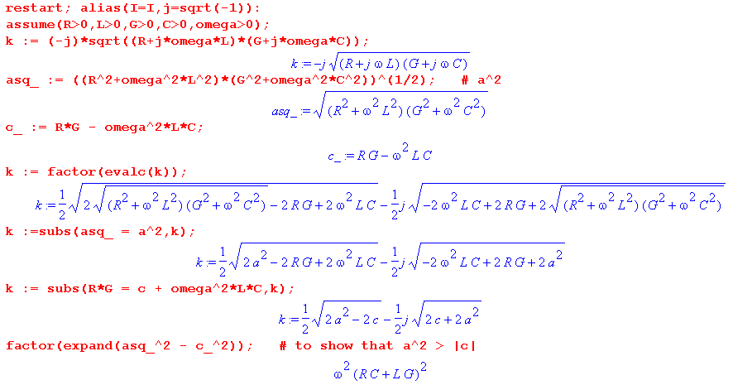

Fact 2: In the high frequency limit (where L ≈ Le), (Q.2)

Re(k) ≈ ω$\sqrt{LC}$ + $\frac{(RC-LG)2}{8ω(LC)3/2}$ // $\sqrt{LC}$ = 1/vd and ω$\sqrt{LC}$ = ω/vd = βd0
Im(k) ≈ - $\sqrt{LC}$ + $\frac{(RC - GL)2 (RC + GL)}{16ω2 (LC)5/2}$ ω >> R/L and ω >> G/C

Proof of Fact 2: All proofs in this appendix were first (laboriously) done by hand, then Maple was used to verify them. For example, the hand derivation of Fact 2 starts out like this:

a2 ≡ (R2+ω2L2)1/2 (G2+ω2C2)1/2 = LC (R2/L2+ω2)1/2(G2/C2+ω2)1/2

= ω2LC ( 1 + R2/(ωL)2)1/2( 1 + G2/(ωC)2)1/2

and then the expansion (1+x)1/2 = 1 + x/2 - x2/8 is used and the derivation continues. For the result to be valid, we must therefore have

R2/(ωL)2 << 1 and G2/(ωC)2 << 1

which says

ω >> R/L and ω >> G/C .

Rather than show all the hand-done algebra, we just let Maple do the calculation.

First, for Im(k) all output details are shown:

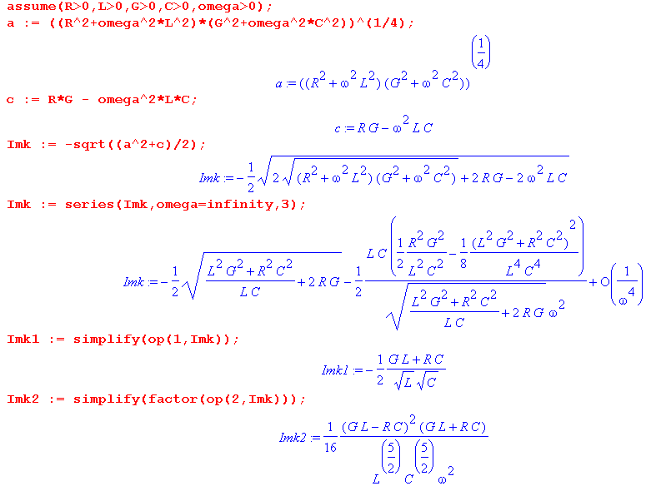

and the reader sees that these first two terms of Im(k) agree with the claim above. Maple has trouble simplifying terms in expressions when they are not isolated, hence the extra code two code lines above.

For Re(k) we suppress the intermediate results to save space (using : instead of ;)

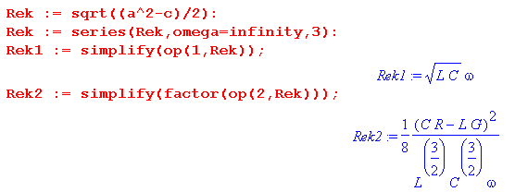
in agreement with the first claim of Fact 2.

Fact 3: In the low frequency limit with G > 0 : (Q.3)

Re(k) ≈ (ω/2) $\sqrt{RG}$
Im(k) ≈ - $\sqrt{RG}$- (ω2/8) $\frac{(RC-LG)2}{(RC)3/2}$ ω << R/L and ω << G/C

Proof of Fact 3:

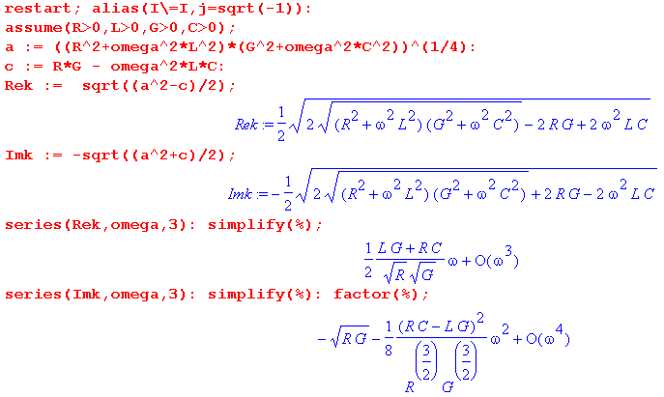

Fact 4: In the low frequency limit with G = 0 , (Q.4)

Re(k) ≈ $\sqrt{RC/2}$ ω1/2 + $\sqrt{C/8R}$ ω3/2
Im(k) ≈ - $\sqrt{RC/2}$ ω1/2 + $\sqrt{C/8R}$ ω3/2 ω << R/L

Proof of Fact 4:

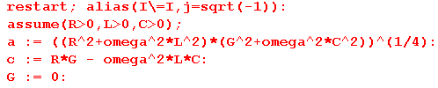
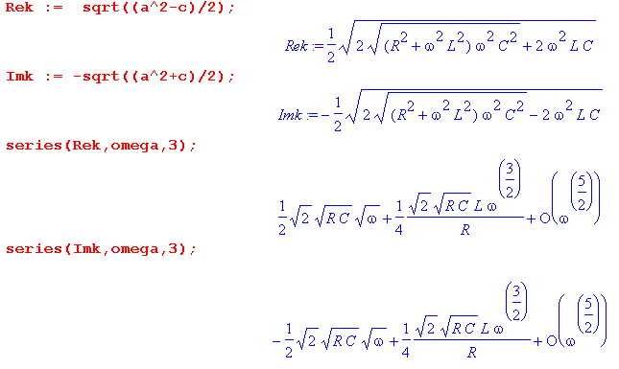

(b) Properties of Z0(ω)

Fact 5: The real + imaginary decomposition of Z0 is given by (Q.5)

Z0 = $\frac{R + jωL}{G + jωC}$ = $\frac{z}{y}$ = (a/$\sqrt{2}$) [ $\sqrt{1+(β/α)}$ - jσ$\sqrt{1-(β/α)}$ ]

where a = ( $\frac{R2+ω2L2}{G2+ω2C2}$)1/4 = |Z0| α = $\sqrt{(R2+ω2L2) (G2+ω2C2)}$
σ = sign(RC-LG) β ≡ RG + ω2LC

Proof of Fact 5: The proof is similar to that of Fact 1. Let

q = $\frac{z}{y}$ = $\frac{R+jωL}{G+jωC}$ = |q| ejθ -π < θ < π ( but see few lines below) .

Then
|q|2 = | $\frac{R+jωL}{G+jωC}$| 2 = $\frac{R2+ω2L2}{G2+ω2C2}$ ≡ a4 => |q| = $\frac{R2+ω2L2}{G2+ω2C2}$= a2 .

Next,

q = $\frac{R+jωL}{G+jωC}$ = $\frac{R+jωL}{G+jωC}$ $\frac{G-jωC}{G-jωC}$ = $\frac{(R+jωL)(G-jωC)}{G2+ω2C2}$ = $\frac{RG+jω(LG-RC) + ω2LC}{G2+ω2C2}$
so
Re(q) = $\frac{RG + ω2LC}{G2+ω2C2}$ > 0 => -π/2 < θ < π/2

Im(q) = $\frac{ω(LG-RC)}{G2+ω2C2}$ sign[Im(q)] = sign(LG-RC) = sign(θ) ≡ Σ .

Then
cosθ = Re(q)/ |q| = $\frac{(RG + ω2LC)}{G2+ω2C2}$ $\frac{G2+ω2C2}{R2+ω2L2}$ = $\sqrt{(G2+ω2C2)(R2+ω2L2)}$

≡ β/α where α ≡ $\sqrt{(G2+ω2C2)(R2+ω2L2)}$ and β ≡ RG + ω2LC .
Now write

s ≡ $\frac{z}{y}$ = $\sqrt{q}$ = |s| eiφ |s| = $\sqrt{|q|}$ = a = |Z0| φ = θ/2 -π/4 < φ < π /4

Re(s) = |s| cosφ = a cos(θ/2) = a $\sqrt{(1 +cosθ)/2}$ = (a/$\sqrt{2}$)$\sqrt{1+β/α}$
Im(s) = |s| sinφ = a sin(θ/2) = Σ a $\sqrt{(1 -cosθ)/2}$ = Σ (a/$\sqrt{2}$)$\sqrt{1-β/α}$

giving the result

s = (a/$\sqrt{2}$) [$\sqrt{1+β/α}$ + jΣ $\sqrt{1-β/α}$]

where a = ($\frac{R2+ω2L2}{G2+ω2C2}$)1/4 = |Z0| α = $\sqrt{(G2+ω2C2)(R2+ω2L2)}$
Σ = sign(LG-RC) β ≡ RG + ω2LC .

Letting σ = -Σ = sign(RC-LG) one gets the final form,

s = (a/$\sqrt{2}$) [$\sqrt{1+β/α}$ - jσ $\sqrt{1-β/α}$]

where a = ($\frac{R2+ω2L2}{G2+ω2C2}$)1/4 = |Z0| α = $\sqrt{(G2+ω2C2)(R2+ω2L2)}$
σ = sign(RC-LG) β ≡ RG + ω2LC .

Our Maple verification of this result is a bit ugly so we omit the code.
An alternate geometric derivation giving the same results begins as follows:

Z0 = $\frac{R +zL}{G +zC}$ = $\frac{L}{C}$$\frac{z + (R/L)}{z + (G/C)}$ = $\frac{L}{C}$$\frac{z + r}{z + g}$ where r = (R/L) and g = (G/C) .

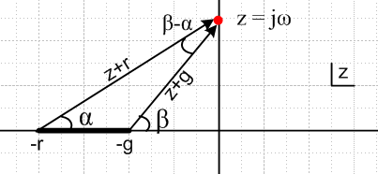 Fig Q.1

The drawing shows the complex z plane for the function Z0(z) = $\frac{L}{C}$$\frac{z + r}{z + g}$in the particular case that r > g, where the z-plane has a branch cut from -r to -g. The z values of interest are only those on the positive imaginary axis where z = jω.

Reader Exercise: Finish this derivation and obtain the results shown in (Q.5).

Hint: cos(β-α) = (rg+ω2)/(AB) and sin(β-α) = ω(r-g)/(AB) where A = $\sqrt{ω2+r2}$ and B = $\sqrt{ω2+g2}$.

Fact 6: In the high frequency limit, (Q.6)

Re(Z0) ≈ $\sqrt{L/C}$ + (1/8ω2) (RC+3GL)(RC-GL) / (C5/2L3/2)
Im(Z0) ≈ - (1/2ω)(RC-GL) / (L1/2C3/2) ω >> R/L and ω >> G/C

Proof of Fact 6:

We first enter into Maple the basic expressions,

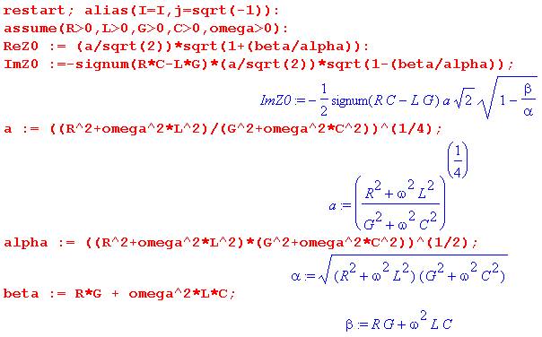
We then request an expansion of Re(Z0) for large ω:

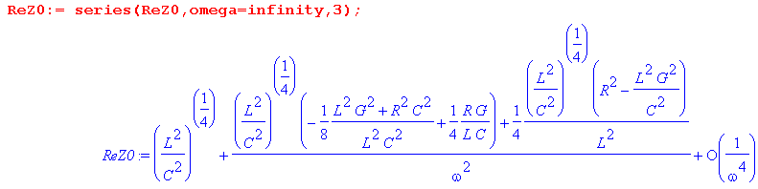
The first term is the expected $\sqrt{L/C}$. The 1/ω2 term can be simplified as follows:

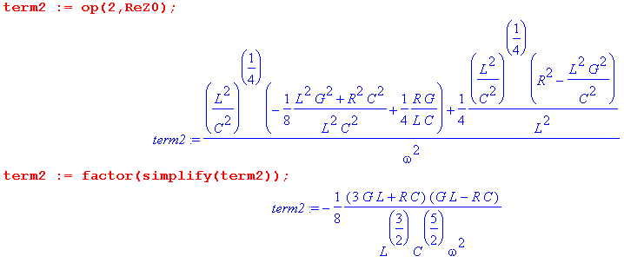
and then the result is

Re(Z0) = $\sqrt{L/C}$ + (1/8ω2) (RC+3GL)(RC-GL) / (C5/2L3/2) + order(1/ω4) .

For the imaginary part we do a similar set of steps:

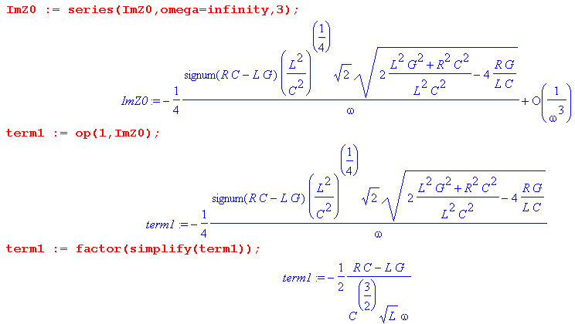
with the result

Im(Z0) = - (1/2ω)(RC-GL) / (L1/2C3/2).

Fact 7: In the low frequency limit with G > 0, (Q.7)

Re(Z0) ≈ $\sqrt{R/G}$ - (ω2/8) (3RC+GL)(RC-GL) / (C5/2L3/2)
Im(Z0) ≈ - (ω/2) (RC-GL) / ( R1/2G3/2) ω << R/L and ω << G/C

Proof of Fact 7:

The Maple expressions are entered as in Fact 6, and then:

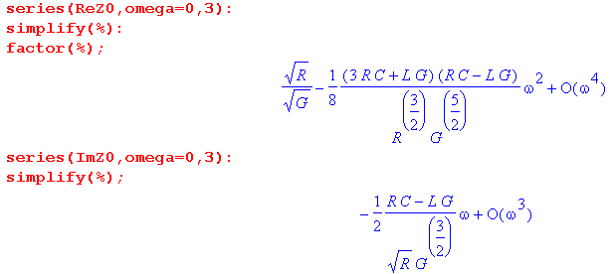
so that

Re(Z0) = $\sqrt{R/G}$ - (ω2/8) (3RC+GL)(RC-GL) / (C5/2L3/2) + order(ω4)

Im(Z0) = - (ω/2) (RC-GL) / ( R1/2G3/2) + order(ω3)

Fact 8: In the low frequency limit with G = 0, both components diverge as 1/$\sqrt{ω}$: (Q.8)

Re(Z0) ≈ (1/$\sqrt{2}$)$\sqrt{R/C}$ 1/$\sqrt{ω}$
Im(Z0) ≈ - (1/$\sqrt{2}$)$\sqrt{R/C}$ 1/$\sqrt{ω}$

Proof of Fact 8:

We first enter the general forms, setting G = 0,

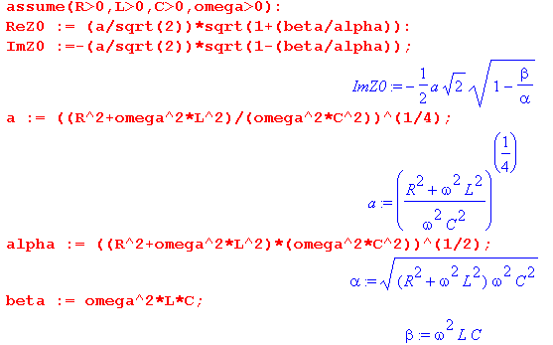
The expansions are then,

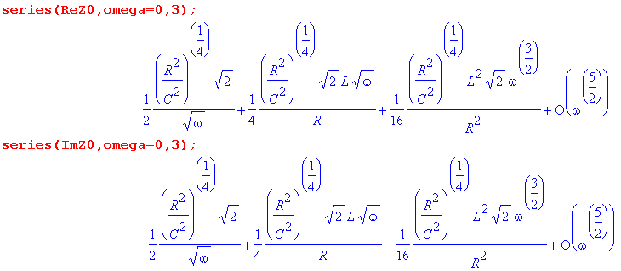
with the final results,

Re(Z0) = (1/$\sqrt{2}$)$\sqrt{R/C}$ $\sqrt{ω}$
Im(Z0) = - (1/$\sqrt{2}$)$\sqrt{R/C}$ $\sqrt{ω}$ .

These results are obvious without using Maple,

Z0 =$\frac{R}{jωC}$ =$\frac{R}{ωC}$ (j)-1/2 = $\frac{R}{ωC}$e-jπ/4 = $\frac{R}{ωC}$ [ 1- j ]/$\sqrt{2}$,

but the expansions provide more terms if needed.

