Appendix R: A case study: Belden 8281 Coaxial Cable

This is an older version of Appendix R. The current version is in file belden v3.doc and that current version has been installed. So THIS doc is now "reviewed".

Here we gradually work our way through the Belden data sheet for its 8281 cable, correlating the data presented there with the general theory of this document. The data sheet is available here

www.belden.com/techdatas/metric/8281.pdf

but we will be quoting most of it below.

(a) The Basic Parameters

We start with:

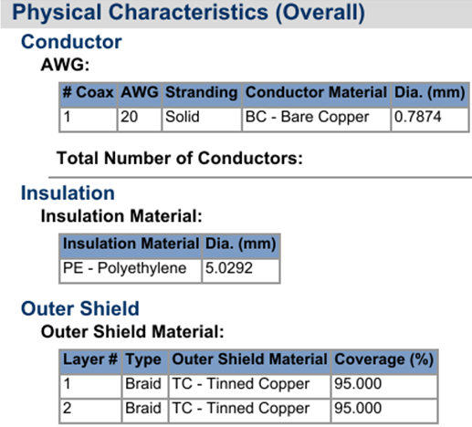

There is a two-layer braided copper shield which has a very thin tin plating to stop oxidation of the copper. Tin is a worse conductor than copper ( σtin/σcopper = 0.16), but we assume below that the plating is so thin that it does not affect our shield model.

So we start accumulating some numbers,

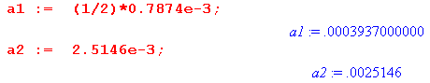

The dielectric constant for the polyethylene (PE) used in this cable we will take to be exactly

εd = 2.30000 ε0

although the reader will recall that this number varies for different types of PE product as shown in the discussion below (3.3.5). We shall also use the loss tangent quoted there (dissipation factor)

tanL = .0002

resulting in this frequency-dependent dielectric conductivity.

σd = εd tanL ω.

We duly enter these expressions into our code for later use:

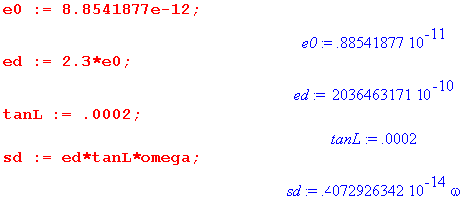

The dimensionless constant K of Chapter 4 can be computed from (4.6.3)

K= 2 ln(a2/a1) = 3.709 (4.6.3)

The capacitance per unit length may then be computed from (4.11.34),

C = 4πεd/K = 69.005 pF/m (4.11.34)

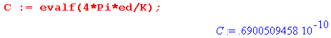

which we find is quite close to Belden's advertised value,

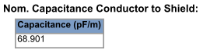

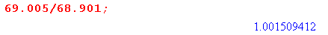

so our error here is less than 2 tenths of one percent.

The external inductance Le may also be computed from (4.11.34).

Le = $\frac{μd}{4π}$ K = $\frac{μ0}{4π}$ K = .3709 μH/m (4.11.34)

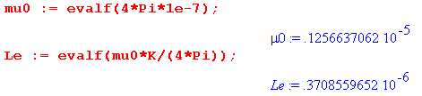

At very high frequency, we expect from (Q.2) the phase velocity of a transmission line wave to be,

vd = 1/$\sqrt{LeC}$ = 1.977 x 108 m/sec

vd/c = .6594

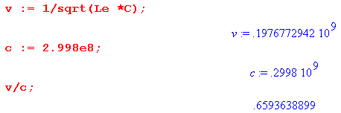
At very high frequency, as shown below and as was discussed in (4.11.36), we know L → Le and that is why we can use Le (external inductance) in the above calculation.
Since vd is the speed of light in the dielectric medium, we should get the same number using (1.1.29) applied to the dielectric

vd = 1/$\sqrt{μ0εd}$

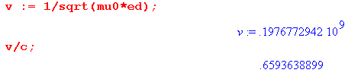
and indeed the number is the same. These identical calculations in fact deliver Belden's official value,

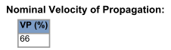

The conductance G of the dielectric can be found from (4.11.34) and (R.1) above,

G = (σd/εd) C = .1380 x 10-13 ω mhos/m (4.11.34)

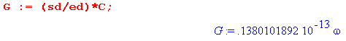
Next we find that the conductor resistances are,

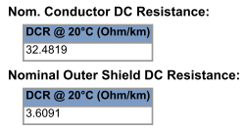

so

R1 = 32.4819 x 10-3 ohms/m
R2 = 3.6091 x 10-3 ohms/m

R = R1+ R2 = 36.0910 x 10-3 ohms/m

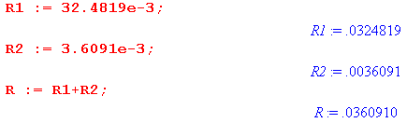

We have so far gathered up R,C, Le and G, but L requires some work. Recall that the DC internal inductance Li of a round wire was computed in (C.3.10) to be

Li = $\frac{μ0}{8π}$ = 50 nH/m = .050 μH/m . (C.3.10)

This is fine for the round center conductor of a coaxial transmission line, but one must also consider the Li of the shield. In the next section we shall derive the following simple model for Li for the Belden 8281 cable,

Li(ω) = Li = 1.16 $\frac{μ0}{8π}$ [ θ(ω<ωt) + (ωt/ω)1/2 θ(ω>ωt) ]

where ωt = (8/a12)(1/μ0σ) .

As shown below, at this frequency the skin depth is exactly half the radius of the center conductor,

δt = (a1/2)
In this ad hoc model, below frequency ωt the inductance is given by 1.16 $\frac{μi}{8π}$ . Comparing to ***, the extra 16% is due to the shield. Above ωt this constant Li tapers off as (ωt/ω)1/2 and eventually we get Li → 0 for very large ω. Obviously this model is not exact, but it seems reasonable.

The total inductance is then

L(ω) = Le+ Li = Le + 1.16 $\frac{μ0}{8π}$ [ θ(ω<ωt) + (ωt/ω)1/2 θ(ω>ωt) ] .

Since we already have a value for Le,we can evaluate this L(ω) anywhere below the transition point to find

L(ωt) = Le + 1.16 $\frac{μ0}{8π}$ = .4289 μH/m

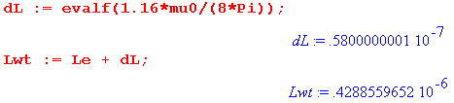

Belden publishes the following value for L,

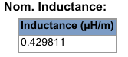

and we can compare their value with our calculation,

LBelden / L(ωt) = .429811/.42886 = 1.00221750688

so again our model error is 2 tenths of one percent. Belden gives no hints as to how it obtains the parameter values it claims, and the number of decimal places is admittedly suspicious. Our agreement with their data is really better than one should expect.

We already have R,G and C, and we can now add our model for L:

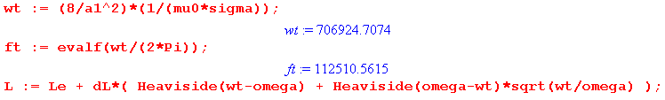

Here we see that that our somewhat arbitrary transition frequency is ωt = 112 KHz. Here is a simple plot of L(ω) versus ω

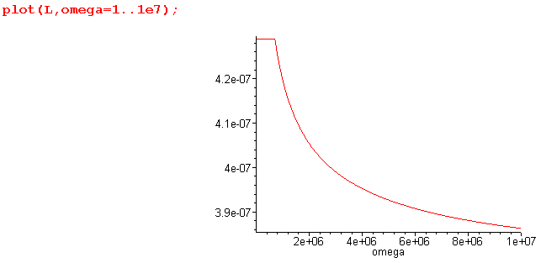

which has the expected model shape, shown here from 0 to 100 MHz. In a true model the sharp corner would be smoothed off in some fashion.
We come next to the matter of Z0, the characteristic impedance. From (4.11.34),

Z0 = $\frac{R + jωL}{G + jωC}$ (4.11.34)

All the pieces are now in place for plot of this function:

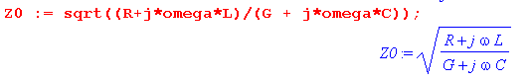
(this line was entered at the very start, before R,L,G,C were known). Plotting only the real part we find

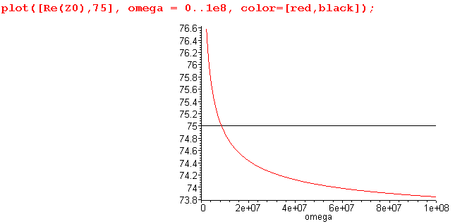
where we have marked the official Z0 of the cable,

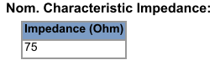

The graph shows the impedance is close to 75 ohms at about 9 MHz, but varies somewhat as one moves to either side of this frequency. Roughly in the range 2 MHz to 100 MHz Z0 ranges from 76.6 to 73.8 ohms. The imaginary part of Z0 over the same ω range is quite small,

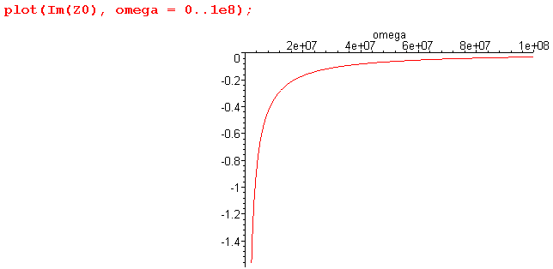
being typically less than 1 ohm.
Here is another plot showing more detail on Re(Z0) for the lower frequency range 0 to 10 MHz,

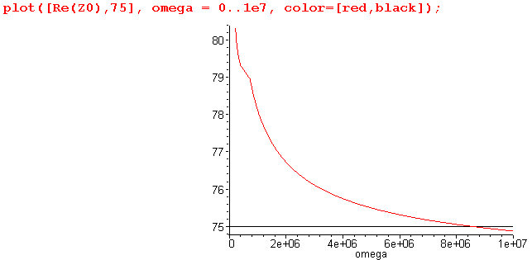

where the kink is due to our simple model for L(ω).

Next, we examine the cable attenuation. With the traveling wave form ej(ωt-kz) the amplitude z dependence is e-jkz = e-az e-jbz where

a = -Im(k) = Re[$\sqrt{(R+jωL)(G+jωC)}$] // attenuation per distance
b = Re(k) = Im[$\sqrt{(R+jωL)(G+jωC)}$] . // phase (5.3.6)

Just to head off any confusion here, look at these details:

e-jkz = e-az e-jbz

e-jkz = e-j[Re(k)+jIm(k)]z = e[-jRe(k)+Im(k)]z = e-jRe(k)z eIm(k)z

= e-jRe(k)z e-[-Im(k)]z = e-jbz e-az

and therefore

b = Re(k)
a = -Im(k)

Here then is a plot of the attenuation factor a,

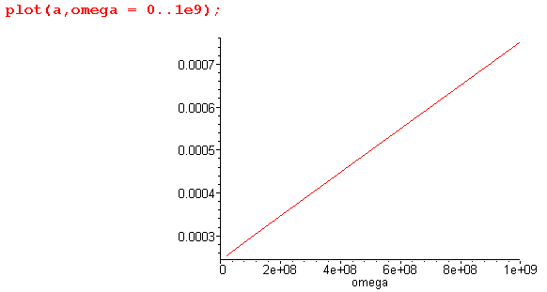

The power attenuation is given by

dB(z) = 20 log10 (e-az) = 20(-az) log10e = 20(-az) .4342944819

= - 8.685889638 az

The loss per 100 meters is obtained by setting z = 100, then

-dB(100m) = 868.5 a

and here is a plot of the power loss per 100 meters,

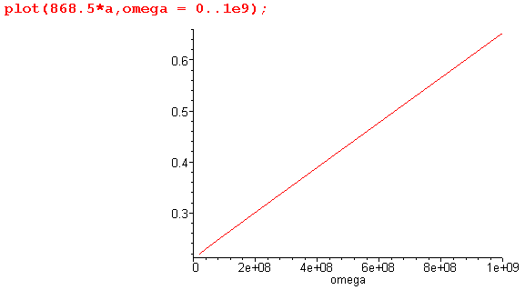

But Belden gives much larger numbers, for example,

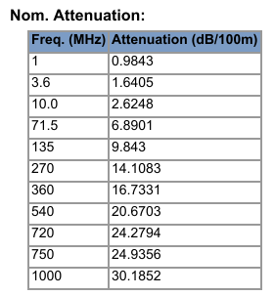

so the machine once again grinds to a halt while I hunt down this bug. Now 10:15AM 7.6.14.

Plan A: If I replace L by Le in the k formula, results are still much too small.

Plan B: Consider the high ω limit. Then we know that

a = -Im(k) = Re[$\sqrt{(R+jωL)(G+jωC)}$]

But both L and G are functions of ω in my model.

σd = εd tanL ω

G = (σd/εd) C =([ εd tanL ω]/εd)C = tanL ωC

R = 36.0910 x 10-3

C = 69.005 x 10-12
L = Le + 1.16 $\frac{μ0}{8π}$ [ θ(ω<ωt) + (ωt/ω)1/2 θ(ω>ωt) ]

= 0.37 x 10-6 + 0.58 x 10-7 [ θ(ω<ωt) + (ωt/ω)1/2 θ(ω>ωt) ]

= 0.37 x 10-6 + 0.58 x 10-7 (ωt/ω)1/2 / / large ω

Now at large ω we know that L→Le so just write then

L = 0.37 x 10-6 = fixed

Then

(R+jωL) = 36.0910 x 10-3 + jω 0.37 x 10-6

At large ω, the jωL term wins and we juat have

(R+jωL) = jω 0.37 x 10-6

Meanwhile,

(G+jωC) = tanL ωC + jωC ≈ jωC

So we then have

(R+jωL) (G+jωC) ≈ jω 0.37 x 10-6 * jωC = - 0.37 x 10-6 C ω2

= - 0.37 x 10-6 x 69 x 10-12 ω2

= - [0.37* 69] x 10-18 ω2 = - 25.53 x 10-18 ω2

Then

$\sqrt{(R+jωL)(G+jωC)}$ ≈ j * 5 x 10-9 ω

k = -j $\sqrt{(R+jωL)(G+jωC)}$ = 5 x 10-9 ω = real with no imaginary part

so in this limit, I lose the attenuation completely.

Plan C: OK, let's try Appendix Q:

Im(k) ≈ - $\sqrt{LC}$ for large ω

Then numerator is

RC + GL = RC + GLe

= RC + tanL ωC Le

= C(R + tanL ω Le)

= C(36.0910 x 10-3 + .0002 ω 0.37 x 10-6 )

= C(36.0910 x 10-3 + .2 ω 0.37 x 10-9 )

Now well above 1 MHz the second term wins so we have

RC + GL ≈ C * .2 ω 0.37 x 10-9

= 69 x 10-12 * .2 ω 0.37 x 10-9

= 5.1 x 10-12 ω x 10-9

= 5.1 x 10-21 ω

Meanwhile, 1/$\sqrt{LeC}$ = .2 x 109 = 2/3 speed of light, so then

- $\sqrt{LC}$ ≈ - 5.1 x 10-21 ω * (1/2) * .2 x 109

= - 2.5 x 10-12 ω * .2

= - 0.5 x 10-12 ω

So I have shown that at high ω,

- Im(k) ≈ $\sqrt{LC}$ = 0.5 x 10-12 ω

At ω = 109, we then get

-Im(k) = 0.5 x 10-3 = a = .0005

My graph above shows this to be .00075 or so we are in the ballpark. So even this was a difficult limit to compute by hand, the limit agrees with my plot and therefore not with Belden.

Plan D: Do Plan C in Maple

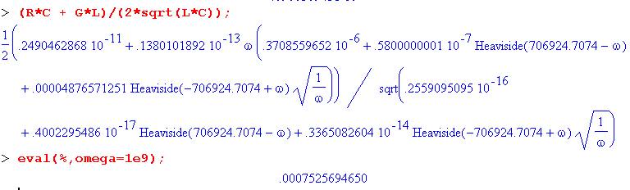

and there once again is Im(k) = .00075 in agreement with my graph.

Plan E: Here is an Excel plot of the Belden data

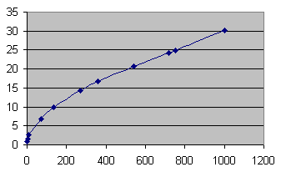

At least it is more or less linear. The plot I get is this:

