Belden and Power Examples Data PhL 7.3.14

This is basically my first work on the Belden Appendix R. I gather the basic facts, but things ended up differently in the final Appendix R from the way they are presented here. Keep this stuff for the record, it has a list of metal conductivities including tin; gold worse than silver and copper!

Data is file www.belden.com/techdatas/metric/8281.pdf which I have stored as a file 8281.pdf.
Maple support file is called "belden and power.mws".

First batch of data:

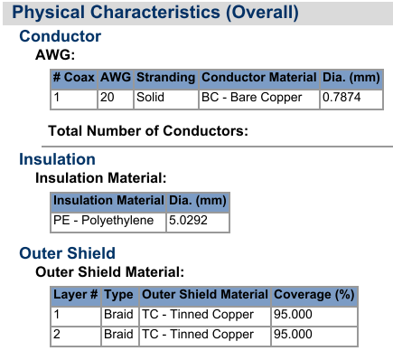

Here we learn that both conductors are basically copper, improved by tinning, with these dimensions:

a1 = .7874/2 = 0.3937 mm inner radius
a2 = 5.0292/2 = 2.5146 mm
dielectric = PE

We can compute K from K = 2 ln(a2/a1) which is (4.6.3) to get

K = 3.709

Next data group:

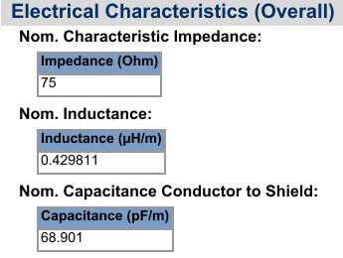

So

C = 68.901 x 10-12 farad/meter
L = 0.429811 x 10-6 henry/meter

Comment added later:

Recall that maybe fix comment about μ0 for a metal!

Le = $\frac{μd}{4π}$ K

If I put in the K value above along with μ0 this gives

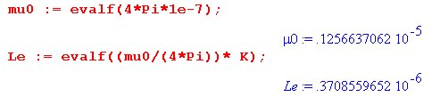
which says

Le = .3709 μH/m [ ends up as .3714 in final App R due to a2 adjustment ]

and this differs from the nominal inductance they give of 0.429811 uH/m. That is a good thing because I expect to have L > Le due to the effect of Li.

From these two numbers I can calculate vd as 1/$\sqrt{LC}$,

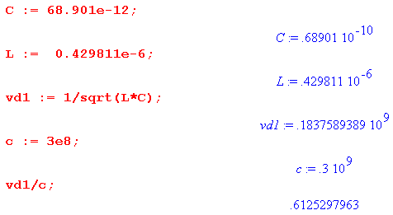

This disagrees with the 66% shown below, I wonder why? Here is another calculation:

[ The disagreement is because Belden gives v = 66%c at high frequency, and that involves Le which is not the datasheet L quoted above which appears on their data sheet. Their L is the DC value of L. This matter is resolved. ]

vd = 1/sqrt(με)

If I assume that μ = μ0, then

vd/c = $\sqrt{ε0/ε}$ = $\sqrt{1/(2.3)}$ = .66

and that is where their 66% comes from.

Again, why this discrepancy with 1/$\sqrt{LC}$ ? Look at Appendix Q. There you see this for large ω

Re(k) = ω$\sqrt{LC}$ + $\frac{(RC-LG)2}{8ω(LC)3/2}$

Losses cause a shift in the phase velocity. I think vd is the lossless value, so I really do think

vd = 1/$\sqrt{LC}$

Now what is L here? It is the L appearing in all the Z0 type formulas, and that is the L taken from z . But all we really know is that

z = R + jωL = Zs1(ω) + Zs2(ω) + jωLe

So the total L is really a function of ω.

Im(z) = ωL = Im(Zs1 + Zs2) + ωLe

L = (1/ω) Im(Zs1 + Zs2) + Le

I don't off hand have a formula for Zs2 for the sheath, but I do have an exact formula for Zs1 for the central conductor. At large ω, I would use the Chapter 2 result which says for the central wire,

Zs1(ω) ≈ $\frac{1}{σ(2πa)δ}$ (1+j) δ << 4a . (2.4.16)

and this is for the central conductor.
So here I have a major problem! Here are the unanswered questions:

(1) How do they arrive at their official value of L? Is this measured at some particular ω?

(2) What is Zs2 for the sheath?

(3) Therefore, what is my model for L(ω) to be used in the k and Z0 formulas?

For the moment, I will defer these questions.

Next data group:

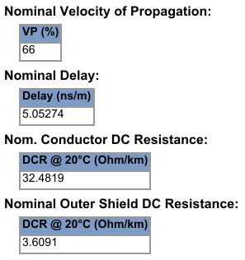

so then

R = (32.4819+3.6091) = 36.091 ohms/km = 36.091 x 10-3 ohms/m = 3.6091 x 10-2 ohm/m

= .036091 ohm/m

The only other data is attenuation which I will attend to soon.

Nothing is said about ε, so I will use my own PE data: (from lines 3.3.5 )

ε'd ≈ 2.3 tanL ≈ 2 x 10-4

This causes the σeff to be a function of frequency from my table

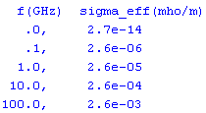

but I will just use the formula

σd,eff(ω) ≈ = 4.07 x 10-15 ω // PE (3.3.6)

We can now compute G from (4.11.34)

G/C = σd,eff/εd

and here are some calcs:

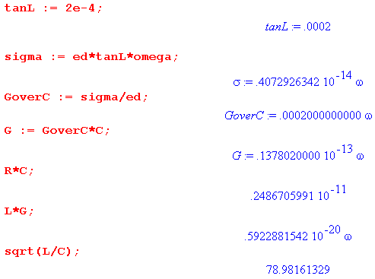

and the last result is off the official 75 ohms by quite a bit. Of course I used "their" value of L even though I don't know what it means.

The L Problem.

Looking at Chapter 2, I conclude that the exact formula given there for the center wire Zs is correct and applicable to Belden. If I could argue that L from the sheath is much smaller, maybe I can get a model going.

Let's look at the DC situation for inductances. For a round wire I show in App C that the internal inductance is given by simply

Li = $\frac{μi}{8π}$ = $\frac{μi}{μ0}$ $\frac{μ0}{8π}$ = $\frac{μi}{μ0}$ $\frac{4π x 10-7}{8π}$ = $\frac{μi}{μ0}$ * 50 nH/m (C.3.10)

Meanwhile, the DC inductance of a thin sheath of radius a2 given by

Li = μi $\frac{1}{6π}$ (d/a2) = $\frac{μi}{8π}$ [ (4/3)(d/a2) ] thin shell, valid for d << a2 (C.6.8)

where d is the sheath thickness and a2 the inner radius of the shield. What are the Belden numbers?

a2 = (1/2) 5.0292 mm

d = two layers of braid

They don't indicate the braid thickness but I can to look at a sample? Cannot find a sample, and hard to measure anyway. Another idea is this: They quote the shield resistance. If I model the shield as a thin copper shell (but it is tinned), then

R = ρ/A = 1/(σA) = 1/(σ 2πa2d).

Then solve to get

σ 2πa2d = 1/R d = (1/R) (1/2πa2σ) = 1/(2πa2σRsh)

We could then use a2 = (1/2) 5.0292 mm and σ for copper and Rsh= 3.6091 ohms and solve for d

σ = 5.81 x 107 mho/m for copper (1.1.29)

Doing this I get that

d = .0003 m = 0.3 mm // recall a1 = 0.3937 mm, a similar number

which seems ballpark OK. Then consider

Li = $\frac{μi}{8π}$ [ (4/3)(d/a2) ]

The factor [..] is unity for the central conductor, whereas for the shield we get

Li = $\frac{μi}{8π}$ [ (4/3)(d/a2) ] = 0.1600 $\frac{μi}{8π}$

so at DC, the shield makes perhaps 1/8th the contribution to Li that the center wire makes.
So yes, that is at DC. As you raise ω, skin effect occurs on both.

Note: Tin is a much worse conductor than copper and things the shield is tinned to stop oxidation.

http://chemistry.about.com/od/moleculescompounds/a/Table-Of-Electrical-Resistivity-And-Conductivity.htm

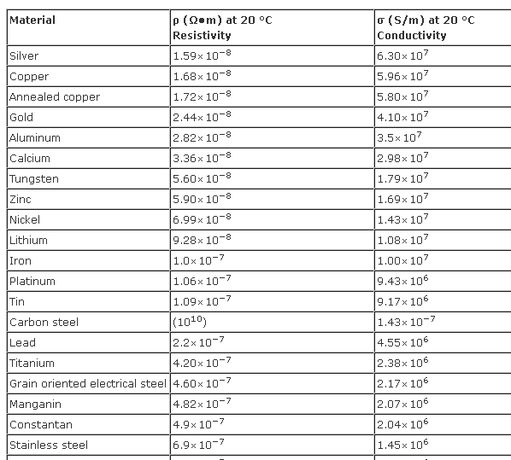

So gold is a WORSE conductor than copper, I did not realize that! Silver is the only better metal. Gold is put on surfaces for corrosion and wear resistance! Tin is much worse than copper at 9 x 106 . A nice table to have.

So I have the center/shield comparison at DC. As ω increases, skin effect gets into both. At large ω, perhaps we can model both as shells of thickness δ. Then

Li (center) = $\frac{μi}{8π}$ [ (4/3)(δ/a1) ] // these models are at high ω
Li (shield) = $\frac{μi}{8π}$ [ (4/3)(δ/a2) ]

a2 = (1/2)* 5.0292 mm = 2.5146 mm
a1 = 0.3937 mm

Then at large ω my model says

Li (shield) / Li (center) = (δ/a2) / (δ/a1) = a1/a2 = 0.3937/ 2.5146 = 0.15656566

which is almost the exact same number. So here is my model

Li = 1.16 $\frac{μi}{8π}$

and I think this is valid at any ω. This includes the shield and the center wire.

In this little effort, I have assume that

Li (center) = $\frac{μi}{8π}$ [ (4/3)(δ/a1) ]

What is the exact result here? I already quoted for the center wire,

Zs1(ω) ≈ $\frac{1}{σ(2πa1)δ}$ (1+j) δ << 4a1 . // center (2.4.16)

The contribution to inductance of this last formula is

Li = (1/ω) Im(Zs1) = (1/ω) $\frac{1}{σ(2πa1)δ}$

But now use δ ≡ $\sqrt{2/ωμσ}$ or δ2 = 2/ωμσ or (1/ω) = δ2 μσ/2 so that

(1/ω) $\frac{1}{σ(2πa1)δ}$ = $\frac{1}{σ(2πa1)δ}$ δ2 μσ/2 = $\frac{1}{(2πa1)}$ δ μ/2

so then for the center wire

Li = (1/2) $\frac{1}{(2πa1)}$ δ μ = (1/4π) μ (δ/a1) = $\frac{μi}{8π}$ (2δ/a1)

which compare to my little formula above

Li (center) = $\frac{μi}{8π}$ [ (4/3)(δ/a1) ]

and they are not too far apart.
So here is my model for Li :

Model for Li for coax cable:

Li = 1.16 Li.center = 1.16 (1/ω) Im(Zs1)

Zs(ω) = $\sqrt{2}$ $\frac{J0(βa1)}{J1(βa1)}$

Again, at high ω you get Zs1(ω) ≈ $\frac{1}{σ(2πa1)δ}$ (1+j) and then

Li (high ω) = 1.16 (1/ω) $\frac{1}{σ(2πa1)δ}$ =1.16 $\frac{1}{(2πa1)}$ δ μ/2

so it all fades away to nothing at very high ω. We know it also at DC.

Summary:

(1) At DC we estimate that including both center and shield:

Li = 1.16 $\frac{μi}{8π}$

(2) At high ω we then estimate that for both we have

Li = 1.16 $\frac{1}{(2πa1)}$ δ μ/2 = 1.16 $\frac{μi}{8π}$ 2 (δ/a1)

How then do I piece these together. Glue together at 2δ/a1 = 1 or δ =a1/2 or (δ/a1) = 2. But I want this all in terms of ω, not σ.

glue point: δ =a1/2 (δ/a1) = 1/2

// δ ≡ $\sqrt{2/ωμσ}$ or δ2 = 2/ωμσ or (1/ω) = δ2 μσ/2

$\sqrt{2/ωμσ}$ = a1/2

2/(ωμσ) = (a1/2)2

2 = (a1/2)2 ωμσ = (a12/4) ωμσ

1 = (a1/2)2 ωμσ = (a12/8) ωμσ

ωt = (8/a12)(1/μσ)

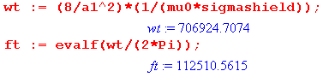

So the transition point is then [ I don't use any such transition point in the final version ]

ωt = 706,924 = 7 x 105

ft = 112.510 KHz

At this frequency my chart says

δ = 209μ = (a1/2) = correct

So we get Li = flat out to frequency ωt, and after that we have

1.16 $\frac{μi}{8π}$ 2 (δ/a1) = 1.16 $\frac{μi}{8π}$ 2 ($\sqrt{2/ωμσ}$/a1)

= 1.16 $\frac{μi}{8π}$ 2 ($\sqrt{2/μσ}$/a1) 1/$\sqrt{ω}$

Recall that

$\sqrt{2/ωtμσ}$ = a1/2
$\sqrt{2/ωμσ}$ = δ

Then

(δ/a1) = $\sqrt{2/ωμσ}$ / [2$\sqrt{2/ωtμσ}$ ] = (1/2) (ωt/ω)1/2

2 (δ/a1) = (ωt/ω)1/2

Check: transition point is ω = ωt so we get

2 (δ/a1) = 1

(δ/a1) = 1/2

Correct. Then here is the model in the non-flat part of the curve

Li = 1.16 $\frac{μi}{8π}$ 2 (δ/a1) = 1.16 $\frac{μi}{8π}$ (ωt/ω)1/2

Finally, here is the model

Li = 1.16 $\frac{μi}{8π}$ for ω < ωt
Li = 1.16 $\frac{μi}{8π}$(ωt/ω)1/2 for ω > ωt

and finally after many hours of goofing around I have some kind of model for Li for the coax cable.

Li = 1.16 $\frac{μi}{8π}$ [ θ(ω<ωt) + (ωt/ω)1/2 θ(ω>ωt) ]

[ In my final Appendix R, I don't state Li in this way because I don't care there about low Li range ]

And then our model for total inductance is

L(ω) = Le + 1.16 $\frac{μi}{8π}$ [ θ(ω<ωt) + (ωt/ω)1/2 θ(ω>ωt) ] ωt = (8/a12)(1/μσ)

where (δt/a1) = 1/2 . ft = 112.510 KHz

Let's put this into numbers:

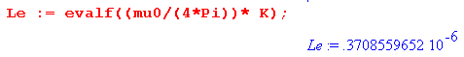

So now we need to learn at what ω the Belden people measured their "L" value.
Perhaps it is 1 MHz ? How large is this extra term?

1.16 $\frac{μi}{8π}$ ≈ 58 nH/m =

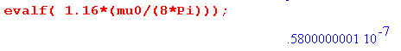
which is .058 μH/m. So my model is now giving, in μH ,

L(ω) = .3709 + .058 [ θ(ω<ωt) + (ωt/ω)1/2 θ(ω>ωt) ]

At the transition point I then have ( my model predicts L_ )

L(ω) = .3709 + .058 = 0.4289 μH/m

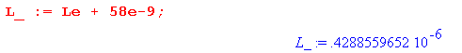

and at any other point the result will be LOWER. Recall now that their quoted value was

L = 0.429811 x 10-6 μH/m

which is VERY close to my number at the transition point, but their number is larger than my transition point number so I cannot model their number no mater what. But we are very close:

Thus, my model has no way to fit their number since all my numbers at high ω will be lower

That suggests that they have measured their number at some higher ω! But what is the ratio at the transition point?

their quote / my model value = L / L_ = .4298/.4288 = 1.002

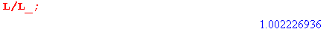
What does the direct C calculation say?

C = 4πεd/K

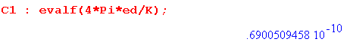

This assumes εrel = 2.30000 exactly. They give this number instead,

68.901 pF/m

which, although very close, is off a bit. Ratio is

1.001510785

so that is 1/10th of 1 %.

Could I adjust εd to make things work even better? I would need to lower my εd. Leave as is!

Question: What happens with the speed of light vd business? I know that

(1) in the high ω limit, L = Le [ correct, and this gives the 66% ]

(2) in that same limit, I know that vd = 1/$\sqrt{LC}$

(3) so what I really know is that

vd = 1/$\sqrt{LeC}$

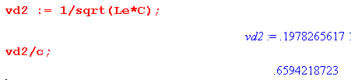
so this problem is rescued! [ yup ]

Question: What about the 75 ohm impedance? Again I can go at high ω where L = Le

Z0 = $\sqrt{Le/C}$

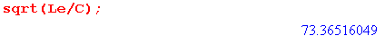
This seems farther from the nominal 75Ω than it should be.

What "L" should go into the full Z0 formula? It is the full L, not Le. So finally I get to combine the two models.

First, we know that

Z0 = $\frac{R + jωL}{G + jωC}$

I have expressions for everything here! My model for L gives L_.

L(ω) = Le + 1.16 $\frac{μi}{8π}$ [ θ(ω<ωt) + (ωt/ω)1/2 θ(ω>ωt) ]

