Belden Version 3 PhL 7.6.14

This was installed as Appendix R on 7/28/134.
=
My original Belden and Power notes are Version 1.
My original Appendix R is version 2.
This is version 3.

**********************************************************

Appendix R: Belden 8281 Coaxial Cable, a Case Study 1
(a) Geometry of the cable 1
(b) Capacitance C 3
(c) Conductance G 3
(d) External inductance L_{e} 4
(e) Total DC Inductance 4
(f) High Frequency Inductance and Resistance 6
(g) The Tinning Correction 7
(h) Characteristic Impedance 10
(i) Phase Velocity and Attenuation 13

Appendix R: Belden 8281 Coaxial Cable, a Case Study

Here we gradually work our way through Belden's data sheet for its "8281" coaxial cable, correlating the data presented there with the general theory of this document. The data sheet is available here

www.belden.com/techdatas/metric/8281.pdf

but we will be quoting most of it below. We note that over the last few decades, the parameters on this data sheet have changed slightly. At its market introduction (more than 20 years ago), this 75Ω coaxial cable was pretty much top of the line for general purpose RF use and is still available today. It is often used to carry uncompressed analog video signals. Today Belden offers even better coaxial cables for use with high bandwidth digital video signals. Such cables often have a foam dielectric to reduce attenuation, while the 8281 cable has a solid polyethylene dielectric.
Below we use various equations from our main document to construct a "model" of the Belden cable, but this model is limited to "high frequency" meaning here roughly f > 1 MHz. A more careful analysis would also produce a "low frequency" model for frequencies from DC to 1 MHz, and would then blend these two models at the boundary in some smooth manner.

(a) Geometry of the cable

We start with this data from the Belden specification,

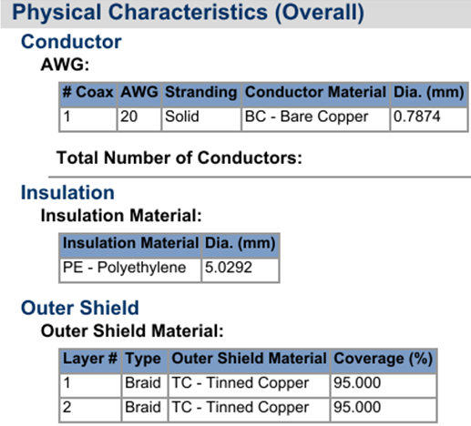

The center wire is solid copper with a specified diameter of 0.7874 mm, so a1 = .7874/2 mm = 0.3937 mm = 393.7 μ. The diameter of the PE core is specified as 5.0202 mm so the radius is 5.0202/2 = 2.5101mm = 2510.1μ. This core is surrounded by a tinned double copper braid. One sometimes adds the radius (80 μ) of the fine braiding wire to the effective outer cable radius, but we shall add 11.5 μ to the radius since this makes C match the Belden data sheet value if εd/ε0 = 2.3000. So a2 = 2510.1+11.5 = 2521.6 μ. We then have,

a1 = 393.7 μ inner wire radius
a2 = 2521.6 μ inside radius of the shield

Obviously the 2.3000 number is not exact. We are just building a reasonable model here to try and replicate the Belden claimed cable parameters, and some parameters have to be tuned to get consistency. The double braid is not exactly the same as a solid cylindrical shell of copper, so things are approximate.
As we go along here, the corresponding Maple code will be displayed. So far then,

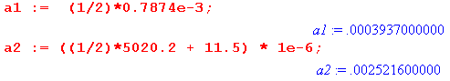

where all quantities are stated in the usual SI units (meters for a1 and a2). From these radii one computes K from (4.6.3),

K = 2 ln(a2/a1) , (4.6.3)

to get K = 3.7141,

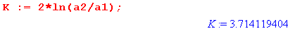

(b) Capacitance C

Assuming εd/ε0 = 2.3000, one uses (4.4.17)

C = 4πεd/K capacitance per unit length (4.4.17)

to get

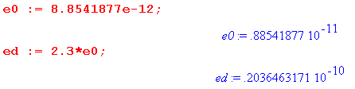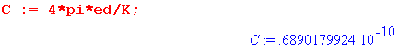

The Belden data sheet quotes C = 68.901 pF/m.

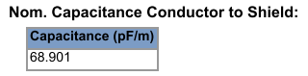

in agreement with our calculation. We regard C as a constant independent of ω.

(c) Conductance G

The conductance G of the dielectric is related to the capacitance according to

G = (σd/εd) C (4.11.34)

where σd is the dielectric conductivity. Recall now (3.3.4),

σeff = ( σd + ωε'd tanL) (3.3.4)

which gives the effective conductivity of the dielectric in terms of the DC conductivity σd , the real part of εd called ε'd and the loss tangent factor. For PE we know that σd ~ 10-15 so we neglect that term. We shall be using tanL = .0005 below, and since this is small, ε'd ≈ εd. Finally, to reduce symbol clutter we rename σeff to be σd so the above equation becomes

σd = εd tanL ω => (σd/εd) = tanL ω

and then

G = tanL ω C = tanL 2πf C . (R.1)

Although Fig 3.1 mentions tanL = .0002 for a high quality sample of polyethylene, our experience has shown that for the bulk low-cost PE product used in coaxial cables, tanL ≈ .0005. The larger loss is due to many effects including milling, aging (oxidation), water absorption ("treeing") and additives intended to reduce these loss effects. Very poor quality PE can have a loss tangent (tanL= tanδ = dissipation factor) of .0075. For more accuracy, one can develop frequency dependent models for tanL .

The corresponding Maple expressions are duly entered,

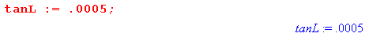

where the last notation indicates that G(f) is a function of frequency f.

In either the Z0 or attenuation calculations below, the quantity G + jωC ( = y) always appears as a grouping, and we have determined that

G + jωC = tanL ω C + jωC = (-j tanL + 1) jωC = (1 - 0 .0005j ) jωC . (R.2)

Based on this grouping, one sees that our model is not very sensitive to the value of tanL as long as it is a relatively small value.

(d) External inductance Le
Using the numbers developed so far, one computes Le from Le = $\frac{μ0}{4π}$ K in (4.11.34) :
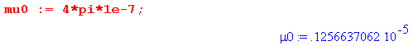
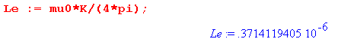
which is Le = 371.41 nH/m.

(e) Total DC Inductance

From (C.3.10) we know that the center wire DC internal inductance is given by

Li(center) = $\frac{μ0}{8π}$ = 50 nH/m DC (C.3.10)

If we assume the shield has a thickness t, we know from (C.6.8) that

Li(shield) = $\frac{μ0}{8π}$ [ (4/3)(t/a2) ] DC thin shell, valid for t << a2 (C.6.8)

We can compute an effective shield thickness t by making use of its DC resistance R2DC:

R2DC = ρ/A = 1/(σA) = 1/(σ 2πa2t)

=> t = 1/(σ 2πa2R2DC) (R.3)

Then
Li(shield) = $\frac{μ0}{8π}$ [ (4/3) $\frac{1}{σ 2πa22R2DC}$] . (R.4)

The value of R2DC is specified as 3.6091 ohms/km,

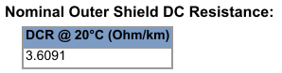

Here then are some calculations leading to a total DC inductance for the cable,

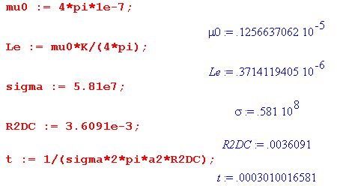

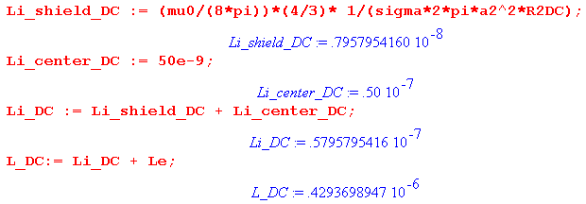

The center wire contributes 50.00 nH/m to the DC internal inductance, while the shield contributes another 7.96 nH/m giving a total of 57.96 nH/m for the total cable internal DC inductance. When this is added to the external inductance Le of 371.4 nH/m, the total is seen to be 429.37 nH/m. The Belden data sheet quotes 429.811 nH/m giving a small discrepancy of 1/10th of 1% compared to our calculation,

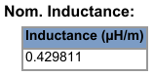

We see that Belden's "nominal inductance" is the total DC inductance of the cable Le + Li .

(f) High Frequency Inductance and Resistance

At high ω where the skin effect dominates, one thinks of the current being restricted to a sheath of approximate thickness δ (skin depth). In Chapter 2 we showed that, for the center conductor of radius a1, the high frequency resistance and internal inductance (per unit length) are given by,

R1 = $\frac{1}{σ(2πa1)δ}$ (2.4.18)
L1i = (1/ω) R1 = $\frac{1}{ωσ(2πa1)δ}$ = $\sqrt{2/ωμ0σ}$ = $\frac{1}{2πa1} \sqrt{\frac{μ0}{2σω}}$ . (2.4.19)

It was noted that R1 has the simple interpretation of being the resistance of a shell of radius a1 and thickness δ.

Since this same kind of thin skin-effect sheath also exists on the inner surface of the outer conductor, we shall assume that the corresponding parameters for the outer conductor are obtained by replacing a1 by a2 in the above, so

R2 = $\frac{1}{σ(2πa1)δ}$
L2i = $\frac{1}{ωσ(2πa2)δ}$ = $\sqrt{2/ωμ0σ}$ = $\frac{1}{2πa2} \sqrt{\frac{μ0}{2σω}}$ (R.5)

We have assumed that the shield and center conductor are made of the same metal (copper) with σ and δ. For other cables, the shield might be aluminum foil, and one would then adjust the above equations.

Adding, we then arrive at these expressions for high frequency resistance and internal inductance:

R = $\frac{1}{σ(2π)δ}$ [ $\frac{1}{a1}$ + $\frac{1}{a2}$ ]

Li = $\frac{R}{ω}$ = $\frac{1}{ωσ(2π)δ}$ [ $\frac{1}{a1}$ + $\frac{1}{a2}$ ] = $\frac{1}{fσ(2π)2δ}$ [ $\frac{1}{a1}$ + $\frac{1}{a2}$ ] (R.6)

At 1 MHz (2.3.9) says δ = 66μ . Since the center conductor has a1 = radius 394μ and the shield has thickness t = 301μ, we shall restrict our model to apply only to frequencies over 1 MHz (ballpark).

For the Belden 8281 cable, the first term in [ $\frac{1}{a1}$ + $\frac{1}{a2}$ ] is 6.4 times larger than the second term

so most of the R and Li at high frequency come from the inner conductor, not the shield.

(g) The Tinning Correction

A model complication is that the 160μ diameter copper braid wires (34 gauge) of the shield are coated with tin of thickness 1.3μ (50 micro-inches). This coating is added to prevent the copper shield from oxidizing. At 1 GHz (2.3.9) gives δcopper = 2.09μ. Since tin has about 6.3 times more resistance than copper, and since δ = $\sqrt{2/ωμσ}$, one finds that δtin = 5.24μ at 1 GHz. As the frequency increases, one has to somehow gradually replace the copper δ with the tin δ in the second term of the R and Li expressions above. An analytic solution to this problem can be found by applying the Helmholtz equation [∇2+β2]E = 0 to a simple one-dimensional model of the tin/copper interface. We have done this and then obtained the following "phenomenological" model to handle the tinning correction:

R = $\frac{1}{σ(2π)δ}$ [ $\frac{1}{a1}$ + $\frac{1}{a2}$* tf ]

Li = $\frac{1}{fσ(2π)2δ}$ [ $\frac{1}{a1}$ + $\frac{1}{a2}$* tf ] Li = R /(2πf)

tf = 1.765 + 0.8 tanh($\sqrt{f(GHz)}$ - 1.9) " tinning factor" (R.7)

Here is a plot of this tinning factor for f ranging from 10 KHz to 1 GHz,

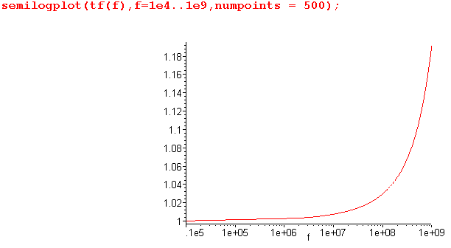 Fig R.1
Tinning Factor versus Frequency

It was shown above that $\frac{1}{a1}$ is 6.4 times larger than $\frac{1}{a2}$, so the tinning factor correction is fairly small at frequencies below 1 GHz (our region of interest). Even at 1 GHz we have

$\frac{Rcorrected}{Runcorrected}$ = $\frac{1}{a1}$$\frac{1}{a2}$$\frac{1}{a1}$$\frac{1}{a2}$ = 1.026

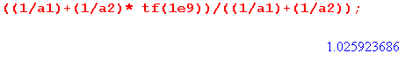

so the tinning factor increases R and Li by about 2.6% at 1 GHz, and less below 1 GHz. Although small, we shall include this tinning correction in our calculations below.

Here then are the Maple entries for high-frequency R and Li, where δ = $\sqrt{2/(ωμσ)}$ = $\sqrt{1/(πfμσ)}$ :

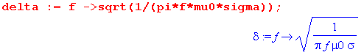

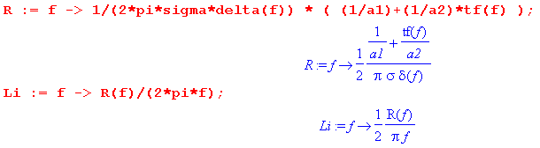

Since δ ~ 1/$\sqrt{f}$ and Li ~ 1/(δf) ~ 1/$\sqrt{f}$, the internal inductance Li drops off rapidly at high frequencies and is in general much smaller than Le. This is due to the fact shown in (C.6.8) that the internal inductance of an annular shell goes to zero as that shell (thickness δ) becomes thinner. Here is a plot of Li (red), Le = 371.4 nH (black), and L = Li+ Le (green) for f in the range 1 MHz to 1 GHz,

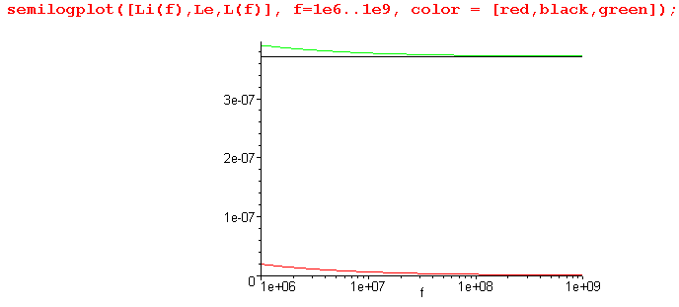 Fig R.2

Thus, for our range of interest, L is dominated by Le.

The corresponding plot of resistance R is the following,

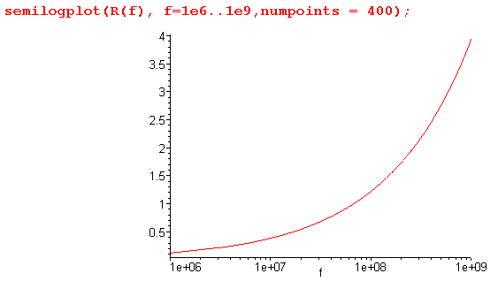 Fig R.3

Notice that this R is in ohms/m, whereas the DC resistances of the center wire and shield are stated in ohms/km,

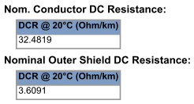

Compared to these DC resistances, resistance R is quite large, and of course this is due to the skin effect.

(h) Characteristic Impedance

Although the cable has a nominal Z0 of 75Ω,

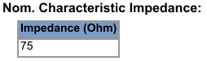

the actual Z0 is a slow function of frequency and can vary slightly (~1.5Ω) from the advertised nominal value. Recall from Chapter 4 that

Z0 ≡ V(z)/i(z) = $\frac{z}{y}$ = $\frac{R + jωL}{G + jωC}$ (4.11.16)

which is in general complex. We enter this into Maple,

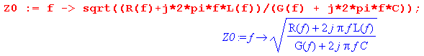

where the functions R(f), L(f) and G(f) have been stated above. We then plot Re{Z0} for f ranging from 1MHz to 10 GHz,

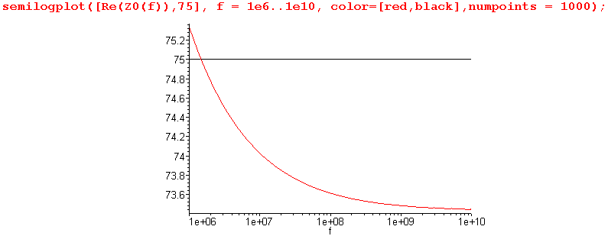 Fig R.4

Recall that our cable model using high frequency expressions for Li and R is only valid above 1 MHz more or less. The plot shows that the cable has Z0 = 75Ω near f = 2 MHz, but drops to 73.48 Ω at 1 GHz, and is a little larger than 75Ω below 2 MHz.
The imaginary part of Z0 over this same frequency range is on the order of - 1 Ω :

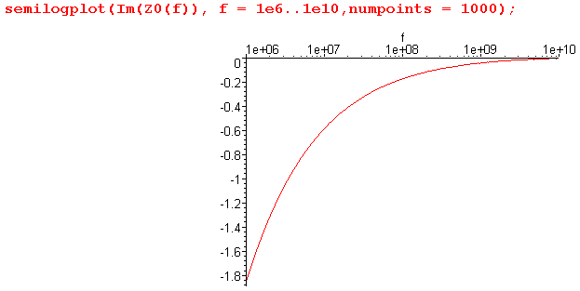 Fig R.5

A proper no-reflections termination of the cable thus requires both a resistance on the order of 75Ω and a small reactive component.
Since the imaginary part is so small, there is little distinction between Re(Z0) and |Z0|. This is illustrated in the following plot,

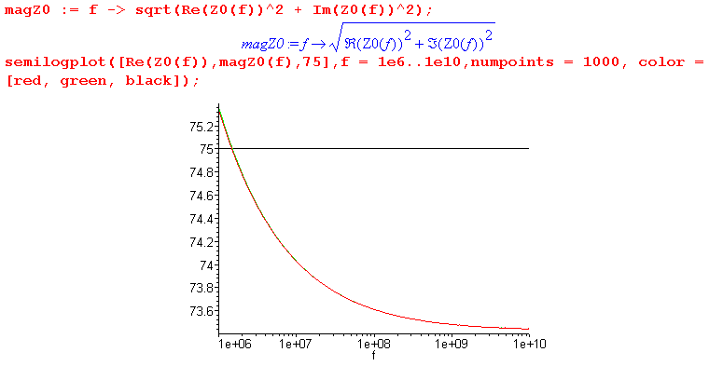
Fig R.6
where the red ( Re(Z0) ) and green ( |Z0| ) curves lie right on top of each other.
At large ω, we expect Z0 to approach a limiting value of 73.42Ω ,

Z0 = $\sqrt{L/C}$ → $\sqrt{Le/C}$

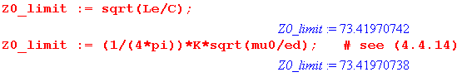

in agreement with Fig R.4 above.
At very low ω, we have instead that Z0 = $\sqrt{R/G}$. One can use R = .036 Ω/m by adding the DC resistances of the shield and center conductor. However, G is miniscule at DC since polyethylene is such a good insulator, so Z0 is in the 3 MΩ range,

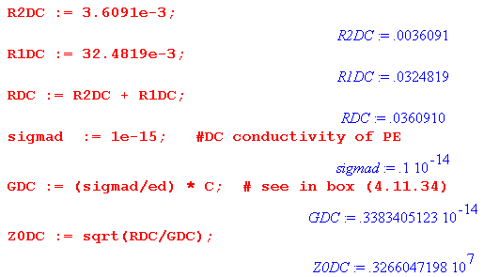

Here we have assumed σd ~ 10-15 mho/m, though this could be much larger for the kind of PE that is used in Belden cables, resulting in a somewhat smaller Z0DC.
Our model does not account for micro detail involving the mesh shield and manufacturing variations, and one finds with a network analyzer (and an actual piece of Belden 8281 cable) that there is "noise" superimposed on our idealized plot of Z0 versus f which has an RMS value on the order of 1 ohm, see the work of Van Der Burgt. He argues that due to this "noise", it makes little sense to try to pin down a Z0 tolerance beyond current values, although cable makers still try to do it as part of their marketing specmanship wars.

(i) Phase Velocity and Attenuation

Recall (5.3.6) which we apply to the voltage on a transmission line whose left end is at z = 0:

V(z) = V(0) e-jkz = V(0) e-az e-jbz jk = a + jb = $\sqrt{zy}$ = $\sqrt{(R+jωL)(G+jωC)}$

a ≡ Re($\sqrt{zy}$) = Re[$\sqrt{(R+jωL)(G+jωC)}$] = - Im(k) // attenuation per distance of F(z)
b = Im($\sqrt{zy}$) = Im[$\sqrt{(R+jωL)(G+jωC)}$] = Re(k) . // phase of F(z) (5.3.6)

Conventional symbols for the attenuation and phase constants are α and β, but here we call them a and b.

Phase Velocity

One can see that, for large ω,

b = Im[$\sqrt{(R+jωL)(G+jωC)}$] = Im[$\sqrt{(jωL)(jωC)}$] = ω Im[$\sqrt{-LC}$] = ω $\sqrt{LC}$

and therefore the cable phase velocity is given by

vphase = ω/Re(k) = ω/b = 1/$\sqrt{LC}$ .

Since L ≈ Le in our frequency range of interest, and since the speed of light in the dielectric is determined by vd = 1/$\sqrt{LeC}$ = 1/$\sqrt{μdεd}$ [see (4.11.28) ], we conclude that

vphase = vd = 1/$\sqrt{LeC}$ = 1/$\sqrt{μdεd}$

and we can compute this two different ways, knowing that the result must be the same,

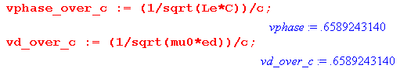
This is in agreement with the Belden claim,

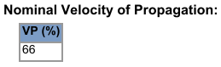

The time for a phase front to move 1 meter is given by 1/vd ,

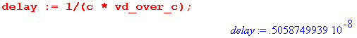
which is 5.059 nsec. Belden gives

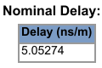

which is within 1/10th a 1% of our computed value.

Reader Exercise: Derive an expression for group velocity vg in the presence of attenuation (k is complex). How does your result compare with the classical expression 1/vg = ∂k/∂ω or vg = ∂ω/∂k ? Using expressions of the model above, compute vg as a function of frequency. Since vg varies with f, the cable exhibits dispersion -- pulses spread out as they are attenuated. Determine the group delay for a narrow pulse to travel 1 m down the Belden cable. How does this delay compare with the phase delay noted above? What is the effect of the tinning correction on group delay?

Attenuation

It is traditional to express attenuation in "voltage decibels" defined in this manner,

dB(z) = - 20 log10(voltage attenuation over distance z) '' decibels"

= - 20 log10(e-az) = 20 az log10(e) = [ 20 log10(e)] az = 8.686 az (R.8)

Belden provides attenuation data for z = 100 m of cable, so we just write

dB = 868.6 a = 868.6 [ - Im(k) ] > 0 (R.9)

Here then is a plot of attenuation for frequency f in the range 1 MHz to 1 GHz :

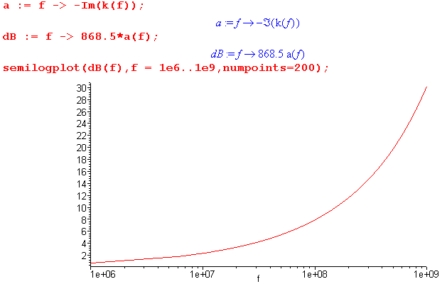 Fig R.7

In order to compare this theoretical attenuation prediction with Belden's provided data, we first evaluate our attenuation at the frequencies listed on the Belden data sheet,

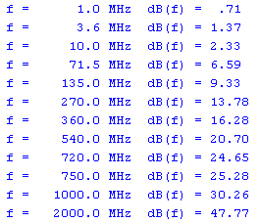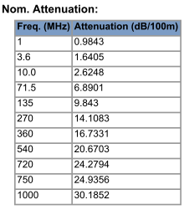

Model Calculation of Attenuation Belden's Specified Attenuation

The following spreadsheet then compares Belden's data with our model prediction,

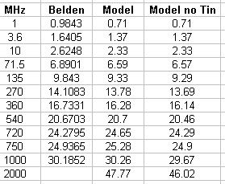

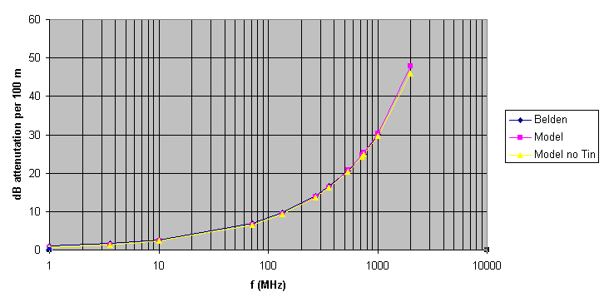
Fig R.8

Since the black diamond Belden points are pretty much covered over by the Model's purple squares, we conclude that the Model is pretty good, although there is a 30% error at 1 MHz which is at the limit of our model validity.
We have included in the spreadsheet a model column which ignores the tinning correction (yellow triangles). This column was obtained by setting tf(f) = 1 in the Maple code. We added a point at 2 GHz for which Belden gives no data, and at that point one sees that the tinning correction starts to become a little more visible. Tinning increases attenuation.
At one time we measured the attenuation of 100 m of Belden 8281 cable using a network analyzer and found that the above model (with tinning correction) accurately represents the cable up to 100 GHz.

