Equation of continuity with conducting dielectrics PhL 10.28.13

This doc considers a whole series of questions about the meaning of the symbols in div J = -∂tρ : free charge? bound charge? conduction current? polarization current? I was confused at first, but think I got everything fully nailed down, and then the results are part of note 7 in Section 1.1 of lines doc. I found external verifications for my critical solutions.

This document seeks to answer the following simple question:

Question: What is the meaning of the Equation of Continuity in the context of one or more media which are each conducting dielectrics? We often write div J = -∂tρ, but, in this context, what is the meaning of J and what is the meaning of ρ ?

Subsidiary questions:
(1) What is the meaning of div D = ρ? OK, ρ = ρfree
(2) What is the meaning of div E = ρ/ε ? OK, ρ = ρfree
(3) What is the meaning of displacement current Jd = ∂tD ? OK
(4) Is Jd related in some way to ρp ? OK

Maybe studying the conducting capacitor would help.
Maybe studying the boundary between two such media would help.
Forget transmission lines, get this stuff figured out first. Then do transmission lines.

Conjectures for out in the middle of a medium of ε :

D = εE ?? correct

div D = ρfree ?? correct

div E = (ρfree + ρpol)/ε0 ?? correct

div E = ρfree/ ε ?? correct

I think I have to write this all up from dead scratch, bringing in the P vector, and so on. In other words, I have to write a whole book chapter on the subject of electric fields inside dielectrics, but I want them to be conducting dielectrics. This is not a standard textbook topic. And of course AC at the same time. Maybe I can avoid having to write this book chapter.

Launch. We start with Maxwell's equations in a uniform isotropic medium ε and μ. The medium can be conducting, as indicated by Jc.

curl H = ∂D/∂t + Jc Maxwell curl H equation (1.1.1)

Jd ≡ ∂D/∂t // a new definition, displacement current

curl E = - ∂B/∂t Maxwell curl E equation (1.1.2)

div D = ρfree Maxwell div D equation (1.1.3)

div B = 0 Maxwell div B equation (1.1.4)

B = μH magnetic permeability μ (1.1.5)

D = εE electric permeability ε (dielectric constant) (1.1.6)

Jc = σE Ohm's Law (σ = conductivity) (1.1.7)

div(J) = - ∂ρ/∂t Equation of Continuity (1.1.8)

In free space, we set μ = μ0 and ε = ε0. I am not sure of the meaning of the last equation, so I color it blue for now. I think ρfree drives D, so I show that explicitly. I think J in the curl H equation is conduction current so I put a subscript c on it.

Question: I think I understand how Jc moves free charge around.
Does the displacement current Jd move polarization charge around? Or is that a misconception?
I have "a million questions".
Is there polarization charge on the plate of a capacitor?
Interfaces always raise extra questions not raised "out in the middle" of a medium.

1. The Conducting Dielectric Capacitor " the case n = 2 "

You have an electric field E in a medium which might be both dielectric and conducting. This E field aligns dipoles at some level, and you get some P, meaning PdV is the total amount of dipole moment in volume dV (that is why symbol P is used for this). In a simple model. P is proportional to E, so people usually write P = ε0χeE [Jackson (4.36)] . I might have written this P = χ'eE to have an absolute quantity. We then have this kind of capacitor picture

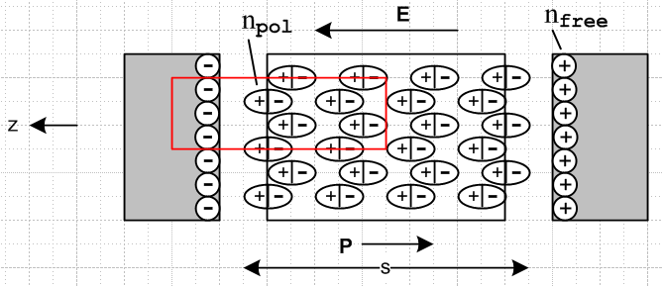

Analysis of the capacitor

1. There are no wires hooked up to the capacitor plates, they each have free charge Q.

2. Imagine the dielectric is not present and we have some E field E0 = E0. Since div E0 = ρfree/ε0 in this case, a gaussian pillbox tells us that nfree/ε0 = E0 using "the integral form". The potential across the capacitor is given by V = Δφ = E0s = (nfree/ε0)s . If the area is A, then Qfree = nfreeA . Therefore

V = (nfree/ε0)s = snfree/ε0 = (s/ε0)(Qfree/A) = Qfree[ s/(Aε0)]

Then Q = CV tells us that C0 = Aε0/s is the capacitance of this capacitor with no dielectric

3. We now add the dielectric, and it produces some npol as described below which partially cancels nfree. The same gaussian pillbox then tells us that (nfree - npol)/ε0 = E and we end up with some E < E0.

4. When the dielectric block is inserted, the dipoles rotate into a position as shown, which produces this polarization surface charge npol (volume charge ρpol) on the ends. The claim is that this bound charge ρpol is given by ρpol = -div P where PdV is the amount of dipole moment in volume dV. Jackson shows why this is so on page 153 where he computes the effect of P first on potential φ, and then on E. He shows that in effect, there is ρtot = ρfree + ρpol where ρpol = -div P. Thus,

div E = ρtot/ε0 = ρfree/ε0 + ρpol/ε0 = ρfree/ε0 – div P / ε0

5. We can then construct "a version of E" which "sees" only ρfree as follows. I will refer to this version of E by the unofficial name D'. From the above line,

div [ E + P/ε0 ] = ρfree/ε0

div [ D' ] = ρfree/ε0 D' = E + P/ε0 // so D' sees only ρfree

6. In a simple model, P is proportional to E and we can write P = χ'eE = ε0χeE .

7. Now write

D' = E + P/ε0 //

= E + χeE

= (1+χe)E

= (ε/ε0) E ε = ε0(1+χe)

You can see that D' is larger than E. And notice that

div E = (ε0/ε) div D' = (ε0/ε)ρfree/ε0 = ρfree/ε

Thus you can write div E two different ways which are really the same:

div E = (ρfree + ρpol)/ε0

div E = ρfree/ε

8. We claim that D' = E0, the larger E field that was there before the dielectric was inserted. We shall now prove this claim. From above we had

E0 = nfree/ε0

The fact that div [ D'] = ρfree/ε0, when applied in its integral form for the above red pillbox, says

D' = nfree/ε0 // thus D' = E0 QED

9. What is the new capacitance of this thing with the dielectric inserted? Our formula is Q = CV where Q is the Qfree on the plates. This quantity did not change when the dielectric was added, but I claim that V got reduced. Recall that It is V = Es and E used to be E0 but it is now reduced to E so V is less. In fact

E = (ε0/ε) D' = (ε0/ε) nfree/ε0 = nfree/ε

V = Es = snfree/ε = s(Qfree/A)/ε = Qfree[ s/(Aε)]

=> C = Aε/s // compare to C0 = Aε0/s

The capacitance has increased by factor ε/ε0.

10. Review: The meaning of D' is that it is the E field that would be there if there were no dielectric, in a situation where free surface charges stay the same before and after dielectric is added. Due to the dielectric presence, the resulting E field is E = (ε0/ε) D' which is reduced. Or E = D' - P/ε0 which again shows E is reduced relative to D'.

11. Why is D called "displacement" ? This is a somewhat tricky question. First of all, in the Maxwell curl H equation the right side is Jc + ∂tD , conduction current plus "displacement current". ∂tD is a current because it has the units of a current. You might think that Jd ≡ ∂tD arises just from the displacement of the bound charge in the dielectric. You can see how the bound charge gets "displaced" to the left or right by the applied E field. But it turns out this is just one term of Jd and the other term has the name "vacuum displacement" in which nothing is displaced at all, it is just a term. We have

Jd = Jp + Jv = polarization current + vacuum displacement current

= ∂tP + ε0∂tE

and the curl equation says curl H = Jc + Jd . The extra term is necessary so that div (RHS) = 0 since this is true of the LHS. I show this fact below from P&P. So the "displacement current" is due to the "displacement" or "polarization" of the dielectric bound charge, and due to the "displacement" of the vacuum. Since the displacement current is ∂tD, the field D is called "the displacement". So that is the long answer to the question. Ampere did not know about this vacuum term, and Maxwell is credited for deducing its presence for time-varying fields. Without this term, there would be light, no plane waves.
I have a PDF now DJVU which discusses the history here, I just read some of it (Selvan) and Jackson has had some comments on this subject.

12. It happens that the official displacement D is defined by D = ε0D' and so D does not then have the same scale as E due to the extra factor ε0. We can then translate the above equations:

div [ E + P/ε0] = ρfree/ε0

div [ ε0E + P] = ρfree

div [ D] = ρfree/ε0 D = ε0E + P // so D sees only ρfree

Since D' = E + P/ε0, we find that D = ε0D'

In a simple model, P is proportional to E and we can write P = χ'eE = ε0χeE . Now write

D = ε0E + P //

= ε0E + ε0χeE

= ε0(1+χe)E

= εE ε = ε0(1+χe) // as before

The scaling of D is chosen so that Jd = ∂tD

13. Superposition of conductivity. If we suddenly turn on σ in the dielectric, we get Jc = σE. This is fine, but to maintain steady state, we need now to supply a DC current to the plates to feed this current. Basically we just have a capacitor and a resistor in parallel. Without this DC current, Qfree would drop to 0 being exhausted by supplying Jc.

14. The notion of bound-charge current. It seems clear that as the molecules rotate under the effect of a changing E field, it is as if we had a flow of charge in our dielectric moving left and right under the AC signal. The actual bound charge at the left plate does not in fact physically move to a position outside the right plate. This is really the same as with a conduction current Jc where the actual electrons which enter at one end of a resistor are not the same electrons that emit from the other end.
So how do you come up with an expression for the bound charge current Jd ?

Here is a sequence the seems logical:

a) we know that ρb = - div P

b) since bound charge cannot be converted to free charge, you would think that continuity would apply separately to bound charge and we would write [ this is verified below ]

∂tρb = - div Jb

where Jb is a current associated with the movement of bound charge.

c) applying ∂t to (a) tells us that

∂tρb = - div ∂tP

d) Comparing this with (b) suggests that

div Jb = div ∂tP

One possible solution would be

Jb = ∂tP + curl F for any F // since div curl F = 0

but in fact the correct solution is just what you would think

Jb = ∂tP

e) We know that D = ε0E + P which says

P = D - ε0E

∂tP = ∂tD - ε0∂tE
or
Jp = Jd - ε0∂tE

Note that Jp and Jd are not the same due to this extra "Maxwell term".

f) So, there is this other current Jd called the displacement current which is

Jd = ∂tD

so that

∂tP = Jd - ε0∂tE

g) comparing to the above, we then have

Jb = ∂tP + curl F = Jd - ε0∂tE + curl F

Is there some F such that

curl F = ε0∂tE ?

I don't think so. Also I like the idea that F = 0. Then

Jb = ∂tP

If P is not changing in time, then there is no bound current!

h) my conclusion is this

Jb = Jd - ε0∂tE

which says the bound-charge current is not the same as the displacement current. With Ohm's law

Jb = Jd - (ε0/σ)∂tJc

This is a fairly strange relationship between the three kinds of currents.

Can I find external support for these conclusions?

Consider Panofsky p121 hardback. In (7-54) they show

jtot = jtrue + ∂tP + curl M

For P&P, "true current" p 117 = "motion of true charges". The call ∂tP the "polarization current" which I like. The last item is "magnetization current" . All fine. So at least I am not alone in talking about my bound-charge current Jb which is their polarization current. We then come to page 121 Sec 7-12 as quoted above with the three kinds of current. Now they claim this fact:

div jtot = -∂tρtot

Now let's follow carefully on p 122. He replaces ρtot = ε0 div E which is fine and result is (7-58). Now he claims that

div ∂tP + ε0div ∂tE = div D because div P + ε0 div E = div D
because P + ε0 E = D

This leads to (7-59), fine. I agree then that div jtot ≠ 0. Something with a non-zero divergence is called "not solenoidal". The B field for example is "solenoidal", fine.
They say: if you add the mystery term ε0∂tE to the total current, you get some new current they call c which does have div c = 0. Why is that important? [see below] This extra term is "vacuum displacement current". This one is present, but there are no physical carriers!
So I think this is the upshot of this discussion:

c = jtot + jP + jV + jM = jtrue + jV

= σE + ∂tP + ε0∂tE + curl M

= σE + ∂tD + curl M

and the Maxwell equation says

curl B = μ0 c // P&P (8.2)

Aha. Here is the problem, suppose you try this:

curl B = μ0 jtot // not true

Apply div to both sides, and on left you get 0 and on right you do not get 0 ! That is the problem Maxwell noticed. The vector field curl B is solenoidal, so the RHS has to be solenoidal as well, and that is fixed up by adding the extra piece!

You can absorb the curl M current into H and then you get

curl H = σE + ∂tD // (8-5)

I will not get into details of M, but now I ask the question which is the main topic of this whole document: What are the valid Continuity Equations?

Since the extra current term jV = ε0∂tE does not involve any charges, it is never part of a continuity equation. So at least we have one fact.

The remaining three kinds of current DO involve charges, and P&P claim that

div jtot = -∂tρtot // p 122 near the top

So at least I have one meaning for Continuity.

Now, we have three kinds of charges:
free charges supporting the conduction current Jc of Ohm's Law
bound charges supporting the polarization current Jp = ∂tP
bound charges "going in circles" which support the magnetization current JM = curl M

I am willing for now to ignore the third kind of charge, and say there are only two kinds of charge. I then argue that you cannot convert between free charge and bound charge, modulo ionization which I don't care about. So each of these two kinds of charge ought to be conserved separately. Thus, I conjecture the following extra Continuity equations

div Jp = -∂tρp
div Jc = -∂tρfree
div JM = -∂tρmag // just add this one since cannot convert here either.

Can I get confirmation of any of these equations?

Green Jackson never really talked about even a polarization current.

MIT OpenCourseWare has some Haus and Melcher PDF stuff:

This is a book on Amazon, 742 pages 1989. It has good reviews, is out of print, the chapters appear in the MIT course, and I think I can get a full pdf. Done. No copyright page, no page numbers, yes TOC, no index, 11.18 MB. These two are current MIT big shots and I think I can believe what their book says. This looks like an extremely good and practical book. It does in fact have a lot on transmission lines, but I don't see the King gauge. I tried scribd with an upload of P&P errata as payment, but it is just the same file and had to use IE and it failed anyway.

They start off with

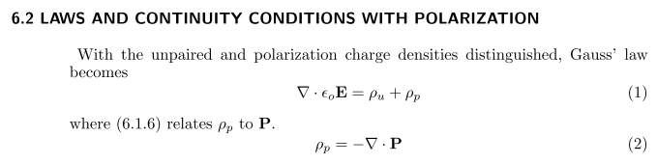

which is fine by me. They then say all of my words and claim finally that

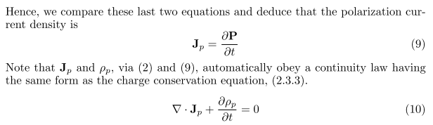
So there is one support vote for a separate continuity equation for polarization current and polarization charge.
Note that EQS approximation means electroquasistatic approximation where curl E = 0.To me, this just means electrostatics which just means potential theory, and the MIT book has Chap 4 on that. Now here we continue:

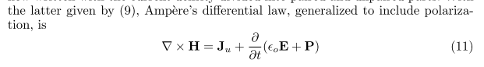
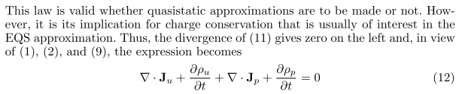

Where does (12) come from? There are four terms. First is obvious. for the other three:

div ∂t(ε0E + P) = ε0∂t(divE) + ∂t div P = ∂t(ρu + ρp) + ∂t div P

= ∂tρu + ∂tρp + div (∂tP)

and that gives (12) as stated. But of course we know that div (∂tP) = -∂tρp so this cancels the middle term on the previous line and we get

div Ju + ∂tρu = 0

so that

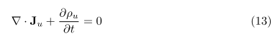

So there is my other continuity equation! The authors imply that somehow you need the EQS approximation, but I don't see that. Here are the ingredients going into (13):

• the Maxwell curl H equation in exact form, which requires div (RHS) = 0

• the fact that div E = (ρu+ρp)/ε0

• the fact that div P = -ρp.

So I don't think EQS is needed for this result.

Conclusion: Ignoring magnetization, there are three distinct Equations of Continuity. The equation is valid separately for polarization charge ρb with current Jb, and for free charge ρf with current Jf, and then of course for the sum. The Maxwell vacuum displacement current term does not relate to charges and does not play a role in any charge continuity equations
So all questions at the start of this doc have been answered.

