More on King 1/ξ issue PhL 10.31.13

All painful stuff when I could not fathom that King 1/4πξ leading factor. I feel it is fully resolved now and one of the "plans" below is correct to the way things ended up. Just keeping this "for the record".

Let's look more closely at (old) Appendix B and the parallel plate capacitor.

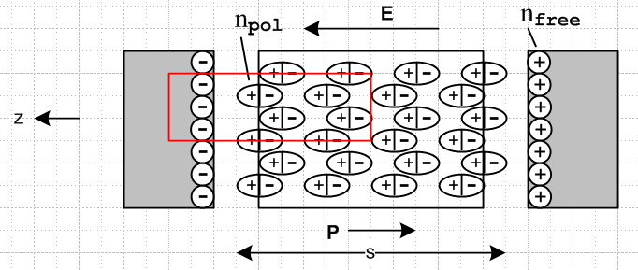

If we "turn off conductivity" and have just a capacitor and CV = Q = nA. In an AC circuit we can write I = ∂tQ → jωQ so we have

Q = I/jω = nA => I = jωnA (B.1)

Now "turn on the conductivity" so the latent resistor appears. Then

I = jωnA + V/R R = s/(σA) // since R = V/IR = Es/JA = (s/A)(E/J) = (s/A)(1/σ) = s/(Aσ)
or
I = jωnA + VAσ/s . (B.2)

Since I = jωQ this says

jωQ = jωnA + VAσ/s

Q = nA + VAσ/(jωs)

The current I or the charge Q now has two pieces which are out of phase.

From Gauss' box we know that

div E = ρ/ε ⇔ (1/ε)∫V ρ dV = ∫S E • dA if ε is constant in space (1.1.19)

which tells us that

n/ε = E // no surprise there

We also know

V = Es // no surprise here

J = σE // no surprise here either

Therefore,

Q = nA + VAσ/(jωs)

= (εE)A + (Es)Aσ/(jωs)

= (EA)(ε + σ/jω)

= (EA) ξ

= ({V/s}A) ξ

= V [ Aξ/s ]

= V C' ξ = ε + σ/jω

Again, this shows how Q and V are out of phase. We can no longer claim that Q = CV gives a simple real capacitance, we have then introduce Q = C'V if we like, where C' is complex capacitance which will involve both the real capacitance and the conductance stuff. Fine, it is all very clear.
So far I have no need for Qeff or neff or anything like that.

Question: What is the DC limit of the above situation? We get ξ → σ/jω → -j∞. We then find that

Q = V [ Aξ/s ] = 0.

The physical reason is that at ω= 0, the charge just leaks away through the conducting dielectric. You then end up with

Q = 0 n = 0 E = 0 J = 0 V = 0

and everything has come to a complete stop.

Question: What is the potential inside the above capacitor? We know that

φ(z) = -(V/s)z => φ has the same phase as V

E = -∂zφ = V/s // since Az ≈ 0 since there is no longitudinal current in the cap

We cannot say φ(z) is "real", only that it has the phase of V. We have seen that V and Q are out of phase.

Plan A: The notion of nfree versus neff

Here is a different way to approach the toy problem above. Start with

Q = I/jω = nfreeA => I = jωnfreeA (B.1)

Nothing has really been done so far. Then assume this

div E = ρ/ξ which then => nfree = Eξ

Then since V = Es we find that

V = Es = (nfree/ξ)s = (Q/A)s/ξ = Q(s/Aξ)

and there is your phase shift and then

C = Q/V = Aξ/s

and there is your complex capacitance!

So the assumption of div E = ρ/ξ seems in this example to be equivalent to assuming div E = ρ/ε and then manually adding the resistance current. So how can this be put on a logical footing for the general case?

Maybe go back to that current adder idea:

Q = I/jω = nA => I = jωnA with conductivity turned off

I = jωnA + V/R R = s/(σA) turned on

I = jωQeff Qeff = neff A

Here the turning on of the resistance is the same as replacing Q→ Qeff and n → neff and ρ → ρeff.

OK, lets go at once to the general case. In one of my puzzles.doc sections I show that in general

RC = (ε/σ)

for arbitrary capacitor with 3D arbitrary shapes. Now start off with

I = jωQ = jω ∫n dA

Then manually add the resistance current to get

I = jωQ + V/R

which seems to violate I = ∂tQ [ yes it does, see all fixed up in lines doc]

Plan B: how about a different idea. [ did not go far]

We have Ifeed in the wire feed both kinds of currents, using our current conservation at interface rule. First, at any point in the dielectric we have this fact:

Jtot = J + ∂tD = J + jωεE = σEA + jωεE = jω(ε + σ/jω)E = jωξE

If we look at a point just outside the surface of one of the conductors this is still true. If Jfeed is the normal current just inside the conductor surface, we would say

Jfeed(x1) = Jtot(x1)

where x1 is a point on the surface of conductor C1. The total feeding current is then

Ifeed = ∫ Jfeed(x1)dA1 = ∫ jωξE dA = jωξ ∫EdA

where E is the normal field at some point on the surface. We know E = n/ε where n is the free surface charge, so then we have

Ifeed = jωξ/ε ∫ndA = jω(ξ/ε)Q = jωQeff Qeff = (ξ/ε)Q Q = (ε/ξ)Qeff

So we now have an "extra" phase shift beyond the usual 90 degree one between Ifeed and Q.

You could then say this: "From the view of the feeding current, the effect of turning on the resistance is the same as starting with the resistance off than then making the replacement Q → Qeff which for the surface charge means n → neff and ρ → ρeff. "

If I make this change in the φ Helmholtz integral, it gives the wrong result

φ(x,ω) = $\frac{1}{4πε}$∫ρs(x',ω)$_{0}$dV' resistance off

φ(x,ω) = $\frac{1}{4πε}$∫(ξ/ε) ρs(x',ω)$\frac{e-jβ(ω)R}{R}$dV' resistance on

I think the problem is that φ is related to voltage V and not to current I, so things are backwards.

Plan C: Let's try to repeat the above from a voltage perspective instead of a current perspective. But I have a problem here because it seems that potential and V does not change when resistance is turned on, at least in my approach to things. The surface charge n does not change, it is I that changes. The feed current increases to make up for loss of n, and so n stays the same.
But suppose the feeding I were fixed by a current source or some mechanism. Then we have

Ifeed = jωQoff = I0 resistance turned OFF
Ifeed = jω(ξ/ε)Qon = I0 resistance turned ON

So with a current source supply at I0 it is Q which is forced to change. We now have

(ξ/ε)Qon = Qoff

Qon = (ε/ξ) Qoff

So now the rule with a current source is that we have to do this

Qoff → (ε/ξ) Qoff

Q → (ε/ξ) Q

ρs → (ε/ξ) ρs

From this perspective, we get

φ(x,ω) = $\frac{1}{4πε}$∫ρs(x',ω)$_{0}$dV' resistance off

φ(x,ω) = $\frac{1}{4πε}$∫(ε/ξ) ρs(x',ω)$\frac{e-jβ(ω)R}{R}$dV' resistance on R = |x - x'|

which is what I want. When we turn on the resistance, if we assume the current I stays fixed, then it is the voltage or φ that must change.
Now suppose with At = 0 we integrate φ to get V. The dV' integral in the above is over both conductors. We then have

ΔV = φ(x1,ω) - φ(x2,ω)

= $\frac{1}{4πε}$∫(ε/ξ) ρs(x',ω) [$\frac{e-jβ(ω)R1}{R1}$- $\frac{e-jβ(ω)R2}{R2}$]dV' R1 = |x1 - x'| R2 = |x2 - x'|

In the electrostatic limit we get

ΔV = $\frac{1}{4πξ}$∫C1+C2 ρs(x',ω) [ 1/R1 - 1/R2] dV'
= $\frac{1}{4πξ}$∫C1+C2 ns(x',ω) [ 1/R1 - 1/R2] dS'

where I manage to convert to a surface integral over both conductors instead of a volume integral. We then have

ΔVoff = $\frac{1}{4πε}$∫C1+C2 ns(x',ω) [ 1/R1 - 1/R2] dS'

ΔVon = $\frac{1}{4πξ}$∫C1+C2 ns(x',ω) [ 1/R1 - 1/R2] dS'

Meanwhile I guess we can say

Q = ∫C1 ns(x',ω) dS' = we imagine this stays fixed, and also ns stays fixed as we turn ON.

Then we have

ΔVoff = Q/Zoff Zoff = C, the capacitance

ΔVon = Q/Zon

Then

ΔVoff/ ΔVon = Zon/Zoff = $\frac{1}{4πε}$/ $\frac{1}{4πξ}$ = ξ/ε

=> Zon = (ξ/ε) Zoff = (ξ/ε) C = C', the complex capacitance

Now how would I apply the current source idea to the parallel plates? We could say

I0 = jωnoffA Coff = Aε/s resistance turned OFF

I0 = jωnonA + VAσ/s Con = Aξ/s resistance turned ON

This is what I want to see, now how do I make that happen analogous to the general case? For the first line I get this:

Eoff = noff/ε and noff = Qoff/A => Eoff = Qoff/(Aε)

Voff = Eoff s = Qoff[s/(Aε)] => Coff = Qoff/Voff = (Aε/s)

Ioff = jωnoffA

Now we turn on the resistance but keep the current fixed as if a current source. Somehow we must have a reduction in Q by factor (ε/ξ) so what causes this to happen? First I want to rewrite a piece of the above

Ion = jωnonA + Von/R = jωQon

Now I want to rewrite the second term as

Von = Eons = (non/ε)s = nons/ε

so then we have

Ion = jωnonA + (nons/ε )/[ s/(σA)] = jωnonA + nonσA/ε = (jωnonAε + nonσA)/ε

= jωAnon (ε + σ/jω)/ε = jωA non(ξ/ε) // Qon = A non

Now do the current source thing to say

Ioff = jωnoffA = I0

Ion = jωnonA(ξ/ε) = I0

Then equating we find

noff = non(ξ/ε)

non = (ε/ξ)noff = reduced

So it is this reduced n that we put into our φ integral?

I just don't like doing it this way.

Now how do we justify this last equation? Just as Ion includes the effect of both currents, if we then write Ion = ∂tQon = jωQon, then Qon sees both currents. But you would think that Qon = nonA just by the meaning of the variables involved! How can I make this clear and not fuzzy? We really have'

Qon(ω) = non(ω)A(ξ/ε) = frequency domain solution

so then

Q = An(ξ/ε)

Ioff = jωnoffA

Ion = jωnonA + VonAσ/s

Eon = non/ε and non = Qon/A => Eon = Qon/(Aε)

Von = Eon s = Qo[s/(Aε)] => Coff = Qoff/Voff = (Aε/s)

Ioff = jωnoffA

******************************

Now let's jump back to Chapter 4 and ignore any constants errors I may have made. We have

V(z) = $\frac{2}{4πε}$q(z) *
{ $^{\int_{C1}^{}{}}$dx' dy' a1(x',y') [ K0(jβs1) - K0(jβs2)]
- $^{\int_{C2}^{}{}}$dx' dy' a2(x',y') [ K0(jβs1) - K0(jβs2)] } (4.2.3)

β2 = μεω2 - jωμσ = ω2μ ( ε - jσ/ω) → 0 in the DC limit

Now in the DC limit we find β → 0 and then V→0 just as in the capacitor example. All is then well in this limit.

If we take q(z) to have zero phase at some z of interest, V(z) in general will be complex, indicating a phase shift just as in the capacitor above! Is there a way I can recover the simple plate capacitor from the above formula? Let's give it a try. We have a2(x',y') = constant, and, since

$^{\int_{C1}^{}{}}$dx dy a1(x,y) = 1

we find that a2(x',y') = 1/A, We then have

V(z) = $\frac{2}{4πε}$q(z) /A *
{ $^{\int_{C1}^{}{}}$dx' dy' [ K0(jβs1) - K0(jβs2)] - $^{\int_{C2}^{}{}}$dx' dy' [ K0(jβs1) - K0(jβs2)] }

s ≡ $\sqrt{(x-x')2 + (y-y')2}$

Here is a picture

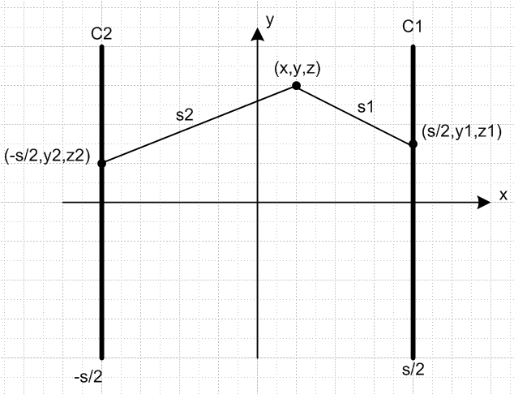

and so we have

s1 = $\sqrt{(x-s/2)2 + (y-y1)2 + (z-z1)2}$
s2 = $\sqrt{(x+s/2)2 + (y-y2)2 + (z-z2)2}$

Then we can write

{} = { $^{\int_{C1}^{}{}}$dx' dy' [ K0(jβs1) - K0(jβs2)] - $^{\int_{C2}^{}{}}$dx' dy' [ K0(jβs1) - K0(jβs2)] }

= { $^{\int_{C1}^{}{}}$dz1 dy1 [ K0(jβs1) - K0(jβs2)] - $^{\int_{C2}^{}{}}$ dz2 dy2 [ K0(jβs1) - K0(jβs2)] }

{ $^{\int_{C1}^{}{}}$dx' dy' [ K0(jβs1) - K0(jβs2)] - $^{\int_{C2}^{}{}}$dx' dy' [ K0(jβs1) - K0(jβs2)] }

**********************************************

STOP, I have screwed up, it is a mess. Start over and track each item with a proper drawing. We start with this

φ1(x) = $\frac{1}{4πε}$∫$_{}^{}$ ρ1(x') $\frac{e-jβR}{R}$ dx'dy'dz' R = |x - x'| (4.1.1)

where I will take z' to be the longitudinal xline direction. Of course ρ1(x') is a surface charge, but I have it expressed as a 3D charge density, that is OK. Now consider

ρ1(x,y,z) = a1(x,y) q1(z) . (4.1.2)
C/m3 1/m2 C/m

What is going on here? I guess I just pretend a(x,y) is a smooth distribution over the conductor cross section for right now, but later it has to become a distribution with some kind of δ stuff. Next we get

φ1(x,y,z) = $\frac{1}{4πε}$$^{\int_{C1}^{}{}}$dx' dy' a1(x',y') $^{\int_{-∞}^{∞}{}}$dz' q(z') $\frac{e-jβR}{R}$ . (4.1.5)

Let's try to compute this when C1 is the parallel plate here. Note that R = R1.

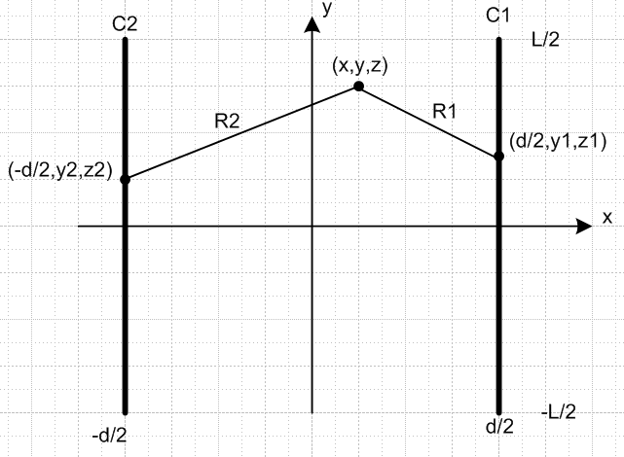

Lets now try this form

a1(x',y') = δ(x'-d/2)/L

Then we can confirm

$^{\int_{C1}^{}{}}$dx' dy' a1(x',y') = $^{\int_{-L/2}^{L/2}{}}$dy' $^{\int_{-∞}^{∞}{}}$dx' δ(x'-d/2)/L

= $^{\int_{-L/2}^{L/2}{}}$dy' (1/L) = 1 .

Then we get

φ1(x,y,z) = $\frac{1}{4πε}$ (1/L) $^{\int_{-L/2}^{L/2}{}}$dy' $^{\int_{-∞}^{∞}{}}$dx' δ(x'-d/2) $^{\int_{-∞}^{∞}{}}$dz' q(z') $\frac{e-jβR}{R}$ .

= $\frac{1}{4πε}$ (1/L) $^{\int_{-L/2}^{L/2}{}}$dy' $^{\int_{-∞}^{∞}{}}$dz' q(z') $\frac{e-jβR}{R}$ R = R1

where now R is the distance from our observation point (x,y,z) to a point (d/2,y',z') on plate 1. That is to say

R = R1 = $\sqrt{(x-d/2)2 + (y-y')2 + (z-z')2}$ = $\sqrt{(z-z')2 + s2}$

where s is the transverse part of the distance

s = $\sqrt{(x-d/2)2 + (y-y')2}$.

Now assume that q(z) = q = total charge per distance z on the plate. Then q = Q/(dL). We seem to have

φ1(x,y,z) = $\frac{1}{4πε}$ (1/L) q $^{\int_{-L/2}^{L/2}{}}$dy' $^{\int_{-∞}^{∞}{}}$dz' $\frac{e-jβR}{R}$ R = R1

This integral is done in Appendix G as (G.11) which says

I0(x) = $^{\int_{-∞}^{∞}{}}$dz' $\frac{e-jβR}{R}$ = 2 K0(jβs) . (G.11)

so we end up then with

φ1(x,y,z) = $\frac{1}{4πε}$ (1/L) q 2 $^{\int_{-L/2}^{L/2}{}}$dy' K0(jβ$\sqrt{(x-d/2)2 + (y-y')2}$)

Wow, this seems to be the exact potential of an isolated rectangular plate with charge Q and dimensions d by L where we run at some frequency ω,

β2 = μεω2 - jωμσ = ω2μ ( ε - jσ/ω) → 0 in the DC limit

If we go to the small β limit we can use

K0(z) ≈ -ln(z/2)

and then we have

φ1(x,y,z) = - $\frac{1}{4πε}$ (1/L) q 2 $^{\int_{-L/2}^{L/2}{}}$dy' ln(jβ$\sqrt{(x-d/2)2 + (y-y')2}$/2)

φ1(x,y,z) = - $\frac{1}{4πε}$ (1/L) q 2 $^{\int_{-L/2}^{L/2}{}}$dy' ln(jβs/2)

How are we doing on dimensions? Apart from the leading factor, we need C/L. We have

L-1 (C/L) L = C/L check

Now

ln(jz) = ln(ejπz) = jπ + ln(z)

if we want to use it. Is this a doable integral?

$^{\int_{-L/2}^{L/2}{}}$dy' ln(jβs/2)

First make s be the integration variable. Then.

s = $\sqrt{(x-d/2)2 + (y-y')2}$ (y-y') = $\sqrt{s2-(x-d/2)2}$

ds = (1/2)s-1 2(y-y')dy' = s-1$\sqrt{s2-(x-d/2)2}$dy'

dy' = ds s/$\sqrt{s2-(x-d/2)2}$

Then

$^{\int_{-L/2}^{L/2}{}}$dy' ln(jβs/2) = ∫ ds s/$\sqrt{s2-(x-d/2)2}$ ln(jβs/2)

= ∫ ds s/$\sqrt{s2-(x-d/2)2}$ [ ln(jβ/2) + ln(s) ]

Now y' = L/2 means s = $\sqrt{(x-d/2)2 + (y-L/2)2}$ = s2

Now y' = -L/2 means s = $\sqrt{(x-d/2)2 + (y+L/2)2}$ = s1

Then we have

$^{\int_{-L/2}^{L/2}{}}$dy' ln(jβs/2) = ln(jβ/2) $^{\int_{s1}^{s2}{}}$ ds s/$\sqrt{s2-(x-d/2)2}$

+ $^{\int_{s1}^{s2}{}}$ ds s ln(s) /$\sqrt{s2-(x-d/2)2}$

Now maybe write ln(s) = (1/2)ln(s2) and d(s2) = 2sds = dz so integrals are then

$^{\int_{-L/2}^{L/2}{}}$dy' ln(jβs/2) = ln(jβ/2) (1/2)$^{\int_{s12}^{s22}{}}$ dz/$\sqrt{z-(x-d/2)2}$

+ (1/2) $^{\int_{s12}^{s22}{}}$ dz ln(z)/$\sqrt{z-(x-d/2)2}$

But these now are doable integrals

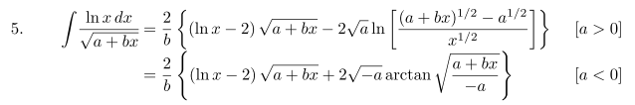

What a true mess this is. I am not sure why I am doing this problem. I just wanted to verify the formula for a parallel plate capacitor!

