11.23.13

This doc is where I developed my new version of Section 1.3 (c) which no longer mentions surface currents Jm. Probably the section has evolved further since it was installed into lines doc. This doc is just for archive purposes, could be thrown out some day.

(c) The Potential Wave Equations in the King and Lorenz Gauges with Conductors

We refer to a certain gauge condition below as "the King gauge" because King (see Refs.) made extensive use of this condition in his books and papers at least as early as 1945. Perhaps this gauge has some official name, but we are not aware of it.

We start with this King gauge and treat A and then φ. Then we do the Lorenz gauge case for A and φ, and finally we look at the wave equations for E and B. The motivation for using the King gauge is made clear.

Unlike most sources on this subject, we allow for the possibility that the conductors' μi might differ from that of the dielectric.

KING GAUGE

Wave equation for A

Consider the following general cross section of a transmission line which happens to be of coaxial cable type,
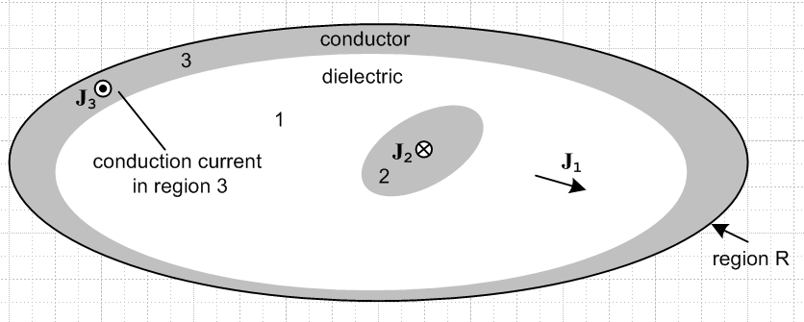

The gray regions 2 and 3 are conductors, while the white region 1 is the (possibly conducting) dielectric. Currents J1, J2 and J3 are conduction currents.

We start by selecting the King gauge for region 1 and we apply it to all three regions,

div A = - μ1ε1 ∂tφ - μ1σ1φ // King gauge, applied to all of R . (1.3.18)

We first obtain the wave equation for A in region 1. Start with (1.3.3) which gives the wave equation for A before any gauge choice is made

(∇2 - μ1ε1 ∂t2) A = grad [μ1ε1 ∂tφ + divA ] - μ1J . // region 1 (1.3.3)

Now insert the King gauge (1.3.18) to get

(∇2 - μ1ε1 ∂t2) A = grad [μ1ε1 ∂tφ + (- μ1ε1 ∂tφ - μ1σ1φ) ] - μ1J

= - μ1σ1 grad φ - μ1J

= - μ1σ1 (-E -∂tA) - μ1(σ1E) . // from (1.3.1) and J = σ1E

= - μ1σ1 ( -∂tA) .

Thus the wave equation for A in region 1 is

(∇2 - μ1ε1 ∂t2 - μ1σ1∂t) A = 0 // region 1 (1.3.19)

This is a damped wave equation with no driving source; the equation is homogeneous.

Now we start over with (1.3.3) for region 2:

(∇2 - μ2ε2 ∂t2) A = grad [μ2ε2 ∂tφ + divA ] - μ2J2 // region 2 (1.3.3)

As before, we insert the region 1 King gauge expression (1.3.18) for div A, even though we are now working in region 2,

(∇2 - μ2ε2 ∂t2) A = grad [μ2ε2 ∂tφ + (- μ1ε1 ∂tφ - μ1σ1φ) ] - μ2J2

= [μ2ε2 ∂t + (- μ1ε1 ∂t - μ1σ1) ] gradφ - μ2J2

= [ (μ2ε2 - μ1ε1) ∂t - μ1σ1) ] gradφ - μ2J2

= [ (μ2ε2 - μ1ε1) ∂t - μ1σ1) ] (-E-∂tA) - μ2J2 // using (1.3.1)

= [ (μ2ε2 - μ1ε1) ∂t - μ1σ1) ] (-J2/σ2-∂tA) - μ2J2 // J2 = σ2E

≈ [ (μ2ε2 - μ1ε1) ∂t - μ1σ1) ] (-∂tA) - μ2J2 // since σ2 is very large in conductor 2

= - [ (μ2ε2 - μ1ε1) ∂t2 - μ1σ1∂t ] A - μ2J2

Notice that we have chosen not to set J2 = σ2E in region 2 for the last term, we just leave it as J2. Moving the first term on the right to the left we get

( ∇2 - μ2ε2 ∂t2 + [ (μ2ε2 - μ1ε1) ∂t2 - μ1σ1∂t ] ) A = - μ2J2
or
( ∇2 - μ1ε1 ∂t2 - μ1σ1∂t ) A = - μ2J2 // region 2 (1.3.20)

On the left side we see the same region 1 damped wave operator although we are in region 2, and J2 is the conduction current density in region 2. A similar result will be obtained for region 3. Thus we have shown that

(∇2 - μ1ε1 ∂t2 - μ1σ1∂t ) A = 0 region 1
(∇2 - μ1ε1 ∂t2 - μ1σ1∂t ) A = - μ2J2 region 2
(∇2 - μ1ε1 ∂t2 - μ1σ1∂t ) A = - μ3J3 region 3 (1.3.21)

We can combine these into a single equation which is then valid over all of region R,

(∇2 - μ1ε1 ∂t2 - μ1σ1) A = - μ2J2 - μ3J3 all of region R (1.3.22)

with the understanding that the conduction current in region 1 has already been accounted for and Ji represents conduction currents in conductor i .We could generalize this result for a region R containing any number N of conductors labeled i = 2,3...N+1

(∇2 - μ1ε1 ∂t2 - μ1σ1) A = - Σi=2N+1μiJi all of region R (1.3.23)

Wave equation for φ

We first obtain the wave equation for φ in region 1. Start with (1.3.2) which gives the wave equation for φ before any gauge choice is made

∇2φ + ∂t[div A] = -ρ/ε1 . (1.3.2)

Now use the same global region R King gauge (1.3.18) for div A.

∇2φ + ∂t[- μ1ε1 ∂tφ - μ1σ1φ] = - ρ1/ε1

(∇2 - μ1ε1 ∂t2 - μ1σ1∂t)φ = - (1/ε1)ρ1 // region 1 (1.3.24)

Again the same damped region 1 wave operator appears on the left side. Since the King gauge is the same in all three regions, we can write

(∇2 - μ1ε1 ∂t2 - μ1σ1∂t)φ = - (1/ε1)ρ1 // region 1
(∇2 - μ1ε1 ∂t2 - μ1σ1∂t)φ = - (1/ε2)ρ2 // region 2
(∇2 - μ1ε1 ∂t2 - μ1σ1∂t)φ = - (1/ε3)ρ3 // region 3 (1.3.25)

where ρ always means free charge. The three equations are basically the same because the pre-gauge equation (1.3.2) has no region-specific parameters apart from ε1, in contrast with (1.3.3) quoted above.

Now the only actual free charge present is the surface charge on the outside surfaces of the conductors and we regard this as being in region 1. There is no free charge inside the dielectric or inside the conductors. We can then combine the above three equations into a single equation for all of region R

(∇2 - μ1ε1 ∂t2 - μ1σ1∂t)φ = - (1/ε1)ρs all of region R (1.3.26)

where now ρs is the surface charge on the conductors.

Conclusion for wave equations in the King gauge

Here then are the wave equations for φ and A in region R using the region 1 King gauge:

Potential Wave Equations in the King Gauge (1.3.27)

(∇2 - μ1ε1 ∂t2 - μ1σ1∂t)φ = - (1/ε1)ρs all of region R (1.3.26)
(∇2 - μ1ε1 ∂t2 - μ1σ1∂t)A = - Σi=2N μiJi all of region R (1.3.23)
div A = - μ1ε1 ∂tφ - μ1σ1φ King gauge (1.3.18)

1 = dielectric 2,3,4.... = conductors
ρs = total free surface charge on all conductors
Ji = current in conductor i ( current in dielectric exists but does not appear in Σi μiJi)

King never writes these wave equations in his transmission-line theory book, so it is difficult to find verification of our logic pathway in his book. However, Panofsky and Phillips do show the equations and we quote the relevant section from p 241 of their book where we identify their parameters μ,ε,σ with our region 1 parameters μ1, ε1, σ1 :

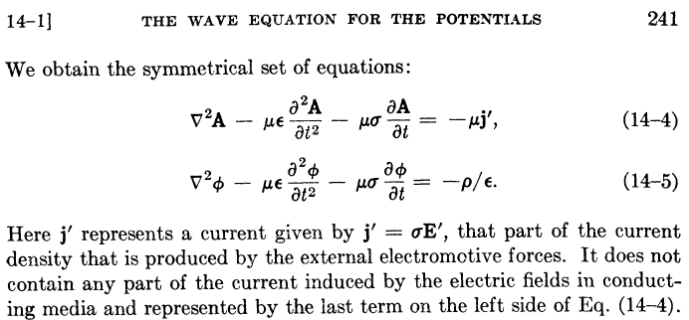

Their last sentence says that J = σE in the conducting dielectric has been incorporated into the -μσ∂tA term in their first equation, just as we have done above. These authors have assumed that the μ's of the dielectric and the conductors are all the same (normally μ = μ0). In order to obtain the above equations, Panofsky and Phillips use the King gauge (1.3.18) but they refer to this gauge simply as "the Lorentz condition" (illustrating Comments 1and 2 above) . From their page 240,

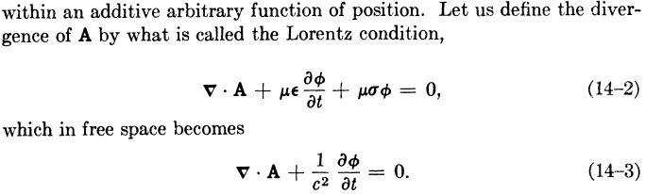

LORENZ GAUGE

If we carry out exact same program with respect to Fig ** using a global Lorenz gauge for all of R,

divA = - μ1ε1∂tφ , (1.3.28)

we obtain these results for A, where in region 1 the conduction current is not absorbed into a damping term on the left side,

(∇2 - μ1ε1 ∂t2)A = - μ1J1 region 1
(∇2 - μ1ε1 ∂t2)A = - μ2J2 region 2
(∇2 - μ1ε1 ∂t2)A = - μ3J3 . region 3

As before, all three equations have the same wave operator on the left side. Again assuming N conductors, we combine these into a single equation as follows

(∇2 - μ1ε1 ∂t2)A = - Σi=1N μiJi all of region R (1.3.28)

Meanwhile, the results for φ are

(∇2 - μ1ε1 ∂t2)φ = -ρ/ε1 region 1
(∇2 - μ1ε1 ∂t2)φ = -ρ/ε2 region 2
(∇2 - μ1ε1 ∂t2)φ = -ρ/ε3 region 3

so that with the same comments made earlier (ρs includes all surface charges bordering region 1)

(∇2 - μ1ε1 ∂t2)φ = -ρs/ε1 all of region R (1.3.29)

COMPARISON

We can now do a side by side comparison:

King Gauge:
(∇2 - μ1ε1 ∂t2 - μ1σ1∂t)φ = - ρs/ε1 all of region R (1.3.26)
(∇2 - μ1ε1 ∂t2 - μ1σ1) A = - Σi=2N μiJi all of region R (1.3.23)
div A = - μ1ε1 ∂tφ - μ1σ1φ King gauge region 1 (1.3.18)

Lorenz Gauge:
(∇2 - μ1ε1 ∂t2)φ = -ρs/ε1 all of region R
(∇2 - μ1ε1 ∂t2)A = - Σi=1N μiJi all of region R
divA = - μ1ε1∂tφ Lorenz gauge region 1

In the Lorenz gauge, we get undamped wave operators, but the first sum on the right of the A equation includes a sum over the current in the dielectric, whereas this is not the case in the King gauge. In a situation where we have prescribed currents Ji in the conductors, it is inconvenient to have to worry about the dielectric conduction current J1 which complicates the solution of the problem (this will become more obvious later). In the King gauge, we get damped wave operators but we have to include only the current in the conductors since the current in the dielectric has been incorporated into the damping term. When we transform to the frequency domain and write the Helmholtz equation for A and its Helmholtz Integral solution, we need only integrate over the conductors which makes life easier.

E AND B WAVE EQUATIONS

Meanwhile, the E and B field wave equations of course don't know anything about gauges and from (1.2.1) and (1.2.2) we have, with respect to Fig. ** ,

(∇2 - μ1ε1 ∂t2)E = μ1∂tJ1 + (1/ε1) grad ρ1 = μ1∂tJ1 + (1/ε1) grad ρs // region 1
(∇2 - μ2ε2 ∂t2)E = μ2∂tJ2 + (1/ε2) grad ρ2 = μ2∂tJ2 // region 2
(∇2 - μ3ε3 ∂t2)E = μ3∂tJ3 + (1/ε3) grad ρ3 = μ3∂tJ3 // region 3
(1.3.30)
(∇2 - μ1ε1 ∂t2)B = - μ1 curl J1 // region 1
(∇2 - μ2ε2 ∂t2)B = - μ2 curl J2 // region 2
(∇2 - μ3ε3 ∂t2)B = - μ3 curl J3 // region 3

where Ji = σiE . We cannot unify each group of three equations into a single region R equation as we could in the potential case since the wave operators are different in each region. Using Ji = σiE and curl E = - ∂tB we get

(∇2 - μ1ε1 ∂t2 - μ1σ1∂t)E = (1/ε1) grad ρs // region 1
(∇2 - μ2ε2 ∂t2 - μ2σ2∂t)E = 0 // region 2
(∇2 - μ3ε3 ∂t2 - μ3σ3∂t)E = 0 // region 3
(1.3.31)
(∇2 - μ1ε1 ∂t2 - μ1σ1∂t)B = 0 // region 1
(∇2 - μ2ε2 ∂t2 - μ2σ2∂t)B = 0 // region 2
(∇2 - μ3ε3 ∂t2 - μ3σ3∂t)B = 0 // region 3

Again the three damped wave operators are different. The solution of these equations requires solving the first for its particular solution, finding all possible homogenous solutions to all 6 equations using appropriate harmonic forms with "constants to be determined", then matching these conditions at the two boundaries to evaluate the constants. In contrast, in the potential problem of (1.3.27),

(∇2 - μ1ε1 ∂t2 - μ1σ1∂t)φ = - (1/ε1)ρs all of region R (1.3.26)
(∇2 - μ1ε1 ∂t2 - μ1σ1∂t)A = - Σi=2N μiJi all of region R (1.3.23)
div A = - μ1ε1 ∂tφ - μ1σ1φ King gauge (1.3.18) (1.3.27)

one worries about a single unified region R and there is only one damped wave operator. The method of solution is to find the particular solutions of the φ and A equations, add in homogenous solutions and match boundary conditions.

