The King Gauge Problem PhL 10.14.13

I am doing battle here with The King Problem #2 that the A wave equation has no source J. I review my own ancient 1991 King notes, I look at PDF book by Martin but don't find the answer. Along the way I learn for the first time here about Lorenz versus Lorentz gauge. I then consider a long list of "Plans" to try to deal with this King Problem #2. Plan A: is it the homo solution term ∫σ dSξ f(ξ) ∂ξn g(x|ξ) of Stak that I am ignoring? I just flail away here. In Plan E I decide to grind through some King reading which I then did, but did not find the answer there. In Plan G for the first time I draw a nice picture showing some conductors in gray and the intervening dielectric in white, and for the first time I starting thinking in terms of regions 1,2,3. I consider the analogy with Poisson and I have the idea that a current deep inside a conductor refracts out through the surface, and thus "gets through" in its influence on A in the dielectric. I then restart with this idea and a simpler drawing. It is confusing because you have to deal with two different propagators to get from source J out to observation point in the dielectric. But then I end up "dangling" conductors into region 1 and am back to the "applied " Ja idea. A wonderful flail document! Things continue in a doc of the same title + "continued".

___________________________________________________________________________________

The rubber is meeting the road now in my ongoing battle with explaining King's stuff. Here is my biggest problem right now:

1. Statement of the Problem. 1
2. The offering of Martin. 2
3. Some possible Plans 6
Plan A: 6
Plan B: 7
Plan C: 7
Plan D: 8
Plan E: 8
Plan F: 8
4. Plan G 8
An Analogous Poisson Problem 9
An Analogous Poisson Problem, Version 2 12

1. Statement of the Problem [ The King Problem #2 ]

My potential equations have many forms. Here is one:

(∇2 - με ∂t2)φ = - (1/ε)ρ (1.3.4)

(∇2 - με ∂t2)A = - μJ (1.3.5)

These are the μ and ε that appear in Maxwell's equations. Inside a conductor, I have noted that it is not clear what μ is doing.

Big New Bug: I am trying to add a King gauge section after my relativity note, and I end up with these equations

(∇2 - με ∂t2- μσ∂t) A = 0 (1.3.15)

(∇2 - με ∂t2- μσ∂t)φ = -ρ/ε (1.3.16)

divA = - με ∂tφ - μσφ (1.3.17)

where I used J = σE . In the frequency domain these say

(∇2 + βc2) A = 0
(∇2 + βc2) φ = -ρ/ε

The problem is that the first equation now has no source, so my solutions from (1.5.9) would be
φ(x,ω) = $\frac{1}{4πε} \int_{}^{}{ρ(x',ω) \frac{e-jβc(ω)R}{R}dV'}$ R = |x - x'| (1.5.9)
A(x,ω) = $\frac{μ}{4π}\int_{}^{}{Ja(x',ω) \frac{e-jβc(ω)R}{R}dV'}$ R = |x - x'| (1.5.10)
where now I have to make up some Ja "applied" in order to have a source!!! Something is very wrong. I have read all of King's text, and he just gives no justification for this.
Do I have any King notes somewhere? Yes, I have lots of notes from 1991. I was having lots of King paradoxes and issues, especially with the King gauge thing. I perused some of these notes, I was indeed really suffering and I think many issues have been finally figured out.

But this βc thing is going to be a big problem for me. I am going to use the Az integral solution in (4.3.1) and it is crucial that the β in there be the complex β. β goes along being whatever you want until we get to (4.5.3) . Well, it is still just β there. But eventually you get down to this

y = G + jωC = jβ2/(ωLe) (4.5.12)

Here if β is the non-complex β, you get no jωC part in your field equations!!! So here it HAS to be the complex β. So I have a very major problem that is a complete showstopper.

My first reaction is to try to find some other source that talks about this King gauge.

2. The offering of Martin.

I found a promising PDF by Martin which is in fact quite similar to mine. The opening Chapter 1 is very close to my stuff. In Chap 2 he talks about the Lorenz Gauge by that name,

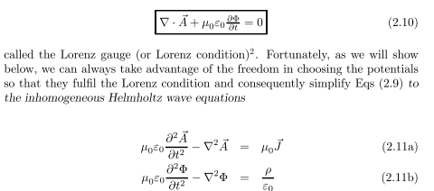

So there he has my wave equations with the non-complex β, all is well so far. He then says there are other gauge choices and talks about the Coulomb gauge and so

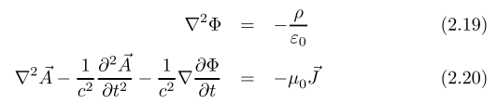

He mentions no King gauge. Later he has

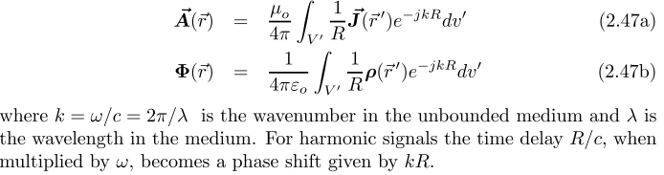

and he is using the non-complex k wavenumber, consistent with earlier stuff. So far, none of the King stuff. This chapter 2 then goes off into radiation stuff, all quite messy, no King yet.

In Chapter 3 Martin gets around to these wave equations,

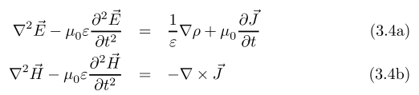

which exactly match my (1.2.1) and (1.2.2).
On page 73 of Chapter 3 suddenly conductivity σ appears. He gets this wave equation,

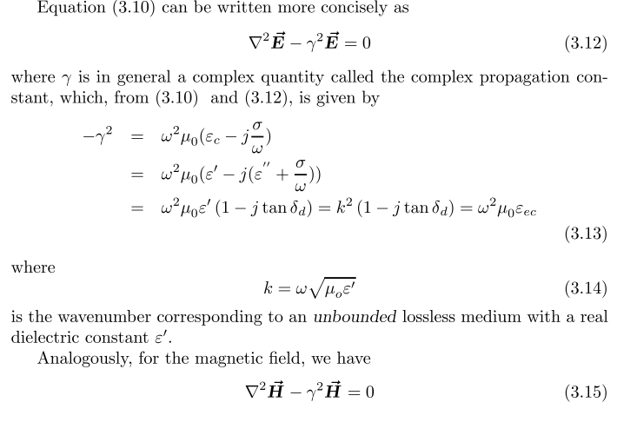

I would associate these equations with my pair,

(∇2 - με ∂t2 - μσ ∂t)E = (1/ε) grad ρ // J = σE assumed (1.2.3)

(∇2 - με ∂t2 - μσ ∂t)B = 0 // J = σE assumed (1.2.4)

in a place where ρ = 0. So we are still all together. He even has some nice pix of my type, like,

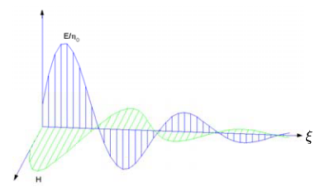

where he is talking I think about a damped plane wave with the above damping term. Great! He then cranks out skin depth and surface impedance.

Chap 4 is on refraction and reflection.

Chapter 5 is on waveguides and transmission lines! My hope increases. But alas, he never really gets beyond waveguides. These have E and B field boundary conditions and don't involve the potentials that I am having trouble with.
You can see that this is a book in progress, sort of like mine, quite interesting. He gets off into many subjects I do not. In particular, he never derives the transmission line equations, so he avoids my problem.
I guess I need a source that talks about these transmission line equations? I will try to find some books specializing in this subject, probably a good idea just in general!
Rachidi book on Google has no hits on gauge that are of interest.
CERN doc. This has a great picture at least,

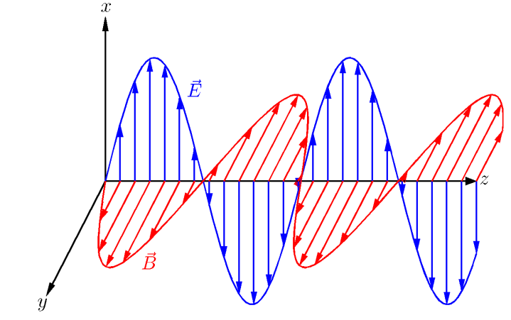

OUCH! I learn that it is really Lorenz gauge after a guy, and Lorentz is a totally different person. I will have to fix that up! But Jackson calls it Lorentz as I do, at least in Green. Aha! This is in fact an actual error in green Jackson that is fixed in blue. In green he calls it the Lorentz condition, and in blue the Lorenz condition.

I have found some Jackson errata by Jackson himself dated Nov 2001! It is a PDF which I have saved. My copy is a 9th printing, as indicated by

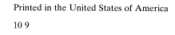

So my copy has none of the errors, but Jackson is going to fess up on this Lorenz matter!

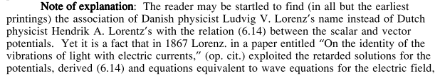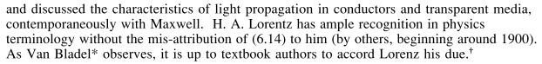

So I will comment on this in lines.

How can I ferret out this King gauge condition?

Suppose King is just flat out wrong! Suppose I just ignore his gauge. How can I bail out my derivation of the transmission line equations?

3. Some possible Plans
_________________________________________________________________________

Plan A: Consider again my derived equations,

(∇2 - με ∂t2- μσ∂t) A = 0 (1.3.15)

(∇2 - με ∂t2- μσ∂t)φ = -ρ/ε (1.3.16)

divA = - με ∂tφ - μσφ (1.3.17)

Compare the first equation to the Laplace equation

∇2u = 0

From my meta-6 Stak notes I have

u(x) = ∫R dξ g(x|ξ) q(ξ) – ∫σ dSξ f(ξ) ∂ξn g(x|ξ)

where the second term is an integral with a prescribed u = f(ξ) on a boundary and the derivative I think is the surface charge! [ wrong! ] But g is a Green's which vanishes on the boundaries. Put this on hold for now.

Plan B: Suppose you are in the dielectric in which both ρ and J are 0. Then both these pairs of equations are true (this is the Jackson approved pair)

(∇2 - με ∂t2)E = μ∂tJ + (1/ε) grad ρ = 0 (1.2.1)
(∇2 - με ∂t2)B = - μ curl J = 0 (1.2.2)

(∇2 - με ∂t2 - μσ ∂t)E = (1/ε) grad ρ = 0 // J = σE assumed (1.2.3)
(∇2 - με ∂t2 - μσ ∂t)B = 0 // J = σE assumed (1.2.4)

So here is my question: How is it possible, out in the middle of the dielectric, for a homo wave equation to be both damped and undamped? Answer: in the dielectric σ = 0 so those damping terms are not really there.

OK, let's go inside the conductor. Then the two pairs of equations are

(∇2 - με ∂t2)E = μ∂tJ + (1/ε) grad ρ = μ∂tJ (1.2.1)
(∇2 - με ∂t2)B = - μ curl J (1.2.2)

(∇2 - με ∂t2 - μσ ∂t)E = (1/ε) grad ρ = 0 // J = σE assumed (1.2.3)
(∇2 - με ∂t2 - μσ ∂t)B = 0 // J = σE assumed (1.2.4)

Here you get your choice of a damped homo wave equation with no sources, or an undamped inhomo wave equation with driver terms.

It is only inside metal where I have a problem. So no paradox here.

Plan C: Let's look at the two sets of potential wave equations and their two different sets of potentials:

(∇2 - με ∂t2)φ = - (1/ε)ρ (1.3.4)
(∇2 - με ∂t2)A = - μJ (1.3.5)
divA = - με ∂tφ (1.3.6)

(∇2 - με ∂t2- μσ∂t)φ = -ρ/ε (1.3.16)
(∇2 - με ∂t2- μσ∂t)A = 0 (1.3.15)
divA = - με ∂tφ - μσφ (1.3.17)

Let's get into ω space just to make it obvious we have nothing more than scalar Helm equations

(∇2 +ω2με) φ = - (1/ε)ρ (1.3.4)
(∇2 +ω2με)Az = - μJz (1.3.5)
divA = - μεjω (1.3.6)

(∇2 +ω2με - μσjω)φ = -ρ/ε (1.3.16)
(∇2 +ω2με - μσjω)Az = 0 (1.3.15)
divA = - με jωφ - μσφ (1.3.17)

Put this Plan on hold for a moment.

Plan D: In the above set of choices for (A,φ), which choice gives a φ which measures "voltmeter difference" ? Since the two φ's are different, they probably cannot both be "voltmeter" potentials.

I think my answer to this question in lines doc is OK. It says if you stay in a z=constant plane, then φ will be a voltmeter voltage. A good question and a good answer. Assume that At ≈ 0 and Az = large. I am willing to go with that answer for now.

What happens in Chapter 4 where I am doing potential work for a transmission line? Is either of my two φ's above voltmeter voltage? I guess the question is this: is it true that Az >> At in both gauges? What argument do I have that says At << Az if I cannot make a connection to the current!!!

So it really seems that the Lorenz gauge is more appropriate for making this assumption.

So OK, why can't I just assume β = the simple real wavenumber and forget the complex one?

The φ discussion goes the same with either β !

The W(z) discussion is much more opaque! At one point I claim that W(z) = Le i(z), in order to identify Le as some kind of "inductance", but what does this equation even mean? As I read in that section, things just don't make much sense. I need to go derive all this stuff in my verifications doc.

Plan E: Let's put the King Gauge stuff on hold, and jump down and try to grind through the transmission lines section, and I will assume that β is my simple real β.
OK, I have worked on this Plan E for a while, see temp 2 doc. I have a better understanding of the problem, but no solution yet other than add conductance by hand.

Plan F: Suppose we regard the wave equation

(∇2 - με ∂t2- μσ∂t)A = 0 (1.3.15)

as only being "operational" in the dielectric. The wires are then some kind of boundaries. Argg!! total trash. My whole approach requires integrating the solution over the insides of the wires.

4. Plan G

First, concerning the j' term in the Panofsky wave equation. First, here is a picture of a dielectric Region surrounded by a conductor Region,

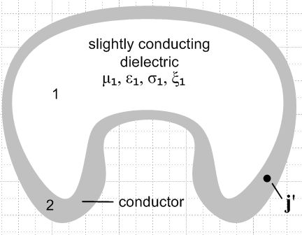 Fig 1

We start with this wave equation

(∇2 - μ1ε1 ∂t2)A(x,t) = - μJ1(x,t) valid in Region 1

For the moment, suppose Region one does not conduct at all. Then we have

(∇2 - μ1ε1 ∂t2)A1(x,t) = 0 valid in Region 1

∇2φ1 = 0 analogous Poisson equation for Region 1

In Region 2 we have this situation

(∇2 - μ2ε2 ∂t2)A2(x,t) = - μ2J2(x,t) valid in Region 2

∇2φ2 = ρ2/ε2 analogous Poisson equation for Region 2

In the Poisson case of a point charge near a boundary between two dielectrics where there is a point charge in Region 2, we know that ∇2φ1 = 0 does NOT force φ1 = 0 inside Region 1. Rather, this is one equation in a two-Region problem with a boundary. Just so, A1 will not be 0 in Region 1 despite the fact that it has no driving term on the right side.

An Analogous Poisson Problem

Although we are not directly interested in this problem, it serves as an analogy to a problem we will later study involving currents and the vector potential.

Consider the situation depicted in this drawing involving two dielectric Regions,

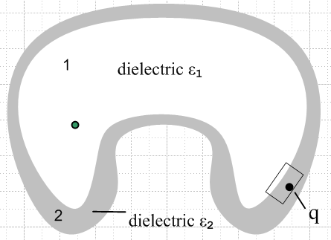 Fig 2

Here q is a point charge somewhere in the middle of Region 2 which has ε2. The equations are

∇2φ1 = 0 Region 1
∇2φ2 = ρ2/ε2 where ρ2 = q δ(x-xq) . Region 2

If we do a blow-up of the boundary Region near charge q, and assume that the boundary is relatively flat with respect to the position of q, we obtain a picture which looks like the following, which shows the direction of electric field lines (they bend at the boundary) :

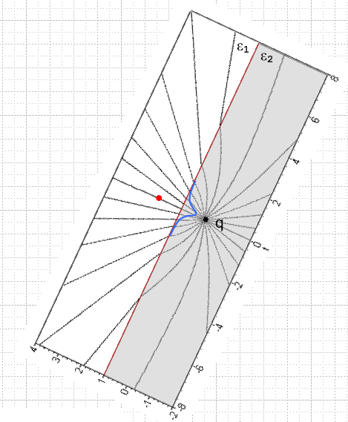 Fig 3

In this standard electrostatics problem [see Jackson *** ], the electric field lines from the point charge experience "electrostatic refraction" at the boundary. In Region 2, as Jackson shows, the field lines are curved because in Region 2 the field is effectively caused by point charge q and a mirror image charge q' in Region 1 (red). In Region 1 (notice that the field lines there are straight and all point to q), the field is effectively caused by a point charge q" located at the position of charge q. The sizes of q' and q" are,

q' = – $\frac{ε2-ε1}{ε2+ε1}$q q" = $\frac{2ε2}{ε2+ε1}$q .

Our Maple plot in Fig 3 assumes ε2 = 2 and ε1 = 1, so q' = - q/3 and q" = 4/3 q. The image charge q' (red) exactly models the effect of the polarization charge (blue) induced at the boundary by q. For ε2>ε1 as in our example, this charge is negative, pulling the field lines in Region 2 toward a dipole-like pattern. Also for ε2>ε1, q" is a magnified version of q.
Now suppose we have ε2 = ε1. In this case, the field lines no longer refract at the boundary because q' = 0. Also q" = q. It is as if we simply combined Region 1 and Region 2 into a single Region for which we would then write this Poisson equation

∇2φ12 = ρ/ε1 = q δ(x-xq)/ε1 combined Region 1 and Region 2

If we restrict our interest to Region 1, then, since the charge is all in Region 2, we have

∇2φ12 = 0 for Region 1

Although our Region 1 equation **** has no driving term, it is clear that the potential in Region 1 is going to be given by the solution to **** which, as in (A.0.2) is this,

φ1(x) = $\frac{1}{4πε1}$∫d3x' $\frac{ρ(x')}{|x-x'|}$ ρ(x') = q δ(x'-xq) in Region 1

As shown in (A.0.3), we may regard $\frac{1}{4π}$ $\frac{1}{|x-x'|}$as the free-space electrostatic propagator g(x,x'), and then our solution may be written

φ1(x) = $\frac{1}{ε1}$∫ g(x,x') ρ(x')d3x' ρ(x') = q δ(x'-xq) in Region 1

In the propagator language, we can say that a tiny piece of charge [ρ(x')d3x'] at point x' "propagates" according to the kernel function propagator g(x,x') from location x' to location x where it contributes then to ε1φ1(x), as if this were some sort of static scattering scenario. Later in the Helmholtz scenario, one really does have a scattering action with a time element, but here things are just static.
One final point concerns the green dot on the left side of Fig 2. If we take this dot to be our Region 1 observation point x, then φ1(x) is given by ** above, despite the fact that there is no Region 1 "line of sight" between the green dot observation point and the point charge q. We have ε2 = ε1 so both the gray and white Region are of the same medium, but we have not specified the medium in the grid area outside these Regions. The potential from point charge q propagates to the observation point in exactly the same way whether or not there is a Region 1 line of sight between these points.

STOP. This is not really right. If the grid were more ε1 Region or were a conductor, there would be induced charges on it which would affect things which we have ignored above.

Let's start over on this with a more appropriate shape. And I think I had 1 and 2 swapped above.

An Analogous Poisson Problem, Version 2

Although we are not directly interested in this problem, it serves as an analogy to a problem we will later study involving currents and the vector potential.

Consider the situation depicted in this drawing involving two dielectric Regions,

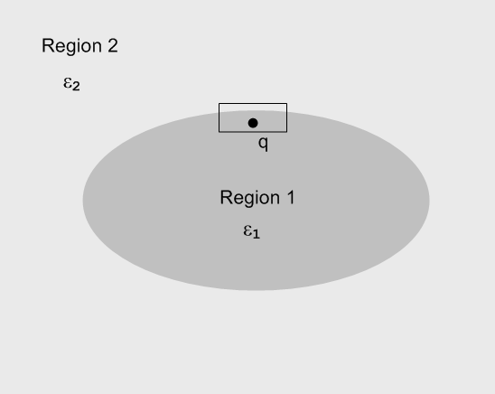 Fig 2

Here q is a point charge somewhere inside Region 1 which has ε1. The equations are

∇2φ2 = 0 Region 2
∇2φ1 = ρ1/ε1 where ρ1 = q δ(x-xq) . Region 1

If we do a blow-up of the boundary Region near charge q, and assume that the boundary is relatively flat with respect to the position of q, we obtain a picture which looks like the following, which shows the direction of electric field lines (they bend at the boundary) :

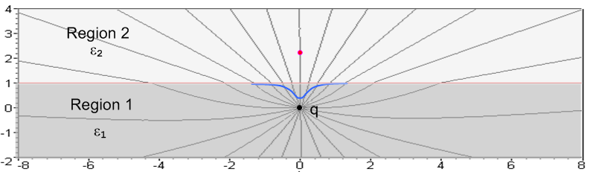

In this standard electrostatics problem [see Jackson *** ], the electric field lines from the point charge experience "electrostatic refraction" at the boundary. In Region 1, as Jackson shows, the field lines are curved because in Region 1 the field is effectively caused by point charge q and a mirror image charge q' in Region 2 (red). In Region 2 (notice that the field lines there are straight and all point to q), the field is effectively caused by a point charge q" located at the position of charge q. The sizes of q' and q" are,

q' = – $\frac{ε2-ε1}{ε2+ε1}$q q" = $\frac{2ε2}{ε2+ε1}$q .

Our Maple plot in Fig 3 assumes ε2 = 2 and ε1 = 1, so q' = - q/3 and q" = 4/3 q. The image charge q' (red) exactly models the effect of the polarization charge (blue) induced at the boundary by q. For ε2>ε1 as in our example, this charge is negative, pulling the field lines in Region 1 toward a dipole-like pattern. Also for ε2>ε1, q" is a magnified version of q.
Now suppose we have ε2 = ε1. In this case, the field lines no longer refract at the boundary because q' = 0. Also q" = q. It is as if we simply combined Region 1 and Region 2 into a single Region 12 for which we would then write this Poisson equation

∇2φ12 = ρ/ε1 = q δ(x-xq)/ε1 combined Region 1 and Region 2 (1)

If we restrict our interest to Region 2 only, then, since the charge is all in Region 1, we have

∇2φ2 = 0 for Region 2 (2)

Although our Region 2 equation (2) is homogeneous and has no driving term, it is clear that the potential in Region 2 is going to be given by the solution to (1) which, as in (A.0.2) is this,

φ2(x) = $\frac{1}{4πε2}$∫d3x' $\frac{ρ(x')}{|x-x'|}$ ρ(x') = q δ(x'-xq) in Region 2

As shown in (A.0.3), we may regard $\frac{1}{4π}$ $\frac{1}{|x-x'|}$as the free-space electrostatic propagator E(x,x'), and then our solution may be written

φ2(x) = $\frac{1}{ε2}$∫ E(x,x') ρ(x')d3x' ρ(x') = q δ(x'-xq) in Region 2

In the propagator language, we can say that a tiny piece of charge [ρ(x')d3x'] at point x' "propagates" according to the kernel function propagator E(x,x') from location x' to location x where it contributes then to ε2φ2(x), as if this were some sort of static scattering scenario. Later in the Helmholtz scenario, one really does have a scattering action with a time element, but here things are just static.
If ε1 ≠ ε2, the above solution for φ2(x) is no longer correct as stated. One would have to first compute the boundary polarization charge on the entire boundary between the regions, then that surface charge density would have to be added to whatever free charge density existed inside Region 1 (such as q) to obtain the total influence on φ2(x). In other words,

φ2(x) = ∫dS [(1/4πε0)/R3] σpol + (1/4πε1)(q/R1)

In the second term ε1 appears rather than ε0 because this second term includes the effect of the point charge q and its immediate surrounding region of polarization charge which shields q and reduces the potential from q as shown by factor (ε0/ε1). In this manner, one would in effect account for the refraction of field lines on the entire boundary. For an arbitrarily shaped boundary this would require a significant amount of work. Even for the simple Jackson case of Fig **, where the boundary is between two infinite half spaces, the computation is non-trivial if one expands the potential in each region on cylindrical harmonics e±kzJ0(kρ) which is the best-suited coordinate system. It happens that the "image method" works for this simple half-space and that computation can then be avoided.

Comment: I am still missing one item. If ε1 ≠ ε2 and we have the original charge q and we have the surface polarization charge all known, do we use ε1 or do we use ε2 in the free space propagator, or is it some combination? In the Jackson case, with his definition of q", one used ε2 which is that of the region of observation, region 2. I am still unsure whether the effect in region 2 can be obtained with the region 2 propagator applied to both the full q and the polarization charge. I think I need to get this nailed down.

Idea 1: maybe you compute D first? After all, div D = ρ, the free charge only.

Idea 2: obtain φ on the boundary then do a Dirichlet problem in region 2?

Idea 3: do a Neumann problem using the pol charge density?

Paradox: Suppose you redid the Jackson problem for D instead of E. Since D doesn't see pol charge, you would think the solution would just be D = q/4π (1/R) or something like that. Then when you convert to E, what causes the diffraction at the boundary??

Response to Comment (added later on 10.26.13). I think I have now "nailed down" this issue, and the details are in document "Point charge in two dielectrics, Part 3.doc", section 2. There I show that you can write the potential in region 2 in these two different ways,

φ2(ρ,z) = (1/4πε2) q"/R1 // Jackson's way
φ2(ρ,z) = (1/4πε1) q/R1 + ∫dS [(1/4πε0)σpol/R3 ] // region 2

It is the second way that I am referring to in the current doc, and so ε1 is what is used there. In this second way, ε1 is used in the first term since the local shielding is accounted for by ε1, and the second integral term uses ε0 since this is a straight coulomb calculation of the effect of σpol on the boundary. It already is polarization charge.

New Question: How does the above "it is clear that" discussion change if region 2 has conductivity σ2 ? This is one of our two "nubbins" King questions. Without σ2 we wrote above

∇2φ1 = 0 Region 1
∇2φ2 = ρ2/ε2 where ρ2 = q δ(x-xq) . Region 2

Now where did the Poisson equation come from? We need to rederive it from Maxwell.

div E = ρ/ε E = -∇φ

=> div (∇φ) = - ρ/ε which IS ∇2φ = -ρ/ε

There is the derivation. Now how would σ affect things? I don't think it changes the Poisson equation one iota. Ouch!
But maybe I need to reconsider the Maxwell equations. I understand how ε does its shielding and that is why you have div E = ρ/ε which reduces ρ, instead of div E = ε/ε0. You are adding a new kind of charge into the problem. But J does not create a net charge anywhere!
Now why is it that I want to see ξ in the Poisson equation? There are two reasons.

(1) King clearly has it there sitting in his page 11 Eq (23), and I have seen it in other King places. For example, page 254 of his EE book which I copied says take ε0→ ξ and then that puts ξ in the Helm integral. There is no doubt about what King is saying we should do, I am just trying to justify it.

(2) In my lines doc, I need to have β2 be complex in (4.5.8) and that comes from div A = - j (β2/ω) φ with complex β which is the "King gauge". But maybe that is a separate issue from ε or ξ in the Helm integral. I need β complex to make the capacitance and bulk resistance both be present in TL parameter y.

Suppose then that I go back to the earlier picture, where 2 is our conducting dielectric.

Assume that we include surface charge in region 1 and that region 2 has conductivity. Then let's redo our "it is clear that" argument like so:

(∇2+ βc2)φ2 = 0 Region 2
(∇2+ βc2)φ1 = ρ1/ε1 where ρ1 = q δ(x-xq) . Region 1

So I really don't have a problem having βc be complex in the φ potential world. So my issue (2) is already solved, and I don't need ξ in the Helm integral denominator.

So maybe I really have three King issues. The only remaining one is how to get a current source to drive the A equation. My true A equation is this, in a region where we have Ohm's Law

(∇2+ βc2)Az2 = 0

My problem is that this has no "source" to "make it go". I have to manually add μJa as an applied current to the right side to get

(∇2+ βc2)Az2 = μJaz

If you have a thin wire dangling through your region 2, and it has some forced current Ja, then that is what you are supposed to use. But how do you justify this idea???

