Puzzles related to transmission lines PhL 10.26.13

All very painful early stuff. I was fighting with the King gauge and with the symbol ξ and how it "got into" his Az Helmholtz integral. This all relates to my famous picture showing the "regions" of interest,

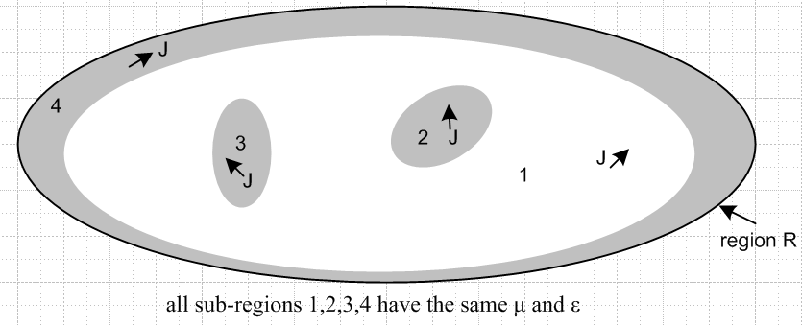

and how you handle the King gauge in the various regions. It was a Battle Royale, but I think it is now all resolved and written up in lines doc. See individual comments in red below. Early on I had to take a horrible "saving position" that you move the conductor currents to the surface, etc, see pix below.

Puzzle 1. Derive the Poisson equation 1
Puzzle 2. Helmholtz Integrals for the Lorenz gauge 1
Puzzle 3. Idea for understanding the King Helmholtz integral for A 2
Puzzle 4. Is there a way to handle embedded J_{c} in the conductors? 6
Puzzle 5. Let's make sure the resolution of Puzzle #3 gives me the right TL equations. 7
Puzzle 6. How could the King ξ factor possibly arise? 11
Puzzle 7. How are R and C related for an arbitrarily shaped capacitor? 16
Puzzle 8. What does one say about damped wave equations? 17

Puzzle 1. Derive the Poisson equation

Here is a derivation of the Poisson equation:

div E = ρfree/ε E = -∇φ

=> div (∇φ) = - ρfree /ε ⇔ ∇2φ = -ρfree /ε

Here ρ ρfree is the total free charge. This result seems the same whether or not the medium ε has some conductivity σ. Boundary conditions on φ may somehow know about σ, but the equation itself does not. This is electrostatics, there is no "gauge" here.

Comments: Above is pretty clear. I was wondering how one might get ∇2φ = -ρ/ξ and concluded there is no way and that this basic Poisson equation is simply not locally affected by σ in a medium! The issue here is my major confusion about King's use of the ξ quantity in his Az integral. Later this got resolved, but it took a lot of work and a new understanding of certain things.

Puzzle 2. Helmholtz Integrals for the Lorenz gauge

Using the pure Lorenz gauge we find that β is real and we have all this:

( ∇2 + β2) φ(x,ω) = - (1/ε)ρf (x,ω) (1.5.3)

( ∇2 + β2) A(x,ω) = - μJc(x,ω) (1.5.4)

β2 ≡ ω2με = ω2/v2 => β = ω/v = wavenumber = 2π/λ (1.5.5)

φ(x,ω) = $\frac{1}{4πε}$∫ρf(x',ω)$\frac{e-jβ(ω)R}{R}$dV' R = |x - x'| (1.5.9)
A(x,ω) = $\frac{μ}{4π}$∫Jc(x',ω)$\frac{e-jβ(ω)R}{R}$dV' R = |x - x'| (1.5.10)

In electrostatics, the Poisson solution is

φ(x,ω) = $\frac{1}{4πε}$∫ρ(x',ω) $\frac{1}{R}$dV

Unless ρ is somehow affected by σ indirectly, φ is independent of σ. There is no sense that somehow the potential φ at some point will be less if σ is turned on compared to if σ = 0.

Note: in the integral 1.5.10, if μ is a conductive medium, you must integrate over J in the medium.

Comments: All equations are correct as stated, and we are just showing the Helmholtz 3D propagator as outlined now in Appendix H. But the interpretations of symbols is where the rubber meets the road:

• the ρf in (1.5.9) is the true surface charge, but as I show in lines doc, it is ρc = (ξ/ε)ρf that enters the BC's of a problem and then $\frac{1}{4πε}$ ρf = $\frac{1}{4πξ}$ ρc and that is how King Problem #1 gets resolved.
• the Jc above has to include currents on conductor surfaces, When this is taken into account, the resulting A can be evaluated inside or outside the conductor, and in each case the appropriate μ appears.

Puzzle 3. Idea for understanding the King Helmholtz integral for A

Idea for solving one of the King Problems -- that for A.

// all sub-regions 1,2,3,4 have the same μ and ε

Consider the following picture:

The lined outer boundary defines a region called region R which is filled with one or more media all of which have the same value of magnetic parameter μ. The outer boundary could be finite or infinite, in which case region R is all space. Within region R are four subregions, three of which are made gray. The region R could be a 3D ellipsoidal shape, in which case the subregions are all 3D subregions of space. Or, the region R could be the cross section of a transmission line of some thickness dz. In this case, the gray regions might be conductors and the white region a dielectric, with the proviso that the dielectric and the conductors have the same value of μ, presumably μ = μ0. If region 4 is made non-gray and region R is taken to be infinite, the drawing might represent a slice of a two conductor transmission line, and if regions 2 and 3 had the same round shape, it would be "twin-lead". On the other hand, if region 3 is made non-gray and region 2 is round and at the center of region R also taken to be round, this would be the cross section of a coaxial cable. One could assume any number of dark subregions (conductors) in the figure.
Within region R, and before assuming any specific "gauge", we know that the "wave equation" for the vector potential A has this form, where A, φ, and J are all functions of (x,t),

(∇2 - με ∂t2)A = grad [με ∂tφ + divA ] - μJ (1.3.2)

Here φ and A are both coupled together, so this is not strictly a wave equation for A (yet). Current J can exist in all subregions, as indicated in the figure. Suppressing the second argument, we can write symbolically

J(x) = J1(x) θ1(x) + J2(x) θ2(x) + J3(x) θ3(x) + J4(x) θ4(x)

where current J1 exists only in subregion 1, J2 only in subregion 2, and so on. Here for example,

θ1(x) = 1 if x lies in subregion 1, otherwise = 0.

Here then is the trick. In subregion 1 only (this being the transmission line dielectric region), we assume isotropic uniform Ohm's law and write J1 = σ1 E. Then the wave equation becomes

(∇2 - με ∂t2)A

= grad [με ∂tφ + divA ] - μ[σ1 E θ1(x) + J2(x) θ2(x) + J3(x) θ3(x) + J4(x) θ4(x) ]
We then replace E using E = - grad φ - ∂tA to get

(∇2 - με ∂t2)A = grad [με ∂tφ + divA ] - μ[σ1 (- grad φ - ∂tA) θ1(x)]

- μ[J2(x) θ2(x) + J3(x) θ3(x) + J4(x) θ4(x) ]

and then

[∇2 - με ∂t2 - μσ1 θ1(x)∂t] A = grad [με ∂tφ + divA +μσ1φ θ1(x) ]

- μ[J2(x) θ2(x) + J3(x) θ3(x) + J4(x) θ4(x) ]

Now I see that those θ1(x) are going to ruin this nice plan, and once again we are back at the starting blocks with no progress on this problem. But I will try to make it go anyway. We still have a differential equation that is meaningful. Let's define now the following function

σ(x) ≡ σ1 θ1(x) = σ1 in region 1, = 0 in all the gray regions.

Then we have

[∇2 - με ∂t2 - μ σ(x) ∂t] A = grad [με ∂tφ + divA +μ σ(x) φ ] - μJc

where Jc ≡ J2(x) θ2(x) + J3(x) θ3(x) + J4(x) θ4(x) = current in the conductors. In ω space we get

[∇2 + ω2 με - jωμ σ(x)] A = grad [μεjωφ + divA +μ σ(x) φ ] - μJc (*)

Within each subregion, this is a Helmholtz equation, but it is not a uniform Helmholtz equation over the entire region R due to σ(x), the Achilles heel. We could go on to select this gauge for all of region R

[μεjωφ + divA +μ σ(x) φ] = 0 (**)

and we are then left with

[∇2 + ω2 με - jωμ σ(x)] A = - μJc valid over all of region R (***)

The question is: what do we do next?

Comments on the above: To simplify things, I assumed all μi = μ. Before selecting a gauge, this gives equation (*) above where σ(x) ≡ σ1 θ1(x) . As stated, the problem at this point is that the LHS operator's propagator will be different in region 1 from the conductor regions, and I don't know what the Helmholtz integral is for such an operator with a variable σ(x). My first shot is gauge condition (**) which is different in the different regions, and this results in (***) where I still have the different propagators problem. So even with the simplification of all μ the same, I don't know where to go next. I was truly facing a Puzzle here.

Approach #1: We assume that σ = σ1 in the conductor regions. Since the dielectric σ1 might be 1010 SI units and the actual conductor conductivity 10-7 SI units, this would seem a very bad assumption. But if we go ahead and assume it anyway, we get this result

[∇2 + ω2 με - jωμσ1] A = - μJc valid over all of region R

This is what appears in Panofsky page 211 equation (13-4). With this assumption, we can integrate this equation over the volume of region R to get

A(x,ω) = $\frac{μ}{4π}$∫Jc(x',ω)$\frac{e-jβR}{R}$dV' where β2 = ω2 με - jωμσ1] = complex

This result also appears in King page 11 equation (24).

So how might we justify this seemingly very bad assumption? I don't have an answer right now.
Maybe we compare this with the exact result. So let's go back to the exact equation

[∇2 + ω2 με - jωμ σ(x)] A = - μJc valid over all of region R

If we were to assume that all conductor currents were really surface currents, due perhaps to extreme skin effect, meaning we are at large ω, then we might regard these currents as being essentially in subregion 1. That is, we just move the currents slightly from their actual location just inside the boundaries of the conductors (gray regions) to being just inside the boundary of the dielectric (white region 1). Moving the currents this infinitesimal amount should have no effect on the solution A. Then the above equation can be written as

[∇2 + ω2 με - jωμ σ1] A = - μJc valid over all of subregion 1

and this then is the equation of Panofsky or King. That MUST BE their assumption, though it is not states as an assumption by either author.

If we are at low frequencies so there is no skin effect, but if the conductors are very thin compared to the transverse geometry of the transmission line, then again there is not much error introduced by changing the conductor current pattern from a uniform current J across the conductor cross section to a pure surface current if the same magnitude. This would apply to power transmission lines perhaps.

If we are low frequencies and the conductors are "fat" in the cross section geometry, then equation ** does not apply because the currents cannot simply be moved to the conductor surfaces without making significant error. But how might we estimate this error? Suppose we use the following method to replace the volume current density in a conductor with a surface current density,

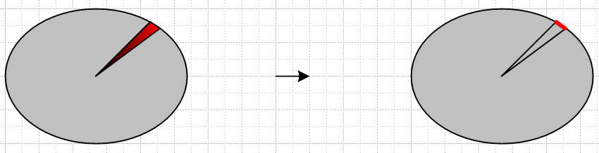

Here we indicate by the red wash that J in the conductor might be non-uniform. In the tiny angular segment shown we arrange for the surface current to be the same as the integrated volume current in the wedge. In this manner, the resulting overall surface current at least reflects the possible asymmetry of the volume current. Then the question of error would require a comparison of these two situations:

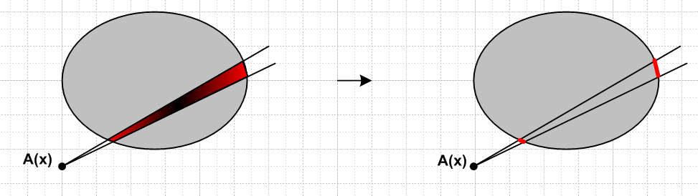

On the left we integrate over J in the trapezoidal region shown, while on the right the integral comes only from the two surface patches shown. It seems conceivable that the resulting A(x) might not be too different in the two cases, though one would have to do a detailed analysis and there could be anomalous distributions that make the two not very equivalent. But if we go ahead and assume that the equivalent surface current computed as above gives essentially the same A(x) as the actual volume current...

Comment: OK, given the conundrum in the previous comment, I arrived at a compromise situation that the equations above are approximately correct for super skin effect or for super thin conductors, arguing that in such cases, with tiny error, you just "move" the currents to the wire outer surfaces so the currents are then in effect lying inside the σ1 medium, and then you don't have to think about "two different propagators". In retrospect, this was a pretty reasonable path to take given that I did not know the correct path at that time. I even started to write this up inside lines doc.

PAUSE HERE to start another Puzzle.

Puzzle 4. Is there a way to handle embedded Jc in the conductors?

In the above scenario we obtained this equation

[∇2 + ω2 με - jωμ σ(x)] A = - μJc valid over all of region R

where σ(x) is a constant in each subregion. It is σ1 in subregion 1, and it is 0 in other subregions. The question here is this: is there some way to write A as an integral over Jc for all of region R, despite the fact that the white and gray regions have different Helmholtz equations?
To study this, we start again a new series of pictures. β1 β2

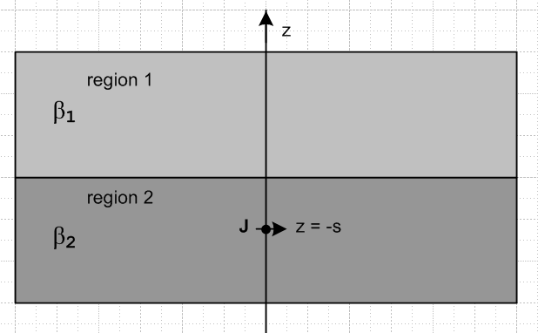

[∇2 +β12] A = 0 valid over all of region 1

[∇2 +β22] A = -μJ valid over all of region 2 J = J0δ(x+s)

Here we have in mind that region 2 is a conductor and we have some chunk of current density in its interior as shown. These are infinite half spaces. What is the solution to this problem?
What happens at the boundary? We know B = curl A. I think A is continuous at the boundary. If both have the same μ, I would guess that B is also continuous.
The propagator is different in the two regions! I see comments on the web like this

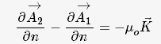

which suggest that a surface current would cause a jump in the normal A component, in analogy with electrostatics. [maybe not ] Maybe there will be an induced surface current in the above situation? Is there an analog to polarization charge? That kind of charge does not "move" very well. But Panofsky does talk about polarization current.
I suspect that the solution of the above problem is similar to the electrostatic problem in the sense that you have to solve both regions at the same time. BUT, I think this problem is much harder because A and J are both vector quantities. You would have to come up with some Smythian form for A in terms of the cylindrical atoms in a region with no currents, and those atoms I am not sure of, since we really have the vector Laplacian here if we go to cylindrical coordinates. Moon and Spencer are talking about a scalar Laplacian thing. But yes, M&S do get into it in their Section V. The ODE's are on page 139 but solutions are not stated there except in special cases. Things don't separate in general. If you take z to the right in the above picture, then Az is to the right, and for THAT cyl system, the Az equation is just the scalar Helm equation. So for a longitudinal current as in the above, you get the close analogy.
So maybe you could solve the above problem for Az using the regular φ Helm problem. But we no longer then have azimuthal symmetry as we did in the φ problem with z up. Then in a Smythian form you are going to get all the azimuthal quantum numbers appearing. You would then have to do a fancy expansion for the Helm Greens' (not just 1/R but the expo on the top) in terms of Jp Bessel functions and whatever else is in those atoms, then you match the Az boundary condition perhaps at the boundary.
This just sounds like a long messy problem even just for Az. If that problem were of great interest to me, I could research it. You might have image currents and surface currents, who knows!
So I think I will let this little problem "go" (for this year), and be happy with my puzzle solution as noted above.

Puzzle 5. Let's make sure the resolution of Puzzle #3 gives me the right TL equations.

We go to Chapter 4 and we start with

φ1(x) = $\frac{1}{4πε}$108∫$_{}^{}$ ρ1(x') $\frac{e-jβR}{R}$ dx'dy'dz' R = |x - x'| (4.1.1)

Notice that I have ε, where King has ξ in the denominator. Notice also that β here is complex and is equal to

β2 = μεω2 - jωμσ = ω2μ ξ = β02 - jωμσ = μ[εω2 - jωσ] = μω [εω - jσ] = ω2μ[ε-jσ/ω]

Now we are in the dielectric where σ ~ 10-10 or less. I then argue that the σ term can be roughly neglected so we then have (but it cannot be neglected in the phasor e-jβR when doing the integral)

β2 ≈ β02

Remember that inside the metal with large σ, we had β being that e-3πj/2 phase thing, but now things are completely different.

I then talk about the transmission line limit. I show that Km(jβs) can be power series expanded because the argument is roughly jβ0s and s << λ then gives us the desired long wave limit. Fine.

I then argue that my V(x) is voltmeter voltage, I don't make the right argument, but I could using the fact that Ax = Ay ≈ 0. Eventually I get this result

V(z) = $\frac{2}{4πε}$108q(z){ $^{\int_{C1}^{}{}}$dx' dy' a1(x',y') ln(s2/s1) -$^{\int_{C2}^{}{}}$dx' dy' a2(x',y') ln(s2/s1) } (4.2.5)

We now have a problem. The integral object {... } is real, ε is real, but I know from my adjusted Appendix B that V and q are out of phase, but this does not appear in the above equation!

At this point, I think I should just throw out my discussion concerning C' q and qeff and just let the equation above sit there. Or I could define the integral as K as the integral at this point and then claim

C = q/V = 2πε/K

Comment: K is real, ε is real, C is real. [ If ε is complex, OK, C is complex ]. King has 1/4πξ which at this point would give q/V = 2πξ/K and then q and V would be out of phase. Then at this point I guess I would argue that C' = q/V = 2πξ/K. Let's see what that would do later on.

But then I get fuzzy, invoking Appendix B. I argue that q(z)/ε = C', the complex capacitance. This seems a weak point in my presentation. The integral above seems real inside {...}. That means that q(z) and V(z) have the same complex phase. If you just say Q = CV, you get C = q/V = real, which I guess is OK for the C part. But where is the leakage current in the above equation? This is where King's ξ might be helpful. If we have ξ in place of ε, then at this point I would argue

C' = q/V = real * ξ = real * [ε-jσ/ω] = C + G/jω

So this area of my doc needs some serious cleanup.

Let's now go look now at the current part. In Section 4.3 I start with

Az1(x) = $\frac{μ}{4π}$∫$_{}^{}$ Jz1(x') $\frac{e-jβR}{R}$ dx'dy'dz' R = |x - x'| (4.3.1)

where β is again the complex β. I then get

W(z) = $\frac{2μ}{4π}$i(z){ $^{\int_{C1}^{}{}}$dx' dy' b1(x',y') ln(s2/s1) -$^{\int_{C2}^{}{}}$dx' dy' b2(x',y') ln(s2/s1) } repair? (4.4.3)
W(z) = Le i(z) (4.4.7)
Le = $\frac{μ}{2π}${$^{\int_{C1}^{}{}}$dx' dy' b1(x',y') ln(s2/s1) -$^{\int_{C2}^{}{}}$dx' dy' b2(x',y') ln(s2/s1) } (4.4.8)

So I then have a real Le at this point.
Now finally we arrive at Section 4.5 where I try to derive the TL equations. Let's go through the steps. I first quote previous results

q(z) = C V(z) // this would be q = C' V with the King Thing

Note: the above equation, either q = CV or q =C'V, is never used below !!!

W(z) = Le i(z) (4.5.1)

Then here is the usual E equation and also the King gauge

E = - grad φ - ∂A/∂t div A = - σ μ φ - $\frac{με}{c2} \frac{∂φ}{∂t}$ (4.5.2)
In ω domain,

Ez = - ∂φ/∂z - jωAz div A ≈ ∂Az/∂z = - j (β2/ω) φ (4.5.4)

I then make a simple clean argument that the above implies that

Ez1 - Ez2 = - ∂V/∂z - jωW ∂W/∂z = - j (β2/ω) V (4.5.5)

Then comes surface impedance

Ez1 = Zi1 i1(z) Ez2 = Zi2 i2(z) (4.5.6)

and then the above becomes [ key equations: ]

(Zi1 + Zi2) i(z) = - ∂V/∂z - jωW ∂W/∂z = - j (β2/ω) V (4.5.7)

In the left equation insert W(z) = Le i(z) so it becomes

(Zi1 + Zi2) i(z) = - ∂V/∂z - jω Le i(z)

∂V/∂z = - [ jωLe + Zi1 + Zi2)] i(z) ≡ - z i(z)

where then

z = jωLe + (Zi1 + Zi2) = jωLe + Re(Zi1 + Zi2) + j Im(Zi1 + Zi2)

= jωLe + Re(Zi1 + Zi2) + jω (1/ω) Im(Zi1 + Zi2)

= Re(Zi1 + Zi2) + jω [Le + (1/ω) Im(Zi1 + Zi2) ]

= R + jωL

where

R = Re(Zi1 + Zi2) L = Le + (1/ω) Im(Zi1 + Zi2)

In the right equation of (4.5.7) we replace W by Le i(z) so it becomes

Le ∂ i(z)/∂z = - j (β2/ω) V

∂zi(z) = - [jβ2/(ωLe) ] V = - y V(z)

where then

y = jβ2/ω = (1/Le)(j/ω)β2 = (1/Le) (j/ω) ω2μ ξ = (1/Le) jωμξ = (1/Le) jωμ[ε+σ/(jω)]

= jω (1/Le) με + μσ(1/Le)

= G + jωC

where, if μ and ε are real,

G = μσ(1/Le) C = με (1/Le)

My next discussion seems unnecessary at this point. Suppose at this point I define

K = {$^{\int_{C1}^{}{}}$dx' dy' a1(x',y') ln(s2/s1) -$^{\int_{C2}^{}{}}$dx' dy' a2(x',y') ln(s2/s1) } (4.5.17)

Then I know that

Le = $\frac{μ}{2π}$K => (1/Le) = (2π/μ)(1/K)

G = μσ(1/Le) = μσ(2π/μ)(1/K) = 2πσ/K

C = με (1/Le) = με (2π/μ)(1/K) = 2πε/K // agrees with earlier result.

and we can then express 3 of the 4 line parameters in terms of geometric integral K.

None of these results would be changed if we had the King Thing.

As an experiment, I have added in red a factor of 108 in my (4.1.1) integral for φ, which is the definition of φ for this problem. So φ is huge, and V = Δφ is also huge. I have not scaled up q or ρ correspondingly. But 4.2.5 shows how V is now huge. This factor 108 has no effect on the current side of things since φ or V don't appear there. When we get to 4.5.4, the φ in these two equations is now huge, but it is still just called φ. Equation (4.5.4) makes it seem that Az should also be huge! But looking at (4.3.1) there is nothing there to make Az be huge unless you make J huge. So isn't this a contradiction? We have not really changed the scale of q or of jωq which is I, or ρ, or J, but the gauge condition suggests that Az has gotten huge? How can Az both be normal size and be huge size? Well, ∂zAz is what got huge in 4.5.4. But that suggests a change in β0. But β is a function of constants like μ, ω, σ so it is the same. So OK, lets say that ∂zAz got huge, but Az did not get huge to remove this last paradox. Now since W is proportional to Az, you would argue that W did not change. Question: if V is huge, is ∂zV also huge? Who knows. If =∂zV got huge, then i(z) in (4.5.7) must be huge and that means J got huge which means W got huge, so everything is getting huge together now. So then if J got huge, Az also got huge and W got huge.
This is totally unclear. I cannot see any immediate difference whether I use 1/4πε or 1/4πξ in the Helmholtz integral for φ as in 4.1.1. It seems like a "units change" only.

The upshot of this puzzle is that my TL equations come out the same with or without the King ξ.

Warning: You really need to keep in mind what is free charge and what is polarization charge. When you just write ρ, that is not very clear.

Puzzle 6. How could the King ξ factor possibly arise?

My conclusion is that the King ξ factor in his φ Helmholtz integral is just plain wrong. (10.29.13)

The only possible way would be to have it appear here: (see puzzle #3 equations above)

( ∇2 + β2) φ(x,ω) = - (1/ε)ρ(x,ω) → - (1/ξ)ρ(x,ω)

So where is this equation coming from? Here are the steps of my derivation

E = - grad φ - ∂tA // (1.3.1) ok

div E = - div grad φ - ∂t (div A) // take div of both sides ok (1.3.3)

ρfree/ε = -∇2φ - ∂t(- με ∂tφ) // div E = ρfree/ε and use same gauge choice as above

(∇2 - με∂t2)φ = - (1/ε)ρfree // all done

OK stop. Here I have use the pure Lorenz gauge. How are things different if I use the King gauge? Go back a step

div E = - div grad φ - ∂t (div A) // take div of both sides ok (1.3.3)

Now assume

div E = ρfree /ε and divA = - με ∂tφ - μσφ

Then we get

ρfree /ε = - div grad φ - ∂t[- με ∂tφ - μσφ]

ρfree /ε = -∇2φ + ∂t[με ∂tφ + μσφ]

ρfree /ε = -∇2φ + με ∂t2φ + μσ ∂t φ

- ρfree /ε = ∇2φ - με ∂t2φ - μσ ∂t φ

So now we have the damping term fine. But ρfree /ε is still just ρfree /ε

Conclusion: There is only ONE WAY to get ξ to appear in the ε PDE if you use the King gauge, and that way is that you must assume this:

div E = ρ/ξ

In the dielectric, we have ρ = 0 so ε or ξ makes no difference there. The issue is going to be at the boundary of the dielectric. Maybe the charge density at the boundary gets changed when we move it to the dielectric? So maybe the issue is the meaning of ρ here?

Warning: when we write div E = ρ/ε, that really means div E = ρfree/ε.
So please be careful about this. nfree npol

So consider this picture

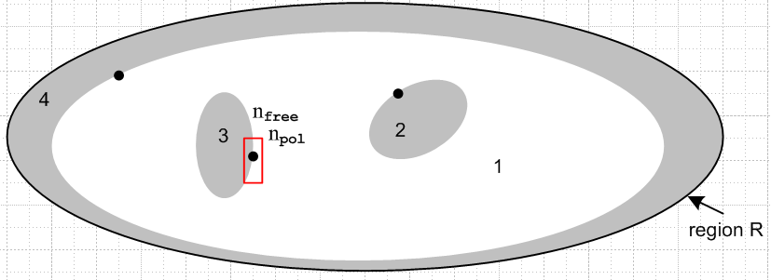

where I show some surface charge density ntot on the surfaces of the conductors and 1 = dielectric. I imagine that the normal En fields are zero inside the conductors (ignoring pumping field etc etc). Now how do we apply an equation like div E = ρ/ε or ρ/ξ to this picture? I don't care about inside the conductors. Away from the boundaries in the dielectric we know ρ = 0 so there is no issue. The issue is right AT the boundaries. Now how do these things work:

div D = ρfree

D = εE

div(εE) = ρfree ⇔ ∫V ρfree dV = ∫S εE • dA

So then we have to look at an integral form,

div D = ρfree ⇔ ∫V ρfree dV = ∫S D • dA (1.1.13)
div (εE) = ρfree ⇔ ∫V ρfree dV = ∫S εE • dA (1.1.14)

So we need a little pillbox to study this, like the one shown in red. The total charge enclosed is nfreedA so we have,

nfreedA = 0 + εEndA since εEn = 0 inside the conductor

=> nfree = εEn => En = nfree/ε

There is no ξ appearing here!!!! [ OK on 10.26.13 ] Go ahead and let the dielectric conduct, the En field stays the same provided you replenish nfree from within the conductor.

Question: is there polarization charge at the boundary in addition to free charge? Yes, there is, it surrounds the surface charge on the metal (at least on one side), doing its usual shielding thing. That is why we have En = n/ε instead of the larger En = n/ε0. So I claim this polarization charge is already accounted for. And there is no significant Et at a conductor surface.

Added 10.26.13. There are three separate continuity rules at the boundary, the first two add up to the third total one. Above you see the rule for the free charge, the result is correct. Another continuity rule says

div P = -ρpol ⇔ ∫V ρpol dV = - ∫S P • dA (1.1.13)

Assuming P = 0 inside the conductor, this says

npol = -P where P = D - ε0E = εE - ε0E = (ε-ε0)E = (ε-ε0) nfree/ε

so
npol = - (ε-ε0) nfree/ε = - (1 - ε0/ε) nfree

which seems about right. Opposite sign, only partial cancellation, and so on. But what I really wanted was this:

∂tρpol = - div Jp =- div (∂tP)

But this is already accounted for above where I had div P = -ρpol . So from these two continuity equations I have learned that

En = nfree/ε
npol = - (1 - ε0/ε) nfree

Of course you can set En = J/σ to get

Jc = σ nfree/ε

But now for this same pillbox we know from our one rule of TOTAL charge conservation that

div Jtot = - ∂tρtot ⇔ -∂t[∫V ρtot dV] = ∫S Jtot • dA (1.1.16)

Now the total current is Jc + Jd so we have [ STOP! This is valid with ρtot = 0 ]

Jtot = σE + jωεE = jωξE // this is Jc + Jd

The integral form then says

0 = jω(ξ1E1n - ξ2E2n)dA
or
0 = ξ1E1n - ξ2E2n

So I have just redone what I did in King meets Stak.

Back now to the picture:

If dielectric region 1 has σ, then we have Jn = σEn and now σ has appeared in the analysis! We then have

Jn = σ nfree/ε at a boundary surface, current is flowing off!

Then continuity says

-∂t[nfreedA] = (σnfree/ε)dA => -jωnfree = (σ/ε) nfree

But this says nfree = 0. The reason is that I neglected to include the current which feeds things from the inside of the conductor. I am inclined to say that it equals Jn and then nfree stays constant. That is

-∂t[nfreedA] = ∫S J • dA = 0 => nfree = constant

This leakage current to maintain n is presumably supplied by the conductor which has very low resistance and can easily supply this. It would do it at DC certainly. I am not sure at high ω what happens. My round wire analysis showed Jρ which feeds this current and the displacement current.
So in this scenario we have

Jz1 = Jz2 or σ1Ez1 = σ2Ez2

and that would tell me something about Ez1 inside the metal (it tells me it is very small).
But how does my derived King BC fit into this picture? That said ξ2 Ez2 = ξ1 Ez1. The puzzler questions I think are endless! Sisyphus was here. The King BC says

(ε2+σ2/jω) Ez2 = (ε1+σ1/jω) Ez1

If the above σ1Ez1 = σ2Ez2 is true from conduction current matching, then it must also be true that

ε2 Ez2 = ε1 Ez1

and there is no E field phase shift.
But I think there really is polarization current flowing out my little pillbox above. [ yes] How does that affect things? You might think the real continuity condition (and the only true one) is this

div Jtot = - ∂tρtot ⇔ -∂t[∫V ρtot dV] = ∫S Jtot • dA (1.1.16)
// valid if ρtot = 0

Then we know that Jtot = Jd + Jc = jωεE + σE. Then the above says

0 = (jωεE + σE)dA = jω (ε + σ/jω)EdA = jωξEdA => 0 = - ξE => E = 0

This is what happens if you don't feed the leakage, everything goes away in steady state!

What did my Chapter 2 round wire study show about σ effect outside the round wire? My list of assumptions says nothing about what is outside the wire! My solution in box 2.1.26 is incomplete in that it just assumes some E(a) and J(a) at the boundary of the wire. There is no medium out there, there is no "other wire", everything is azisym. If I were to embed this wire in a medium ε dielectric, I think these constants would be determined, The B field in particular would be easy: 2πrB = I and then you would have that B(a) = I/2πa and this implies a certain E(a) according to 2.1.23. Maybe this would be something to add to that chapter. If there were some σ in the dielectric, then the solution which shows only Jz is not correct and the whole thing falls apart. It would still be azisym however.
How would Chapter 2 change if I included a radial Jr and Er? I would then have

$\frac{∂ [ r Bφ(r)]}{∂r}$= (μσ) [r Ez(r) ]. (2.1.7)

$\frac{∂Ez(r)}{∂r}$= jωBφ(r) . (2.1.9)

I think their derivations still go through. So do all the following equations. Then Eρ is just some independent thing. Maybe it would only appear in dealing with the surface BC. The box (2.1.26) would all be as stated but with B = Bφ and E = Ez.
But then you would have to face this equation more fully

(∇2 + β2) E(x,ω) = 0 . (2.1.12)

if there is some Eρ present to feed the leakage surface current.

(∇2E)ρ = ∇2Eρ - (2/ρ2) ∂φEφ - (1/ρ2) Eρ

So then we have

[∂ρ2 + (1/ρ)∂ρ + (1/ρ2)∂φ2 + ∂z2 - (1/ρ2) + β2] Eρ - (2/ρ2) ∂φEφ = 0

[∂ρ2 + (1/ρ)∂ρ + ∂z2 - (1/ρ2) + β2] Eρ = 0 // see D.1.15

I might be able to tie this all together using Appendix D, or perhaps just do it there. It would be a special case I suppose with just the m = 0 term in the result. If I look at the big result in D.4.6 I guess the solution is just this

Ez(r,0) = (1/2) I Rdc [$\frac{xa J0(x)}{J1(xa)}$]

Er(r,0) = (j/2) (aβd) I Rdc [ $\frac{J1(x)}{J1(xa)}$]

Eφ(r,0) = 0

so I guess I have already solve this problem to some extent.

βd = ω $\sqrt{μdxd}$ ξd = [εd + σd/(jω)] ≈ εd dielectric

so I guess I have even included the dielectric here somehow! This is only for fields inside, but then I do the outside fields as well in D.6. Maybe I should develop that solution a little more. There would the matter of radiation I suppose.

Puzzle 7. How are R and C related for an arbitrarily shaped capacitor?

I remember seeing this in some book, not understanding it, but I think I am going to get it now.

The potential difference between two conductors is V = - $^{\int_{1}^{2}{}}$E • ds from one to the other.

The total current passing between them is ∫J • dA over any slicing surface. So you could pick that surface just above one of the conductors where you know En = qfree/ε so Jn = σ qfree/ε. Then this total current is just σQ/ε where Q is the total free charge on that conductor's surface. Since R = E/I,

R = $^{\int_{1}^{2}{}}$•• = $\frac{V}{(σQ/ε)}$

Meanwhile, for the capacitor we have C = Q/V.

C = $\frac{Q}{V}$

Therefore we must have

RC = $\frac{V}{(σQ/ε)}$ Q/V = (ε/σ). // this is P&P p 110 (7-15).

regardless of how complicated is the geometry of the capacitor.
Now you can write these ratios in a different form. First, since J = σE, we have

R = $^{\int_{1}^{2}{}}$•• // this is P&P p 110 (7-13)

Meanwhile, div E = ρ/ε says ∫ E•dA = Qenclosed/ε so if we make this be any cutting surface like the one used above, we will have Qenc = Q = ε ∫ E•dA. Thus we could write

C = •$^{\int_{1}^{2}{}}$• // this is P&P p 110 (7-12), see (2-11) where ε = κε0

Puzzle 8. What does one say about damped wave equations?

I first write undamped wave equations (ρ = free charge, J = conduction current)

( ∇2 + β2) φ(x,ω) = - (1/ε)ρ(x,ω) (1.5.3)

( ∇2 + β2) A(x,ω) = - μJ(x,ω) (1.5.4)

β2 ≡ ω2με = ω2/v2 => β = ω/v = wavenumber = 2π/λ (1.5.5)

This is in the Lorenz gauge divA = - με ∂tφ = -jωμεφ . The β2 are real so there is no "loss" as you do the solution integrals,

φ(x,ω) = $\frac{1}{4πε}$∫ρ(x',ω)$\frac{e-jβ(ω)R}{R}$dV' R = |x - x'| (1.5.9)
A(x,ω) = $\frac{μ}{4π}$∫J(x',ω)$\frac{e-jβ(ω)R}{R}$dV' R = |x - x'| (1.5.10)

But J is the conduction current everywhere including in the dielectric. There is not ρ in the dielectric. Looking at the φ equation, φ in this gauge does not damp out for large R since β is real so the expo has no decaying part. In contrast, in the King gauge both integrals damp down for larger R due to the exponential since β for them is complex. Both gauges of course give the same E and B fields. In the Lorenz gauge, the A integral somehow damps out due to the fact that J exists everywhere. When one uses

B = curl A E = - grad φ - ∂tA . (1.3.1)

The E and B fields come out the same in either gauge, despite the fact that the King gauge appears to have damping potentials while the Lorenz gauge does not. We can write 1.5.10 as

ALorenz(x,ω) = $\frac{μ}{4π}$∫region1 J(x',ω)$\frac{e-jβ(ω)R}{R}$dV' + $\frac{μ}{4π}$∫cond surfaces J(x',ω)$\frac{e-jβ(ω)R}{R}$dV'

AKing(x,ω) = $\frac{μ}{4π}$∫cond surfaces J(x',ω)$\frac{e-jβcR}{R}$dV'

These two must have the same curl! Meanwhile,

φLorenz(x,ω) = $\frac{1}{4πε}$∫ cond surfaces ρ(x',ω)$\frac{e-jβ(ω)R}{R}$dV'

φKing(x,ω) = $\frac{1}{4πε}$∫ cond surfaces ρ(x',ω)$\frac{e-jβcR}{R}$dV'

So these two potentials are also different, but only due to the phasor.

The E and B fields always damp out since they satisfy the damped wave equation.

