Repair Section 1.3 (c) PhL 11.16.13

Here I try a different King Gauge and try to still obtain a unified wave equation in all region R.

Review 11.22.13. I was trying to "clean up" Section 1.3, but I did not know about the bulk Jm currents, and I did not realize that putting in the Jm surface currents was wrong. I wander off and try the μ0 gauge which I deal with again in Disaster 2. This current do really has no saving graces, because it was written under two wrong assumptions!

KING GAUGE

Wave equation for A

Consider the following general cross section of a transmission line which happens to be of coaxial cable type,
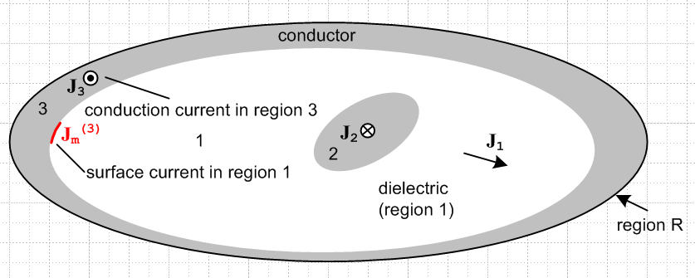

The gray regions 2 and 3 are conductors, while the white region 1 is the (possibly conducting) dielectric. Currents J1, J2 and J3 are conduction currents, while Jm(3) represents a possible surface current in region 1 which runs on the surface of conductor 3. It runs in a direction opposite J3 and only exists in the case that μ1 ≠ μ3. [ but there are also volume Jm currents that I have not mentioned. ]

We start by selecting the King gauge for region 1 and we apply it to all three regions,

div A = - μ0ε1 ∂tφ - μ0σ1φ // applied to all of R . (1.3.18)

The big change is that I am using μ0 instead of μ1 in this gauge. I guess I am editing on the fly here.

We first obtain the wave equation for A in region 1. Start with (1.3.3) which gives the wave equation for A before any gauge choice is made

∇2(A - μ0ε1 ∂t2)A = grad [divA + μ0ε1 ∂t φ] - μ0(Jc1+Jm1) // region 1 (1.3.3)

where Jc1 and Jm1 are the conduction and magnetization currents in region 1.

Now insert the King gauge (1.3.18) to get

(∇2 - μ0ε1 ∂t2) A = grad [μ0ε1 ∂tφ + (- μ0ε1 ∂tφ - μ0σ1φ) ] - μ0 Jc1+Jm1)

= - μ0σ1 grad φ - μ0 Jc1+Jm1)

= - μ0σ1 (-E -∂tA) - μ0(σ1E+Jm1) . // from (1.3.1) and Jc1 = σ1E in region 1

= + μ0σ1∂tA - μ0Jm1

so our final result is then

(∇2 - μ0ε1 ∂t2- μ0σ1∂t) A = - μ0Jm1 // region 1 (1.3.19)

This is a damped wave equation driven by surface current Jm1. If there is no surface current, this is a homogeneous damped wave equation that A must satisfy within region 1.
ok edit pass to here
Now we start over with (1.3.3) for region 2:

(∇2 - μ0ε2 ∂t2) A = grad [μ0ε2 ∂tφ + divA ] - μ0(Jc2+Jm2) // region 2 (1.3.3)

As before, we insert the region 1 King gauge expression (1.3.18) for div A, even though we are now working in region 2,

(∇2 - μ0ε2 ∂t2) A = grad [μ0ε2 ∂tφ + (- μ0ε1 ∂tφ - μ0σ1φ) ] - μ0(Jc2+Jm2)

= [μ0ε2 ∂t + (- μ0ε1 ∂t - μ0σ1) ] grad φ - μ0(Jc2+Jm2)

= [μ0(ε2- ε1) ∂t - μ0σ1) ] grad φ - μ0(Jc2+Jm2) )

= [μ0(ε2- ε1) ∂t - μ0σ1) ] (-E-∂tA) - μ0(Jc2+Jm2)

Since region 2 is a conductor, we assume a perfect conductor and set E = 0 so that

(∇2 - μ0ε2 ∂t2) A = [μ0(ε2 - ε1) ∂t - μ0σ1) ] (-∂tA) - μ0(Jc2+Jm2)

(∇2 - μ0ε2 ∂t2) A = [μ0(ε2 - ε1) ∂t (-∂tA) - μ0σ1 (-∂tA)) ] - μ0(Jc2+Jm2)

(∇2 - μ0ε2 ∂t2) A = [- μ0(ε2 - ε1) ∂t2A + μ0σ1 (∂tA) ] - μ0(Jc2+Jm2)

(∇2 - μ0ε1 ∂t2- μ0σ1∂t) A = - μ0(Jc2+Jm2) // region 2

On the left side we see the same region 1 damped wave operator although we are in region 2 A similar result will be obtained for region 3. Thus we have shown that

(∇2 - μ0ε1 ∂t2- μ0σ1∂t) A = - μ0Jm1 region 1
(∇2 - μ0ε1 ∂t2- μ0σ1∂t) A = - μ0(Jc2+Jm2) region 2
(∇2 - μ0ε1 ∂t2- μ0σ1∂t) A = - μ0(Jc3+Jm3) region 3

old: [ here I put the surface currents into region 1. all in the old and wrong way of thinking. ]

(∇2 - μ1ε1 ∂t2 - μ1σ1∂t ) A = - μ1Jm = -μ1[ Jm(2) + Jm(3)] region 1
(∇2 - μ1ε1 ∂t2 - μ1σ1∂t ) A = - μ2J2 region 2
(∇2 - μ1ε1 ∂t2 - μ1σ1∂t ) A = - μ3J3 region 3 (1.3.21)

We can combine these into a single equation which is then valid over all of region R,

(∇2 - μ0ε1 ∂t2- μ0σ1∂t) A = - μ0Jm1- μ0(Jc2+Jm2) - μ0(Jc3+Jm3) all of region R (1.3.22)

(∇2 - μ1ε1 ∂t2 - μ1σ1) A = -μ1[ Jm(2) + Jm(3)] - μ2J2 - μ3J3 all of region R (1.3.22)

with the understanding that the conduction current in region 1 has already been accounted for We could generalize this result for a region R containing any number N of conductors labeled i = 2,3...N+1

(∇2 - μ0ε1 ∂t2- μ0σ1∂t) A = -μ0 [ Σi=1N Jm(i)+ Σi=2N Jc(i)] all of region R (1.3.23)

Wave equation for φ

We first obtain the wave equation for φ in region 1. Start with (1.3.2) which gives the wave equation for φ before any gauge choice is made

∇2φ + ∂t[div A] = -ρ/ε1 (1.3.2)

Now use the same global region R King gauge (1.3.8) for div A.

∇2φ + ∂t[- μ0ε1 ∂tφ - μ0σ1φ] = - ρ1/ε1

(∇2 - μ0ε1 ∂t2 - μ0σ1∂t)φ = - (1/ε1)ρ1 // region 1 (1.3.24)

Again the same damped region 1 wave operator appears on the left side. Since the King gauge is the same in all three regions, we can write

(∇2 - μ0ε1 ∂t2 - μ0σ1∂t)φ = - (1/ε1)ρ1 // region 1
(∇2 - μ0ε1 ∂t2 - μ0σ1∂t)φ = - (1/ε2)ρ2 // region 2
(∇2 - μ0ε1 ∂t2 - μ0σ1∂t)φ = - (1/ε3)ρ3 // region 3 (1.3.25)

where ρ always means free charge. The three equations are basically the same because the pre-gauge equation (1.3.2) has no region-specific parameters apart from ε1, in contrast with (1.3.3) quoted above.

Now the only actual free charge present is the surface charge on the outside surfaces of the conductors and we regard this as being in region 1. There is no free charge inside the dielectric or inside the conductors. We can then combine the above three equations into a single equation for all of region R

(∇2 - μ0ε1 ∂t2 - μ0σ1∂t)φ = - (1/ε1)ρs all of region R (1.3.26)

where now ρs is the surface charge on the conductors.

Conclusion for wave equations in the King gauge

Here then are the wave equations for φ and A in region R using the region 1 King gauge:

(∇2 - μ0ε1 ∂t2 - μ0σ1∂t)φ = - (1/ε1)ρs all of region R (1.3.26)
(∇2 - μ0ε1 ∂t2 - μ0σ1∂t)A = -μ0 [ Σi=1N Jm(i)+ Σi=2N Jc(i)] all of region R (1.3.23)
div A = - μ0ε1 ∂tφ - μ0σ1φ King gauge (1.3.18)

where ρs is the total surface charge on all conductors and Ji is the current in the interior of conductor i.

King never writes the inhomogeneous wave equations (1.3.23) and (1.3.26) in his transmission-line theory book, so it is difficult to find verification of our logic pathway in his book. However, Panofsky and Phillips do show the equations and we quote the relevant section from their book where we identify their parameters μ,ε,σ with our region 1 parameters μ1, ε1, σ1 :

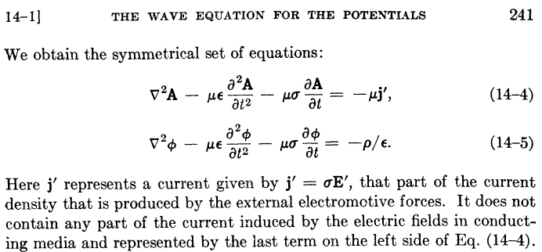

Their last sentence says that usual J = σE in the conducting dielectric has been incorporated into the -μσ∂tA term in their first equation, just as we have done above. These authors have assumed that the μ's of the dielectric and the conductors are all the same (normally μ = μ0). In this case, there are no surface currents and our (1.3.23a) can be written

(∇2 - μ1ε1 ∂t2 - μ1σ1) A = - μ1 Σi=2N Ji = - μ1 j' all of region R (1.3.23a)

and then we can identify their current j' with the sum over the current densities in the conductors. In order to obtain the above equations, Panofsky and Phillips use the King gauge (1.3.18) but they refer to this gauge simply as "the Lorentz condition" (illustrating Comment 1 above) . From their page 240,

