Save Section 1.3 retired on 11.23.13 at 7:30 AM PhL 11.23.13

12/5/13 Comments: I have since done a complete rework of this section and the retired section is below. In this retired section, I included surface currents Jm in the Helmholtz analysis. I later realized that such currents should NOT be included, and furthermore that there are bulk Jm currents present in addition to surface currents, so I had two things wrong. So below is just for archive purposes.

(c) The Potential Wave Equations in the King and Lorenz Gauges with Conductors

We refer to a certain gauge condition below as "the King gauge" because King (see Refs.) made extensive use of this condition in his books and papers at least as early as 1945. Perhaps this gauge has some official name, but we are not aware of it.

We start with this King gauge and treat A and then φ. Then we do the Lorenz gauge case for A and φ, and finally we look at the wave equations for E and B. The motivation for using the King gauge is made clear.

Unlike most sources on this subject, we allow for the possibility that the conductors' μi might differ from that of the dielectric. As shown in Appendix B, when this is the case the conductors develop surface magnetization current densities which we represent below as Jm(i) in a volume density notation. We show in Appendix B that the magnetization surface current density on a conductor surface is given by

Kz(i)(x) = (μ2/μ1 - 1) Hθ(i)(x) (B.1.9)

where x is a point on the surface of conductor i and Hθ(i)(x) is the H field tangent to the conductor in its cross sectional plane. In the case then that μi= μ1 (conductor same as dielectric) we get Kz(i)(x) = 0 and Jm(i)(x) = 0 on that conductor's surface.

KING GAUGE

Wave equation for A

Consider the following general cross section of a transmission line which happens to be of coaxial cable type,
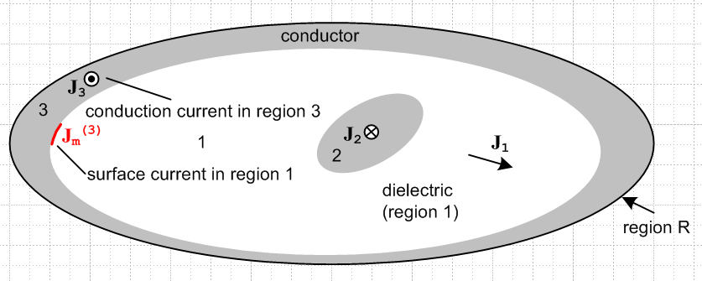

The gray regions 2 and 3 are conductors, while the white region 1 is the (possibly conducting) dielectric. Currents J1, J2 and J3 are conduction currents, while Jm(3) represents a possible surface current in region 1 which runs on the surface of conductor 3. It runs in a direction opposite J3 and only exists in the case that μ1 ≠ μ3.

We start by selecting the King gauge for region 1 and we apply it to all three regions,

div A = - μ1ε1 ∂tφ - μ1σ1φ // applied to all of R . (1.3.18)

We first obtain the wave equation for A in region 1. Start with (1.3.3) which gives the wave equation for A before any gauge choice is made

(∇2 - μ1ε1 ∂t2) A = grad [μ1ε1 ∂tφ + divA ] - μ1J . // region 1 (1.3.3)

Now insert the King gauge (1.3.18) to get

(∇2 - μ1ε1 ∂t2) A = grad [μ1ε1 ∂tφ + (- μ1ε1 ∂tφ - μ1σ1φ) ] - μ1J

= - μ1σ1 grad φ - μ1J

= - μ1σ1 (-E -∂tA) - μ1J . // from (1.3.1)

Now the current J includes all currents in region 1. The obvious current is the conduction current J1 = σ1E. Less obvious but just as important are the magnetization currents Jm which flow on the outer surfaces of the conductors if they have a μ different from μ1. Allowing for such Jm we write

(∇2 - μ1ε1 ∂t2) A = - μ1σ1 (-E -∂tA) - μ1(σ1E) - μ1Jm
or
(∇2 - μ1ε1 ∂t2) A = - μ1σ1 ( -∂tA) - μ1Jm .

Thus the wave equation for A in region 1 is

(∇2 - μ1ε1 ∂t2 - μ1σ1∂t) A = - μ1Jm // region 1 (1.3.19)

This is a damped wave equation driven by those surface currents. If there are no surface currents, this is a homogeneous damped wave equation that A must satisfy within region 1.

Now we start over with (1.3.3) for region 2:

(∇2 - μ2ε2 ∂t2) A = grad [μ2ε2 ∂tφ + divA ] - μ2J2 // region 2 (1.3.3)

As before, we insert the region 1 King gauge expression (1.3.18) for div A, even though we are now working in region 2,

(∇2 - μ2ε2 ∂t2) A = grad [μ2ε2 ∂tφ + (- μ1ε1 ∂tφ - μ1σ1φ) ] - μ2J2

= [μ2ε2 ∂t + (- μ1ε1 ∂t - μ1σ1) ] gradφ - μ2J2

= [ (μ2ε2 - μ1ε1) ∂t - μ1σ1) ] gradφ - μ2J2

= [ (μ2ε2 - μ1ε1) ∂t - μ1σ1) ] (-E-∂tA) - μ2J2 // using (1.3.1)

Since region 2 is a conductor, we assume a perfect conductor and set E = 0 so that

(∇2 - μ2ε2 ∂t2) A = - [ (μ2ε2 - μ1ε1) ∂t - μ1σ1) ] (∂tA) - μ2J2

= - [ (μ2ε2 - μ1ε1) ∂t2 - μ1σ1∂t ] A - μ2J2 .

Notice that we have chosen not to set J2 = σ2E in region 2, we just leave it as J2. Moving the first term on the right to the left we get

( ∇2 - μ2ε2 ∂t2 + [ (μ2ε2 - μ1ε1) ∂t2 - μ1σ1∂t ] ) A = - μ2J2

( ∇2 - μ1ε1 ∂t2 - μ1σ1∂t ) A = - μ2J2 // region 2 (1.3.20)

On the left side we see the same region 1 damped wave operator although we are in region 2, and J2 is conduction current in region 2. A similar result will be obtained for region 3. Thus we have shown that

(∇2 - μ1ε1 ∂t2 - μ1σ1∂t ) A = - μ1Jm = -μ1[ Jm(2) + Jm(3)] region 1
(∇2 - μ1ε1 ∂t2 - μ1σ1∂t ) A = - μ2J2 region 2
(∇2 - μ1ε1 ∂t2 - μ1σ1∂t ) A = - μ3J3 region 3 (1.3.21)

We can combine these into a single equation which is then valid over all of region R,

(∇2 - μ1ε1 ∂t2 - μ1σ1) A = -μ1[ Jm(2) + Jm(3)] - μ2J2 - μ3J3 all of region R (1.3.22)

with the understanding that the conduction current in region 1 has already been accounted for, J2 represents currents in conductor 2 and J3 represents currents in conductor 3, and Jm(i) is any surface current which may be present on these conductors. We could generalize this result for a region R containing any number N of conductors labeled i = 2,3...N+1

(∇2 - μ1ε1 ∂t2 - μ1σ1) A = - Σi=2N+1[ μ1Jm(i) + μiJi] all of region R (1.3.23)

Notice that the dielectric μ1 goes with all the Jm(i), while the conductor μi go with the Ji.

If it happened that μ3 = μ2 = μ1 , then Jm(i) = 0 and the last equation appears as

(∇2 - μ1ε1 ∂t2 - μ1σ1) A = - μ1 Σi=2N+1 Ji all of region R (1.3.23a)

Wave equation for φ

We first obtain the wave equation for φ in region 1. Start with (1.3.2) which gives the wave equation for φ before any gauge choice is made

∇2φ + ∂t[div A] = -ρ/ε1 (1.3.2)

Now use the same global region R King gauge (1.3.8) for div A.

∇2φ + ∂t[- μ1ε1 ∂tφ - μ1σ1φ] = - ρ1/ε1

(∇2 - μ1ε1 ∂t2 - μ1σ1∂t)φ = - (1/ε1)ρ1 // region 1 (1.3.24)

Again the same damped region 1 wave operator appears on the left side. Since the King gauge is the same in all three regions, we can write

(∇2 - μ1ε1 ∂t2 - μ1σ1∂t)φ = - (1/ε1)ρ1 // region 1
(∇2 - μ1ε1 ∂t2 - μ1σ1∂t)φ = - (1/ε2)ρ2 // region 2
(∇2 - μ1ε1 ∂t2 - μ1σ1∂t)φ = - (1/ε3)ρ3 // region 3 (1.3.25)

where ρ always means free charge. The three equations are basically the same because the pre-gauge equation (1.3.2) has no region-specific parameters apart from ε1, in contrast with (1.3.3) quoted above.

Now the only actual free charge present is the surface charge on the outside surfaces of the conductors and we regard this as being in region 1. There is no free charge inside the dielectric or inside the conductors. We can then combine the above three equations into a single equation for all of region R

(∇2 - μ1ε1 ∂t2 - μ1σ1∂t)φ = - (1/ε1)ρs all of region R (1.3.26)

where now ρs is the surface charge on the conductors.

Conclusion for wave equations in the King gauge

Here then are the wave equations for φ and A in region R using the region 1 King gauge:

(∇2 - μ1ε1 ∂t2 - μ1σ1∂t)φ = - (1/ε1)ρs all of region R (1.3.26)
(∇2 - μ1ε1 ∂t2 - μ1σ1) A = - Σi=2N [ μ1Jm(i) + μiJi] all of region R (1.3.23)
div A = - μ1ε1 ∂tφ - μ1σ1φ King gauge (1.3.18)

where ρs is the total surface charge on all conductors and Ji is the current in the interior of conductor i.

King never writes the inhomogeneous wave equations (1.3.23) and (1.3.26) in his transmission-line theory book, so it is difficult to find verification of our logic pathway in his book. However, Panofsky and Phillips do show the equations and we quote the relevant section from their book where we identify their parameters μ,ε,σ with our region 1 parameters μ1, ε1, σ1 :

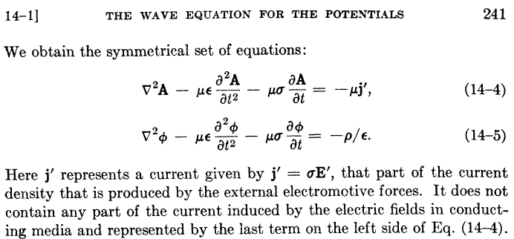

Their last sentence says that usual J = σE in the conducting dielectric has been incorporated into the -μσ∂tA term in their first equation, just as we have done above. These authors have assumed that the μ's of the dielectric and the conductors are all the same (normally μ = μ0). In this case, there are no surface currents and our (1.3.23a) can be written

(∇2 - μ1ε1 ∂t2 - μ1σ1) A = - μ1 Σi=2N Ji = - μ1 j' all of region R (1.3.23a)

and then we can identify their current j' with the sum over the current densities in the conductors. In order to obtain the above equations, Panofsky and Phillips use the King gauge (1.3.18) but they refer to this gauge simply as "the Lorentz condition" (illustrating Comment 1 above) . From their page 240,

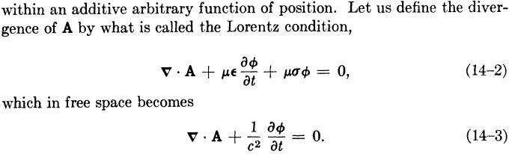

LORENZ GAUGE

If we carry out exact same program with respect to Fig ** using a global Lorenz gauge for all of R,

divA = - μ1ε1∂tφ , (1.3.27)

we obtain these results for A, where in region 1 the conduction current is not aborbed into a damping term on the left side,

(∇2 - μ1ε1 ∂t2)A = - μ1J1 - μ1Σi=2NJm(i) region 1
(∇2 - μ1ε1 ∂t2)A = - μ2J2 region 2
(∇2 - μ1ε1 ∂t2)A = - μ3J3 . region 3

As before, all three equations have the same wave operator on the left side. Again assuming N conductors, we combine these into a single equation as follows

(∇2 - μ1ε1 ∂t2)A = - Σi=1N μiJi - μ1 Σi=2NJm(i) all of region R (1.3.28)

Meanwhile, the results for φ are

(∇2 - μ1ε1 ∂t2)φ = -ρ/ε1 region 1
(∇2 - μ1ε1 ∂t2)φ = -ρ/ε2 region 2
(∇2 - μ1ε1 ∂t2)φ = -ρ/ε3 region 3

so that with the same comments made earlier (ρs includes all surface charges bordering region 1)

(∇2 - μ1ε1 ∂t2)φ = -ρs/ε1 all of region R (1.3.29)

COMPARISON

We can now do a side by side comparison:

King Gauge:
(∇2 - μ1ε1 ∂t2 - μ1σ1∂t)φ = - ρs/ε1 all of region R (1.3.26)
(∇2 - μ1ε1 ∂t2 - μ1σ1) A = - Σi=2N μiJi - μ1 Σi=2NJm(i) all of region R (1.3.23)
div A = - μ1ε1 ∂tφ - μ1σ1φ King gauge region 1 (1.3.18)

Lorenz Gauge:
(∇2 - μ1ε1 ∂t2)φ = -ρs/ε1 all of region R
(∇2 - μ1ε1 ∂t2)A = - Σi=1N μiJi - μ1 Σi=2NJm(i) all of region R
divA = - μ1ε1∂tφ Lorenz gauge region 1

In the Lorenz gauge, we get undamped wave operators, but the first sum on the right of the A equation includes a sum over the current in the dielectric, whereas this is not the case in the King gauge.

If all we let μ and ε and σ be the parameters of the dielectric, and if we assume that the conductors all have the same μ, the Jm currents vanish and the comparison becomes

King Gauge:
(∇2 - με ∂t2 - μσ∂t)φ = - ρs/ε all of region R (1.3.26)
(∇2 - με ∂t2 - μσ) A = - μΣi=2N Ji all of region R (1.3.23)
div A = - με ∂tφ - μσφ King gauge for region 1 (1.3.18)

Lorenz Gauge:
(∇2 - με ∂t2)φ = -ρs/ε all of region R
(∇2 - με ∂t2)A = - μΣi=1N Ji all of region R
divA = - με∂tφ Lorenz gauge for region 1

In a situation where we have prescribed currents Ji in the conductors, it is inconvenient to have to worry about the dielectric conduction current J1 which complicates the solution of the problem (this will become more obvious later). In the King gauge, we get damped wave operators but we have to include only the current in (and maybe on) the conductors. The current in the dielectric has been incorporated into the damping term. When we transform to the frequency domain and write the Helmholtz equation for A and its Helmholtz Integral solution, we need only integrate over the conductors which makes life easy.

E AND B WAVE EQUATIONS

Meanwhile, the E and B field wave equations of course don't know anything about gauges and from (1.2.1) and (1.2.2) we have, with respect to Fig. ** ,

(∇2 - μ1ε1 ∂t2)E = μ1∂tJ + (1/ε1) grad ρ1 = μ1∂tJ + (1/ε1) grad ρs // region 1
(∇2 - μ2ε2 ∂t2)E = μ2∂tJ2 + (1/ε2) grad ρ2 = μ2∂tJ2 // region 2
(∇2 - μ3ε3 ∂t2)E = μ3∂tJ3 + (1/ε3) grad ρ3 = μ3∂tJ3 // region 3
(1.3.30)
(∇2 - μ1ε1 ∂t2)B = - μ1 curl J1 // region 1
(∇2 - μ2ε2 ∂t2)B = - μ2 curl J2 // region 2
(∇2 - μ3ε3 ∂t2)B = - μ3 curl J3 // region 3

where again we need to think of J = σ1E + Jm . We cannot unify each group of three equations into a single region R equation as we could in the potential case since the wave operators are different in each region. Using J = σ1E + Jm and curl E = - ∂tB the region 1 equations can be written as

(∇2 - μ1ε1 ∂t2 - μ1σ1∂t)E = (1/ε1) grad ρs + μ1∂tJm // region 1
(∇2 - μ1ε1 ∂t2 - μ1σ1∂t)B = 0 // region 1 (1.3.31)

but this does not help in unifying the regions, and one is left with a difficult boundary value problem. In contrast, the solution of the King gauge potential equations over all of region R is straightforward, as we shall see a few sections below. It is always important to realize exactly for what region a partial differential equation is valid , since related integral theorems are specific to that region.

