Save old Section 1.3 (c) and (d) + comment + 1.6 PhL 11.4.13

This is an interesting doc. Here I was doing the idea that you could sort of "move" a current from inside a conductor to the conductor surface, and then that current could be considered part of dielectric region 1. It was not a bad idea, considering the problems I was having. I then had a notion of the current's emitted potential Az as "refracting" at the boundary a little bit, like that Jackson electrostatics problem, the picture is included below. I later got all this stuff working right, no need to "move currents", so this is just for archive. It has been a very long and painful journey!

(c) The Potential Wave Equations in the King gauge

An alternate to the Lorenz gauge choice (1.3.6) is this modified Lorenz gauge which we shall call the King gauge since it appears in his books. It has an extra term -μσφ compared to the Lorenz gauge :

divA = - με ∂tφ - μσφ . (1.3.18)

Recall our coupled potential wave equations before a gauge choice is made,

∇2φ + ∂t (div A) = - ρ/ε . (1.3.2) (1.3.19)

(∇2 - με ∂t2) A = grad [με ∂tφ + (divA) ] - μJ . (1.3.3) (1.3.20)

In a transmission line context, ρ = ρfree exists only as surface charge on the conductors, and we shall refer to this charge as ρs. There is no free charge in the dielectric or inside the conductors. On the other hand, a conduction current J exists inside the dielectric (J = σE) and inside the conductors (call it J1). At this point we make an approximation (to be reviewed in Section 1.6) that we can replace the internal conductor current distribution J1 with an "equivalent" surface current distribution Js. These surface currents are then on an equal footing, so to speak, with the surface charge ρs on those conductors. We then write

J = σE + Js . (1.3.21)
Applying the King gauge to our two wave equations (1.3.19) and (1.3.20), the first becomes

∇2φ + ∂t (- με ∂tφ - μσφ) = - ρs/ε
or
(∇2 - με ∂t2- μσ ∂t) φ = - ρs/ε .

Meanwhile, the right side of (1.3.20) becomes

grad [με ∂tφ + (divA) ] - μJ

= grad [με ∂tφ + (- με ∂tφ - μσφ) ] - μ{ σE + Js }

= grad [με ∂tφ + (- με ∂tφ - μσφ) ] - μ{ σ[- grad φ - ∂tA] + Js }

= grad [- μσφ ] - μ{ σ[- grad φ - ∂tA] + Js }

= μσ ∂tA- μJs

and so (1.3.20) becomes

(∇2 - με ∂t2) A = μσ ∂tA - μJs
or
(∇2 - με ∂t2 - μσ∂t) A = - μJs .

The resulting potential wave equations in the King gauge are then

(∇2 - με ∂t2 - μσ ∂t) φ = - (1/ε) ρs (1.3.22)
(∇2 - με ∂t2 - μσ ∂t) A = - μJs (1.3.23)
divA = - με ∂tφ - μσφ // King gauge (1.3.18) . (1.3.24)

King never writes the inhomogeneous wave equations (1.3.22) and (1.3.23) in his transmission-line theory book, they only appear in homogeneous form in the frequency domain as p 10 (17) and (18), so the approximation discussed above never comes up. Panofsky and Phillips do show the equations and we quote the relevant section from their book mainly to show their unusual comment about their current j' which we have associated with the approximation surface current Js :

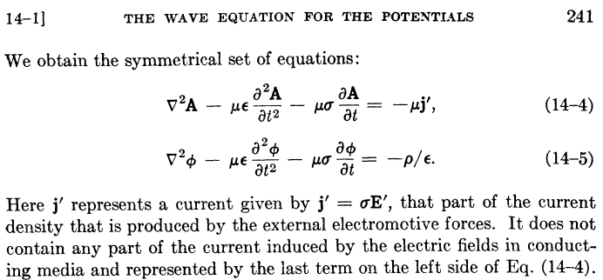

In other words, the usual J = σE in the conducting bulk dielectric has been incorporated into the -με∂tA term in their first equation, just as we have done above. This leaves their j' to be some other current, and we have given our interpretation above as to its meaning. We treat this question in more detail in Section 1.6 below. In order to obtain the above equations, Panofsky and Phillips use the King gauge (1.3.24) but they refer to this gauge simply as "the Lorentz condition" : (from their page 240)

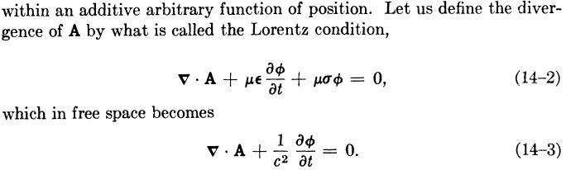

We can compare the above equations (1.3.22-24) with the true Lorenz gauge situation, where we make our same assumption (1.3.21) about equivalent surface currents, and Jdc = σE is the dielectric conduction current,

(∇2 - με ∂t2)φ = - (1/ε)ρs (1.3.4)
(∇2 - με ∂t2)A = -μ J = - μ[Jdc + Js] (1.3.5)
divA = - με ∂tφ . // Lorenz gauge (1.3.6)

Given the surface current approximation, the King gauge equations are simpler to deal with since the dielectric current is absorbed into the damped wave operator and one need worry only about the surface current Js. The reader is reminded that the two solutions for (φ,A) in the different gauges (Lorenz and King) are different but yield the same fields E and B. In the King gauge, there will be a loss when the sources are "propagated" into the dielectric medium (as shown below) and both φ and A see this loss. In the Lorenz gauge, φ sees no such loss, but A does see a loss due to the explicit loss driving term Jdc = σE. One can rewrite (1.3.5) as

(∇2 - με ∂t2)A = - μ[Jd + Js] = - μ[σE + Js]

= - μ[σ{- grad φ - ∂tA } + Js] = μσ grad φ + μσ ∂tA - μJs

so that

(∇2 - με ∂t2 - μσ ∂t)A = μσ grad φ - μJs // Lorenz gauge (1.3.25)

which shows that this Lorenz A will have a lossy propagator, but the source is a complicated combination of the surface current and the gradient of φ, so in this form the equation is not decoupled.

(d) The Field Wave Equations with the surface current approximation

We can re-examine the field wave equations (1.2.1) and (1.2.2) in the context of the approximation
J = σE + Js of (1.3.21). (The field equations of course don't have a gauge.) For E we find

(∇2 - με ∂t2)E = μ∂tJ + (1/ε) grad ρs (1.2.1)

(∇2 - με ∂t2)E = μ∂t[σE + Js] + (1/ε) grad ρs

(∇2 - με ∂t2 - μσ∂t)E = μ∂tJs + (1/ε) grad ρs

and for B,

(∇2 - με ∂t2)B = - μ curl J (1.2.2)

= - μ curl [σE + Js] = -μσ curl E - μ curl Js = μσ ∂tB - μ curl Js

so that

(∇2 - με ∂t2 - μσ∂t)B = -μ curl Js .

Thus we end up with these field wave equations with the surface current approximation,

(∇2 - με ∂t2 - μσ∂t)E = μ∂tJs + (1/ε) grad ρs (1.3.26)
(∇2 - με ∂t2 - μσ∂t)B = -μ curl Js (1.3.27)

These equations have the same damped wave operator present in the King gauge potential wave equations, but the sources ρs and Js on the right side appear in a complicated form which requires pre-processing by the operators ∂t, grad and curl. In contrast, the King gauge potential equations have simple unprocessed sources:

(∇2 - με ∂t2 - μσ ∂t) φ = - (1/ε) ρs (1.3.22)
(∇2 - με ∂t2 - μσ ∂t) A = - μJs (1.3.23)

Soon we will convert these two equations into frequency-domain Helmholtz equations and write explicit solutions as Helmholtz integrals, but we first pause for a distraction.

*********************************

It will turn out that we can approximate e-jβR ≈ 1 in what is called "the transmission line limit". Equation (1.5.10) then says that φ has the same phase as ns and that means that V will have the same phase as ns . Since Qs is the surface integral of ns, that means V and Qs have the same phase. If Qs were the charge in the equation I = ∂tQs, one would conclude that V and I were in phase. But we know that V and I are going to be out of phase if the dielectric conducts, as in the parallel plate example above. This is the result obtained when one realizes that I = ∂tQ where Q = ∫ncdA . Looking at (1.5.11), one sees that nc is out of phase with φ and thus Q is out of phase with V, as expected.

**************************

1.6 The Surface Current Approximation

Consider the following general cross section of a transmission line which happens to be of coaxial cable type,
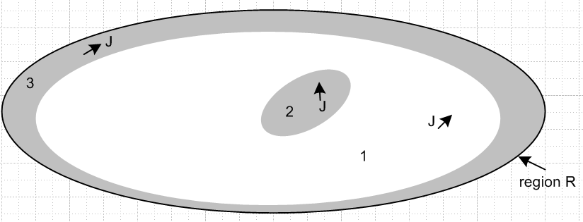

The gray regions 2 and 3 are conductors, while the white region 1 is the dielectric.
Each of the three regions 1,2,3 has its own separate Helmholtz equation of the form (1.3.3) converted to the frequency domain,

(∇2 + β0(i)2) A(i) = grad [μiεi jωφ(i) + (divA(i)) ] - μiJ(i) . (1.3.3)

where β0(i)2 = ω2μiεi. In each region we could define a region-specific King gauge to end up with the transformed version of (1.5.4),

(∇2 + β(i)2) A(i)(x,ω) = - μ Js(i)(x,ω)

where β(i)2 = ω2μi ξi and where Js(i) represents surface current on the boundary of region i. Each such surface current is in fact common to the two regions bordering the surface.
Where do these surface currents come from? They are "induced" by the conduction currents inside the subregions and by the physical boundary conditions at the surfaces.
The situation is somewhat analogous to what happens at the boundary between two dielectrics when a point charge is placed in one dielectric and is observed across the boundary from the other dielectric. In this electrostatics problem, the E field must satisfy continuity conditions Et1 = Et2 and ε1En1 = ε2En2 at the boundary. Although there is no free charge on the boundary, there is in fact an induced polarization charge there (blue below). One can define the position of the point charge and its mirror position across the boundary as "image points". Although it is certainly not obvious, the effect of the blue induced polarization charge as viewed from side A can be simulated by a point charge of a certain magnitude located at the image point on side B. This being the case, in the figure below the E field on the ε1 side is that of a point charge at the actual point charge location which is reduced in magnitude by the amount of the image point charge at the same location, which is in fact just the integral of the blue curve. This problem is treated in Jackson Section 4.4 and the resulttng electric field lines look something like this which shows that the E lines are refracted at the boundary,

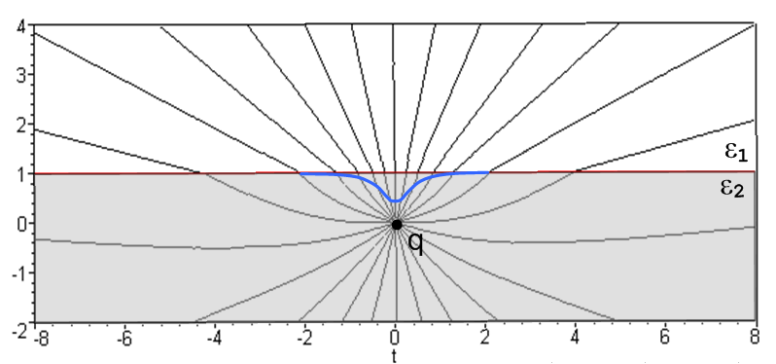

Our problem with the vector potential A is more complicated since it is a vector Helmholtz equation instead of a scalar Poisson equation, but one might imagine that if μ1 ≠ μ2 a "point current" JdV on one side of a boundary might induce a surface current on the boundary, just as in the above figure the point charge q on one side of a boundary induces a surface charge on the interface boundary.
What is clear is that for Figure *** there is no single Helmholtz equation which is valid for the entire region R, and thus there is no single Helmholtz integral for the solution potential A of the form (1.5.8). The Helmholtz integral for each subregion will have its own propagator exp(-jβiR)/R. In the conductors, βi is very large because σi is very large, so one cannot assume exp(-jβiR) ≈ 1 in these regions, though that can be done in the dielectric subregino 1 in the "transmission line limit" to be discussed later.
In order to exactly solve this problem for a geometry of Figure 1, one would have to establish boundary conditions for A, and one would have to find surface currents which satisfy Maxwell's equations in all regions and at the boundaries between regions, and one is then faced with the usual conundrum of "circular electrodynamics" where it is not clear even where to begin. It is for this reason that we give up on solving the problem for all of region R, and we instead focus on the Helmholtz equation only in subregion 1. We then make the "surface current approximation" for the two cases outlined below, and then at least we have a solution for many situations of interest.

Case 1: If the frequency ω is high enough relative to the transmission line geometry dimensions, skin effect forces the conductor currents out to a region just below the conductor surface due to the skin effect (see *** below). It is then a reasonable approximation to think of these skin effect currents as being surface currents on the boundaries of region 1, which can then be incorporated into a region 1 Helmholtz problem. In other words, the resulting solution A for the problem with skin effect currents just inside the conductors should not be dramatically different from the solution A obtained by treating these currents as surface currents on the region 1 boundary. We can then use our region 1 Helmholtz equation when then reads

(∇2 + β12) A(x,ω) = - μJs(x,ε)

where Js represents the boundary surface current (albeit in a volume current density notation). In other words, the conduction current in region 1 is J = σ1E + Js and the σ1E part is incorporated into β12 and then the Helmholtz equation has a driving term - μJs which is just the surface current. We can then use our generic Helmholtz integral solution which is

A(x,ω) = $\frac{μ}{4π}$∫Js(x',ω)dV' R = |x - x'| (1.5.8)

where we can allow the dV' integral to extend slightly into the conductors to pick up the skin currents.

Case 2: For any frequency ω, if the conductors are very "thin" compared to their separation, then there is not much distinction between a "point current" JdV inside the conductor and a point current on the conductor surface. In this case, we assume we have a region 1 Helmholtz problem where the conductor currents have all been moved to the surface, but we still use the above solution for A by allowing the volume integral to simply pick up all the conductor current in the conductor interior. At low frequency this current will be uniform across the conductor, and at mid frequencies it will be weighted somewhat away from the interior region.

Case 3: At low frequencies and with fat conductors our region 1 Helmholtz solution is not applicable. However, one could consider the following approximation method if the currents inside the conductors are known (that is, "prescribed") :

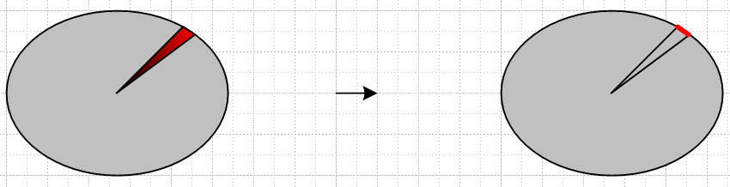

Here we indicate by the red wash that J in the conductor might be non-uniform. In the tiny angular segment shown we arrange for the surface current in the right picture (red) to be the same as the integrated volume current in the wedge of the left picture. In this manner, the resulting computed surface current at least reflects the possible asymmetry of the volume current. Then the question of error would require a comparison of these two situations:

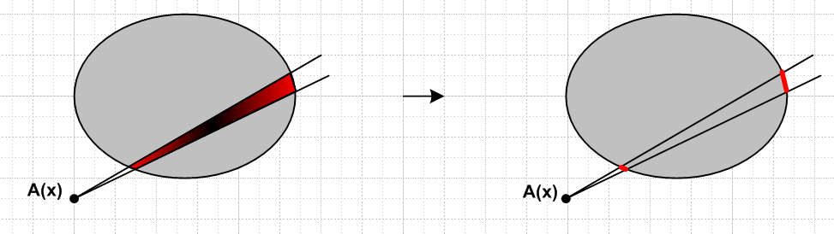

As outlined above, we don't have a fast way to analyze the situation on the left, but we might hope that the picture on the right gives an A(x) not too different from the exact solution.

To summarize, if we have the situation of Case 1 (skin effect) or Case 2 (thin conductors), we can use the following equations to compute the potentials in the dielectric, and then from these potentials we may compute the E and B fields using (1.3.1) :

Potential Solutions for Case 1 and Case 2

φ(x,ω) = $\frac{1}{4πξ}$∫nc(x',ω)$\frac{e-jβ(ω)R}{R}$dS' R = |x - x'| (1.5.11)

A(x,ω) = $\frac{μ}{4π}$∫J(x',ω)$\frac{e-jβ(ω)R}{R}$dV' R = |x - x'| (1.5.8)

β2 = μεω2 - jωμσ = ω2μ ( ε - jσ/ω) = ω2μ ξ ξ ≡ ε - jσ/ω = ε + σ/jω (1.5.1)

divA = - με ∂tφ - μσφ // King gauge (1.3.13)

B = curl A E = - grad φ - ∂tA . (1.3.1)

In the Helmholtz integral for A, the volume integration extends slightly into the conductors to pick up the skin effect current or the entire volume current for thin conductors. In the Helmholtz integral for φ, the charge density is nc and not the actual surface charge density ns as outlined in ****.
The Helmholtz integrals for φ and A as shown above appear as equations (23) and (24) on page 11 of King's Transmission-line Theory book. We have spent some 30 pages of this document deriving the equations in the box above and clarifying the meaning of the symbols involved (such as nc) and specifying the conditions under which we expect the computed potentials φ and A to be accurate. In his book, King simply states these Helmholtz integrals with no derivation and no comments about applicability, though in his opening section (page 1) he states "... it is never sufficient to be provided merely with a formula that is to be used to compute actual results in an engineering problem without a complete statement of the circumstances to which it applies and the conditions under which it will yield accurate results."

*************************

3.4 Normal (radial) current conservation at the surface of a conductor

The normal component of total current is conserved at the boundary between a dielectric and conductor. The reason this is true follows from the integral form (1.1.18) of Maxwell (1.1.1) in the ω domain,

H•ds = ∫(jωεE + σE)•dA . (3.4.1)

Imagine a small "loop" which lies parallel to the boundary surface (red square below),

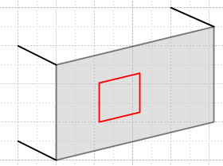 Fig 3.2

The integral of H around this loop does not change as the loop slides through the surface, because the parallel components of H are continuous at a surface, as was shown in (1.1.21). Thus, the total current, represented as the integrand of the right side of (3.4.1) must be continuous at the surface. We can then write, [ Note: this is the King BC! ]

(jωεd + σd)ENd = (jωεc + σc)ENc (3.4.2)

where d = dielectric and c = conductor and EN is the normal component of the E field.

On the conductor side, total current is dominated by the conduction current since σc is so large. In fact, for frequencies below 1018 Hz, we can completely neglect jωεc relative to σc. [ ref ]

On the dielectric side, exactly the opposite is true. In Section 3.3 we showed that the DC conductivity of the dielectric is completely negligible, and the loss tangent contribution is on the order of 10-4 times the displacement current. Thus, the displacement current is the dominant term in the dielectric. [ ref ]

The ratio of normal Ed to normal Ec at a boundary between conductor and dielectric is therefore given by

(jωεd)ENd ≈ (σc)ENc => $\frac{ENd}{ENc}$ ≈ $\frac{σc}{ωεd}$ . (3.4.3)

Again, we can look at some typical numbers.

σc = 5.81 x 107 mho/m (copper)
εd = 2.3 ε0 (polyethylene) (3.4.4)
ε0 = 8.85 x 10-12 farad/m

At a "high" frequency of ~ 500GHz the ratio in (3.4.3) is ~ 106, and at lower frequencies the ratio increases, since the displacement current drops off. Thus, we arrive at these useful facts:

Fact 1: The total current in a dielectric is dominated by displacement current, while that in a conductor is dominated by conduction current.

Fact 2: At a boundary between a good dielectric and a good conductor, the normal E field is at least 1 million times larger in the dielectric than it is in the conductor for frequencies under 500 GHz.

This large jump in EN at the boundary must be supported by a significant surface charge density n on the boundary, since [εdENd - εcENc] = n according to (1.1.22).

The main point of this section is that the "total current" Jtot ≡(jωεE + σE) flows right through the square surface loop shown in Fig 3.2, but changes its nature from mostly conduction current on one side to mostly displacement current on the other side. In the next section, we identify the normal direction with the local radial direction. Then the total current passing through a tiny square patch like that in Fig 3.2 can be regarded as being "fed" by the radial current Jr just inside the conductor where Jr = σEr .

***********

