Section 1.3 (c) rewrite PhL 11.4.13

I am not sure which "rewrite" this is. The date 11.4 makes it seem early on, so I guess this was before the Jm surface current rewrite which was later followed by a no-Jm rewrite! That section took a beating!

No changes are needed for (a) and (b), so we start with (c):

(c) The Potential Wave Equations in the King and Lorenz Gauges

We start with the King gauge and treat A and then φ. Then we do the Lorenz gauge case for A and φ, and finally we look at the wave equations for E and B. The motivation for using the King gauge is made clear.

KING GAUGE

Wave equation for A

Consider the following general cross section of a transmission line which happens to be of coaxial cable type,
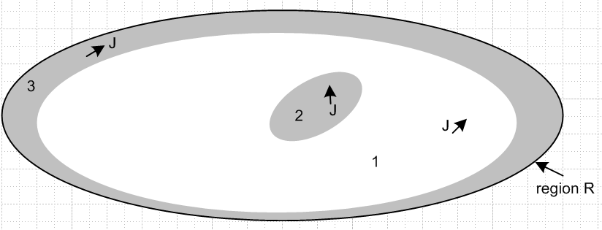

The gray regions 2 and 3 are conductors, while the white region 1 is the dielectric. We start by selecting the King gauge for region 1 and we apply it to all three regions,

div A = - μ1ε1 ∂tφ - μ1σ1φ // applies to all of R (1.3.18)

We first obtain the wave equation for A in region 1. Start with (1.3.3) which gives the wave equation for A before any gauge choice is made

(∇2 - μ1ε1 ∂t2) A = grad [μ1ε1 ∂tφ + divA ] - μ1J // region 1 (1.3.3)

Now insert the King gauge (1.3.18) to get

(∇2 - μ1ε1 ∂t2) A = grad [μ1ε1 ∂tφ + (- μ1ε1 ∂tφ - μ1σ1φ) ] - μ1J

= - μ1σ1 grad φ - μ1J

= - μ1σ1 (-E -∂tA) - μ1(σ1E) // using (1.3.1) and J = σ1E

= μ1σ1 ∂tA

Thus the wave equation for A in region 1 is

(∇2 - μ1ε1 ∂t2 - μ1σ1∂t) A = 0 // region 1 (1.3.19)

This is a homogeneous damped wave equation.

Now we start over with (1.3.3) for region 2:

(∇2 - μ2ε2 ∂t2) A = grad [μ2ε2 ∂tφ + divA ] - μ2J // region 2 (1.3.3)

As before, we insert the King gauge expression for div A.

(∇2 - μ2ε2 ∂t2) A = grad [μ2ε2 ∂tφ + (- μ1ε1 ∂tφ - μ1σ1φ) ] - μ2J

= [μ2ε2 ∂t + (- μ1ε1 ∂t - μ1σ1) ] gradφ - μ2J

= [ (μ2ε2 - μ1ε1) ∂t - μ1σ1) ] gradφ - μ2J

= [ (μ2ε2 - μ1ε1) ∂t - μ1σ1) ] (-E-∂tA) - μ2J // using (1.3.1)

Since region 2 is a conductor, we assume a perfect conductor and set E = 0 so that

(∇2 - μ2ε2 ∂t2) A = - [ (μ2ε2 - μ1ε1) ∂t - μ1σ1) ] (∂tA) - μ2J

= - [ (μ2ε2 - μ1ε1) ∂t2 - μ1σ1∂t ] A - μ2J .

Notice that we have chosen not to use J = σ2E for J in region 2, we just leave it as J. Moving the first term on the right to the left we get

( ∇2 - μ2ε2 ∂t2 + [ (μ2ε2 - μ1ε1) ∂t2 - μ1σ1∂t ] ) A = - μ2J

( ∇2 - μ1ε1 ∂t2 - μ1σ1∂t ) A = - μ2J // region 2 (1.3.20)

On the left side we see the same region 1 damped wave operator although we are in region 2, and J represents currents only in region 2 which we will call J2. A similar result will be obtained for region 3. Thus we have found that

(∇2 - μ1ε1 ∂t2 - μ1σ1) A = 0 region 1
(∇2 - μ1ε1 ∂t2 - μ1σ1∂t ) A = - μ2J2 region 2
(∇2 - μ1ε1 ∂t2 - μ1σ1∂t ) A = - μ3J3 region 3 (1.3.21)

We can combine these into a single equation

(∇2 - μ1ε1 ∂t2 - μ1σ1) A = - μ2J2 - μ3J3 all of region R (1.3.22)

with the understanding that the current in region 1 has already been accounted for, J2 represents currents in conductor 2 and J3 represents currents in conductor 3. We could generalize this result for a region R containing any number N of conductors in regions 2,3,4...N

(∇2 - μ1ε1 ∂t2 - μ1σ1) A = - Σi=2NμiJi all of region R (1.3.23)

Wave equation for φ

We first obtain the wave equation for φ in region 1. Start with (1.3.2) which gives the wave equation for φ before any gauge choice is made

∇2φ + ∂t[div A] = -ρ/ε1 (1.3.2)

Now use the same global King gauge (1.3.8) for div A.

∇2φ + ∂t[- μ1ε1 ∂tφ - μ1σ1φ] = - ρ/ε1

(∇2 - μ1ε1 ∂t2 - μ1σ1∂t)φ = - (1/ε1)ρ // region 1 (1.3.24)

Again the same damped region 1 wave operator appears on the left side. Since the King gauge is the same in all three regions, we can write

(∇2 - μ1ε1 ∂t2 - μ1σ1∂t)φ = - (1/ε1)ρ // region 1
(∇2 - μ1ε1 ∂t2 - μ1σ1∂t)φ = - (1/ε2)ρ // region 2
(∇2 - μ1ε1 ∂t2 - μ1σ1∂t)φ = - (1/ε3)ρ // region 3 (1.3.25)

where ρ always means free charge. The three equations are basically the same because the pre-gauge equation (1.3.2) has no region-specific parameters apart from ε1, in contrast with (1.3.3) quoted above.

Now the only actual free charge present is the surface charge on the outside surfaces of the conductors and we regard this as being in region 1. There is no free charge inside the dielectric or inside the conductors. We can then combine the above three equations into a single equation for all of region R

(∇2 - μ1ε1 ∂t2 - μ1σ1∂t)φ = - (1/ε1)ρs all of region R (1.3.26)

where now ρs is the surface charge on the conductors.

Conclusion for wave equations in the King gauge

Here then are the wave equations for φ and A in region R using the region 1 King gauge:

(∇2 - μ1ε1 ∂t2 - μ1σ1∂t)φ = - (1/ε1)ρs all of region R (1.3.26)
(∇2 - μ1ε1 ∂t2 - μ1σ1) A = - Σi=2NμiJi all of region R (1.3.23)
div A = - μ1ε1 ∂tφ - μ1σ1φ King gauge region 1 (1.3.18)

where ρs is the total surface charge on all conductors and Ji is the current in the interior of conductor i.

King never writes the inhomogeneous wave equations (1.3.23) and (1.3.26) in his transmission-line theory book, so it is difficult to find verification of our logic pathway in his book. However, Panofsky and Phillips do show the equations and we quote the relevant section from their book:

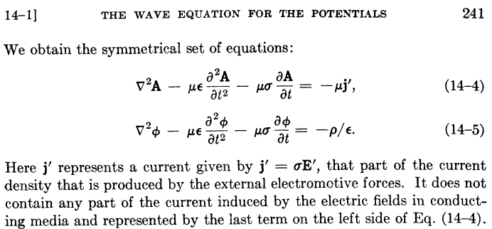

In other words, the usual J = σE in the conducting dielectric has been incorporated into the -μσ∂tA term in their first equation, just as we have done above. This leaves their j' to be conduction currents inside the conductors. They have assumed all conductors have the same μ to write -μj' . In order to obtain the above equations, Panofsky and Phillips use the King gauge (1.3.18) but they refer to this gauge simply as "the Lorentz condition". From their page 240,

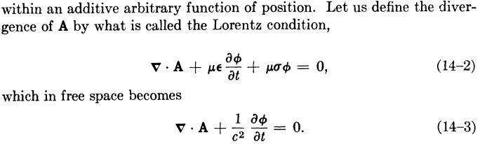

LORENZ GAUGE

If we carry out exact same program with respect to Fig ** using a global Lorenz gauge for all of R,

divA = - μ1ε1∂tφ , (1.3.27)

we obtain these results for A ,

(∇2 - μ1ε1 ∂t2)A = - μ1J1 region 1
(∇2 - μ1ε1 ∂t2)A = - μ2J2 region 2
(∇2 - μ1ε1 ∂t2)A = - μ3J3 region 3

so that

(∇2 - μ1ε1 ∂t2)A = - Σi=1NμiJi all of region R . (1.3.28)

The results for φ are

(∇2 - μ1ε1 ∂t2)φ = -ρ/ε1 region 1
(∇2 - μ1ε1 ∂t2)φ = -ρ/ε2 region 2
(∇2 - μ1ε1 ∂t2)φ = -ρ/ε3 region 3

so that with the same comments made earlier

(∇2 - μ1ε1 ∂t2)φ = -ρs/ε1 all of region R (1.3.29)

COMPARISON

We can now do a side by side comparison

King Gauge:
(∇2 - μ1ε1 ∂t2 - μ1σ1∂t)φ = - ρs/ε1 all of region R (1.3.26)
(∇2 - μ1ε1 ∂t2 - μ1σ1) A = - Σi=2NμiJi all of region R (1.3.23)
div A = - μ1ε1 ∂tφ - μ1σ1φ King gauge region 1 (1.3.18)

Lorenz Gauge:
(∇2 - μ1ε1 ∂t2)φ = -ρs/ε1 all of region R
(∇2 - μ1ε1 ∂t2)A = - Σi=1NμiJi all of region R
divA = - μ1ε1∂tφ Lorenz gauge region 1

In the Lorenz gauge, we get undamped wave operators, but we have to include the current distribution in the conducting dielectric which is J1 in the sum. In a situation where we have prescribed currents in conductors 2 and 3, it is inconvenient to have to worry about the dielectric current which complicates the solution of the problem (this will become more obvious later).

In the King gauge, we get damped wave operators but we have to include only the current in the conductors. The current in the dielectric has been incorporated into the damping term. When we transform to the frequency domain and write the Helmholtz equation for A and its Helmholtz Integral solution, we need only integrate over the conductors which makes life easy.

E AND B WAVE EQUATIONS

Meanwhile, the E and B field wave equations of course don't know anything about gauges and from (1.2.1) and (1.2.2) we have, with respect to Fig. ** ,

(∇2 - μ1ε1 ∂t2)E = μ1∂tJ1 + (1/ε1) grad ρ1 = μ1∂tJ1 + (1/ε1) grad ρs // region 1
(∇2 - μ2ε2 ∂t2)E = μ2∂tJ2 + (1/ε2) grad ρ2 = μ2∂tJ2 // region 2
(∇2 - μ3ε3 ∂t2)E = μ3∂tJ3 + (1/ε3) grad ρ3 = μ3∂tJ3 // region 3
(1.3.30)
(∇2 - μ1ε1 ∂t2)B = - μ1 curl J1 // region 1
(∇2 - μ2ε2 ∂t2)B = - μ2 curl J2 // region 2
(∇2 - μ3ε3 ∂t2)B = - μ3 curl J3 // region 3

We cannot unify each group of three equations into a single region R equation as we could in the potential case since the wave operators are different in each region. Using J1 = σ1E and curl E = - ∂tB the region 1 equations can be written as

(∇2 - μ1ε1 ∂t2 - μ1σ1∂t)E = + (1/ε1) grad ρs // region 1
(∇2 - μ1ε1 ∂t2 - μ1σ1∂t)B = 0 // region 1 (1.3.31)

but this does not help in unifying the regions, and one is left with a difficult boundary value problem. In contrast, the solution of the King gauge potential equations over all of region R is straightforward, as we shall see below.

