11.7.13

This edited stuff was installed into lines on 11.7.13. Can throw this file out after a while.

I think this was my very first version to use the picture you see below. I later redid this adding surface currents, and then after that I redid it again removing those surface currents!

(c) The Potential Wave Equations in the King and Lorenz Gauges with Conductors

We start with the King gauge and treat A and then φ. Then we do the Lorenz gauge case for A and φ, and finally we look at the wave equations for E and B. The motivation for using the King gauge is made clear.

KING GAUGE

Wave equation for A

Consider the following general cross section of a transmission line which happens to be of coaxial cable type,
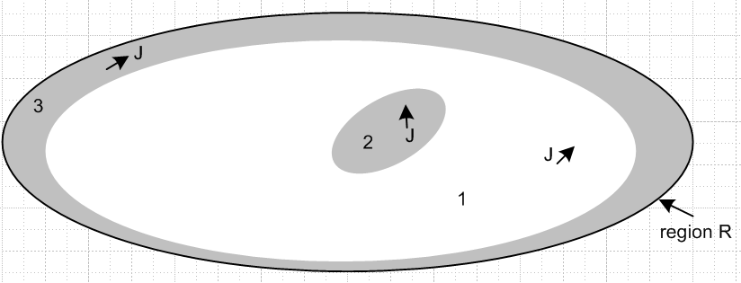

The gray regions 2 and 3 are conductors, while the white region 1 is the dielectric. We start by selecting the King gauge for region 1 and we apply it to all three regions,

div A = - μ1ε1 ∂tφ - μ1σ1φ // applies to all of R (1.3.18)

We first obtain the wave equation for A in region 1. Start with (1.3.3) which gives the wave equation for A before any gauge choice is made

(∇2 - μ1ε1 ∂t2) A = grad [μ1ε1 ∂tφ + divA ] - μ1J // region 1 (1.3.3)

Now insert the King gauge (1.3.18) to get

(∇2 - μ1ε1 ∂t2) A = grad [μ1ε1 ∂tφ + (- μ1ε1 ∂tφ - μ1σ1φ) ] - μ1J

= - μ1σ1 grad φ - μ1J

= - μ1σ1 (-E -∂tA) - μ1J // from (1.3.3)

Now the current J includes all currents in region 1. The obvious current is the conduction current Jc = σ1E. Less obvious but just as important are the magnetization currents Jm which flow on the outer surfaces of the conductors if they have a μ different from μ1. Allowing for such Jm we write

(∇2 - μ1ε1 ∂t2) A = - μ1σ1 (-E -∂tA) - μ1(σ1E) - μ1Jm
or
(∇2 - μ1ε1 ∂t2) A = - μ1σ1 ( -∂tA) - μ1Jm

Thus the wave equation for A in region 1 is

(∇2 - μ1ε1 ∂t2 - μ1σ1∂t) A = - μ1Jm // region 1 (1.3.19)

This is a homogeneous damped wave equation driven by those surface currents.

Now we start over with (1.3.3) for region 2:

(∇2 - μ2ε2 ∂t2) A = grad [μ2ε2 ∂tφ + divA ] - μ2J // region 2 (1.3.3)

As before, we insert the region 1 King gauge expression (1.3.18) for div A, even though we are now working in region 2,

(∇2 - μ2ε2 ∂t2) A = grad [μ2ε2 ∂tφ + (- μ1ε1 ∂tφ - μ1σ1φ) ] - μ2J2

= [μ2ε2 ∂t + (- μ1ε1 ∂t - μ1σ1) ] gradφ - μ2J2

= [ (μ2ε2 - μ1ε1) ∂t - μ1σ1) ] gradφ - μ2J2

= [ (μ2ε2 - μ1ε1) ∂t - μ1σ1) ] (-E-∂tA) - μ2J2 // using (1.3.1)

Since region 2 is a conductor, we assume a perfect conductor and set E = 0 so that

(∇2 - μ2ε2 ∂t2) A = - [ (μ2ε2 - μ1ε1) ∂t - μ1σ1) ] (∂tA) - μ2J2

= - [ (μ2ε2 - μ1ε1) ∂t2 - μ1σ1∂t ] A - μ2J2 .

Notice that we have chosen not to set J2 = σ2E in region 2, we just leave it as J2. Moving the first term on the right to the left we get

( ∇2 - μ2ε2 ∂t2 + [ (μ2ε2 - μ1ε1) ∂t2 - μ1σ1∂t ] ) A = - μ2J2

( ∇2 - μ1ε1 ∂t2 - μ1σ1∂t ) A = - μ2J2 // region 2 (1.3.20)

On the left side we see the same region 1 damped wave operator although we are in region 2, and J represents currents only in region 2 which we will call J2. A similar result will be obtained for region 3. Thus we have shown that

(∇2 - μ1ε1 ∂t2 - μ1σ1∂t ) A = - μ1Jm = -μ1[ Jm(2) + Jm(3)] region 1
(∇2 - μ1ε1 ∂t2 - μ1σ1∂t ) A = - μ2J2 region 2
(∇2 - μ1ε1 ∂t2 - μ1σ1∂t ) A = - μ3J3 region 3 (1.3.21)

We can combine these into a single equation which is then valid over all of region R,

(∇2 - μ1ε1 ∂t2 - μ1σ1) A = -μ1[ Jm(2) + Jm(3)] - μ2J2 - μ3J3 all of region R (1.3.22)

with the understanding that the conduction current in region 1 has already been accounted for, J2 represents currents in conductor 2 and J3 represents currents in conductor 3, and Jm(i) is any surface current which may be present on these conductors. We could generalize this result for a region R containing any number N of conductors in regions 2,3,4...N

(∇2 - μ1ε1 ∂t2 - μ1σ1) A = - Σi=2N[ μ1Jm(i) + μiJi] all of region R (1.3.23)

If it happened that μ3 = μ2 = μ1 , then Jm(i) = 0 and the last equation appears as

(∇2 - μ1ε1 ∂t2 - μ1σ1) A = - μ1 Σi=2 Ji all of region R (1.3.23a)

Wave equation for φ

We first obtain the wave equation for φ in region 1. Start with (1.3.2) which gives the wave equation for φ before any gauge choice is made

∇2φ + ∂t[div A] = -ρ/ε1 (1.3.2)

Now use the same global King gauge (1.3.8) for div A.

∇2φ + ∂t[- μ1ε1 ∂tφ - μ1σ1φ] = - ρ/ε1

(∇2 - μ1ε1 ∂t2 - μ1σ1∂t)φ = - (1/ε1)ρ // region 1 (1.3.24)

Again the same damped region 1 wave operator appears on the left side. Since the King gauge is the same in all three regions, we can write

(∇2 - μ1ε1 ∂t2 - μ1σ1∂t)φ = - (1/ε1)ρ // region 1
(∇2 - μ1ε1 ∂t2 - μ1σ1∂t)φ = - (1/ε2)ρ // region 2
(∇2 - μ1ε1 ∂t2 - μ1σ1∂t)φ = - (1/ε3)ρ // region 3 (1.3.25)

where ρ always means free charge. The three equations are basically the same because the pre-gauge equation (1.3.2) has no region-specific parameters apart from ε1, in contrast with (1.3.3) quoted above.

Now the only actual free charge present is the surface charge on the outside surfaces of the conductors and we regard this as being in region 1. There is no free charge inside the dielectric or inside the conductors. We can then combine the above three equations into a single equation for all of region R

(∇2 - μ1ε1 ∂t2 - μ1σ1∂t)φ = - (1/ε1)ρs all of region R (1.3.26)

where now ρs is the surface charge on the conductors.

Conclusion for wave equations in the King gauge

Here then are the wave equations for φ and A in region R using the region 1 King gauge:

(∇2 - μ1ε1 ∂t2 - μ1σ1∂t)φ = - (1/ε1)ρs all of region R (1.3.26)
(∇2 - μ1ε1 ∂t2 - μ1σ1) A = - Σi=2N [ μ1Jm(i) + μiJi] all of region R (1.3.23)
div A = - μ1ε1 ∂tφ - μ1σ1φ King gauge region 1 (1.3.18)

where ρs is the total surface charge on all conductors and Ji is the current in the interior of conductor i.

King never writes the inhomogeneous wave equations (1.3.23) and (1.3.26) in his transmission-line theory book, so it is difficult to find verification of our logic pathway in his book. However, Panofsky and Phillips do show the equations and we quote the relevant section from their book where we identify their parameters μ,ε,σ with our region 1 parameters μ1, ε1, σ1 :

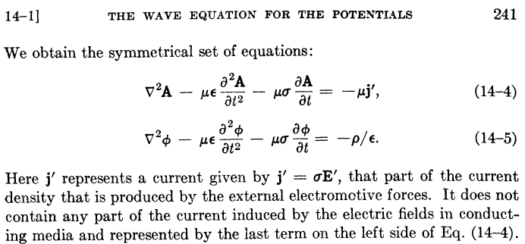

In other words, the usual J = σE in the conducting dielectric has been incorporated into the -μσ∂tA term in their first equation, just as we have done above. These authors have assumed that the μ's of the dielectric and the conductors are all the same (normally μ = μ0). In this case, there are no surface currents and our (1.3.23a) can be written

(∇2 - μ1ε1 ∂t2 - μ1σ1) A = - μ1 Σi=2N Ji = - μ1 j' all of region R (1.3.23a)

and then we can identify their current j' with the sum over the current densities in the conductors. In order to obtain the above equations, Panofsky and Phillips use the King gauge (1.3.18) but they refer to this gauge simply as "the Lorentz condition". From their page 240,

