Paradoxes applying div J integral rule PhL 10.11.13

The paradox went away when I drew the currents with the correct phases! In the first figure below, the current Jz is phased wrong and that led to the paradox, and also led me to draw the E and B arrows incorrectly as being staggered!

This section contains two other useful chunks of information:
the plane wave solution (which I might add somewhere)
a start into the full twin-lead solution E and B fields (which I might add somewhere)

1. Statement of Paradox 1 1
2. Plane Waves in Vacuo. 2
3. Is my big drawing correct? 5
5. Question: Why did I think Fig 2 was wrong with aligned E and B? 8
6. The twin-lead full solution. 11

1. Statement of Paradox 1

The first appearance of this problem is with my picture (which may be wrong) of a transmission line section,

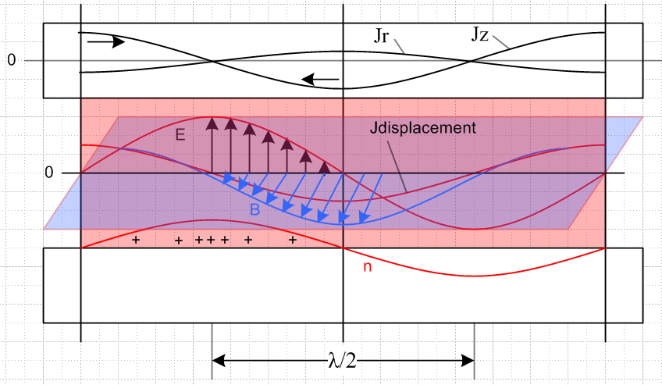

The div J integral rule says this:

-∂t[∫V ρ dV] = ∫S J • dA = -∂t Qenclosed

Box of interest: A cylinder of length λ/2 aligned with the upper round conductor in this picture, centered left right, and with curved surface just inside the conductor surface.

Paradox 1: In computing ∫S J • dA, the two end caps make no contribution since Jz= 0 at both ends. There seems to be a displacement current emanating from this piece of conductor which is fed by Jr inside the conductor, and this Jr seems to be positive all around the cylinder. Thus, ∫S J • dA due to this current is some positive number. Thus, the total ∫S J • dA integral is some positive number. But, I have stated earlier that you cannot have any charge ρ inside a conductor, you can only have it on the surface. But the surface is excluded from my box. So if ρ ≡ 0 inside my box, how can -∂t Qenclosed ≠ 0 ?

Right now this is a pending paradox; I will no doubt laugh at it when the paradox is resolved.

Maybe I can come up with some simpler paradox that has the same problem. First, I want to clear up a confusion I have about plane waves in open space.

2. Plane Waves in Vacuo.

What does these really look like? Assume goes in the z direction. Try to find a solution of this form:

E(x,y,z,t) = ej(ωt-kz+φ$_{E}$) E0

B(x,y,z,t) = ej(ωt-kz+φ$_{B}$) B0

Maxwell's equations in vacuo state

(1/μ0) curl B = ε0∂E/∂t => curl B = (μ0ε0)∂E/∂t => (1.1.1)

curl B = c-2∂E/∂t

curl E = - ∂B/∂t (1.1.2)

Inserting my forms, we find

curl E(x,y,z,t) = (∂xEy- ∂yEx) + (∂yEz- ∂zEy) + (∂zEx- ∂xEz)

= -(∂yEx) + (∂zEx) = (∂zEx) = -jk ej(ωt-kz+φ$_{E}$)E0

curl B(x,y,z,t) = (∂xBy- ∂yBx) + (∂yBz- ∂zBy) + (∂zBx- ∂xBz)

= (∂xBy) - (∂zBy) = -(∂zBy) = + jk ej(ωt-kz+φ$_{B}$) B0

∂E/∂t = jω ej(ωt-kz+φ$_{E}$) E0

∂B/∂t = jω ej(ωt-kz+φ$_{B}$) B0

Therefore, the two curl equations say this:

-jk ej(ωt-kz+φ$_{E}$)E0 = - jω ej(ωt-kz+φ$_{B}$) B0 curl E = - ∂B/∂t (1)

+jk ej(ωt-kz+φ$_{B}$) B0 = c-2 jω ej(ωt-kz+φ$_{E}$) E0 curl B = c-2∂E/∂t (2)

Simplify both equations

k ej(ωt-kz+φ$_{E}$)E0 = ω ej(ωt-kz+φ$_{B}$) B0 curl E = - ∂B/∂t (3)

k ej(ωt-kz+φ$_{B}$) B0 = c-2 ω ej(ωt-kz+φ$_{E}$) E0 curl B = c-2∂E/∂t (4)

Matching magnitudes and phases in each equation we get

k E0 = ω B0 φE = φB

kB0 = c-2ω E0 φE = φB

The phases are therefore the same. The magnitude equations say

E0/B0 = ω/k = k/[c-2ω] => ω/k = kc2/ω => ω2 = k2c2 => ω = ck

=> c = ω/k = λ/T = as expected. and B0 = (k/ω)E0 = (1/c)E0

Thus, the plane wave solution is this (set both phases to 0)

E(x,y,z,t) = ej(ωt-kz) E0 E0 = cB0

B(x,y,z,t) = ej(ωt-kz) B0

In terms of real fields

E(x,y,z,t) = E0 cos(ωt-kz) E0 = cB0
B(x,y,z,t) = B0 cos(ωt-kz)

Blue Jackson p 259 says the Poynting vector is (all here is in SI units)

S = E x H = (1/μ0) E x B = (1/μ0) cB02 cos2(ωt-kz)

Jackson's energy conservation equation says

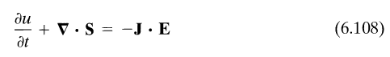
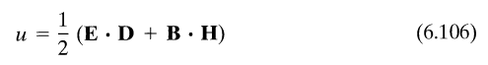

and in vacuo we have J = 0 and then

div S = -∂tu

Now we get

u = (1/2)(ε0E2+ (1/μ0)B2) = (1/2)(ε0E02+ (1/μ0)B02) cos2(ωt-kz)

= (1/2)(ε0c2B02+ (1/μ0)B02) cos2(ωt-kz)

= (1/2)(ε0c2+ (1/μ0)) B02cos2(ωt-kz)

= (1/2)ε0(c2+ (1/ε0μ0)) B02cos2(ωt-kz)

= (1/2)ε0(2c2) B02cos2(ωt-kz)

= ε0 c2B02cos2(ωt-kz)

Check units: ε0 = farad/m B0 = amp-henry/m2 c = m/sec

ε0 c2 B02 = amp2 henry2 farad/m5 * m2/sec2

= amp2 henry sec2/m5 *m2/sec2

= amp2 ohm-sec sec2/m5 *m2/sec2 = amp2 ohm sec3/m5 *m2/sec2

= watt sec3/m5 = joule sec2/m5 *m2/sec2 = joule/m3 = energy density u

So I arrive at some conclusions:

Fact 1: In a plane wave, the E and B vectors are in phase. They are both large at the same time, and they are both small at the same time.

Corollary: My big drawing above seems wrong in this respect, but maybe the wave between the conductors is not a plane wave analog.

Fact 2: There are times when the Poynting vector is 0, and when u is 0, etc. If you draw a picture of a wave, the energy flow vector and u density are not constant in z for fixed t. But at any point, you will find that div S = -∂tu which is the energy conservation statement.

3. Is my big drawing correct?

Neither of my two transmission line books attempts to draw E and B fields as I have attempted, so I cannot check their pictures. Image search finds nothing either in the sense I want to see it.

Since I presumably solve the whole problem later in my doc, maybe I should look at the solution! I have just read through my solution. I first compute the potential difference between two conductors

V(z) = $\frac{2}{4πε}$q(z){ $^{\int_{C1}^{}{}}$dx' dy' a1(x',y') ln(s2/s1) -$^{\int_{C2}^{}{}}$dx' dy' a2(x',y') ln(s2/s1) } (4.2.5)

where the surface charge density is ρ1(x,y,z) = a1(x,y) q1(z) on conductor 1, etc. This then relates the unknown functions V(z), q(z), a1(x',y') and a2(x',y'). The si are transverse distances. We have only a transverse integral. The above form is in the "transmission line limit", otherwise includes K functions and is much messier. Note that everything is real in the above equation. I then repeat the calculation to obtain W(z) which is ΔAz between the conductors.

W(z) = $\frac{2μ}{4π}$i(z){ $^{\int_{C1}^{}{}}$dx' dy' b1(x',y') ln(s2/s1) -$^{\int_{C2}^{}{}}$dx' dy' b2(x',y') ln(s2/s1) } (4.4.3)

where the Jz current density is Jz1(x,y,z) = b1(x,y) i1(z). This relates the four unknown functions W(z), i(z), b1(x',y') and b2(x',y')

Pause: how do the dimensions work out on these two things,

ρ1(x,y,z) = a1(x,y) q1(z) 1/m2 * C/m I guess
Jz1(x,y,z) = b1(x,y) i1(z). 1/m2 * amp I guess

I guess you would then say

∫dxdy ρ1(x,y,z) = q1(z) ∫dxdy a1(x,y) = C/m = q1(z)
∫dxdy Jz1(x,y,z) = i1(z) ∫dxdy b1(x,y) = C/m = i1(z)

with the normalization (4.1.3). Thus q1 is the total surface charge per length on conductor 1, while i1(z) is the total current in conductor 1. Good. Where did I get all this stuff from??? King at least has something but not the full spiel I give.

So far then I have two integral equations and 8 unknown functions!!! E and B fields not even mentioned at this point. I then show that these integrals are in fact capacitance C' and mutual inductance Le of the line per unit length. Ouch, very complicated, but at least these ugly integrals have an interpretation.

Note: the two big integrals just give Δφ(z) and ΔAz(z) where you are taking two points, one on each conductor, at the same z. These are not expressions for fields of x,y,z!

Starting at 4.5.3 I then bring in the E field using E = - grad φ - jωA with div A = - j (β2/ω) φ as the gauge choice. I then get Ez1 - Ez2 = - ∂V/∂z - jωW as the difference between the conductors of Ez at their surfaces. Suddenly in (4.5.8) I end up with

$\frac{∂V(z)}{∂z}$= - [ Zi1+ Zi1+ jωLe ] i(z) $\frac{∂i(z)}{∂z}$= - [ jβ2/(ωLe)] V(z) (4.5.8)

If we know the surface impedances and if we know Le then this would be 2 equations in 2 unkonwns which are V(z) and i(z), the super basic quantities of interest. But then these things become just the parameters of the transmission line R,L,G and C and we have (4.5.9) and (4.5.10)

$\frac{∂V(z)}{∂z}$= - z i(z) $\frac{∂i(z)}{∂z}$= - y V(z) (4.5.9)

z = R + jωL y = G +jωC (4.5.10)

The circle DOES seem to have closed at this point, but I still don't have a field solution. I then claim another equation which is this

$\frac{∂i(z)}{∂z}$= - [ jωC'] V(z) (4.5.14)

and perhaps this could help in my pictures. C' is complex, that needs to be pondered.
I then go on to relate C' and Le to a certain integral K in 4.5.17 of the 2D charge density distributions called ai.

Comments: I say nothing about the φ,Az, E or B anywhere, nothing in the dielectric or in the conductor.

I then jump into the 2 wire wide spaced line where a1(r,θ) = δ(r - a1)/(2πa1) so this function goes away as an unknown and then we can compute K. The coax cable has the same simple fact.

But then I attack the general "transverse problem". I seem to be starting afresh with (5.2.1), looking for homo solutions to the two potential wave equations.

Now I write ρ(x,y,z) = ρt(x,y) q(z) which I guess I intend to use only on a conductor surface. Why do I call this ρt whereas earlier I called it a1(x,y) ? Anyway, I make these ansatz's:

ρ(x,y,z) = ρt(x,y) q(z) (5.2.5)
φ(x,y,z) = (1/2πε) q(z) φt(x,y) (5.2.6)

This second one I presume I will use at any point in space. The idea is that it has a common scaling in z, something I have more or less been assuming -- the idea that the shape does not change, just the scale, and here the scale is q(z). I then come up with a separated φ Helmholtz

[ ∇t2 + (β2 +kφ2)] φt(x,y) = -2πρt(x,y) (5.2.10)

[ ∇z2 - kφ2 ] q(z) = 0 (5.2.11)

where kφ is the separation constant, fine. And do the same for

Az(x,y,z) = (μ/2π) i(z) Azt(x,y)

[ ∇t2 + (β2 +kA2 )] Azt(x,y) = 0 (5.2.15)

[ ∇z2 - kA2 ] i(z) = 0 (5.2.16)

where kA is the separation constant here. So at least we have separated the problem into z and x,y separate problems coupled by these constants. The two z equations are these

$\frac{∂2Az}{∂z2}$- kA2 Az = 0 $\frac{∂2φ}{∂z2}$- kφ2 φ = 0 (5.2.17)

I then show that the two constants are the same an in fact

kA2 = kφ2 = zy ≡ k2

and I show that k2 ≈ - βd2 for a low-loss line.

Section 5.3 then attacks the transverse problem. I then have this large simplification:

φt(x,y) = Azt(x,y) in the dielectric (5.3.7)

OK, for very good conductors I then finally solve a sample problem as in (6.3.13): two possibly close round conductors of different radii. Now I am stating φ and Az everywhere in space, not just on the conductors. The "same shape" pattern is f(x,y). Here is this solution

General solution of two-wire transmission line :

φ(x,y,z) = (1/2πε) q(z) f(x,y) Le = (μ/2π)K
Az(x,y,z) = (μ/2π) i(z) f(x,y) C = 2πε/K
G = 2πσ/K
f(x,y) = ln [ $\frac{(x+d)2 + y2}{(x–d)2 + y2}$ ]

K = ln [ (d/a1) + $\sqrt{(d/a1)2 + 1}$] ± ln [ (d/a2) + $\sqrt{(d/a2)2 + 1}$]

+ sign for conductors as in Figure 2 (separated)
– sign for conductors as in Figure 3 (concentric)

d = (1/2b) $\sqrt{b4 + (a12 - a22)2 - 2b2(a12 + a22)}$ (6.3.13)

Notice that φ and Az are real, things look very simple. I should be able to obtain the E and B fields from these two equations and maybe get the data I am looking for!
Where is time dependence here?? Hold the phone. Well t is replaced by ω with our usual time FT, so that is why you see jω everywhere. So I would say

φ(x,y,z,t) = (1/2πε) q(z) f(x,y) ejωt
Az (x,y,z,t) = (μ/2π) i(z) f(x,y) ejωt

But the doc then just ends and I don't do this! So maybe now is the time!

Fact: It seems that φ, q, i and Az all have max values at the same time! Since B follows i and E follows q and φ, the E and B fields should max at the same time. Just as with a plane wave!!!!

5. Question: Why did I think Fig 2 was wrong with aligned E and B?

What caused me to doubt it and to draw a new fancy figure with E and B staggered?

My picture Fig 2 now seems correct, and my thing above in color is completely wrong. In my color picture I have B tracking with Jz which is correct. I then assumed that Jr tracks with Jz and drew in a Jr curve. I then argued that this Jr feeds displacement current which should then correspond with the place that E = 0 (maximum change).

I think my alignment of Jz with Jr is wrong. So where might I have learned something about these two animals?
In my Chapter 2 round wire analysis, the solutions were

E(x,t) = E0 ejωt $\sqrt{ωμσ}$$\sqrt{ωμσ}$$\sqrt{ωμσ}$$\sqrt{ωμσ}$ (2.2.14)

B(x,t) = - E0 ejωt ejπ/4$\frac{μσ}{ω}$ $\sqrt{ωμσ}$$\sqrt{ωμσ}$$\sqrt{ωμσ}$$\sqrt{ωμσ}$ (2.2.15)

There is no Er hence no Jr in this problem! The issue of Jr does not even arise!

Then I launch into Chapter 3. In 3.4 I mention the radial current really for the first time. What do I have to say about it? On the two sides of the boundary I say that

(jωεd + σd)ENd = (jωεc + σc)ENc (3.4.2)

(jωεd)ENd ≈ (σc)ENc => $\frac{ENd}{ENc}$ ≈ $\frac{σc}{ωεd}$ . (3.4.3)

I might write the last line as

(jωεd)ENd ≈ Jr

and here you see the π/2 phase shift at least between Jr and ENd which presumably is the E arrows in my color drawing. The drawing has the correct alignment between Jr and E (I think). I can get the polarity from the notion of pumping charge.

Conclusion: My color picture is WRONG and perhaps that is why I got my div J paradox. [ yes! ]

Action Item: draw a new picture that has things done right.

Here then is my new picture [ has since been updated ]

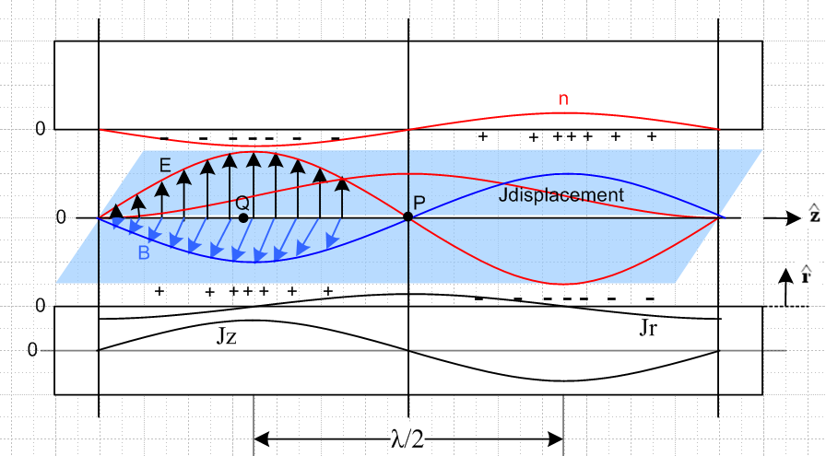

Explanation of new picture:

(1) Blue items are out of the plane of paper, so the B field arrows point to the viewer.

(2) Looking at E x B, we see that the wave is traveling to the right in the direction.

(3) The E field arrows point from positive charge to negative charge, so this is why the + and - signs are distributed as shown.

(4) The conductors are fixed to the paper, everything else is moving to the right at velocity v. This includes the E and B arrows and their curves, the charge density and its curve n, and the two current curves shown on the bottom.

(4) At point Q, since B is coming out of paper to the viewer, the longitudinal current Jz at that value of z must be pointing to the right. This is why Jz is shown positive at this point in the lower conductor, and this calibrates the position of the Jz curve. Maximum Jz occurs with maximum B.

(5) At point P on plane z = zP, since the wave and charge density is moving to the right, there is a need to build up positive charge on the lower conductor at zP. This positive charge is delivered by the radial current Jr in the lower conductor.

Question: why don't the + charges just slide along the surface to the right, so there is then no need for this Jr to produce the charge at point P? Let's skip (5) and instead try (6)

(6) At point P, the electric field is increasing "up" with time. This is what happens in a capacitor as it charges. In the capacitor, we associate this with a displacement current in the direction of increasing E. So at point P we should have a displacement current pointing up. This Jdisp is fed by Jr at the lower conductor as shown.

Now let's reconsider Paradox 1.

Box of interest: A cylinder of length λ/2 aligned with the lower round conductor in this picture, centered left right, and with curved surface just inside the conductor surface.

-∂t[∫V ρ dV] = ∫S J • dA = -∂t Qenclosed

Now I will start saying that Qenclosed = 0 so it must be that

∫J•dA = 0

Endcaps? At the left endcap, Jz points to the right, but dA points to the left, so this endcap produces a negative contribution to ∫J•dA . At the right endcap, we get an exactly identical negative contribution. Since the Jr current is outwardly directed, it makes a positive contribution. These two contributions must cancel since Qenclosed . This will then force some relationship between Jz and Jr. The 2I idea.

Conclusion: In this new picture, there is no longer a Paradox 1 !

In my older picture, not only were things aligned wrong, but my interpretation of the notion of change at a point was wrong!

Question: recall from above that

(jωεd)ENd ≈ Jr

In the time domain this says, with my ωt-kz phase convention,

εd∂tENd = Jr

So in my picture, I expect Jr to be + slope of E. Now in my picture, if you sit at point P and wait dt, you will see EN increasing, so I expect Jr to be positive which it is. Also consider

Jr = ejπ/2 ωεdENd

This suggests the Jr "leads" E by π/2, and that also agrees with the picture. This is because ejωt winds CCW as time increases, so a leader is CCW of the follower.

–––––––––––––––––––––––––––––––––––––

6. The twin-lead full solution.

Go back now to

General solution of two-wire transmission line :

φ(x,y,z) = (1/2πε) q(z) f(x,y) Le = (μ/2π)K
Az(x,y,z) = (μ/2π) i(z) f(x,y) C = 2πε/K
G = 2πσ/K
f(x,y) = ln [ $\frac{(x+d)2 + y2}{(x–d)2 + y2}$ ]

K = ln [ (d/a1) + $\sqrt{(d/a1)2 + 1}$] ± ln [ (d/a2) + $\sqrt{(d/a2)2 + 1}$]

+ sign for conductors as in Figure 2 (separated)
– sign for conductors as in Figure 3 (concentric)

d = (1/2b) $\sqrt{b4 + (a12 - a22)2 - 2b2(a12 + a22)}$ (6.3.13)

Let's compute the fields!

B = curl A E = - grad φ - ∂A/∂t . (1.3.1)

Now write out the curl again,

B = curl A(x,y,z,t) = (∂xAy- ∂yAx) + (∂yAz- ∂zAy) + (∂zAx- ∂xAz)

= ∂yAz - ∂xAz

= (μ/2π)[ i(z) ∂yf(x,y) - i(z) ∂xf(x,y)]

= (μ/2π) i(z) [ ∂yf(x,y) - ∂xf(x,y) ]

grad φ = ∂xφ + ∂yφ + ∂zφ

= (1/2πε) [ q(z)∂xf(x,y) + q(z)∂yf(x,y) + ∂zq(z) f(x,y) ]

∂A/∂t = (∂Az/∂t) = (μ/2π) ∂zi(z) f(x,y)

Then we add our two terms

E = - grad φ - ∂A/∂t = – (1/2πε) [ q(z)∂xf(x,y) + q(z)∂yf(x,y) + ∂zq(z) f(x,y) ]
– (μ/2π) ∂zi(z) f(x,y)

Now we know that i(z) and q(z) are in phase and behave as e-jkz so ∂z → -jk and then

B = (μ/2π) i(z) [ ∂yf(x,y) - ∂xf(x,y) ]

E = - grad φ - ∂A/∂t = – (1/2πε) q(z) [∂xf(x,y) + ∂yf(x,y) -jk f(x,y) ]
+ (μ/2π) jk i(z) f(x,y)

= {– (1/2πε) q(z) + (μ/2π) jk i(z) } f(x,y) – (1/2πε) q(z) [∂xf(x,y) + ∂yf(x,y) ]

Don't know best way to write this, but there is a result! Try again on E,

2πE = {– (1/ε) q(z) + μ jk i(z) } f(x,y) – (1/ε) q(z) [∂xf(x,y) + ∂yf(x,y) ]

Fine, but now how are i(z) and q(z) related? I will collect a few equations:

qeff(z) = C' V(z) [ q(z) = C V(z) ] W(z) = Le i(z) (4.5.1)

So this let's me say

q(z) = C V(z) where C is the capacitance per unit length that I have an expression for

i(z) = W(z)/Le

But how do I get W(z) ? W(z) ≡ Az1(x1) - Az2(x2) how does that help? Here is another

$\frac{∂V(z)}{∂z}$= - z i(z) $\frac{∂i(z)}{∂z}$= - y V(z) (4.5.9)

where

z = R + jωL y = G +jωC (4.5.10)

So I suppose $\frac{∂i(z)}{∂z}$= -jk i(z) and then

-jk i(z) = - y V(z)

and then I know i(z) as well, everything from V(z). z y Z Y

I will do this in detail when the time comes, but I see the method I think! I see no obvious Jr vs Jz magnitude deal, but I can use the picture!

