Math Problem: A Self Driven Heat Equation PhL 12.17.13

This material has all been installed in new Section 3.1.

1. My motivation is this equation which seems to arise in charge diffusion,

D∇2ρ -∂tρ - (σ/ε)ρ = 0 (1)

∂tρ = D∇2ρ - (σ/ε)ρ (2)

∇2ρ - (1/D)∂tρ - (σ/Dε)ρ = 0 (3)

[∇2 - (1/D)∂t]ρ = (σ/Dε)ρ (4)

It seems to be a heat equation whose source is its own solution. This is not something that was treated by Stak, he assumed a source q(x) that was prescribed.

2. Write (2) in this form

∂tρ = a∇2ρ + bρ (5) a = D b = - (σ/ε) < 0

If we seek a 1D solution, this equation reads

∂tρ = a∂x2ρ + bρ (5)

This matches a Polyanin form

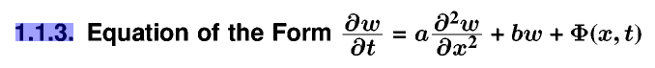

and P claims this fundy solution

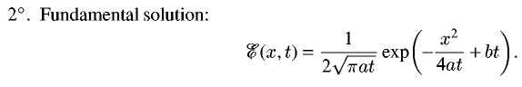

This gives me a hint to perhaps simplify the original equation. Consider

∂tρ = a∇2ρ + bρ

and try

u = ρ e-bt

∂tu = ρ(-b e-bt) + ∂tρ e-bt = -bu + ∂tρ e-bt

and try

ρ = ebtu

∂tρ = b ebtu + ebt∂tu = ebt(bu + ∂tu)

∇2ρ = ebt∇2u

Then we have

∂tρ = a∇2ρ + bρ
or
ebt(bu + ∂tu) = a ebt∇2u + b ebtu
or
(bu + ∂tu) = a ∇2u + b u
or
∂tu = a ∇2u

and I have then successfully obtained the heat equation!

3. If we have a delta function source q(x) for the heat equation, we know how it evolves using the propagator, and that is where P's equation comes from

This is the Saxon propagator thing with the extra ebt. The first term describes a packet at x = 0 which gets broader as time increases, since width is $\sqrt{4at}$. The second term must be an exponential decay!

So my solution would be

ρ(x,t) =1/[2$\sqrt{πDt}$] exp(-x2/4Dt) e-(σ/ε)t

This IS the solution to the following equation

(∂t - a ∇2)u = δ(x)δ(t) // with some constant.

which I could write as

(∂t - a ∇2)[ ρ e-bt] = δ(x)δ(t)

(∂tρ) e-bt -b ρ e-bt - a e-bt∇2 ρ = δ(x)δ(t)

[∂tρ -b ρ - a∇2 ρ] = δ(x)δ(t) ebt = δ(x)δ(t)

So my solution is the propagator for this equation

[∂t -b - a∇2 ]ρ = δ(x)δ(t)

If we start with a source pulse at x = 0 and t = 0, we get decaying propagation.

Go back to

∇2ρ - (1/D)∂tρ = (σ/Dε)ρ

In a good conductor, (σ/Dε)ρ >> ∇2ρ so this equation is

- (1/D)∂tρ ≈ (σ/Dε)ρ

- ∂tρ ≈ (σ/ε)ρ

ρ(r,t) = ρ(r,0) e-t/τ τ = ε/σ = a very short time

In a good dielectric, (σ/Dε)ρ << ∇2ρ so the equation is

∇2ρ - (1/D)∂tρ = 0

∂tρ - D∇2ρ = 0 ∂t = sec-1 ∇2 = m-2 D = m2/sec

which is the diffusion/heat equation. Now Stak considers this equation

∂tE - a∇2E = q δ(x)δ(t) 5.133

so the connection is a = D. Stak shows in (5.140) that the solution is

ρ(r,t) = q exp(-r2/4Dt) / (4πDt)3/2

What about dimensions here??? The factor

(4πDt)-3/2 = ( m2/sec * sec)-3/2 = m-3 which is correct.

So in a good dielectric what does this say? As t increases, the distribution spreads out, since it has a radius of about s = $\sqrt{4Dt}$. And the scale at the center decays as (4πDt)-3/2. that is

ρ(0,t) = q / (4πDt)3/2

At t = 0 it is of course infinite since δ(t). So what is the time constant here? Suppose I consider a tiny volume V in which the charge is located, centered at r = 0. then

ρ(0,t)V = q V / (4πDt)3/2

I don't think I am doing this right! I am really interested in

∂tρ - D∇2ρ = 0 ρ(r,0) = ρo(r)

not the causal Green's problem. I have some initial charge distribution, what happens to it? In 3D radial world this equation is

∂tρ = D∇2ρ = D [r-2∂r(r2∂rρ) ] = D [ ∂r2ρ + (2/r) ρ ] D = a = m2/sec

This is Polyanin 1.2.3. He lists off a ton of solutions. For r in (0,∞) he writes

ρ(r,t) = [2r$\sqrt{πat}$]-1 $^{\int_{0}^{∞}{}}$r'dr' ρ(r',0) { exp[-(r-r')2/4at] - exp[-(r+r')2/4at] }

with a Butkovskiy reference from 1979. I verified that it works at t = 0 based on the fact that only the first term contributes and a little fiddling. NOW suppose we use a delta for ρ(r',0) = q δ(r) which has the right dimensions, and we use δ(r) = δ(r)/4πr2 so that ∫ δ(r) dV = 0. then

ρ(r,t) = [2r$\sqrt{πat}$]-1 $^{\int_{0}^{∞}{}}$r'dr' q δ(r')/4πr'2 { exp[-(r-r')2/4at] - exp[-(r+r')2/4at] }

= [2r$\sqrt{πat}$]-1 (q/4π) $^{\int_{0}^{∞}{}}$r'-1dr' { exp[-(r-r')2/4at] - exp[-(r+r')2/4at] } δ(r')

The integrand is supposed to be evaluated at r' = 0, but we have a 0/0 situation, so Hopital?

num = exp[-(r-r')2/4at] - exp[-(r+r')2/4at]

∂r'num1 = exp[-(r-r')2/4at] * ∂r' [-(r-r')2/4at]

= exp[-(r-r')2/4at] [ -2(r-r')/4at * (-1) ]

= exp[-(r-r')2/4at] [ (r-r')/2at ]

∂r'num2 = exp[-(r+r')2/4at] * ∂r' [-(r+r')2/4at]

= exp[-(r+r')2/4at] [ -2(r+r')/4at * (+1) ]

= exp[-(r+r')2/4at] [ -(r+r')/2at ]

∂r'num ≈ exp[-(r)2/4at] { (r-r')/2at + (r+r')/2at ] }

= exp[-(r)2/4at] r/at

∂r'den = ∂r'r' = 1

So then we have

ρ(r,t) = [2r$\sqrt{πat}$]-1 (q/4π) exp[-(r)2/4at] r/at

= [2$\sqrt{πat}$]-1 (q/4π) exp[-(r)2/4at] 1/at

= [$\sqrt{4πat}$]-1 (q) exp[-(r)2/4at] 1/(4πat)

= q [4πat]-3/2 exp[-(r)2/4at]

and this is my same solution as before -- this is the fundy solution! How can that be? Here I did not pulse the source only at t = 0, I just said ρ(r,0) = qδ(r). AHA! The reason is explained in Stak 5.136! I dimly remember this now. So I am treating the right problem here, and the result is then as expected.

I just found this in my Stak support notes,

1. ft(x) = exp(-x2/(4t))/ ($\sqrt{πt}$) limt→0 ft(x) = 2 δ(x)

so that would be another way to verify the t = 0 limit of the above

Next: try a little narrow Gaussian for ρ(r',0) and see what it does with Maple.

Problem: What I don't like about the delta source at t = 0 is that it is infinite at t = 0 and so I cannot come up with a time constant for it to spread out? The spread radius is r = $\sqrt{4at}$ so that says how big it has become by time t, starting at t = 0. You have to pick a specific distance to get a time constant!
Suppose I pick r = 1 nm = 10-9m, a small but macroscopic distance. Then for germanium

r2 = 4at t = (1/4a)r2 = (1/4D)r2 = (1/4)(r2/D)

D = 100 cm2/sec x [1m2/104cm2] = 100 x 10-4 m2/sec = 10-2m2/sec ok

r2/D = 10-18 m2 / [10-2m2/sec ] = 10-16 sec

t = (1/4)(r2/D) = (1/4) 10-16 sec = very fast

I thought this was going to be slow, not fast?? Polyethylene?

I found a paper that I think does a theoretical study of poly and concludes in its abstract that

μ = 2 x 10-3cm2/Vs = electron mobility in pure amorphous PE

pdfserv.aip.org/JCPSA6/vol_119/iss_5/2669_1.pdf

As I poke around, the idea is that a dielectric doesn't have any free electrons so it really has no free charge at all. The very high σ values I quote in lines (σ ≈ 10-15 mho/m) reflects that fact. I have the equation

σ = (nq2τ/m) = conductivity

where I think n is supposed to be the density of electrons, and I guess THAT is pretty small in PE. So maybe D doesn't really matter because there are no free electrons to diffuse in the first place. This is true of dielectrics and insulators. So maybe I don't really have to do anything at all on this subject!

Article of Jones says PE really does have a crystalline periodic structure and thus really does have energy bands.

***********************************************************

So maybe Dt = 4 is when the charge is gone, so τ ≈ D/4, What is D for a dielectric??

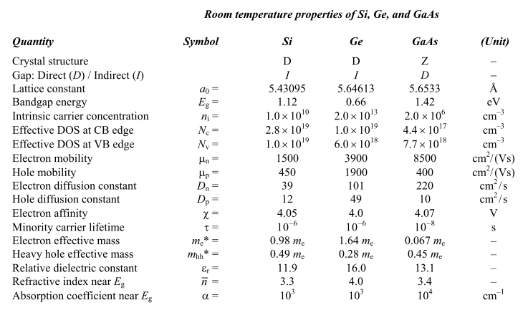

Here I think claim is D = 100 cm2/sec for Ge, but dimensions seem wrong. No they are right. I found a particle physics paper claiming 35 for Si instead of 39.

http://www.kayelaby.npl.co.uk/toc/

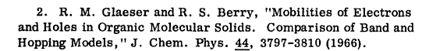

In a symmetric infinite medium the solution is, for D = 1,

ρ(r,t) = θ(t) [4π(t)]-3/2 exp(-r2/4t)

