Rewrite of Chapter 4 PhL 1.5.14

This is installed.

Chapter 4: Transmission Line Equations 1
4.1 Computation of potential φ due to one conductor of a transmission line 1
4.2 Computation of potential φ due to both conductors of a transmission line 3
4.3 The Transmission Line Limit 4
4.4 General Calculation of V(z) 6
4.5 Example: Transmission line with widely-spaced round wires of unequal diameters 11
4.6 Example: A coaxial cable 15
4.7 Computation of A_{z} due to one conductor of a transmission line 19
Comments regarding μ 20
4.8 Computation of potential A_{z} due to both conductors of a transmission line 22
4.9 Transmission Line Limit Revisited 22
4.10 General Calculation of W(z) 22
4.11 The Classic Transmission Line Equations 25
Digression on the meaning of C' 29
An example of K = K_{L} 30

Chapter 4: Transmission Line Equations

In this Chapter we use the potential integral expressions derived in Chapter 1 to derive the classic transmission line equations. We learn that most transmission line parameters are determined by a single geometric integral K. The approximations are clearly stated.

4.1 Computation of potential φ due to one conductor of a transmission line

Our starting point is the potential φ expression given in box (1.5.23) for the potential at some arbitrary point x in the dielectric due to conductor C1 of a transmission line,

φ1(x,ω) = $\frac{1}{4πξ}$∫$_{}^{}$ ρ1(x',y',z',ω)$\frac{e-jβR}{R}$dx'dy'dz' . R = |x - x'| (4.1.1)

Here the point x' = (x',y',z') runs over the surface of C1 and R is the distance between the observation point x in the dielectric and the integration point x'. Parameters β and ξ are for the dielectric.

Comments on ρ1:

(1) ρ1 is the volume charge density associated with "surface charge" n1 according to ρ1dV' = n1dS' .

(2) ρ1 is a distribution. For example, for a round wire of radius a we expect ρ1 to be proportional to δ(r'-a) where r' = $\sqrt{x'2+y'2}$. Perhaps ρ1 = f(θ')δ(r'-a) where (r',θ',z') are cylindrical coordinates with axis at the round wire center.

(3) Recall from Section 1.5 (c) and (1.5.17) the fact that there are two distinct areal charge distributions called nc and ns which are related by nc = (ξ/ε)ns. Here ns is the actual surface charge distribution, whereas nc is an adjusted charge density which is directly associated with the current I in the conductor and which accounts for possible leakage in the dielectric. Our n1 and ρ1 are associated with this nc adjusted charge distribution, not with ns. That is why the external factor in (4.1.1) is 1/4πξ instead of 1/4πε.

Consider now this charge density ρ1(x). Following a standard methodology, we make the assumption that its functional form may be factored in the following manner,

ρ1(x,y,z) = α1(x,y) q1(z) . (4.1.2)
C/m3 1/m2 C/m

The dimensions of the functions in this factorization are as indicated, so the charge goes with q1. Moreover, without any loss of generality we select the relative scale of the two factors such that the integral of α1(x,y) over a slice of conductor C1 at any z is unity,

$^{\int_{C1}^{}{}}$dx dy α1(x,y) = 1 . (4.1.3)

Therefore, we can interpret q1(z) as the total charge per unit length on C1 at location z :

$^{\int_{C1}^{}{}}$dx dy ρ1(x,y,z) = q1(z) $^{\int_{C1}^{}{}}$dx dy α1(x,y) = q1(z) • 1 = q1(z) .

Assume that q2(z) is the charge on the other conductor C2 of a two-conductor transmission line. If q1(z) + q2(z) ≠ 0, then we have a net charge per unit length and the transmission line is acting as a radiating antenna as well as a transmission line. From now on, we ignore this superposed radiation problem and assume that at each value of z, the net charge on both conductors is 0 -- the line is "balanced". This means that

q2(z) = - q1(z) ≡ -q(z) . (4.1.4)

To simplify notation, we now dispense with the subscript and denote q1(z) = q(z). However, we maintain the subscript on α1(x,y) to emphasize that the two conductors can have completely different cross sectional shapes. The shape of the transverse distribution of charge on C1 is determined by α1(x,y), but the total charge is q(z) per unit length.

How can we justify assumption (4.1.2)? This is "separation of variables". The idea is that we assume it without any justification, and then we try to find a solution to our problem which is consistent with the assumption. All we really want is to find a solution to our basic differential equations with their boundary conditions, and any assumptions we make can be justified in the end once we have found a solution. On the other hand, if an assumption like (4.1.2) does not lead to a solution, then it must have been a bad assumption. We have seen earlier how the expected EM field pattern on a transmission line has a constant transverse "shape" and this certainly motivates the assumption (4.1.2).

Now insert (4.1.2) into (4.1.1) to get,

φ1(x,y,z) = $\frac{1}{4πξ}$$^{\int_{-∞}^{∞}{}}$dz' q(z') $^{\int_{C1}^{}{}}$dx' dy' α1(x',y') $\frac{e-jβR}{R}$ (4.1.5)

R2 = (x-x')2 + (y-y')2 + (z-z')2 .

4.2 Computation of potential φ due to both conductors of a transmission line

Let us now write the potential at an arbitrary point x in the dielectric due to both conductors C1 and C2 :

φ12(x) = φ1(x) + φ2(x) =

$\frac{1}{4πξ}$$^{\int_{-∞}^{∞}{}}$dz' q(z'){ $^{\int_{C1}^{}{}}$dx1' dy1' α1(x1',y1') $_{1}$ – $^{\int_{C2}^{}{}}$dx2' dy2' α2(x2',y2') $_{2}$ }

R12 = (x-x1')2 + (y-y1')2 + (z-z')2 = s12 + (z-z')2 s12 = (x-x1')2 + (y-y1')2 (4.2.1)
R22 = (x-x2')2 + (y-y2')2 + (z-z')2 = s22 + (z-z')2 s22 = (x-x2')2 + (y-y2') .

The minus sign between the terms is due to (4.1.4). Each conductor has its own arbitrary transverse charge distribution αi. The transverse integration variables on C1 are dx1' dy1', while those on C2 are instead dx2' dy2'. In the last two lines we introduce certain transverse distances s1 and s2 as shown. The same dz' integration variable is used for both conductors. The following drawing shows an arbitrary dielectric point x = (x,y,z) located in the z = z plane. The point x1' = (x1',y1',z') lies on C1 at some point of the C1 integration and similarly for x2' = (x2',y2',z'). The full distances R1 and R2 and the transverse distances s1 and s2 are shown.

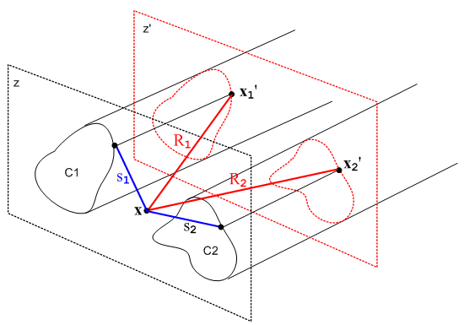 Fig 4.1

One can imagine an expression similar to (4.2.1) for a transmission line consisting of N conductors with some relationship among the qi(z) on each conductor, but we shall restrict our interest to N = 2.

4.3 The Transmission Line Limit

Consider again the potential at x due to both conductors shown in (4.2.1),

φ12(x) = $\frac{1}{4πξ}$$^{\int_{-∞}^{∞}{}}$dz' q(z'){ $^{\int_{C1}^{}{}}$dx1' dy1' α1(x1',y1') $_{1}$ – $^{\int_{C2}^{}{}}$dx2' dy2' α2(x2',y2') $_{2}$ }
(4.3.1)

As the red-dashed z = z' plane shown in Fig 4.1 is pushed back far from the z = z plane, the vectors which are labeled by distances R1 and R2 become more aligned, and both R1 and R2 become larger. During the transverse integrations over x1' and x2', these Ri vectors then don't vary much. One could then replace the transverse charge density α1(x1',y1') with a point charge at the "center of the conductor" and not make much difference in the R1 vector and its length R1. In this situation, the {...} integrand of the above integral has this form

{ $_{1}$ – $_{2}$ } . // when |z-z'| is large (4.3.2)

If we then expand the exponentials showing the first few terms, this becomes

{ $\frac{1-jβR1+(jβ)2R12/2}{R1}$ – $\frac{1-jβR2+(jβ)2R22/2}{R2}$ } = { [ $\frac{1}{R1}$ - $\frac{1}{R2}$ ] + [-jβ + jβ ] + (jβ)2/2 [R1-R2] + ... }
= { [ $\frac{1}{R1}$ - $\frac{1}{R2}$ ] - β2/2 [R1-R2] + order(β3) } (4.3.3)

Since R1 ≈ R2 for large |z-z'| as just discussed, both the leading term and the β2 term are small in an absolute sense as long as β2 is not huge. When |z-z'| is large, both R1 and R2 are large and thus both 1/R1 and 1/R2 are small, and [ 1/R1 - 1/R2] is smaller still due to cancellation between the terms.
So our first point is that, in the dz' integration, the main contribution to φ12(x) comes from regions of z' for which |z-z'| is small.
Given then that the dz' integration in (4.3.1) is dominated by that part for which |z-z'| is small, we can see that for this controlling integration region the size of distances R1 and R2 will be on the order of the transverse dimension of the transmission line, assuming that we select the point x somewhere between the two conductors. If we vaguely define the transmission line's transverse extent as distance D, then suppose we make the following assumption concerning β :

βD << 1 "small β" . (4.3.4)

In this case, we can replace e-jβR$_{1}$ = 1 and e-jβR$_{2}$ = 1 in the integration without significantly changing the result. Then as shown in (4.3.3) there will be a correction term that is order β2 which we shall neglect, as well as higher terms of order βn with n> 2.
Notice that the linear β term vanished exactly in our large |z-z'| analysis. This linear term also vanishes in the full analysis since the αi transverse charge functions are normalized to unity:

{ $^{\int_{C1}^{}{}}$dx1' dy1' α1(x1',y1') $\frac{-jβR1}{R1}$ – $^{\int_{C2}^{}{}}$dx2' dy2' α2(x2',y2') $\frac{-jβR2}{R2}$ }

= (-jβ) {$^{\int_{C1}^{}{}}$dx1' dy1' α1(x1',y1') - $^{\int_{C1}^{}{}}$dx1' dy1' α1(x1',y1') ) = (-jβ) {1 - 1} - 0. (4.3.5)

Thus, by setting β = 0 in (4.3.1) we are ignoring corrections on the order of β2 and higher, and if β is small, these corrections are very small.
The Helmholtz parameter β for the dielectric is 2π/λ where λ is the wavelength of a wave passing down the transmission line. Thus, our "small β" assumption stated above can also be written

λ >> D (4.3.6)

which says the wavelength is much longer than the size of the transmission line transverse dimensions. This assumption is called the Transmission Line Limit. If we operate within this limit, then (4.3.1) may be approximated as

φ12(x) = $\frac{1}{4πξ}$$^{\int_{-∞}^{∞}{}}$dz' q(z'){ $^{\int_{C1}^{}{}}$dx1' dy1' α1(x1',y1') $\frac{1}{R1}$– $^{\int_{C2}^{}{}}$dx2' dy2' α2(x2',y2') $\frac{1}{R2}$ } (4.3.7)

We shall now use the small β assumption one more time. We assume that the linear charge density q(z') has the characteristics of a wave traveling down the transmission line ( see also Chapter 5),

q(z) = q(0) e-jβz // q(z,t) = q(0,0) ej(ωt-kz) (4.3.8)

so that

q'(z) = -jβ q(z)

q"(z) = (-jβ)2q(z) and so on.

We can then write a Taylor expansion for linear charge density q(z') which appears in our integration,

q(z') = q(z) + (z'-z) q'(z) + (1/2) (z'-z)2 q"(z) + ...

= q(z) + (-jβ) q(z) (z'-z) + (1/2) (-jβ)2 q(z) (z'-z)2 + ...

= q(z) [ 1 + (-jβ) (z'-z) + (1/2) (-jβ)2(z'-z)2 + ... ] (4.3.9)

Since both R1 and R2 are even functions of the quantity (z'-z), and since there is no other (z'-z) dependence in the (4.3.7) integrand, the (-jβ) term in (4.3.9) contributes nothing (this is also true more generally for (4.3.1)). Thus, if we assume small β, we can approximate q(z') ≈ q(z) where we are then ignoring a β2 size term. Once again, if β is small, β2 is very small so our error in replacing q(z') by q(z) is very small. We are only interested in the contributing region where |z-z'| is on the order of transverse dimension D, so the same βD << 1 is being assumed as earlier.
We arrive then at our final result for the potential at a point between the conductors,

φ12(x) = $\frac{1}{4πξ}$ q(z) $^{\int_{-∞}^{∞}{}}$dz'{ $^{\int_{C1}^{}{}}$dx1' dy1' α1(x1',y1') $\frac{1}{R1}$– $^{\int_{C2}^{}{}}$dx2' dy2' α2(x2',y2') $\frac{1}{R2}$ } (4.3.10)

where we have thrown out terms of order β2 and higher. In this transmission line limit approximation, our Helmholtz integral (4.3.1) has been reduced to essentially an electrostatics Coulomb integral where we just sum over the contribution of each piece of charge to the total potential. As noted earlier, q(z) has the normalization of nc and not ns as discussed in Section 1.5 (c) which explains why the leading factor is $\frac{1}{4πξ}$ and not $\frac{1}{4πε}$. This allows for the dielectric to have some conductance.
It should be noted that the integral of (4.3.10) converges due to the subtraction of the two terms which in turn results from the two conductors having opposite linear charge densities. The individual terms in (4.3.10) do not converge and are in fact each logarithmically divergent in the sense $^{\int_{-∞}^{∞}{}}$dz' (1/z') = ∞ .

4.4 General Calculation of V(z)

We now introduce two new points x1 and x2. The point x1 lies on C1 in the z = z plane, while x2 lies on C2 in this same plane. We then evaluate φ12(x) at x = x1 and subtract from that φ12(x) at x = x2 and in this way we obtain the potential difference between the surfaces of the two conductors at z = z. Recall,

Fact 6: The potential φ is constant over the surface of either conductor at a fixed z. (3.8.10)

Thus, the potential difference will be independent of the locations of x2 and x1 as long as they are on their respective surfaces and both have z = z. For this reason, the potential difference is a function only of z. Thus we write, using two copies of (4.3.10),

V(z) ≡ φ12(x1) - φ12(x2)

= $\frac{1}{4πξ}$ q(z) $^{\int_{-∞}^{∞}{}}$dz'{ $^{\int_{C1}^{}{}}$dx1' dy1' α1(x1',y1') $\frac{1}{R11}$– $^{\int_{C2}^{}{}}$dx2' dy2' α2(x2',y2') $\frac{1}{R12}$ }
– $\frac{1}{4πξ}$ q(z) $^{\int_{-∞}^{∞}{}}$dz'{ $^{\int_{C1}^{}{}}$dx1' dy1' α1(x1',y1') $\frac{1}{R21}$– $^{\int_{C2}^{}{}}$dx2' dy2' α2(x2',y2') $\frac{1}{R22}$ } (4.4.1)
where

R112 = (x1-x1')2 + (y1-y1')2 + (z-z')2 = s112 + (z-z')2 s112 = (x1-x1')2 + (y1-y1')2
R122 = (x1-x2')2 + (y1-y2')2 + (z-z')2 = s122 + (z-z')2 s122 = (x1-x2')2 + (y1-y2')2
R222 = (x2-x2')2 + (y2-y2')2 + (z-z')2 = s222 + (z-z')2 s222 = (x2-x2')2 + (y2-y2')2
R212 = (x2-x1')2 + (y2-y1)2 + (z-z')2 = s212 + (z-z')2 s212 = (x2-x1')2 + (y2-y1)2 (4.4.2)

The vector R12 points from our new point x1 to an integration point x2' on C2. Here is a drawing of our new and more complicated situation:

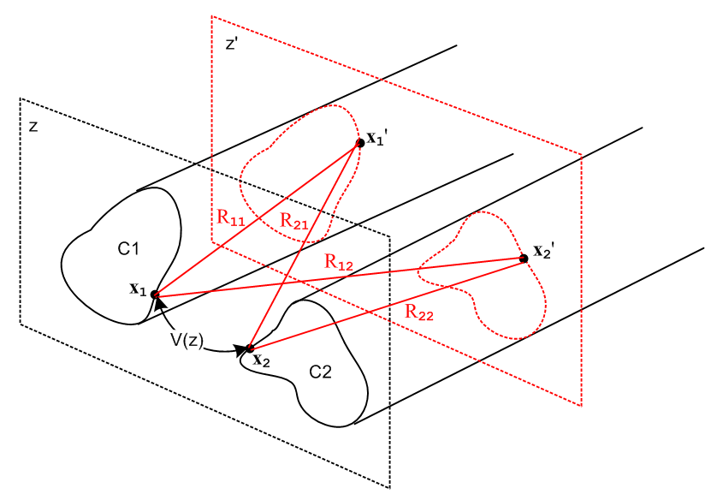
Fig 4.2
We next rearrange the four terms in (4.4.1) to get

V(z) (4.4.3)
= q(z) $\frac{1}{4πξ}$$^{\int_{-∞}^{∞}{}}$dz' {$^{\int_{C1}^{}{}}$dx1' dy1' α1(x1',y1')( $\frac{1}{R11}$- $\frac{1}{R21}$) -$^{\int_{C2}^{}{}}$dx2' dy2' α2(x2',y2') ($\frac{1}{R12}$- $\frac{1}{R22}$) } .

It is now possible to carry out the dz' integrations. The integral of interest is the following,

$^{\int_{-∞}^{∞}{}}$dx { $\sqrt{a2+ x2}$ - $\sqrt{b2+ x2}$ } = ln(b2/a2) (4.4.4)

The separate integrals here are logarithmically divergent, but the combination converges. Thus,

$^{\int_{-∞}^{∞}{}}$dz' ( $\frac{1}{R11}$- $\frac{1}{R21}$) = $^{\int_{-∞}^{∞}{}}$dz' ($\sqrt{s112 + (z-z')2}$ - $\sqrt{s212 + (z-z')2}$) = ln(s212/s112)
and
$^{\int_{-∞}^{∞}{}}$dz' ( $\frac{1}{R12}$- $\frac{1}{R22}$) = ln(s222/s122) (4.4.5)

so that

V(z) = q(z) $\frac{1}{4πξ}$ {$^{\int_{C1}^{}{}}$dx1' dy1' α1(x1',y1') ln(s212/s112) -$^{\int_{C2}^{}{}}$dx2' dy2' α2(x2',y2') ln(s222/s122) }

s212 = (x2-x1')2 + (y2-y1)2 s222 = (x2-x2')2 + (y2-y2')2 (4.4.6)
s112 = (x1-x1')2 + (y1-y1')2 s122 = (x1-x2')2 + (y1-y2')2 .

The four transverse distances are shown in this figure,

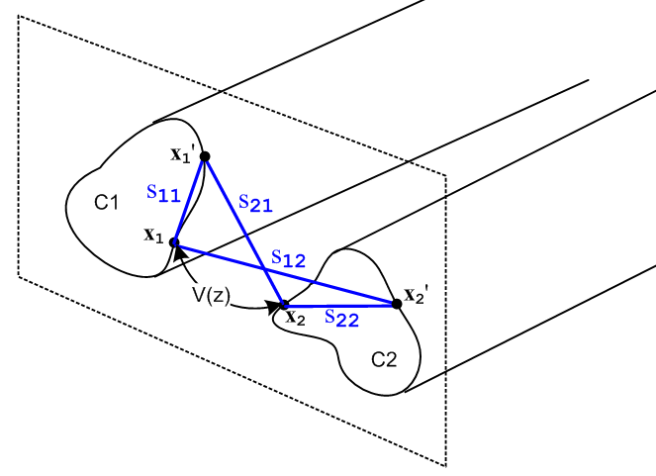 Fig 4.3

Equation (4.4.6) expresses the potential between the two transmission line conductors at some plane z in terms of the charge distributions on the conductors αi. In general, these charge distributions are not known, so one cannot regard (4.4.6) as a general purpose silver bullet to solve transmission line problems. On the other hand, as we shall see, equation (4.4.6) is one of a group of equations which will allow us to express several different transmission line parameters in terms the same integral, and one then obtains a relation between these parameters.
For example, in analogy to what we did with a parallel plate capacitor in (1.5.19). we may define the complex capacitance C' per unit length of our transmission line using (4.4.6) as follows:

$\frac{1}{C'}$ = $\frac{V(z)}{q(z)}$ = $\frac{1}{4πξ}$ {$^{\int_{C1}^{}{}}$dx1' dy1' α1(x1',y1') ln(s212/s112) -$^{\int_{C2}^{}{}}$dx2' dy2' α2(x2',y2') ln(s222/s122) }

= $\frac{1}{4πξ}$ K and V(z) = q(z) $\frac{1}{4πξ}$ K (4.4.7)

where K is a dimensionless real number obtained from a geometric integral of the normalized transverse charge distributions αi (recall that αi is dimensionless in (4.1.2)),

K ≡ $^{\int_{C1}^{}{}}$dx1' dy1' α1(x1',y1') ln(s212/s112) -$^{\int_{C2}^{}{}}$dx2' dy2' α2(x2',y2') ln(s222/s122) . (4.4.8)

Recall from (1.5.20) that (C, C and G are discussed further in Section 4.11 below)

C' = C + 1/(jωR') = C + G/(jω) (4.4.9)

where conductance (per unit length) G is associated with the imaginary part of C'. We then have

4πξ/K = C + G/jω
or
4π(ε+σ/jω)/K = C + G/jω // (1.5.1) for ξ

so that

C = 4πε/K capacitance per unit length of the transmission line

G = 4πσ/K conductance per unit length of the transmission line
so
C/G = ε/σ . (4.4.10)

Here G = 1/R' is the conductance across the dielectric between a unit length of the two conductors. This is unrelated to the longitudinal resistance R of the conductors themselves, though that parameter will arise later on in the form Zs. We only have G ≠ 0 if the dielectric has some conductance σ ≠ 0.

Note from above and (1.2.8) that dim(C) = dim(ε) = farad/m and dim(G) = dim(σ) = mho/m .

We will show below in Section 4.11 that the external inductance per unit length of our transmission line is also related to this same constant K,

Le = (μ/4π)K . (4.4.11)

As shown in Appendix XXX, the (complex) characteristic impedance of a transmission line is given by

Z0 = $\frac{R + jωL}{G + jωC}$ . (4.4.12)

At sufficiently large ω we can neglect the R and G terms to get this real value,

Z0 = $\frac{L}{C}$. // large ω (4.4.13)

As shown later in (4.11.32), for large ω L → Le so

Z0 = $\frac{Le}{C}$ = $\frac{(μ/4π)K}{4πε/K}$ = (1/4π) K $\sqrt{μ/ε}$ = (1/4π) K Zm (4.4.14)

where Zm = $\sqrt{μ/ε}$ is the "impedance of the dielectric medium" having μ and ε. Recall that for free space we had in (1.1.29)

Zfs = $\sqrt{μ0/ε0}$ = 376.73032 ohms => Zfs /4π = 29.97948 ≈ 30 Ω . (4.4.15)

Typically one has μ = μ0 so then (note that εrel , K and KL are dimensionless),

Z0 ≈ (K /$\sqrt{εrel}$) 30Ω εrel ≡ ε/ε0 . (4.4.16)

We then summarize the parameters of a transmission line in terms of dimensionless integrals K and KL:

C = 4πε/K capacitance per unit length (4.4.17)

G = 4πσ/K transverse conductance per unit length

Le = (μ/4π) K external inductance per unit length

Z0 ≈ (K /$\sqrt{εrel}$) 30Ω characteristic impedance μ = μ0, εrel ≡ ε/ε0

R = Re(Zs1+Zs2) resistance of conductors, see (4.11.30)

L = Le + (1/ω) Im(Zs1+ Zs2) total inductance, see (4.11.30)

Zsi = conductor surface impedance due to possible skin effect at frequency ω (Chapter 2)

The last three items are not determined by integral K and we just mention them for completeness's sake. All these equations will be more fully developed in Section 4.11 below, but we jump the gun a bit in order to display two important examples.

4.5 Example: Transmission line with widely-spaced round wires of unequal diameters

Consider a transmission line of two round wires of radii a1 and a2 and center line spacing b. In the case that b >> a1 and a2, the charge distribution on each round wire is symmetric about the wire and in this situation ( a rare one admittedly) we know the two charge distributions:

α1(x,y) = α1(r,θ) = δ(r - a1)/(2πa1)
α2(x,y) = α2(r,θ) = δ(r - a2)/(2πa2) . (4.5.1)

The 1/(2πa1) factor is required so that the integral of α1 is unity as required by (4.1.3),

$^{\int_{C1}^{}{}}$dx dy α1(x,y) = $^{\int_{0}^{2π}{}}$dθ $^{\int_{0}^{∞}{}}$rdr α1(r,θ) = $^{\int_{0}^{2π}{}}$dθ $^{\int_{0}^{∞}{}}$rdr δ(r - a1)/(2πa1)

= $^{\int_{0}^{2π}{}}$dθ a1/(2πa1) = 2π a1/(2πa1) = 1 . (4.5.2)

Note: The reason the αi are symmetric is that the two conductors are so far apart that each one is essentially "in isolation" and so the charge assumes an axially symmetric distribution. An analogy would be that for two point charges far apart, the E field close to either point charge is spherically symmetric because close to one charge the field of the other can be neglected.

Our task is then to compute the integral K shown in (4.4.8),

K = $^{\int_{0}^{2π}{}}$dθ1 $^{\int_{0}^{a1}{}}$r1dr1 [δ(r1 - a1)/(2πa1)] ln(s212/s112)
-$^{\int_{0}^{2π}{}}$dθ2 $^{\int_{0}^{a2}{}}$r2dr2 [δ(r2 - a2)/(2πa2)] ln(s222/s122) .

= $^{\int_{0}^{2π}{}}$dθ1 1/(2π) ln(s212/s112)
-$^{\int_{0}^{2π}{}}$dθ2 1/(2π) ln(s222/s122)

= 1/(2π) { $^{\int_{0}^{2π}{}}$dθ1 [ln(s212) - ln(s112)] - $^{\int_{0}^{2π}{}}$dθ2 [ln(s222) - ln(s122)] } (4.5.3)

where we then have four integrals to evaluate.

We shall choose our V(z) potential-determining reference points x1 and x2 as shown in this drawing,
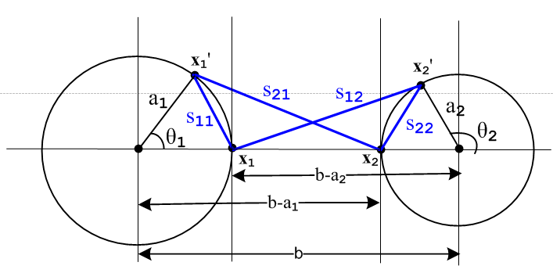 Fig 4.4

The four sij distances can be read off from the drawing using the law of cosines,

s212 = a12 + (b-a1)2 - 2 a1(b-a1) cos(θ1)

s112 = a12 + a12 - 2 a1 a1 cos(θ1) = 2a12(1 - cos(θ1))

s222 = a22 + a22 - 2 a2 a2 cos(π-θ2) = 2a22(1 + cos(θ2))

s122 = a22 + (b-a2)2 + 2 a2(b-a2) cos(θ2) (4.5.4)

We then invoke the following integral from p 531 of GR7,

which we rewrite as

$^{\int_{0}^{2π}{}}$dθ ln (A ± Bcosθ) = 2π ln[(1/2)(A + $\sqrt{A2-B2}$ )] . (4.5.5)

The four integrals are then easily evaluated:

$^{\int_{0}^{2π}{}}$dθ1 ln(s212) = $^{\int_{0}^{2π}{}}$dθ1ln([a12 + (b-a1)2 - 2 a1(b-a1) cos(θ1)]

A = a12 + (b-a1)2 B = 2 a1(b-a1)

A2-B2 = [a12 + (b-a1)2]2 - 4 a12(b-a1)2 = [a12 - (b-a1)2]2 => $\sqrt{A2-B2}$= (b-a1)2- a12 > 0 b >> a1

=> $^{\int_{0}^{2π}{}}$dθ1 ln(s212) = 2π ln[(1/2)( a12 + (b-a1)2 + (b-a1)2 - a12 ) = 2π ln[(b-a1)2] .

The fourth integral is the same with 1↔ 2, and the different sign of the second term in s122 makes no difference,

$^{\int_{0}^{2π}{}}$dθ2 ln(s122) = 2π ln[(b-a2)2] .

The second integral is

$^{\int_{0}^{2π}{}}$dθ1 ln(s112) = $^{\int_{0}^{2π}{}}$dθ1ln([2a12(1 - cos(θ1))] A = B = 2a12 , A2-B2 = 0

= 2π ln[(1/2) 2a12] = 2π ln(a12) .

The third integral is similar giving

$^{\int_{0}^{2π}{}}$dθ2 ln(s222) = 2πln(a22) .

To summarize:

$^{\int_{0}^{2π}{}}$dθ1 ln(s212) = 2π ln[(b-a1)2]
$^{\int_{0}^{2π}{}}$dθ1 ln(s112) = 2π ln(a12)
$^{\int_{0}^{2π}{}}$dθ2 ln(s222) = 2πln(a22)
$^{\int_{0}^{2π}{}}$dθ2 ln(s122) = 2π ln[(b-a2)2] . (4.5.6)

Then from (4.5.3) we find

K = 1/(2π) { $^{\int_{0}^{2π}{}}$dθ1 [ln(s212) - ln(s112)] - $^{\int_{0}^{2π}{}}$dθ2 [ln(s222) - ln(s122)] }
= ln[(b-a1)2] - ln(a12) - ln(a22) + ln[(b-a2)2] = ln [$\frac{(b-a1)2(b-a2)2}{a12a22}$]
= 2 ln [$\frac{(b-a1)(b-a2)}{a1a2}$] = 2 ln [$\frac{b2}{a1a2}$] // since we assumed at the start that b >> a1, a2
= 4 ln(b/$\sqrt{a1a2}$) . (4.5.7)
Therefore the transmission line parameters from (4.4.17) are,

K = ln(b/$\sqrt{a1a2}$)
C = 4πε/K = πε / ln(b/$\sqrt{a1a2}$)
G = 4πσ/K = πσ / ln(b/$\sqrt{a1a2}$)
Le = (μ/4π) $\sqrt{KKL}$ = (μ/π) ln(b/$\sqrt{a1a2}$)
Z0 = ($\sqrt{KKL}$ /$\sqrt{εrel}$) 30Ω = (1/$\sqrt{εrel}$) ln(b/$\sqrt{a1a2}$) 120Ω , (4.5.8)

Sometimes these formulas are written in terms of wire diameters di = 2ai in which case

K = 4 ln[b/$\sqrt{a1a2}$] = 4 ln[2b/$\sqrt{d1d2}$] = 2 ln[4b2/d1d2] . (4.5.9)

Since we are assuming b >> d1,d2 we know that x ≡ 2b2/d1d2 >> 1. Therefore

ch-1x = ln[x + $\sqrt{x2-1}$] ≈ ln(2x) // an identity Siegel 8.56, then an approximation (4.5.10)
so
ch-1(2b2/d1d2) ≈ ln(4b2/d1d2) .

Then we can write K as

K = 2 ln[4b2/d1d2] = 2 ch-1(2b2/d1d2) (4.5.11)

and so

Z0 = (K /$\sqrt{εrel}$) 30Ω = (1/$\sqrt{εrel}$) ch-1(2b2/d1d2) 60Ω . (4.5.12)

It is not easy to find expressions for C,G and Le for the unequal radii geometry, but Z0 does appear for example in Reference RDE page 29-23 where we find:

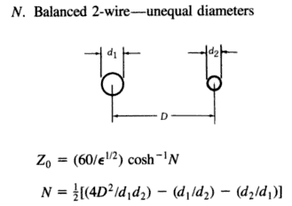 Fig 4.5

with D = our b. For D >> d1,d1 this shows N = 2D2/(d1d2), and this then agrees with (4.5.12). This quoted result is in fact correct (with the two extra terms shown in N) even when D is not large. We shall derive this result in Chapter 5 after developing more powerful tools. // a promise made...

In the special case that a1 = a2 ≡ a we get,

K = 4 ln(b/a)
C = 4πε/K = πε/ ln(b/a)
G = 4πσ/K = πσ/ ln(b/a)
Le = (μ/4π) $\sqrt{KKL}$ = (μ/π) ln(b/a)
Z0 = ($\sqrt{KKL}$/$\sqrt{εrel}$) 30Ω = (1/$\sqrt{εrel}$) ln(b/a) 120Ω
= (1/$\sqrt{εrel}$) ln(2b/d) 120Ω d = 2a . (4.5.13)

The first three results agree with King TLT p17 (30b),

The expression for Z0 agrees with the source quoted above,

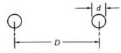 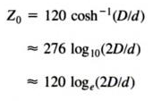 Fig 4.6

where again D = b and for "air" εrel= 1.

4.6 Example: A coaxial cable

A coaxial cable is the other transmission line where we know the surface charge distribution is that given by (4.5.1). The analysis of the previous section resulting in (4.5.3) is then unchanged, and we find that K is still given by (4.5.3),

K = 1/(2π) { $^{\int_{0}^{2π}{}}$dθ1 [ln(s212) - ln(s112)] - $^{\int_{0}^{2π}{}}$dθ2 [ln(s222) - ln(s122)] } . (4.5.3)

What is different is that we have a different picture describing the various sij distances. The new picture is this, where the cross section circles have radii a2 > a1 :

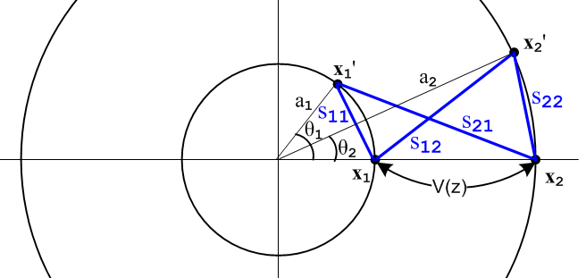 Fig 4.7

As we did in the previous section, we "read off" the sij expressions using the law of cosines:

s212 = a12 + a22 - 2 a1a2cos(θ1)

s112 = a12 + a12 - 2 a1 a1 cos(θ1) = 2a12(1 - cos(θ1))

s222 = a22 + a22 - 2 a2 a2 cos(θ2) = 2a22(1 - cos(θ2))

s122 = a22 + a12 - 2 a1a2 cos(θ2) . (4.6.1)

Recalling,

$^{\int_{0}^{2π}{}}$dθ ln (A ± Bcosθ) = 2π ln[(1/2)(A + $\sqrt{A2-B2}$ )] . (4.5.5)

we find,

$^{\int_{0}^{2π}{}}$dθ1 ln(s212) = $^{\int_{0}^{2π}{}}$dθ1 ln[a12 + a22 - 2a1a2cos(θ1)] A = a12 + a22 B = 2a1a2

A2-B2 = (a12 +a22)2 - 4a12a22 = (a12 -a22)2 => $\sqrt{A2-B2}$ = (a22 -a12) > 0 since a2 > a1
so
$^{\int_{0}^{2π}{}}$dθ1 ln(s212) = 2π ln[(1/2)( a12 + a22 + (a22 -a12) ) = 2πln(a22) .

Similarly

$^{\int_{0}^{2π}{}}$dθ2 ln(s122) = 2π ln[(1/2)( a12 + a22 + (a22 -a12) ) = 2πln(a22) = same as above .

The other two integrals are,

$^{\int_{0}^{2π}{}}$dθ1 ln(s112) = $^{\int_{0}^{2π}{}}$dθ1 ln[2a12(1 - cos(θ1))] A = B = 2a12
= 2π ln[(1/2)2a12] = 2πln(a12)

$^{\int_{0}^{2π}{}}$dθ2 ln(s222) = $^{\int_{0}^{2π}{}}$dθ1 ln[2a22(1 - cos(θ2))] A = B = 2a22
= 2π ln[(1/2)2a22] = 2πln(a22) .
To summarize:

$^{\int_{0}^{2π}{}}$dθ1 ln(s212) = 2πln(a22)
$^{\int_{0}^{2π}{}}$dθ1 ln(s112) = 2π ln(a12)
$^{\int_{0}^{2π}{}}$dθ2 ln(s222) = 2π ln(a22)
$^{\int_{0}^{2π}{}}$dθ2 ln(s122) = 2π ln(a22) . (4.6.2)

Then from (4.5.3) we find

K = 1/(2π) { $^{\int_{0}^{2π}{}}$dθ1 [ln(s212) - ln(s112)] - $^{\int_{0}^{2π}{}}$dθ2 [ln(s222) - ln(s122)] }

= ln(a22) - ln(a12) - ln(a22) + ln(a22) = ln(a22/a12) = 2 ln(a2/a1) . (4.6.3)

The coaxial transmission line parameters are then given by,

C = 4πε/K = 2πε / ln(a2/a1)
G = 4πσ/K = 2πσ / ln(a2/a1)
Le = (μ/4π)K = (μ/2π) ln(a2/a1)
Z0 = (K /$\sqrt{εrel}$) 30Ω = (1/$\sqrt{εrel}$) ln(a2/a1) 60Ω (4.6.4)

We verify the C and Le parameters from http://en.wikipedia.org/wiki/Coaxial_cable ,

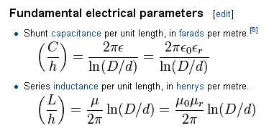 Fig 4.8

To verify the Z0 value, first recall that (the positive square root is implied here)

ch-1x = ln[x + $\sqrt{x2-1}$] // Siegel identity 8.56, valid for x ≥ +1 (4.6.5)

If we set x ≡ $\frac{1}{2}$( $\frac{a}{b}$ + $\frac{b}{a}$) = $\frac{1}{2}$$\frac{a2+b2}{ab}$ and we assume a > 0 and b > 0, then

x2 - 1 = $\frac{1}{4}$$\frac{(a2+b2)2}{a2b2}$ - 1 = $\frac{1}{4}$ { $\frac{(a2+b2)2 - 4a2b2}{a2b2}$} = $\frac{1}{4}$$\frac{(a2-b2)2}{a2b2}$
=> $\sqrt{x2-1}$= $\frac{1}{2}$$\frac{|b2-a2|}{ab}$ = sign(b-a) $\frac{1}{2}$($\frac{b}{a}$- $\frac{a}{b}$)

=> x + $\sqrt{x2-1}$ = $\frac{1}{2}$($\frac{a}{b}$ + $\frac{b}{a}$) + sign(b-a) $\frac{1}{2}$($\frac{b}{a}$- $\frac{a}{b}$) =

=> ln [x + $\sqrt{x2-1}$] = ln [ ] = sign(b-a) ln(b/a)

Thus we have shown that (note that both sides are invariant under a ↔ b )

ch-1[$\frac{1}{2}$($\frac{a}{b}$ + $\frac{b}{a}$)] = sign(b-a)ln $\frac{b}{a}$ a > 0 and b > 0 (4.6.6)

With this rather elaborate fact, and since we have b > a, we can rewrite Z0 above as

Z0 = (1/$\sqrt{εrel}$) ch-1[$\frac{1}{2}$($\frac{a}{b}$ + $\frac{b}{a}$)] 60 Ω . (4.6.7)

Again we quote from reference RDE page 29-24

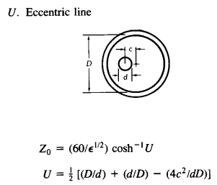 Fig 4.9

In our centered case c = 0 so U = (1/2)(D/d+d/D) and we have agreement. We shall do the off -center case later on.

Comment: In the examples of Sections 4.5 and 4.6, the current distributions in the involved round wires are axially symmetric. Therefore all the results of Chapter 2 apply. In particular, Chapter 2 calculates the surface impedance Zs for a round wire in complete detail, including its limits for large and small ω. For example, at low frequency for a wire of radius a,

Zs(ω) = $\frac{1}{σπa2}$ + jω $\frac{μ}{8π}$ = Rs + jωLs // low frequency limit (2.4.12)

and one sees that Rs is the expected DC resistance and Ls is the internal impedance Li as computed in Appendix C equation (C.3.5).

Having presented our two Examples, we now resume development of the transmission line equations.

4.7 Computation of Az due to one conductor of a transmission line

In summary box (1.5.23) we state the following Helmholtz integral for the vector potential arising from currents in a set of conductors,

A(x,ω) = $\frac{1}{4π}$ Σi∫μiJi(x',ω) $\frac{e-jβR}{R}$dV' (1.5.23)

where the sum Σi is over the conductors and μi is the permeability of conductor i.
In our transmission line context, and as discussed in Chapter 3, the dominant current is in the z (longitudinal) direction, while transverse currents are very small. For example, in the estimate of Section 3.7 (s) we found that Jr/Jz < 1.4 x 10-4 below 10 GHz and Jr/Jz < 4.6 x 10-8 at low frequency. Looking at the above Helmholtz solution to the Helmholtz equation, if we neglect these transverse currents, we are then in effect neglecting the transverse components of A, and this is what we shall do from now on:

Fact: The transverse components Ax and Ay can be neglected so that A = Az. (4.7.1)

Our starting point then is the potential Az expression given in box (1.5.23) for the potential Az at some arbitrary point x in the dielectric due to conductor C1 of a transmission line,

Az1(x,ω) = $\frac{μ1}{4π}$∫$_{}^{}$ Jz1(x',y',z',ω)$\frac{e-jβR}{R}$dx'dy'dz' . R = |x - x'| (4.7.2)

Here the point x' = (x',y',z') runs over the volume of C1 and R is the distance between the observation point x in the dielectric and the integration point x'. Parameter β is for the dielectric while μ1 is for the conductor.

In the analogous φ solution (4.1.1) everything has the same form as (4.7.2) but in (4.1.1) the charge density exists only on the conductor surface. Nevertheless, we represented that charge density as a volume density, and only later in examples set that volume density to a surface distribution. Thus, the parallel between the φ and the Az analysis is very close. Another difference is that for φ the leading factor was 1/(4πξ) where ξ was the complex dielectric constant for the dielectric. In (4.7.2) this factor is replaced by (μ1/4π) where μ1 is the magnetic permeability of the conductor .

We next make the same assumption of separation of variables to write

Jz1(x,y,z) = b1(x,y) i1(z)
A/m2 1/m2 A (4.7.3)

where i1 is scaled such that

$^{\int_{C1}^{}{}}$dx dy b1(x,y) = 1 . (4.7.4)

Here b1(x,y) describes the distribution of the current density across the conductor C1 cross section. At DC this density is a uniform constant, but at higher ω the density becomes non-uniform in two ways. First, it becomes concentrated away from the central region due to the skin effect. Second it is non-uniform in that it tends to concentrate on the portion of conductor C1 which is closest to conductor C2. In the corresponding equation ρ1(x,y,z) = α1(x,y) q1(z) of (4.1.2), α1(x,y) exists only on the conductor surface, and is generally non-uniform in the second sense noted above for b1(x,y).

As before, we can now interpret i1(z) as the total current in C1 at z. Again assuming that there is no net superposed radiating antenna current, we have equal and opposite currents in the two conductors,

i2(z) = - i1(z) = -i(z) . (4.7.5)

This then leads to

Az1(x,y,z) = $\frac{μ1}{4π}$$^{\int_{-∞}^{∞}{}}$dz' i(z') $^{\int_{C1}^{}{}}$dx' dy' b1(x',y') $\frac{e-jβR}{R}$ . (4.7.6)

Comments regarding μ

This is a subtle subject and is not discussed in King's transmission line theory book.
If the conductor and dielectric have the same permeability so that μ1 = μ, then there exists no "magnetic boundary" between the conductor and dielectric. The solution (4.7.2) is then smooth at this boundary, and so Az1(x,y,z) "naturally" satisfies these two boundary conditions,

Az1(x+) = Az1(x-)
(1/μ)∂nAz1(x+) = (1/μ1) ∂nAz1(x+) (4.7.7)
where x+ is just outside the conductor surface and x- is just inside. The second equation here is just (1.1.46) in the case that there is no free surface current Kfree flowing on the boundary, and indeed in our example at hand there is no such free surface current. Since we have assumed that μ = μ1, this second boundary condition just says ∂nAz1(x+) = ∂nAz1(x+). Since there is no magnetic boundary at the conductor/dielectric interface, the solution (4.7.2) is continuous and all its derivatives are also continuous at the boundary, since nothing special happens at that boundary. Thus, the Helmholtz integral solution provides the whole solution for Az1 since it meets both "boundary conditions" at this pseudo boundary.
If on the other hand we have μ1 ≠ μ, then there is a magnetic boundary between conductor and dielectric which we have to worry about. In this case, (4.7.2) cannot possibly satisfy the second boundary condition of (4.7.7) since, as already noted, the Az1 of (4.7.2) satisfies ∂nAz1(x+) = ∂nAz1(x+). Thus, in this case (4.7.2) is not the full solution for Az1. One must add a homogeneous Helmholtz equation solution to (4.7.2) in order to have a proper solution for Az1 that satisfies both equations in (4.7.7).
It turns out that the correct total Az1 solution can be generated by adding a certain fictitious surface current to Jz1 in (4.7.2). Since such a surface current vanishes on both sides of the boundary between μ and μ1, the Helmholtz solution due just to this surface current is in fact a homogeneous solution to the Helmholtz equation in both the conductor and dielectric regions, away from that boundary. It turns out moreover that the correct fictitious surface current to add is in fact the magnetization surface current Jm which is created at the boundary between μ ≠ μ1. Adding this surface current is just a "trick" in order to generate the correct homogeneous adder solution so that the resulting total Az1 satisfies both boundary conditions in (4.7.7). Formally speaking, the Ji appearing in (1.5.3) and the Jz1 (4.7.1) should not include such magnetization currents since this J is really the J in Maxwell's equation curl H = ∂tD + J, and this J does not include magnetization currents -- it includes only normal conduction currents.
In our current Chapter 4, we want (4.7.2) to represent the complete solution for Az1 and for that reason we must restrict our analysis to the situation where dielectric and all conductors have the same permeability which we shall just call μ. In practice, one normally has μ= μ1 = μ0. In order to handle the more general case of μ ≠ μ1, we have to deal with the inhomogeneous adder solutions or equivalently with the abovementioned fictitious surface current, and this greatly complicates our analysis which is already quite complicated. So we now make the same assumption made by King and other authors:

Fact: From now on, conductors and dielectric must have the same permeability μ. (4.7.8)

Appendix M delves more into this subject for the simple case of a round wire operating at low frequency. It is shown explicitly how the fictitious surface current Jm causes Az1 to satisfy (4.7.7). The reader examining Appendix M will appreciate that we have not tried to generalize for μ1 ≠ μ. King does not do this, and the author has seen no source where this general treatment is carried out. Since wires and dielectrics in transmission lines are normally non-magnetic, the generalized treatment is not of great practical interest.

Having now mentioned that the Helmholtz integral might not provide a total solution, the reader might fairly ask why it is that the Helmholtz integral solution φ1(x,ω) of (4.1.1) provides a complete and viable solution to the φ Helmholtz equation, given that in general the conductor (ε1) and dielectric (ε) have different ε values, so there should be an "electric boundary" where ε meets ε1. The reason is that, according to (1.1.47), the boundary condition corresponding to the second line of (4.7.7) reads

[ε1En(x+) - εEn(x+)] = nfree(x) .

Since we are neglecting transverse A components as stated in (4.7.1), and since our notation ∂n indicates a normal conductor derivative which is transverse (to z), we have

E = - grad φ - ∂tA => En = -∂nφ (4.7.9)

so we have then this set of boundary conditions for φ1,

φ1(x+) = φ1(x-)
[ε1∂nφ1(x+) - ε∂nφ1(x-)] = nfree(x). (4.7.10)

These look a bit like (4.7.7) for Az1. The big difference is that in this case there does exist a free surface charge nfree and it simply adjusts itself to make (4.7.10) be true. Thus, the Helmholtz integral (4.1.1) does in fact meet the required electrical boundary conditions without the need for a homogeneous solution adder term. A less formal way to state this is that, in the electrical case, we can regard the surface charge as in fact lying on the dielectric side of the boundary, and then the boundary is of no interest in our problem of analyzing fields in the dielectric.

4.8 Computation of potential Az due to both conductors of a transmission line

Let us now write the potential at an arbitrary point x in the dielectric due to both conductors C1 and C2. We accept the requirement of (4.7.8) and require that all conductors have the same μ as the dielectric, so then μ1 = μ and μ2 = μ. Then,

Az12(x) = Az1(x) + Az2(x) =

$\frac{μ}{4π}$$^{\int_{-∞}^{∞}{}}$dz' i(z'){ $^{\int_{C1}^{}{}}$dx1' dy1' b1(x1',y1') $_{1}$ – $^{\int_{C2}^{}{}}$dx2' dy2' b2(x2',y2') $_{2}$ }

R12 = (x-x1')2 + (y-y1')2 + (z-z')2 = s12 + (z-z')2 s12 = (x-x1')2 + (y-y1')2 (4.8.1)
R22 = (x-x2')2 + (y-y2')2 + (z-z')2 = s22 + (z-z')2 s22 = (x-x2')2 + (y-y2') .

The picture going with the above equation is identical to Fig 4.1 except the points x1' and x2' can be in the interior of the conductors, not just on the boundary of the conductor.

4.9 Transmission Line Limit Revisited

In Section 4.3 we discussed the so-called transmission line limit of small β in the context of the scalar potential φ. We could (but won't) repeat the discussion verbatim here making the following substitutions:

q(z) → i(z) αi → bi φ12 → Az12 $\frac{1}{4πξ}$ → $\frac{μc}{4π}$ .

The conclusion is that in the transmission line limit (small β, long wavelength λ = 2π/β) we may write

Az12(x) = $\frac{μ}{4π}$ i(z) $^{\int_{-∞}^{∞}{}}$dz'{ $^{\int_{C1}^{}{}}$dx1' dy1' b1(x1',y1') $\frac{1}{R1}$– $^{\int_{C2}^{}{}}$dx2' dy2' b2(x2',y2') $\frac{1}{R2}$ } (4.9.1)

4.10 General Calculation of W(z)

We now introduce two new points x1 and x2. The point x1 lies on C1 in the z = z plane, while x2 lies on C2 in this same plane. We then evaluate Az12(x) at x = x1 and subtract from that Az12(x) at x = x2 and in this way we obtain the Az potential difference between the surfaces of the two conductors at z = z which we shall call W(z). Recall,

Fact 7: The potential Az is constant over the surface of either conductor at a fixed z. (3.8.11)

Thus, the Az potential difference will be independent of the locations of x2 and x1 as long as they are on their respective surfaces and both have z = z. For this reason, the Az potential difference is a function only of z. Thus we write, using two copies of (4.9.1),

W(z) ≡ Az12(x1) - Az12(x2)

= $\frac{μ}{4π}$ i(z) $^{\int_{-∞}^{∞}{}}$dz'{ $^{\int_{C1}^{}{}}$dx1' dy1' b1(x1',y1') $\frac{1}{R11}$– $^{\int_{C2}^{}{}}$dx2' dy2' b2(x2',y2') $\frac{1}{R12}$ }
– $\frac{μ}{4π}$ i(z) $^{\int_{-∞}^{∞}{}}$dz'{ $^{\int_{C1}^{}{}}$dx1' dy1' b1(x1',y1') $\frac{1}{R21}$– $^{\int_{C2}^{}{}}$dx2' dy2' b2(x2',y2') $\frac{1}{R22}$ } (4.10.1)
where

R112 = (x1-x1')2 + (y1-y1')2 + (z-z')2 = s112 + (z-z')2 s112 = (x1-x1')2 + (y1-y1')2
R122 = (x1-x2')2 + (y1-y2')2 + (z-z')2 = s122 + (z-z')2 s122 = (x1-x2')2 + (y1-y2')2
R222 = (x2-x2')2 + (y2-y2')2 + (z-z')2 = s222 + (z-z')2 s222 = (x2-x2')2 + (y2-y2')2
R212 = (x2-x1')2 + (y2-y1)2 + (z-z')2 = s212 + (z-z')2 s212 = (x2-x1')2 + (y2-y1)2 (4.10.2)

The picture going with the above equation is identical to Fig 4.2 except, once again, the points x1' and x2' can be in the interior of the conductors, not just on the surface of the conductor. Also, we replace the figure's double arrow label V(z) with W(z). We then reorder the four terms to get

W(z) (4.10.3)
= $\frac{μ}{4π}$ i(z)$^{\int_{-∞}^{∞}{}}$dz' {$^{\int_{C1}^{}{}}$dx1' dy1' b1(x1',y1')( $\frac{1}{R11}$- $\frac{1}{R21}$) -$^{\int_{C2}^{}{}}$dx2' dy2' b2(x2',y2') ($\frac{1}{R12}$- $\frac{1}{R22}$) } .

The dz' integrals are the same as those done in Section 4.4 and we then arrive at

W(z) = i(z) $\frac{μ}{4π}$ {$^{\int_{C1}^{}{}}$dx1' dy1' b1(x1',y1') ln(s212/s112) -$^{\int_{C2}^{}{}}$dx2' dy2' b2(x2',y2') ln(s222/s122) }

s212 = (x2-x1')2 + (y2-y1)2 s222 = (x2-x2')2 + (y2-y2')2 (4.10.4)
s112 = (x1-x1')2 + (y1-y1')2 s122 = (x1-x2')2 + (y1-y2')2

which is analogous to (4.4.6) for V(z). The corresponding drawing is analogous to Fig 4.3 where, once again, the integration points x1' and x2' are inside the conductor :

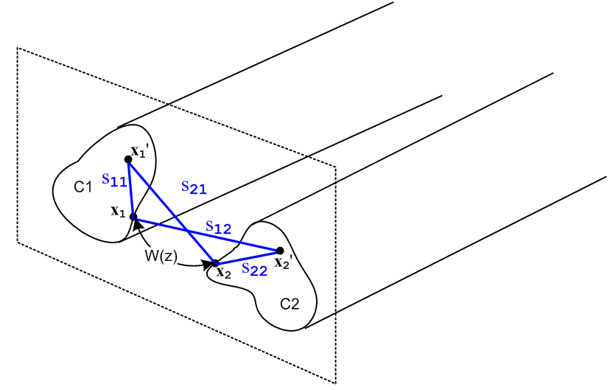 Fig 4.10
Equation (4.10.4) expresses the Az potential between the two transmission line conductors at some plane z in terms of the current distributions bi within the conductors.

Now, the Stokes theorem applied to B = curl A says

curl A = B ⇔ A • ds = ∫S B • dA . (1.1.39)

Consider the red loop shown in this top view of the two transmission line conductors. The loop is intended to have a tiny width dz, and the top view obscures the fact that each conductor has an arbitrary cross section. The loop makes contact with the points x1 and x2 shown in the previous figure,

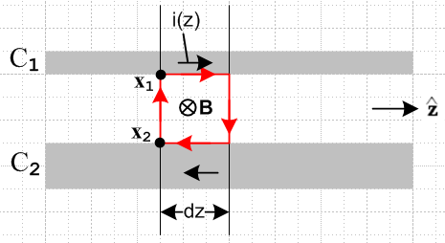 Fig 4.11

Since we neglect any transverse components of A, the Stokes theorem says

[Az1(top) - Az2(bottom) ] dz = [ magnetic flux through red loop] = ∫S B • dA . (4.10.5)

If we regard the two short dz length conductor pieces as forming a tiny "inductor", closed on the ends by the vertical red lines, we can use this definition of inductance to compute the inductance of that inductor:

[magnetic flux through red loop] = (Ledz) i(z) (4.10.6)

Here (Ledz) is the inductance of our tiny loop, so Le is the transmission line inductance per unit length. We know (as in Appendix C) that there will be magnetic flux inside the conductors as well as between them, and for that reason Le as defined here only accounts for the "external" inductance of the transmission line, again see Appendix C.
Since [Az1(top) - Az2(bottom) ] = W(z) according to (4.10.1), we may combine (4.10.5) and (4.10.6) to obtain

W(z) = Le i(z) . (4.10.7)

Therefore from (4.10.4) we have found that

Le = $\frac{W(z)}{i(z)}$ = $\frac{μ}{4π}$ KL (4.10.8)

where KL is the following dimensionless real number,

KL ≡ $^{\int_{C1}^{}{}}$dx1' dy1' b1(x1',y1') ln(s212/s112) -$^{\int_{C2}^{}{}}$dx2' dy2' b2(x2',y2') ln(s222/s122) . (4.10.9)

This number is reminiscent of the number K obtained in Section 4.4,

K ≡ $^{\int_{C1}^{}{}}$dx1' dy1' α1(x1',y1') ln(s212/s112) -$^{\int_{C2}^{}{}}$dx2' dy2' α2(x2',y2') ln(s222/s122) . (4.4.8)

In the next section it will be shown that these two dimensionless numbers are exactly the same.

4.11 The Classic Transmission Line Equations

The results of the previous sections of this chapter may be succinctly summarized as:

(4.11.1)
$\frac{1}{C'}$ = $\frac{V(z)}{q(z)}$ = $\frac{1}{4πξ}$ K (4.4.7)
Le = $\frac{W(z)}{i(z)}$ = $\frac{μ}{4π}$ KL (4.10.8)

K ≡ $^{\int_{C1}^{}{}}$dx1' dy1' α1(x1',y1') ln(s212/s112) -$^{\int_{C2}^{}{}}$dx2' dy2' α2(x2',y2') ln(s222/s122) . (4.4.8)
KL ≡ $^{\int_{C1}^{}{}}$dx1' dy1' b1(x1',y1') ln(s212/s112) -$^{\int_{C2}^{}{}}$dx2' dy2' b2(x2',y2') ln(s222/s122) (4.10.9)

Notice that we have made no assumptions whatsoever about the cross-sectional shape of the transmission line. We have only assumed that the transverse dimensions are small compared to the wavelength λ that corresponds to β -- this was the transmission line limit.

There are several equations from Chapter 1 which we shall now press into service:

E = - grad φ - ∂tA (1.3.1)
div A = - με ∂tφ - μσφ . // the King gauge (1.3.18)

In the frequency domain these become,

E = - grad φ - jωA
div A = - j (β2/ω) φ . // the King gauge, see (1.5.1) and (1.5.5) re β2 (4.11.2)

According to the Fact stated in (4.7.1), potential A has only component Az, so these equations become

Ez(x) = - ∂zφ(x) - jωAz(x)
∂zAz(x) = - j (β2/ω) φ(x) . (4.11.3)

The potentials in the above equations are those due to both conductors and were denoted as φ12 and Az12 in the previous sections. We then rewrite the above as

Ez12(x) = - ∂zφ12(x) - jωAz12(x)
∂zAz12(x) = - j (β2/ω) φ12(x) (4.11.4)

where of course Ez12(x) is the z-directed electric field at some point x in the dielectric due to both conductors. Recall now the conductor-surface-located points x1 and x2 as shown for example in Figure 4.2. If we evaluate each of the above equations at x = x1 and then x = x2 and then subtract, we get

Ez12(x1) - Ez12(x2) = -∂z[φ12(x1) - φ12(x2)] - jω[Az12(x1) - Az12(x2)]
∂z[Az12(x1) - Az12(x2)] = - j (β2/ω)[φ12(x1) - φ12(x2)] . (4.11.5)

Then using these definitions

V(z) ≡ φ12(x1) - φ12(x2) (4.4.1)
W(z) ≡ Az12(x1) - Az12(x2) (4.10.1)

Ez1 ≡ Ez12(x1)
Ez2 ≡ Ez12(x2) (4.11.6)

we may rewrite (4.11.5) in this simple manner,

Ez1 - Ez2 = - ∂zV - jωW
∂zW = - j (β2/ω) V . (4.11.7)

The quantity Ez1 is the longitudinal electric field at the surface of conductor C1. It is related to the conductor's at-the-surface current density by Jz = σ Ez. If the conductor were "perfect", we would have σ = ∞ and Ez1 = 0. Real conductors are of course not perfect. As shown in (2.4.1), Ez1 can be related to the total current in the conductor i(z) by a quantity known as the surface impedance Zs, so

Ez1 = Zs1 i1(z) Ez2 = Zs2 i2(z) . (4.11.8)

The surface impedance of a perfect conductor is zero. Since i1(z) = -i2(z) = i(z), we rewrite (4.11.7) as,

(Zs1 + Zs2) i(z) = - ∂zV(z) - jωW(z)
∂zW(z) = - j (β2/ω) V(z) . (4.11.9)

The circle now closes when we insert into (4.11.9) the fact that W = Le i(z) from (4.11.1),

(Zs1 + Zs2) i(z) = - ∂zV - jω Le i(z)
Le ∂z i(z) = - j (β2/ω) V

which we then rearrange as

∂zV(z) = - [ Zi1+ Zi1+ jωLe] i(z)
∂z i(z) = - [ jβ2/(ωLe)] V(z) . (4.11.10)
These are the classic transmission line equations. They are usually written in this form:

$\frac{∂V(z)}{∂z}$= - z i(z) $\frac{∂i(z)}{∂z}$= - y V(z) (4.11.11)

where

z = R + jωL y = G +jωC . (4.11.12)

Note: We have been using bold notation only for vectors, and we now break that guideline by bolding these complex quantities z and y. Our purpose for this bolding is to distinguish them from Cartesian coordinates z and y which typically appear in the same problem. In King's books, all complex parameters are put in bold font, but we do this only for z and y.

Here, z and y are called the transmission line impedance and admittance, and the four numbers R,L,G,C are defined to be the appropriate real and imaginary parts. Comparing (4.11.10) and (4.11.11), we may therefore conclude that:

z = R + jωL = Zs1 + Zs2 + jωLe (4.11.13)

y = G + jωC = jβ2/(ωLe) . (4.11.14)

The expression for z seems quite reasonable since ωLe = XL = inductive reactance, but the expression for y seems a bit unusual. This is because we still have more work to do.

There is one more equation we have not yet made use of. Recall from Chapter 1 the integral form of the equation of continuity, which in the frequency domain takes this form,

div J = - jωρ ⇔ -jω[∫V ρ dV] = ∫S J • dS . (1.1.35)

We now apply this to a gaussian box (blue) whose faces have the same shape as the conductor cross section but are slightly larger than that cross section so as to include the conductor surface charge :

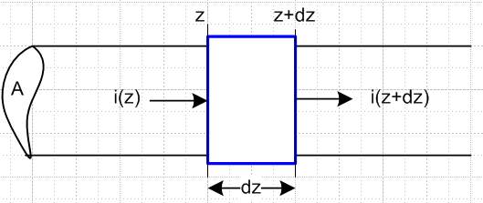 Fig 4.12

We find that

-jω[q(z)dz] = i(z+dz) - i(z) = total current flowing out of the box

which then says

∂z i(z) = -jωq(z) . (4.11.15)

From summary box (4.11.1) recall that q(z) = C'V(z) so we get

∂z i(z) = - [ jωC'] V(z) . (4.11.16)

Comparison with the second equation of (4.11.10) we find the following identity,

- [ jβ2/(ωLe)] = - [ jωC']
or
LeC' = β2/ω2 = μξ . // see (1.5.1) regarding β2 (4.11.17)

Then we can write (4.11.14) as

y = G + jωC = jβ2/(ωLe) = j (β2/ω2) (ω/Le) = j (LeC') (ω/Le) = jωC' . (4.11.18)

Thus, the line capacitance C is the real part of complex capacitance, C = Re(C'), and G = - Im(C').

Digression on the meaning of C'

Back in Section 1.5 (c) we discussed the fact that nc = (ξ/ε) ns which relates actual surface charge ns to the adjusted surface charge density nc which allows for dielectric leakage. This relationship (1.5.17) was derived in two different ways. As noted in Comment (3) at the start of Section 4.1, and looking at (4.1.1) and (4.1.2), one sees that the linear charge density q(z) which appears in all our equations is in fact related to nc and not ns, so we momentarily shall refer to q(z) as qc(z). Then qc(z) = ∫nc dxdy = an integral over the conductor surface for length dz. The actual charge on the surface of this piece of conductor is qs(z) ≡ ∫ns dxdy and therefore qc/qs = nc/na = (ξ/ε). The capacitance C per unit length of our transmission line is defined by qs = C V(z) . The complex capacitance C', which includes the effect of dielectric leakage current, is defined by qc = C' V(z). Therefore

C'/C = qc/qs = (ξ/ε) . (4.11.19)

and so then from (4.11.19) and (1.5.1),

y = G + jωC = jωC' = jω(ξ/ε)C = jω (1 - jσ/εω)C = jωC + (σ/ε)C (4.11.20)

so that

G = (σ/ε)C . (4.11.21)

We saw an example of (4.11.19) in (1.5.19) for a parallel plate capacitor, and more generally in (4.4.10).
We may now rewrite the first equation in summary box (4.11.1) as

$\frac{1}{C'}$ = $\frac{1}{4πξ}$ K => $\frac{1}{C}$ = $\frac{1}{4πε}$ K . (4.11.22)

Next, combining (4.11.17) and (4.11.19) we find that

LeC' = μξ (4.11.23)

LeC = με = 1/v2 (4.11.24)

where v is the speed of light in the dielectric. Now the second equation in (4.11.1) says that

Le = $\frac{μ}{4π}$ KL . (4.11.25)

Inserting (4.11.25) for Le and (4.11.22) for C' into (4.11.23) gives

($\frac{μ}{4π}$ KL ) (4πξ/K) = μξ
or
KL = K . (4.11.26)

This is a remarkable connection between our two seemingly unrelated constants K and KL,

K ≡ $^{\int_{C1}^{}{}}$dx1' dy1' α1(x1',y1') ln(s212/s112) -$^{\int_{C2}^{}{}}$dx2' dy2' α2(x2',y2') ln(s222/s122) (4.4.8)
KL ≡ $^{\int_{C1}^{}{}}$dx1' dy1' b1(x1',y1') ln(s212/s112) -$^{\int_{C2}^{}{}}$dx2' dy2' b2(x2',y2') ln(s222/s122) , (4.10.9)

Since K involves a surface integral of surface charge densities αi whereas KL involves a full volume integral of the current densities bi, it seems unlikely these integrals would be equal, but they are equal.

An example of K = KL

The equality even seems unlikely in a case with symmetric densities on round wires, so let's do a check using our Section 4.5 example with widely-space round wires of unequal diameters. The first thing we need is a new picture to display the "kinematics" of the KL integral,

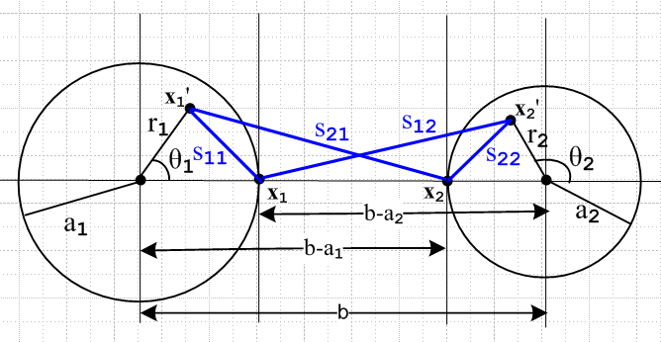 Fig 4.13

As before, we read off the four distances of interest using the law of cosines. The new distances are of course all different than they were before since x1' and x2' are now each integrated over their respective disks instead of the bounding circles.

s212 = r12 + (b-a1)2 - 2 r1(b-a1) cos(θ1)
s112 = r12 + a12 - 2 r1 a1 cos(θ1)
s222 = r22 + a22 + 2 r2 a2 cos(θ2)
s122 = r22 + (b-a2)2 + 2 r2(b-a2) cos(θ2) .

The integration rule is still

$^{\int_{0}^{2π}{}}$dθ ln (A ± Bcosθ) = 2π ln[(1/2)(A + $\sqrt{A2-B2}$ )] . (4.5.5)

The first integral is:

$^{\int_{0}^{2π}{}}$dθ1 ln(s212) = $^{\int_{0}^{2π}{}}$dθ1ln([r12 + (b-a1)2 - 2 r1(b-a1) cos(θ1)]

A = r12 + (b-a1)2 B = 2 r1(b-a1)

A2-B2 = [r12 + (b-a1)2]2 - 4 r12(b-a1)2 = [r12 - (b-a1)2]2 => $\sqrt{A2-B2}$= (b-a1)2- r12 > 0 b >> a1

=> $^{\int_{0}^{2π}{}}$dθ1 ln(s212) = 2π ln[(1/2)( r12 + (b-a1)2 + (b-a1)2 - r12 ) = 2π ln[(b-a1)2]

But this integral is the same as before! The s112 integral is obtained from the above with b-a1→a1

$^{\int_{0}^{2π}{}}$dθ1 ln(s112) = 2π ln(a12)

which is also the same as before. The other two integrals are found from 1→ 2. Our integral summary is then exactly the same as (4.5.6),

$^{\int_{0}^{2π}{}}$dθ1 ln(s212) = 2π ln[(b-a1)2]
$^{\int_{0}^{2π}{}}$dθ1 ln(s112) = 2π ln(a12)
$^{\int_{0}^{2π}{}}$dθ2 ln(s222) = 2π ln(a22)
$^{\int_{0}^{2π}{}}$dθ2 ln(s122) = 2π ln[(b-a2)2] . (4.5.6)

We now assume that the current densities bi each have radial symmetry,

b1(r1,θ1) = b1(r1) (4.11.27)

where b1(r1) is a completely arbitrary function, with the following normalization of (4.7.4),

$^{\int_{0}^{2π}{}}$dθ1 $^{\int_{0}^{a1}{}}$r1dr1 b1(r1) = 1 => $^{\int_{0}^{a1}{}}$r1dr1 b1(r1) = 1/2π . (4.11.28)

We now proceed to calculate the constant KL

KL = $^{\int_{0}^{2π}{}}$dθ1 $^{\int_{0}^{a1}{}}$r1dr1 b1(r1) ln(s212/s112) -$^{\int_{0}^{2π}{}}$dθ2 $^{\int_{0}^{a2}{}}$r2dr2b2(r2) ln(s222/s122)

= $^{\int_{0}^{a1}{}}$r1dr1 b1(r1) $^{\int_{0}^{2π}{}}$dθ1 ln(s212/s112) - $^{\int_{0}^{a2}{}}$r2dr2b2(r2) $^{\int_{0}^{2π}{}}$dθ2 ln(s222/s122)

= 2π $^{\int_{0}^{a1}{}}$r1dr1 b1(r1) [ln[(b-a1)2]- ln(a12)] - $^{\int_{0}^{a2}{}}$r2dr2b2(r2) [ ln[(b-a2)2] - ln(a22)]

= 2π [ln[(b-a1)2/a12] $^{\int_{0}^{a1}{}}$r1dr1 b1(r1) - 2π [ln[(b-a2)2/a22] $^{\int_{0}^{a2}{}}$r2dr2 b2(r2)

= [ln[(b-a1)2/a12] - [ln[(b-a2)2/a22]

= ln [$\frac{(b-a1)2(b-a2)2}{a12a22}$]

= K as obtained in (4.5.7) (4.11.29)

and we have then shown KL = K for this particular example. The key fact is that the dθ integrals appear to be functions of ri , but the ri2 terms cancel and so the dθ integrals are independent of ri.

We now summarize our results:

Classical Transmission Line Equations and Parameters (4.11.30)

K ≡ $^{\int_{C1}^{}{}}$dx1' dy1' α1(x1',y1') ln(s212/s112) -$^{\int_{C2}^{}{}}$dx2' dy2' α2(x2',y2') ln(s222/s122) (4.4.8)
KL ≡ $^{\int_{C1}^{}{}}$dx1' dy1' b1(x1',y1') ln(s212/s112) -$^{\int_{C2}^{}{}}$dx2' dy2' b2(x2',y2') ln(s222/s122) , (4.10.9)

K = KL real and dimensionless (4.11.26)

$\frac{∂V(z)}{∂z}$ = - z i(z) where z = R + jωL transmission line equations
$\frac{∂i(z)}{∂z}$ = - yV(z) (4.11.11) y = G +jωC (4.11.12)

z = Zs1 + Zs2 + jωLe (4.11.13) XL ≡ ωLe , XC ≡ 1/(ωC)
y = jωC' = jωC + (σ/ε)C (4.11.20) G = (σ/ε)C (4.11.21)

R = Re(Zs1+ Zs2) L = Le + (1/ω) Im(Zs1+ Zs2)

Le = $\frac{μ}{4π}$ K (4.11.25) and (4.11.26)

C' = 4πξ/K (4.11.22) C' = (ξ/ε)C (4.11.19)
C = 4πε/K (4.11.22)
G = 4πσ/K (4.11.22) + (4.11.21)

LeC' = μξ (4.11.23)
LeC = με = 1/v2 (4.11.24)

Z0 = $\frac{R + jωL}{G + jωC}$ = $\frac{z}{y}$ Appendix reference!
Z0 (large ω) ≈ $\frac{L}{C}$ ≈ $\frac{Le}{C}$ = (1/4π) K $\sqrt{μ/ε}$ = (K/4π) Zm // See comments below

λ >> D (4.3.6) assumed transmission line limit where β = 2π/λ

β2 = μεω2 - jωμσ = ω2μ ( ε - jσ/ω) = ω2μ ξ ξ ≡ ε - jσ/ω . (1.5.1)

Comments:

1. In Chapter 2 we computed the surface impedance Zs for a round wire (radius a, μc, σc) in the case of axially symmetric current and we found that, for large ω,

Zs(ω) ≈ $\frac{1}{σc(2πa)δ}$ (1+j) (2.4.16)

δ ≡ $\sqrt{2/ωμcσc}$ = skin depth (2.2.20)

so that
Zs(ω) ≈ $\frac{1}{2π}$ $\frac{μc}{2a2σc}$ (1+j) $\sqrt{ω}$ (4.11.31)

Presumably the result will be Zs(ω) ~ $\sqrt{ω}$ for any conductor cross section shape. Then

L = Le + (1/ω) Im(Zs1+ Zs2) = Le + (stuff) 1/$\sqrt{ω}$ → Le for large ω (4.11.32)

For this reason, the high frequency characteristic impedance Z0 can be written as shown above.

2. Conductors have internal inductance Li as well as external inductance Le. In Appendix C.3 (a) we compute the low frequency internal inductance of a round wire to be Li = μc/8π = (μc/μ0) * 50 nH/m . Our Chapter 4 transmission line development makes no mention of Li. This can be traced to Figure 4.11 where only the external magnetic flux is involved. In fact, Li is accounted for in the imaginary part of the surface impedance Zs . For example, we found that for our round wire situation,

Zs(ω) = $\frac{1}{σcπa2}$ + jω $\frac{μc}{8π}$ = Rs + jωLs // low frequency limit (2.4.12)

and here one sees that Ls = $\frac{μc}{8π}$ = Li .

3. We have assumed that ε and μ are real. If not, the usual adjustments can be made in (4.11.30) for the interpretations of R,L,G and C. See for example (3.3.4) concerning σ being replaced by σeff if ε has an imaginary part.

4. Apart from the symmetric cases like the examples of Section 4.5 and 4.6, we do not yet have a way to compute K and the transmission line parameters since the charge and current distributions αi and bi are not known. This matter will be remedied in Chapter 5.

5. A stripline transmission line of width w and separation s with s << w is the simplest example of the above summary:

E = V/s n = εE = εV/s q = nw C = q/V = εw/s => K = 4πε/C = 4π(s/w)
so
C = 4πε/K = ε (w/s) K = 4π (s/w)
G = 4πσ/K = σ (w/s)
Le = (μ/4π) K = μ (s/w)
Z0 ≈ (K /$\sqrt{εrel}$) 30Ω = 4π (s/w) (1/$\sqrt{εrel}$) 30Ω = (s/w) (1/$\sqrt{εrel}$) 377Ω

