Bug with small beta limit in Ch 4 PhL 1.3.14

My old Chapter 4 did have a big flaw. I want to be talking small β, but my main expansion assumed large β as you see in (4.2.2) quoted below. This resulted in full rework of Chapter 4 and it used to have an Appendix G for support, but that is now gone and replaced with old Appendix M.

Nothing like a brand new and fatal bug to deal with after working 3+ months on this monster.

Plan A 1
Plan B. 6
Plan C 8
Plan D 11
Plan E 14

Plan A. My expression for V(z) is this,

V(z) = $\frac{1}{4πξ}$$\sum_{m=0}^{∞}{}$$\frac{2 (2m-1)!!}{(2m)!}$ $\frac{1}{(jβ)m}$q(2m)(z) *
{ $^{\int_{C1}^{}{}}$dx' dy' a1(x',y') [ s1m Km (jβs1) - s2m Km (jβs2)]
- $^{\int_{C2}^{}{}}$dx' dy' a2(x',y') [ s1m Km (jβs1) - s2m Km (jβs2)] } (4.2.2)

where si = | xi - x' | and x1 is a point on C1 and x2 a point on C2. I am trying to discuss the small β limit of this expression and trying to show that beyond the leading term, things are order β2. But as I examine things, this seems completely wrong. If I look at any of the "four terms" in the above, say for m > 0, I see this

$\frac{1}{(jβ)m}$ Km (jβs1) ≈ $\frac{1}{(jβ)m}$ 2m-1(m-1)! z-m

= $\frac{1}{(jβ)m}$ 2m-1(m-1)! (jβs1)-m = $\frac{1}{(jβ)m}$ 2m-1(m-1)!$\frac{1}{(jβs1)m}$

= $\frac{1}{(jβ)2m}$ 2m-1(m-1)! s1-m

So the larger m is, the more this thing blows up in my face! It's as if the expansion I used is completely wrong. [ yup ]
Let's back up a bit to this point, where I have one of my "four terms" :

φ1(x,y,z) = $\frac{1}{4πξ}$$\sum_{n=0}^{∞}{}$(1/n!) q(n)(z) $^{\int_{C1}^{}{}}$dx' dy' a1(x',y') $^{\int_{-∞}^{∞}{}}$dz' (z'-z)n $\frac{e-jβR}{R}$. (4.1.7)

R = $\sqrt{(z'-z)2 + s2}$

It seems quite clear that as β→0, the dz' integral blows up something like this

$^{\int_{-∞}^{∞}{}}$dz' (z'-z)n-1

and that of course is what my exact integration shows.

$^{\int_{-∞}^{∞}{}}$dz' (z'-z)n $\frac{e-jβR}{R}$
= sn fn(βs) = (G.10)

My expansion of q(z) just makes things worse, bringing in those powers (z'-z)n.

Is it possible that my Km(jβs) limit is wrong? I have to allow that β can be completely real in a good dielectric, so we really are going right ON the imaginary axis with the argument.

According to green Jackson page 75, we can write this in terms of Hm(1)(-βs). Do I know anything about that function for small β ? It seems that Ym(-βs) will diverge.

So we still have our power divergence for small z no matter how you write it.

It must be that you should not do this dz' integral at this point in the calculation! King deals with this question on his page 16, and I thought I was cleverly generalizing his work.

First of all, King only deals with 2 terms instead of my four terms, because he assumes "a balanced line". That is to say, he assumes φ2 = -φ1 so that then V = φ1-φ2 = 2φ1 as in his top page 15. Of course he is already "into" his simple example.

Suppose I hold off on the expansion of q(z) so that, for some observation point x in the dielectric,

φ1(x,y,z) = $\frac{1}{4πξ}$$^{\int_{C1}^{}{}}$dx' dy' a1(x',y') $^{\int_{-∞}^{∞}{}}$dz' q1(z') $\frac{e-jβR}{R}$ . (4.1.5)

φ2(x,y,z) = $\frac{1}{4πξ}$$^{\int_{C2}^{}{}}$dx' dy' a2(x',y') $^{\int_{-∞}^{∞}{}}$dz' q2(z') $\frac{e-jβR}{R}$ . (4.1.5)

Now assume only that q1 = q and q2 = -q1 = -q so we then have

φ1(x,y,z) = $\frac{1}{4πξ}$$^{\int_{C1}^{}{}}$dx' dy' a1(x',y') $^{\int_{-∞}^{∞}{}}$dz' q(z') $\frac{e-jβR}{R}$ . (4.1.5)

φ2(x,y,z) = $\frac{1}{4πξ}$$^{\int_{C2}^{}{}}$dx' dy' a2(x',y') $^{\int_{-∞}^{∞}{}}$dz' [-q(z')] $\frac{e-jβR}{R}$ .

where R = |x-x'| but of course x' takes different values for the different integrals. I am really stuck at this point, I don't see how to do anything with the subtraction. Maybe slide dz' integration to the left,

φ1(x,y,z) = $\frac{1}{4πξ}$$^{\int_{-∞}^{∞}{}}$dz' q(z')$^{\int_{C1}^{}{}}$dx' dy' a1(x',y') $\frac{e-jβR}{R}$ . (4.1.5)

φ2(x,y,z) = $\frac{1}{4πξ}$$^{\int_{-∞}^{∞}{}}$dz' [-q(z')]$^{\int_{C2}^{}{}}$dx' dy' a2(x',y') $\frac{e-jβR}{R}$ .

Maybe I can say something about the transverse integral in the transmission line limit where λ >> d.

φ1(x,y,z) = $\frac{1}{4πξ}$$^{\int_{-∞}^{∞}{}}$dz' q(z')$^{\int_{C1}^{}{}}$dx1' dy1' a1(x1',y1') $\frac{e-jβR1}{R1}$ .

R12 = (x-x1')2 + (y-y1')2 + (z-z1')2

φ2(x,y,z) = $\frac{1}{4πξ}$$^{\int_{-∞}^{∞}{}}$dz' [-q(z')]$^{\int_{C2}^{}{}}$dx2' dy2' a2(x2',y2') $\frac{e-jβR2}{R2}$ .

R12 = (x-x2')2 + (y-y2')2 + (z-z2')2

Both integrations have a common z' coordinate, so no need for z1' and z2'.

Now it is true that, in the TL limit, we will have βR1 << 1 and βR2 << 1 so we could do expansions:
[ we can do these expansions even if βR is NOT << 1 because ∞ disk of convergence ]

φ1(x,y,z) = $\frac{1}{4πξ}$$^{\int_{-∞}^{∞}{}}$dz' q(z')$^{\int_{C1}^{}{}}$dx1' dy1' a1(x1',y1') R1-1 Σn=0∞ (-jβR1)n/n!
φ2(x,y,z) = $\frac{1}{4πξ}$$^{\int_{-∞}^{∞}{}}$dz' [-q(z')]$^{\int_{C2}^{}{}}$dx2' dy2' a2(x2',y2') R2-1 Σn=0∞ (-jβR2)n/n! .

φ1(x,y,z) = $\frac{1}{4πξ}$$^{\int_{-∞}^{∞}{}}$dz' q(z') Σn=0∞ $\frac{1}{n!}$ (-jβ)n$^{\int_{C1}^{}{}}$dx1' dy1' a1(x1',y1') R1n-1
φ2(x,y,z) = - $\frac{1}{4πξ}$$^{\int_{-∞}^{∞}{}}$dz' q(z') Σn=0∞ $\frac{1}{n!}$ (-jβ)n$^{\int_{C2}^{}{}}$dx2' dy2' a2(x2',y2') R2n-1

Now I claim that,

$^{\int_{C1}^{}{}}$dx1' dy1' a1(x1',y1') R1n-1 = f1n(x,y,z; z')

which is a function only of geometry and certainly does not depend on β. What exactly does this integral represent? Here is a picture, where we are integrating the red dot around the red boundary for each φi

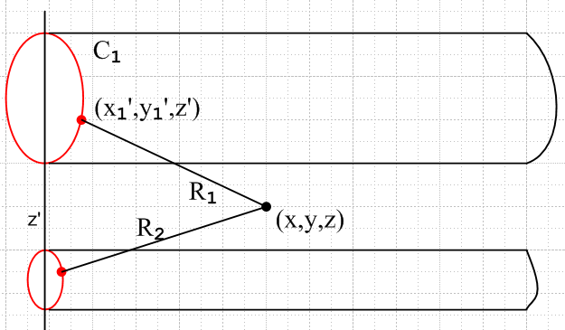

If we regard a1(x1',y1') as a normalized weighting function, it is like a probability and then what we have is

$^{\int_{C1}^{}{}}$dx1' dy1' a1(x1',y1') R1n-1 = <R1n-1> = expected value of R1n-1 = average value of R1n-1

You can see that if the two points have a very large z separation compared to other separations (that is, if the angle R1 makes is close to parallel with the conductor) then

R12 = (x-x1')2 + (y-y1')2 + (z-z1')2 ≈ (z-z1')2 => R1 ≈ |z-z1|

<R1n-1> ≈ |z-z1|n-1

So then we have

φ1(x,y,z) = $\frac{1}{4πξ}$$^{\int_{-∞}^{∞}{}}$dz' q(z') Σn=0∞ $\frac{1}{n!}$ (-jβ)n f1n(x,y,z; z')
φ2(x,y,z) = - $\frac{1}{4πξ}$$^{\int_{-∞}^{∞}{}}$dz' q(z') Σn=0∞ $\frac{1}{n!}$ (-jβ)n f2n(x,y,z; z')

At least we seem to have a small-β expansion now. Then,

φ12 = φ1-φ2 = $\frac{1}{4πξ}$$^{\int_{-∞}^{∞}{}}$dz' q(z') Σn=0∞ $\frac{1}{n!}$ (-jβ)n [ f1n(x,y,z; z') - f2n(x,y,z; z') ]

We can write out some of the terms:

φ12 = $\frac{1}{4πξ}$$^{\int_{-∞}^{∞}{}}$dz' q(z') [ f10(x,y,z; z') - f20(x,y,z; z') ]
+ $\frac{1}{4πξ}$$^{\int_{-∞}^{∞}{}}$dz' q(z') Σn=2∞ $\frac{1}{n!}$ (-jβ)n[ f1n(x,y,z; z') - f2n(x,y,z; z') ]

which has the form

φ12 = $\frac{1}{4πξ}$$^{\int_{-∞}^{∞}{}}$dz' q(z') [ f10(x,y,z; z') - f20(x,y,z; z') ] + order(β2)

Write the first two non-vanishing terms only as

φ12 = $\frac{1}{4πξ}$$^{\int_{-∞}^{∞}{}}$dz' q(z') [ f10(x,y,z; z') - f20(x,y,z; z') ]

+ $\frac{1}{4πξ}$$^{\int_{-∞}^{∞}{}}$dz' q(z') (1/2) (-jβ)2[ f12(x,y,z; z') - f22(x,y,z; z') ]

Now look back at

$^{\int_{C1}^{}{}}$dx1' dy1' a1(x1',y1') R1n-1 = f1n(x,y,z; z')

For large z-z', we have roughly that R12 = (z-z1')2 so this becomes

f1n(x,y,z; z') for large |z-z'| ≈ $^{\int_{C1}^{}{}}$dx1' dy1' a1(x1',y1') |z-z'|n-1 = |z-z'|n-1
f2n(x,y,z; z') for large |z-z'| ≈ $^{\int_{C2}^{}{}}$dx2' dy2' a1(x2',y2') |z-z'|n-1 = |z-z'|n-1

This really means we can write

φ12 = φ1-φ2 = $\frac{1}{4πξ}$$^{\int_{-Λ}^{Λ}{}}$dz' q(z') Σn=0∞ $\frac{1}{n!}$ (-jβ)n [ f1n(x,y,z; z') - f2n(x,y,z; z') ]

where perhaps Λ ≥ 100 d where d is the diameter of a tube which can contain both conductors. The main point is that each term in the n sum has a convergent dz' integral AND we have things in a power series expansion in β. The first two series terms are then

φ12 = $\frac{1}{4πξ}$$^{\int_{-Λ}^{Λ}{}}$dz' q(z') [ f10(x,y,z; z') - f20(x,y,z; z') ]

- (1/2) β2 $\frac{1}{4πξ}$$^{\int_{-Λ}^{Λ}{}}$dz' q(z') [ f12(x,y,z; z') - f22(x,y,z; z') ]

Jan 4, 2014

Plan B. Let's go back to

φ12 = φ1-φ2 = $\frac{1}{4πξ}$$^{\int_{-∞}^{∞}{}}$dz' q(z') Σn=0∞ $\frac{1}{n!}$ (-jβ)n [ f1n(x,y,z; z') - f2n(x,y,z; z') ]
or
φ12 = φ1-φ2 = $\frac{1}{4πξ}$$^{\int_{-∞}^{∞}{}}$dz' q(z') Σn=0∞ $\frac{1}{n!}$ (-jβ)n [<R1n-1> - <R2n-1> ]

$^{\int_{C1}^{}{}}$dx1' dy1' a1(x1',y1') R1n-1 = f1n(x,y,z; z') = <R1n-1>

R12 = (x-x1')2 + (y-y1')2 + (z-z')2 = s12 + (z-z')2
R22 = (x-x2')2 + (y-y2')2 + (z-z')2 = s22 + (z-z')2

and maybe do something with this difference function. s1 s2

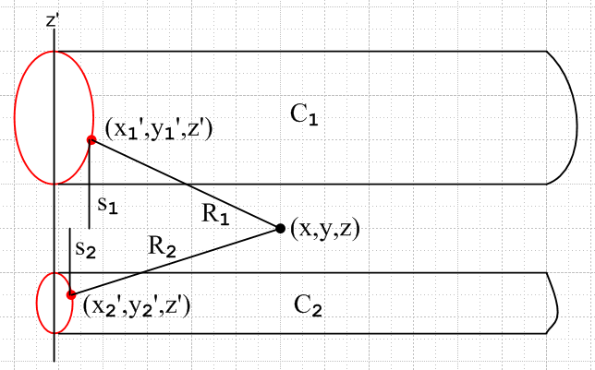

Let's try an expansion for where |z-z'| is large.

R12 = (z-z')2 + s12 = (z-z')2 [ 1 + s12/ (z-z')2]

R1 = |z-z'| ( 1 + s12/ |z-z'|2)1/2

R1n-1 = |z-z'|n-1 ( 1 + s12/ |z-z'|2)(n-1)/2 // (1+x)n = 1n x + n 1n-1x + ....
or
R1n-1 ≈ |z-z'|n-1 ( 1 + $\frac{n-1}{2}$$\frac{s12}{|z-z'|2}$)
R2n-1 ≈ |z-z'|n-1 ( 1 + $\frac{n-1}{2}$$\frac{s22}{|z-z'|2}$)

Then write

<R1n-1> - <R2n-1> = $^{\int_{C1}^{}{}}$dx1' dy1' a1(x1',y1') R1n-1 - $^{\int_{C2}^{}{}}$dx2' dy2' a2(x2',y2') R2n-1

= $^{\int_{C1}^{}{}}$dx1' dy1' a1(x1',y1') { |z-z'|n-1 ( 1 + $\frac{n-1}{2}$$\frac{s12}{|z-z'|2}$) }

- $^{\int_{C2}^{}{}}$dx2' dy2' a2(x2',y2') { |z-z'|n-1 ( 1 + $\frac{n-1}{2}$$\frac{s22}{|z-z'|2}$) }

Now the "1" contributions exactly cancel due to the normalization of a1 and a2 , so that is the main cancellation idea realized yesterday. We then have

<R1n-1> - <R2n-1> ≈ $^{\int_{C1}^{}{}}$dx1' dy1' a1(x1',y1') { |z-z'|n-1 ($\frac{n-1}{2}$$\frac{s12}{|z-z'|2}$) }
- $^{\int_{C2}^{}{}}$dx2' dy2' a2(x2',y2') { |z-z'|n-1 ($\frac{n-1}{2}$$\frac{s22}{|z-z'|2}$) }

= $\frac{n-1}{2}$ |z-z'|n-3 { $^{\int_{C1}^{}{}}$dx1' dy1' a1(x1',y1') s12 - $^{\int_{C2}^{}{}}$dx2' dy2' a2(x2',y2') s22 }

This appears to be a step in the right direction. I could write more terms in this expansion, but let's hold off on that for the moment. What is the meaning of the integrals appearing here? For a given point x in the dielectric, the first integral is a mean value of s12 from the line specified by x,y as z varies.

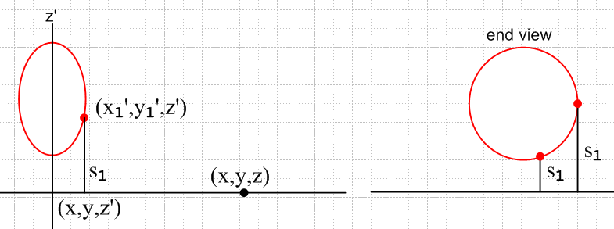

So I have then shown that

<R1n-1> - <R2n-1> ≈ $\frac{n-1}{2}$ |z-z'|n-3 [<s12> - <s22> ]

Then

φ12 = φ1-φ2 = $\frac{1}{4πξ}$$^{\int_{-∞}^{∞}{}}$dz' q(z') Σn=0∞ $\frac{1}{n!}$ (-jβ)n [<R1n-1> - <R2n-1> ]

≈ $\frac{1}{4πξ}$$^{\int_{-∞}^{∞}{}}$dz' q(z') Σn=0∞ $\frac{1}{n!}$ (-jβ)n $\frac{n-1}{2}$ |z-z'|n-3 [<s12> - <s22> ]

≈ $\frac{1}{4πξ}$ [<s12> - <s22> ] Σn=0∞ $\frac{1}{n!}$ (-jβ)n $\frac{n-1}{2}$ $^{\int_{-∞}^{∞}{}}$dz' q(z')|z-z'|n-3

OK, at least I have done something. But for larger n, the dz' integral still diverges, so what went wrong?

Plan C

Well, suppose we "back up" even more like so:

φ1(x,y,z) = $\frac{1}{4πξ}$$^{\int_{-∞}^{∞}{}}$dz' q(z')$^{\int_{C1}^{}{}}$dx1' dy1' a1(x1',y1') $_{1}$ .

φ2(x,y,z) = $\frac{1}{4πξ}$$^{\int_{-∞}^{∞}{}}$dz' [-q(z')]$^{\int_{C2}^{}{}}$dx2' dy2' a2(x2',y2') $_{2}$ .

And supposed to DON'T expand the exponential yet. Then

φ12(x) = φ1(x) - φ2(x) =

$\frac{1}{4πξ}$$^{\int_{-∞}^{∞}{}}$dz' q(z'){ $^{\int_{C1}^{}{}}$dx1' dy1' a1(x1',y1') $_{1}$ – $^{\int_{C2}^{}{}}$dx2' dy2' a2(x2',y2') $_{2}$ }

Now let's try an expansion of $_{1}$. As above we write,

R1 = |z-z'| ( 1 +$\frac{s12}{|z-z'|2}$)1/2

$_{1}$ = exp[ -jβ |z-z'| ( 1 +$\frac{s12}{|z-z'|2}$)1/2 ] / |z-z'| ( 1 +$\frac{s12}{|z-z'|2}$)1/2

≈ exp[ -jβ |z-z'| ( 1 + $\frac{1}{2}$$\frac{s12}{|z-z'|2}$) ] / |z-z'| ( 1 + $\frac{1}{2}$$\frac{s12}{|z-z'|2}$)

≈ exp[ -jβ |z-z'| -jβ $\frac{1}{2}$$\frac{s12}{|z-z'|}$) ] / |z-z'| ( 1 + $\frac{1}{2}$$\frac{s12}{|z-z'|2}$)

≈ exp[ -jβ |z-z'| ] exp[ -jβ $\frac{1}{2}$$\frac{s12}{|z-z'|}$) ] / |z-z'| ( 1 + $\frac{1}{2}$$\frac{s12}{|z-z'|2}$)

= $\frac{e-jβ|z-z'|}{|z-z'|}$ * $\frac{1}{2}$$\frac{s12}{|z-z'|}$$\frac{1}{2}$$\frac{s12}{|z-z'|2}$ (*)

If I do this as well for $_{2}$, then the "leading term" exactly cancels in φ12 , as happened in my last attempt. Let's go ahead and write it all out

φ12 ≈ $\frac{1}{4πξ}$$^{\int_{-∞}^{∞}{}}$dz' q(z') $^{\int_{C1}^{}{}}$dx1' dy1' a1(x1',y1') [$\frac{e-jβ|z-z'|}{|z-z'|}$ * $\frac{1}{2}$$\frac{s12}{|z-z'|}$$\frac{1}{2}$$\frac{s12}{|z-z'|2}$]

- $\frac{1}{4πξ}$$^{\int_{-∞}^{∞}{}}$dz' q(z') $^{\int_{C2}^{}{}}$dx2' dy2' a2(x2',y2') [$\frac{e-jβ|z-z'|}{|z-z'|}$ * $\frac{1}{2}$$\frac{s22}{|z-z'|}$$\frac{1}{2}$$\frac{s22}{|z-z'|2}$]

or
φ12 ≈ $\frac{1}{4πξ}$$^{\int_{-∞}^{∞}{}}$dz' q(z') $\frac{e-jβ|z-z'|}{|z-z'|}$ $^{\int_{C1}^{}{}}$dx1' dy1' a1(x1',y1') [$\frac{1}{2}$$\frac{s12}{|z-z'|}$$\frac{1}{2}$$\frac{s12}{|z-z'|2}$]

- $\frac{1}{4πξ}$$^{\int_{-∞}^{∞}{}}$dz' q(z') $\frac{e-jβ|z-z'|}{|z-z'|}$ $^{\int_{C2}^{}{}}$dx2' dy2' a2(x2',y2') [$\frac{1}{2}$$\frac{s22}{|z-z'|}$$\frac{1}{2}$$\frac{s22}{|z-z'|2}$]

I think there is a finite β = 0 term sitting here:

φ12β=0 = $\frac{1}{4πξ}$$^{\int_{-∞}^{∞}{}}$dz' q(z') $\frac{1}{|z-z'|}${ $^{\int_{C1}^{}{}}$dx1' dy1' a1(x1',y1') [$\frac{1}{2}$$\frac{s12}{|z-z'|2}$]
- $\frac{1}{4πξ}$$^{\int_{-∞}^{∞}{}}$dz' q(z') $\frac{1}{|z-z'|}$ $^{\int_{C2}^{}{}}$dx2' dy2' a2(x2',y2') [$\frac{1}{2}$$\frac{s22}{|z-z'|2}$]
or

φ12β=0 ≈ $\frac{1}{4πξ}$$^{\int_{-∞}^{∞}{}}$dz' q(z') $\frac{1}{|z-z'|}${ $^{\int_{C1}^{}{}}$dx1' dy1' a1(x1',y1') [1 - $\frac{1}{2}$$\frac{s12}{|z-z'|2}$]
- $\frac{1}{4πξ}$$^{\int_{-∞}^{∞}{}}$dz' q(z') $\frac{1}{|z-z'|}$ $^{\int_{C2}^{}{}}$dx2' dy2' a2(x2',y2') [1 - $\frac{1}{2}$$\frac{s22}{|z-z'|2}$]

The leading terms cancel due to ai normalization and we are left with

φ12β=0 ≈ (- $\frac{1}{2}$) $\frac{1}{4πξ}$$^{\int_{-∞}^{∞}{}}$dz' q(z') $\frac{1}{|z-z'|3}$ { <s12> - <s22> }

= (- $\frac{1}{2}$) $\frac{1}{4πξ}$ { <s12> - <s22> } $^{\int_{-∞}^{∞}{}}$dz' q(z') $\frac{1}{|z-z'|3}$

Now suppose we put in a power series for q(z'),

q(z') = q(z) + q'(z) (z'-z) + ..

Then the leading term diverges at the end near z' = 0,'

$^{\int_{-∞}^{∞}{}}$dz' q(z) $\frac{1}{|z-z'|3}$ = q(z) $^{\int_{-∞}^{∞}{}}$dz' $\frac{1}{|z-z'|3}$ = q(z) $^{\int_{-∞}^{∞}{}}$dx $\frac{1}{|x|3}$ = 2 q(z) $^{\int_{0}^{∞}{}}$dx x-3 = diverges

This I guess is due to my expansion for large |z-z'| being bad for small |z-z'|. Ignoring this for the moment:

OK, now maybe is the time to do our exponential expansion

exp[ -jβ $\frac{1}{2}$$\frac{s12}{|z-z'|}$] = Σn=0∞ (1/n!) (jβ $\frac{1}{2}$$\frac{s12}{|z-z'|}$)n

= 1 + Σn=1∞ (1/n!) (jβ $\frac{1}{2}$$\frac{s12}{|z-z'|}$)n

But since I only expanded two terms in (*) above, the higher terms here are not too meaningful. So maybe only keep the first two terms:

exp[ -jβ $\frac{1}{2}$$\frac{s12}{|z-z'|}$] ≈ 1 + (1/2) jβ $\frac{1}{2}$$\frac{s12}{|z-z'|}$

Then we get

$\frac{1}{2}$$\frac{s12}{|z-z'|}$$\frac{1}{2}$$\frac{s12}{|z-z'|2}$ ≈ [1 + (1/2) jβ $\frac{1}{2}$$\frac{s12}{|z-z'|}$] [1 - $\frac{1}{2}$$\frac{s12}{|z-z'|2}$ ] ≈ 1 + (jβ/4)$\frac{s12}{|z-z'|}$ + order($\frac{1}{|z-z'|2}$)

Then put pieces together again

φ12 ≈ $\frac{1}{4πξ}$$^{\int_{-∞}^{∞}{}}$dz' q(z') $\frac{e-jβ|z-z'|}{|z-z'|}${ $^{\int_{C1}^{}{}}$dx1' dy1' a1(x1',y1') [1 + (jβ/4)$\frac{s12}{|z-z'|}$]

- $\frac{1}{4πξ}$$^{\int_{-∞}^{∞}{}}$dz' q(z') $\frac{e-jβ|z-z'|}{|z-z'|}${ $^{\int_{C2}^{}{}}$dx2' dy2' a2(x2',y2') [1 + (jβ/4)$\frac{s22}{|z-z'|}$]

As already noted, the leading terms cancel and we then have

φ12 ≈ $\frac{1}{4πξ}$$^{\int_{-∞}^{∞}{}}$dz' q(z') $\frac{e-jβ|z-z'|}{|z-z'|}${ $^{\int_{C1}^{}{}}$dx1' dy1' a1(x1',y1') [ (jβ/4)$\frac{s12}{|z-z'|}$]

- $\frac{1}{4πξ}$$^{\int_{-∞}^{∞}{}}$dz' q(z') $\frac{e-jβ|z-z'|}{|z-z'|}${ $^{\int_{C2}^{}{}}$dx2' dy2' a2(x2',y2') [(jβ/4)$\frac{s22}{|z-z'|}$]

= (jβ/4) $\frac{1}{4πξ}$$^{\int_{-∞}^{∞}{}}$dz' q(z') $\frac{e-jβ|z-z'|}{|z-z'|2}$ { <s12>t - <s22>t }
or

φ12(x,y,z) ≈ (jβ/4) $\frac{1}{4πξ}${ <s12>t - <s22>t }$^{\int_{-∞}^{∞}{}}$dz' q(z') $\frac{e-jβ|z-z'|}{|z-z'|2}$

Now the dz' integral seems a little more convergent. But the leading term seems order β and not β2 ? What result am I eventually expecting?

V(z) = $\frac{2}{4πε}$q(z){ $^{\int_{C1}^{}{}}$dx' dy' a1(x',y') ln(s2/s1) -$^{\int_{C2}^{}{}}$dx' dy' a2(x',y') ln(s2/s1) } (4.2.5)

This is of course another step of differencing, but it has no β dependence.

Plan D Start again,

φ12(x) = φ1(x) - φ2(x) =

$\frac{1}{4πξ}$$^{\int_{-∞}^{∞}{}}$dz' q(z'){ $^{\int_{C1}^{}{}}$dx1' dy1' a1(x1',y1') $_{1}$ – $^{\int_{C2}^{}{}}$dx2' dy2' a2(x2',y2') $_{2}$ }

R12 = (x-x1')2 + (y-y1')2 + (z-z')2 = s12 + (z-z')2
R22 = (x-x2')2 + (y-y2')2 + (z-z')2 = s22 + (z-z')2

Again, for x somewhere in the middle, this thing has to be finite for any β. If a1 = a2 as in King's example, then you get the difference function ($_{1}$ - $_{2}$) which is how he deals with things. His symmetry then allows consideration of only 2 terms instead of 4 terms for V(x).

What happens if I start off with the expansion

q(z') = q(z) + q'(z) (z'-z) + ..

This will only be valid when z' is close to z, so why is this useful? One argument is this: when z' is far from z, contributions to the above integrals are small because the two Ri are large. So the main contribution comes from the region where z' is near z, and then this expansion is reasonable. then

φ12(x) = φ1(x) - φ2(x) =

q(z) $\frac{1}{4πξ}$$^{\int_{-∞}^{∞}{}}$dz' { $^{\int_{C1}^{}{}}$dx1' dy1' a1(x1',y1') $_{1}$ – $^{\int_{C2}^{}{}}$dx2' dy2' a2(x2',y2') $_{2}$ }

+ q'(z) $\frac{1}{4πξ}$$^{\int_{-∞}^{∞}{}}$dz' (z'-z) { $^{\int_{C1}^{}{}}$dx1' dy1' a1(x1',y1') $_{1}$ – $^{\int_{C2}^{}{}}$dx2' dy2' a2(x2',y2') $_{2}$ }

The problem is then to show that this second line is small compared to the first line in the transmission line limit. But if I make the ansatz that

q(z) = q(z0)e-jβz for z dependence

then

q'(z) = -jβq(z) and then we have

φ12(x) = φ1(x) - φ2(x) =

q(z) $\frac{1}{4πξ}$$^{\int_{-∞}^{∞}{}}$dz' { $^{\int_{C1}^{}{}}$dx1' dy1' a1(x1',y1') $_{1}$ – $^{\int_{C2}^{}{}}$dx2' dy2' a2(x2',y2') $_{2}$ }

-jβq(z)$\frac{1}{4πξ}$$^{\int_{-∞}^{∞}{}}$dz' (z'-z) { $^{\int_{C1}^{}{}}$dx1' dy1' a1(x1',y1') $_{1}$ – $^{\int_{C2}^{}{}}$dx2' dy2' a2(x2',y2') $_{2}$ }

and then the second term is down by a factor of β (at least, maybe it will be more)

Idea: in this second term, each Ri is even in (z'-z). Thus, $_{1}$ is even in (z'-z) as is $_{2}$. Thus, the entire integrand {...} is even in (z'-z), and thus the entire second integral vanishes exactly!! If we then do the next term in the power series

q(z') = q(z) + q'(z)(z'-z) + (1/2)q"(z) (z'-z)2 + ....

q(z) = q(z0)e-jβz

q'(z) = (-jβ)q(z)

q"(z) = (-jβ)2q(z)

Then the next term will be

(-jβ)2q(z) $\frac{1}{8πξ}$$^{\int_{-∞}^{∞}{}}$dz' (z'-z)2 {$^{\int_{C1}^{}{}}$dx1' dy1' a1(x1',y1') $_{1}$ – $^{\int_{C2}^{}{}}$dx2' dy2' a2(x2',y2') $_{2}$ }

and this term is then order β2 in agreement with King.
So at this point, although pieces are not all there, we have shown that if we drop β2 and higher terms, we end up with

φ12(x) = q(z) $\frac{1}{4πξ}$$^{\int_{-∞}^{∞}{}}$dz' { $^{\int_{C1}^{}{}}$dx1' dy1' a1(x1',y1') $_{1}$ – $^{\int_{C2}^{}{}}$dx2' dy2' a2(x2',y2') $_{2}$ }

So then I only have this thing to deal with, but of course I have to get to the four terms.

V(z) = φ12(x1) - φ12(x2) = potential between conductors.

When things are symmetric as in King's example, then we get

V(z) = φ12(x1) - φ12(x2) = 2 φ12(x1)
or
V(z) = q(z) $\frac{1}{2πξ}$$^{\int_{-∞}^{∞}{}}$dz' { $^{\int_{C1}^{}{}}$dx1' dy1' a1(x1',y1') $_{1}$ – $^{\int_{C2}^{}{}}$dx2' dy2' a2(x2',y2') $_{2}$ }

where now

R12 = (x1-x1')2 + (y1-y1')2 + (z-z')2 = s112 + (z-z')2
R22 = (x1-x2')2 + (y1-y2')2 + (z-z')2 = s122 + (z-z')2

Now I think if the wires are thin, and we take our touch points to be the nearest points, and we assume the average value for x1' is the wire center, then we get

R12 ≈ a2 + (z-z')2

R22 ≈ (x1-x2)2 + (y1-y2)2 + (z-z')2 ≈ b2 + (z-z')2

where d is the separation of the thin wires. I think in this case, the transverse integration is 1 and we have

V(z) = q(z) $\frac{1}{2πξ}$$^{\int_{-∞}^{∞}{}}$dz' { $_{1}$ – $_{2}$ }

Now the leading term with β = 1 would be

V(z) = q(z) $\frac{1}{2πξ}$$^{\int_{-∞}^{∞}{}}$dz' { $\frac{1}{R1}$ – $\frac{1}{R2}$ }

= q(z) $\frac{1}{2πξ}$$^{\int_{-∞}^{∞}{}}$dz' { $\frac{1}{(z-z')2}$ - $\frac{1}{d2 + (z-z')2}$ }

= q(z) $\frac{1}{2πξ}$$^{\int_{-∞}^{∞}{}}$dx { $\sqrt{a2+ x2}$ - $\sqrt{b2+ x2}$ }

According to Maple,

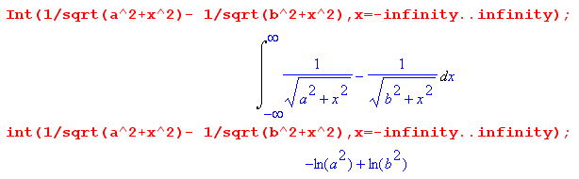

so this integral is

$^{\int_{-∞}^{∞}{}}$dz' { $\frac{1}{R1}$ – $\frac{1}{R2}$ } = $^{\int_{-∞}^{∞}{}}$dx { $\sqrt{a2+ x2}$ - $\sqrt{b2+ x2}$ } = ln(b2/a2) = 2ln(b/a)

in agreement with King, and then we get

V(z) = q(z) $\frac{1}{2πξ}$ 2ln(b/a) = q(z) $\frac{1}{πξ}$ ln(b/a) = Q/C'

C' = πξ/ln(b/a)

Taking the ε part we get

C = πε/ln(b/a) // agrees with King (30b), and so on for R.

So at least I see how the King thing works, vaguely. He makes a lot of approximations, I hoped to do better.

Plan E I now assume that higher terms are β2 by the argument given in Plan D, and now I concentrate on evaluation of the main term. Here is my potential at an arbitrary central point,

φ12(x) = φ1(x) - φ2(x) =

q(z) $\frac{1}{4πξ}$$^{\int_{-∞}^{∞}{}}$dz' { $^{\int_{C1}^{}{}}$dx1' dy1' a1(x1',y1') $_{1}$ – $^{\int_{C2}^{}{}}$dx2' dy2' a2(x2',y2') $_{2}$ }

But if I am doing β = 0, this is really

φ12(x) = φ1(x) - φ2(x) =

q(z) $\frac{1}{4πξ}$$^{\int_{-∞}^{∞}{}}$dz' { $^{\int_{C1}^{}{}}$dx1' dy1' a1(x1',y1') $\frac{1}{R1}$ – $^{\int_{C2}^{}{}}$dx2' dy2' a2(x2',y2') $\frac{1}{R2}$ }

I am done with all expansion things, and I only have to compute this term. I think I should draw a picture that shows all the R's that will be involved.

φ12(x1) = q(z) $\frac{1}{4πξ}$$^{\int_{-∞}^{∞}{}}$dz' { $^{\int_{C1}^{}{}}$dx1' dy1' a1(x1',y1') $\frac{1}{R11}$ – $^{\int_{C2}^{}{}}$dx2' dy2' a2(x2',y2') $\frac{1}{R12}$ }

R112 = (x1-x1')2 + (y1-y1')2 + (z-z')2 = s112 + (z-z')2 s112 = (x1-x1')2 + (y1-y1')2

R122 = (x1-x2')2 + (y1-y2')2 + (z-z')2 = s122 + (z-z')2 s122 = (x1-x2')2 + (y1-y2')2

φ12(x2) = q(z) $\frac{1}{4πξ}$$^{\int_{-∞}^{∞}{}}$dz' { $^{\int_{C1}^{}{}}$dx1' dy1' a1(x1',y1') $\frac{1}{R21}$ – $^{\int_{C2}^{}{}}$dx2' dy2' a2(x2',y2') $\frac{1}{R22}$ }

R222 = (x2-x2')2 + (y2-y2')2 + (z-z')2 = s222 + (z-z')2 s222 = (x2-x2')2 + (y2-y2')2

R212 = (x2-x1')2 + (y2-y1)2 + (z-z')2 = s212 + (z-z')2 s212 = (x2-x1')2 + (y2-y1)2

R222 = | r2 - r2'|2

Then finally we have

V(z) = φ12(x1) - φ12(x2)

= q(z) $\frac{1}{4πξ}$$^{\int_{-∞}^{∞}{}}$dz' { $^{\int_{C1}^{}{}}$dx1' dy1' a1(x1',y1') $\frac{1}{R11}$ – $^{\int_{C2}^{}{}}$dx2' dy2' a2(x2',y2') $\frac{1}{R12}$ }
- q(z) $\frac{1}{4πξ}$$^{\int_{-∞}^{∞}{}}$dz' { $^{\int_{C1}^{}{}}$dx1' dy1' a1(x1',y1') $\frac{1}{R21}$ – $^{\int_{C2}^{}{}}$dx2' dy2' a2(x2',y2') $\frac{1}{R22}$ }

= q(z) $\frac{1}{4πξ}$$^{\int_{-∞}^{∞}{}}$dz' { $^{\int_{C1}^{}{}}$dx1' dy1' a1(x1',y1')( $\frac{1}{R11}$- $\frac{1}{R21}$) - $^{\int_{C2}^{}{}}$dx2' dy2' a2(x2',y2') ($\frac{1}{R12}$- $\frac{1}{R22}$) }

Now what??? I could move the dz' integrations to the right. Then I need, for example,

$^{\int_{-∞}^{∞}{}}$dz' ( $\frac{1}{R11}$- $\frac{1}{R21}$)

= $^{\int_{-∞}^{∞}{}}$dz' ($\sqrt{s112 + (z-z')2}$ - $\sqrt{s212 + (z-z')2}$)

But I think I know this integral! Recall from above that

$^{\int_{-∞}^{∞}{}}$dx { $\sqrt{a2+ x2}$ - $\sqrt{b2+ x2}$ } = ln(b2/a2) = 2ln(b/a)

So then we should have

$^{\int_{-∞}^{∞}{}}$dz' ( $\frac{1}{R11}$- $\frac{1}{R21}$) = $^{\int_{-∞}^{∞}{}}$dz' ($\sqrt{s112 + (z-z')2}$ - $\sqrt{s212 + (z-z')2}$) = 2ln(s21/s11)

and then

$^{\int_{-∞}^{∞}{}}$dz' ( $\frac{1}{R12}$- $\frac{1}{R22}$) = 2ln(s22/s12)

and then I arrive here:

V(z) = q(z) $\frac{1}{2πξ}$ { $^{\int_{C1}^{}{}}$dx1' dy1' a1(x1',y1') ln(s21/s11) - $^{\int_{C2}^{}{}}$dx2' dy2' a2(x2',y2') ln(s22/s12) }

I think then this is a more precise version of what I have in my lines doc. Here is a picture to go with the original equations

= q(z) $\frac{1}{4πξ}$$^{\int_{-∞}^{∞}{}}$dz' { $^{\int_{C1}^{}{}}$dx1' dy1' a1(x1',y1')( $\frac{1}{R11}$- $\frac{1}{R21}$) - $^{\int_{C2}^{}{}}$dx2' dy2' a2(x2',y2') ($\frac{1}{R12}$- $\frac{1}{R22}$) }

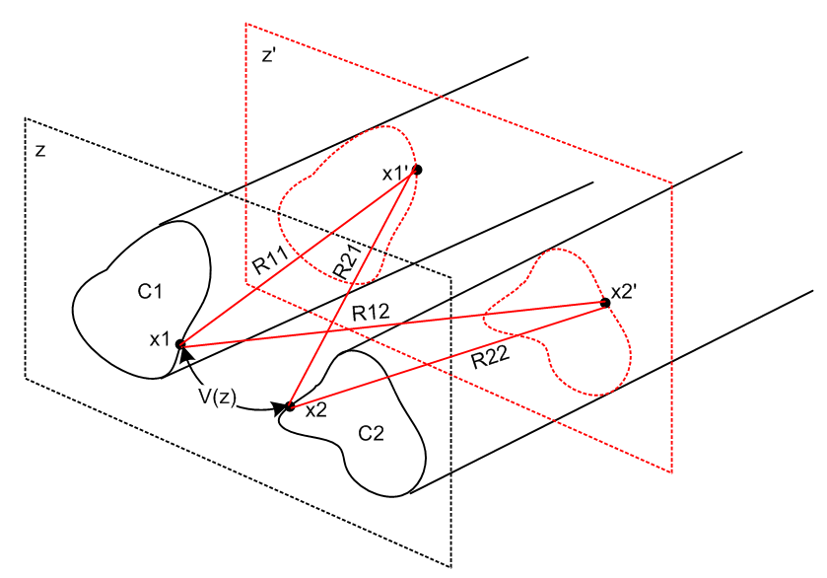

The last equation has a different picture all in a constant z plane:

V(z) = q(z) $\frac{1}{2πξ}$ { $^{\int_{C1}^{}{}}$dx1' dy1' a1(x1',y1') ln(s21/s11) - $^{\int_{C2}^{}{}}$dx2' dy2' a2(x2',y2') ln(s22/s12) }

s112 = (x1-x1')2 + (y1-y1')2 s212 = (x2-x1')2 + (y2-y1)2
s122 = (x1-x2')2 + (y1-y2')2 s222 = (x2-x2')2 + (y2-y2')2
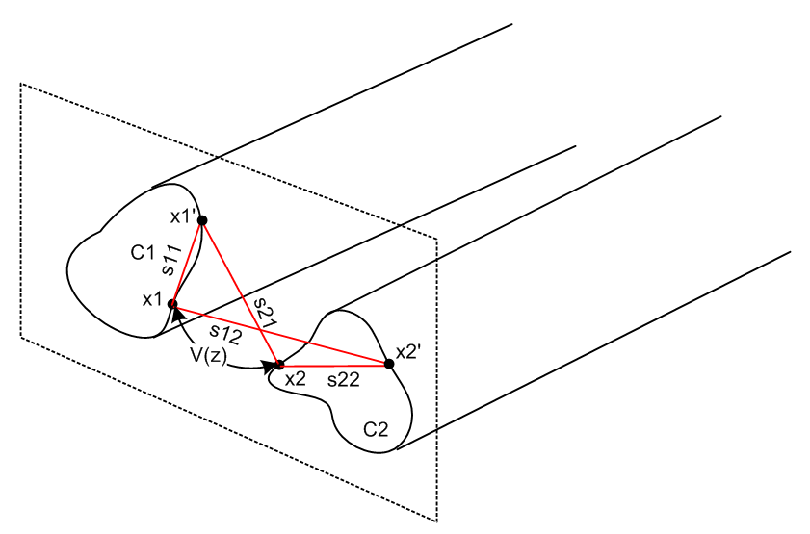
Let's now try the two circles:

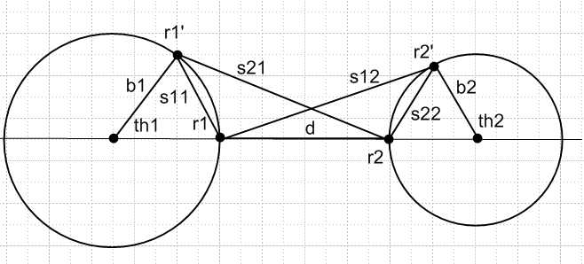

STOP! On the next line, I assume incorrectly that the surface charge is uniform around the round wires, but that is of course only valid for d >> b1, b2 so THAT is my error!! That is why the result I get below disagrees with King, because it makes a false assumption right at the start
So that above equation is valid in the sense that, if you KNEW a1(x1',y1') and a2(x1',y1'), you then have a result. So what good is this whole approach since we DONT know these things except in the large separation case?

V(z) = q(z) $\frac{1}{2πξ}$ { $^{\int_{C1}^{}{}}$dx1' dy1' δ(r - b1)/(2πb1) ln(s21/s11) - $^{\int_{C2}^{}{}}$dx2' dy2' δ(r - b2)/(2πb2) ln(s22/s12) }

= q(z) $\frac{1}{4π2ξ}$ { $^{\int_{0}^{∞}{}}$ dr1' $^{\int_{0}^{2π}{}}$dθ'1 δ(r1' - b1) ln(s21/s11) - $^{\int_{0}^{∞}{}}$ dr2' $^{\int_{0}^{2π}{}}$dθ'2 δ(r2' - b2) ln(s22/s12) }

= q(z) $\frac{1}{4π2ξ}$ { $^{\int_{0}^{2π}{}}$dθ'1 ln(s21/s11)|r1'=b1 - $^{\int_{0}^{2π}{}}$dθ'2 ln(s22/s12)| r2'=b2 }

Now

s112 = (x1-x1')2 + (y1-y1')2 = b12 + b12 - 2b1b1cos(θ1) = 2b12 [ 1-cos(θ1)]
s122 = (x1-x2')2 + (y1-y2')2 = (d+b2)2 + b22 - 2(d+b2) b2cos(π-θ2)

s212 = (x2-x1')2 + (y2-y1)2 = (d+b1)2 + b12 - 2(d+b1) b1cos(θ1)
s222 = (x2-x2')2 + (y2-y2')2 = 2b22( 1+cos(θ1)) seem OK

Inserting these, we get

V(z) = q(z) $\frac{1}{4π2ξ}$ { $^{\int_{0}^{2π}{}}$dθ'1 ln(s21/s11)|r1'=b1 - $^{\int_{0}^{2π}{}}$dθ'2 ln(s22/s12)| r2'=b2 }

= q(z) $\frac{1}{4π2ξ}$ (1/2) * (T1 + T2 + T3 + T4)

T1 = + $^{\int_{0}^{2π}{}}$dθ'1 ln(s212) = $^{\int_{0}^{2π}{}}$dθ'1 ln [(d+b1)2 + b12 - 2(d+b1) b1cos(θ1')]

T2 = - $^{\int_{0}^{2π}{}}$dθ'1 ln(s112) = - $^{\int_{0}^{2π}{}}$dθ'1 ln [2b12 ( 1-cos(θ1'))]

T3 = - $^{\int_{0}^{2π}{}}$dθ'2 ln(s222) = - $^{\int_{0}^{2π}{}}$dθ'2 ln [2b22( 1+cos(θ2')) ]

T4 = + $^{\int_{0}^{2π}{}}$dθ'2 ln(s122) = $^{\int_{0}^{2π}{}}$dθ'2 ln[(d+b2)2 + b22 + 2(d+b2) b2cos(θ2')]

This seems more complicated than the example I did in lines doc. Well, I allow arbitrary b1, b2 and d in this example, whereas I did not in the text. now I need to know this integral

$^{\int_{0}^{2π}{}}$dx ln (A + Bcosx) = 2π ln[(1/2)(A + $\sqrt{A2-B2}$ )] following from GF7 p531

Let's assume the condition is met for all four terms, check this later. Then

T1: A = (d+b1)2 + b12 B = - 2(d+b1) b1

A2-B2 = [(d+b1)2 + b12]2 - 4(d+b1)2 b12

= (d+b1)4 + b14 - 2(d+b1)2 b12 = [(d+b1)2 - b12]2
Then

T1 = 2πln[(1/2)( (d+b1)2 + b12) + (d+b1)2 - b12)] = 2π ln[(d+b1)2] = 4π ln(d+b1)
_________________

T2: A = 2b12 B = -2b12

A2-B2 = 0
Then

T2 = - 2πln[b12] = - 4π ln(b1)
_______________________

T3: A = 2b22 B = 2b22

A2-B2 = 0
Then

T3 = - 2π ln[b22] = -4π ln(b2)
_____________________

T4: A = (d+b2)2 + b22 B = 2(d+b2) b2

T4 = + 4π ln(d+b2)
_____________________

To summarize:

T1 = 4π ln(d+b1)
T2 = -4π ln(b1)
T3 = -4π ln(b2)
T4 = 4π ln(d+b2)

Then we get

V(z) = q(z) $\frac{1}{4π2ξ}$ (1/2) * (T1 + T2 + T3 + T4)

= q(z) $\frac{1}{πξ}$(1/2)* (ln(d+b1) + ln(d+b2) - ln(b1) - ln(b2)

= q(z) $\frac{1}{2πξ}$ ln [$\frac{(d+b1) (d+b2)}{b1 b2}$] d = inner touch distance bi = radii

For very large d this says

V(z) = q(z) $\frac{1}{2πξ}$ ln [$\frac{d2}{b1 b2}$]

If we change to diameters instead of radius this becomes

V(z) = q(z) $\frac{1}{2πξ}$ ln [$\frac{2d2}{d1 d2}$]

The capacitance is then

1/C = $\frac{1}{2πε}$ ln [$\frac{2d2}{d1 d2}$]

How can I verify this result? It says that

C = 2πε/ ln [$\frac{2d2}{d1 d2}$]

Suppose we had equal radii. Then we would have

C = 2πε/ ln [$\frac{d2}{b1 b2}$] = 2πε/ ln [$\frac{d2}{b12}$] = πε / ln(d/b)

and this does agree with King p 17 (30b). So at least I have a verification for equal radii which means my overall constant is right.

Now go back to my more general result:

V(z) = q(z) $\frac{1}{2πξ}$ ln [$\frac{(d+b1) (d+b2)}{b1 b2}$]

Let's change symbols on my result by using

B = distance between centers = d + b1 + b2

d + b1 = B-b2 d + b2 = B - b1

Then my result becomes

V(z) = q(z) $\frac{1}{2πξ}$ ln [$\frac{(B-b2) (B - b1)}{b1 b2}$]

The capacitance is then

1/c = $\frac{1}{2πε}$ ln [$\frac{(B-b2) (B - b1)}{b1 b2}$]

c = 2πε 1/ ln [$\frac{(B-b2) (B - b1)}{b1 b2}$]

This agrees with King p 28 if I can show that:

(ch-1ψ1 + ch-1ψ2) = ln [$\frac{(B-b2) (B - b1)}{b1 b2}$]

He has, converted to my notation,

ψ1 = (B2+b22 -b12)/(2Bb1)
ψ2 = (B2+b12 -b22)/(2Bb2)

Let's try some numbers

B = 9 b1 = 2 b2 = 3 d = 4





Result: My result disagrees with King! No need to go any further. A third source is that I do this problem myself later in lines where I find that

K = f(x1) - f(x2) = B1 - B2 = ln [(d/a1) + $\sqrt{(d/a1)2 + 1}$] + ln [(d/a2) + $\sqrt{(d/a2)2 + 1}$]
where ai are the radii and 2d is the distance between the foci. My drawing is very unclear. I am doing the potential 2D method, so my result should be same as King's. My b is distance between centers. I claim that

d = (1/2b) $\sqrt{b4 + (a12 - a22)2 - 2b2(a12 + a22)}$ (6.3.7)

But things then look pretty messy for the above K. But my result has no verification, so it is just another floating calculation, not useful to me right now!

Matick has a result on page 317 for two equal radii with S as the center separation. So let's compare the three results for that case:

King: ψ1 = ψ2 = B/2b so then

[ ψ1 + $\sqrt{ψ12-1}$] [ ψ2 + $\sqrt{ψ22-1}$] = [ ψ1 + $\sqrt{ψ12-1}$]2

= ψ12 + ψ12- 1 + 2 ψ1$\sqrt{ψ12-1}$ = 2ψ12 - 1 + 2 ψ1$\sqrt{ψ12-1}$

= 2(B/2b)2 - 1 + 2(B/2b) $\sqrt{(B/2b)2-1}$

So King's result is then related to

ln [2(B/2b)2 - 1 + 2(B/2b) $\sqrt{(B/2b)2-1}$]

Me: ln [$\frac{(B-b2) (B - b1)}{b1 b2}$] = ln [$\frac{(B-b)2}{b2}$] =2 ln [$\frac{(B-b)}{b}$]

Matick: ln $\sqrt{B2-4b2}$

So we have three different results! I will put in my numbers B = 9 and b = 2, and this shows that King and Matick I think agree, because I find numerically that

($\sqrt{B2-4b2}$)2 = 2(B/2b)2 - 1 + 2(B/2b) $\sqrt{(B/2b)2-1}$

which is the same analytically as

[(B/2b) + $\sqrt{(B/2b)2-1}$]2 = 2(B/2b)2 - 1 + 2(B/2b) $\sqrt{(B/2b)2-1}$

I predict LHS = RHS. Eval

LHS = (B/2b)2 + (B/2b)2 - 1 + 2(B/2b) $\sqrt{(B/2b)2-1}$

= 2 (B/2b)2 - 1 + 2(B/2b) $\sqrt{(B/2b)2-1}$ // yes

So I think King and Mat are compatible. It is MY result that is clearly wrong, it is "too simple".

Then

(ch-1ψ1 + ch-1ψ2) = ln [ ψ1 + $\sqrt{ψ12-1}$] + ln [ ψ2 + $\sqrt{ψ22-1}$]

= ln { [ ψ1 + $\sqrt{ψ12-1}$] [ ψ2 + $\sqrt{ψ22-1}$] }

So what I want to show is this:

ln { [ ψ1 + $\sqrt{ψ12-1}$] [ ψ2 + $\sqrt{ψ22-1}$] } = ln [$\frac{(B-b2) (B - b1)}{b1 b2}$]

which is to say, I want to show that

[ ψ1 + $\sqrt{ψ12-1}$] [ ψ2 + $\sqrt{ψ22-1}$] = $\frac{(B-b2) (B - b1)}{b1 b2}$

But numerically I have already shown above that this does not work! MY result after my huge calculation is wrong somehow. There will be many things to check, Manana!

___________________________________________________________________________

The capacitance result is not stated in my Radio Eng book, but page 592 shows a result for Z which has some relevance. Meanwhile, King does this problem and gets a result on page 28 which indicates

1/c = (1/2πε) [cosh-1$\frac{D2-b22+b12}{2b1D}$ + cosh-1$\frac{D2-b12+b22}{2b2D}$]

where D = distance between centers = d + b1+b2 .

Theorem: cosh-1x = ln[x + $\sqrt{x2-1}$] ≡ ln(y)

Proof: Show that

cosh(ln[x + $\sqrt{x2-1}$) = x

Evaluate the LHS :

cosh(ln[x + $\sqrt{x2-1}$) = cosh(ln(y)) = (1/2) [ elny + e-lny] = (1/2) [y +1/y]

= (1/2) [x + $\sqrt{x2-1}$ + x - $\sqrt{x2-1}$] = x QED This is Spiegel 8.56, duh huh

Now I just showed the following on scratch paper:

y = ch-1ψ1 + ch-1ψ2

=>

y = ln [ ψ1ψ2 + ψ2$\sqrt{ψ12-1}$ + ψ1$\sqrt{ψ22-1}$ + $\sqrt{ψ12-1}$$\sqrt{ψ22-1}$ ]

so at least I can make some connection to logs. Just out of curiosity,

ψ1 = $\frac{D2-b22+b12}{2b1D}$

ψ12 - 1 = [(D2-b22+b12)2 - (2b1D)2 ] / (2b1D)2

Consider

(x2-y2+z2)2 - 4 z2x2

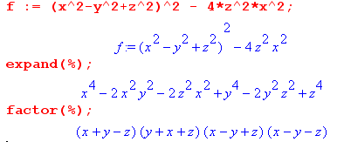

Then

(x2-y2+z2)2 - 4 z2x2 = [ (x+y)2 - z2] [ (x-y)2 - z2]

Thus suggests that we get this not-very-simple expression,

ψ12 - 1 = [ (D+b2)2 - b12] [ (D-b2)2 - b12] / (2b1D)2

$\sqrt{ψ12-1}$ = $\sqrt{(D+b2)2 - b12}$$\sqrt{(D-b2)2 - b12}$ / (2b1D)

Then I guess

$\sqrt{ψ22-1}$ = $\sqrt{(D+b1)2 - b22}$$\sqrt{(D-b1)2 - b22}$ / (2b2D)

ψ1ψ2 + ψ2$\sqrt{ψ12-1}$ + ψ1$\sqrt{ψ22-1}$ + $\sqrt{ψ12-1}$$\sqrt{ψ22-1}$

= (ψ1+$\sqrt{ψ12-1}$)( ψ2+ $\sqrt{ψ22-1}$)

ψ1+$\sqrt{ψ12-1}$ = $\frac{D2-b22+b12}{2b1D}$ + $\sqrt{(D+b2)2 - b12}$$\sqrt{(D-b2)2 - b12}$ / (2b1D)

= [ D2-b22+b12 + $\sqrt{(D+b2)2 - b12}$$\sqrt{(D-b2)2 - b12}$] / (2b1D)

Does this simplify?

Web Scan. It is not easy to find what I want. I search on "unequal diameters" and get a hit

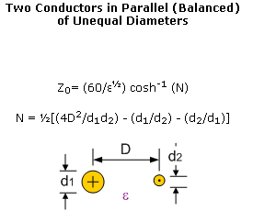
http://www.rfcafe.com/references/electrical/transmission-lines.htm

This seems different from King's result.

Why don't I say anything about "impedance" of a line? I just added some notes above the start of lines 4.6 and concluded there that at large ω

Z0 =$\sqrt{με}$ 1/C

For my two round wire line with large spacing I get

C = πε / ln ( b/$\sqrt{a1a2}$) (4.6.5)

That would imply that

Z0 = (1/πε)$\sqrt{με}$ ln ( b/$\sqrt{a1a2}$) = (1/π) $\sqrt{μ/ε}$ ln ( b/$\sqrt{a1a2}$)

Now assume μ = μ0 and ε = (ε/ε0)ε0 so then

Z0 = (1/π) $\frac{μ}{ε}$ln ( b/$\sqrt{a1a2}$) = (1/π) $\frac{μ0}{(ε/ε0)ε0}$ln ( b/$\sqrt{a1a2}$)

= (1/π) $\frac{μ0}{ε0}$$\sqrt{ε/ε0}$ ln ( b/$\sqrt{a1a2}$) = (1/π) 376.73032 ohms * $\sqrt{ε/ε0}$ ln ( b/$\sqrt{a1a2}$)

= 119.9169852 $\sqrt{ε/ε0}$ ln ( b/$\sqrt{a1a2}$)

= 119.9169852 $\sqrt{ε/ε0}$ ln ( 2b/$\sqrt{d1d2}$)

≈ 120 $\sqrt{ε/ε0}$ ln ( 2b/$\sqrt{d1d2}$) (**)

Now

y = lnx ey = elnx = x

z = logx 10z = 10logx = x 10z = ey

z = log(ey) = ylog(e)

y = ln(ey) = ln(10z) = z ln(10)

logx = log(e)lnx

lnx = ln(10)logx

log(e) = 0.434294482

ln(10) = 2.302585093

These are inverses of each other. It is hard to find this simple fact on the web!

lnx = 2.302585093 logx // write this down somewhere for next time.

Continuing the above

Z0 = (1/π)* 376.73032 ohms * $\sqrt{ε/ε0}$ 2.302585093 log10 ( b/$\sqrt{a1a2}$)

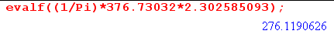

= 276.1190626 $\sqrt{ε/ε0}$ log10 ( b/$\sqrt{a1a2}$)

Here ai are radius values. Write a1 = d1/2 to get

$\sqrt{a1a2}$ = $\sqrt{d1d2}$/2

and then I get

Z0 =276.1190626 ohms $\sqrt{ε/ε0}$ log10 ( 2b/$\sqrt{d1d2}$)

This agrees with radio book page 592! Finally something agrees with something! That book clearly states that it is assuming b is >> the radii.

Now how does this fit into the picture,

For large D, the claim is that N = 2D2/d1d2 and then they claim that

Z0 = 60 $\sqrt{ε/ε0}$cosh-1(2D2/d1d2)

Now consider

y = cosh-1(x) x = cosh y x = large and y = large

x = (1/2)[ ey + e-y] ≈ (1/2)ey

ln(2x) = y y = ln(2x)

So their result becomes

Z0 = 60 $\sqrt{ε/ε0}$ln(4D2/d1d2) = 120 $\sqrt{ε/ε0}$ln( 2D/$\sqrt{d1d2}$)

This agrees with my (**) above, so now we have two agreements.

